

**Acrylic sheet**

**Contents**

**Introduction** ......................................... ………….. 1

**Physical Properties of ACRYGLAS®** 2

Cleaning................................................. 3

Masking.................................................. 3

Some general hints .............................. 4

**Cutting ACRYGLAS acrylic sheet** . 4

Cutting with a power saw............. 4

Cutting with circular saws ..................... 10

Cutting with hand saws ....................... 12

Routing and shaping............................ 13

Turning ................................................... 15

**Drilling ACRYGLAS acrylic sheet**. 10

**Finishing ACRYGLAS acrylic sheet** 11

Scraping................................................ 11

Filing ...................................................... 11

Sanding ................................................. 12

Polishing ............................................... 13

**Forming ACRYGLAS acrylic sheet** 15

Forming with a strip heater ................ 15

Other forming techniques................... 17

**Joining ACRYGLAS acrylic sheet** 18

Preparation of the joint ....................... 18

Capillary cementing ............................ 19

Dip or soak cementing........................ 20

Viscous cementing .............................. 21

**Glazing with ACRYGLAS acrylic sheet** 22

INTRODUCTION

**Vision Acryglas® is a trusted leader in the development and manufacture of high-performance**

**extruded acrylic (PMMA) sheets. ACRYGLAS® acrylic sheets represent the pinnacle**

**of quality in continuously manufactured sheet technology. Crafted using a proprietary, cutting**

**-edge process, these sheets deliver exceptional performance — offering tight thickness**

**tolerances, superior optical clarity, and minimal internal stress.**

**Designed for both economy and excellence, ACRYGLAS® sheets are produced in large volumes**

**to ensure competitive pricing without compromising quality. Whether you need crystal-clear**

**transparency, vibrant translucence, or bold opaque finishes, ACRYGLAS® has you covered.**

**Available in a wide range of standard sizes, thicknesses, and color options, ACRYGLAS®**

**sheets are the ideal solution for applications demanding consistency, durability, and**

**visual appeal — from architectural glazing and retail displays to industrial and creative uses.**



**Features & Benefits**

•  Continuously manufactured (extruded)  
•  Excellent weather resistance with a ten year warranty  
•  Easier to fabricate at lower temperatures than cast sheet products  
•  Ideal for thermoforming with low shrinkage

**Standard Product Specifications**

**Sizes :** Range from 48" x 96" to 75" x 100"  
**Thickness :** Available from 1.5mm to 12mm in Clear and color  
**Colors :** Standard colors available

Physical Properties Of

Extruded Acrylic sheet

|  |  |  |
| --- | --- | --- |
| Property | ASTM Method | Test Value |

Mechanical

|  |  |  |
| --- | --- | --- |
| Specific Gravity | D 792 | 1.19 |
| Tensile Strength | D 638 | 658 Kg/Cm² |
| Elongation | D 638 | 5.0 % |
| Tensile Modulus | D 638 | 24624 Kg/Cm² |
| Flexural Strength | D 790 | 964 Kg/Cm² |
| Flexural Modulus | D 790 | 29575 Kg/Cm² |
| Izod Impact Strength | D 256 | 21.4 J/m |
| Rockwell Hardness – ‘R’ | D 785 | M-87 |
| Scale |  |  |
| Barcol Hardness | D 2583 | 47 % |
| Light Transmission | D 1003 | 93 % |
| Heat Deflation Temperature | D 648 | 87.2 ˚C |
| Vicat Softening Temperature | D 1525 | 102.9 ˚C |
| Flamability(Rate Of Burning) | D 635 | 1.6 Mm/Min |
| Dielectric Strength | D 149 | 9.3 Kv/mm |
| Volume Resistivity | D 257 | 11x10¹⁵ Cm |
| Surface Resistivity | D 257 | 1.8x10¹⁶ |
|  | D 570 | 0.20 % |
|  | --- | None |
|  | --- | None |

Optical Thermal

Electrical

Water Absorption

Odor Taste

Notes: (a) Test values; should not be used for specification purposes.

* Values shown are for 0.250” thickness. Some values will change with thickness or pigmentation.
* It is recommended that temperatures should not exceed 160˚F for continuous service, or 190˚F for short intermittent use.

Working with AcryGlas

Acrylic Sheet / AcryGlas®

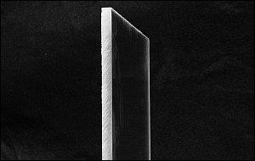

Before we begin...

CLEANING :

* + Do not remove the film or paper protector from the acrylic until you absolutely have to. The material can be scratched relatively easily.
  + When cleaning the acrylic material, only use cleaners that are approved by the manufacturer. Unlike glass, glass cleaners (like those with ammonia) can damage acrylic
  + Vision Acryglas® sheets are produced in clean-room environments and typically arrive ready to use. However, proper care and periodic cleaning help preserve their clarity, durability, and finish

**General Cleaning Instructions**

* + Use a soft cotton or microfiber cloth slightly moistened with clean water to remove dust.
  + For routine cleaning, apply a mild soap solution or Vision Acryglas Plastic Cleaner with
  + light pressure.
  + Rinse thoroughly with lukewarm water and blot dry using a soft, non-abrasive cloth.
  + Avoid harsh chemicals or dry wiping, as they may scratch the surface.

MASKING :

## Masking Guidelines for Fabrication & Painting

### Best Practices:

* Keep the masking on during all fabrication steps.
* Remove masking **immediately after installation** if exposed outdoors, as sunlight can

degrade the film.

* Always remove masking **before any heat-forming** or **annealing** to avoid surface damage.

### 🎨 For Painting & Printing:

* Use **plain PE film** for sheets intended for screen or digital printing to avoid ghosting.
* For painted designs, **liquid maskants** may also be applied.

When cutting acrylic for applications where the edge will be visible and will need to be either polished or at least very smooth, it's absolutely imperative that you get the cut right the first time. It may seem that you could easily fix any roughness in the edge with a bit of sandpaper. Well... it ain't that simple. It's VERY time consuming to have to fix the results of a bad cut. Sanding, filing and scraping go very slowly, especially on rough surfaces. If the cut/finished edge will be against another piece of straight material when it's installed, a slight dip in the edge (which can be caused by hand finishing) can look very bad. If the edge has to be straight and square, a table saw with the right blade is what you'll need to use to make the cuts (especially in materials thicker than 1/8").

Cutting Acrylic:

There are a couple of different ways to cut acrylic. Since my experience is mainly with thin acrylic sheeting (1/2" or less), that's what I'll cover.

Cutting with Power Saws :

1. **Table/Circular Saw:**

To understand some of the following information, you'll need to know a bit more about circular saw blades.

You'll see standard blades with teeth simply cut from the material that makes up the rest of the blade. These are budget blades and are rarely used. The better blades have carbide teeth welded or brazed onto the steel. These are much more durable and can last for many years if not abused.

Blades come in different configurations. The teeth on the following blade are in the most common configuration. This is an ATB (Alternate Tooth Bevel) blade. The second blade is a more specialized blade. The teeth are in a TCG (Triple Chip Grind) configuration. The teeth alternate from straight to beveled. The beveled tooth is beveled on both sides and flat on top.

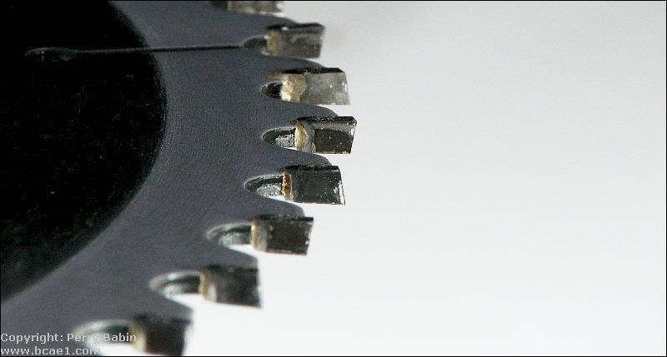.

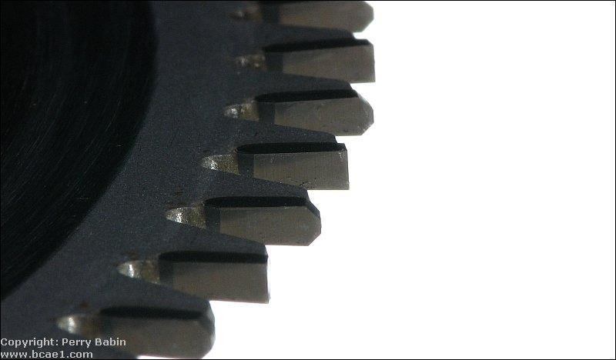

Another characteristic is the rake angle. Blades used for cutting non-ferrous metals and plastics typically have a 0° rake angle. A tooth with a 0° rake angle will have it's face aligned perfectly with a line drawn through the center of the blade. The first image below shows a blade with a moderate rake angle. The second had a 0° rake angle.

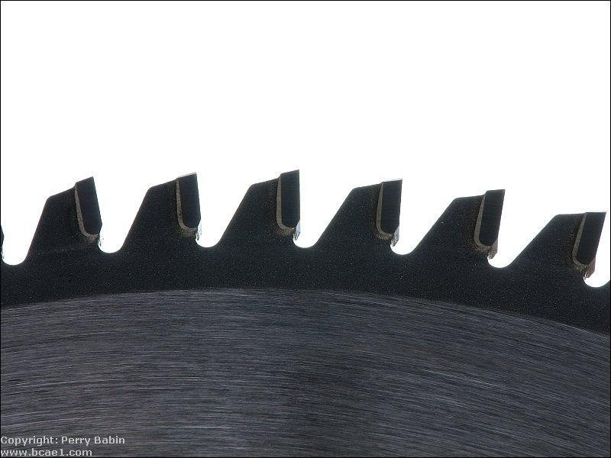

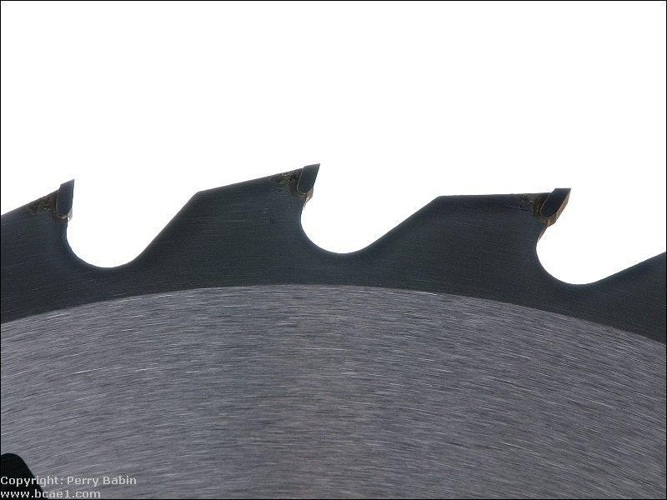

For rough cutting acrylic, you can use a table saw or a circular saw with a fine blade. Blades with fine closely spaced teeth (like those used for plywood) will work relatively well. Blades with widely spaced teeth and a significant rake angle (like those preferred for cutting MDF) will cause significant chipping. I've used an [Oldham B7254760](https://www.google.com/search?hl&q=Oldham%2BB7254760&sourceid=navclient-ff&rlz=1B3GGHP_enUS452US452&ie=UTF-8) on a circular saw and a Skil 75160 on a table saw (cutting both 1/4" and 0.706" material) with good results. For the casual DIYer, the finish with these may be good enough (not requiring a more expensive blade). When using a hand held circular saw, use a guide to make sure you get a straight cut with minimal chipping.

The Irwin 15199 is a TCG blade and does a very good job on a table saw. There was absolutely no chipping on the 1/4" or the 0.706 material that I used it on.

There are blades made specifically for cutting acrylic. If you're going to be cutting a lot of acrylic or are using very expensive (thick) material, you need to invest in a blade specifically designed for cutting plastics and laminates. Blades with a triple chip grind (like the Irwin blade mentioned) are well suited for acrylic so if you can't find a blade that is specifically made for acrylics, the general purpose TCG blades may work well enough. When you get a blade that cuts the acrylic well,

you can make about 5-10 light passes with a scraper and then do a bit of light sanding and the edge is good enough for most any purpose (polishing or joining, to be covered a bit later).

Chipping was mentioned above. Chipping is the breaking of the material at the top and/or bottom face at the line of cut. If you need to have a perfect, good looking joint, you cannot have any chipping. The first image below shows significant chipping. The second image is a much cleaner cut.

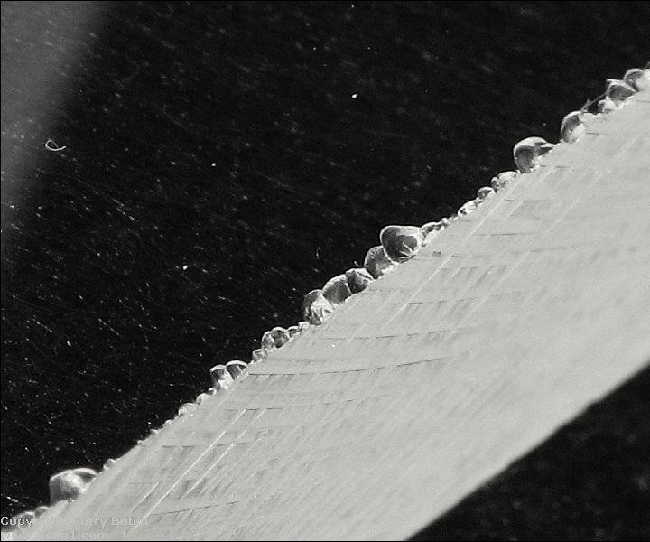

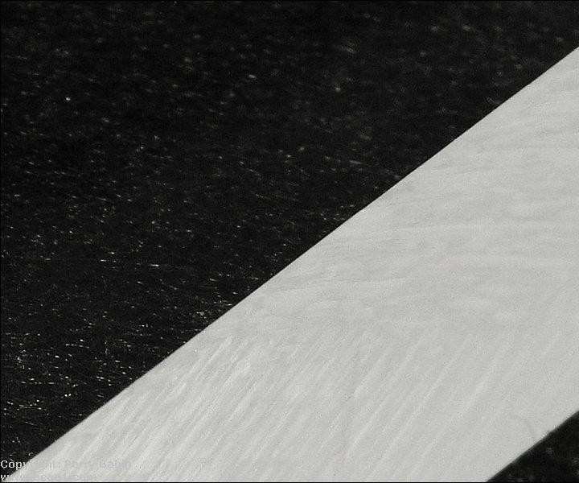

A note about price...

You can buy carbide tipped blades that will cut MDF for $10 and they'll do a fine job, on MDF. When buying a blade that will work well on acrylic, expect to pay at least $40. The best blades will likely be over $100. Used properly, they will last a very long time and are well worth the up-front cost but the cost can be a bit of a surprise.

Many of us have table saws that were made for general purpose cutting and do a good job for building speaker enclosures from MDF. Acrylic is expensive, when someone buys an acrylic enclosure, they expect it to be perfect. You can't sand away 1/16th of an inch like you can with an MDF enclosure. When cutting acrylic, where the tolerances may need to be within a few thousandths of an inch to make

the pieces fit together perfectly. This means that any runout (play, slack, wear...) in the bearings for the blade shaft make a big difference. When the blade is working hard to make a cut through the middle of a sheet of acrylic, the runout may be more of an issue than when just trimming a few thousandths off of the edge. If your saw has enough runout to make the cut edge a bit rough (blade will go deeper in a few places), make the first cut about 1/2 of the width of the teeth on the blade. Then move the fence to where it needs to be and trim the last few thousandths of an inch off of the edge.

1. **Jigsaw:**

Jigsaws can be used to cut acrylic when you need something other than a straight cut. If a jigsaw is all you have and you need to keep costs down, the right blade and a bit of preparation can produce good results. To reduce the work of cleaning up the cut, use the finest blade that you can find. Blades with reduced depth (like those used for scroll work - shown below) will work best due to less friction and less resistance when turning the blade. You'll have to experiment with cutting speed to see what works best. Too much pressure can cause excessive chipping. Going too slow may cause the acrylic to melt. If the acrylic melts when cutting, use a light lubricating oil. Have someone apply the oil to the blade as you're making the cut. DON'T use an aerosol dispensed oil. The propellant may be flammable and may be ignited by the jigsaw motor. I've had good results with the blade shown below (Bosch T101AOF). This blade is made for cutting laminated flooring.

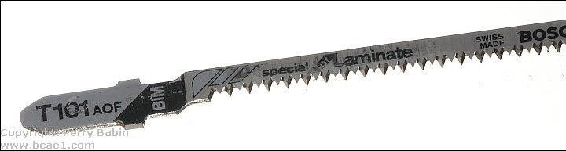

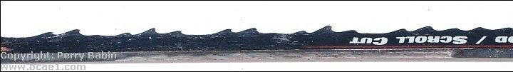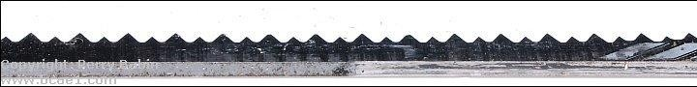Below, you can see the blade profiles for the blade above (first image) and a standard jigsaw blade. As you can see, the tips of the teeth on the laminate blade are directly in front of the body of the blade. On the scroll blade, the teeth cut a kerf wider than the body of the blade. Between these two blades, it would seem that the scroll blade would cut faster but the laminate blade cuts much more quickly.

You should also experiment with the various setting on your particular jigsaw. With some blades, for example, the cut will be very bad (so bad that the material melts back together) when the blade is set to a normal, straight up and down stroke but when the jigsaw is set to the maximum orbital setting, that same blade will make a clean cut.

Cutting with Knife or Scriber Saws :

**Score and Break:**

Thin acrylic sheets (less than ~1/4") can be cut much like regular glass. Instead of using a hardened wheel to chip a line in the glass, you'll use a scoring tool to cut a deep scratch in it. The cutting edge of the scoring tool looks something like a single tooth of a table saw blade (but much thinner). You apply pressure to the tool and drag it along a straight edge guide (which should be clamped securely in place to prevent it from moving). You need to continue scoring the acrylic until the cut is ~1/8 of the way through the material (it may take 20 passes on 1/4" thick stock). After that's done, you'll have to clamp it down on the edge of a table (or something similar).

The edge of the table needs to align with the cut. The edge of the table needs to be perfectly square (a radiused edge on the table won't provide the proper stress along the desired cut line). It needs to be clamped very securely so that it can not flex or move. You'll then apply pressure to the piece that's beyond the edge of the table until it snaps. If it was cut deeply enough, it will break cleanly along the desired line. If it was not cut deeply enough, the cut (on the side opposite the scoring) can be as far outside of the desired cut line as the thickness of the material. The image below shows an inexpensive scoring tool (I think it cost ~$3).

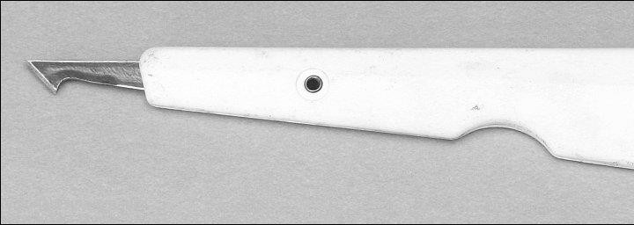

This is an Olfa PC-L. It costs ~$10 from McMaster-Carr (part # 38595A65). This one has replaceable blades, [storage for blades in the handle](http://www.bcae1.com/images/jpegs/IMG_5133b.jpg) and a larger handle which reduces fatigue.

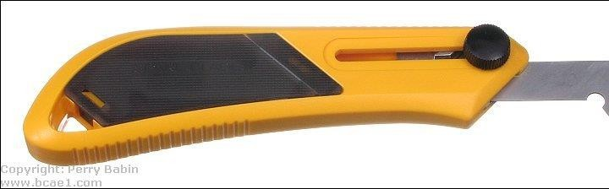

**Note:**

* + When scoring the material, it's likely that you'll not score as deeply on the end where you begin the scoring. Go back and score from the other direction to ensure that the edge breaks cleanly.
  + When possible, score from both sides. This takes a bit more effort but will result in a cleaner break.

If you have trouble keeping the straight edge in place and can't clamp it so it can't move,

you may make multiple scores which will result in a bad cut. If your straight edge slips

place the scoring blade in the slot as close to the edge of the cut as possible and slide

the straight edge up against it. That will ensure that it's in the right place. Do this for both

ends of the scored line.

* + To keep the straight edge and the workpiece as steady as possible (when they can't be clamped), the following will help. The first is a material that is soft and almost adheres to the items placed on it as well as the work surface. This prevents the workpiece from moving. Notice that it says it grips on top and bottom. This is what you want. This is about $4 a roll at Wal-Mart. The second is a piece of angle stock with electrical tape on the edge that is placed on the acrylic. The tape stops it from moving. The angle stock protects your fingers from the blade. The stock can be purchased from virtually any home improvement or hardware store.

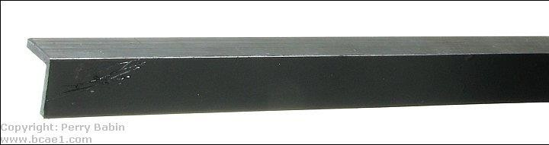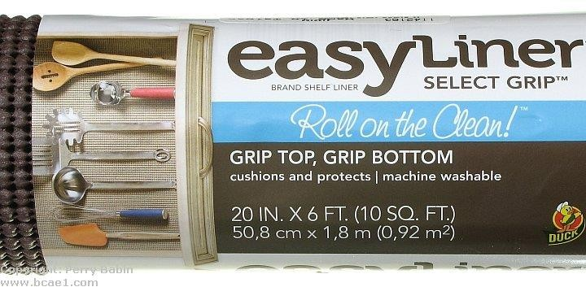

**Cutting with Hand Saws :**

Cutting acrylic sheets with a hand saw is a basic but effective method, particularly for small or occasional jobs where power tools are not necessary. A hand saw features a straight blade with fine teeth, and it is operated manually using a back-and-forth motion. When cutting acrylic, it's essential to use a saw with fine, closely spaced teeth—such as a hacksaw or a crosscut saw—to minimize chipping and cracking. The sheet should be firmly clamped to a stable work surface to prevent vibration, which can lead to uneven cuts or damage.

Cutting should be done slowly and steadily, with light pressure, allowing the teeth to work through the material without overheating or binding. This method is best suited for straight cuts in thinner acrylic sheets (generally up to 5 mm) and may require post-processing, such as sanding or polishing, to smooth out the cut edges. While not the fastest or cleanest method , using a hand saw is a cost-effective and accessible option, especially for DIY users or when powertools are not available.

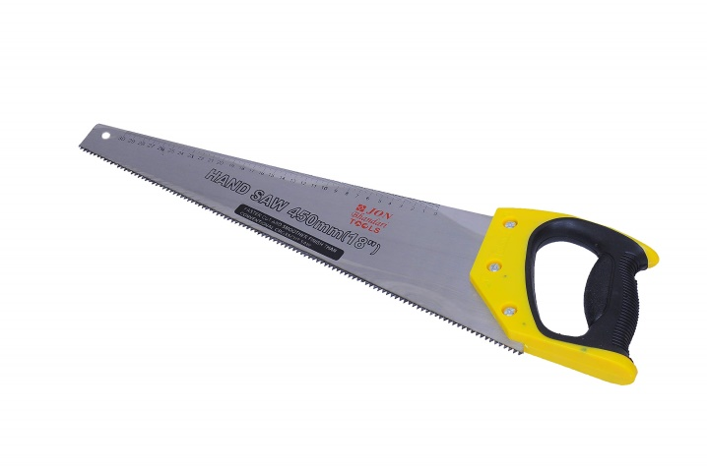

**Routing and Shaping :**

A router can be used to cut acrylic for either straight or curved cuts. For curved cuts, you'll want to use a router with a collar and a guide (pattern or jig made from 1/4 inch plywood or aluminum). You'll want to rough cut the material within ~1/8 of an inch of the desired finished shape with a jig saw. Trying to cut too much acrylic can lead to melting of the material unless you have a bit well suited to cut plastic. To prevent chipping, make sure the bit is not allowed to break contact with the cut edge. If it does break contact with the material and you push the router bit back into the edge too quickly, the cutter may chip the acrylic. Spiral bits are generally better than straight-cut bits and slow-spiral bits tend to be a bit better than standard spiral bits. You also must make sure you have a sharp bit (carbide tipped or solid carbide recommended) to prevent melting of the material. Again, you'll have to experiment to see what works best for you.

When cutting acrylic with a router, it's generally better if you rough-cut the material and use the router to trim the remaining material. You can use the router or any other saw for the rough-cut. If you are cutting through a large panel and want a fine finish on the cut, you need to support both pieces of the panel. If you don't support both pieces, the piece that falls away as the cut it finished could cause the corner of either piece to chip. This is a minor problem for rough cuts but for cuts where you don't want to do any finishing of the cut edge, it's important.

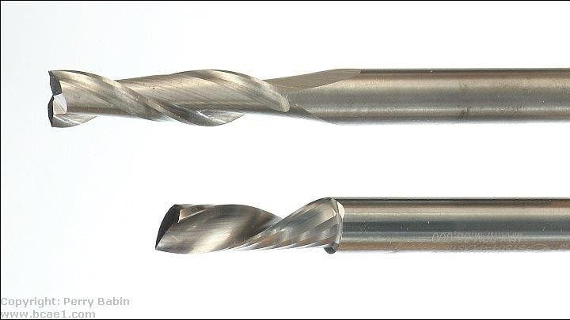The bits below are solid carbide spiral bits. The top is a standard spiral (Whiteside RU2100). The bottom is a slow spiral (Amana 51504). Both do a good job but the slow spiral produces cuts that are a bit cleaner. Using the slow spiral on 1/4" material, the cut is so good that minimal work wet-sanding with 400 grit paper leaves the edge good enough for flame polishing

When you buy router bits, there are up-cut and down-cut bits. If you are cutting slots or have a vacuum connected to your router to remove shavings, you'll likely want the up-cut bit. Otherwise, I'd recommend the downcut bit. The downcut bit will throw the shavings down and away from you.

When making a cut along a fence with a router, its face has to be very smooth and it has to be very rigid, especially for long cuts. To make it rigid, it needs to be relatively deep. At least 6" of depth for 2 feet of length with 3/4" plywood is needed for critical cuts. Oak, ash or birch will work better than pine plywood. To make the face of the fence smooth enough to prevent any flaws from showing up in the cut, you will likely need to face it with metal stock. Aluminum angle stock works well. You can use iron stock but it's generally too rough.

If you cut along a straight edge that's not stiff enough, you will make a bowed cut. This is because most people push hard against the straight edge to make sure that the router doesn't veer away from it. This can cause a weak straight edge to flex slightly. For some applications, this won't be a problem but if you're going to bond the cut edge to the face of another piece of acrylic, it can make getting a perfect bond nearly impossible. If you do get a good bond, the piece that you bond it to will be bowed and under constant stress. Again, if you're bonding two pieces together, use a saw with a fence like a table saw.

Previously, runout was mentioned. This can be a problem with routers also. A poor quality or old router with excessive runout will make it impossible to get a good, smooth cut. If your router isn't producing good cuts and you need a good router, do some research (google, forums, reviews...) to find a router that's not going to have excessive runout. If you use the various woodworking forums, tell them that you're cutting acrylic and need to have a router with little or no runout. I'd suggest small, trim routers. The Bosch pr20evsk does a good job. Larger routers often have a collet that holds the bit. That adds one more piece that could add runout. Trim routers typically accept 1/4" bits without the collet.

Of course, you know to wear safety glasses when doing any cutting or grinding but it's even more critical when using solid carbide bits. Carbide is extremely hard which makes it a good material for cutters but it's also very brittle. When they break (and they're not difficult to break) they can shatter and cause significant injury. In a router, they're spinning at 25,000+ RPMs. When they shatter, they will have the ability to penetrate skin. This means that it's important that you protect yourself well. A full face shield and a heavy apron aren't excessive. If your router has shields, keep them in place.

The cost of router bits (like specialized saw blades) can be a bit of a shock. Some of the relatively small bits (1/4" diameter, 1" cut) can cost nearly $100. These are typically specialized bits but sometimes that's what you need to do the job properly.

Router Safety...

Respect the router. Too many people don't give a router the respect it deserves. A router can do a LOT of damage to anything if it's not used properly. This includes hands and fingers. Before you plug the router in, make sure that it's off and on a stable surface. Before you switch it on, have it where it needs to be to start the cut. When possible (some have switches that can't be reached from the handles) have both hands on the router when you switch it on. When you turn it off, hold it with both hands when moving it or wait until the motor stops spinning. A router bit is dangerous when it's not spinning. When it's spinning, even when it has almost stopped, it can still do serious damage. For small routers (like trim routers), it's easy to let your fingers go into the cutout where you loosen the collar that holds the bit. Make sure that you keep your fingers out of that area if the router doesn't have a guard. If you want proof that a router can do serious damage, do a Google image search for [router injuries](https://www.google.com/search?q=router%2Binjury&hl=en&safe=off&rlz=1B3GGHP_enUS452US452&prmd=imvnsfd&source=lnms&tbm=isch&ei=WH5OT9-tFNS2twfvm6ilCA&sa=X&oi=mode_link&ct=mode&cd=2&ved=0CA4Q_AUoAQ&biw=1920&bih=835) (do NOT click if you're squeamish).

Turning:

Turning is a machining process where an acrylic rod or cylindrical piece is rotated on a lathe

while a cutting tool shapes it into the desired form. This method is ideal for producing round

parts such as spacers, tubes, or decorative elements. To prevent chipping or melting, sharp carbide-tipped tools and controlled speeds are essential. Light, steady cuts help achieve a

smooth finish, and polishing can be done afterward for optical clarity. Turning is especially

useful for precision shaping in fabrication or custom acrylic part production.