TerraTrace
  - AI + Satellite Methane Intelligence for Oil & Gas Operators

Final Product Report - July 2026 - Confidential, For Team Use Only

1. Executive Summary
TerraTrace is an AI-driven methane intelligence platform for the oil and gas industry. It turns freely available satellite imagery (Sentinel-2, Landsat 8/9) into facility-level leak detection, operational decision support, risk forecasting, regulatory-grade verification, and a cross-company carbon credit exchange - delivered as a single web dashboard.
The core argument: 30% of oil & gas methane emissions could be eliminated at zero net cost - the captured gas pays for the fix. The barrier has never been the economics of repair. It is finding the leak fast enough, cheaply enough, and reliably enough to act on it. Detection technology exists today in fragments (coarse-but-free daily satellites, precise-but-expensive tasked satellites, slow-but-thorough aircraft campaigns) - no single existing provider combines global coverage, facility-level precision, and continuous low-cost monitoring. That gap, not raw sensing capability, is what TerraTrace is built to close.

2. The Problem

2.1 Scale
- Fossil methane emissions: ~124 Mt/yr in 2025-26 (oil 45 Mt, coal 43 Mt, gas 36 Mt) - IEA Global Methane Tracker 2026
- ~70% of fossil methane emissions (nearly 85 Mt) can be abated with existing technology; over 35 Mt at zero net cost
- Oil & gas alone leaks roughly two-thirds the methane footprint of the entire global coal sector
- A small number of super-emitter events (~5% of facilities) account for 50-80% of total O&G methane emissions in a given region

2.2 Why methane, why now
- Methane traps ~80x more heat than CO2 over a 20-year horizon, ~28-34x over 100 years (IPCC AR6) - responsible for ~30% of warming since the Industrial Revolution
- It breaks down in ~12 years vs. centuries for CO2 - cuts today deliver measurable climate benefit within a decade
- Oil & gas leaks are fugitive - unintentional, point-source, and fixable with existing technology, unlike diffuse agricultural methane

2.3 Regulatory and economic drivers
- EU Methane Regulation (2024): non-compliant gas imports face market access restriction by 2030
- US EPA OOOOb/c (2024): mandates leak detection & repair, including satellite-triggered super-emitter response
- OGMP 2.0: 140+ operators committed to measurement-based (not estimated) reporting
- Global Methane Pledge: 159 countries, 30% cut by 2030 versus 2020 levels - emissions have plateaued, not dropped
- UNEP estimates leaked methane is worth ~/yr in lost product value - abatement is frequently self-financing

3. The Detection Gap - Why This Is Genuinely Required
Detection technology exists today but is fragmented across an unavoidable coverage/resolution/cost trilemma, and even where it works reliably, action does not follow automatically.
System | Coverage | Resolution / detection limit | Constraint
TROPOMI / Sentinel-5P | Global, daily, free | 7x5.5 km - regional only | Cannot attribute to a facility
GHGSat | Tasked, commercial | ~100-240 kg/hr realistic | Must be tasked; commercial pricing
Sentinel-2 / Landsat (our data source) | Global, free, 5-16 day revisit | 500-5,000 kg/hr depending on surface | Only catches super-emitters, not routine leaks
Aircraft / drone (AIRMO, Carbon Mapper) | Campaign-based | Very high (down to 1-10 kg/hr) | Booked capacity, weeks of lead time, high cost
Self-reported inventories | All facilities | Estimated, not measured | Underestimates real emissions by 48% to 600%+ depending on region

Stanford ran a single-blind test: 9 satellite systems, 82 controlled methane releases. Teams looking at the exact same satellite data only got the right answer 58% of the time. And even when a leak is confirmed through the UN's own alert system (MARS), only ~12% of notifications get any response at all. This isn't a sensing problem anymore - it's an AI-reliability problem and an accountability problem.

4. Competitive Landscape

4.1 AIRMO (airmo.io)
Munich-founded, EUR5M seed, backed by ESA and enterprise contracts with Aramco, Chevron, TurkmenGaz. Combines public satellite feeds with booked aircraft/drone campaigns; building a proprietary LiDAR satellite constellation launching Q1 2027 (zero satellites in orbit as of today). Capacity-constrained, enterprise-priced, contact-us-only model.

4.2 Kayrros
Paris-founded 2016, .9M+ raised, just acquired by Energy Aspects (an energy-markets trading intelligence firm) in May 2026. Runs on TROPOMI plus opportunistic higher-resolution tasking; supplies data behind the IEA's own Global Methane Tracker and UNEP's IMEO. Methane is one product line inside a much broader environmental-intelligence and market-data business.

4.3 Arolytics
Calgary-founded 2018. Not a detection company - a sensor-agnostic emissions management and workflow layer that ingests data from 125+ third-party sources (including GHGSat and Bridger Aerospace) for LDAR tracking and OGMP 2.0 reporting. A potential integration partner rather than a head-on competitor.

4.4 GHGSat, Carbon Mapper, Orbio Earth, MethaneSAT
- GHGSat: purpose-built nanosatellite constellation, ~100-240 kg/hr, premium tasked pricing
- Carbon Mapper: hyperspectral aircraft + EMIT satellite, strong scientific credibility, limited commercial scale
- Orbio Earth: closest technical proof point - free Sentinel-2 SWIR + AI, correctly classified every valid release in the Stanford blind study
- MethaneSAT (EDF): purpose-built satellite, lost contact and shut down in 2025 after 15 months - a cautionary tale for hardware-only bets

4.5 Our differentiation
- Unrationed, self-serve coverage vs. booked capacity - runs on already-orbiting free imagery, no scheduling or minimum contract
- Deliverable now vs. betting on a 2027 satellite launch - no hardware/launch risk
- Serves the tier competitors structurally exclude - small-to-mid operators and emerging-market regulators, not just flagship assets

5. Our Solution - The Four-Step Pipeline
TerraTrace turns freely available satellite imagery into fast, precise, attributable methane leak detection - no new hardware, no manual surveys, no satellite tasking.

Step 01 - Satellite data ingestion
Sentinel-2 (ESA, free, 10m resolution, 5-day revisit) and Landsat 8/9 (USGS, free, 30m, 16-day revisit). Shortwave infrared bands 11/12, where methane absorbs solar radiation and leaves a detectable spectral signature.

Step 02 - AI spectral & spatial analysis
A CNN/Vision Transformer trained on known methane plume spectral signatures detects anomalies in the SWIR bands. Cloud, aerosol and terrain-reflectance filtering, then multitemporal comparison against a clean baseline to reduce false positives, producing a probability heatmap.

Step 03 - Plume detection & source attribution
Anomalies are cross-referenced with facility location databases. ERA5 reanalysis wind-field back-tracing attributes the plume to a source, with emission-rate estimation in kg/hr - the metric OGMP 2.0 and the EU Methane Regulation require. Events exceeding regulatory thresholds are auto-flagged as super-emitters.

Step 04 - Alert, dashboard & regulatory reporting
Operators and regulators are alerted within 24-48 hours of a satellite pass, with GPS coordinates, estimated emission rate, confidence score, and before/after imagery evidence, formatted for OGMP 2.0 and EU Methane Regulation disclosure.

6. Product Walkthrough
The working prototype is a single dashboard covering all seven Solution Document modules plus the Carbon Credit Exchange, organized as eight tabs. Screenshots below are from the live, running application - not mockups.

6.1 Branch Locations (home page)
Selecting a monitored site takes the operator straight into that site's Data Pipeline view.

6.2 Data Pipeline (default landing tab)
Shows exactly how a new data point reaches the dashboard: recent satellite pass cadence (including cloud-cover skips), a real satellite image base layer (NASA public-domain imagery, illustrative) next to the AI-processed methane probability heatmap, and an animated four-step processing pipeline with a live terminal-style log.

6.3 Map & Events
Facility-level incident map with severity/evidence/confidence filters, a dedicated super-emitter panel (plume size, wind direction, dispersion prediction, response status), and full Module 2 event fields in each map popup.

6.4 Overview (Executive Command Center)
Total CH4 emissions, active event count, super-emitter status, avoided emissions, AI-generated operational risk score, asset health, and estimated financial impact (using the .425/kg lost-product-value rate derived from UNEP's /80Mt figures).

6.5 Decisions (Operational Decision Engine)
Root-cause-linked recommendations (valve failure, seal degradation, pressure anomaly) with suggested action, expected reduction, downtime estimate, responsible team and cost - operators can Accept, Reject, or Reset each one.

6.6 Forecast (Dynamic Carbon Risk Forecasting)
Per-asset risk scores and leak probability, a 14-day network risk trend chart, and forecast records incorporating wind, temperature, pressure and flow-rate conditions.

6.7 Verification (Avoided Emissions Verification Engine)
Before/after emission comparison per completed intervention, CO2e reduction, evidence source, verification confidence, full audit trail, carbon-credit eligibility and ESG reporting category (CSRD/GRI/TCFD).

6.8 Network (Industry-wide Methane Intelligence Network)
Anonymized, cross-company equipment benchmarks - failure frequency, emission intensity vs. industry benchmark, equipment risk index, and trend direction, aggregated across contributing operators.

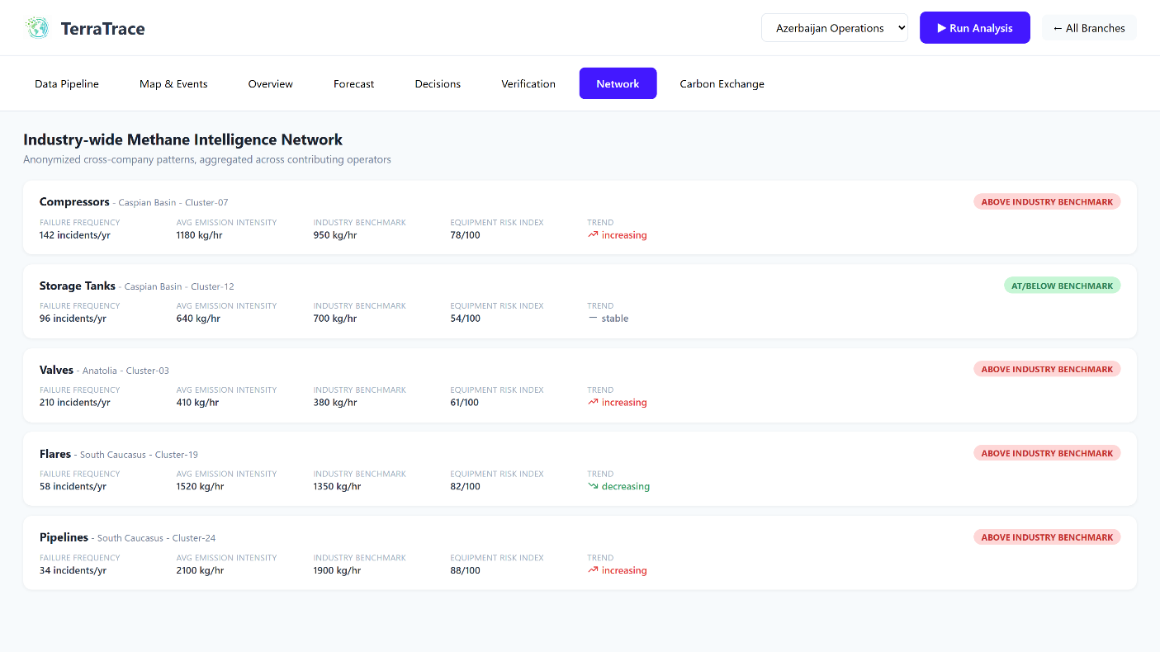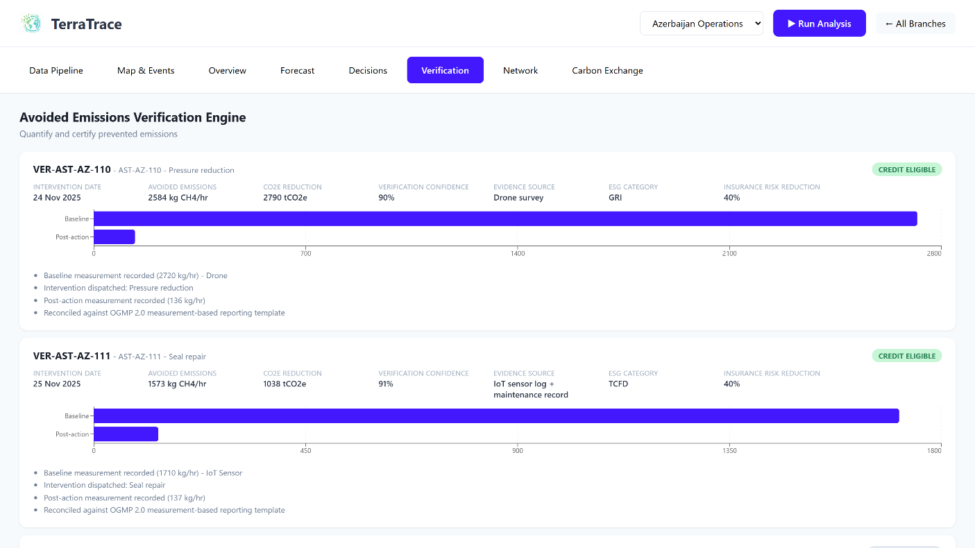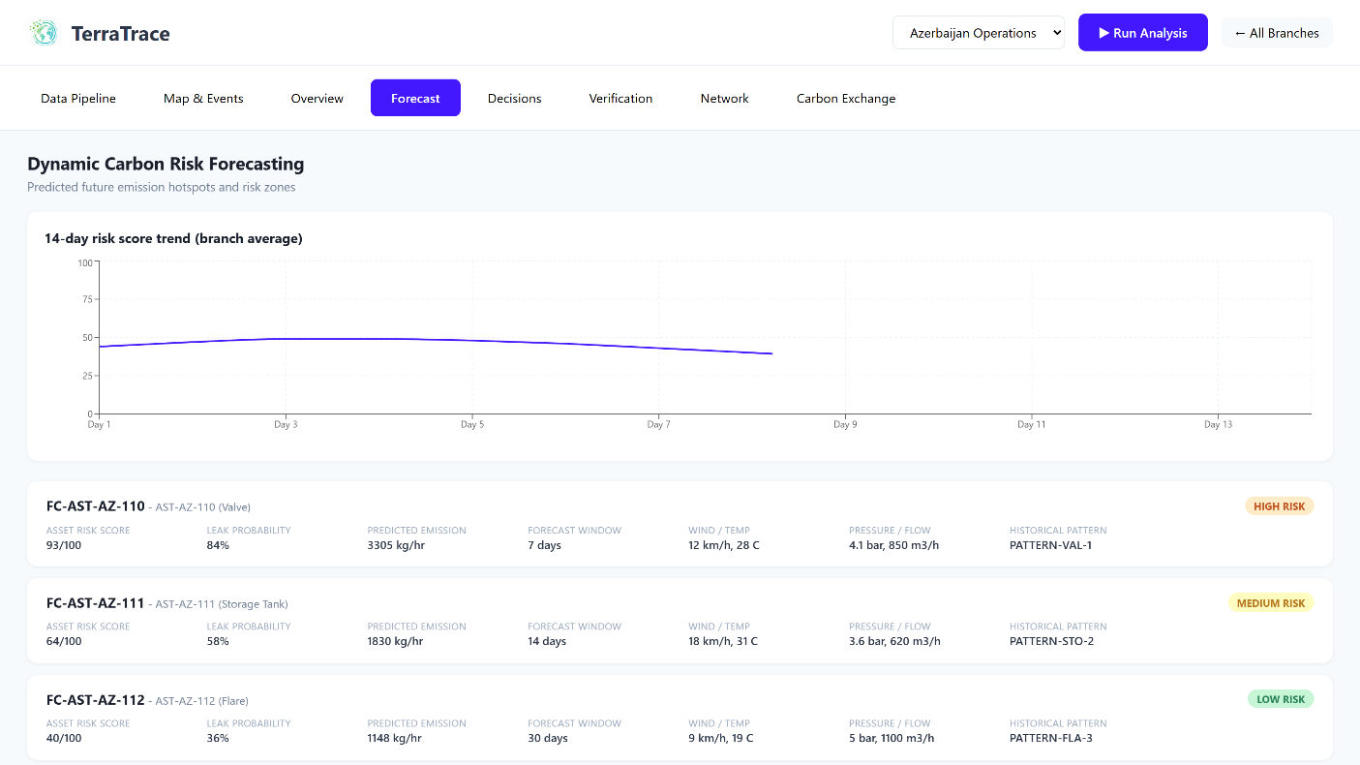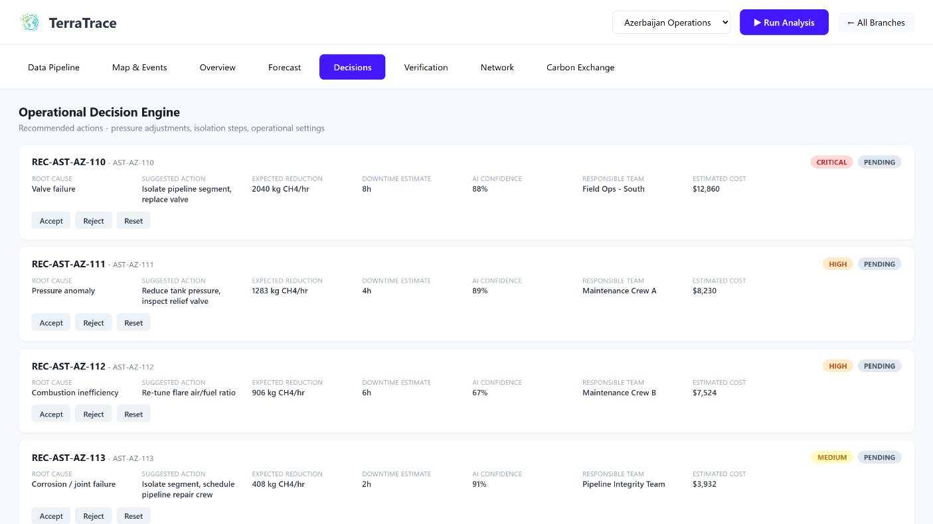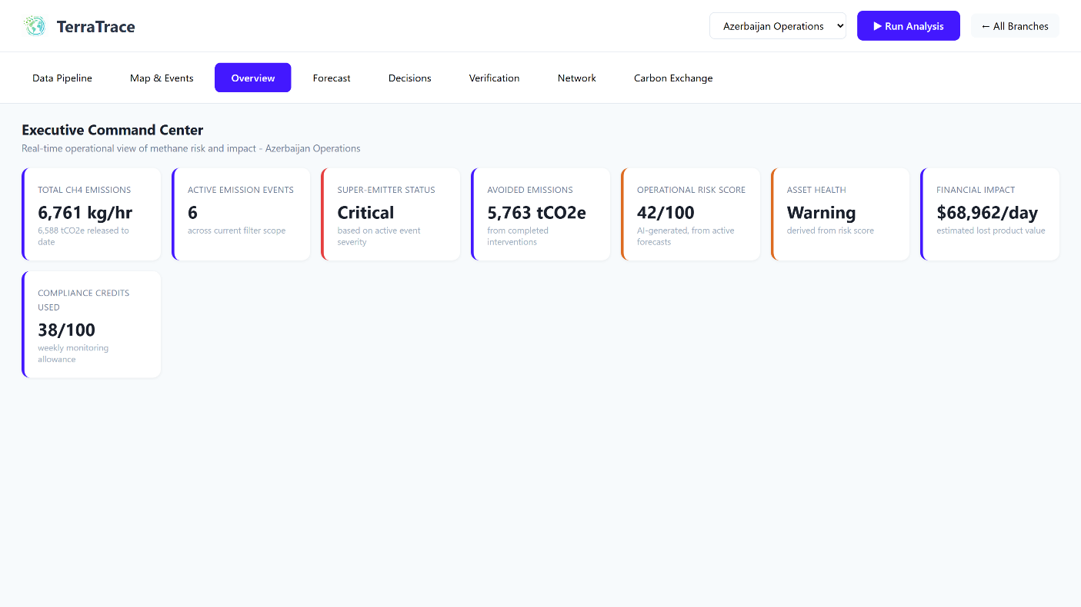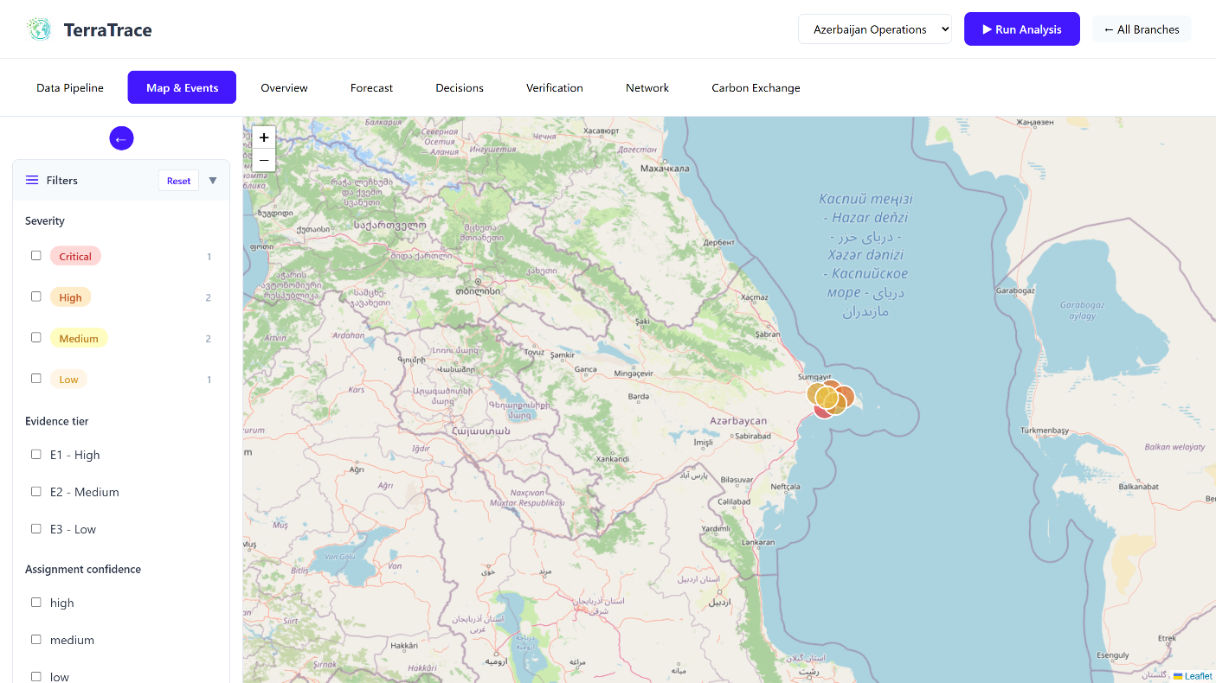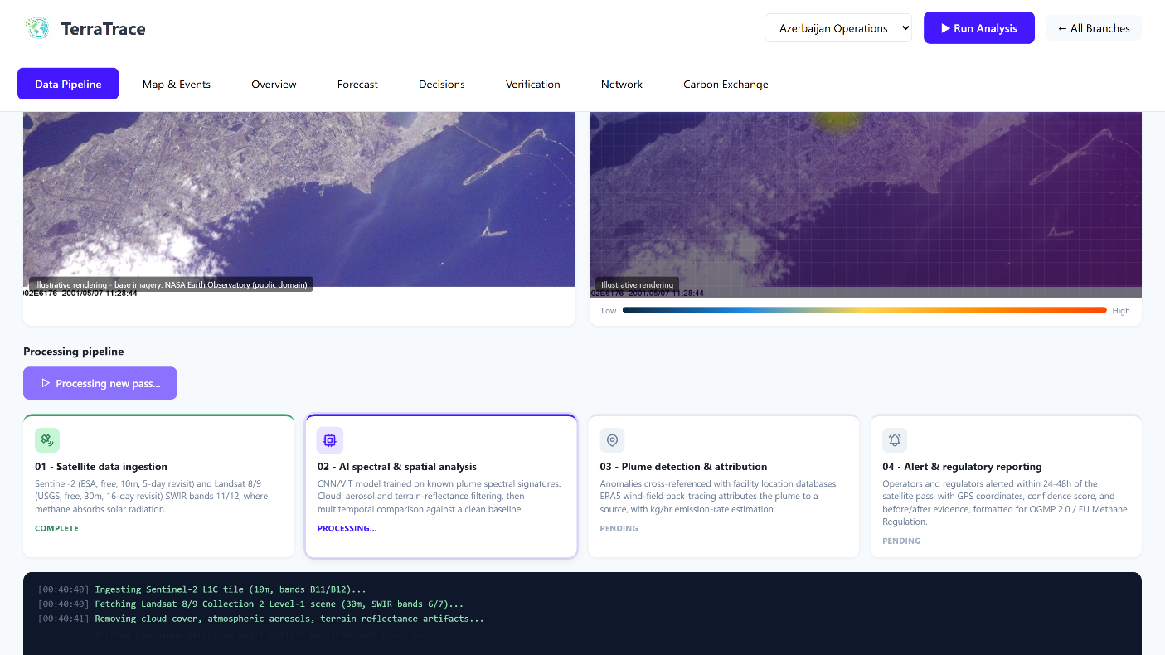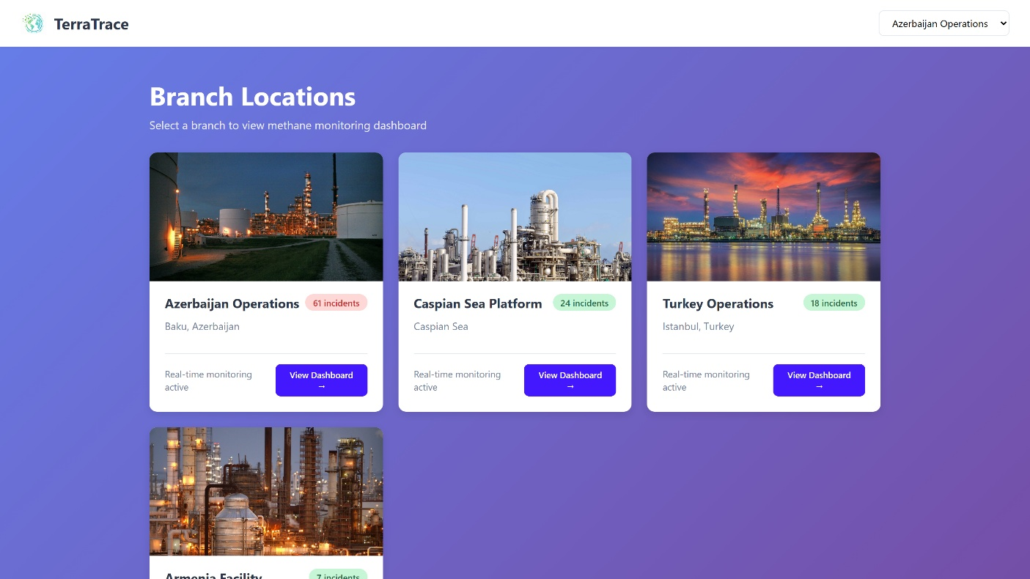6.9 Carbon Exchange
Network-wide surplus/deficit view and auto-matched suggested trades, detailed fully in Section 7.

7. Carbon Credit Exchange - How It Works
Modeled directly on real cap-and-trade mechanics rather than invented rules:
- Compliance markets (e.g. the EU ETS, currently ~-85/tCO2e) set a shrinking cap; entities below their allowance can sell the surplus, entities above it must buy or face a heavy penalty (~EUR100/tonne in the EU ETS)
- Voluntary markets price credits from verified reduction projects roughly -30/tonne on average, tracked through registries (Verra, Gold Standard) that issue a unique serial number per credit and retire it once used, preventing double-counting
- OGMP 2.0 is not itself a trading scheme - it is the measurement backbone that makes a claimed reduction credible enough to sell
In TerraTrace, each branch is allocated a cap-and-trade style allowance set at 85% of its business-as-usual projected emissions. Verified avoided emissions from the Verification Engine reduce a branch's projected emissions, freeing up a sellable surplus. External network-partner operators (representing other companies on the shared monitoring network) are included so the exchange is genuinely cross-company. A matching engine pairs the largest surplus with the largest deficit at a blended reference price of /tCO2e, and trades move through the same lifecycle real registries use: Suggested, Proposed, Accepted, Retired - once retired, a credit is permanently removed from circulation.

8. Business Model & Go-to-Market
The MRV (measurement, reporting, verification) technology market for methane is projected to reach -5B+ by 2030 as regulatory mandates take effect. TerraTrace's wedge is the segment AIRMO, Kayrros and GHGSat structurally underserve:
- Primary customers: small-to-mid oil & gas operators and national regulators in emerging markets, priced out of enterprise-only competitor contracts
- Secondary channel: integration with workflow platforms like Arolytics, feeding our detection output into their existing LDAR/compliance tooling
- Positioning: a continuous, low-cost screening/triage layer that flags high-confidence candidates for premium verification providers, rather than competing head-on for the same flagship-asset enterprise contracts
- Pricing model: multi-year base contract (matching OGMP 2.0's need for a consistent multi-year measurement trend) plus usage-based scaling - not a cancel-anytime subscription, which would undermine both retention and the credibility of the trend data being sold

9. Technical Architecture & Current Prototype Status
Prototype stack: React 18 + Vite, react-router-dom, react-leaflet/Leaflet for mapping, Zustand for cross-tab state (decision statuses, trade statuses), Recharts for charting, date-fns, Tabler Icons.
Honest status check: the current build is a fully working, click-through dashboard on realistic mock data generated from the same field model the real pipeline would use (facility IDs, equipment types, kg/hr rates, wind/weather conditions, confidence scores). There is no live satellite ingestion, trained detection model, or real registry integration yet - those are the roadmap items below. This distinction is deliberately not glossed over: a demo audience should know exactly what is real today versus what is architected for and coming next.

10. Roadmap
- Phase 1 (now): validated product narrative, full-featured mock-data prototype across all 7 Solution Document modules plus Carbon Exchange
- Phase 2: real Sentinel-2/Landsat ingestion pipeline; train and validate a super-emitter detection model against known controlled-release datasets (matching the Stanford blind-study methodology)
- Phase 3: pilot with 1-2 small-to-mid operators or a single national regulator; real OGMP 2.0-formatted reporting output
- Phase 4: registry integration (Verra/Gold Standard-style retirement ledger) to make the Carbon Exchange handle real, auditable credits rather than modeled ones

11. Closing
30% of oil and gas methane leaks could be fixed at zero net cost - the technology gap isn't the fix, it's finding the leak fast enough, cheaply enough, and reliably enough to act on it. TerraTrace exists to close that gap for the operators and regulators every other provider in this space leaves behind.
TerraTrace - Final Product Report - July 2026 - Confidential, For Team Use Only
