**Name – Dhwani Goyal**

**Roll no - 102203783**

**ELC Activity – Handwritten Digit Recognition**

# Case1: K=2, and split=60:40

Accuracy=0.7693452380952381

& Confusion Matrix=

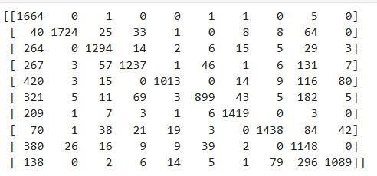

# Case2: K=2, and split=70:30

Accuracy= 0.7984126984126985

& Confusion Matrix=

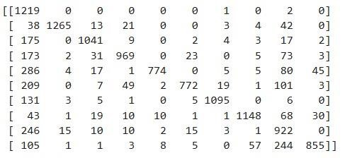

# Case3: K=2, and split=75:25

Accuracy= 0.9572380952380952

& Confusion Matrix=

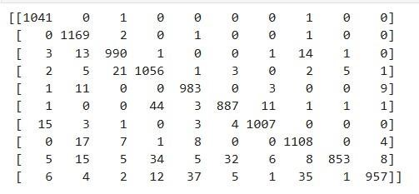

# Case4: K=2, and split=80:20

Accuracy= 0.7008333333333333

& Confusion Matrix=

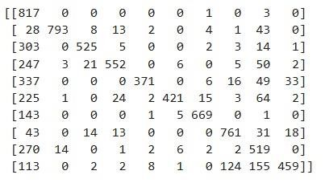

# Case5: K=2, and split=90:10

Accuracy= 0.7111904761904762

& Confusion Matrix=

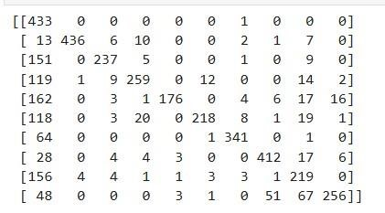

# Case6: K=2, and split=95:5

Accuracy= 0.721

& Confusion Matrix=

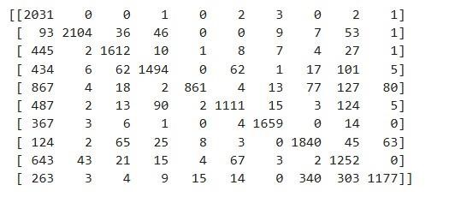

# Case7: K=4, and split=60:40

Accuracy= 0.8164285714285714

& Confusion Matrix=

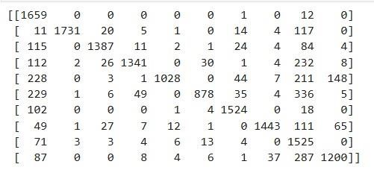

## Case8: K=4, and split=70:30

Accuracy= 0.8211111111111111

& Confusion Matrix=

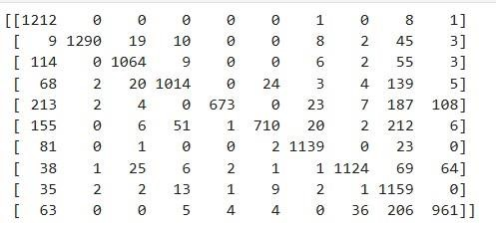

## Case9: K=4, and split=75:25

Accuracy= 0.7452380952380953

& Confusion Matrix=

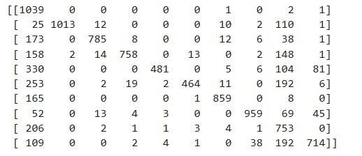

## Case10: K=4, and split=80:20

Accuracy= 0.7585714285714286

& Confusion Matrix=

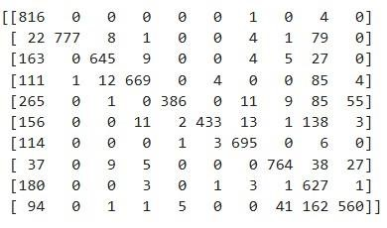

## Case11: K=4, and split=90:10

Accuracy= 0.784047619047619

& Confusion Matrix=

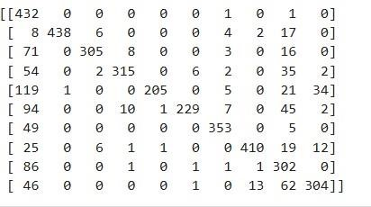

## Case12: K=4, and split=95:5

Accuracy= 0.7965238095238095

& Confusion Matrix=

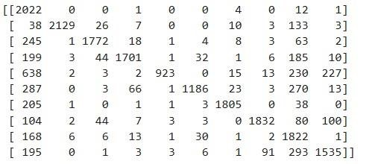

## Case13: K=5, and split=60:40

Accuracy= 0.8211309523809524

& Confusion Matrix=

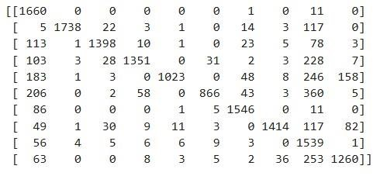

## Case14: K=5, and split=70:30

Accuracy= 0.8256349206349206

& Confusion Matrix=

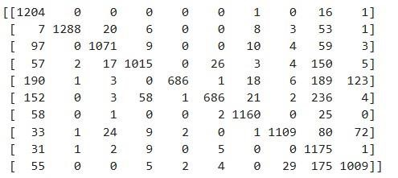

## Case15: K=5, and split=75:25

Accuracy= 0.7743809523809524

& Confusion Matrix=

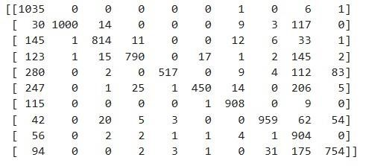

## Case16: K=5, and split=80:20

Accuracy= 0.7867857142857143

& Confusion Matrix=

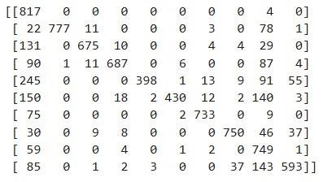

## Case17: K=5, and split=90:10

Accuracy= 0.8095238095238095

& Confusion Matrix=

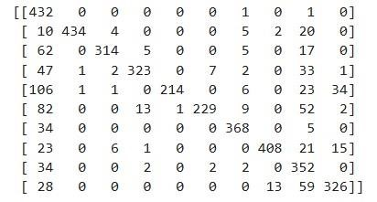

## Case18: K=5, and split=95:5

Accuracy= 0.815047619047619

& Confusion Matrix=

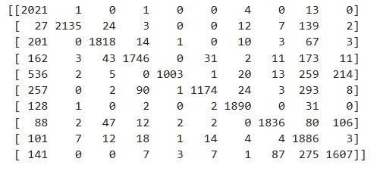

## Case19: K=6, and split=60:40

Accuracy= 0.8235119047619047

& Confusion Matrix=

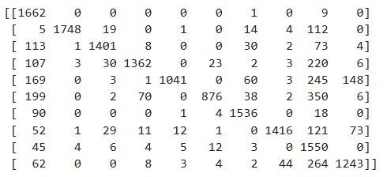

## Case20: K=6, and split=70:30

Accuracy= 0.8280952380952381

& Confusion Matrix=

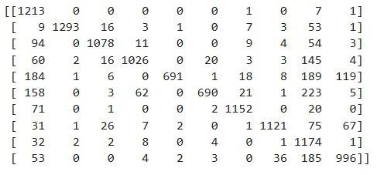

## Case21: K=6, and split=75:25

Accuracy= 0.7916666666666666

& Confusion Matrix=

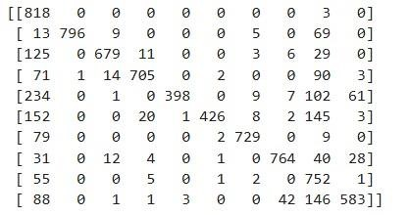

## Case22: K=6, and split=90:10

Accuracy= 0.8192857142857143

& Confusion Matrix=

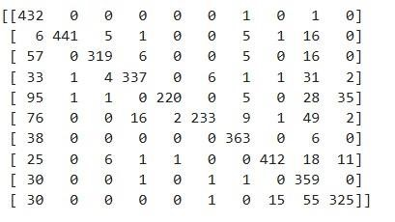

## Case23: K=6, and split=80:20

Accuracy= 0.7916666666666666

& Confusion Matrix=

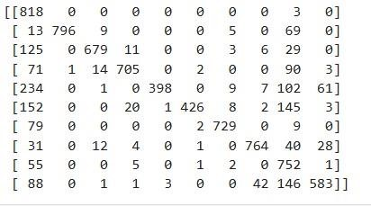

## Case24: K=6, and split=95:5

Accuracy= 0.8225238095238095

& Confusion Matrix=

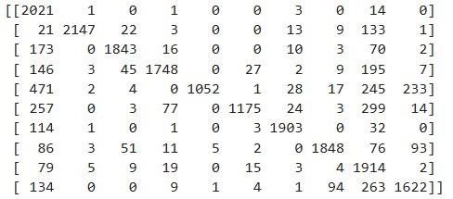

## Case25: K=7, and split=60:40

Accuracy= 0.8245238095238095

& Confusion Matrix=

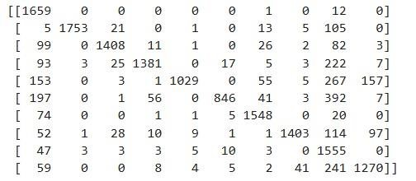

## Case26: K=7, and split=70:30

Accuracy= 0.8288888888888889

& Confusion Matrix=

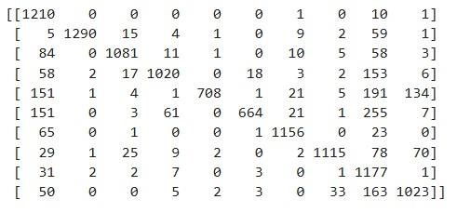

## Case27: K=7, and split=75:25

Accuracy= 0.7856190476190477

& Confusion Matrix=

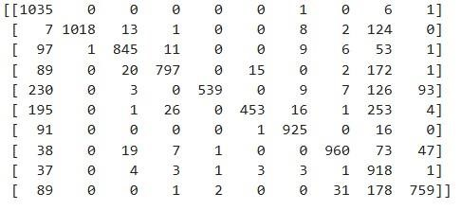

## Case28: K=7, and split=80:20

Accuracy= 0.799404761904762

& Confusion Matrix=

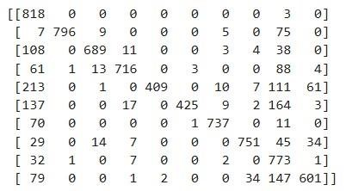

## Case29: K=7, and split=90:10

Accuracy= 0.8330952380952381

& Confusion Matrix=

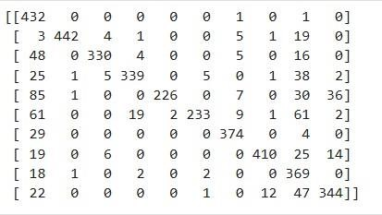

## Case30: K=7, and split=95:5

Accuracy= 0.8266666666666667

& Confusion Matrix=

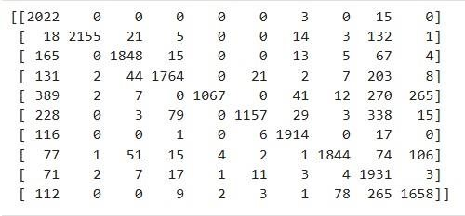

## Case31: K=10, and split=60:40

Accuracy= 0.8299404761904762

& Confusion Matrix=

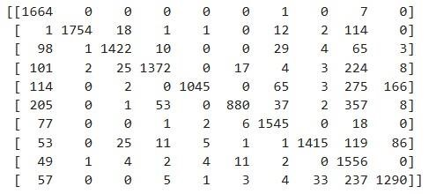

## Case32: K=10, and split=70:30

Accuracy= 0.832936507936508

& Confusion Matrix=

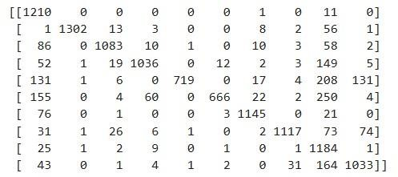

## Case33: K=10, and split=75:25

Accuracy= 0.7973333333333333

& Confusion Matrix=

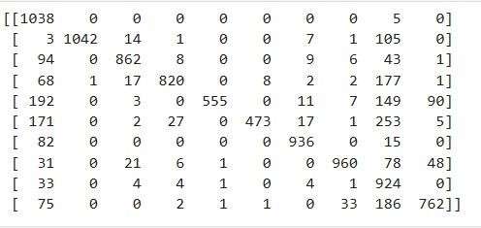

## Case34: K=10, and split=80:20

Accuracy= 0.8082142857142857

& Confusion Matrix=

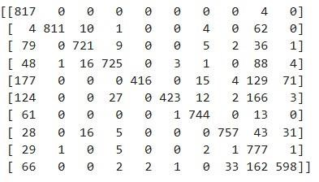

## Case35: K=10, and split=90:10

Accuracy= 0.8452380952380952

& Confusion Matrix=

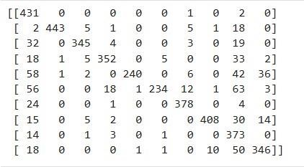

## Case36: K=10, and split=95:5

Accuracy= 0.8346190476190476

& Confusion Matrix=

