Dhwanil Patel
AS.410.712.82.SP25
Final Project Discussion

Background
Antibiotic resistance is a mechanism by which bacteria can develop a resistance to treatment and make it ineffective in treating the bacterial infection. In United States, every year, about 23,000 people lose their lives because of it, and it increases healthcare costs by $20 billion (Nadgir & Biswas, 2023). One of the main reasons for a bacteria obtaining an antibiotic resistance is antibiotic resistance genes (ARGs). In humans, genes are transferred vertically from a parent to an offspring. However, bacteria have another method of gene transfer called horizontal gene transfer (HGT). A bacteria can spread its genetic information to other bacteria via HGT and it’s a major contributor to pathogenic evolution. There are three main methods of HGT: transformation, conjugation, and transduction. Transformation is when the bacteria take in DNA from the environment, conjugation is when bacterium directly transfers the genetic material to another cell, and transduction is when bacteriophages (viruses that infect bacteria) move the genes from one cell to another (Burmeister, 2015).
Depending on the gene, a bacterium can resist the antibiotic via different mechanisms such as active efflux, reduced permeability, ribosome modification etc. (Nadgir & Biswas, 2023). Different classes of enzymes make bacteria resistant in different ways. For example, aminoglycoside modifying enzymes (AMEs) causes a steric hindrance by covalently modifying the hydroxyl or amino groups of the aminoglycoside molecule. This leads to a higher bacterial MIC (minimum inhibitory concentration) which means that it takes more antibiotics to stop the bacteria. Another example is β-lactamases which destroy the antibiotic molecules altogether (Munita & Arias, 2016). This means that knowing the mechanism of the resistance and the class of ARG in a bacteria can be very important in determining an effective treatment plan.
Tools and Methods
There are vastly better tools out there for finding ARGs, some more complex than others. My tool is a simplistic version that locally aligns a bacterial DNA sequence to either the entire database of ARG or to a singular ARG (if the user is concerned about a specific gene). I chose data from two databases, Comprehensive Antibiotic Resistance Database (CARD) and ResFinder, to build my comprehensive database in MySQL. While serving a similar purpose, both databases have different functions. CARD contains 6442 gene sequences and it’s a regularly updated and annotated database of ARGs in general. ResFinder, on the other hand, focuses on acquired genes that are common in pathogens. I chose these two because I figured together, they will encompass a vast majority of common ARGs while providing annotated info on their mechanisms and classes.
The data from these databases was parsed by parse.py. It contains two separate functions, one for each database, because the original data is structured differently in both. In CARD, the sequences data is all within one file called nucleotide_fasta_protein_homolog_model.fasta and the metadata is within aro_index.tsv. I used biopython’s SeqIO to make parsing easy for both functions. In ResFinder, each class of ARGs have a separate folder, making the classification easier. The only thing missing, the mechanism, was obtained from phenotypes.txt file. I grouped all the data using dictionaries in Python. One of the challenges I faced was when populating the database because since the data was from two different databases, their identifiers were different. This means that if a gene appears in both databases, it will have two different identifiers and hence will be in the database twice. To circumvent this, I made the gene name the primary key and found a common naming convention from both databases. If a gene exists in both databases, the source column is changed to “Both” for that gene.
The technology used in this tool includes Python, MySQL, HTML, CSS, jQuery (Javascript), JSON, AJAX, and CGI. HTML serves as the backbone of the web page. CSS styles the look of the web page. jQuery handles user inputs and widgets such as autocomplete. JSON and AJAX handle the data from the webpage to the server and vice versa. The CGI takes in the server requests and applies the python code to produce results and send responses back to the server.
In the HTML script, I create a form with three different user input fields and a submit button as seen in Figure 1 below. The first field is for the DNA sequence. The second field is for the gene name, and it is optional. This is only used if the user is interested in a specific gene. This field has an autocomplete widget, so they’ll be able to search through the database for the gene. The third field is a dropdown box with three choices for which database to search in. The default is “Both” since that makes up my entire database and makes it unique. But if the user wants to check only CARD, the tool allows them to do so. Finally, there is a submit button that will only work if there is a sequence provided in the first field.
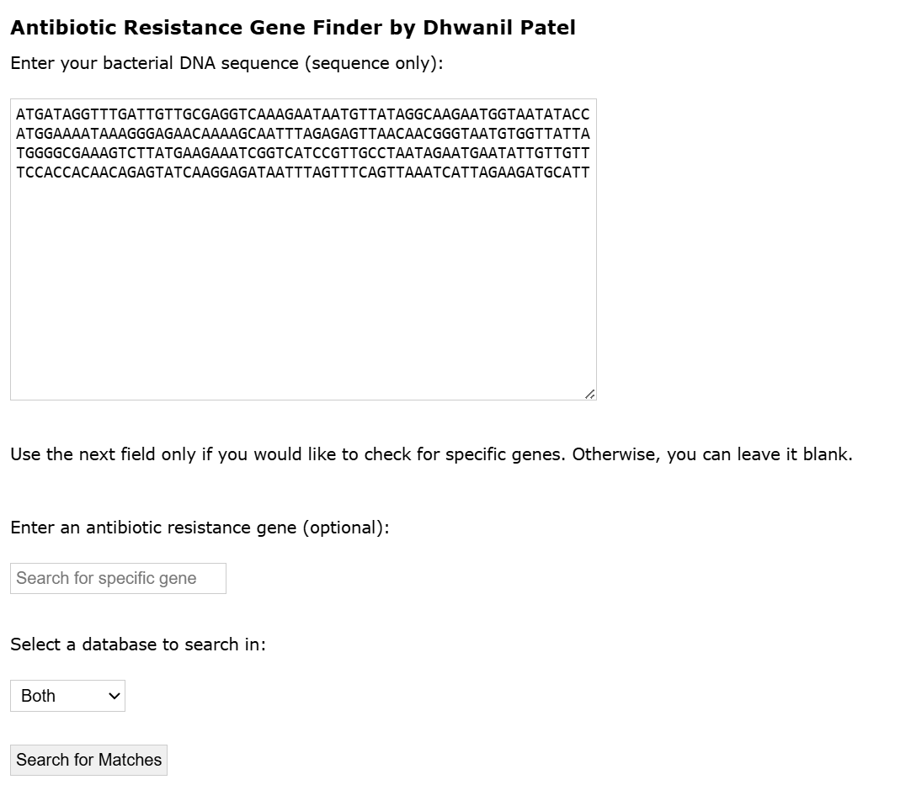
Figure 1: Web application architecture

The CSS file is simple and self-explanatory for the most part. There are two things it does differently aside from standard formatting. It hides the results table until after the search is complete. Also, in the results table, the last column is for the sequence which is often very long to fit into the box. Therefore, I made the box scrollable to allow the user to copy the whole sequence if necessary.
The Javascript file was the hardest for me to work with since I am not to experienced in jQuery, JSON, or AJAX. One of the biggest challenges I was running into was getting the autocomplete request to work and correctly sending the request via AJAX. Because of this, I included various console.log() functions to determine the cause of the error using the browser’s developer tools. Figure 2 below shows the autocomplete request working.
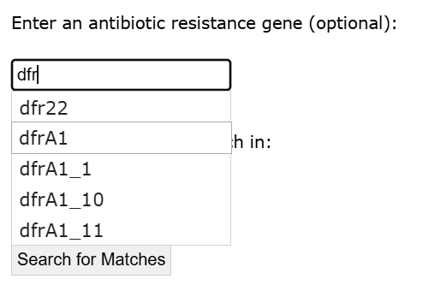
Figure 2: Autocomplete request for the gene field

The CGI script handles both the autocomplete request and the local alignment of the sequence to the MySQL database. Depending on the source chosen, there are separate SQL queries. For the alignment, I use biopython’s Align module. I choose local alignment over global alignment because ARGs make up only part of a bacteria’s genome, so I am looking for the best-matching sub-region with the entire genome. Also, doing local alignment is more tolerant of variations in the sequence that might appear between different strains or from mutations. One of the challenges I faced in this portion is aligning time. With longer sequences, I kept getting a gateway timeout error. To make it more efficient, I used a heap to store the best 100 matches and update it dynamically. Unfortunately, it still wasn’t enough to tackle longer sequences.
Validation
I validate by obtaining a portion of a gene’s sequence from the database and using that as the query. Because it’s directly from the database, it should match that gene as its best match. I used a portion of the gene dfrF as the query sequence. As seen in Figure 3 below, the search yielded it as the best result with one location range (meaning one continuous local match). The results show matches from both databases when using “Both” in the source field in the form. Figure 4 below shows how you can search for a specific gene and a specific database. This search is much faster due to only aligning to one sequence.
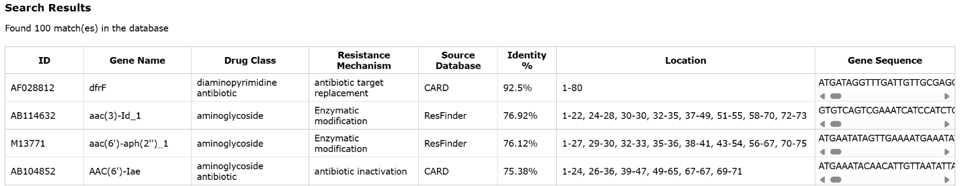
Figure 3: Results with dfrF gene as the query
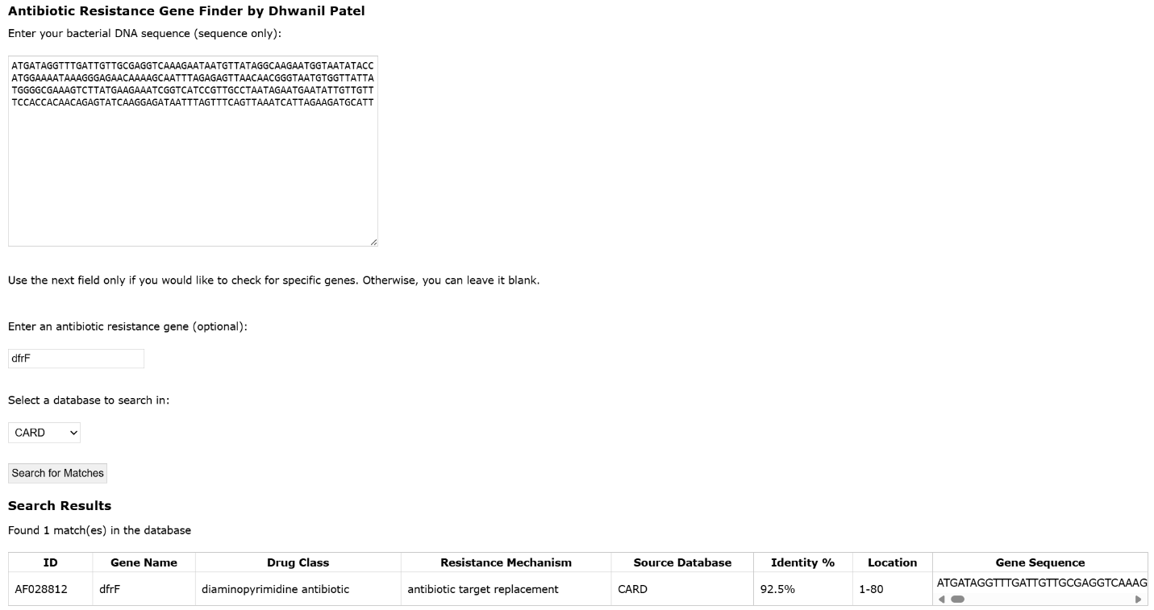
Figure 4: Search with dfrF as the specific gene of interest provided in the second field. Also, CARD is specified as the database.

References:
Bortolaia V, Kaas RS, Ruppe E, Roberts MC, Schwarz S, Cattoir V, Philippon A, Allesoe RL, Rebelo AR, Florensa AR, Fagelhauer L, Chakraborty T, Neumann B, Werner G, Bender JK, Stingl K, Nguyen M, Coppens J, Xavier BB, Malhotra-Kumar S, Westh H, Pinholt M, Anjum MF, Duggett NA, Kempf I, Nykäsenoja S, Olkkola S, Wieczorek K, Amaro A, Clemente L, Mossong J, Losch S, Ragimbeau C, Lund O, Aarestrup F. M.
(2020). ResFinder 4.0 for predictions of phenotypes from genotypes. Journal of Antimicrobial Chemotherapy, 75(12),3491-3500
Burmeister A. R. (2015). Horizontal Gene Transfer. Evolution, medicine, and public health, 2015(1), 193–194. https://doi.org/10.1093/emph/eov018
Munita, J. M., & Arias, C. A. (2016). Mechanisms of Antibiotic Resistance. Microbiology spectrum, 4(2), 10.1128/microbiolspec.VMBF-0016-2015. https://doi.org/10.1128/microbiolspec.VMBF-0016-2015
Nadgir, C. A., & Biswas, D. A. (2023). Antibiotic Resistance and Its Impact on Disease Management. Cureus, 15(4), e38251. https://doi.org/10.7759/cureus.38251

