**Criterion A: Planning**

Learning Goal:

Global Context:

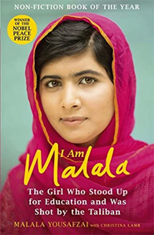**How I chose my learning goal:**

“One child, one teacher, one book, one pen can change the world."― Malala Yousafzai. This quote inspired my interest in teaching and tutoring. In grade 5, we read the autobiographical book, “I Am Malala”. It follows the journey of Malala, who was shot in the head by the Taliban because she continued to go to school when she wasn't allowed to, and campaigning for girls’ education. She is now the youngest Nobel Peace Prize laureate and continues to advocate for education rights. While reading this book, I thought about how many kids around the world had to drop out of school and couldn't get a proper education, and how I should be immensely grateful that I am receiving an education. This also made me fall in love with the vocation of teaching, and how one teacher can have such a significant impact on a student, and her life. I wanted to inspire other people as well because the more teachers there are, the more minds can be shaped, and the brighter our future will be.

Image 1: Book Cover

I wanted to share this knowledge in a modern method, so I decided to produce a podcast show and incorporate the lessons I have learned in the past year that I have been tutoring. The podcast will be designed as short episodes that give teenagers the building blocks for how to tutor, and how they can become professional teachers if they choose to do so in their careers.

Passion drove me to this topic, as tutoring was one of my favorite things to do in my spare time. I loved it so much because I felt a sense of importance, responsibility, and ownership which I had never felt before. It empowered me. Growing up, I never stood up for myself, or expressed my thoughts because I was afraid that people would judge me or make fun of what I had to say. I felt like my ideas added no value to what was being discussed, and that they were worthless. But when I tutored, my students wanted to listen to me and showed interest in what I was saying. It made me more confident. I proved to myself that my thoughts are important and respected, and that I shouldn’t be afraid to express them.

Furthermore, while tutoring, I felt like a winner. Maybe it was beginner’s luck. Maybe it was the topics I was teaching, which were easy since I started by tutoring younger grades, but the taste of success was sweet. This was very important to me as I was fearful of failure. I saw failure as a sign of incompetence, and always avoided anything that might lead me to a contrary outcome. In retrospect, while tutoring, I stumbled many times but the lesson it taught me was that it was okay to fall. It is more important to get up every single time and start again. I learned that correcting my mistake, was not a sign of weakness; it was an opportunity to grow. By realizing that I was able to handle my failures while tutoring, I decided to take risks and challenges in my school life as well. Rather than giving up, I decided to try until I found success.

I also chose tutoring as the topic of my learning goal because I enjoy being surrounded by children. They have a unique, creative, and possibly a rose-tinted view of the world. Their enthusiasm and optimism provided me with hope on the days when I was not feeling my best. I felt free to be my own, true self in front of children, as they would not judge me for what I wore, how I looked, or what I liked. They would laugh with me instead of at me. This is rare to find today among adolescents and grown-ups.

What inspired me deeply is also that my mom is a teacher. Watching her while growing up made me want to emulate her. Her classes were entertaining and educational, helping students grasp the topic fully. Any topic that she’s taught me, I have clearly understood. By the end of this project, I wanted to be able to experience that competence, and provide other teenagers with steps to discover their own passion for teaching. Seeing how significant an impact she had on her students, made me want to adopt tutoring to make someone’s life better. A teacher can have an indelible and transformational impact on a student’s life and future. I want to inspire other individuals to consider teaching and tutoring as a calling. This inspired my learning goal, which is to learn to become a better teacher through research and conducting workshops. While I was brainstorming ideas for the learning goal, I created a mindmap (refer to image 2) which outlined my interests, and then possible learning goals for each of those 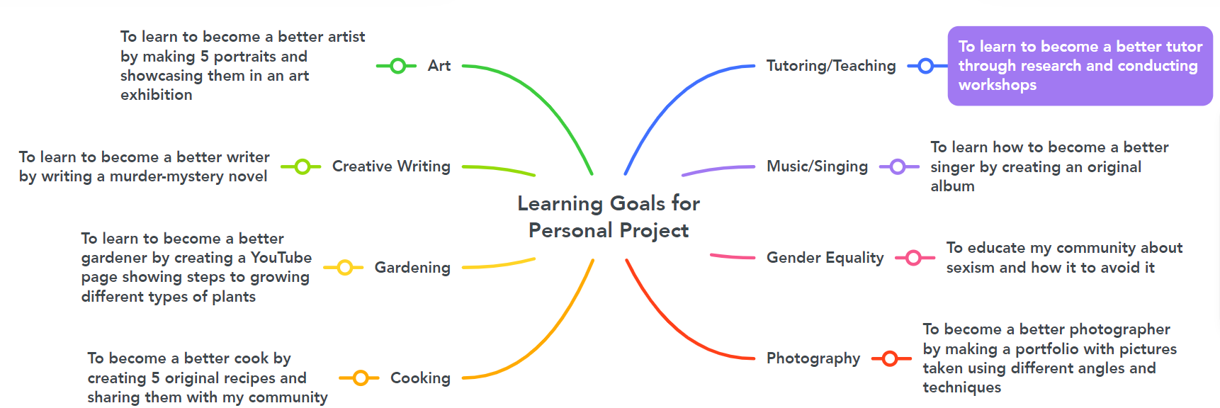interests.

I narrowed it down to the learning goal related to tutoring/teaching (which is highlighted in purple) as it was the topic that I was the most passionate about. I also had prior learning and subject-specific knowledge related to my learning goal (refer to table 1 below). I was confident that I could expand and improve throughout the project, and that I had a strong base to achieve my learning goal.

|  |  |
| --- | --- |
| Prior Learning | Subject-Specific Knowledge |
| Interviewing an expert: I have conducted multiple interviews in the past to collect expert feedback on my product or report. Hence, I feel confident with conducting interviews of parents to gain feedback about the workshops. | Business: In many business revision lessons, we are encouraged to create activities to assess our peers on the topic. Because of this, I was able to learn about educational activities that I could use in my workshops, such as, Kahoot, Quizzes, Word Searches, and topic-related games. |
| Storytelling: When I was younger, I used to watch BrainPOP videos, in which the main character Tim and Moby would narrate stories and apply subject knowledge to those stories. It would help students understand that topic in a fun and engaging way, I was inspired to use storytelling in my workshops to make students understand concepts in an easy manner, and in a way that they wouldn't forget easily. | Digital Design: In DD, we work with many applications such as Canva, Scratch, Adobe Premiere Pro, and Sublime Text. A lot of the time, I would come across a technical error while working on these applications, and to solve that I would use collaboration. I would collaborate with my teacher and my peers and ask them to help me identify and solve errors. This skill is useful as I will have to collaborate when I am teaching the workshops. |
| Survey: I have created and collected many responses to surveys. It is an essential part of collecting evidence in the MYP curriculum. I have also created surveys for personal use, such as when I’m trying to select a board game for me and my family to play and ask them for their preferences. Since I have created surveys on a large variety of topics, I am confident about creating them to gain feedback for my workshops. | History: In History, we evaluate many sources to find out which one is credible, and which one is biased. Through this process, we can come to a reasonable conclusion based on the unbiased sources to find out exactly what happened during a historical event. Similarly, for my lesson plans, I will be evaluating sources through the OPVL method to ensure that they are trustworthy and dependable. |

Image 2: Potential learning goals based on my interests