**Product Goal:** Apodcast that will give teenagers basic information about tutoring, and share with them steps about how to start tutoring

**How I chose my product goal:** First, I wanted to learn hands-on via experimenting and working with different types of formats. Once I had gathered the basic know-how, I wanted to share my knowledge in a contemporary way, based on the target audience. Therefore, I decided to write and produce a podcast that would bring together insights I had gathered by tutoring students in Math and English for about a year. The product I wanted to create was a podcast series that would be tailored to a teenage audience, and uploaded to secure streaming platforms, such as, Spotify and Apple Podcasts. It would be designed as short, engaging episodes, scripted, recorded, edited, and marketed towards teenagers to give them the first steps to tutoring, and answers to their most common questions. Podcasts can be heard on the go – while completing a chore or commuting to school – hence, they are perfect for the target audience. With each episode, templates and resources would be provided in the description box, so that they can use these to teach their students. As I was brainstorming different product goals, I made a table (refer to table 2) that listed 3 different product goals related to my learning goal, their advantages, and their disadvantages. This way, I was able to weigh the pros and the cons of each product goal, and I went with creating a podcast 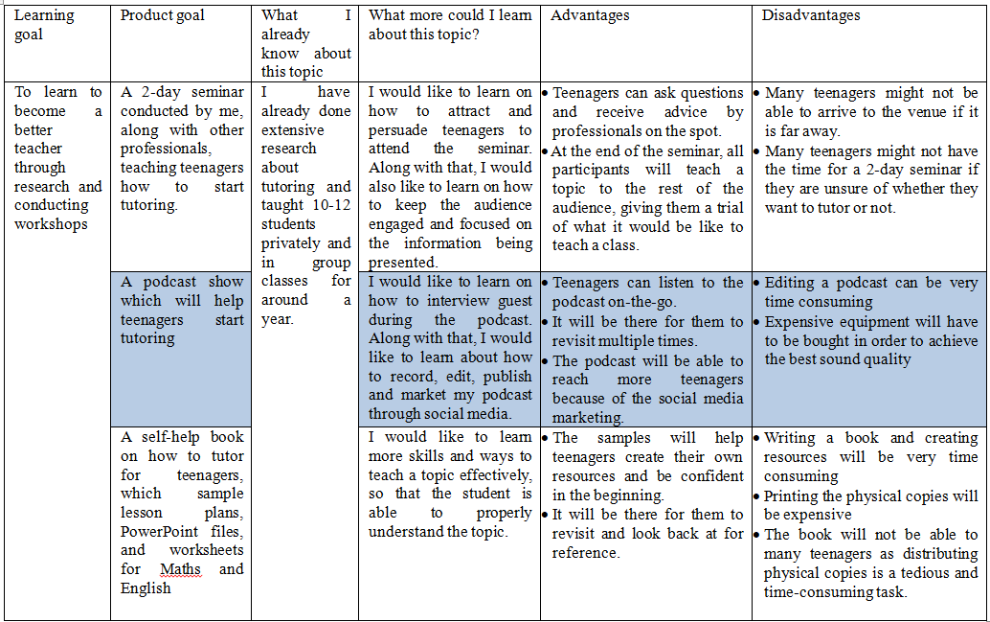show (highlighted in blue) because I had solutions for the disadvantages.

Table 2: Possible product goals

To resolve the disadvantages mentioned in table 2, I will learn how to edit using beginner-friendly software that isn't very complicated to understand, like iMovie or Riverside FM. Additionally, since my episodes are only going to be 5-6 minutes long, there will not be much content to edit. As for the equipment, I have recorded a trial episode with the microphone of a pair of wired headphones, and the quality is excellent. So, I will not have to invest in professional equipment. As I was able to find solutions for both my disadvantages, and because I have prior learning and subject-specific learning (refer to table 1) I think creating a podcast would be the best product goal for this learning goal. I aim to help peers figure out how to explore tutoring and be good at it. Possibly some of them, encouraged by this experience, might even take up teaching as a profession. My goal is to solve their challenges by sharing simple steps that can be adopted. I also wanted to bring in experts who would share insights from their several years of practice and hence accelerate learning with pragmatic suggestions.