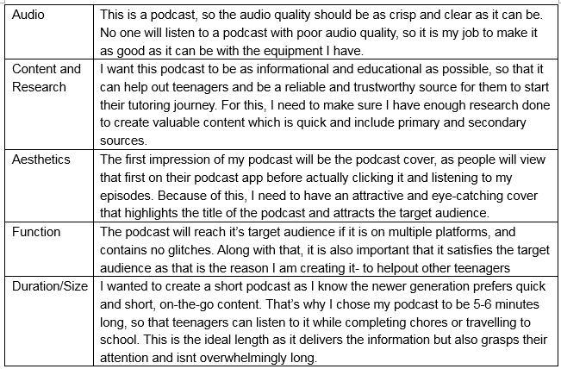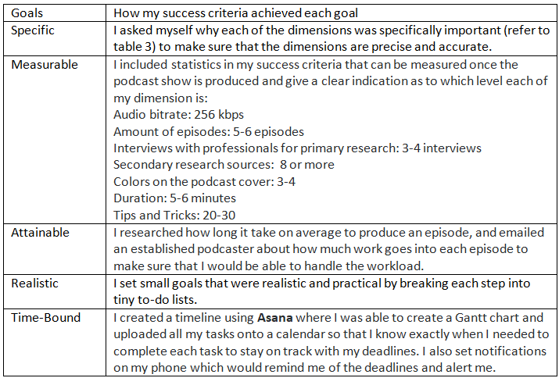**Success Criteria:** I decided to create my success criteria on the five dimensions: Audio, Content and Research, Aesthetics, Function, and Duration/Size. Table 3 explains why I chose each dimension. I have made sure my success criteria comply with the SMART goals framework (refer to table 4).

Table 4: Evaluating my success criteria based on the SMART framework

Table 3: Why I chose these dimensions

To create a challenging yet achievable measure, I analyzed examples of success criteria and consulted my supervisor. I created metrics (refer to table 5) that showed detailed product requirements for each level.

These success criterias are important to me because I want to make a product teenagers can use in their daily lives; a product that is informational and useful, backed with research and rich in content. If the podcast doesn't help any of my listeners, they will move on and look for another way to get the same information. Some of them might get disheartened when they discover that the process is complex or even overwhelming. But with my podcast, these difficulties can be avoided, and teenagers can start tutoring without any hesitation, and with simple methods.

Table 5: Success Criteria

|  |  |  |  |  |  |
| --- | --- | --- | --- | --- | --- |
| **Design Specification** | **Audio**:  What bitrate will the audio be like? How to record clear audio and edit it to reduce background noise? | **Content & Research:**  How many workshops should I conduct to provide accurate information about students in class? How should I make the content credible and engaging for the listeners? | **Aesthetics:**  What elements of a podcast cover would catch the attention of a teenager? | **Function:**  What is the purpose of the podcast? Which streaming platforms would be best to reach the target audience (teenagers)? How many episodes should the podcast have? Which tips and tricks would be useful for beginners? | **Duration:**  How long should each episode be so that the target audience (teenagers) is attentive and focused on the content? |
| **Limited** | **i. poor audio** (32 KBPS or lower) achieved by **no** equipment  scarcely audible throughout the podcast  ii. **inadequate** background music (detectibly loud or soft)  iii. audio and background music **consistently** fluctuating throughout the podcast | i. episodes are **very hard** to understand and **extremely disorganized**.  ii. Content is **extremely hard** to understand, is not at all backed up by scientific facts, and no interviews are conducted.  iii. **Poor** research was conducted.  Primary Research: **No workshops** were held to observe students  Secondary Research: None **or 1-3 source**s are analyzed including YouTube videos, Journals, Articles, Books and more | i. the podcast cover has **no** color and isn’t attractive or eye-catching **at all** | i. podcast is **not accessible/very difficult** to access to the audience.  ii. podcast **isn’t available** on any streaming platforms  iii. the podcast **contains virus/harmful materials**  iv**.** thepodcast is found on **unreliable/inappropriate streaming platforms**  v. the tips, tricks, and advice are **rarely**/not always practicable, relevant, or effective for teenagers  vi. podcast satisfies/helps **only 20%** or less of listeners  vii. **less** than **2** **episodes** with fewer than **5** **tips and tricks** in total. | i. podcast is **limited** in length; each episode is **less than 2 minutes** **long or more than 10 minutes long** |
| **3-4**  **Adequate** | **i. adequate audio** (64 KBPS) achieved by **some** equipment  ii. audible to a **partial** extent throughout the podcast  iii. **adequate** background music (detectibly loud or soft)  iv. audio and background music **majorly** fluctuate through the podcast | i. episodes are **somewhat categorized** but still confusing for teenagers to follow.  ii. Content is **somewhat easy** to understand, **isn’t completely** backed up by scientific facts, and no interviews are held with professionals.  iii. **Adequate** research was conducted.  Primary Research: **2-3 workshops** were held to observe students in real-life and come up with advice based on the student's behavior and response  Secondary Research: **4-6 sources** are analyzed including YouTube videos, Journals, Articles, Books, and more | i. the podcast is **somewhat** attractive and eye-catching and uses colors (1-2 colors) | i. podcast is **scarcely accessible** to the audience.  ii. podcast **is only available on 2 safe** streaming platforms  iii. the podcast **contains many glitches and technical errors (more than 4)**  iv. the tips, tricks, and advice are only sometimes practicable, relevant, or effective for teenagers  v. podcast satisfies/helps **only 40%** of listeners  vi. **less** than **4 episodes** with **less** than **10 tips and tricks** in total. | i. podcast is **adequate** in length; each episode **is more than 3 minutes long and less than 8 minutes** **long** |
| **5-6 Satisfactory** | **i. acceptable audio** (128 KBPS) achieved by **some** equipment  ii. audible to a **mediocre** extent throughout the podcast  iii. **good** background music (either a bit too loud or a bit too soft) to accompany the podcast  iv. audio and background music minorly fluctuates through the podcast | i. episodes are categorized but **could be simplified**.  ii. content is **somewhat easy** to understand and is **partially** backed up by scientific facts, and some (2-3) interviews are held with professionals.  iii. **Average** research was conducted.  Primary Research: **3-4 workshops** were held to observe students in real-life and come up with advice based on the student's behavior and response  Secondary Research: **6-7 sources** are analyzed including YouTube videos, Journals, Articles, Books, and more | i. the podcast cover is **hand-drawn/digitally illustrated** using **multiple artistic elements** (such as characters, 2-3 colors, and text) | i. podcast is **mostly accessible** to the audience.  ii. podcast is onlyavailable on **3 safe streaming** platforms  iii. the podcast **contains some glitches and technical errors (1-3)**  iv. the tips, tricks, and advice are practicable, relevant, or effective for teenagers the **majority of the time**  v. podcast satisfies/helps **only 60%** of listeners  vi. **4-5 episodes** **with less than 15 tips and tricks** in total. | i. podcast is **average**; each episode is around **4-7 minutes long**. |
| **8**  **Excellent** | **i. clear and crisp audio** (256 KBPS) achieved by a professional mic and recording set-up.  ii. audible to a **high** standard throughout the podcast  **iii. excellent** background music (-18dBs and -20dBs lower than the main commentary; not too high or too low) to accompany the commentary of the podcast | i. episodes are **efficiently** categorized and segregated  ii. content is **easy to understand**, backed up by scientific facts, and interviews (3-4) conducted with professionals.  iii. **extensive** research was conducted.  Primary Research: **4-5 workshops** were held to observe students in real-life and come up with advice based on the student's behavior and response  Secondary Research: **8 sources** are analyzed including YouTube videos, Journals, Articles, Books, and more | i. the podcast cover is **hand-drawn/digitally illustrated** using **all** artistic elements (such as characters, 3-4 colors, and text) | i. podcast is **always** accessible to the audience.  ii. podcast available on **all safe** streaming platforms (such as Spotify, Apple Podcasts, Google Podcasts, and Audible)  iii. the podcast **contains no glitches or technical errors**  iv. the tips, tricks, and advice are always practicable, relevant, and effective for teenagers  v. podcast satisfies/helps **80% or more** of listeners  vi. **5-6 episodes with 20-30 tips and tricks** in total. | i. podcast is **excellent** in length; each episode is around **5-6 minutes long**. |

**Action Plan:**

I decided to create a detailed action plan (refer to table 6) for each step I had to complete to accomplish my 5 main goals throughout this project, which were: learning goal, project goal, success criteria and action plan, learning sessions, and the podcast. I also mentioned the ATL skills used in each step, the success criteria dimension it was related to, if the task was completed on time, and if not, the rationale for it. This plan helped me keep track of the dates and allowed me to provide a reasonable explanation for the times I was late in meeting my deadline, allowing me to evaluate my time management skills.

|  |  |  |  |  |  |  |  |
| --- | --- | --- | --- | --- | --- | --- | --- |
| Expected Date | Task: | To-Do: | Success Criteria | ATL Skills | Reflection | New Date | Rationale |
| August 10 | Publishing the podcast and marketing it | * Publish the episode and share the link to social media apps such as WhatsApp, Instagram, and Snapchat | Function | Communication and transfer skills | Completed | On-time |  |
| August 11 | Planning the podcast | * Create a summary and script for episode #2, including at least 5-6 tips that were noted down before * Include primary and secondary research conducted before | Content and Research | Thinking skills such as critical thinking and creative thinking  Organization skills | Completed | August 12 | This script took a lot longer to make as there was a lot of research that was conducted for this episode and condensing that research took more time. |
| August 11 | Recording the podcast | * Record episode #2 and make sure it’s 20-25 minutes long * Interview a professional teacher | Audio, Duration | Critical thinking | Completed | On-time |  |

Table 6: Snippet of Action Plan