Task-1: Deploy a simple Nginx web server in a Kubernetes cluster.
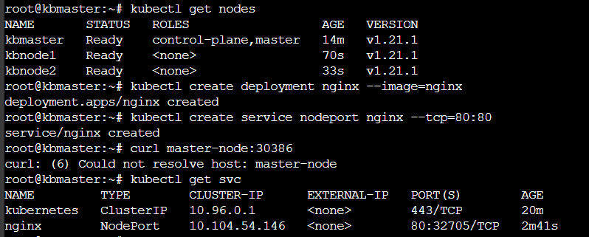
Result:
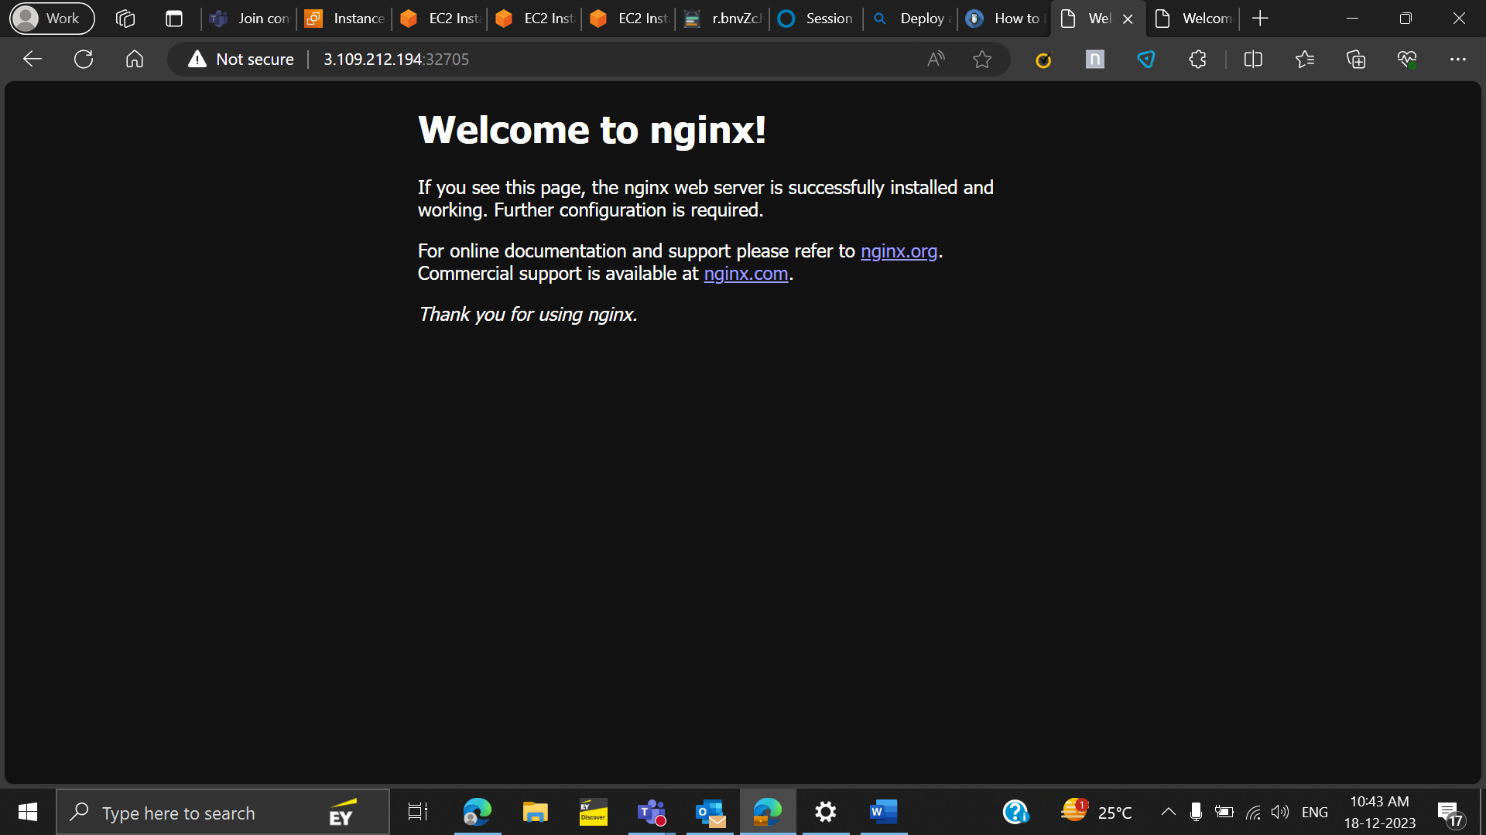
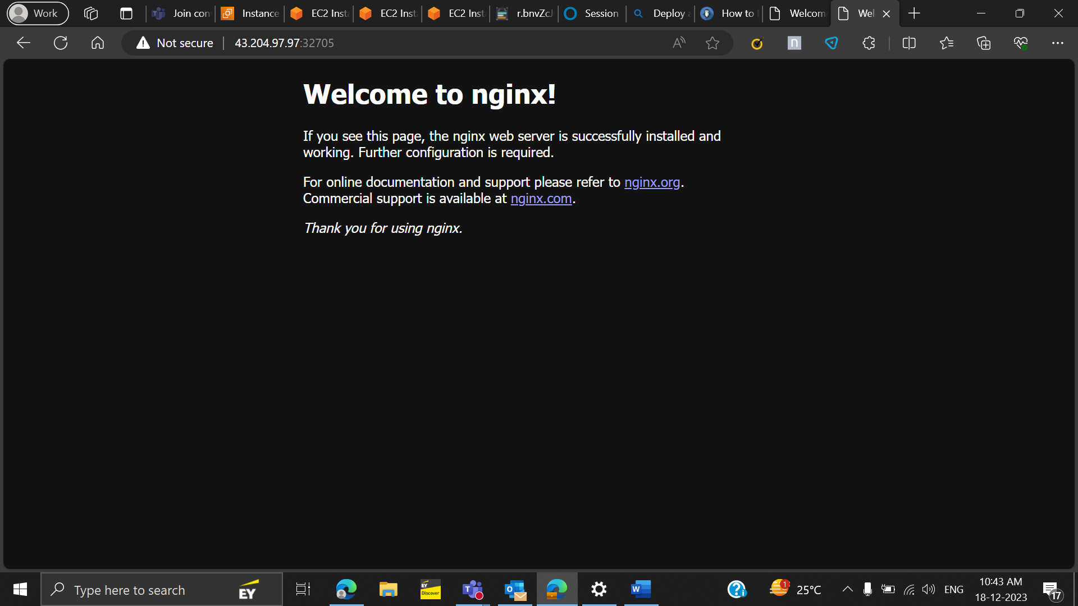
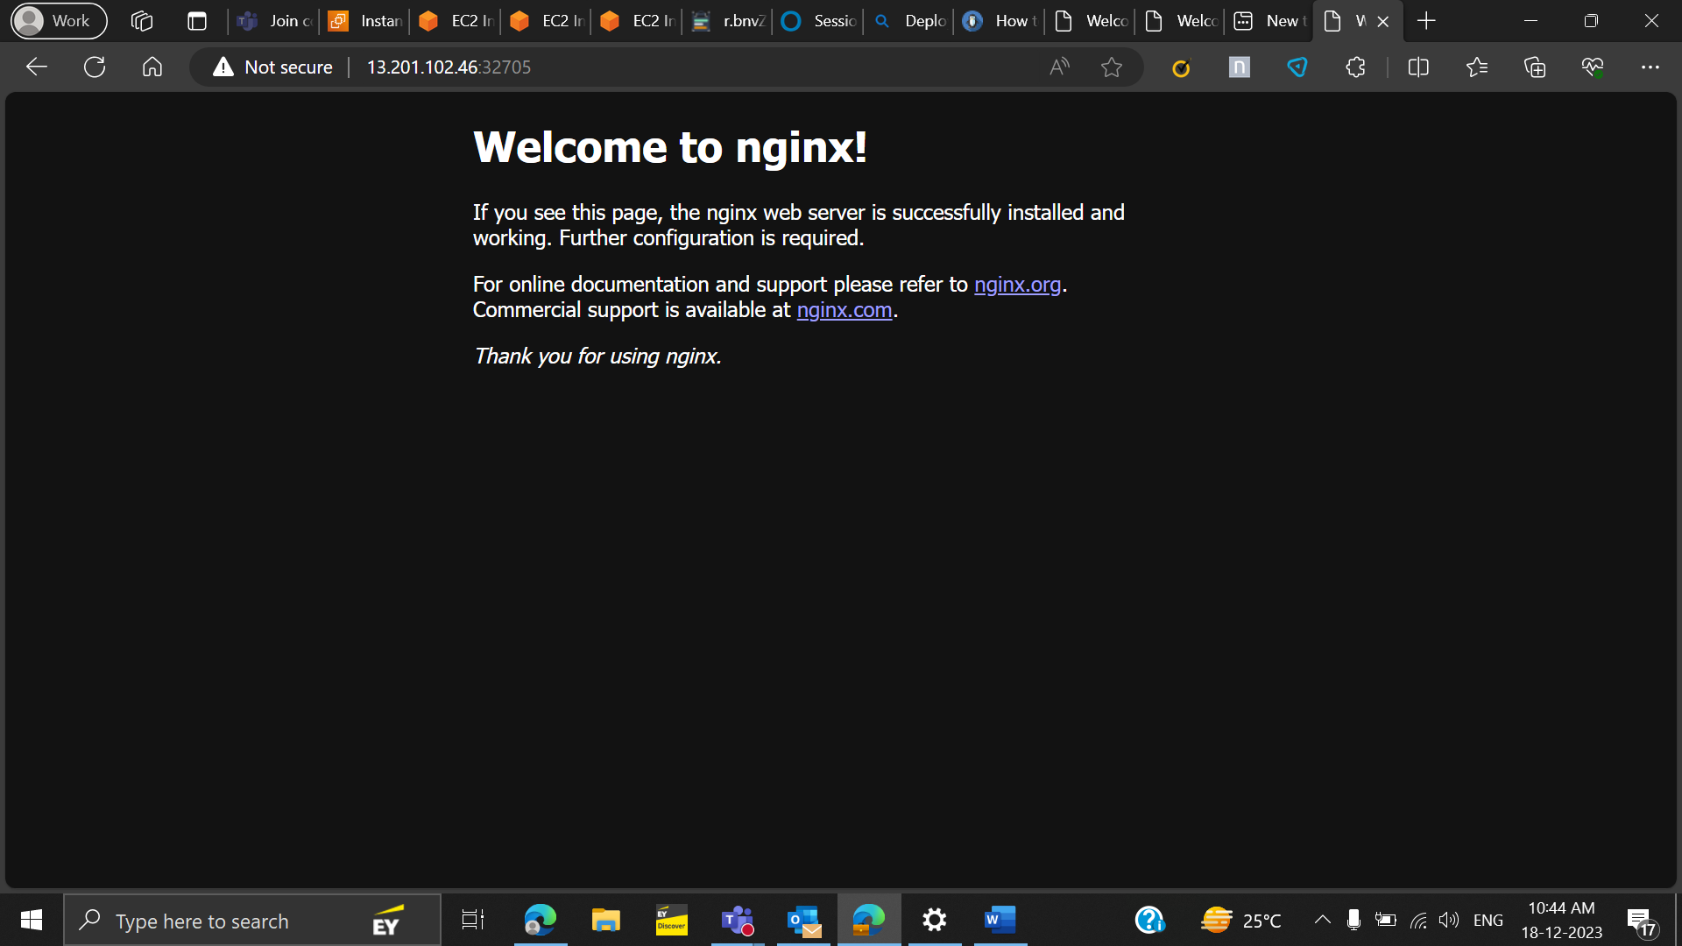

Task 2: Create a Kubernetes Deployment for a multi-replica Nginx
Yaml File:
apiVersion: apps/v1
kind: Deployment
metadata:
name: nginx-deployment
labels:
app: nginx
spec:
replicas: 3
selector:
matchLabels:
app: nginx
template:
metadata:
labels:
app: nginx
spec:
containers:
- name: nginx
image: nginx:1.14.2
ports:
- containerPort: 80
Result:
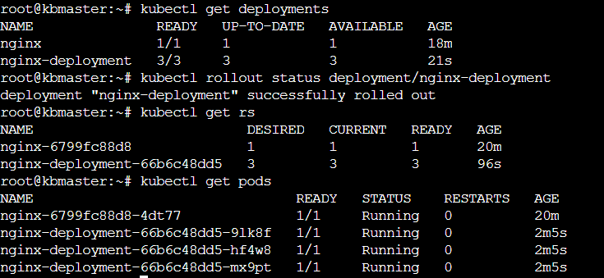
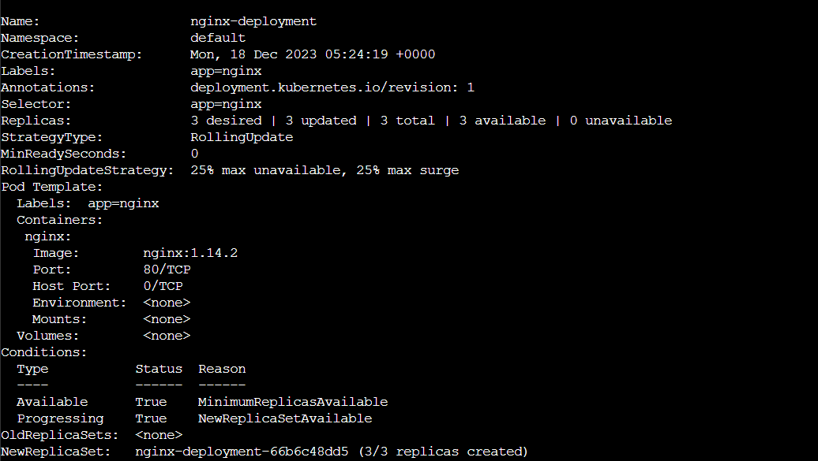

Task 3: Expose the Nginx Deployment using a Kubernetes Service.
Yaml file:
apiVersion: v1
kind: Service
metadata:
name: nginx
namespace: default
labels:
app: nginx
spec:
externalTrafficPolicy: Local
ports:
- name: http
port: 80
protocol: TCP
targetPort: 80
selector:
app: nginx
type: NodePort
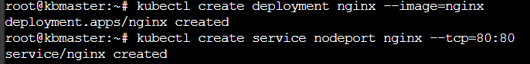
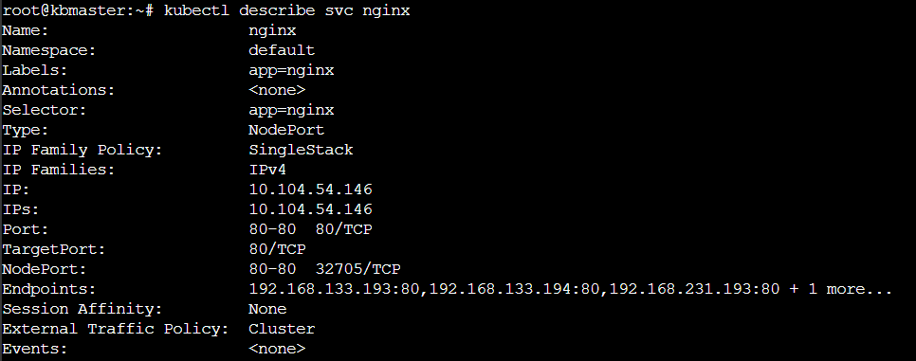
Task 4: Create a Config-Map for storing configuration data and mount it into a Pod.
Config.yaml:
apiVersion: v1
kind: ConfigMap
metadata:
name: my-configmap
data:
app_config.properties: |
key1=value1
key2=value2
key3=value3
pod.yaml:
apiVersion: v1
kind: Pod
metadata:
name: mypod
spec:
containers:
- name: mycontainer
image: ubuntu
volumeMounts:
- name: config-volume
mountPath: /etc/config
volumes:
- name: config-volume
configMap:
name: my-configmap
Task 5: Create a Docker file to run a WordPress application with a linked MySQL container.
Docker-compose.yml
version: "3"

services:
db:
image: mysql:latest
restart: always
environment:
MYSQL_ROOT_PASSWORD: your_mysql_root_password
MYSQL_DATABASE: your_mysql_database_name
volumes:
- ./mysql:/var/lib/mysql

wordpress:
depends_on:
- db
image: wordpress:latest
restart: always
ports:
- "8080:80"
environment:
WORDPRESS_DB_HOST: db:3306
WORDPRESS_DB_USER: root
WORDPRESS_DB_PASSWORD: your_mysql_root_password
WORDPRESS_DB_NAME: your_mysql_database_name
volumes:
- ./wordpress:/var/www/html
Result:
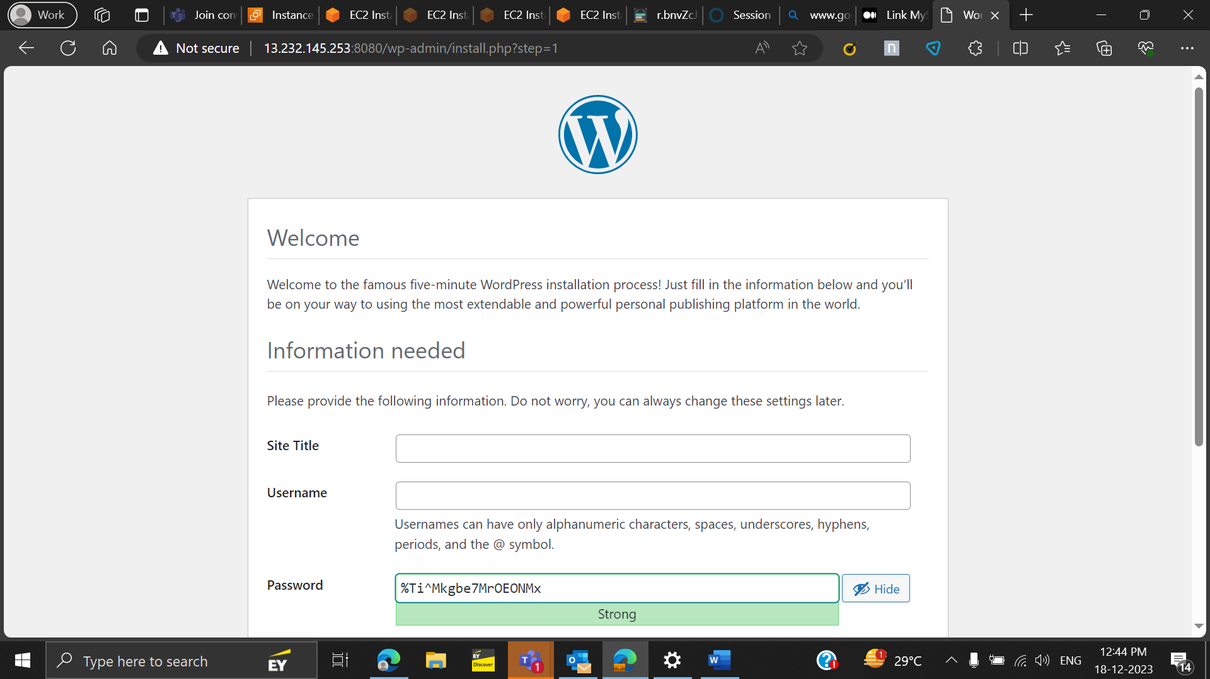

Task 6 : Dockerize a Node.js application and expose it on port 3000
Dockerfile
FROM node:latest
WORKDIR /usr/src/app
COPY package*.json ./
RUN npm install
COPY . .
ENV PORT=3000
CMD [ 'npm', 'app.js' ]
Result:
Node.js app not reachable
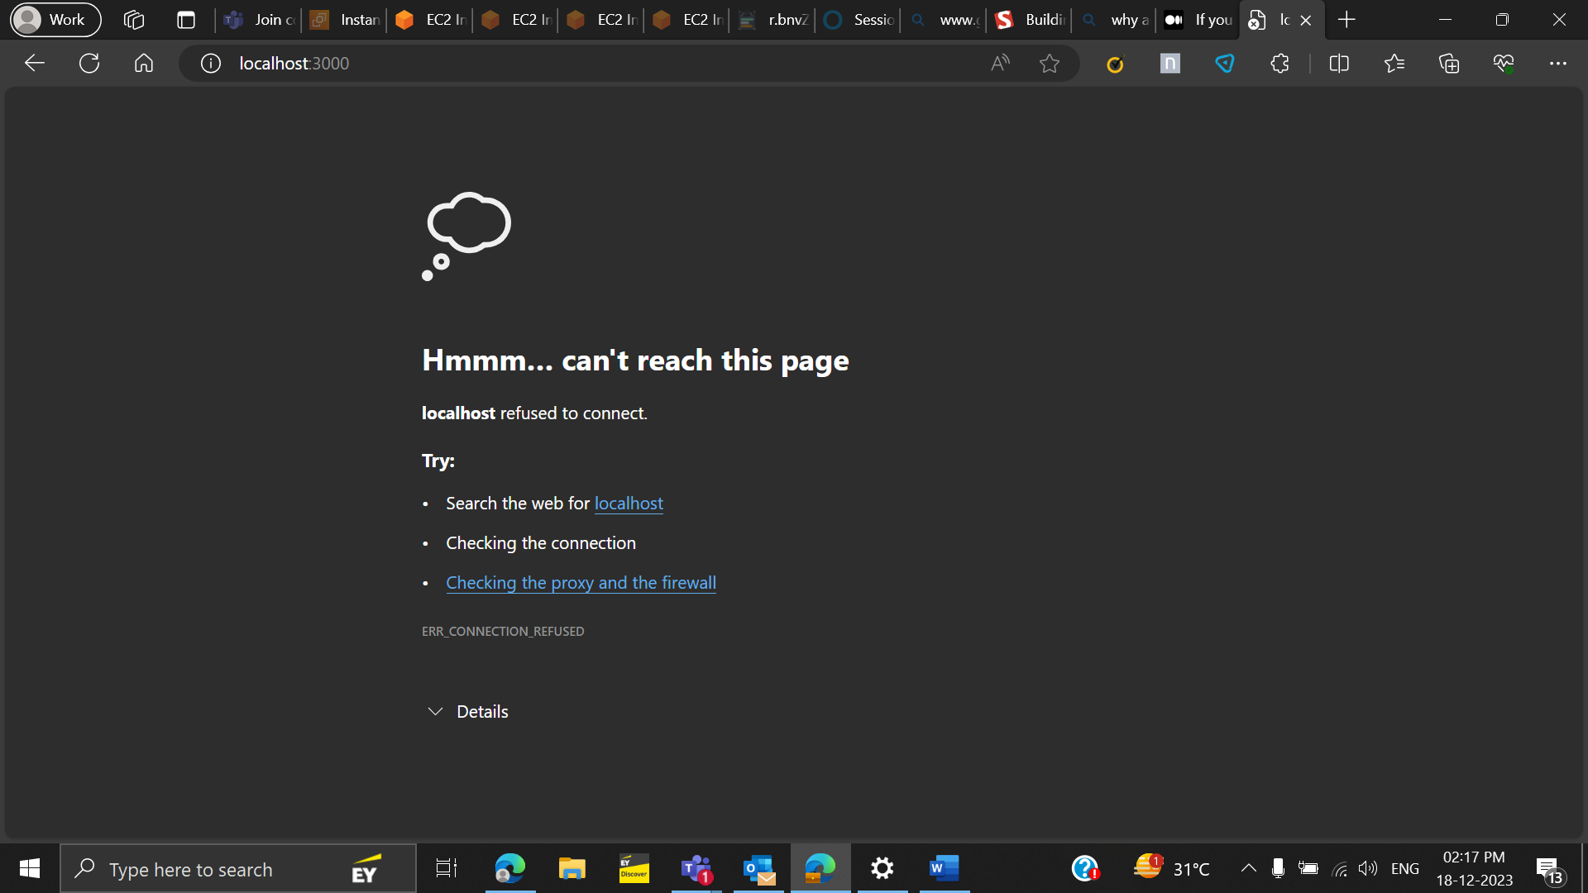
Task 7: Create a Dockerfile for a Python web application using Flask. The application should expose port 5000, and when accessed, it should display "Hello, Docker!" in the browser.
Dockerfile:
FROM python:3.9.12-buster
WORKDIR /flask-docker
COPY requirements.txt .
RUN pip install -r requirements.txt
COPY . .
CMD ["python", "app.py"]
App.py:
from flask import Flask

app = Flask(__name__)
@app.route('/')
def hello():
return 'Hello,Docker!'
if __name__ == '__main__':
app.run(debug=True)
docker run -d -p 5000:5000 7176fe81a234
result:
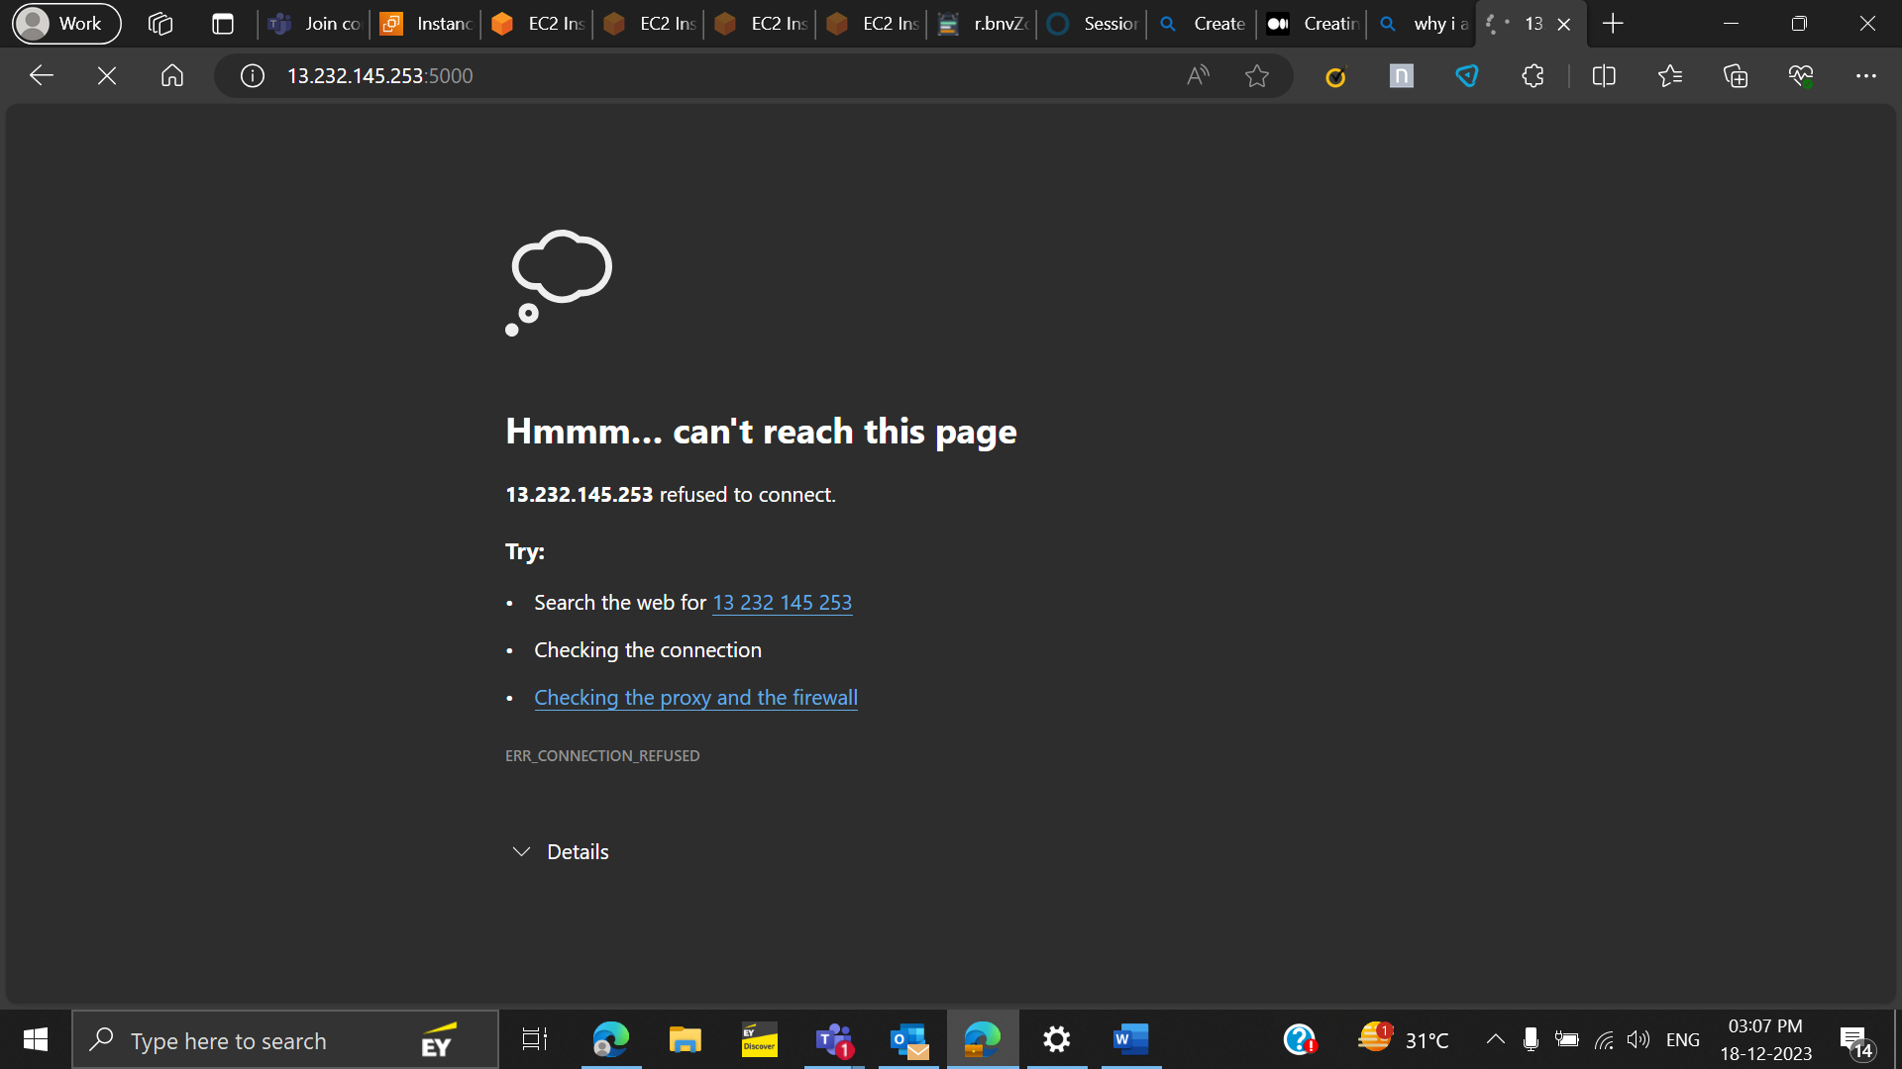
Error:
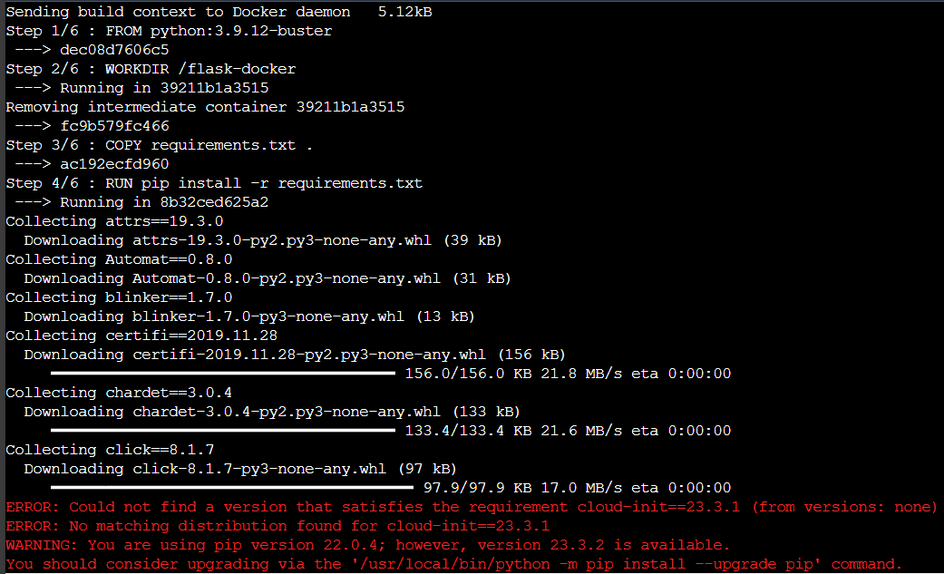

Task 8: Create a Terraform script to provision an AWS EC2 instance with an associated security group allowing incoming traffic on port 22 for SSH.
vpc.tf
provider "aws" {
region = var.region
access_key = var.access_key
secret_key = var.secret_key
}
resource "aws_vpc" "vpc" {
cidr_block = "10.0.0.0/16"

tags = {
Name = "vpc"
}
}

resource "aws_subnet" "subnet" {
vpc_id = aws_vpc.vpc.id
cidr_block = "10.0.1.0/24"
availability_zone = "ap-south-1b"
map_public_ip_on_launch = true

tags = {
Name = "subnet"
}
}

resource "aws_internet_gateway" "igw" {
vpc_id = aws_vpc.vpc.id

tags = {
Name = "igw"
}
}

resource "aws_route_table" "route" {
vpc_id = aws_vpc.vpc.id

route {
cidr_block = "0.0.0.0/0"
gateway_id = aws_internet_gateway.igw.id
}

tags = {
Name = "route"
}
}

resource "aws_route_table_association" "devrouteassoc" {
subnet_id = aws_subnet.subnet.id
route_table_id = aws_route_table.route.id
}

resource "aws_security_group" "sg" {
vpc_id = aws_vpc.vpc.id

ingress {
from_port = 22
to_port = 22
protocol = "tcp"
cidr_blocks = ["0.0.0.0/0"]
}

egress {
from_port = 0
to_port = 0
protocol = "-1"
cidr_blocks = ["0.0.0.0/0"]
}

tags = {
Name = "sg"
}
}

Ec2.tf
provider "aws" {
region = var.region
access_key = var.access_key
secret_key = var.secret_key
}

variable "vpc_id" {
default = "vpc-0db47fd19fbc32358"
}

variable "subnet_id" {
default = "subnet-02c0ef68f549858a0"
}

resource "aws_instance" "instance" {
ami = "ami-0287a05f0ef0e9d9a"
instance_type = "t2.medium"

subnet_id = var.subnet_id

tags = {
Name = "instance"
}
}
Task 9 : Write a Terraform script to provision an AWS RDS instance (MySQL)
#main.tf
#defining the provider as aws
provider "aws" {
region = "${var.region}"
access_key = "${var.access_key}"
secret_key = "${var.secret_key}"
}

#create a security group for RDS Database Instance
resource "aws_security_group" "rds_sg" {
name = "rds_sg"
ingress {
from_port = 3306
to_port = 3306
protocol = "tcp"
cidr_blocks = ["0.0.0.0/0"]
}
egress {
from_port = 0
to_port = 0
protocol = "-1"
cidr_blocks = ["0.0.0.0/0"]
}
}

#create a RDS Database Instance
resource "aws_db_instance" "myinstance" {
engine = "mysql"
identifier = "myrdsinstance"
allocated_storage = 20
engine_version = "5.7"
instance_class = "db.t2.micro"
username = "myrdsuser"
password = "myrdspassword"
parameter_group_name = "default.mysql5.7"
vpc_security_group_ids = ["${aws_security_group.rds_sg.id}"]
skip_final_snapshot = true
publicly_accessible = true
}
Result :
