**Heuristics for a Connect 4 game**

In our Connect 4 game implementation, we employ a score-based system to evaluate a player's performance. The scoring is determined by the number of "2 in a line" and "3 in a line" connections, with consideration given to the potential for extending these connections.

**Scoring Criteria:**

1. **Piece Connections:**
   * We assess connections in every orientation (horizontal, vertical, and diagonal).
   * Scores are awarded independently of orientation, with higher emphasis on longer connections.
   * A 3-piece connection is scored higher than a 2-piece connection, reflecting its greater strategic value.
2. **Blocking Opponent's Win:**
   * Recognizing the importance of defensive play, blocking the opponent's 3-piece and 4-piece connections is prioritized.
   * Successfully preventing an opponent's potential win is rewarded with a higher score than achieving a 3-piece connection for the player.
3. **Positioning Near the Center:**
   * We incentivize placing pieces near the center of the board.
   * Central positions offer increased opportunities for future connections, aligning with our strategic objective of securing wins.

**Score Hierarchy and Weights:**

Scores are awarded in the following order of priority:

1. **4-Piece Connection:** The highest score is granted for achieving a winning 4-piece connection with a weight of **100 points.**
2. **Blocking Opponent's 4-Piece Connection:** Preventing the opponent's potential victory by blocking a 4-piece connection is a top priority. **80 points** are awarded for this move.
3. **3-Piece Connection:** Creating a 3-piece connection is a valuable move, contributing to the player's strategic advantage. **10 points** are awarded.
4. **Centre piece:** Dropping a piece in the middle column is a strategically sound move, as it increases future opportunities. **6 points** are awarded
5. **2-Piece Connection:** Establishing a 2-piece connection is considered, though it carries a lower score compared to higher-order connections. **5 points** are awarded

This scoring system reflects our strategic emphasis on both offensive and defensive manoeuvres. The agent is guided to prioritize actions that enhance its winning potential while actively thwarting the opponent's strategic advances. The preference for central positioning further optimizes the agent's chances of achieving successful connections. The effectiveness of this scoring system will be validated through empirical testing and fine-tuning.

**Worked Examples:**

For these examples let’s assume the red player is the designed AI.

**Case 1**

The AI has an opportunity to make a 3-piece connection. Since there is a score rewarded for making that connection, the AI will place the piece in between the 2 red pieces. The AI would also receive a similar score for placing the piece on the 4th hole from the left because that still makes a 3-piece connection in a window that spans 4 holes. No score is rewarded for placing the piece in the 5th hole since its neither making a 3-piece connection, nor blocking an opponent connection. hence the AI should not make that move.

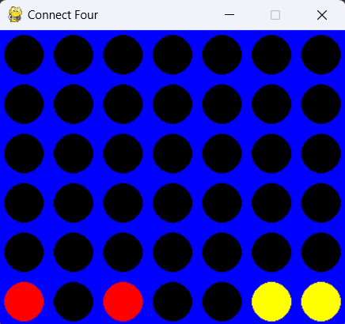

**Case 2**

Here the AI has blocked a possible 4-piece connection as score is rewarded for making that move. The AI had the opportunity to make a 3-piece connection for itself but since the score awarded for blocking an opponent 4 piece connection is higher than making a 3 piece connection, The former will be chosen.

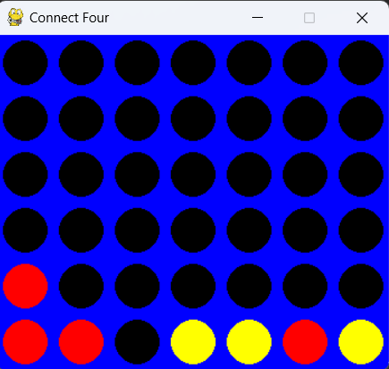

**Case 3:**

Here the AI has made a 3-piece connection as that’s the only move that will award the AI with points.

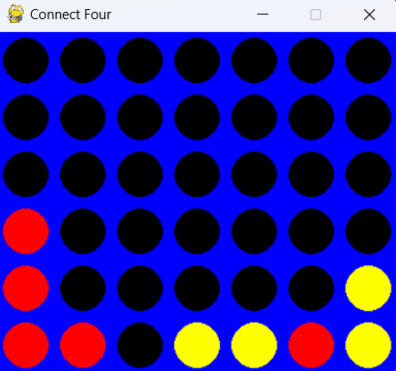

**Case 4:**

In this case both players have a 3-piece connection. In this case the AI will prefer making a 4-piece connection rather than blocking the opponent because it guarantees the win. 4-piece connection is awarded 100 points while blocking an opponent win is awarded 80 points.

