Design for new AI vs AI program using random agents

The provided code is for a 2 player connect 4 game which takes inputs from the user.

In order to design an AI version of the game played by 2 random agents, the decision making section of the code needs to be altered

Below is the section that needs to be replaced:

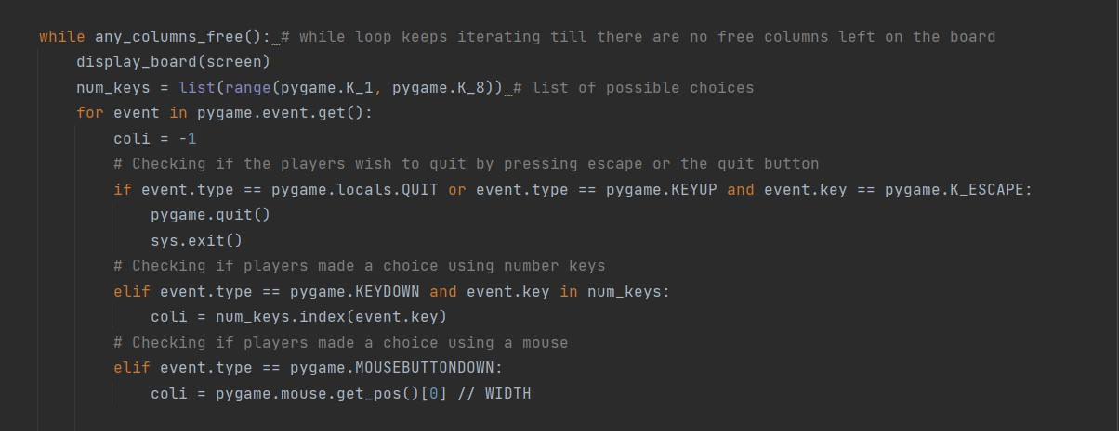

The new approach would involve using the random library in python and randomly choose between the 7 available columns.

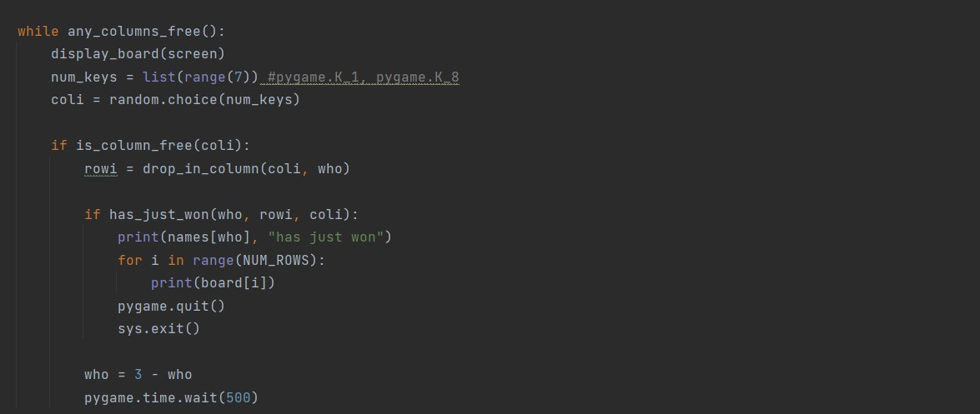

The above code uses to random library to randomly choose from the list num_keys that is a list of possible moves that can be made. This choice is randomly made for both players. The rest of the code remains unaltered.