Name: Desai Dhyan Shiven

Registration Number: 23BCE1310

Project Title
AnnaData: An Autonomous Agri-Bot Providing a Solution to Traditional Farming Challenges

1. Problem Statement
Traditional farming practices heavily depend on manual labor and expensive machinery such as tractors for ploughing, monitoring, and other field operations. Small and medium-scale farmers often face financial constraints in purchasing and maintaining such equipment. Additionally, labor shortages, inefficient field monitoring, and lack of real-time crop health analysis further reduce productivity. There is a need for a cost-effective, autonomous, and scalable solution that reduces manual effort, lowers operational costs, and enhances precision in agricultural activities.

2. Objectives
• To design and develop a cost-effective autonomous agricultural rover to perform field operations.
• To reduce farmers’ dependency on manual labor and expensive tractors or heavy machinery.
• To implement swarm robotics for coordinated multi-rover field coverage.
• To enable autonomous navigation within square and rectangular agricultural fields.
• To integrate weed detection using a trained Deep Learning model for precise weed identification and management.
• To implement solar tracking (sunflower mechanism) for sustainable power generation.
• To utilize ESP-NOW protocol for efficient communication between multiple ESP32-based rovers.
• To improve overall farming efficiency, reduce operational costs, and increase productivity.

3. Methodology / Approach
The project follows a modular and simulation-driven development approach:
• Rover Simulation: Autonomous rover movement is simulated in square and rectangular fields using Gazebo.
• Swarm Simulation: Multiple rover coordination is simulated in Gazebo to demonstrate swarm behavior.
• Hardware Development: ESP32 development boards are used for rover control and communication.
• Communication Protocol: ESP-NOW protocol is implemented for low-latency swarm communication.
• Weed Detection: A Deep Learning model is trained for weed detection to assist farmers in identifying unwanted plant growth in fields.
• Solar Power System: A solar sunflower mechanism is implemented using Arduino Uno for efficient energy harvesting.
• Autonomy Implementation: Full autonomous navigation is under development and testing, transitioning from RC control to complete autonomy.

4. Work Completed So Far
• Created simulation of a single rover moving autonomously in square/rectangular fields using Gazebo.
• Developed simulation of multiple rovers in Gazebo showcasing swarm implementation.
• Currently testing autonomous navigation algorithms (rover presently operates as an RC rover).
• Trained a Deep Learning model for weed detection.
• Implemented a solar sunflower mechanism using Arduino Uno and Arduino IDE.
• Planned implementation of swarm robotics using ESP-NOW protocol with ESP32 development boards.
• System integration of all modules is still remaining and will be completed in the final phase of the project.

5. Screenshots:
- Output screenshot for the photo of a rose flower which is not a weed:

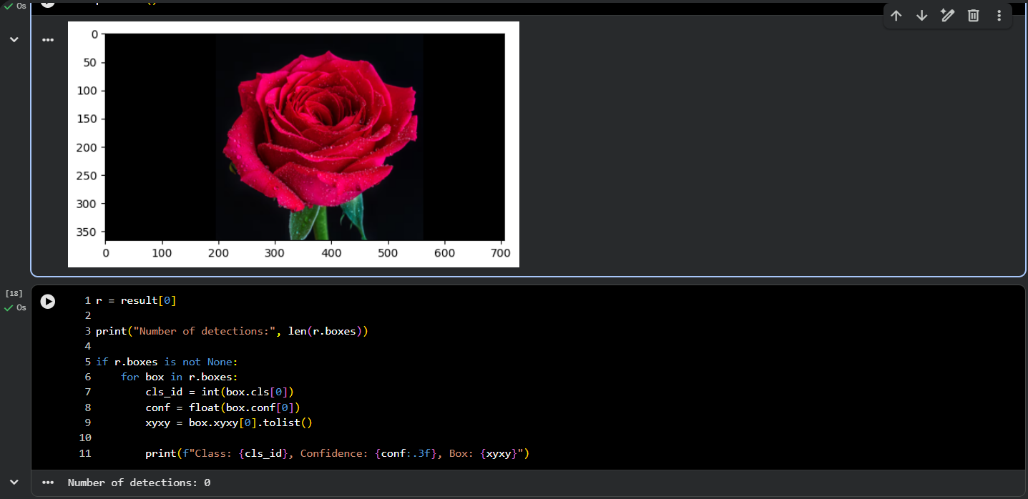

- Output Screenshot for the photo of a weed present in a field:

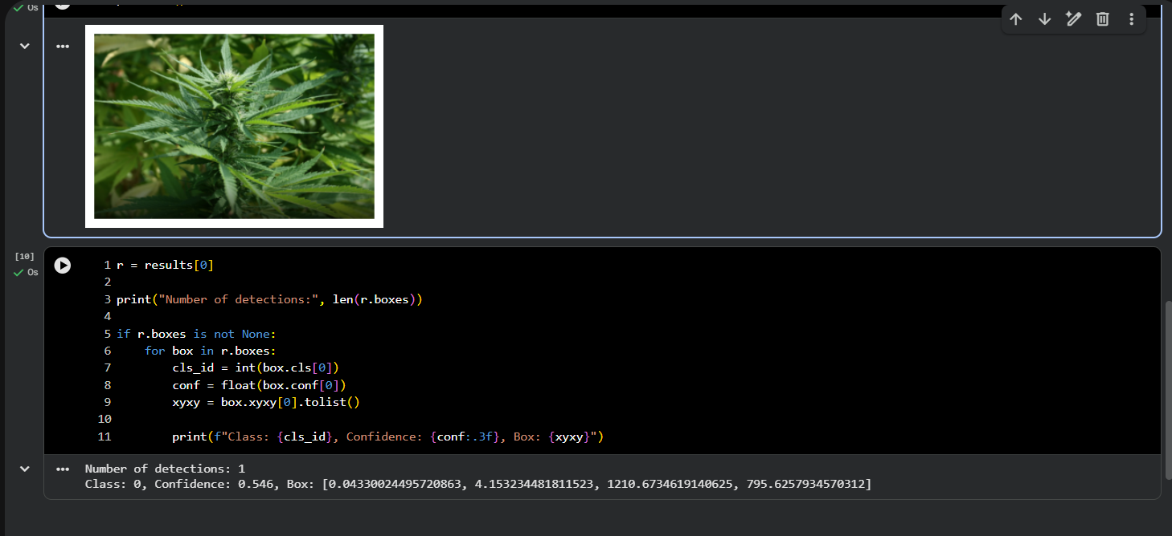

- Photo of the rover:

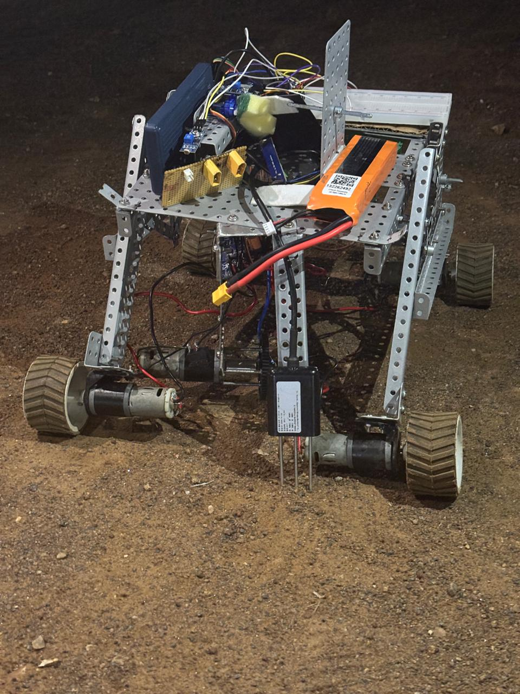

- To access GitHub repo: Click here

Conclusion:
In conclusion, AnnaData demonstrates how autonomous robotics and AI can be combined to address key challenges in modern agriculture. Through structured field navigation, swarm coordination, and intelligent weed detection, the system aims to improve efficiency, reduce manual effort, and support precision farming.
While the current prototype validates the core concepts, future work will focus on full autonomy, 3D-printed lightweight chassis design, and real-world field deployment.
Thank you for your time.

