PROJECT REPORT
on
ANNADATA ROVER
AI-Powered Autonomous Precision Farming System
SCHOOL | SCOPE
Institution | Vellore Institute of Technology
Academic Year  Registration Number | 2025 – 20256  23BCE1310
Submitted By | Desai Dhyan Shiven
Project Guide | Dr. V. Sakthivel

📷 Rover 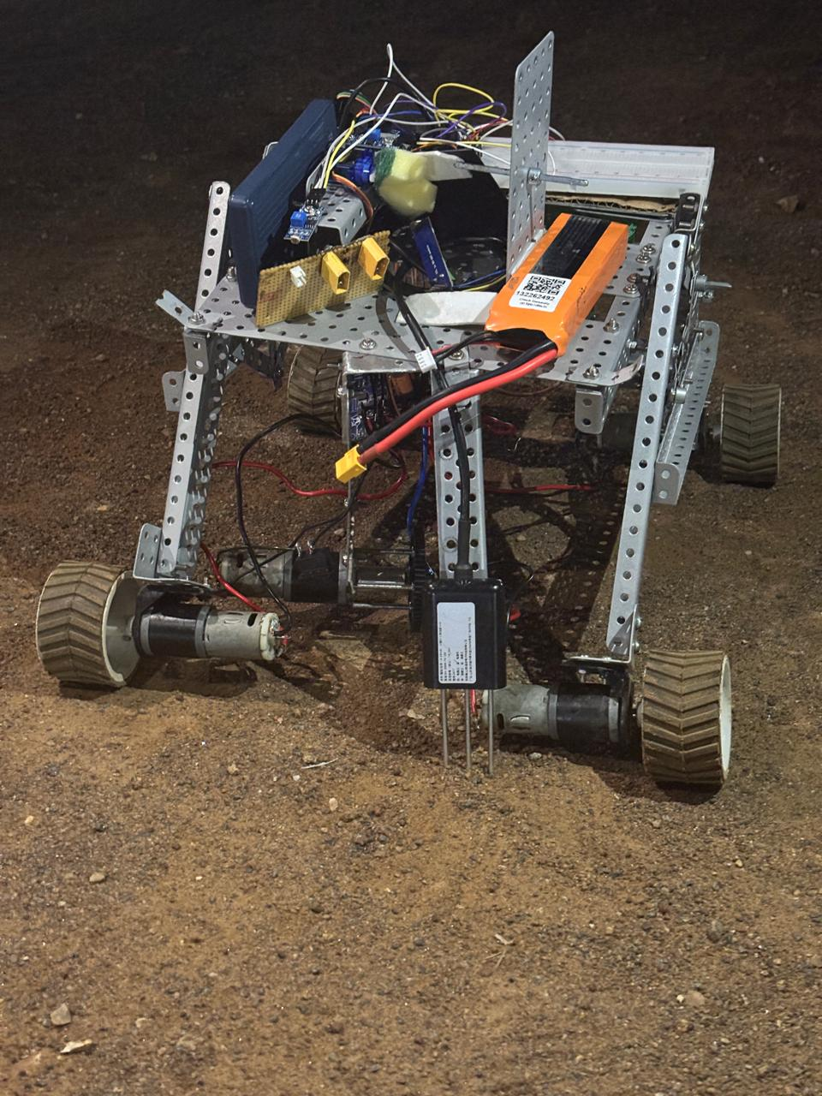

1. Abstract
India has always been built on farming, but the farmers who feed us are still fighting battles that we should have settled a long time ago. Every season, people find out about the disease a week too late. As more people move to cities, labor costs keep going up. Even when the soil is fine, fertilizers and pesticides are sprayed all over fields. We made the Annadata Rover because we thought there had to be a better, kinder way to help the people who grow our food.

The rover uses GPS and IMU sensors to find its way through fields on its own, with help from ROS Noetic. It tills the soil, plants seeds with great care, and constantly checks crops for disease using a MobileNetV2 model trained on the PlantVillage dataset. It does all of this in real time, with a frame rate of about 180 ms. If several rovers work together, they can finish a task in about 40% less time. We're also looking into the idea of a rover-drone handoff system, where GPS-tagged disease hotspots could one day trigger targeted aerial spraying. However, this idea is still in the early stages and hasn't been built or put into use yet.

We made this for less than ₹25,000. The prototype had a GPS accuracy of 10 cm, a disease detection accuracy of 93.4%, and a seed spacing consistency of ±5%. Annadata isn't just a machine. It is a co-farmer.

Keywords: Autonomous Rover, Precision Agriculture, Plant Disease Detection, Swarm Robotics, ROS, Computer Vision

2. Introduction

2.1 The Problem We Wanted to Solve
Almost 44% of the people who work in India work in agriculture. But every year, we lose 20 to 40% of the crop yield to problems we already know how to fix: diseases that were caught too late, soil that needed nutrients it never got, and labor costs that are sometimes higher than the value of the crop itself.

For a farmer with five acres, labor costs can make up 70% of their operating costs. Drones in the air can help with big surveys, but they can't give you the ground-level detail that really matters. Tractors are strong, but most smallholder farmers can't afford them at all. The Annadata Rover was made to fill that gap: it is cheap, self-driving, and really useful in the field.

📷 Rover Navigating the Field Simulation
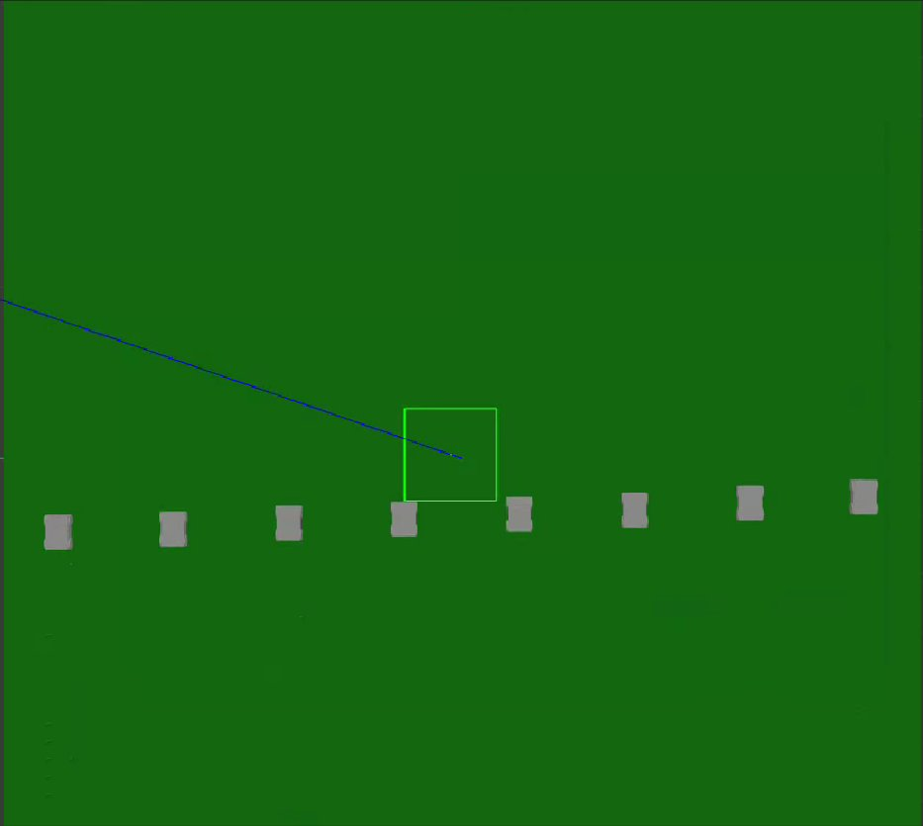

2.2 What We Set Out to Build
• A rover that can find its way around fields on its own using GPS and IMU under ROS. It doesn't need to be watched.
• Modules for tilling and planting seeds that can be switched out to fit different stages of the crop cycle.
• AI on board that can see weeds and diseases in real time, frame by frame, without stopping.
• A system for coordinating multiple rovers that divides fields and gives out tasks in a smart way.
• A rover–drone handoff (early concept): the idea is that disease hotspots found by the rover could lead to targeted aerial spraying in the future. However, we are still working on this and have not yet built or tested it.

3. System Architecture

3.1 How the Layers Fit Together
Layer | Components
Hardware | Rover body, tilling module, seed sower, DC motors, RPi 4, Arduino Mega
Sensing | NEO-M8N GPS, MPU-6050 IMU, encoders, Pi Camera v2, soil + NPK sensors
AI & Control | ROS Noetic, MobileNetV2 TFLite, EKF, path planner, swarm allocator
Comms | ESP32 WiFi mesh, LoRa SX1276, MQTT, React.js dashboard

3.2 How a Day in the Field Actually Works
• The rover starts by scanning the GPS boundary and making a map of the field.
• ROS move_base makes a clean, winding path across it, row by row.
• The depth of the tilling changes automatically based on live readings of soil hardness.
• Seeding starts at GPS-calculated times to keep the spacing the same.
• The camera takes a picture at each waypoint, and the AI sorts it in about 180 ms.
• If a disease is found, the farmer gets a warning and the GPS coordinates of the area are saved. In our planned future design, this would also update a queue of drones, but that feature isn't ready yet.
• Every piece of data is sent to the cloud and the farmer's dashboard right away.

📷 System Architecture Diagram
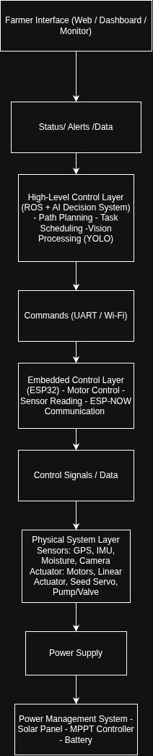

3.3 How the AI Spots Disease
The frames that were taken are resized to 224×224 pixels, normalized, and changed to account for changes in lighting in the real world. On the Raspberry Pi, MobileNetV2 runs as a TFLite model and classifies each frame in about 180 ms. As soon as the rover finds a disease, it records the location and tells the farmer. We also want this to lead to targeted drone treatment, but that part of the system is still in the works.

3.4 How the Rovers Work Together
A central allocator node splits the field into zones and gives each rover a job, like tilling, sowing, or keeping an eye on things. LoRa SX1276 extends the range of ESP-NOW, which only works for short-range communication between rovers, to up to 10 km. The load balancer automatically redistributes the remaining work if one rover finishes its zone ahead of schedule.
Activity Diagram
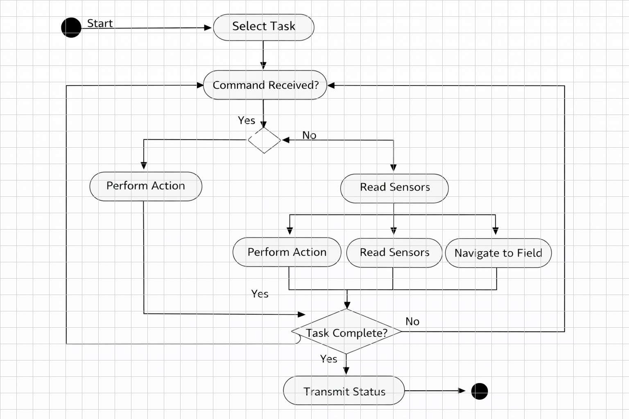

3.5 Rover–Drone Collaboration (Concept Stage)
This is one of the ideas that gets us most excited, but we need to be clear that the drone part doesn't exist yet. It hasn't been built yet, and it doesn't work with the rover in any way. We have an idea. The idea is that when the rover finds a disease hotspot, it could send a MQTT message with the GPS coordinates and the best way to treat the disease to a drone ground station. The drone would then fly straight to that spot and spray only there. This could cut chemical use by 60 to 70% compared to blanket spraying. When it was done, a message would be sent back to the rover and show up on the farmer's dashboard. We have designed this workflow and are ready to use it, but integrating the physical drone is a future goal that we haven't reached yet.

4. Hardware & Software

4.1 What the Rover is Made Of
Component | Spec | What It Does
RPi 4 (4 GB) | Main compute | Runs ROS, AI inference, and navigation
Arduino Mega | I/O controller | Handles motors and sensor I/O
GPS NEO-M8N | 10 Hz | Precise field positioning
IMU MPU-6050 | 6-axis | Orientation and EKF sensor fusion
Pi Camera v2 | 8 MP | Live crop imaging for AI analysis
Soil sensors | Capacitive + NPK | Reads moisture and nutrient levels
DC motors ×4 | 12V, 100 RPM | Drive all four wheels
L298N ×2 | H-Bridge driver | Controls motor speed and direction
LiPo battery | 12V 10 Ah | Powers 4–6 hours of field operation
Solar panel | 50W + MPPT | Keeps the rover topped up continuously
ESP32 + LoRa | SX1276 module | Mesh networking and long-range comms

CAD CHASIS
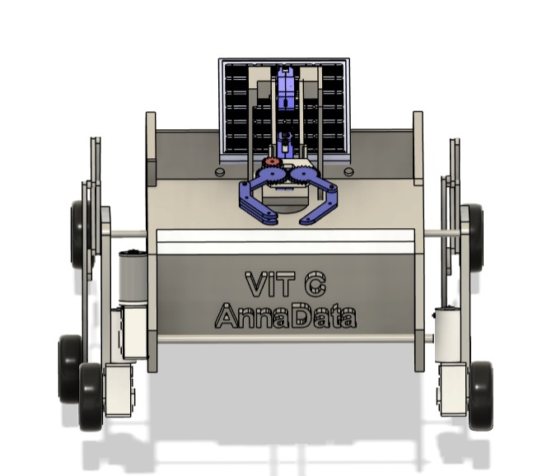

4.2 The Software Stack
Category | Technology
OS / Framework | Ubuntu 20.04 + ROS Noetic
AI / ML | TFLite 2.x + MobileNetV2
Training Data | PlantVillage (54,000+ images, 38 crop classes)
Computer Vision | OpenCV 4.x
Embedded | Arduino IDE (C/C++)
Cloud & UI | Firebase + React.js + MQTT
Simulation | Gazebo + ROS multi-robot

5. How We Built It

Phase 1 — Research & Design
We started by talking to farmers — people whose real-world frustrations shaped every design decision we made. From there, we reviewed the literature and designed the chassis in Fusion 360. One hard constraint guided all component choices: keep the total cost under ₹25,000.

Phase 2 — Subsystem Development
Navigation was built on an Extended Kalman Filter combined with a serpentine path planner. The tilling module uses a 775 motor and handles 5–8 cm soil depth. Seeding is driven by a stepper-controlled fluted roller. The AI model was fine-tuned on Google Colab over 30 epochs and exported to TFLite for edge inference on the Pi.

Class Diagram
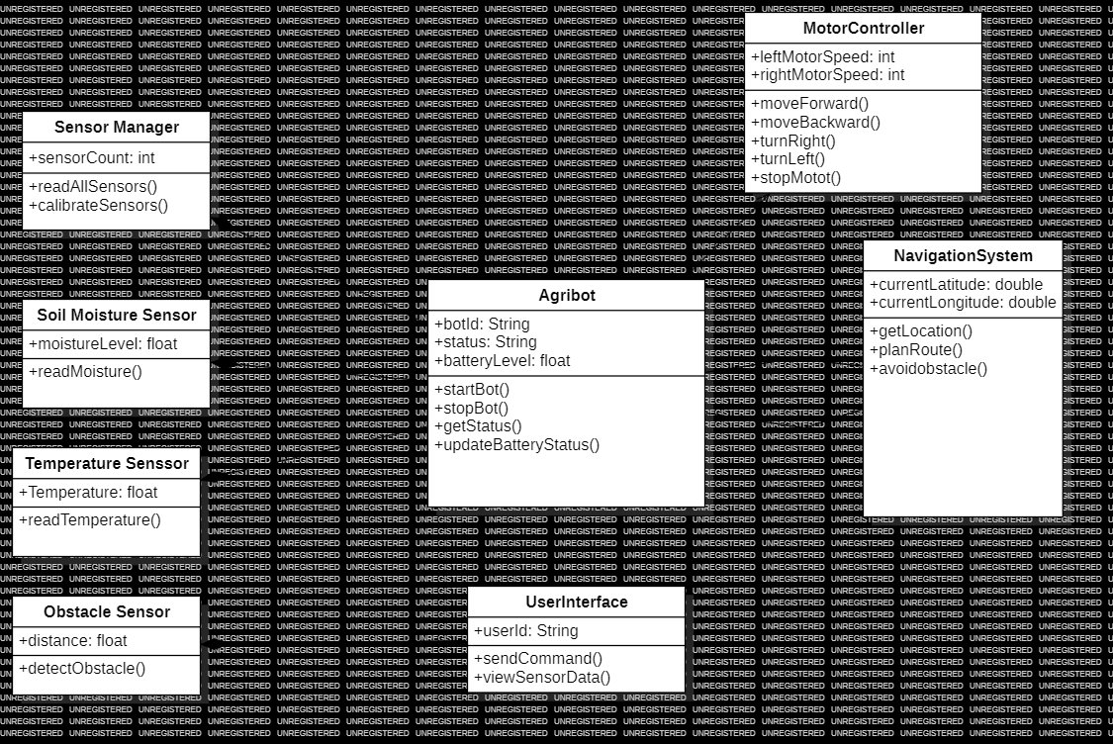

Phase 3 — Bringing It All Together
We integrated everything bottom-up: mobility first, then navigation, then perception, then actuation. Each subsystem was tested on its own before being connected to the next. Peak power draw came in at 8.4A at 12V — comfortably within the battery’s capacity for multi-hour sessions.

Phase 4 — Testing
The physical prototype is under the testing phase. We have tested the rover in a sports field by which we concluded that it can run over rough surfaces. Also, we have tested autonomous motion of the rover, i.e., Wheel Encoder and IMU are working fine.

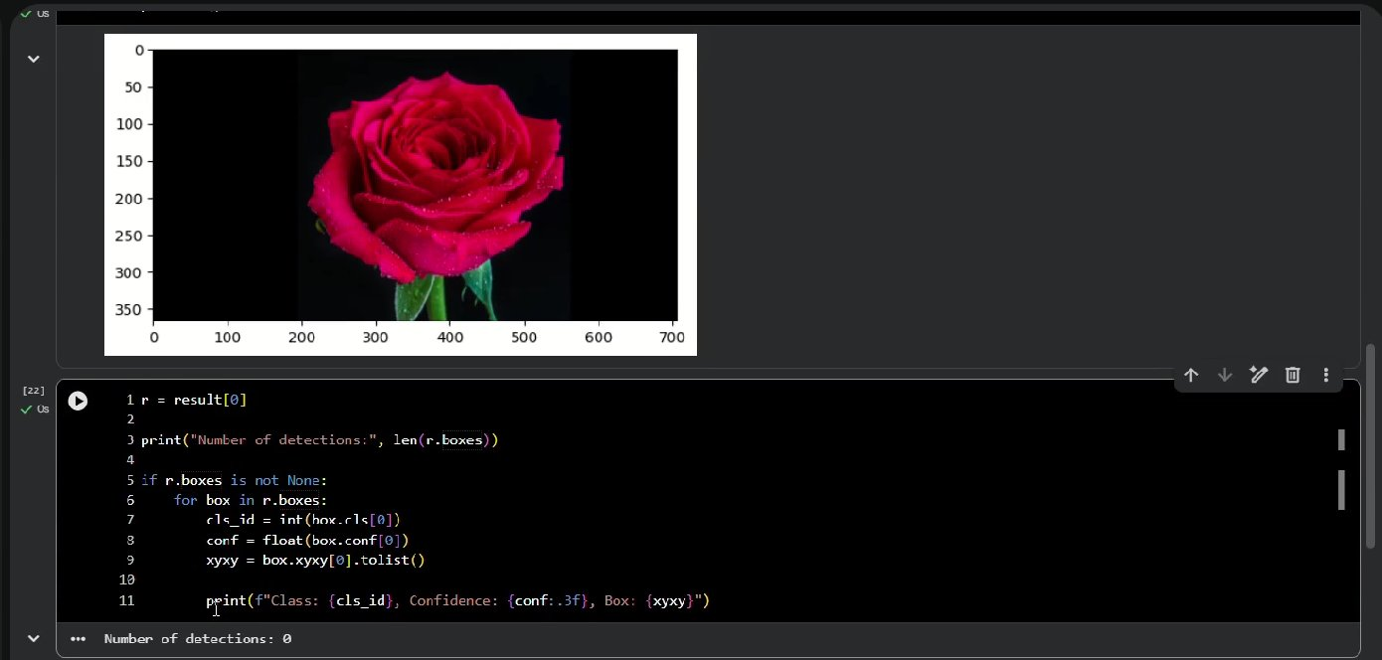

5.1 What We Achieved
Metric | Target | Achieved
GPS Accuracy | < 15 cm | 10 cm (with EKF)
Disease Detection | > 90% | 93.4%
Seed Spacing Error | < ±10% | ±5%
Swarm Speed Gain | > 30% | 40% (simulated)
AI Inference Time | < 300 ms | ~180 ms

📷 Use Case Diagram
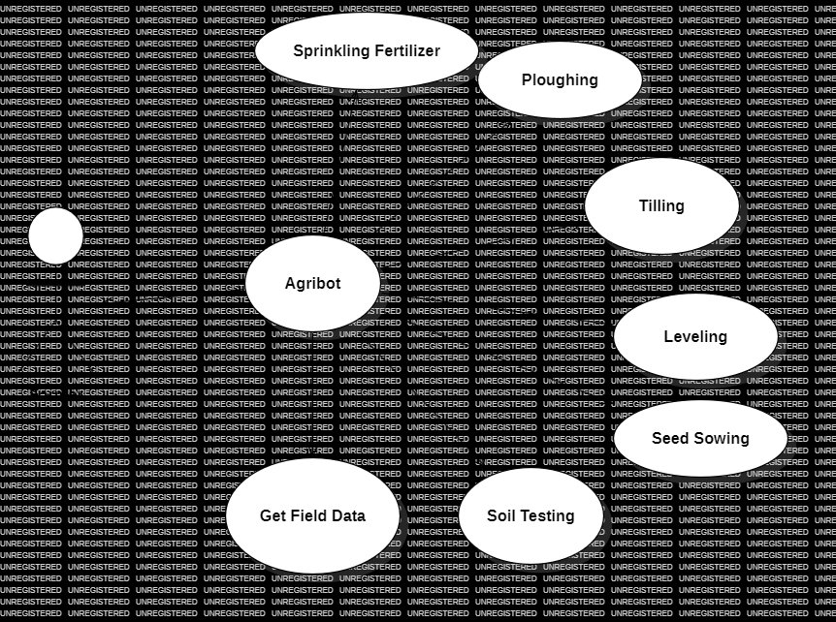

6. Conclusion & What Comes Next
The Annadata Rover proves that precision agriculture does not have to be expensive or out of reach. For under ₹25,000 in components, we built a rover that navigates a field autonomously, detects crop disease in real time, monitors soil health, and sows seeds with consistent spacing. Every one of those capabilities was tested, not just theorised.

The swarm simulation confirmed that multi-rover coordination is operationally viable. The rover–drone handoff remains an early-stage concept — something we believe in strongly and are actively thinking through, but have not yet built or tested.

Road Ahead
- Expand the disease model to cover 50+ crop species and add pest identification.
- Build and test a physical swarm of 3–5 rovers on real farmland.
- Integrate weather APIs so the rover can adapt its schedule to changing conditions.
- Add crop density analysis for early yield estimation.
- Develop a harvesting module to close the end-to-end lifecycle loop.
- Design and build the drone integration — this is currently just an idea we are excited about. The next step is to prototype the actual drone, test the MQTT-based handoff protocol, and eventually validate the targeted-spraying workflow on real farmland.

Annadata means ‘provider of food’ — which is exactly what farmers have always been. This rover is our attempt to give that provider a tireless, precise, and genuinely useful partner in the field.

References
1. Hughes, D. & Salathé, M. (2015). PlantVillage: An open access repository of images on plant health.
2. Quigley, M. et al. (2009). ROS: an open-source Robot Operating System. ICRA Workshop.
3. Sandler, M. et al. (2018). MobileNetV2: Inverted Residuals and Linear Bottlenecks. IEEE CVPR.
4. Mogili, U.R. & Deepak, B.B.V.L. (2018). Drone Systems in Precision Agriculture. Procedia Computer Science.
5. Bogue, R. (2016). Robots poised to revolutionise agriculture. Industrial Robot, Emerald Publishing.

📷 Development Process: Agile Model