Software Architecture and Design Specification
Project: Personal Wealth Management Software
Version: 1.0
Authors: Dhyan Rao, Dhruvagouda Patil, Hanshal Nagesh, Jayant Mahishi (Team 5, Section B)
Date: 05-11-2026
Status: Draft

Revision History
Version | Date | Author | Change Summary
1.0 | 05-11-2026 | Team 5 | Initial architecture and design

Approvals
Role | Name | Signature/Date
Course Coordinator

1. Introduction
1.1 Purpose
This document specifies the architecture and design of the Personal Wealth Management Software.
1.2 Scope
Covers the browser pages, API, business logic, data model, security and CI/CD pipeline for user accounts, the four asset classes (real estate, gold, stocks and cash), the dashboard and administration.
1.3 Audience
Developers, QA engineers, the course TA, assessment evaluators and future maintainers.
1.4 Definitions
ADR, API, CI/CD, CSV, DTO, ORM, REST, STRIDE, TLS. Holding and net worth are defined in the SRS.

2. Document Overview
2.1 How to use this document
Provides the architectural deliverables: UML component, class and sequence diagrams, architecture decisions, a STRIDE threat model and the API design.
2.2 Related Documents
SRS v1.0 (including the RTM in its section 8) and STP v1.0.

3. Architecture
3.1 Goals & Constraints
Goals: keep each user's data private, calculate money exactly, respond within 500 ms, and let four developers work without getting in each other's way. Constraints: two one-week sprints, a fixed stack (FastAPI, SQLAlchemy, SQLite), prices entered by hand, and no paid external services.
3.2 Stakeholders & Concerns
Users: privacy, correct figures, ease of use
Administrator: control over who has access
Developers: modularity, clear ownership of code
Course TA and evaluators: traceability, a working product

3.3 Component (UML) Diagram
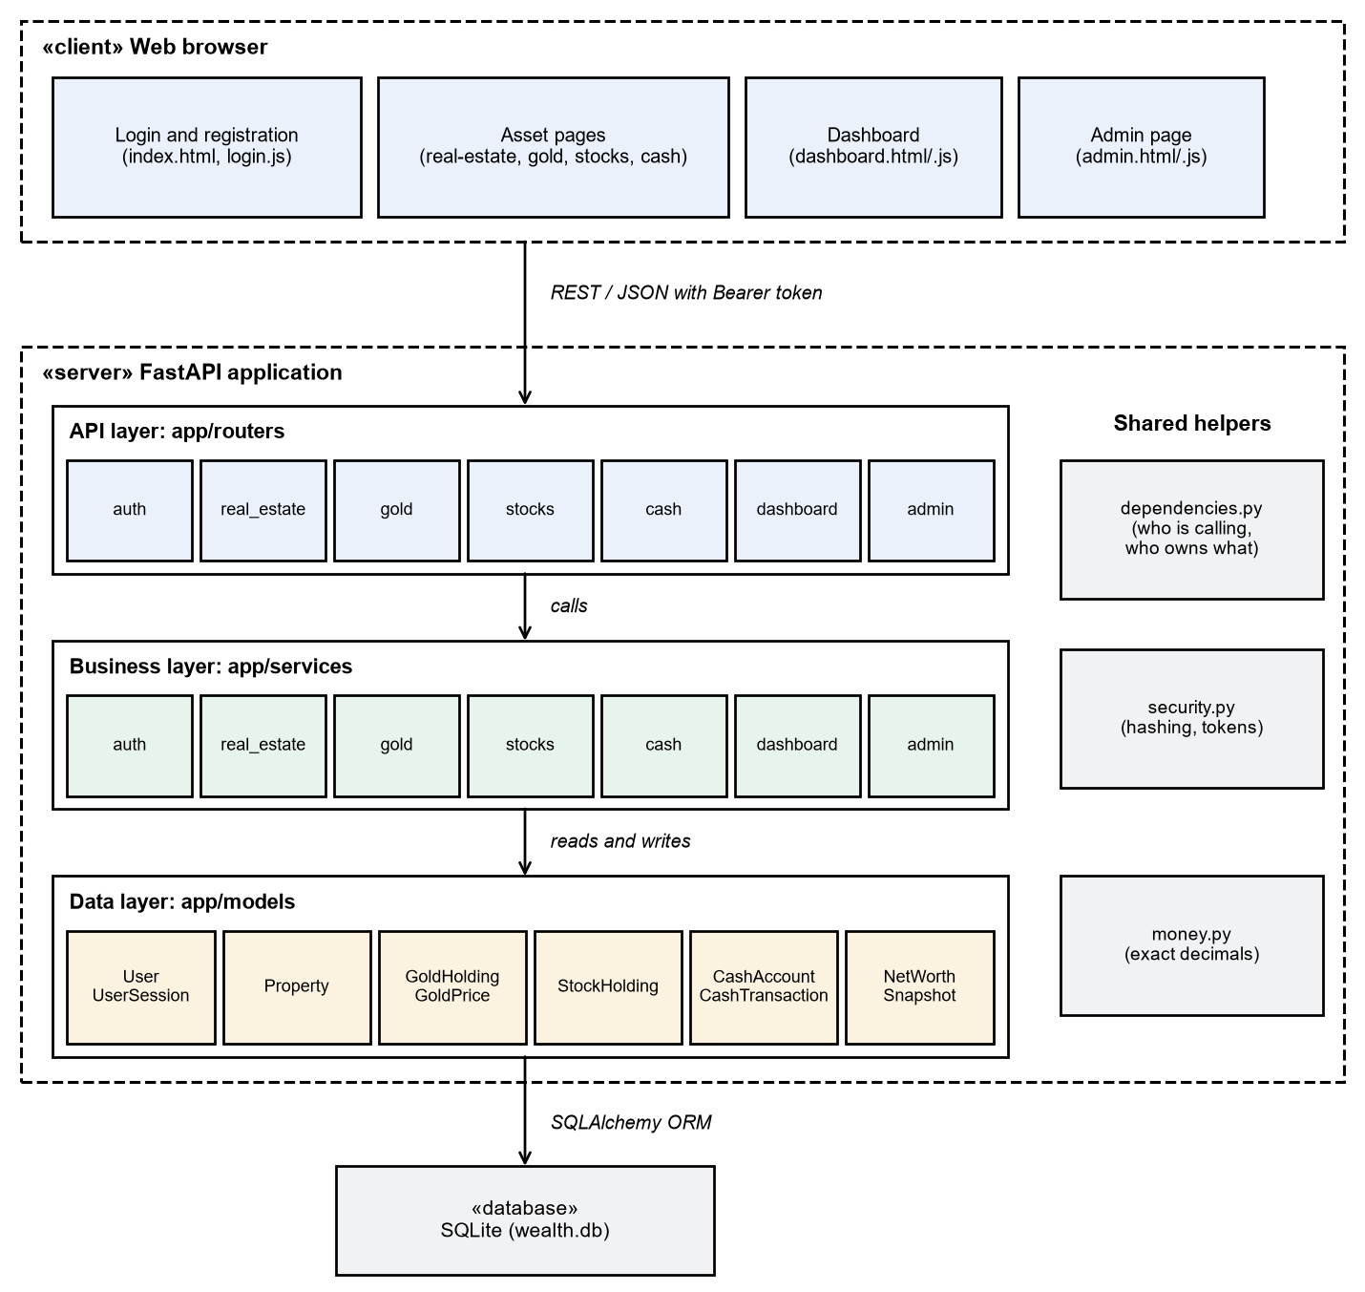
Figure 1: UML component diagram
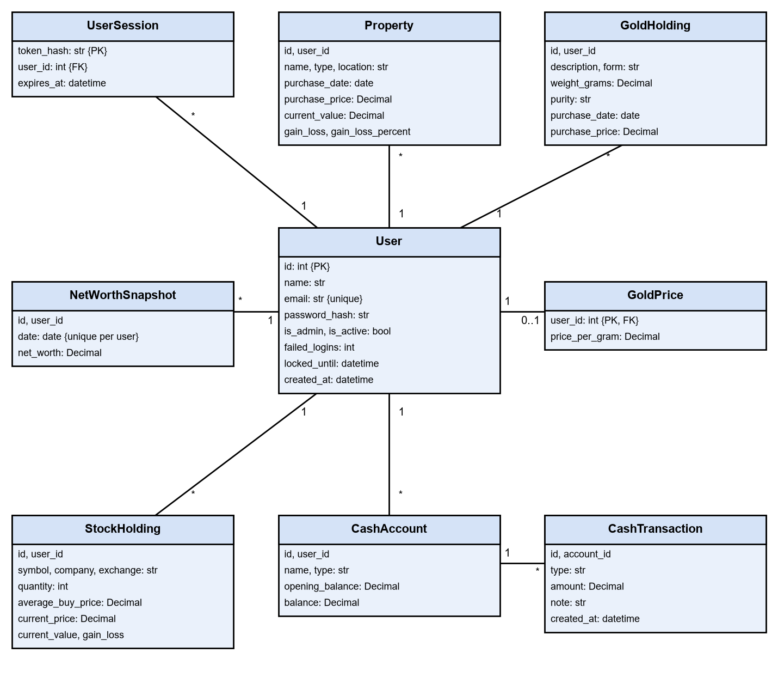
Figure 2: UML class diagram of the data model

3.4 Component Descriptions
- Web UI (app/static): HTML, CSS and JavaScript pages. Shared code in api.js, nav.js and crud.js handles API calls, the navigation bar and add/edit forms.
- API layer (app/routers): one file per feature. Defines URLs, checks input through the schemas and calls the business layer. Routers are loaded automatically.
- Business layer (app/services): login and lockout rules, gold valuation, cash balance updates, net worth, allocation, snapshots and CSV export.
- Data layer (app/models): SQLAlchemy tables, loaded automatically.
- Schemas (app/schemas): Pydantic models that validate requests and shape responses.
- Shared helpers: dependencies.py (session and ownership checks), security.py (password hashing and tokens), money.py (exact decimals).
- Database: a SQLite file, chosen through the DATABASE_URL setting.

3.5 Chosen Architecture Pattern and Rationale
A layered architecture was chosen: each request flows router → service → model, and each layer only talks to the one below it. This gives a clear separation of concerns and lets each developer own a vertical slice of one feature. The key decisions are recorded below.
ADR | Decision | Why | Rejected alternative
ADR-1 | Layered architecture | Simple, testable, and easy to split between 4 developers. | Microservices: too complex for this scale.
ADR-2 | SQLite through SQLAlchemy | No server to install; the ORM gives parameterised queries and allows a later database change. | MySQL: needs setup on every machine.
ADR-3 | Money stored as exact decimal text | SQLite has no decimal type, and floats would cause rounding errors (PWM-NF-003). | Floats: inaccurate. Integer paise: harder to read.
ADR-4 | Server-side sessions with hashed tokens | Logout and deactivation take effect immediately; a database leak does not expose usable tokens. | JWT: cannot be cancelled before it expires.
ADR-5 | scrypt password hashing | Salted and deliberately slow; included in Python. | SHA-256: far too fast to resist guessing.
ADR-6 | Prices entered by the user | No paid data feed or outage risk. | Live price API: out of scope for v1.0.
ADR-7 | Routers and models load automatically | New features add files without editing main.py, so parallel pull requests don't conflict. | A manual list: constant conflicts.

3.6 Technology Stack & Data Stores
Back end: Python 3.12, FastAPI, Pydantic, SQLAlchemy 2, Uvicorn. Data store: SQLite. Front end: HTML, CSS and JavaScript with no framework. Testing and quality: pytest, pytest-cov, ruff. CI/CD: GitHub Actions, Docker and GitHub Container Registry.

3.7 Risks & Mitigations
Risk | Mitigation
Prices go out of date because they are entered by hand | The UI shows the price in use; holdings fall back to purchase price until one is set.
A stolen password or brute-force guessing | Strong password hashing and a 15-minute lock after 5 failed logins.
A session token is stolen from browser storage | Sessions end after 60 minutes, and pages add saved data as plain text, so scripts can't be injected to read the token.
The SQLite file is lost or corrupted | The container keeps data on a separate volume; users can export holdings as CSV.
SQLite slows down with many simultaneous writers | Acceptable at this scale; DATABASE_URL allows a move to a server database.
Team members' changes conflict or break main | Protected main branch, one approval per PR, and automatic lint and test checks.

3.8 Traceability to Requirements
Design ID | Design element | Requirements
DS-Auth-01 | routers/auth, services/auth, models/user, security.py | PWM-F-001 to 003
DS-RE-01 | routers/real_estate, models/real_estate | PWM-F-010 to 012
DS-Gold-01 | routers/gold, services/gold, models/gold | PWM-F-020 to 022
DS-Stock-01 | routers/stocks, models/stock | PWM-F-030 to 032
DS-Cash-01 | routers/cash, services/cash, models/cash | PWM-F-040 to 042
DS-Dash-01 | routers/dashboard, services/dashboard, models/snapshot | PWM-F-050 to 053
DS-Admin-01 | routers/admin, services/admin, make_admin.py | PWM-F-060, 061
DS-Perf-01 | Indexed user_id columns; each request reads only one user's rows | PWM-NF-001
DS-Data-01 | One database transaction per change, committed once | PWM-NF-002
DS-Calc-01 | money.py: ExactDecimal column type and rounding helpers | PWM-NF-003
DS-UX-01 | Responsive CSS, inline validation messages | PWM-NF-004
DS-CI-01 | .github/workflows/ci.yml with a 70% coverage gate | PWM-NF-005
DS-Deploy-01 | Dockerfile, .github/workflows/cd.yml | PWM-NF-006
DS-Sec-01 | dependencies.py, security.py, schemas, FORCE_HTTPS setting | PWM-SR-001 to 007

3.9 Security Architecture
Threat modelling used STRIDE. Each threat maps to a design control and a security requirement.
Threat | Example | Control | Requirement
Spoofing | Guessing or stealing a password | scrypt hashes, account lockout, session expiry | PWM-SR-001, 004
Tampering | Changing another user's records | get_owned() checks every record; all input is validated on the server | PWM-SR-003, 005
Repudiation | Denying an admin action | Lockouts and account changes are written to the pwm.audit log | PWM-SR-004, PWM-F-061
Information disclosure | Reading someone's holdings or finding secrets in logs | Other users' records return 404; tokens are hashed at rest; secrets are never logged; TLS when deployed | PWM-SR-003, 006, 007
Denial of service | Repeated login attempts or very large inputs | Lockout limits password guessing and field lengths limit input. General rate limiting is an open issue (section 4.6). | PWM-SR-004, 005
Elevation of privilege | A normal user calling admin endpoints | require_admin() returns 403 for non-admins | PWM-SR-002

4. Design

4.1 Design Overview
The application is organised into vertical slices, one per feature. Each slice has its own router, schema, model and page. Services expose a holdings() function that returns (name, value) pairs, which is all the dashboard needs, so it stays independent of how each asset is stored.

4.2 UML Sequence Diagrams
The two sequence diagrams below cover logging in and viewing the dashboard. After a correct password, a deactivated account gets 403 instead of a token.
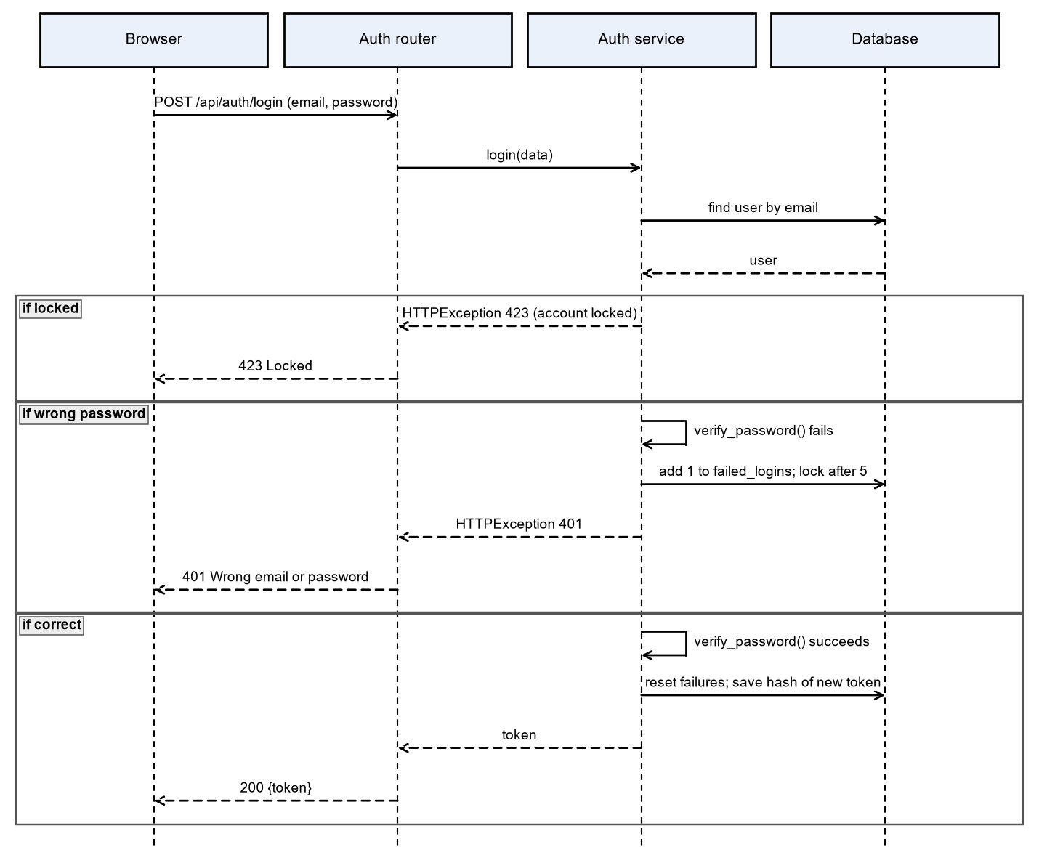
Figure 3: Sequence diagram for logging in
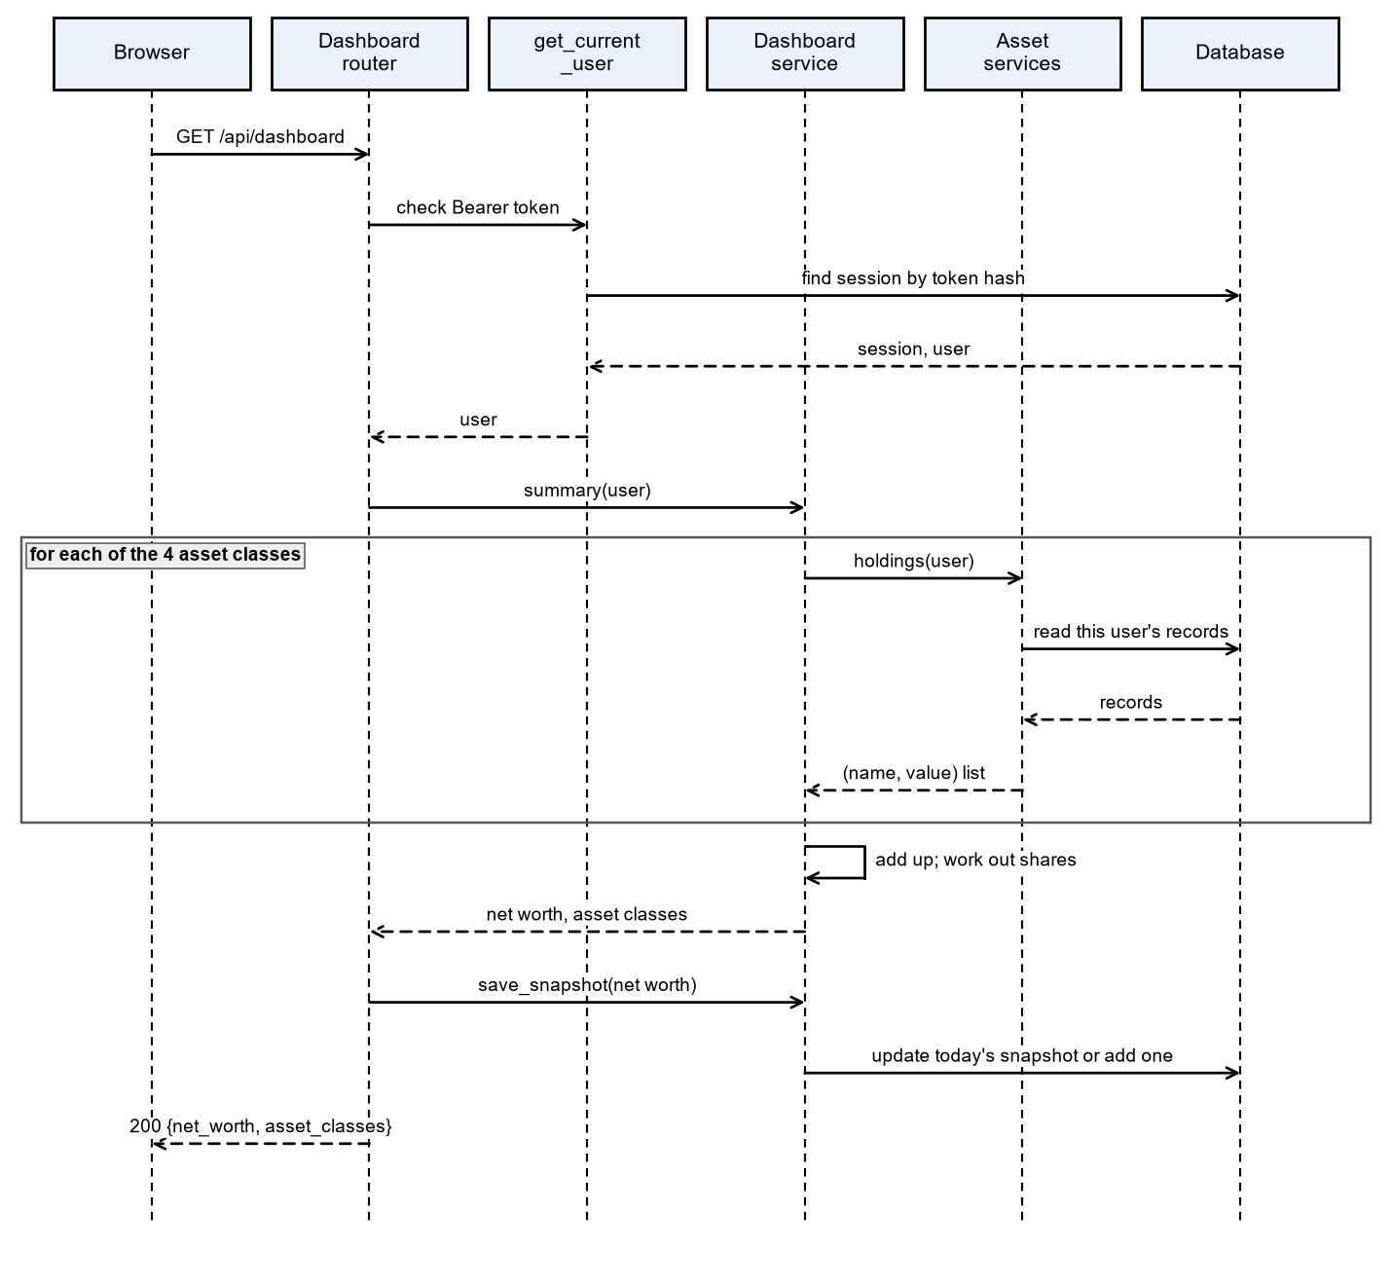
Figure 4: Sequence diagram for viewing the dashboard

4.3 API Design
All endpoints use JSON and require a valid Bearer token unless marked public. Live documentation is served at /docs. Every asset endpoint can also return 401 (not logged in), 404 (not found or not yours) and 422 (invalid input).
Method | Path | Purpose | Success
POST | /api/auth/register | Create an account (public) | 201
POST | /api/auth/login | Log in and get a token (public) | 200
POST | /api/auth/logout | End this session | 204
GET | /api/auth/me | Current user | 200
GET, POST | /api/real-estate | List or add properties | 200, 201
PUT, DELETE | /api/real-estate/{id} | Edit or delete a property | 200, 204
GET, POST | /api/gold | List or add gold holdings | 200, 201
PUT, DELETE | /api/gold/{id} | Edit or delete a holding | 200, 204
GET, PUT | /api/gold/price | Read or set the price per gram of 24K gold | 200
GET, POST | /api/stocks | List or add stock holdings | 200, 201
PUT, DELETE | /api/stocks/{id} | Edit or delete a holding | 200, 204
PUT | /api/stocks/{id}/price | Update a holding's current price | 200
GET, POST | /api/cash | List or add cash accounts | 200, 201
DELETE | /api/cash/{id} | Delete an account and its history | 204
GET, POST | /api/cash/{id}/transactions | History, or record a deposit or withdrawal | 200, 201
GET | /api/dashboard | Net worth and allocation; saves today's snapshot | 200
GET | /api/dashboard/history | Net-worth snapshots, oldest first | 200
GET | /api/dashboard/export.csv | Download holdings as CSV | 200
GET | /api/admin/users | List users (admin only) | 200
POST | /api/admin/users/{id}/deactivate | Deactivate a user (admin only) | 200
POST | /api/admin/users/{id}/reactivate | Reactivate a user (admin only) | 200
GET | /health | Service status (public) | 200
Auth component
Endpoint: /api/auth/login
Method: POST
Request: {email, password}
Response: {token}
Errors: 401 Wrong email or password, 403 Account deactivated, 423 Account locked, 422 Invalid input.
Cash component
Endpoint: /api/cash/{id}/transactions
Method: POST
Request: {type: deposit or withdrawal, amount, note}
Response: {id, type, amount, note, created_at}
Errors: 400 Withdrawal is more than the balance, 401 Not logged in, 404 Not found or not yours, 422 Invalid input.
Dashboard component
Endpoint: /api/dashboard
Method: GET
Request: none (Bearer token only)
Response: {net_worth, asset_classes: [{name, value, percent}]}
Errors: 401 Not logged in.

4.4 Error Handling, Logging & Monitoring
Errors use standard HTTP status codes with a JSON detail message, and messages never reveal whether another user's record exists. The pwm.audit log records lockouts and account changes. Passwords and tokens are never logged. GET /health supports monitoring and is checked by the CD pipeline before an image is published.

4.5 UX Design
Pages adapt from phones to desktops, using one shared navigation bar. Amounts use the Indian format (for example ₹1,00,000.00). Forms show validation errors next to the field, gains show a + sign, and a delete always asks for confirmation.

4.6 Open Issues & Next Steps
Future enhancements: live gold and stock prices, general API rate limiting, password reset by email, safer token storage in HTTP-only cookies, and database migrations with Alembic.

5. Appendices
5.1 Glossary: ADR, API, CI/CD, CSV, ORM, REST, STRIDE, TLS.
5.2 References: IEEE 42010, OWASP Top 10, FastAPI documentation, SRS v1.0.
5.3 Tools: Python and matplotlib (diagrams), Swagger UI (API documentation).

