Software Requirements Specification (SRS)

Project: Personal Wealth Management Software
Version: 1.0
Authors: Dhyan Rao, Dhruvagouda Patil, Hanshal Nagesh, Jayant Mahishi (Team 5, Section B)
Date: 05-11-2026
Status: Draft

Revision history
Version | Date | Author | Change summary | Approval
1.0 | 05-11-2026 | Team 5 | Initial SRS with diagrams embedded

Approvals
Role | Name | Signature / Email | Date
Course Coordinator

Table of Contents
1. Introduction
2. Overall description
3. External interfaces
4. System features (detailed)
5. Non-functional requirements (detailed)
6. Quality attributes & Acceptance tests
7. UML Use-Case Diagram
8. Requirements Traceability Matrix (RTM)

1. Introduction

1.1 Purpose
This document is a Software Requirements Specification (SRS) for the Personal Wealth Management Software. It defines the functional and non-functional requirements, interfaces and verification criteria that the team will use to build and test the application.

1.2 Scope
The application lets a person record what they own in four asset classes (real estate, gold, stocks and cash), keep the current value of each up to date, and see their total net worth in one place. It covers user accounts, asset records, valuation, a dashboard, CSV export and basic user administration. It excludes live market price feeds, links to banks or brokers, buying or selling assets, tax calculation and investment advice.

1.3 Audience
Developers, QA engineers, the project team, the course TA and assessment evaluators.

1.4 Definitions
API, CI/CD, CSV, FR, INR, JSON, NFR, REST, RTM, TLS, UI. Asset class: real estate, gold, stocks or cash. Holding: one recorded asset within a class. Net worth: the total current value of all of a user's holdings.

2. Overall description

2.1 Product perspective
The product is a standalone web application. A browser front end talks to a FastAPI back end, which stores data in a SQLite database. It does not connect to banks, brokers or stock exchanges; all values and prices are entered by the user.

2.2 Major product functions (detailed)
- Register, log in and log out
- Record and maintain real estate properties
- Record and maintain gold holdings, valued from a user-set gold price
- Record and maintain stock holdings, valued from user-set stock prices
- Record cash accounts, deposits and withdrawals
- Show total net worth and allocation across asset classes on a dashboard
- Keep a daily net-worth history
- Export holdings as a CSV file
- Administer user accounts

2.3 User roles and characteristics (expanded)
- User: an individual tracking their own assets; basic computer skills, no finance training needed.
- Administrator: manages user accounts; cannot see any user's financial records.

2.4 Operating environment
Server: Python 3.12 on Windows, macOS or Linux, with a SQLite database file. Client: a current version of Chrome, Edge or Firefox on a laptop, desktop or phone.

2.5 Constraints
Built by a four-person team in two one-week sprints. The stack is fixed as FastAPI, SQLAlchemy and SQLite, with plain HTML, CSS and JavaScript. All amounts are in Indian Rupees (INR). Prices are entered manually because no market data service is used. The product stores no bank passwords, card numbers or broker credentials.

3. External interface requirements

3.1 User interfaces
Web pages for login and registration, a dashboard, one page per asset class and an admin page for user accounts. Forms show validation errors next to the field concerned, and pages adapt to phone-sized screens.

3.2 Hardware interfaces
- No dedicated hardware is required.
- Any device with a current web browser can be used.

3.3 Software interfaces
- Browser to back end: REST API with JSON request and response bodies.
- Back end to database: SQLAlchemy ORM over SQLite.
- Interactive API documentation generated by FastAPI at /docs.
- GitHub Actions runs linting and automated tests on every push and pull request.

3.4 Communications
- HTTP on localhost during development; HTTPS with TLS 1.2+ whenever deployed.
- A session token is sent with every request to a protected endpoint.

4. System features (detailed)
Each requirement below includes acceptance criteria and a reference test case. IDs follow PWM-F-###.

4.1 User Accounts and Authentication
Description: Let people create an account, sign in and sign out, so that each person's records stay private to them.
Req ID | Requirement | Type | Priority | Source/Stakeholder | Acceptance criteria / Test case ref | Comments / Dependencies
PWM-F-001 | The system shall let a new user register with a name, a unique email address and a password. | Functional | High | End user | AC-PWM-F-001: Valid details create an account; a duplicate email is rejected with an error. Test: TC-Auth-01 | See PWM-SR-001
PWM-F-002 | The system shall log in a registered user with their email and password and start a session. | Functional | High | End user | AC-PWM-F-002: Correct details return a session token; wrong details return 401 with a generic message. Test: TC-Auth-02 | Depends on PWM-F-001
PWM-F-003 | The system shall end a session on logout and expire any session 60 minutes after login. | Functional | High | Security | AC-PWM-F-003: After logout or expiry, protected endpoints return 401 for that token. Test: TC-Auth-03 | Depends on PWM-F-002

4.2 Real Estate
Description: Record properties the user owns and track how their value has changed since purchase.
Req ID | Requirement | Type | Priority | Source/Stakeholder | Acceptance criteria / Test case ref | Comments / Dependencies
PWM-F-010 | The system shall let a user add a property with its name, type (residential, commercial or land), location, purchase date, purchase price and current value. | Functional | High | End user | AC-PWM-F-010: A valid property is saved and listed; a missing field or negative amount is rejected. Test: TC-RE-01 | Requires login
PWM-F-011 | The system shall let a user view, edit and delete their properties. | Functional | High | End user | AC-PWM-F-011: Edits appear in the list and a deleted property no longer appears. Test: TC-RE-02 | Depends on PWM-F-010
PWM-F-012 | The system shall show the gain or loss on each property as current value minus purchase price, in rupees and as a percentage. | Functional | Medium | End user | AC-PWM-F-012: A property bought at ₹50,00,000 and now worth ₹60,00,000 shows a gain of ₹10,00,000 (20.00%). Test: TC-RE-03 | Depends on PWM-F-010

4.3 Gold
Description: Record gold by weight and purity, and value it from a gold price that the user keeps up to date.
Req ID | Requirement | Type | Priority | Source/Stakeholder | Acceptance criteria / Test case ref | Comments / Dependencies
PWM-F-020 | The system shall let a user add a gold holding with its description, form (coin, bar, jewellery or digital), weight in grams, purity (24K, 22K or 18K), purchase date and purchase price. | Functional | High | End user | AC-PWM-F-020: A valid holding is saved and listed; a zero or negative weight is rejected. Test: TC-Gold-01 | Requires login
PWM-F-021 | The system shall let a user view, edit and delete their gold holdings. | Functional | High | End user | AC-PWM-F-021: Edits appear in the list and a deleted holding no longer appears. Test: TC-Gold-02 | Depends on PWM-F-020
PWM-F-022 | The system shall let a user set the current price per gram of 24K gold and value each holding as weight × (purity ÷ 24) × price. | Functional | High | End user | AC-PWM-F-022: 10 g of 22K gold at ₹10,000 per gram is valued at ₹91,666.67. Test: TC-Gold-03 | Valued at purchase price until a gold price is set

4.4 Stocks
Description: Record shares held on Indian exchanges and value them from prices that the user keeps up to date.
Req ID | Requirement | Type | Priority | Source/Stakeholder | Acceptance criteria / Test case ref | Comments / Dependencies
PWM-F-030 | The system shall let a user add a stock holding with its symbol, company name, exchange (NSE or BSE), quantity and average buy price. | Functional | High | End user | AC-PWM-F-030: A valid holding is saved and listed; a zero or negative quantity is rejected. Test: TC-Stock-01 | Requires login
PWM-F-031 | The system shall let a user view, edit and delete their stock holdings. | Functional | High | End user | AC-PWM-F-031: Edits appear in the list and a deleted holding no longer appears. Test: TC-Stock-02 | Depends on PWM-F-030
PWM-F-032 | The system shall let a user update the current price of a stock, value the holding as quantity × price, and show its gain or loss. | Functional | High | End user | AC-PWM-F-032: 10 shares bought at ₹100 with a current price of ₹120 show a value of ₹1,200 and a gain of ₹200 (20.00%). Test: TC-Stock-03 | Valued at buy price until a current price is set

4.5 Cash
Description: Track money held as cash or in accounts, including money moving in and out.
Req ID | Requirement | Type | Priority | Source/Stakeholder | Acceptance criteria / Test case ref | Comments / Dependencies
PWM-F-040 | The system shall let a user add a cash account with its name, type (cash in hand, bank account or wallet) and opening balance. | Functional | High | End user | AC-PWM-F-040: A valid account is saved and listed; a negative opening balance is rejected. Test: TC-Cash-01 | Requires login
PWM-F-041 | The system shall let a user record a deposit or withdrawal against a cash account and update its balance. | Functional | High | End user | AC-PWM-F-041: A ₹500 deposit raises the balance by ₹500; a withdrawal above the balance is rejected and the balance is unchanged. Test: TC-Cash-02 | Depends on PWM-F-040
PWM-F-042 | The system shall show the transaction history of a cash account, newest first. | Functional | Medium | End user | AC-PWM-F-042: Recorded transactions appear with date, type and amount, newest first. Test: TC-Cash-03 | Depends on PWM-F-041

4.6 Dashboard and Reports
Description: Bring all asset classes together so the user can see their overall position and how it changes over time.
Req ID | Requirement | Type | Priority | Source/Stakeholder | Acceptance criteria / Test case ref | Comments / Dependencies
PWM-F-050 | The system shall show the user's total net worth as the sum of the current values of all their holdings. | Functional | High | End user | AC-PWM-F-050: The total equals real estate + gold + stocks + cash, to 2 decimal places. Test: TC-Dash-01 | Depends on PWM-F-010, 022, 032, 040
PWM-F-051 | The system shall show each asset class's share of net worth in rupees and as a percentage, with a chart. | Functional | High | End user | AC-PWM-F-051: The rupee amounts add up to net worth and the percentages add up to 100%. Test: TC-Dash-02 | Depends on PWM-F-050
PWM-F-052 | The system shall save at most one net-worth snapshot per day when the dashboard is opened, and show the snapshots as a history chart. | Functional | Medium | End user | AC-PWM-F-052: Opening the dashboard twice in a day leaves one snapshot for that date. Test: TC-Dash-03 | Depends on PWM-F-050
PWM-F-053 | The system shall let a user export all their holdings as a CSV file. | Functional | Low | End user | AC-PWM-F-053: The file has one row per holding with its asset class, name and current value. Test: TC-Dash-04 | Includes only the user's own data

4.7 Administration
Description: Let an administrator manage who can use the system, without giving them access to anyone's financial records.
Req ID | Requirement | Type | Priority | Source/Stakeholder | Acceptance criteria / Test case ref | Comments / Dependencies
PWM-F-060 | The system shall let an administrator view the list of registered users with their name, email and account status. | Functional | Medium | Administrator | AC-PWM-F-060: The list shows all users and no financial data. Test: TC-Admin-01 | Admin only; see PWM-SR-002
PWM-F-061 | The system shall let an administrator deactivate and reactivate a user account. | Functional | Medium | Administrator | AC-PWM-F-061: A deactivated user cannot log in; once reactivated, they can. Each change is logged. Test: TC-Admin-02 | Depends on PWM-F-060

5. Non-functional requirements (detailed)
NFRs below are measurable and tied to test plans. IDs PWM-NF-###.
Req ID | Requirement | Category | Priority | Acceptance criteria / Measurement
PWM-NF-001 | 95% of API requests shall complete within 500 ms with 1,000 stored holdings. | Performance | High | 95th percentile ≤ 500 ms in a load test. Test: TC-Perf-01
PWM-NF-002 | Saved data shall survive an application restart, and a failed save shall leave no partial record. | Reliability | High | All records are intact after a restart; a forced failure leaves the database unchanged. Test: TC-Rel-01
PWM-NF-003 | All money amounts shall be stored and calculated as exact decimals and shown to 2 decimal places. | Accuracy | High | Calculated values match worked examples exactly, with no floating-point rounding errors. Test: TC-Calc-01
PWM-NF-004 | A first-time user shall be able to register and add a holding within 3 minutes without help, and all pages shall be usable at 360 px width. | Usability | Medium | Observed with 3 test users; pages checked at 360 px width. Test: TC-UX-01
PWM-NF-005 | Automated tests shall cover at least 70% of the application code, and every pull request shall pass linting and tests in CI before merging. | Maintainability | High | CI coverage report shows ≥ 70%; main requires a passing check. Test: TC-Maint-01
PWM-NF-006 | The application shall run on Windows, macOS and Linux with Python 3.11 or later. | Portability | Medium | The README setup steps succeed on Windows and on the Linux CI runner. Test: TC-Port-01

5.1. Security

5.1.1 Security Objectives
SO-1 Confidentiality: a user's financial records can be seen only by that user.
SO-2 Integrity: financial records can be changed only by their owner, through validated requests.
SO-3 Accountability: account lockouts and account deactivations are logged so that misuse can be investigated.

5.1.2 Security Requirements
Req ID | Requirement (shall...) | Type | Priority | Acceptance criteria / Test case ref
PWM-SR-001 | Passwords shall be stored only as salted hashes, never as plain text. | Security | High | The stored value is a salted hash, and two users with one password have different hashes. Test: TC-Sec-01
PWM-SR-002 | All endpoints except register, login and health shall require a valid session, and admin endpoints shall also require the admin role. | Security | High | No session returns 401; a non-admin calling an admin endpoint returns 403. Test: TC-Sec-02
PWM-SR-003 | A user shall be able to read or change only their own records. | Security | High | Requesting another user's record returns 404 and reveals nothing. Test: TC-Sec-03
PWM-SR-004 | An account shall be locked for 15 minutes after 5 consecutive failed logins, and the event shall be logged. | Security | High | The sixth attempt is refused even with the correct password, and a log entry exists. Test: TC-Sec-04
PWM-SR-005 | All input shall be validated on the server, and database access shall use parameterised queries. | Security | High | Invalid input returns 422; SQL injection and script payloads have no effect. Test: TC-Sec-05
PWM-SR-006 | Passwords and session tokens shall never be written to logs. | Security | High | A review of logs from a full test run finds no passwords or tokens. Test: TC-Sec-06
PWM-SR-007 | TLS 1.2+ shall be mandatory for all network connections when deployed. | Security | High | Plain HTTP requests to a deployed instance are refused or redirected to HTTPS. Test: TC-Sec-07

6. Quality attributes & Acceptance tests
- Exit criteria for acceptance: All high-priority functional requirements implemented and verified, no critical NFR failures, and RTM shows all test cases passed.
- Acceptance test suites: Authentication, Real Estate, Gold, Stocks, Cash, Dashboard, Administration, Performance, Security and Usability tests.

7. System models and diagrams

7.1 UML Use-Case diagram
The two UML use-case diagrams below show who uses the system and what they can do. An Administrator is also a User, so they can log in and log out in the same way.
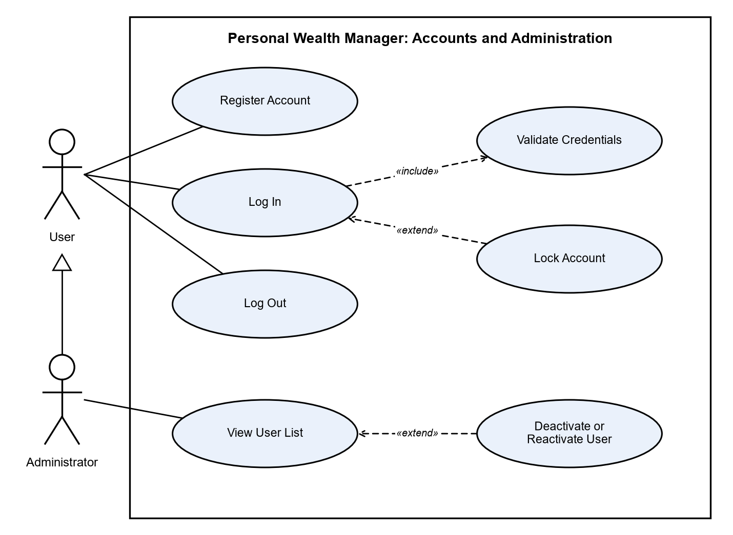
Figure 1: Use cases for accounts and administration
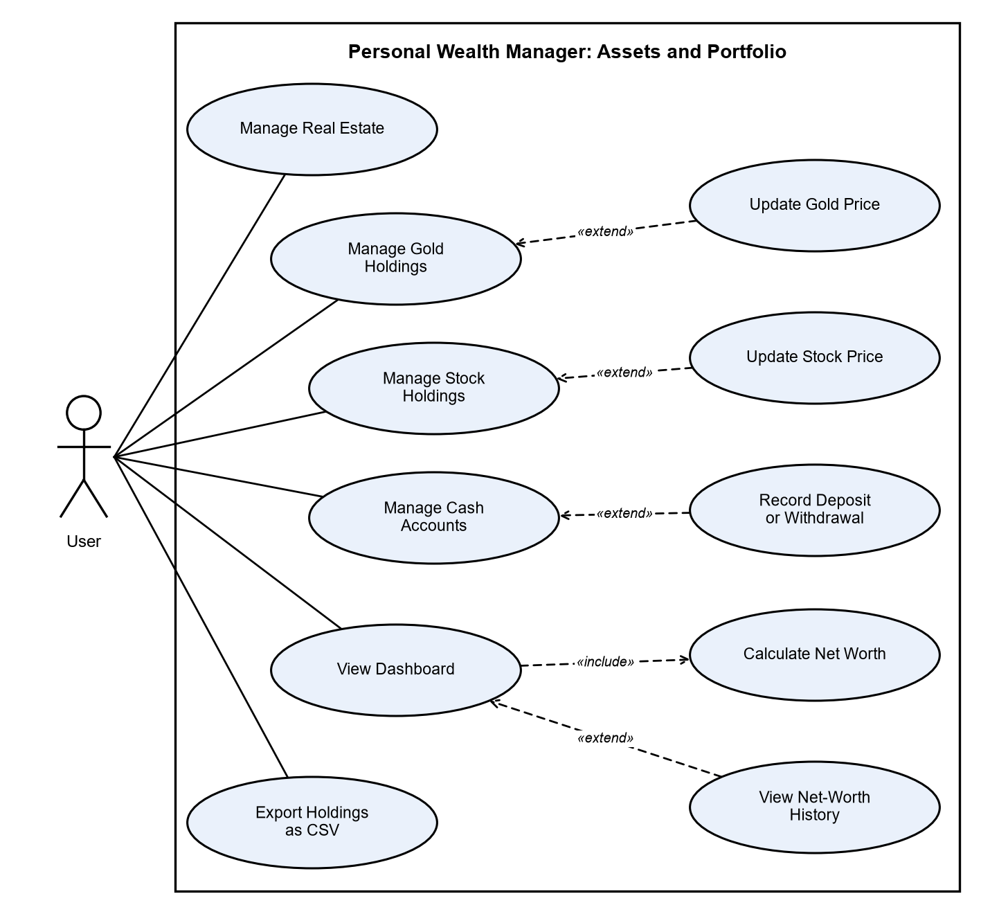
Figure 2: Use cases for assets and portfolio

8. Requirements Traceability Matrix (RTM)
Req ID | Requirement short | Section ref / Design Spec | Module | Test case(s) | Status (N/P/A) | Comments
PWM-F-001 | Register account | 4.1 / DS-Auth-01 | AuthModule | TC-Auth-01 | N
PWM-F-002 | Log in | 4.1 / DS-Auth-01 | AuthModule | TC-Auth-02 | N
PWM-F-003 | Log out and session expiry | 4.1 / DS-Auth-01 | AuthModule | TC-Auth-03 | N
PWM-F-010 | Add property | 4.2 / DS-RE-01 | RealEstateModule | TC-RE-01 | N
PWM-F-011 | View, edit, delete property | 4.2 / DS-RE-01 | RealEstateModule | TC-RE-02 | N
PWM-F-012 | Property gain or loss | 4.2 / DS-RE-01 | RealEstateModule | TC-RE-03 | N
PWM-F-020 | Add gold holding | 4.3 / DS-Gold-01 | GoldModule | TC-Gold-01 | N
PWM-F-021 | View, edit, delete gold | 4.3 / DS-Gold-01 | GoldModule | TC-Gold-02 | N
PWM-F-022 | Gold valuation | 4.3 / DS-Gold-01 | GoldModule | TC-Gold-03 | N
PWM-F-030 | Add stock holding | 4.4 / DS-Stock-01 | StockModule | TC-Stock-01 | N
PWM-F-031 | View, edit, delete stock | 4.4 / DS-Stock-01 | StockModule | TC-Stock-02 | N
PWM-F-032 | Stock valuation | 4.4 / DS-Stock-01 | StockModule | TC-Stock-03 | N
PWM-F-040 | Add cash account | 4.5 / DS-Cash-01 | CashModule | TC-Cash-01 | N
PWM-F-041 | Deposit and withdrawal | 4.5 / DS-Cash-01 | CashModule | TC-Cash-02 | N
PWM-F-042 | Transaction history | 4.5 / DS-Cash-01 | CashModule | TC-Cash-03 | N
PWM-F-050 | Net worth total | 4.6 / DS-Dash-01 | DashboardModule | TC-Dash-01 | N
PWM-F-051 | Asset allocation | 4.6 / DS-Dash-01 | DashboardModule | TC-Dash-02 | N
PWM-F-052 | Net-worth history | 4.6 / DS-Dash-01 | DashboardModule | TC-Dash-03 | N
PWM-F-053 | CSV export | 4.6 / DS-Dash-01 | DashboardModule | TC-Dash-04 | N
PWM-F-060 | View user list | 4.7 / DS-Admin-01 | AdminModule | TC-Admin-01 | N
PWM-F-061 | Deactivate or reactivate user | 4.7 / DS-Admin-01 | AdminModule | TC-Admin-02 | N
PWM-NF-001 | Response time target | 5 / DS-Perf-01 | WebUI / API | TC-Perf-01 | N
PWM-NF-002 | Data durability | 5 / DS-Data-01 | Database | TC-Rel-01 | N
PWM-NF-003 | Money accuracy | 5 / DS-Calc-01 | Services | TC-Calc-01 | N
PWM-NF-004 | Ease of use | 5 / DS-UX-01 | WebUI | TC-UX-01 | N
PWM-NF-005 | Test coverage and CI | 5 / DS-CI-01 | CI pipeline | TC-Maint-01 | N
PWM-NF-006 | Cross-platform support | 5 / DS-Deploy-01 | All | TC-Port-01 | N
PWM-SR-001 | Password hashing | 5.1.2 / DS-Sec-01 | AuthModule | TC-Sec-01 | N
PWM-SR-002 | Access control | 5.1.2 / DS-Sec-01 | All routers | TC-Sec-02 | N
PWM-SR-003 | Data isolation | 5.1.2 / DS-Sec-01 | All routers | TC-Sec-03 | N
PWM-SR-004 | Account lockout | 5.1.2 / DS-Sec-01 | AuthModule | TC-Sec-04 | N
PWM-SR-005 | Input validation | 5.1.2 / DS-Sec-01 | All routers | TC-Sec-05 | N
PWM-SR-006 | No secrets in logs | 5.1.2 / DS-Sec-01 | All modules | TC-Sec-06 | N
PWM-SR-007 | TLS when deployed | 5.1.2 / DS-Sec-01 | Deployment | TC-Sec-07 | N

