**Software Requirements Specification**

**1. Introduction**

# a. Background

* **Objective**

The only objective of this project is to make restaurant management easier, error less and automated.

* **Future scope of the project includes following:** 
  1. *Customer order:* Where customer them self can order their food directly by their device.
  2. *Restaurant analytics:* Where restaurant admin can analyse the restaurant growth with chart , best selling item, best selling category etc.
  3. *Hall booking and payment:* Where customer can book party hall and make advance payment from there. Also can select menu items for party.
* **Application / Motivation:**

In the existing system restaurant can be mange mush easier and error less. This uses less men power so it might be business efficient too. It makes work easier with less communication and no misunderstanding.

# b. Overview

The project is a dynemic website which includes a database connectivity that has been built by using HTML, JavaScript, CSS, and PHP.

It basically a restaurant management website which helps to manage restaurant mor efficient , easier, error less it contains admin page that is help full to do this tasks.

**Requirements**

* + Website should be built such that brand name must be promoted.
  + Waiters should be able to take orders.
  + Cook should be able to see order list to cook.
  + Waiter should be able to track order status to serve food on time.
  + A minimal sell analytics panel for admin
  + Admin can see list of staff member
  + Admin should be able to add or remove staff.
  + Admin must be see and update bill and bill status.

# Environmental Characteristics

* *Hardware requirements*
  + The development of this project requires a computer.
  + An internet connection.
* *Software requirements* 
  + Any latest browser
  + XAMPP software should be set-up
  + A code editor.

1. **Diagram:**
   1. **ER Diagram:** The diagram represents the tables queries in the database named rms with its attributes.

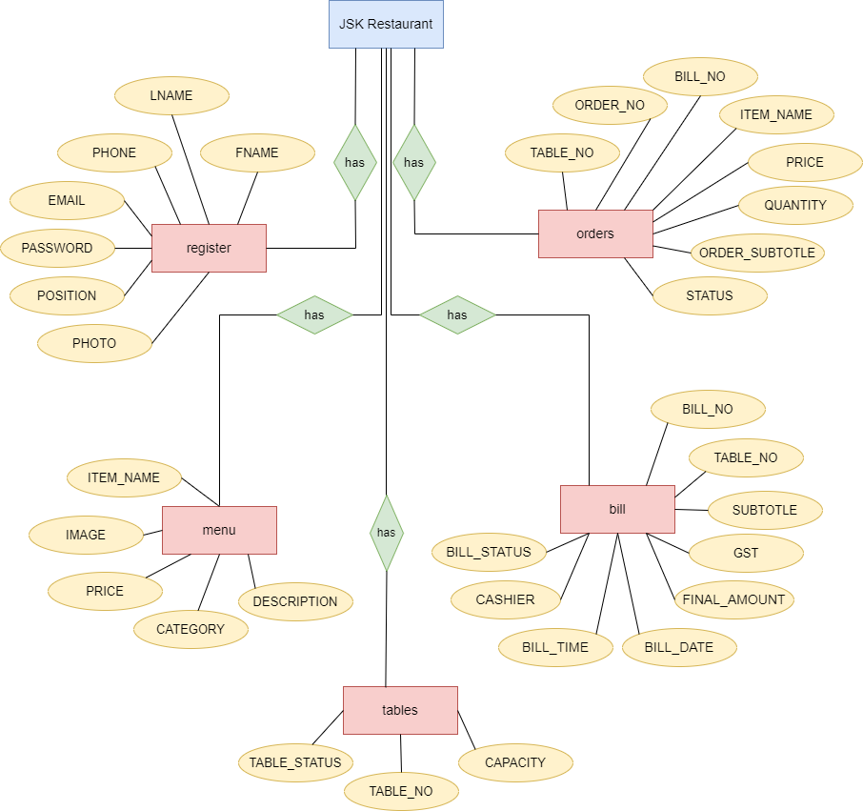

* 1. **Data Flow Diagram**

*Level 0:* Depicts the working of the system

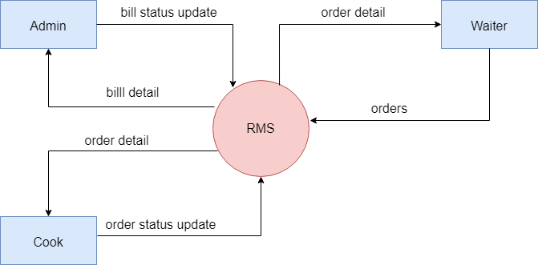

*Level 1(Admin):* Further elaboration of the process of Admin

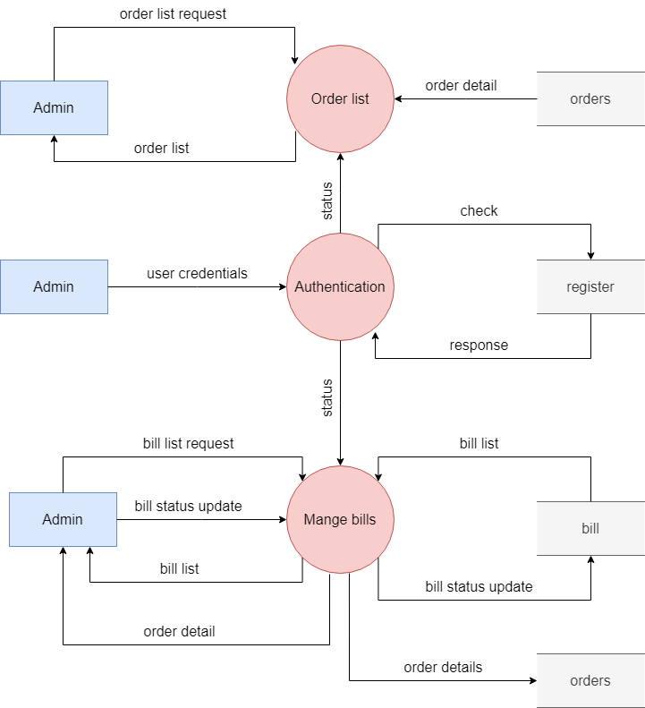

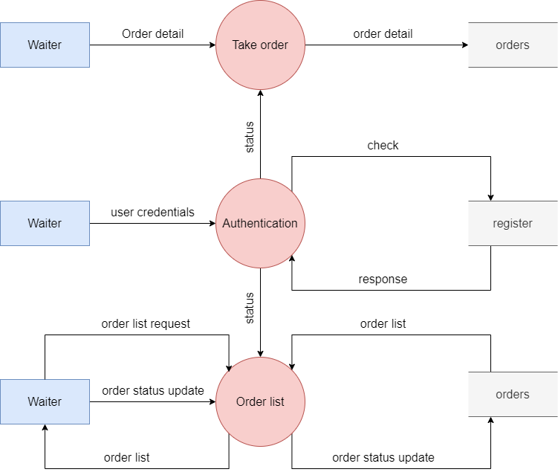 *Level 1(Waiter):* Further elaboration of the process of Waiter

*Level 1(Cook):* Further elaboration of the process of Cook

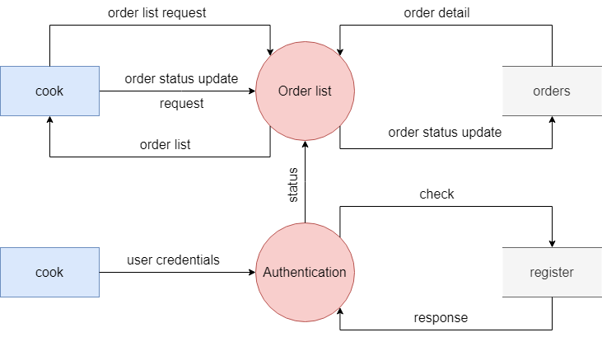

*Level 2(Admin):* Further more elaboration of the process of Admin

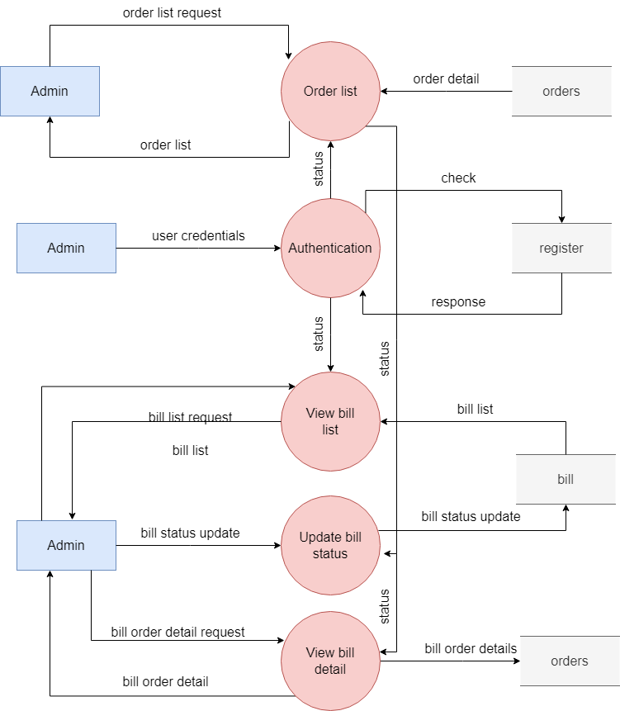

*Level 2(Waiter):* Further more elaboration of the process of Waiter

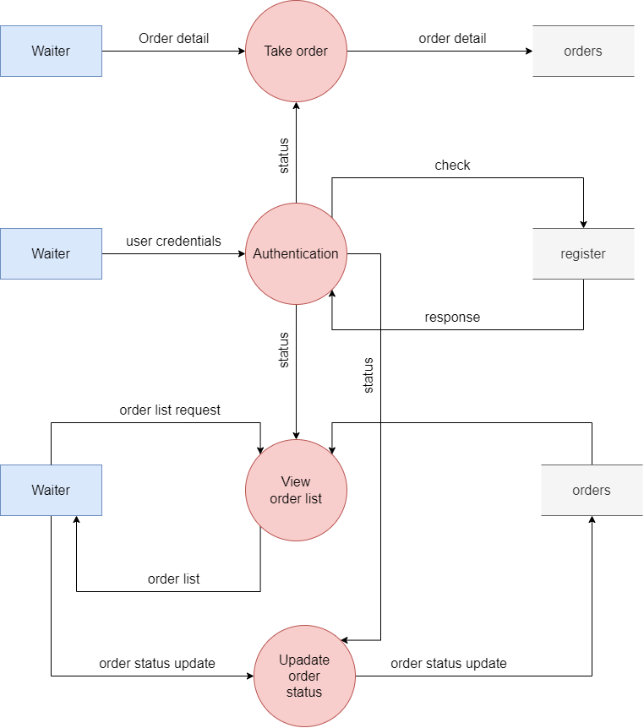

*Level 2(cook):* Further more elaboration of the process of Cook

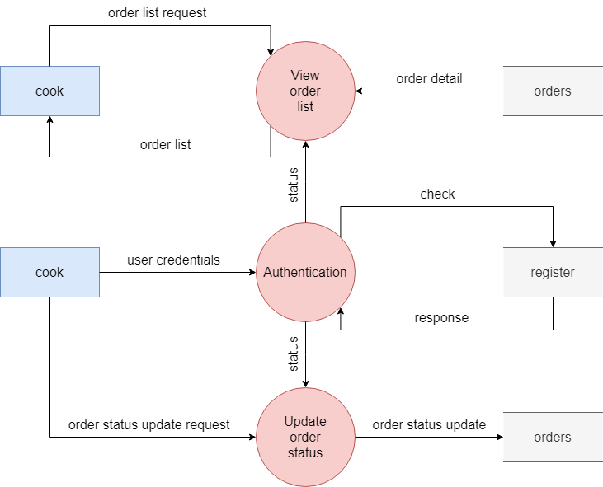

1. **Implementation Screenshots:**

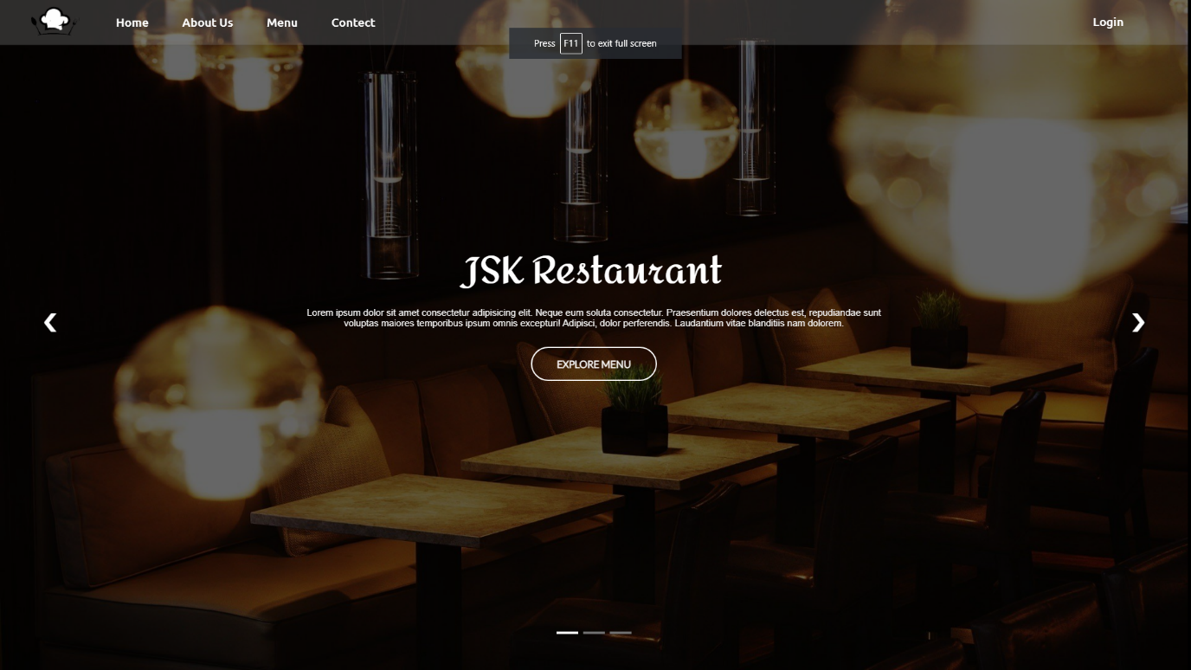

[Figure 1: Home of website]

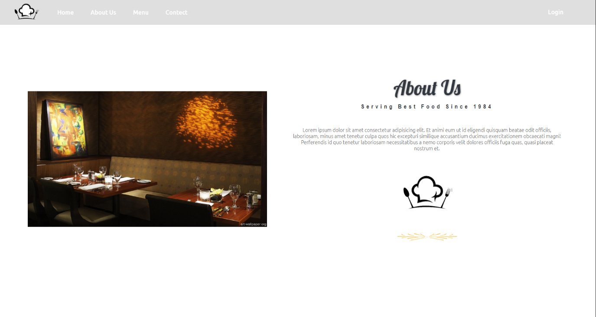

[Figure 2: About Us]

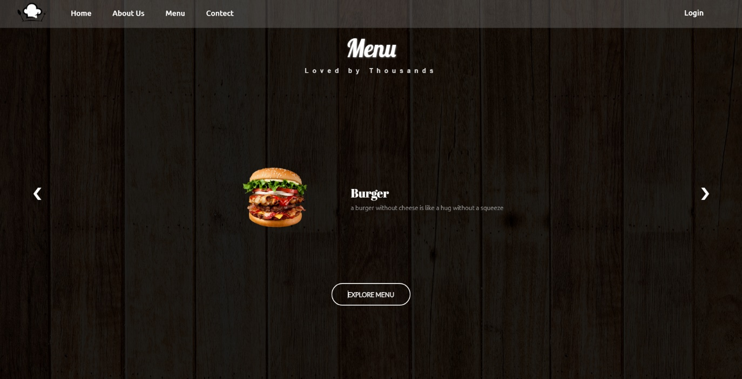

[Figure 3: Menu panel of website]

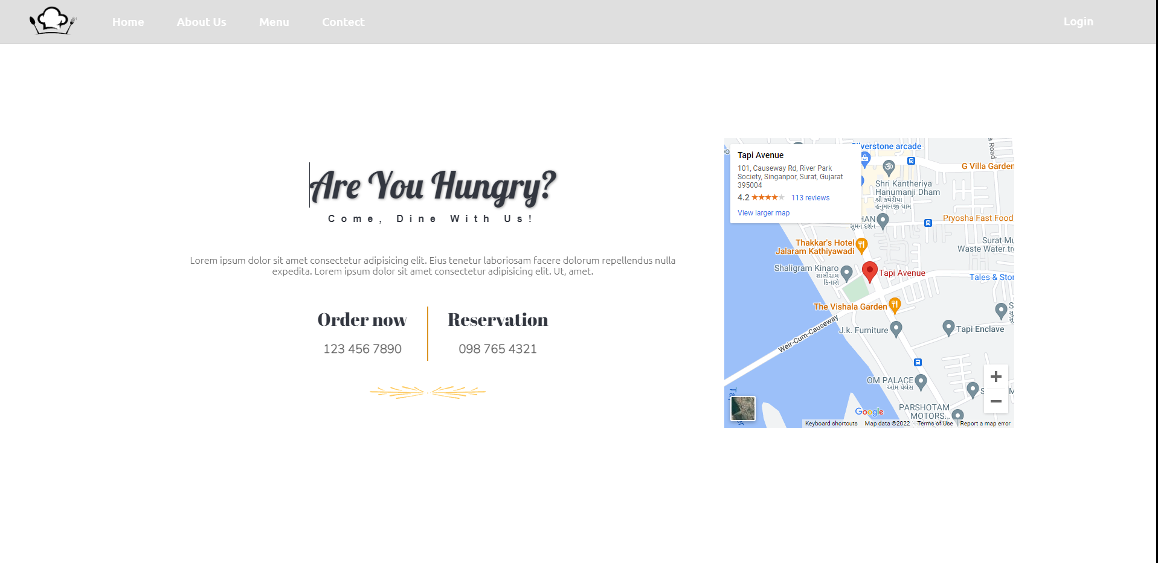

[Figure 4: Contact]

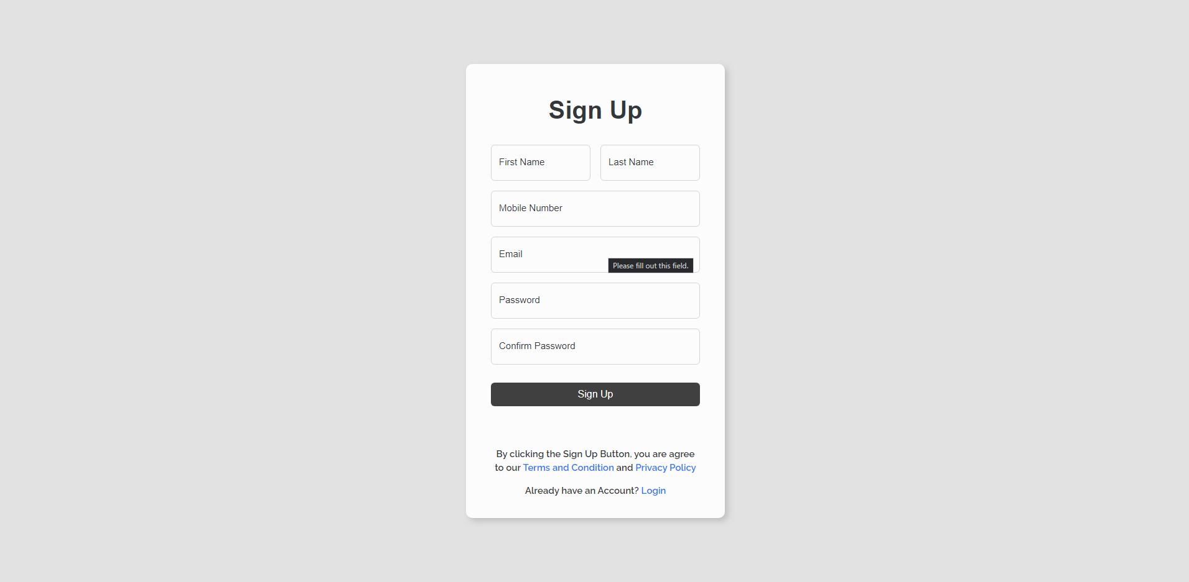

[Figure 5: Sign Up page]

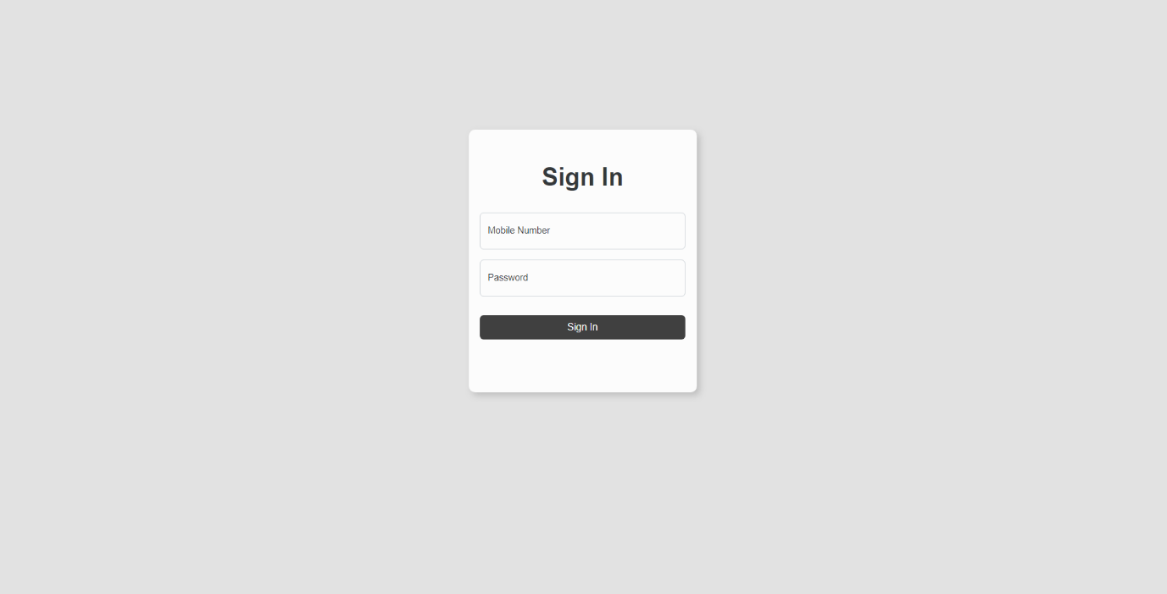

[Figure 6: Sign In page]

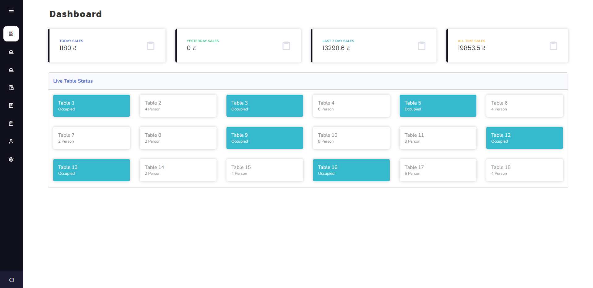

[Figure 7: Dashboard – Home]

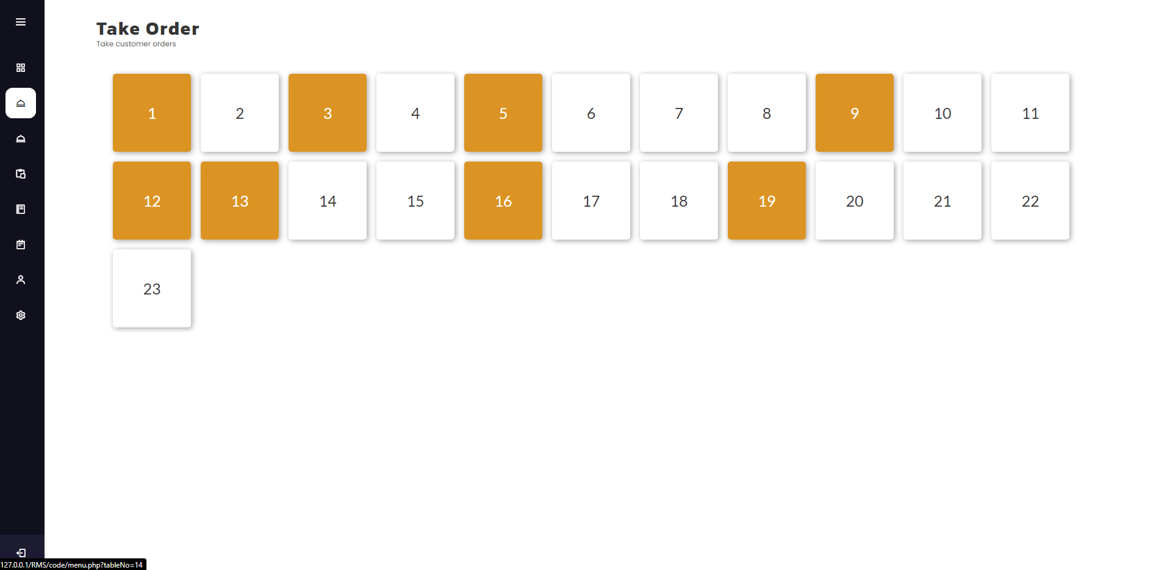 [Figure 8: Dashboard – Take Order]

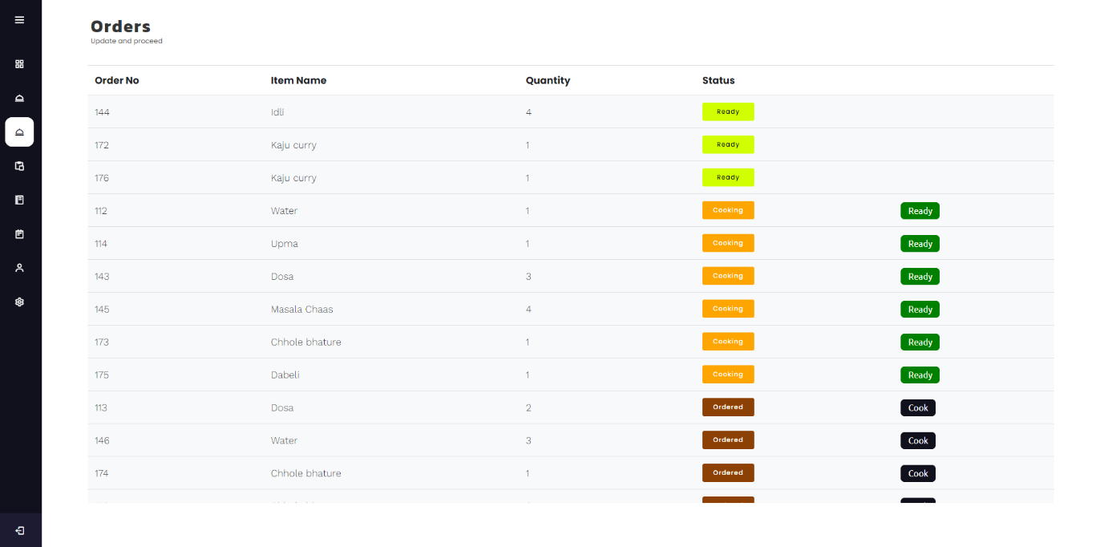 [Figure 7: Dashboard – Orders]

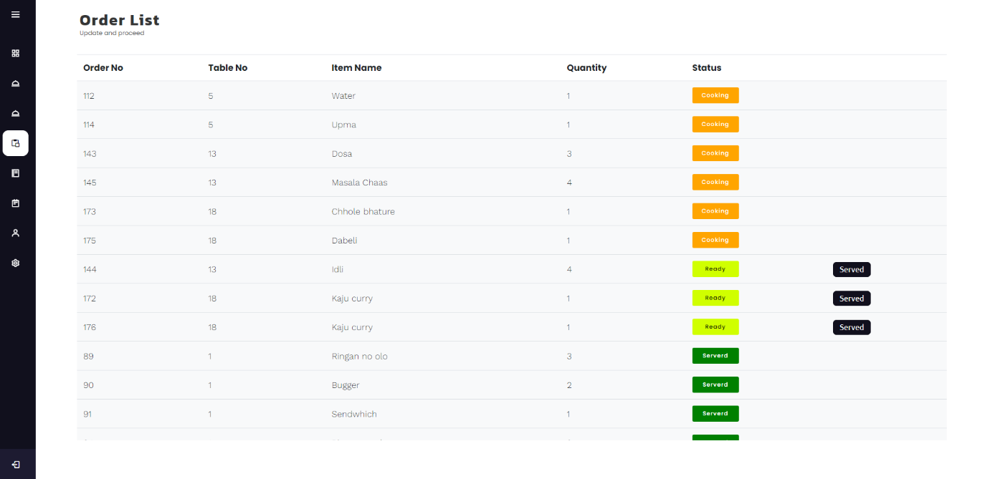

[Figure 7: Dashboard – Order List]

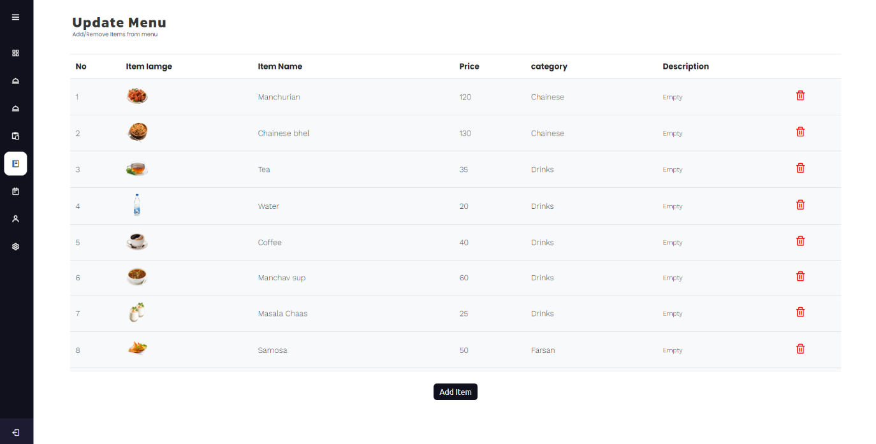

[Figure 7: Dashboard – Menu]

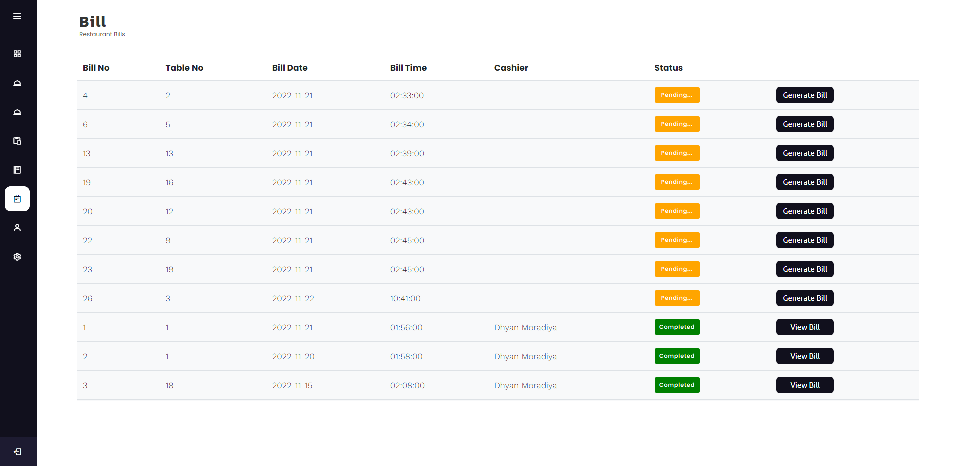 [Figure 7: Dashboard – Bill]

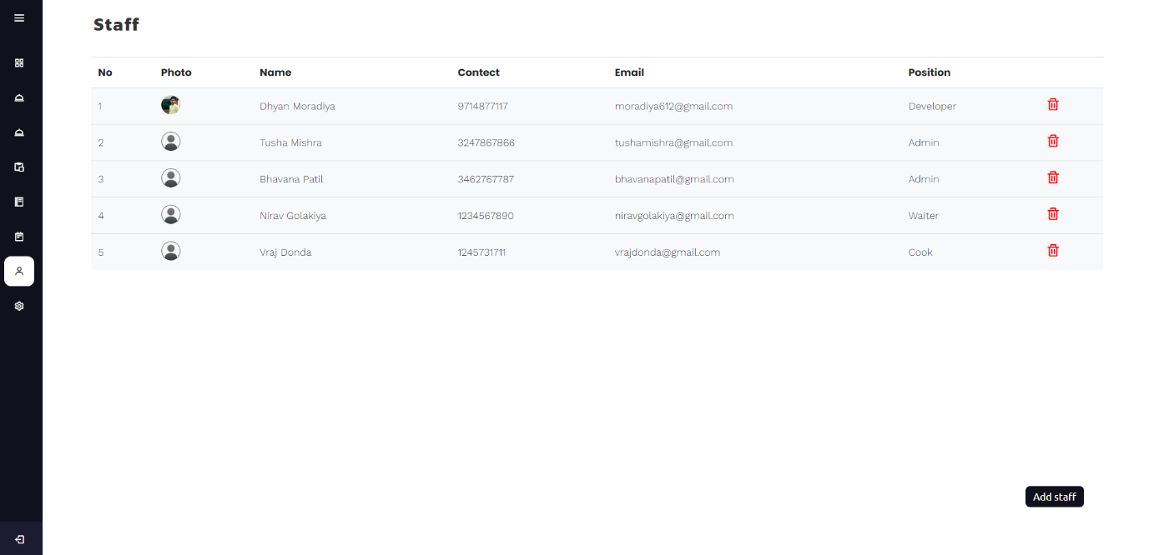

[Figure 7: Dashboard – Staff]

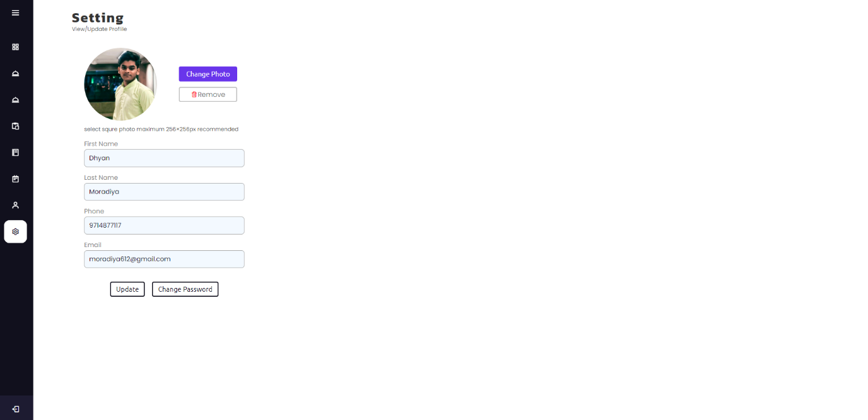

[Figure 7: Dashboard – Setting]