**Smart Kitchen**

**Introduction:**

Create a simulated smart kitchen system using Counterfit that connects to an MQTT broker. The system can monitor temperature, gas leaks, motion, and control appliances like lights and exhaust fans.

**Architecture:**

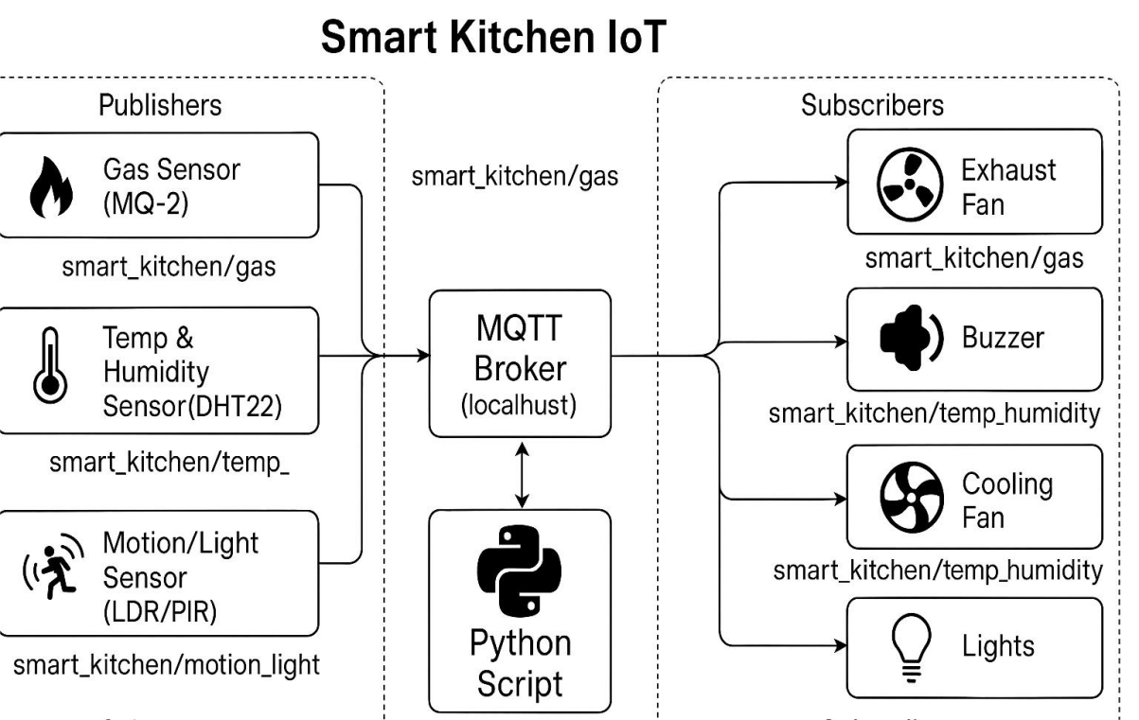

**Note:**

In python script the counterFit will be there.

**Features:**

**1. Gas Leak Detection (MQ-2 Sensor)**

What it does: Detects harmful gas (like LPG) in the kitchen.

**How it works:**

* Continuously reads gas concentration.
* If value exceeds a safe threshold:
* Sends an MQTT alert.
* Turns on exhaust fan (via relay).
* Optionally sounds a buzzer to warn users.

**2. Temperature Monitoring (DHT22 Sensor)**

What it does: Monitors temperature and humidity near the stove or oven.

**How it works:**

* Publishes regular temperature/humidity data to MQTT.
* If temperature crosses a limit (e.g., stove left on accidentally):
* Sends an alert over MQTT.
* Activates a cooling fan or buzzer.
* Prevents fire hazards or overheating.

**3. Smart Lights & Fan Control (LDR / PIR Sensor)**

What it does: Controls lights and fans based on movement and lighting.

**How it works:**

* Detects motion in the kitchen.
* Automatically turns on lights when someone enters.
* Turns off lights when no motion is detected after a delay.
* Publishes light/fan usage data to MQTT (optional).

**4. Central Python Controller**

What it does: Acts as the brain of the system.

**How it works:**

* Reads sensor data using Counterfit APIs.
* Decides actions based on logic (thresholds).
* Sends commands to actuators (fan, buzzer, lights).
* Publishes status updates to MQTT topic like smart_kitchen/status.

**5. MQTT Broker (Mosquitto)**

What it does: Enables communication between devices.

**How it works:**

* Collects data from sensors and sends it to subscribers (e.g., another service or logger).
* Allows you to monitor your kitchen remotely if needed in the future.

**Python Libraries:**

* time
* json
* random
* CounterFitConnection
* GroveGasSensor
* GroveDhtSensor
* GroveLightSensor
* GroveRelay
* Mqtt

**Name:Bachu Dhyaneswar Matriculation Number:30555400**