Question no 1.9

Date 30 – 7 – 2024

Question : program to find the third angle

Author : Dhyanjith p

Roll No : 13

Semester : 1

Programme : BCA

Question : program to find the third angle

int main()

{

int a,b,c,d; // variable to store int values

printf("enter the two angles");

scanf("%d%d",&a,&b); // reading two values from keyboard

c=a+b; //calculating third angle

d=180-c;

printf("the third angle is :%d",d); // displaying output

return 0;

INPUT

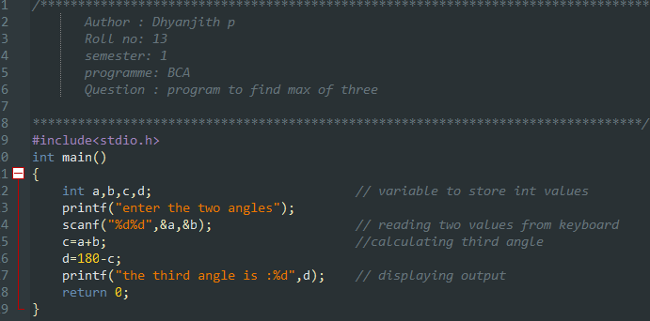

OUTPUT :

