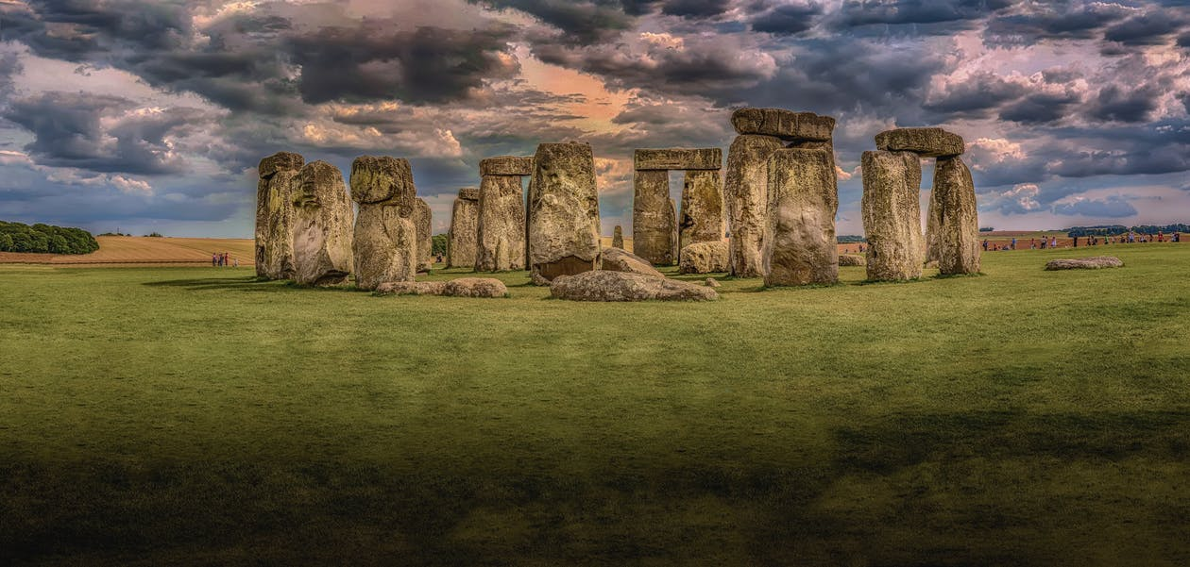

**Monument Travel**

**Assignment 2**

Involves the Physical Modelling of the Monument Travel Case Study.

Based on the same specification as repeated here …

*Specification:*

*Monument Travel offer a range of differing tours, itineraries are all pre-defined, no bespoke tours are offered. Each tour is given a name, a duration, and the standard cost of the tour. Each tour is guided. Guides are employed by the company and have an employee number. Other personal information is kept about the guides including their given and family names, home address, date of birth and date of hire. For insurance purposes the company also records the names of up to 2 next of kin for each employee. Some guides also act as supervisors to newly employed guides.*

*Each guide is encouraged to pass the qualification to lead different tours and each valid qualification passed by a guide needs to be recorded along with the date they achieved that qualification. New guides may or may not be qualified to lead any tours, just as a new tour may not have any guides qualified to lead it. Whilst the company strives to provide a qualified guide on all its tours, this is not always possible.*

*Each tour visits a sequence of locations, at least 3, and at most 10. Each location has a name, type, and description. The same location may be visited on a number of tours, but locations are only recorded if they are visited on at least one tour. The system also needs to record the sequence in which locations are visited on each tour.*

*Individual instances of each tour are called “Outings” by the company. These are scheduled well in advance so that they can be advertised, and employees are aware of their personal guiding schedule. A tour can have many scheduled outings, although a new tour may not have any outings scheduled. Each outing relates to a single defined tour starting on a particular date and time. Each outing must have a single guide assigned to it. Occasionally, guides will be asked to lead outings without passing the official qualification for that tour. Newly hired guides may not be scheduled to lead any outings. Tourists, called “clients” by the company book on outings, after they have registered their name, contact address and telephone number with Monument. Clients can book on any number of outings. Individual clients may also be eligible for a discount due to age, disability, etc. This will be reflected as a percentage and needs to be recorded in order to correctly charge those clients.*

… and the provided E-R solution here:

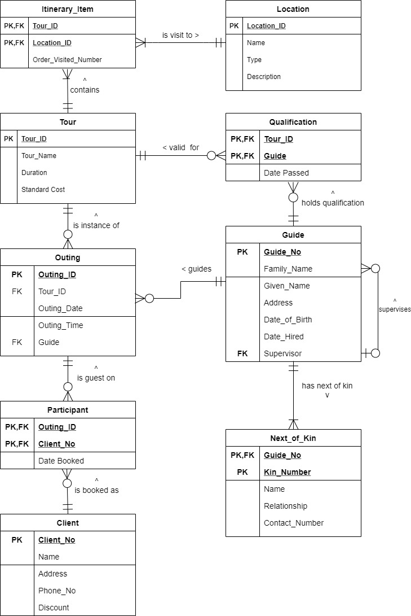

Figure 1 – Finalised E-R Diagram

Assignment 2

For assignment 2, you are required to undertake the following:

1. Write out the Relational Schema for each of the 9 entities detailed

* These should use the format as defined in this example (not taken from the specification) underlining the primary key attributes and marking the foreign key attributes with an asterisk.

Employee (Employee_Number, Name, Address, Department*)

* Use the same names for the Relational Schema statements as are specified in the E-R Diagram below (Figure 1).
* Do NOT add or remove any attributes, specifically, do NOT replace composite Primary Keys with a Simple Primary Key

1. Using your Oracle account, create the table structures as reflected in the E-R diagram below (Figure 1) and your Relational Schema

* Again, use the same names for the CREATE TABLE statements as are specified in the E-R Diagram these should not clash with any existing tables you have created so far, however, if you have created your own tables with the same name, rename them prior to starting this task.
* Ensure that you create encode the following:
* All attributes, labelled as specified in the E-R diagram (including underscores where used)
* Suitable datatypes with sensible sizes and lengths, and reflecting the nominal or quantitative nature of the attribute
* All PRIMARY KEY and FOREIGN KEY constraints
* Use NOT NULL constraints where appropriate
* Provide CHECK constraints where appropriate
* There are no UNIQUE constraints expected

Submission Requirements

Upload a PDF document to CANVAS, it should include:

* A title line including “Assignment 2” followed by your ORACLE USERNAME
* Your 9 Relational Schema statements (Task 1)
* Screenshots of the CREATE TABLE commands you used to create the final version of each of the 9 tables (Please do not capture the whole screen, just the worksheet window, and ensure the screen shots are READABLE in the final document) (Task 2)

Having created the tables in your ORACLE account, please ensure you do not drop them from your ORACLE account until the end of the module (18th January 2022).

Marking Schema

**Relational Schema:**

2 marks per correctly defined relational schema, maintaining entity and attribute names and utilising underscore and asterisk notation

**Create Table statements (considering each table)**

1 mark for conforming to table and attribute names

1 mark for each correct Primary Key specification

2 marks for each correct Foreign Key specification

3 marks for sensible datatype definitions

**Create Table statements (considering all tables)**

8 marks for sensible NOT NULL constraint use

15 marks for creation of CHECK constraints

**Note:**

**If you fail to record your username on the submission document, 5 marks will be deducted from your total.**

**If the tables do not exist in your ORACLE Account, NO marks will be awarded for the CREATE TABLE element of the assignment.**

MAX TOTAL MARKS = 100