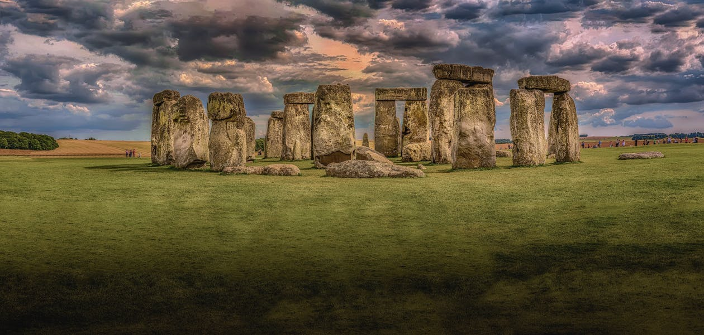

**Monument Travel**

**Assignment 3**

Involves Data Insertion and Querying of the Monument Travel Case Study.

Based on the same specification as repeated here …

*Specification:*

*Monument Travel offer a range of differing tours, itineraries are all pre-defined, no bespoke tours are offered. Each tour is given a name, a duration, and the standard cost of the tour. Each tour is guided. Guides are employed by the company and have an employee number. Other personal information is kept about the guides including their given and family names, home address, date of birth and date of hire. For insurance purposes the company also records the names of up to 2 next of kin for each employee. Some guides also act as supervisors to newly employed guides.*

*Each guide is encouraged to pass the qualification to lead different tours and each valid qualification passed by a guide needs to be recorded along with the date they achieved that qualification. New guides may or may not be qualified to lead any tours, just as a new tour may not have any guides qualified to lead it. Whilst the company strives to provide a qualified guide on all its tours, this is not always possible.*

*Each tour visits a sequence of locations, at least 3, and at most 10. Each location has a name, type, and description. The same location may be visited on a number of tours, but locations are only recorded if they are visited on at least one tour. The system also needs to record the sequence in which locations are visited on each tour.*

*Individual instances of each tour are called “Outings” by the company. These are scheduled well in advance so that they can be advertised, and employees are aware of their personal guiding schedule. A tour can have many scheduled outings, although a new tour may not have any outings scheduled. Each outing relates to a single defined tour starting on a particular date and time. Each outing must have a single guide assigned to it. Occasionally, guides will be asked to lead outings without passing the official qualification for that tour. Newly hired guides may not be scheduled to lead any outings. Tourists, called “clients” by the company book on outings, after they have registered their name, contact address and telephone number with Monument. Clients can book on any number of outings. Individual clients may also be eligible for a discount due to age, disability, etc. This will be reflected as a percentage and needs to be recorded in order to correctly charge those clients.*

… and the provided E-R solution here:

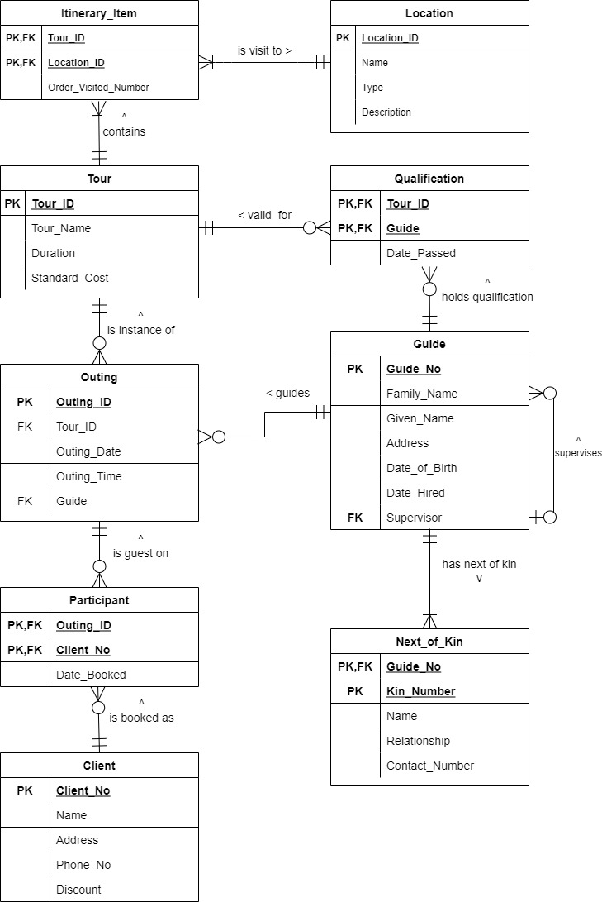

Figure 1 – Modified E-R Diagram

**Assignment Tasks**

**For Assignment 2, you need to do the following:**

1. **Download Ass3.SQL from CANVAS**
2. Follow the instructions **CAREFULLY** inside this file, it tells you **what to do** and **how to submit** your work**.**
3. Other than adding your queries in the indicated slots, **do NOT alter the file.**
4. 9 new tables will be created on your account each starting **A3_**...

These are the tables to use in your queries, so you will need to reference them with the **A3_** at the front anytime you use them.

1. Data will also be inserted into the tables, **only add data as instructed**.

**Submission Requirements**

Please follow the instructions in the file downloaded and rename as instructed

**Marking Schema**

Details are provided in the Ass3.SQL file on CANVAS

MAX TOTAL MARKS = 100