Git Link :

https://github.com/Dhyey1811/Monitoring-and-Logging-lnclasstask3.git

Output in terminal :

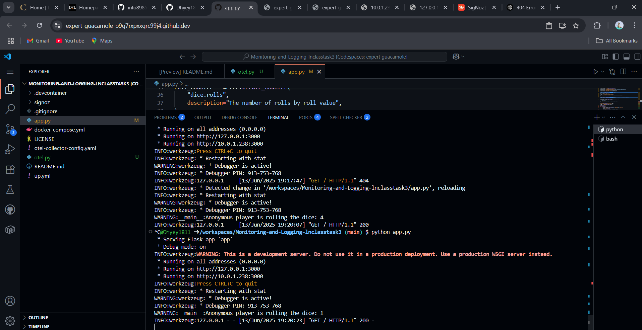

Output :

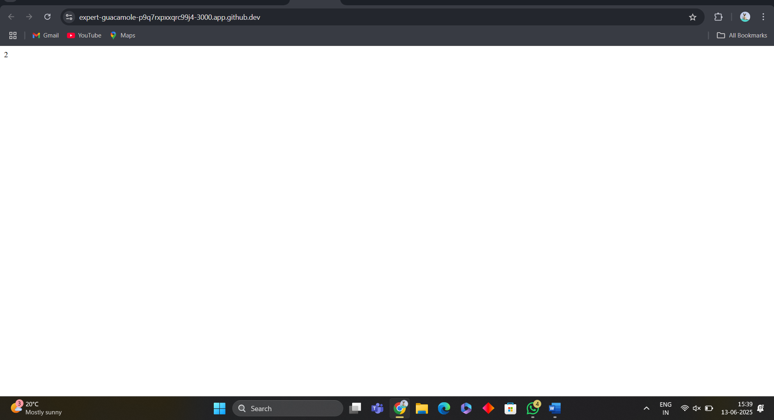

Trace :

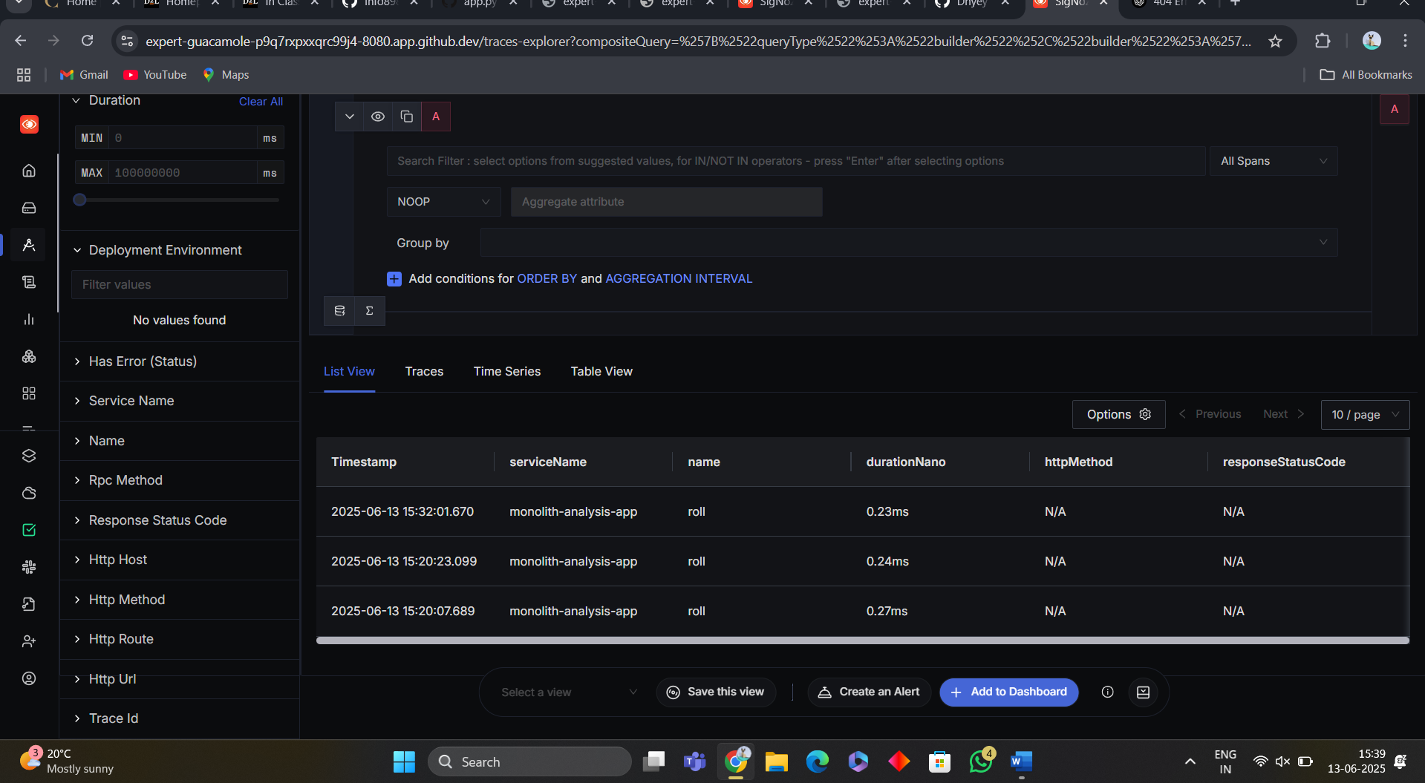

Exception :

