System certifications

Q.7 Where do I submit my application?or How can I apply for getting BIS licence for use of BIS standard mark (ISI) on the product?
A.BIS accepts application for product certification in online mode only (including all payments). To submit your application, please visit our online portal, www.manakonlinein Before registering in the portal, you are advised to go through applicant user manual, FAQs related to portal at https://www.manakonline.in/MANAK/impLinks

ONLINE CERTIFICATION SERVICES

How to register as a user on this portal for online submission of application for grant of license, renewal of license, inclusion of varieties etc under Product Certification Scheme:-

- Normal Procedure (option-1 of Scheme-I) Application User Manual
- Simplified Procedure (option-2 of Scheme-I) Application User Manual.
- GST Implementation
- FAQs
- Integrity Pledge for Licensee/Applicants of BIS Certification
- Product Certification Application Form Template

- Normal Procedure (option-1 of Scheme-I) Application User Manual
- Grant of License Process Flow
- Step 1: Enter the URL https://www.manakonline.in/MANAK/login in Mozilla Firefox web browser.
- Step 2: Click on the Conformity Assessment (Manakonline) tab as shown in (Fig.1)
- 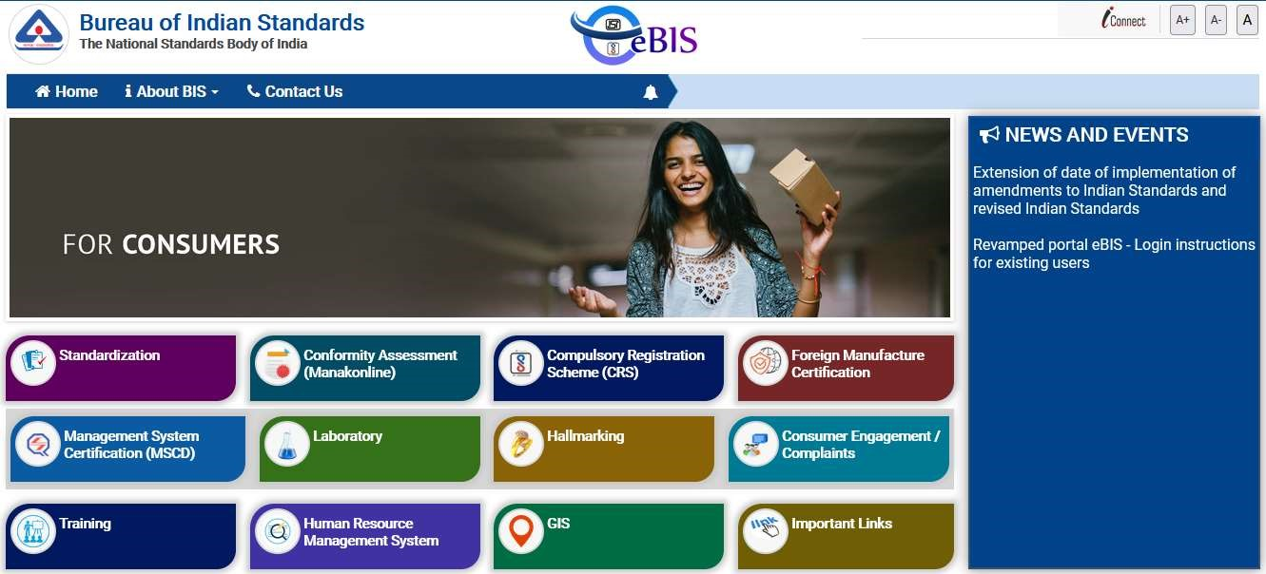
(
Fig.
1)
- Step 3: Click on LOGIN tab as shown in (Fig.2)
- 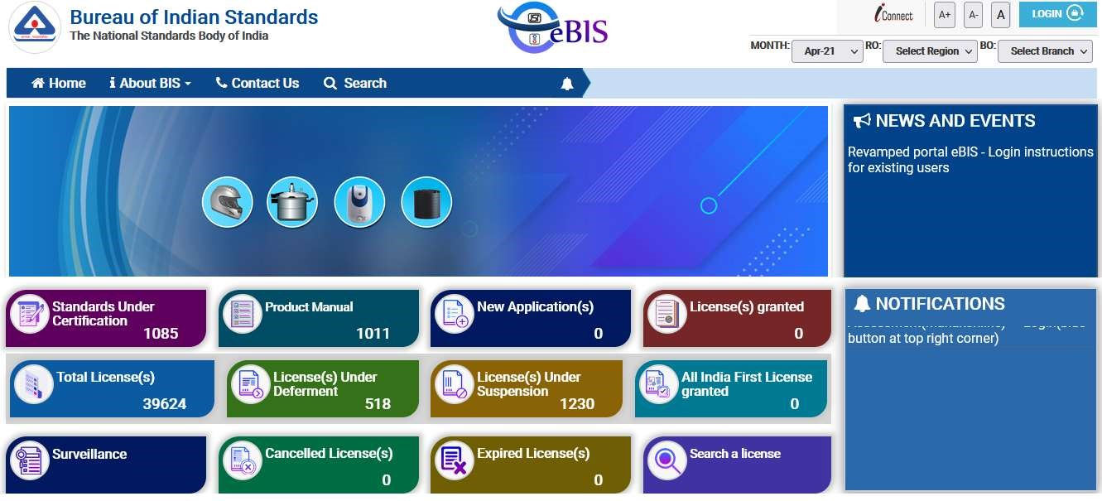
- (Fig.2)
- Step 4: Enter the Username, Password, Captcha and click on Sign in tab as shown in (Fig.3)
- 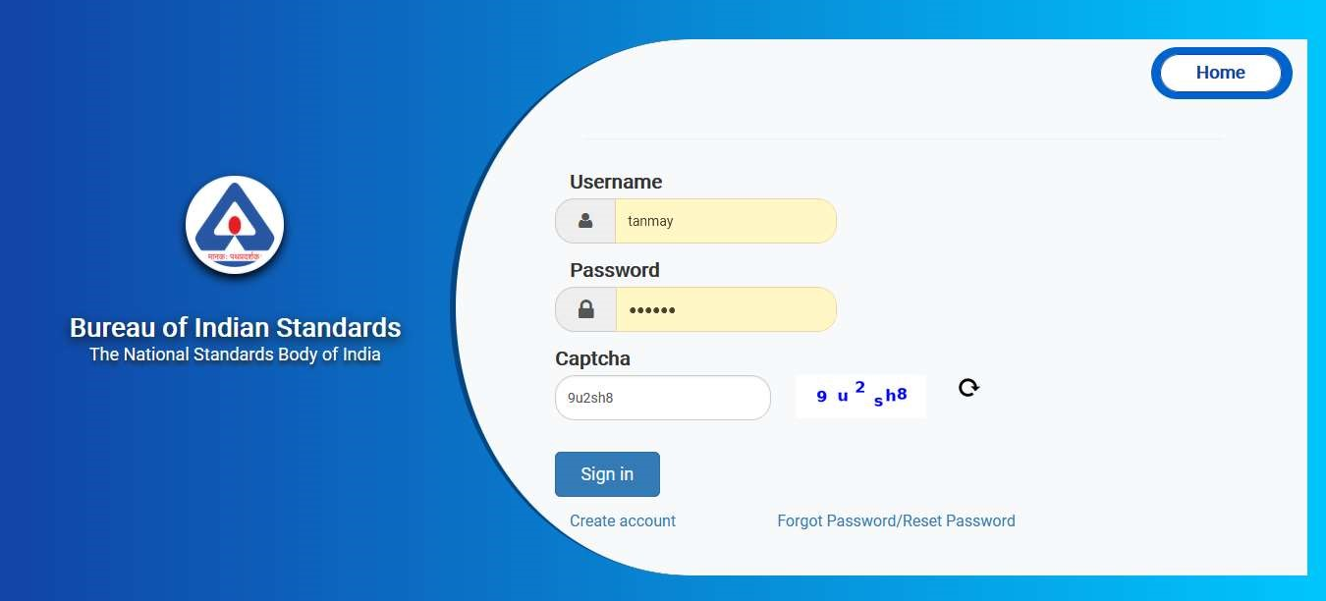
- (Fig.3)
- Step 5: Click on the Product Certification as shown in (Fig.4)
- 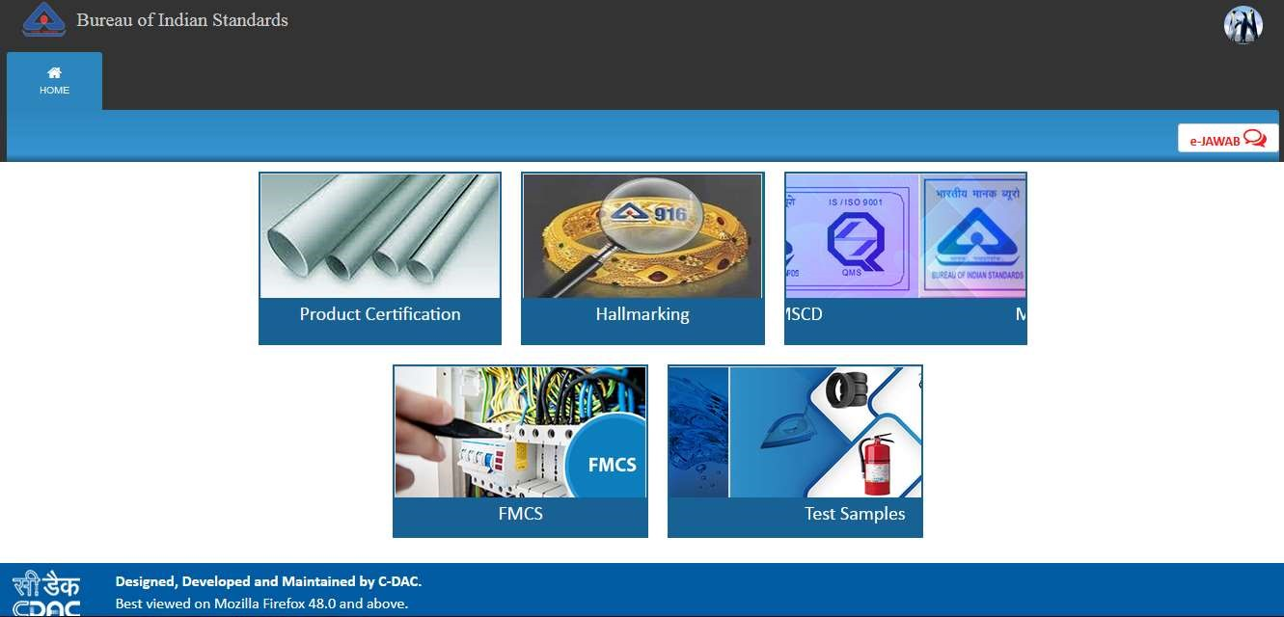
- (Fig.4)
- Step 6: Click on ‘Here’ link against Organization profile to fill the same as shown in (Fig.5)
- 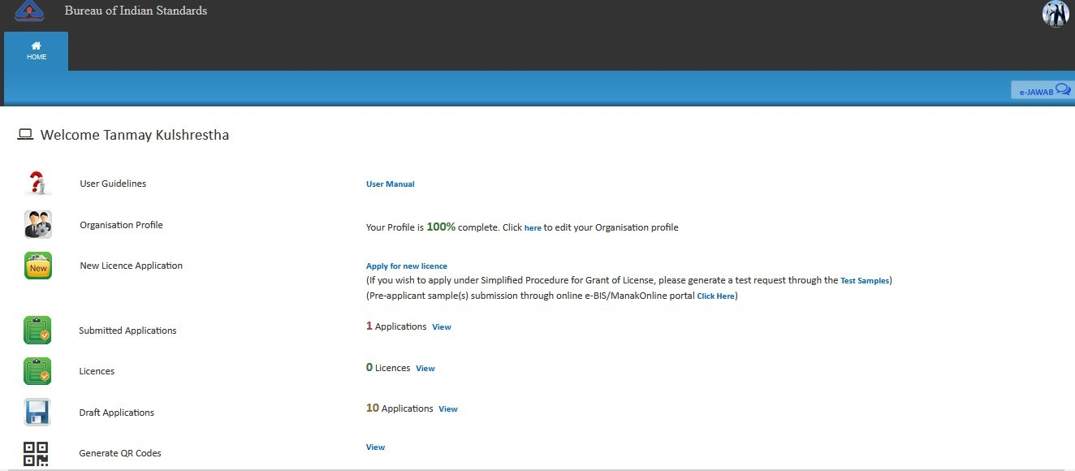
- (Fig.5)
- Step 7: In case you have not entered your organisation profile, please fill up the organisation profile.
- 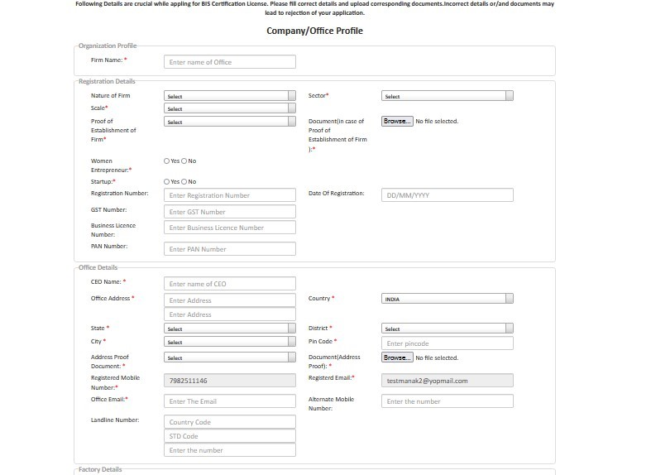
- 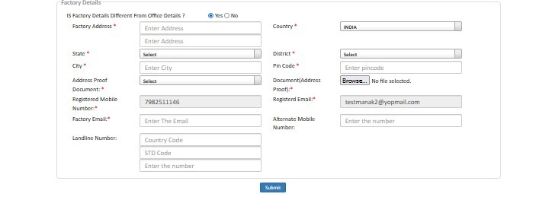
- (Fig.6)
- Step 8: After filling all the details of the profile, click on the ‘Submit’ button as shown in (Fig.7)
- 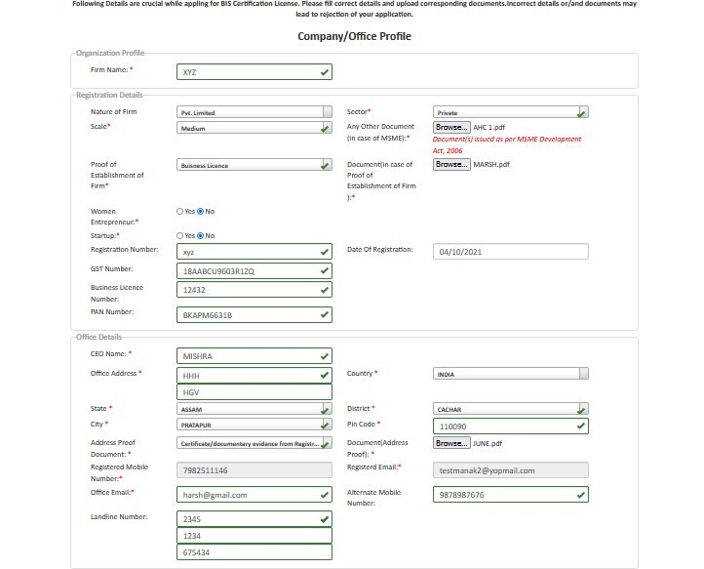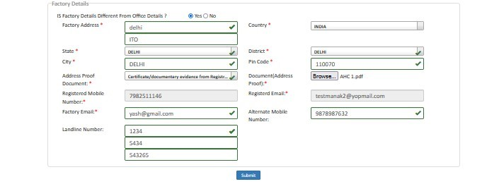
- (fig.7)
- Step 9: Then a success massage will reflect on your screen after successful updation of the profile as shown in (Fig.8)
- 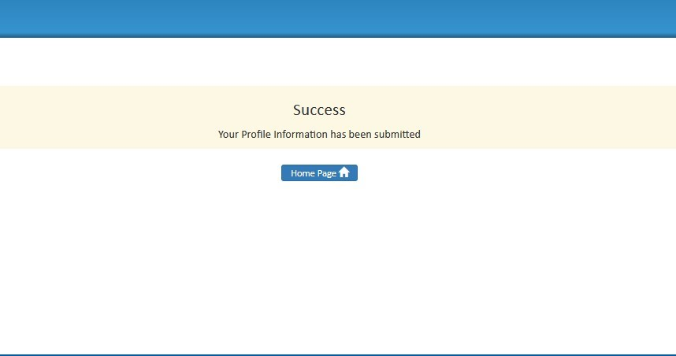
- (Fig.8)
- Step 10: You can apply for new license when the profile is updated. Click on the ‘Apply for New
- License’ link as shown below in (Fig.9). Before filling the application, please go through the guidelines provided by BIS for Grant of License. These can be accessed through following path:
- Go to bis.gov.in > Conformity Assessment > Product Certification Process > Guidelines for grant of license
- (or click on the link- https://www.bis.gov.in/wp-content/uploads/2021/08/GoL-Guidelines-
- WebsiteHosting.pdf)
- 
- (Fig.9)
- Step 11: Then the application form will appear as shown in (Fig.10).
- 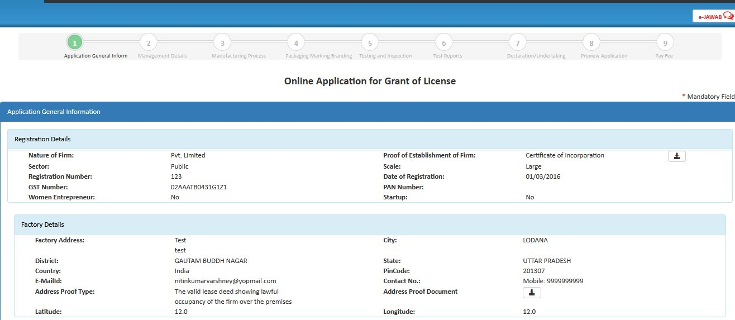
- (Fig.10)
- Step 12: Select option ‘Yes’ if you know the Indian Standard Specification (ISS) for the product against which license is sought and choose the standard accordingly as shown in (Fig.11) <Refer
- Guideline on the website for proper content>
- Provide the acceptance for Marking Fee and STI by clicking on the respective checkboxes and then select the Normal/Simplified procedure accordingly as shown in (Fig.11)
- 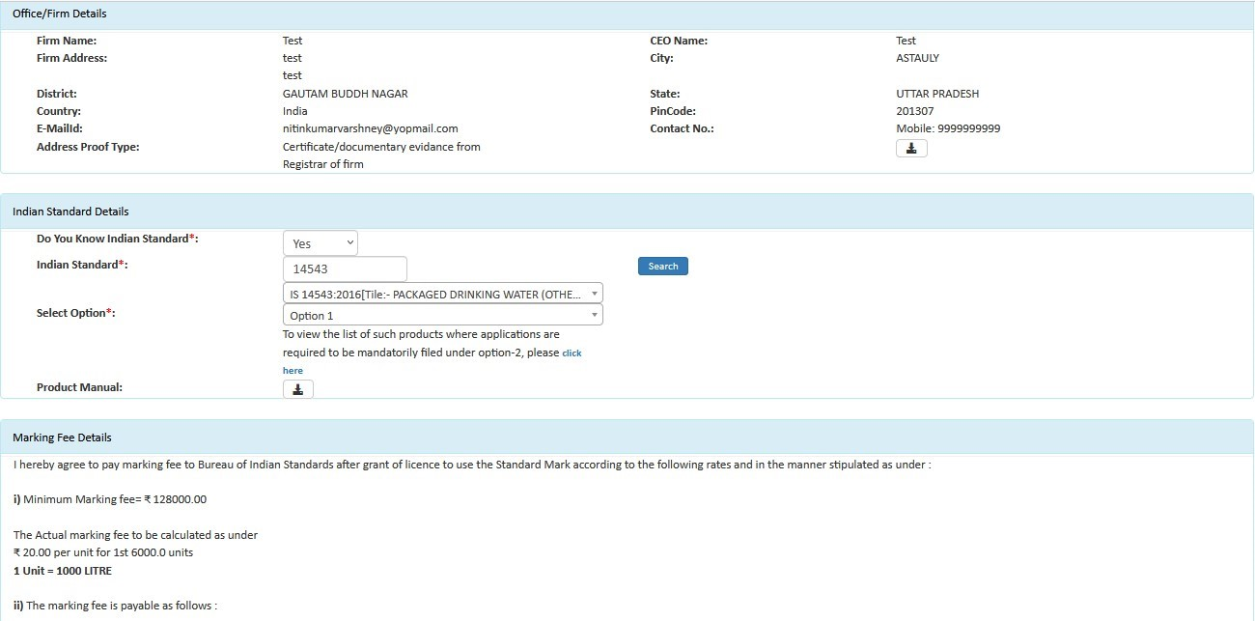
- (Fig 11)
- 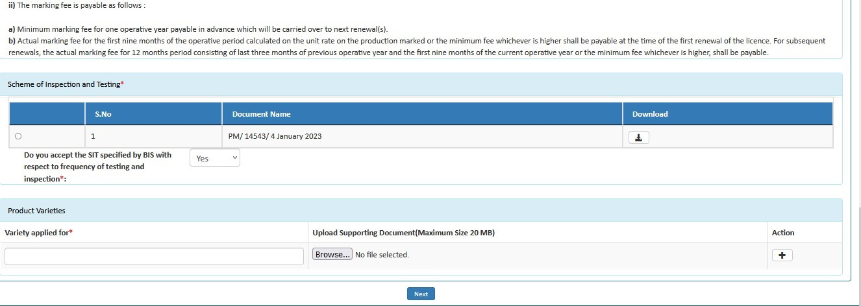
- Option 1 (Normal Procedure): After scrutiny of application is done, a factory visit is carried out and sample is drawn for testing. Once the testing is completed and a report is received, the Branch Office of BIS then process for the Grant of Licence. Sample(s) may not be drawn in case the Grant of Licence is to be consider on the basis of factory testing only.
- Option 2 (Simplified Procedure): The applicant has to submit a test report of their product along with the application. Once the application is submitted, a factory visit is carried out for the verification of manufacturing infrastructure, production process and quality control etc. And then the license may be processed for grant of license. The test report of the sample(s) drawn during the factory visit will be used for review purposes.
- Step 13: Fill the details of Top management, Technical management and Contact person (Fig.12)
- 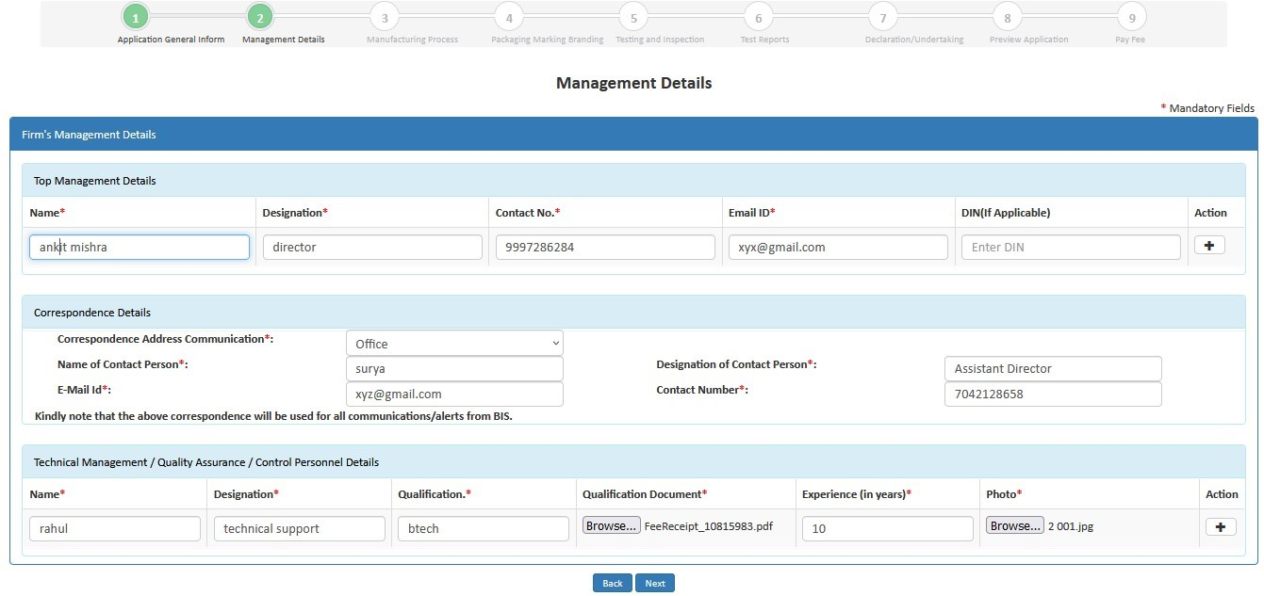
(
Fig
12)
- Step 14- Similarly, fill the details of ‘Testing Equipment’. Click on ‘Yes’ if you want to download the excel file, otherwise click on ‘No’.
- 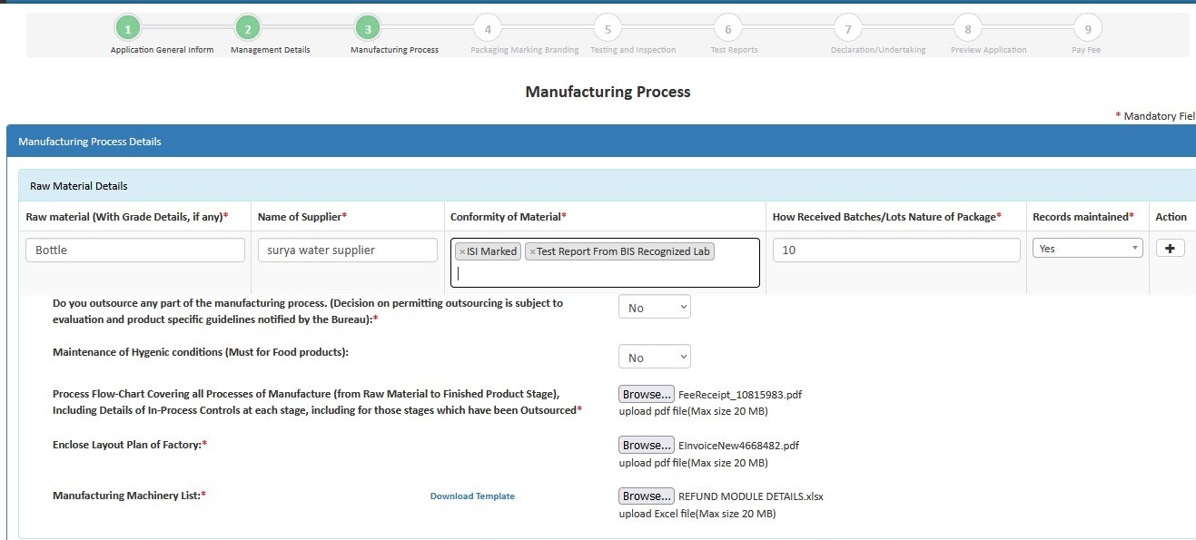
- ( Fig 13)
- Step 15: Then fill the production details, accept declarations and click on ‘Next’ to go to the next page as shown below in (Fig.14)
- 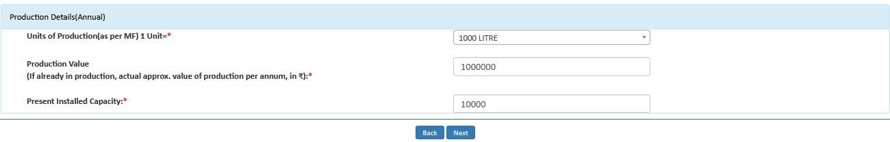
- Step 16: Fill the details of Brand details and click Next.
- 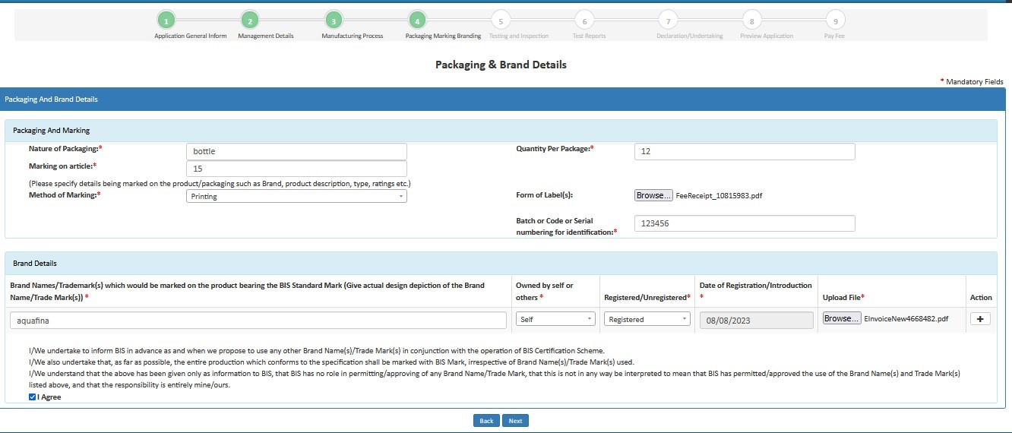
- ( Fig 15)
- Step 17: Fill Testing and Inspection Details as on (fig 16) then click Next Button
- 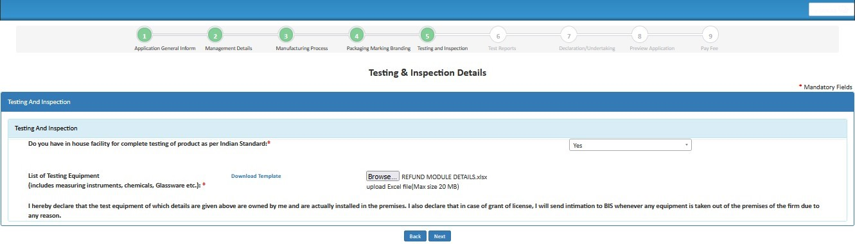
- (Fig 16)
- Step 18: Test Report Section as on (fig 17)
- 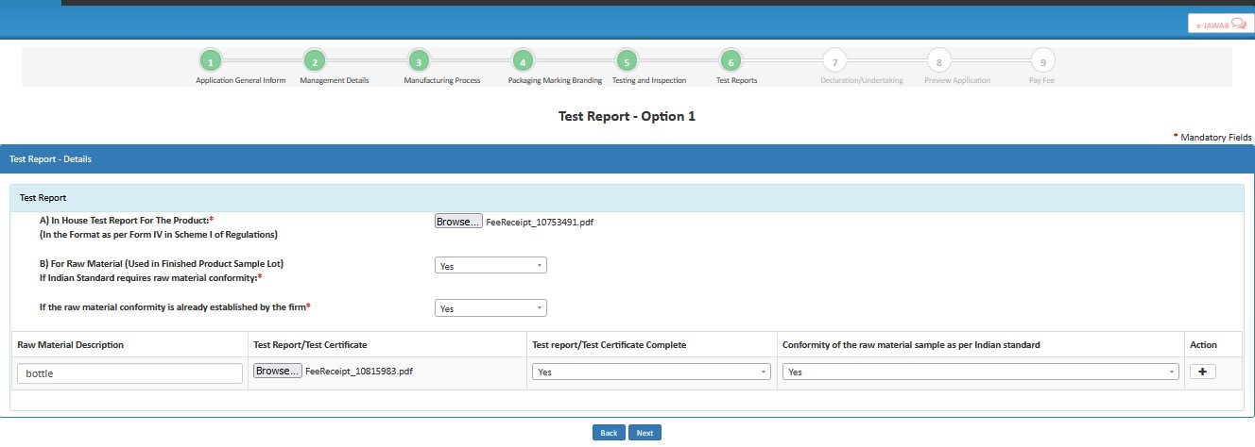
- (fig 17)
- Step 19: Fill Declaration & Undertaking then click on Next Button
- 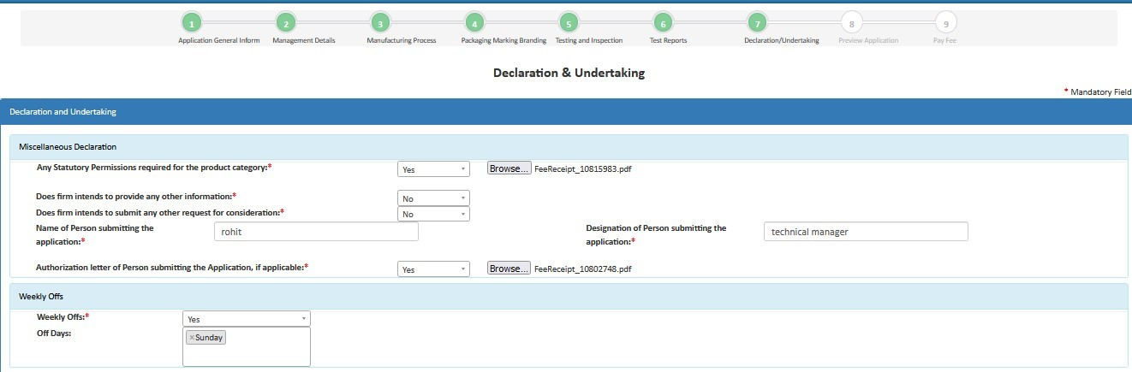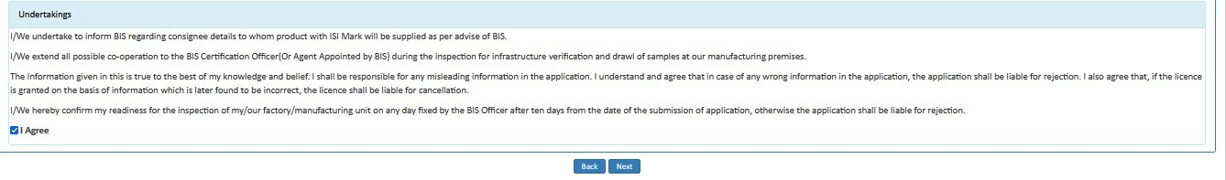
- (fig 18)
- Step 20 : Review Application Details
- 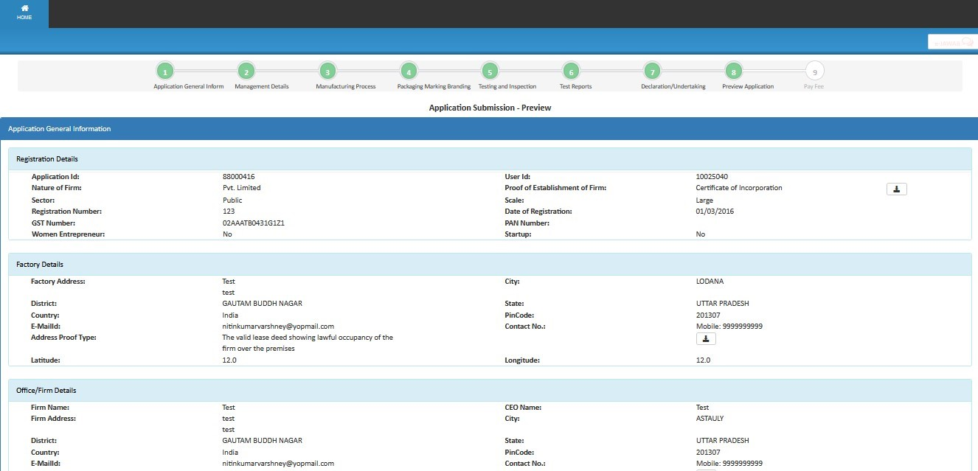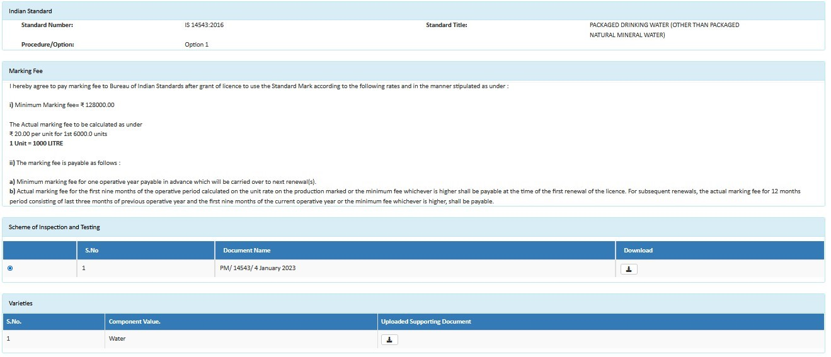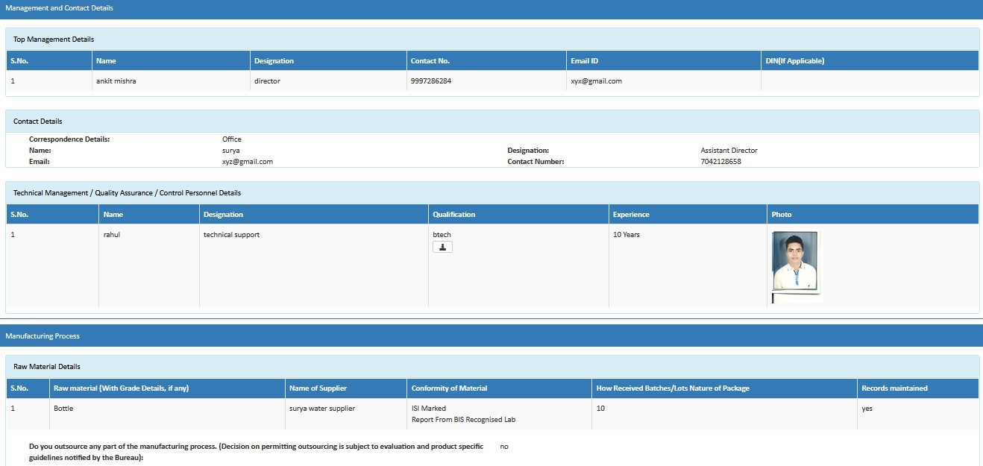
- 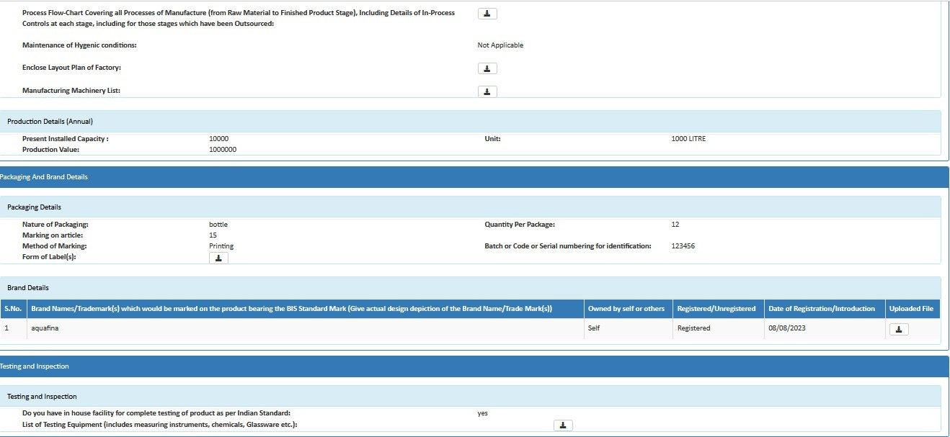
- 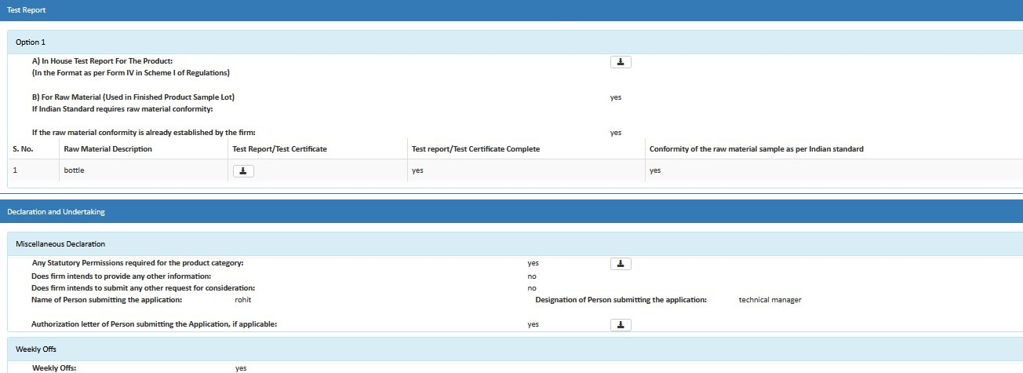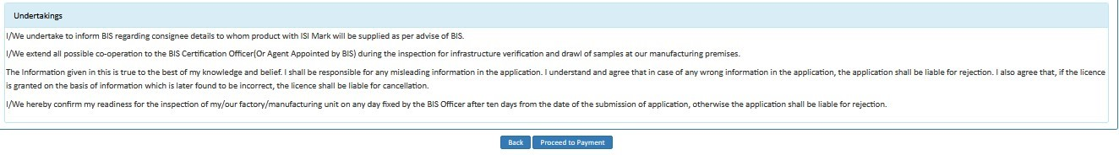
- (Fig 19) Step 21: Later an Application Fee and Contact BIS page will open. Here select the payment mode, agree to the terms and conditions and click on ‘Proceed to Payment’ button as shown in (Fig.20)
- 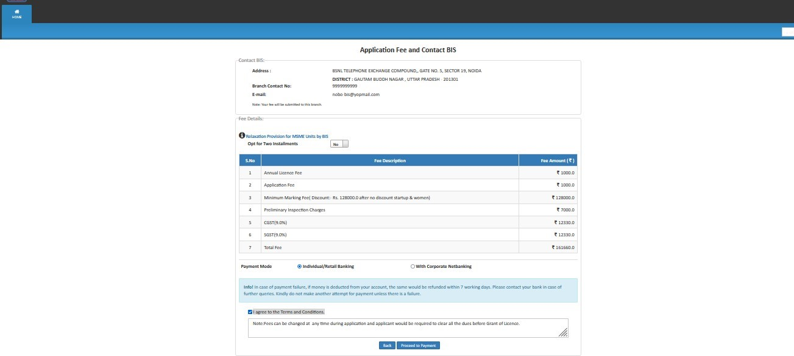
- (Fig 20)
- ➢ Applicant can select checkboxes according to its preference
- Note: -Here Applicant has two payment modes:-
- • Individual/Retail Banking
- • With Corporate Banking
- Step 22: Then on Online Payment page go through the all the instructions regarding transaction charges and click on Pay Now as shown in (Fig.21)
- 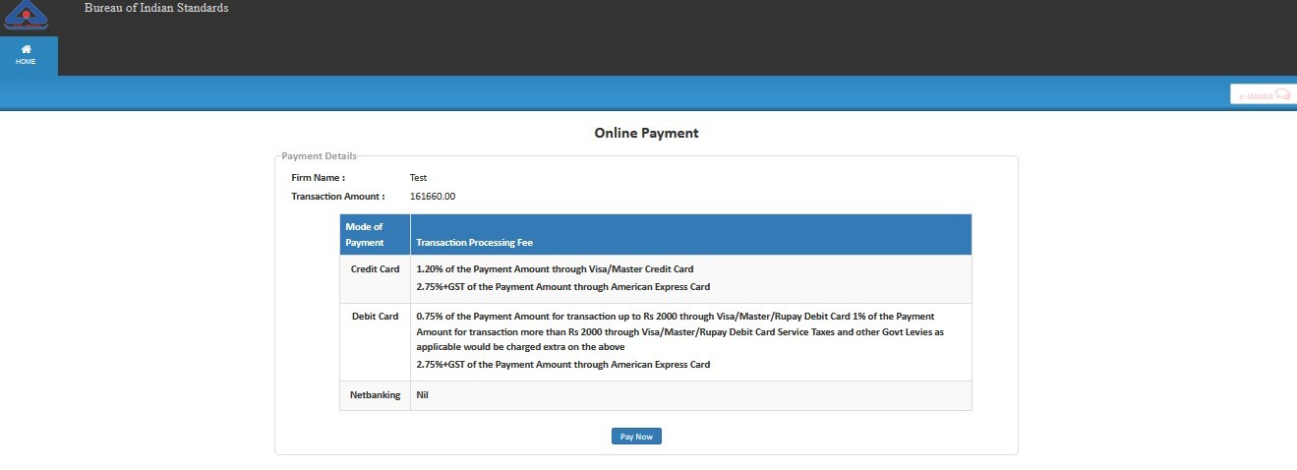
- (Fig 21)
- Step 23: Now, select the appropriate method and Make Payment as shown in
- (Fig.22)
- 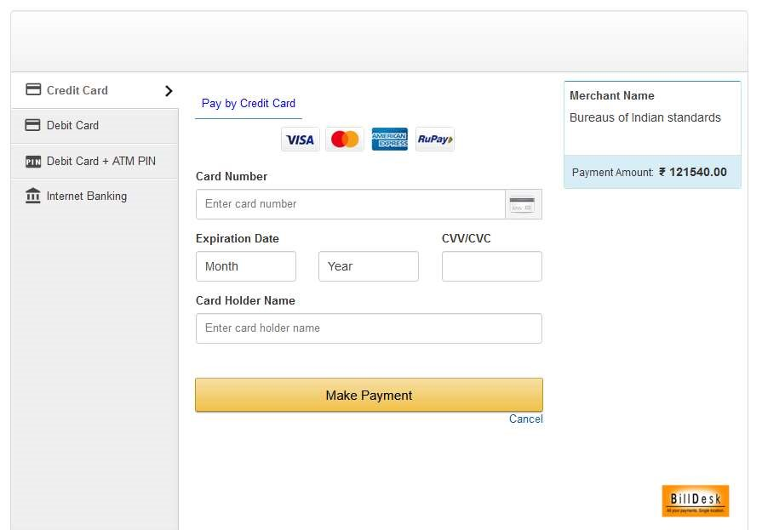
- (Fig 22)

- Simplified Procedure (option-2 of Scheme-I) Application User Manual.
- User Manual for Applying for Grant of License under Option 2

(Simplified Procedure)

- Step 1: Enter the URL https://www.manakonline.in/MANAK/login in Mozilla Firefox web browser.
- Step 2: Click on the Conformity Assessment (Manakonline) tab as shown in Fig.1
- 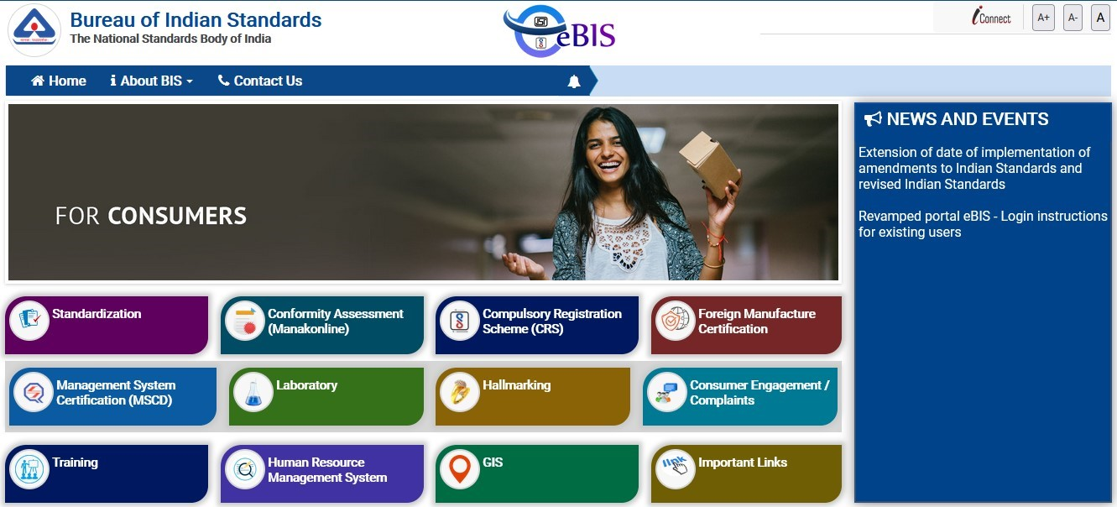

Fig.1

- 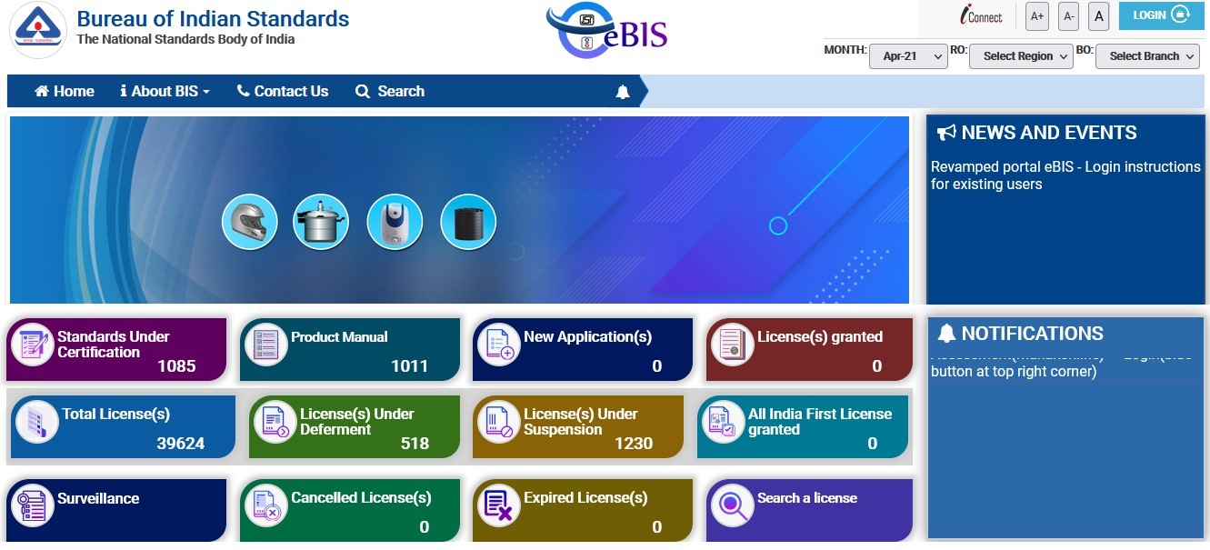
Step 3:

Click on LOGIN tab as shown in Fig.2

- Fig.2
- Step 4: Enter the Username, Password, Captcha and click on Sign in tab as shown in Fig.3
- 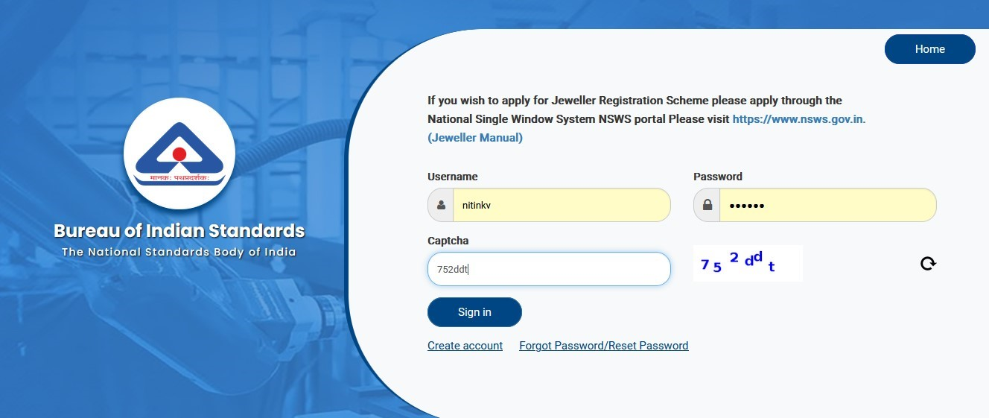

Fig.3

- Step 5: Click on the Product Certification as shown in Fig.4
- 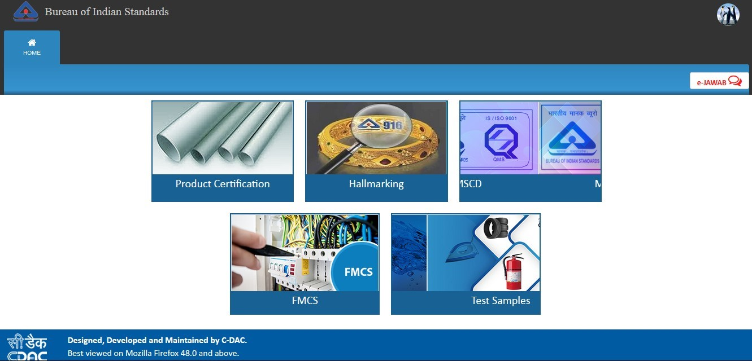

Fig.4

- Step 6: Click on ‘Here’ link against Organization profile to fill the same as shown in Fig.5
- 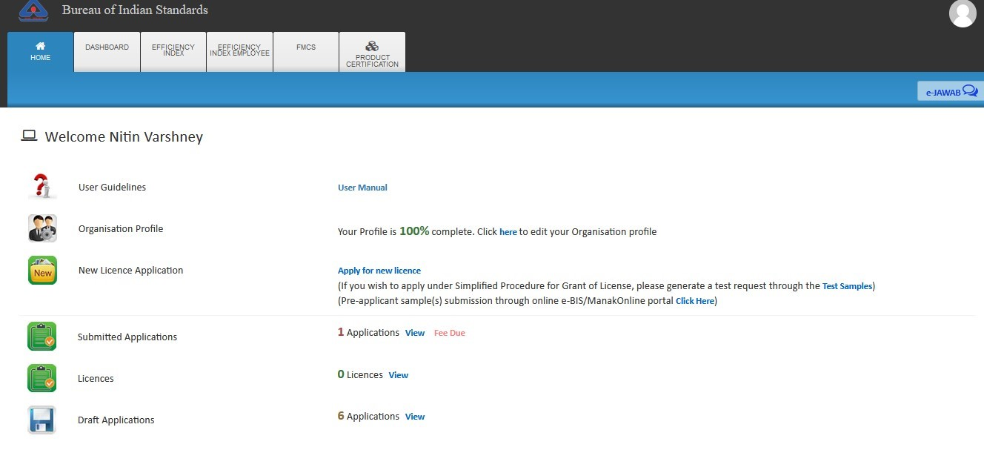

Fig.5

- Step 7: In case you have not entered your organisation profile, please fill up the organisation profile as shown in Fig. 6.
- 

- Fig.6
- Step 8: After filling all the details of the profile, click on the ‘Submit’ button as shown in Fig.7

- 

Fig.7

- Step 9: Then a success message will be reflected on your screen as shown in Fig.8 after successful updation of the profile.
- 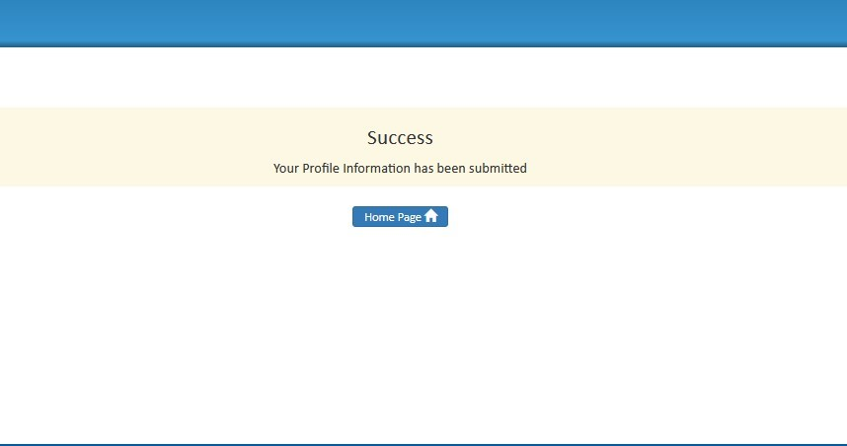

- Fig.8

- Step 10 (QR CODE generation procedure): Go to Applicant dashboard shown in the Fig 9
- and click on the Test Samples Tile.
- 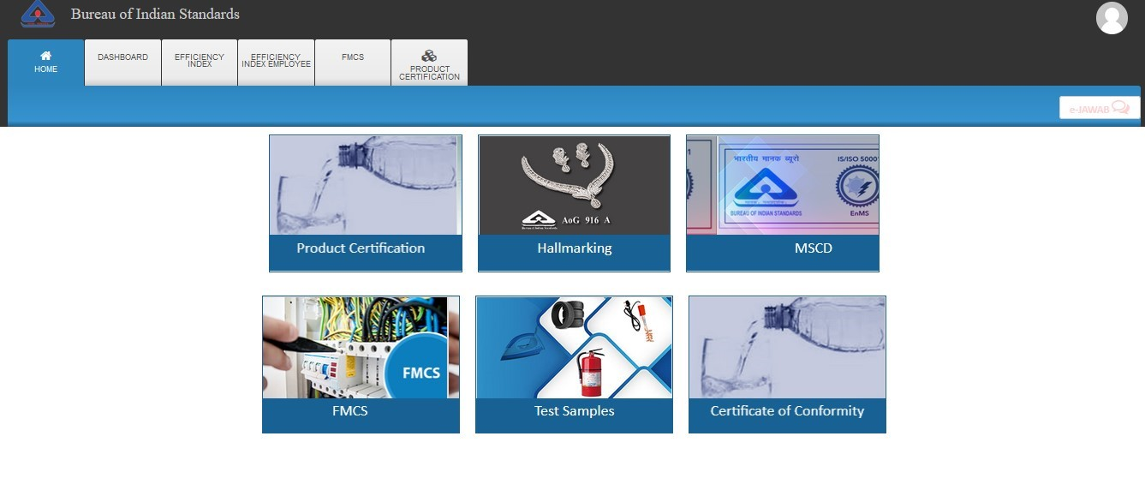

Fig.9

- Step 11: Click on the Generate QR Code “View” section as shown in Fig.10

- 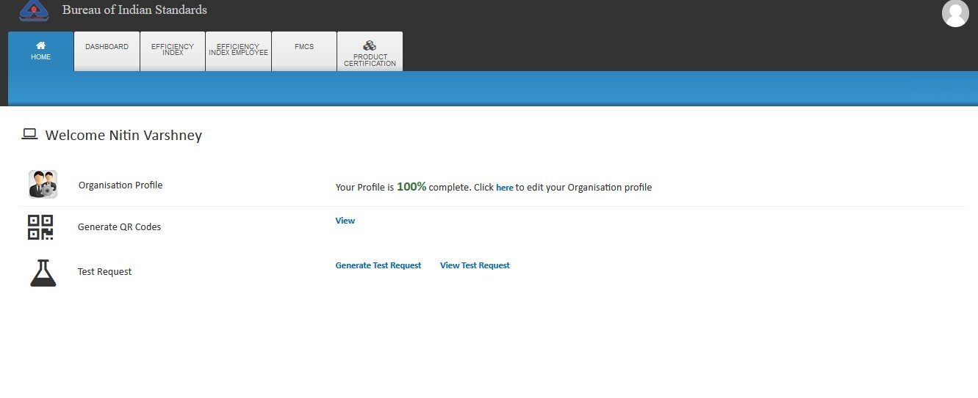

Fig.10

- Step 12: The QR Code Generation page will be shown as Fig. 11.

- 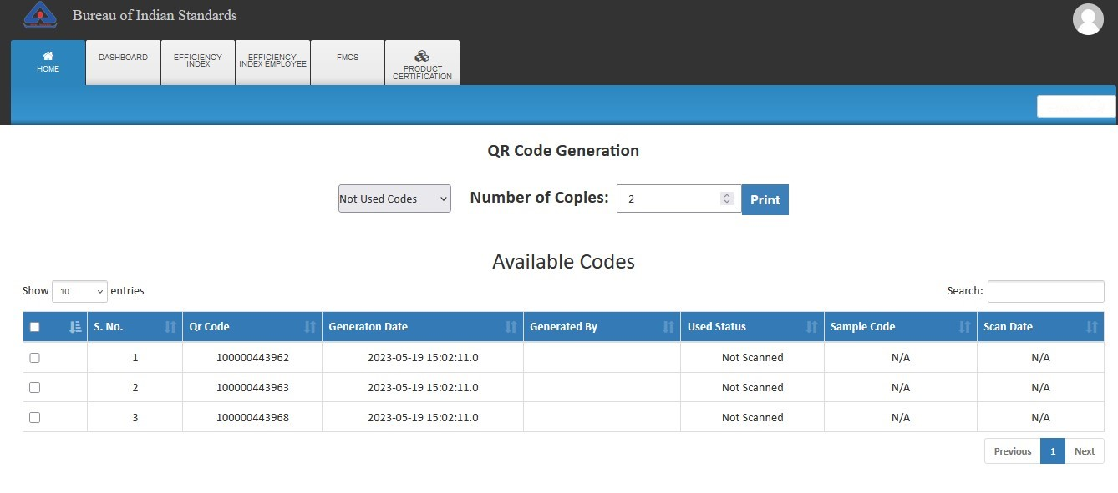
- Fig. 11

- Step 13.A: If sufficient codes available, user can skip the step 13.b
- Step 13.B: In case either available codes are NIL or user want to create new codes, select
- ‘Generate New Code’ from the drop-down and click on the Generate button. After that generated QR Code will be displayed as shown Fig 12.
- 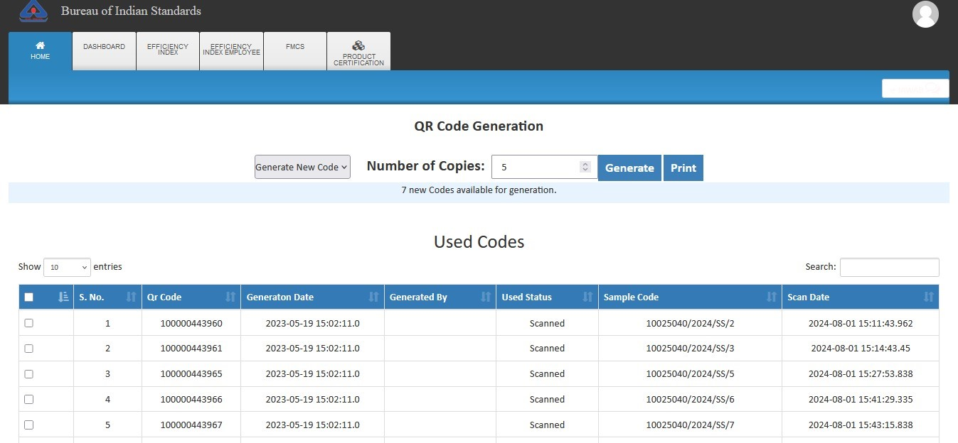

Fig
. 12

- Step 14 (Test Request Generation procedure): Again Go to Home Page and click on
- 
the ‘
Test Samples’
tile

as shown in Fig.13

- Fig.13

- Step 15: Click on the ‘Generate Test Request’ as shown in Fig. 14
- 

Fig. 14

- Step 16: Enter the IS Number and click on the search button as shown in the Fig.15
- 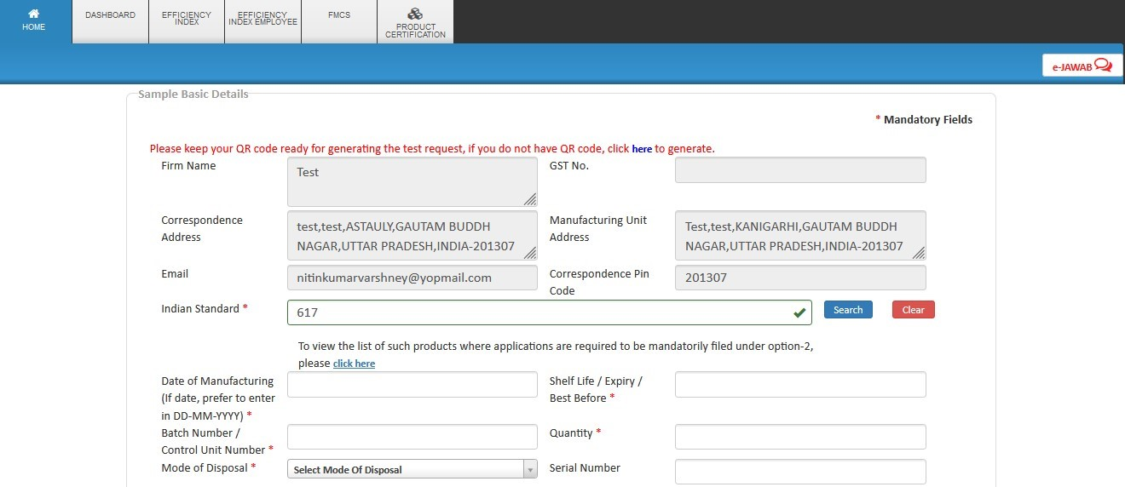

Fig.15

- Step 17: A list will appear below the search button with available IS numbers. Kindly select the required IS number and version from the populated list as shown in the Fig.16.
- 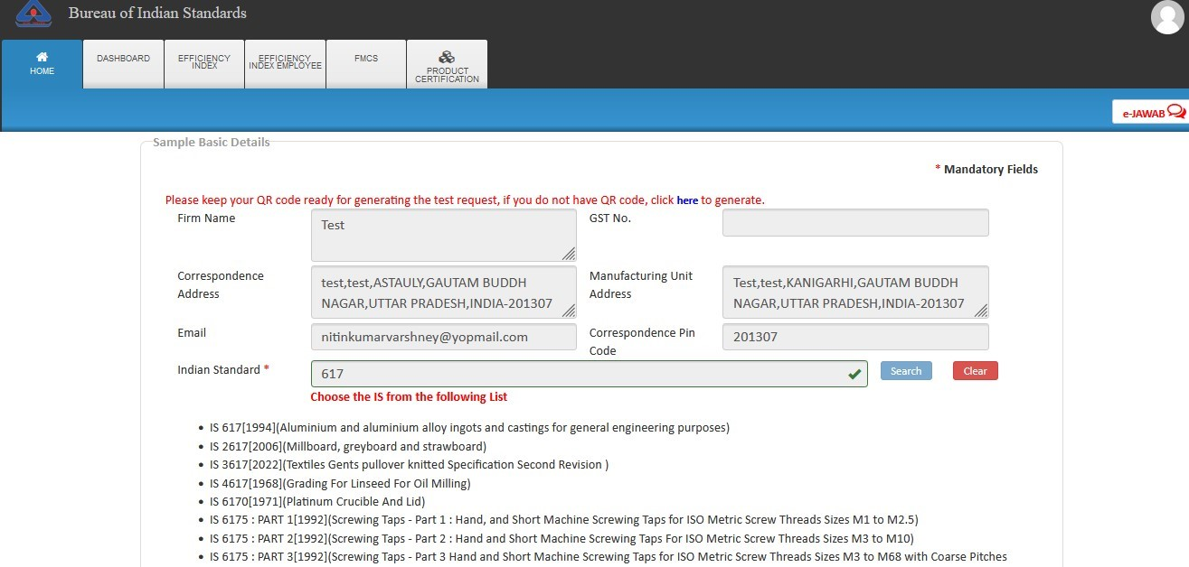

Fig.16

- Step 18: Fill the remaining fields and click on the ‘Check Lab Availability’ as shown in the Fig.17
- 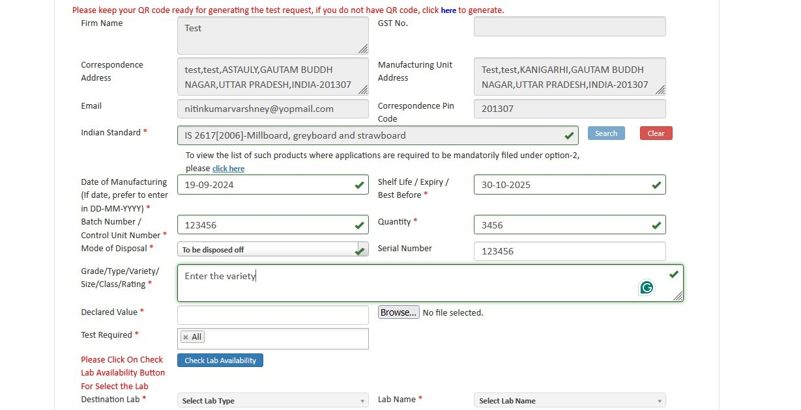

- Fig.17
- Step 19: The new POP window will be opened as shown in the Fig. 18 and click on the Radio
- 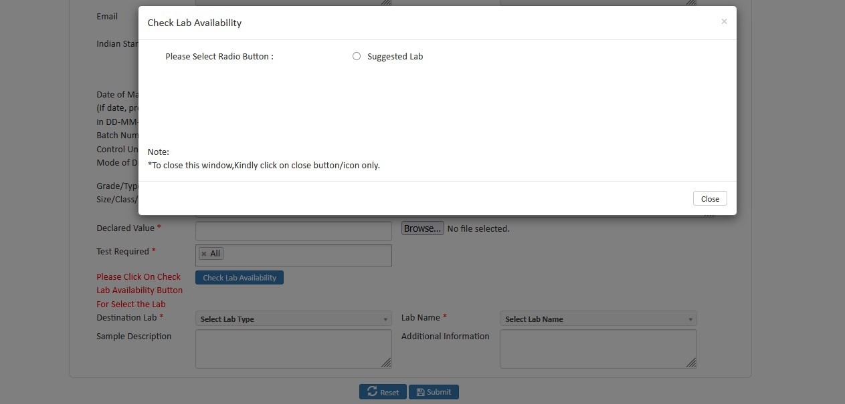
button Suggested Lab

- Fig. 18

- Step 20: Select any of the lab and click on the Submit button as shown in Fig. 19

- 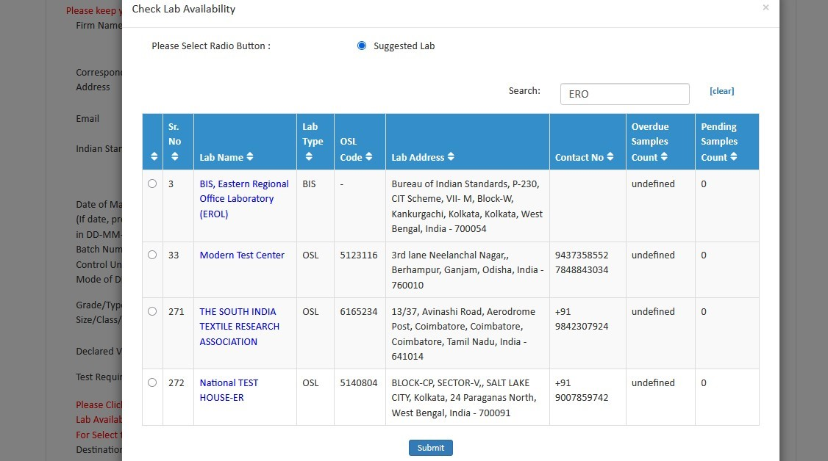

Fig.19

- Step 21: Fill the remaining details and click on the Submit button as shown in Fig.20

- 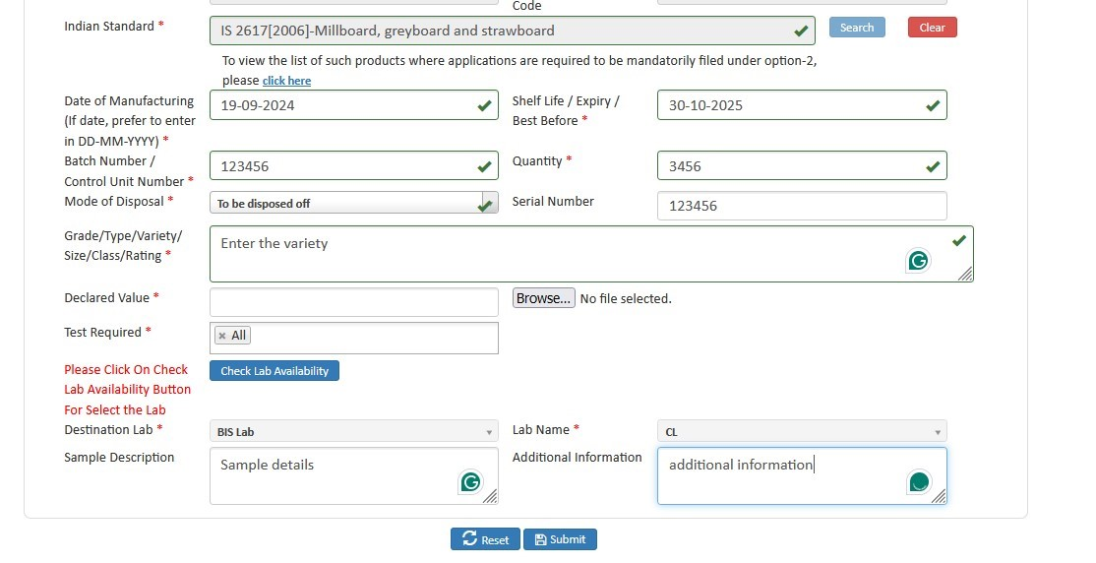

Fig.20

- Step 22: Please enter any of the available QR Code and click on the Submit button as shown in Fig.21.
- 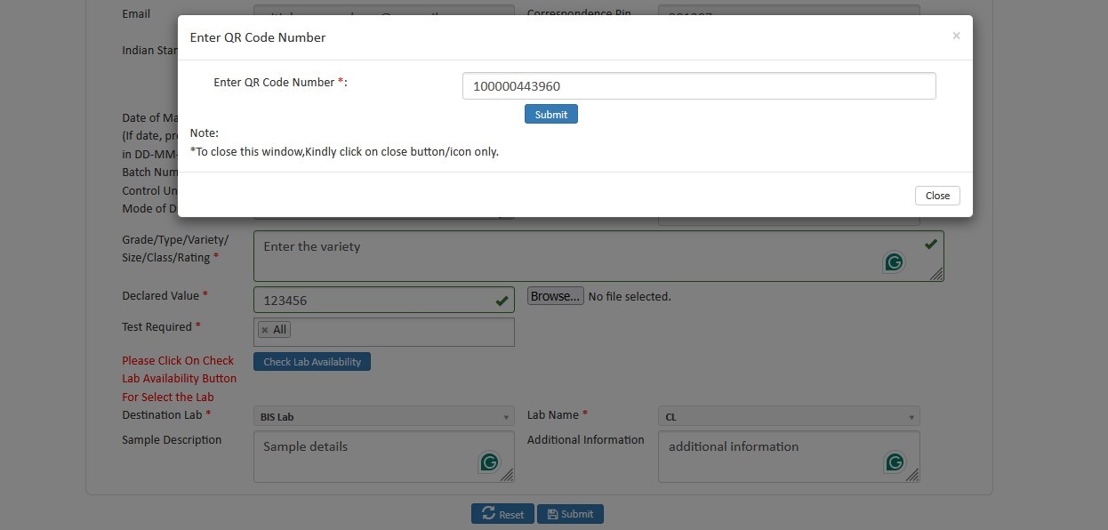

- Fig.21
- Step 23: After that the test request will be sent to the lab as shown in Fig.22 and click on the View Test Request List for checking the status of the generated test request.

- 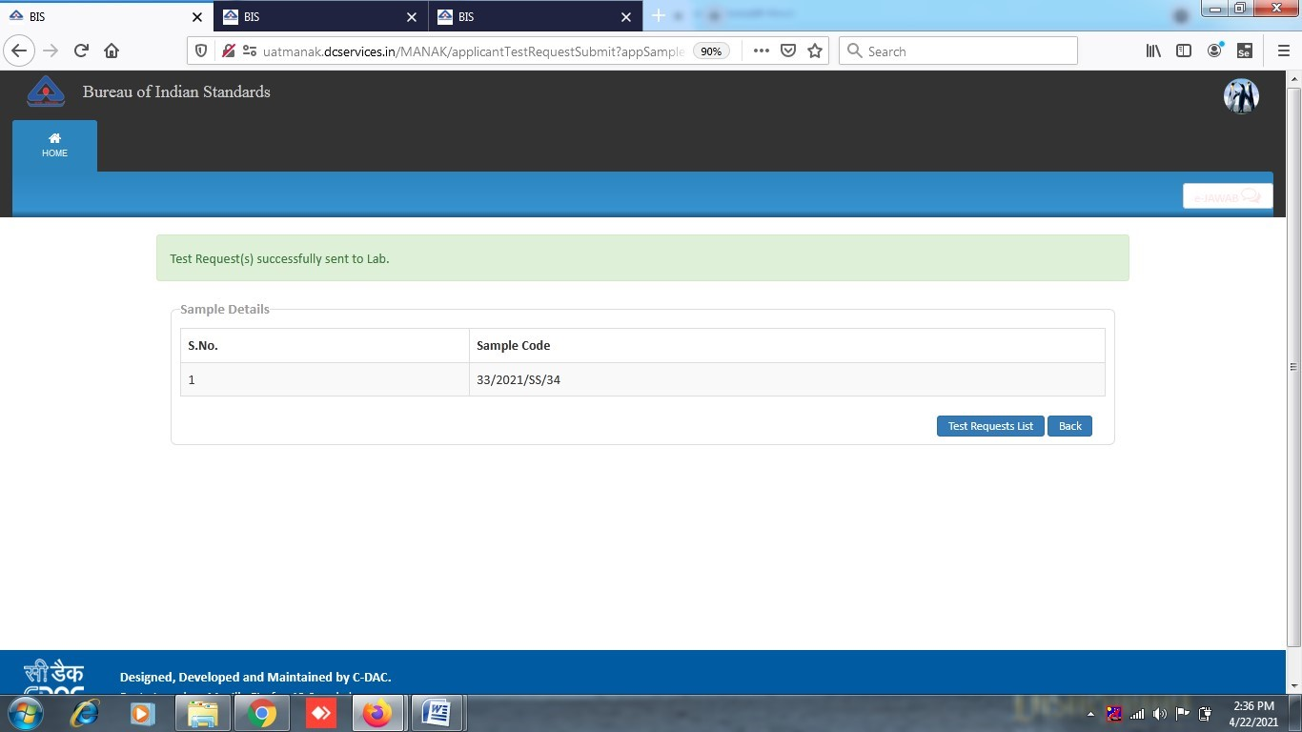

- Fig.22

- Step 24: The test request Details is shown as shown in Fig.23. Click on the View for printing the test request:

- 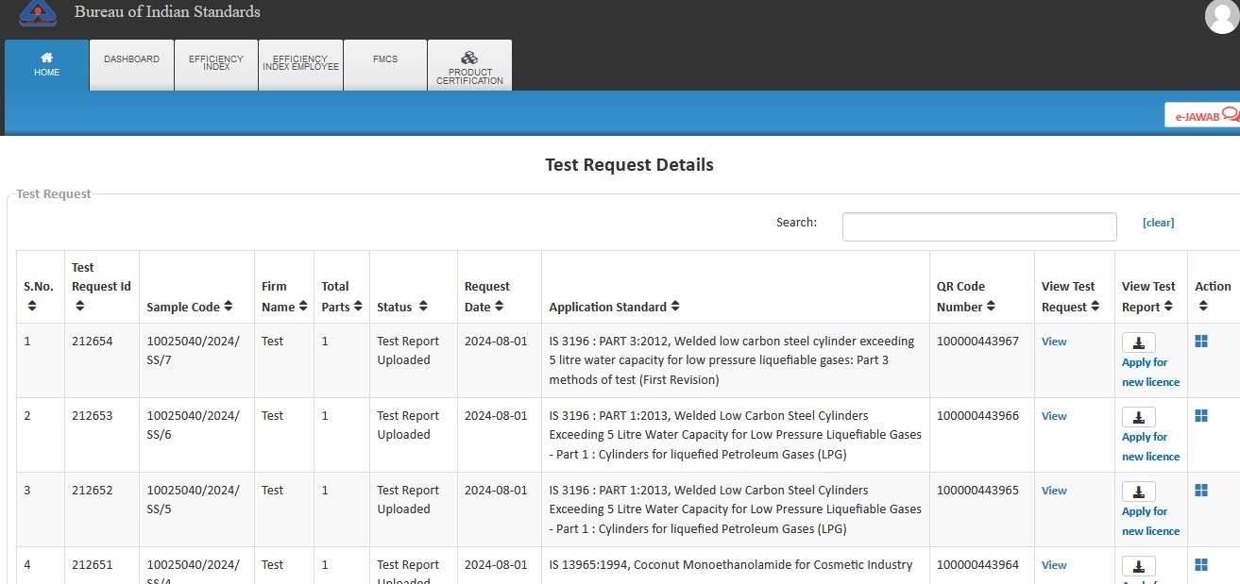

Fig.23

- Step 25: You can apply for new license when the Test report is uploaded by the LAB. Click on the ‘Apply for New License’ as shown in Fig.24

- 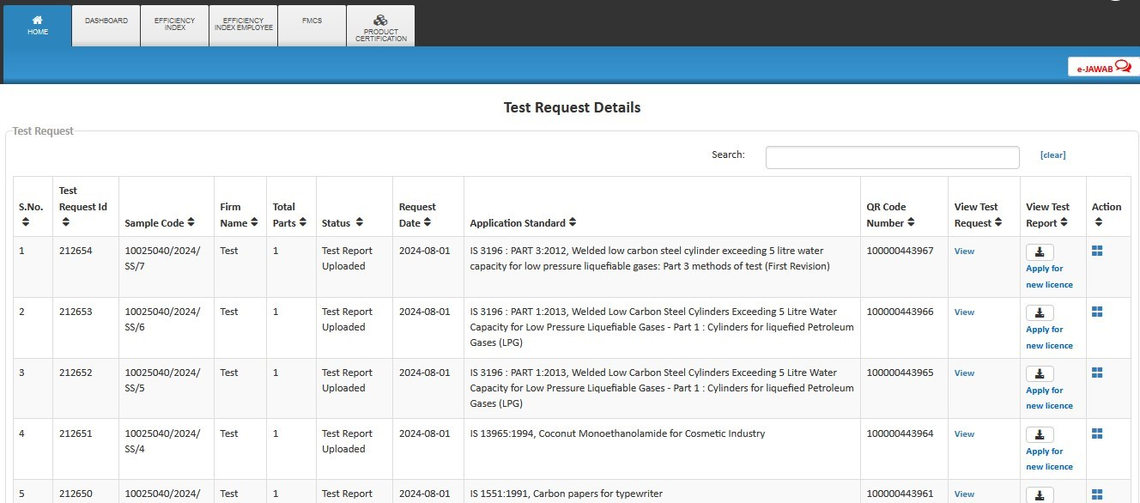

- Fig.24
- Step 26: Then the application form will appear as shown in Fig.25
- 

Fig.25

- Step 27: Select option ‘Yes’ if you know the Indian Standard Specification (ISS) for the product against which license is sought and choose the standard accordingly as shown in Fig.26 (Refer Guideline on the website)

- 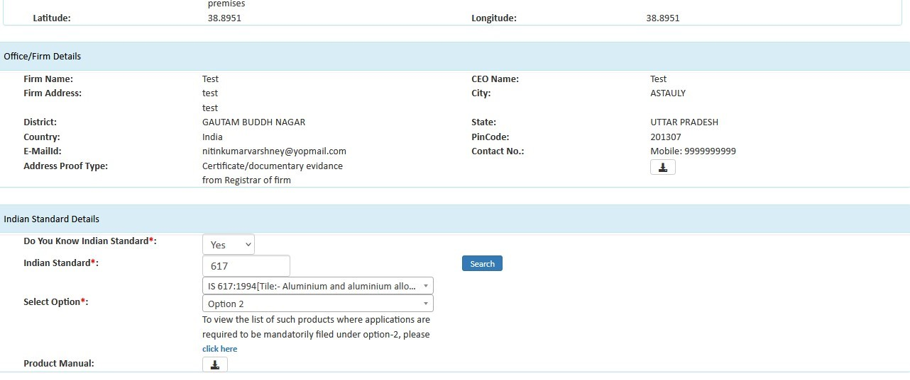

Fig 26

- Provide the acceptance for Marking Fee and STI by clicking on the respective checkboxes and then select the Simplified procedure accordingly as shown in Fig.27
- 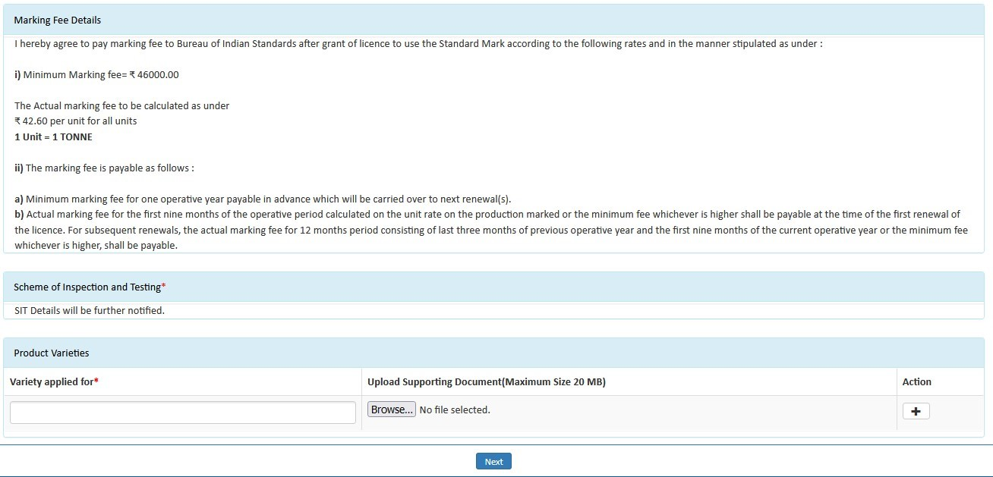

- Fig.27
- Step 28: Fill the details of Top management, Technical management and Contact person Fig.28
- 

Fig.28

- Step 29: Similarly, fill the details of ‘Testing Equipment’. Click on ‘Yes’ if you want to download the excel file, otherwise click on ‘No’.
- 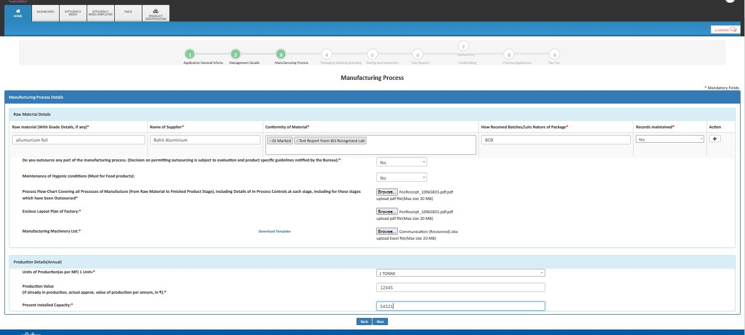

Fig. 29

- Step 30: Then fill the production details, accept declarations and Fill the details of Brand details and click ‘Next’ as shown below in Fig.30
- 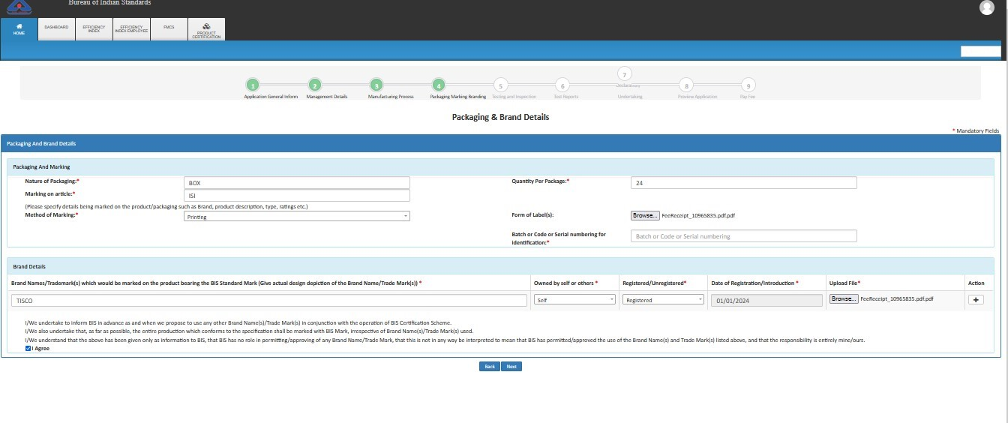

Fig. 30

- Step 31: Fill Testing and Inspection Details as on Fig. 31 then click Next Button
- 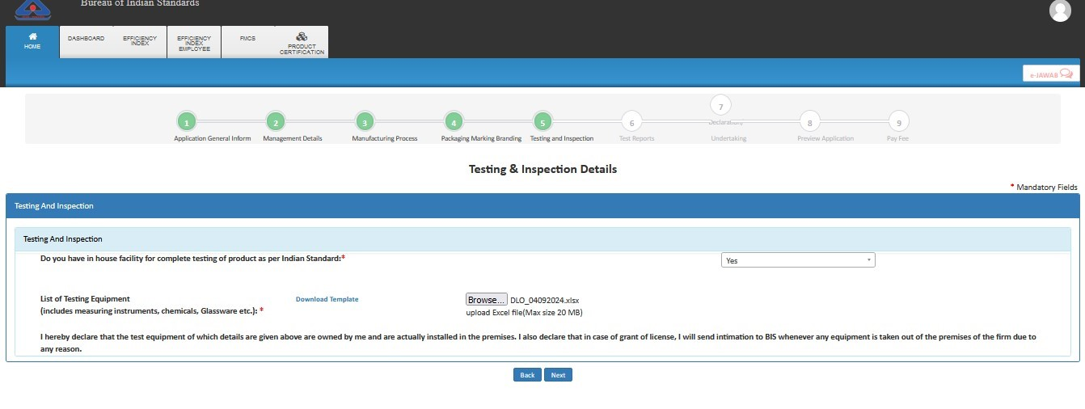

Fig. 31

- Step 32: Select the QR code in the available list as shown in the Fig. 32

- 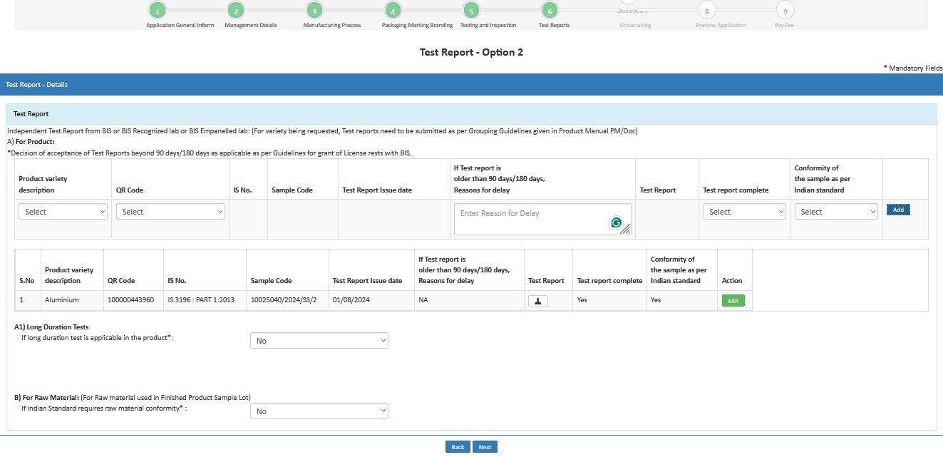

Fig. 32
- Step 33: Fill Declaration & Undertaking then click on Next Button
- 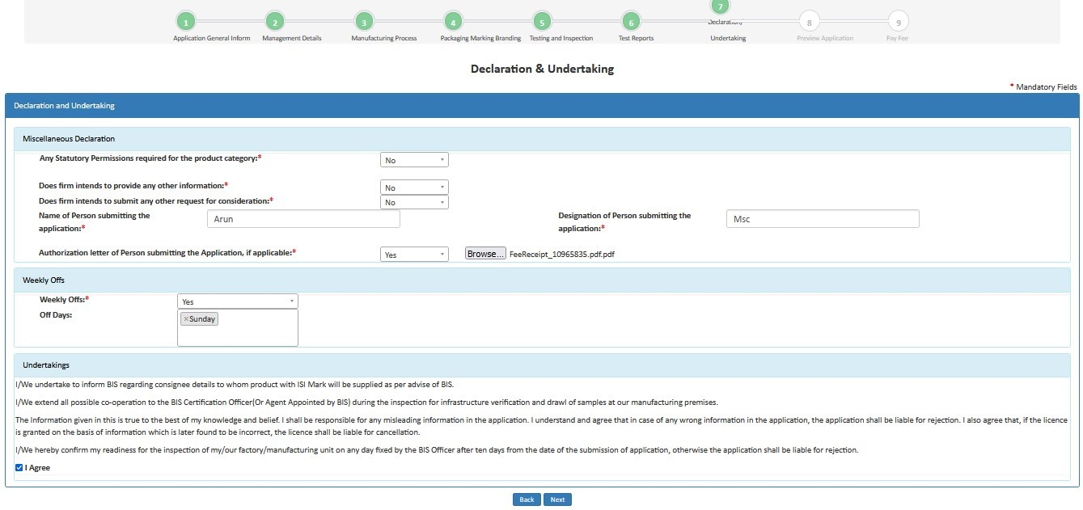

Fig. 33

- Step 34: Review Application Details

- 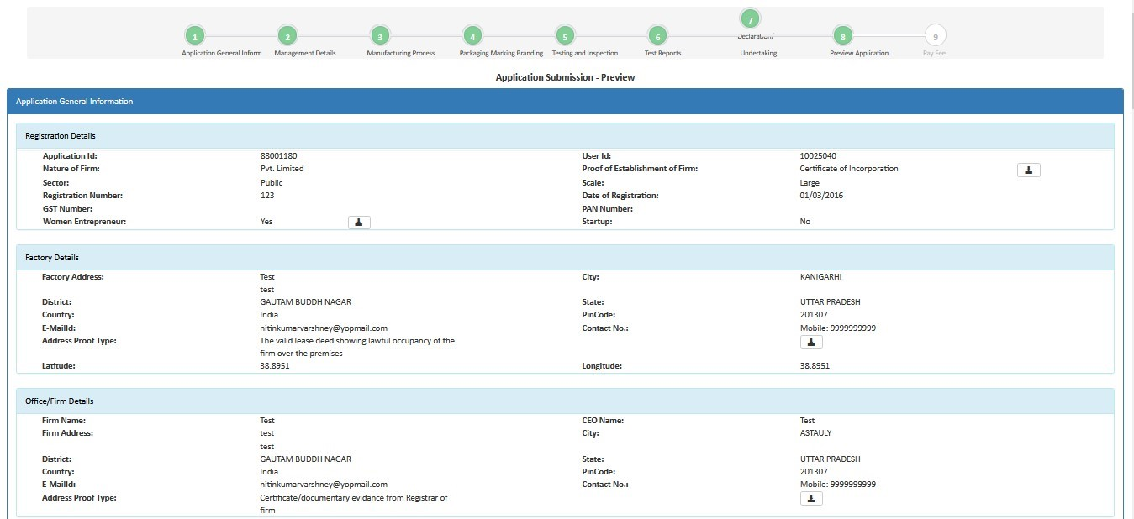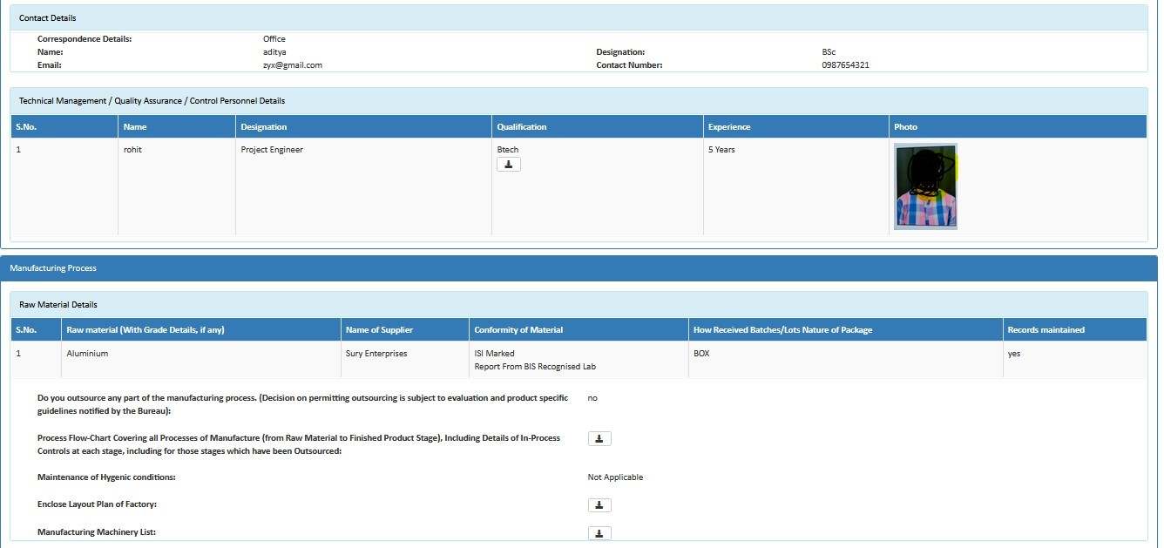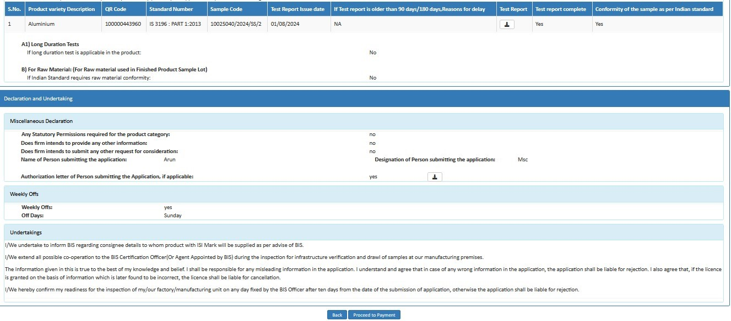

Fig.34
- Step 35: Later an Application Fee and Contact BIS page will open. Here select the payment mode, agree to the terms and conditions and click on ‘Proceed to Payment’ button as shown in Fig.35

- 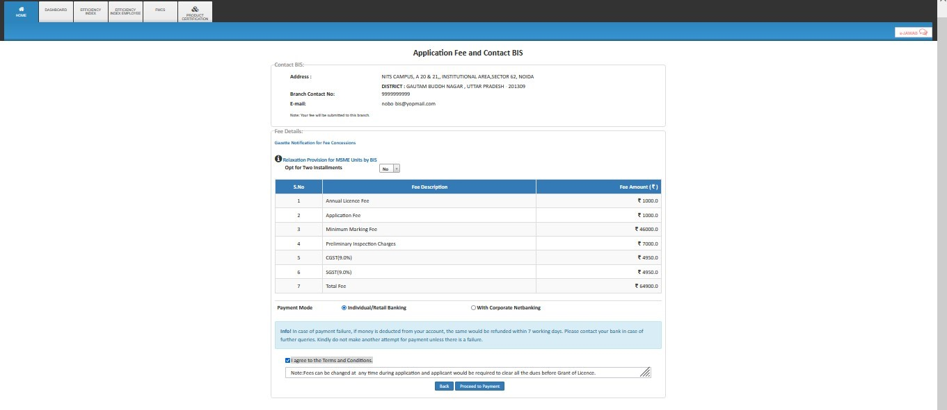

Fig.35
-  
- ➢ Applicant can select any one of the Retail Banking or Corporate Banking payment mode

- Step 36: Then on Online Payment page go through the all the instructions regarding transaction charges and click on Pay Now as shown in Fig.36

- 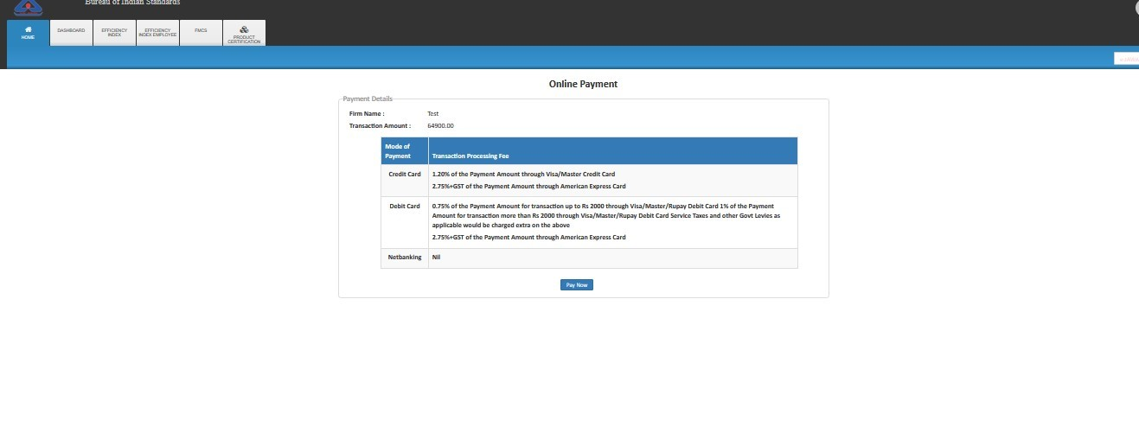

Fig. 36

- Step 37: After completion of payment Go to Home Screen >> Product Certification >> check under Submitted Application as shown in the Fig.37
- 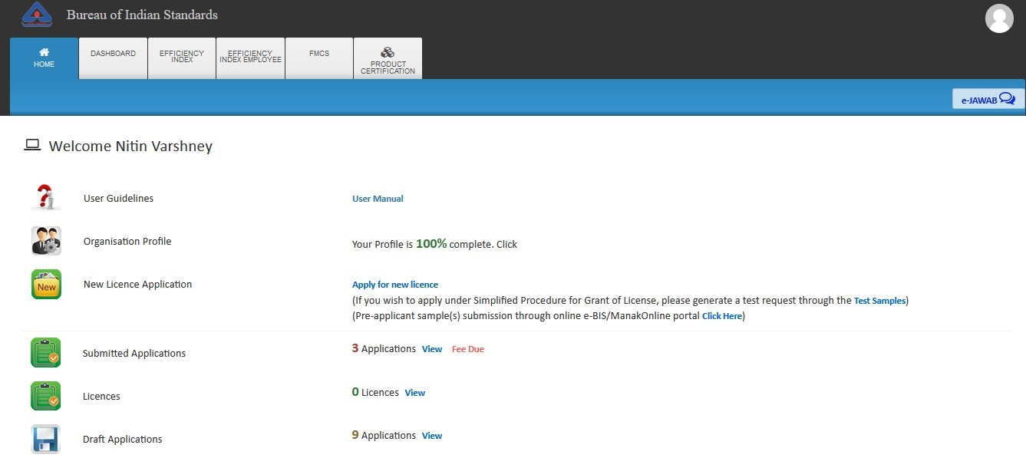

- Fig. 37

- GST Implementation
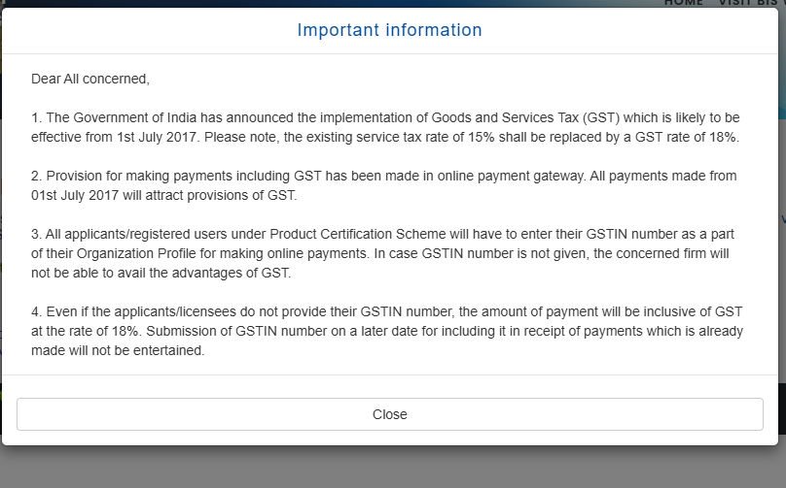

- FAQs
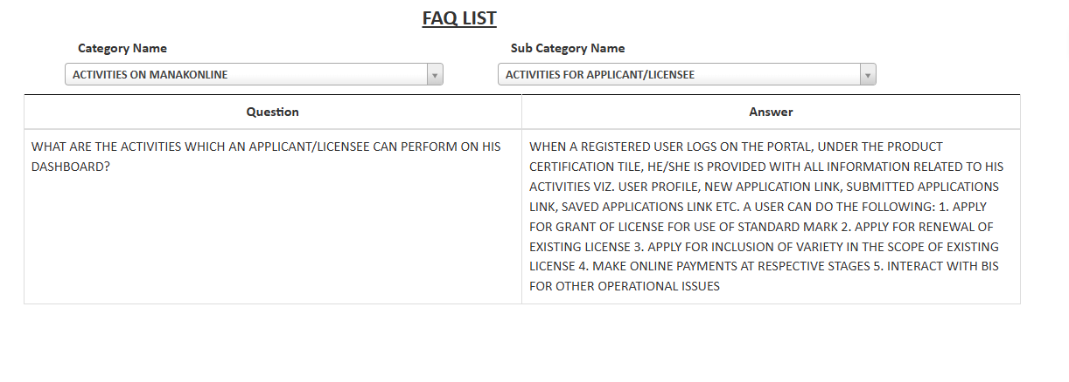
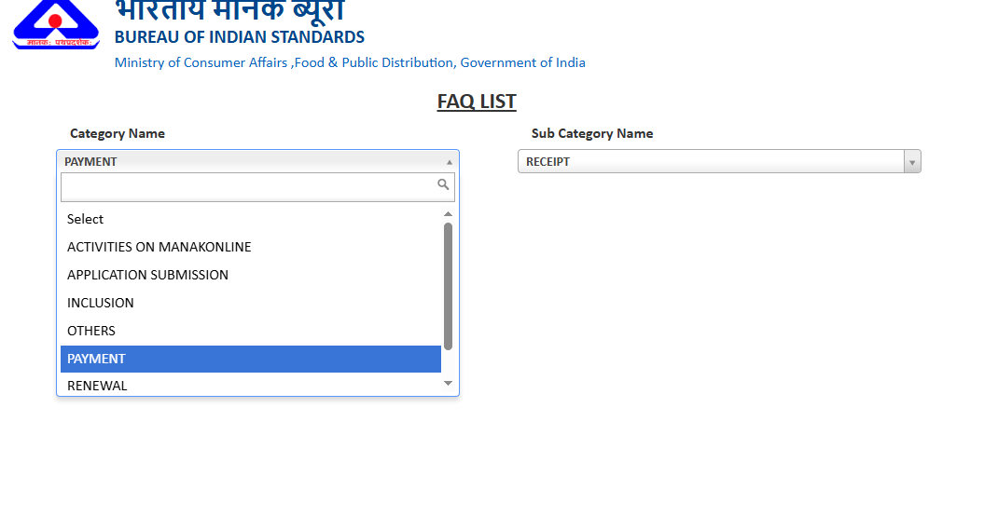

- Product Certification Application Form Template

