Product certification

Q 1 What is a licence?
A. Licence means a licence granted under Section 13 of BIS Act 2016 to use a specified Standard Mark in relation to any goods or article which conforms to a standard.[bis.gov]

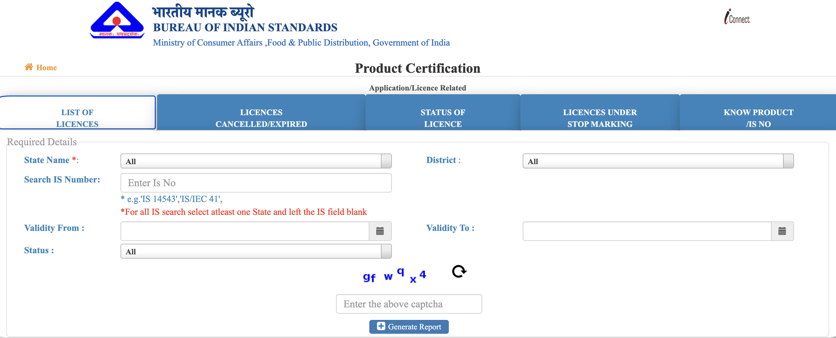
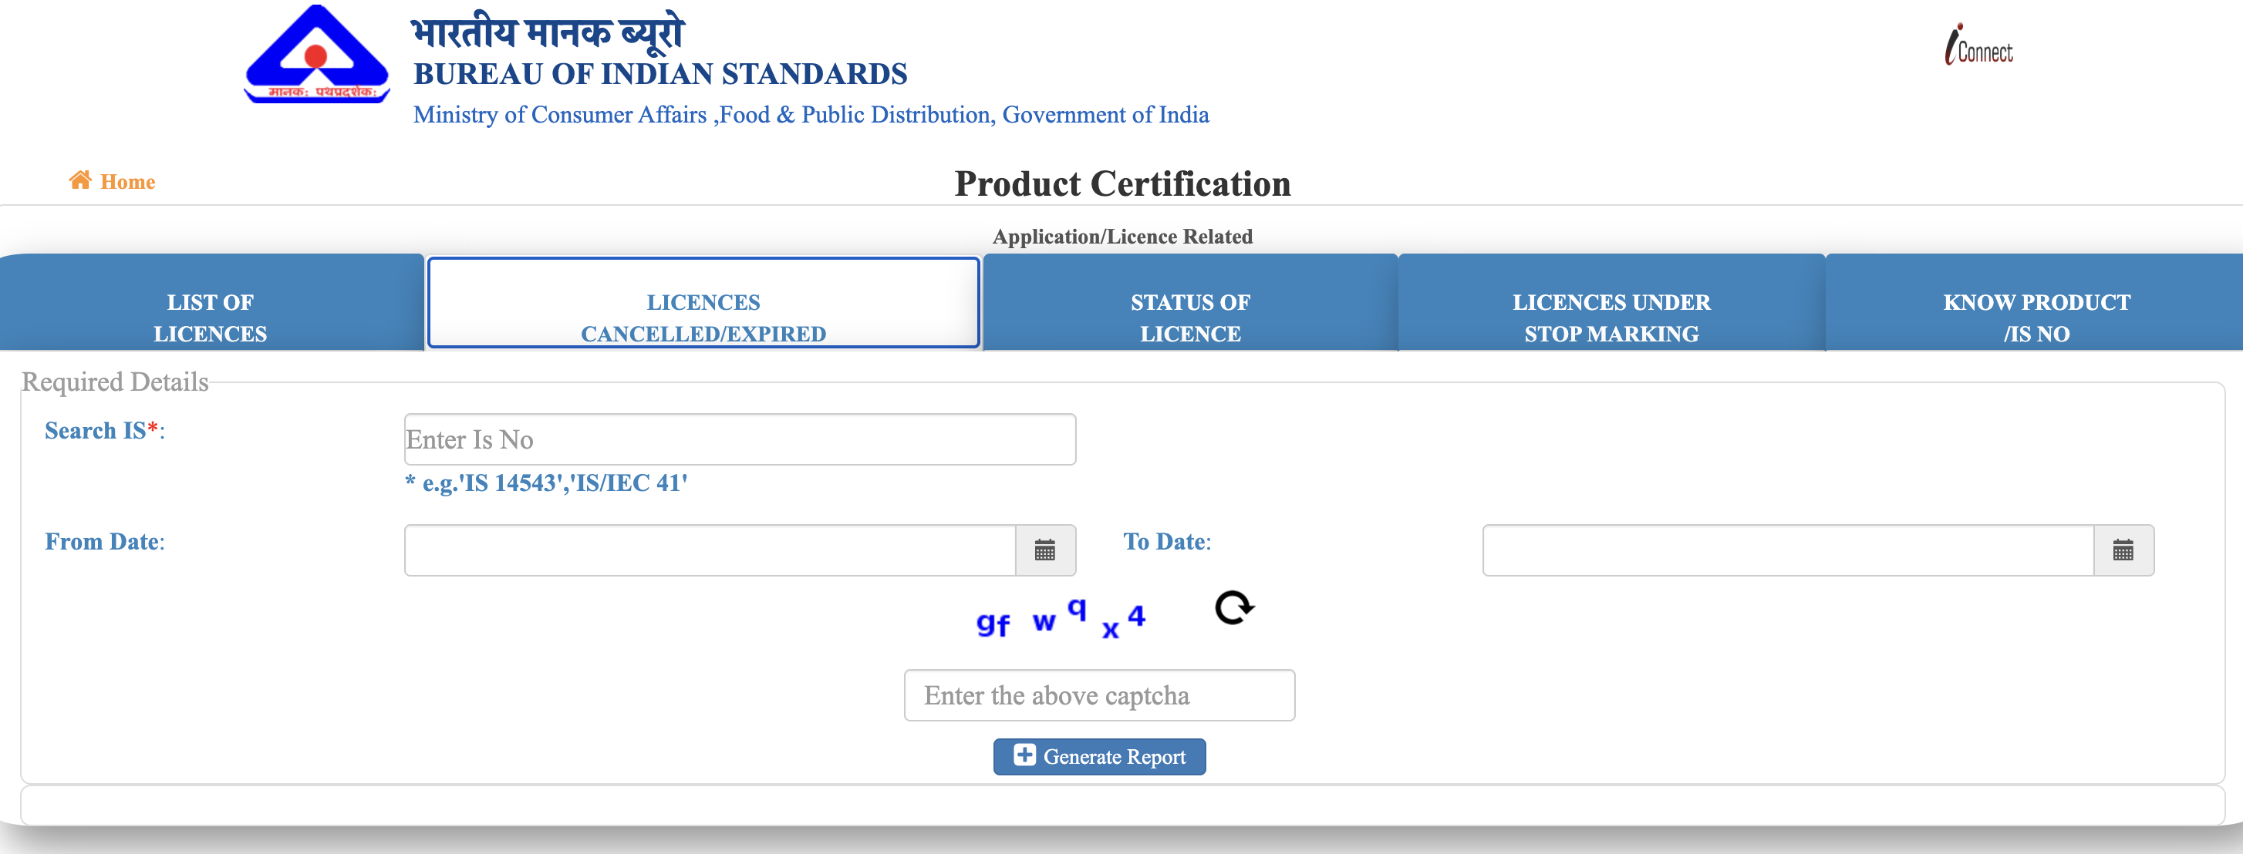
Q.2 I am a manufacturer of a product and interested in applying for BIS product certification licence. How should I apply for it when I am not aware of corresponding Indian Standard Number?
A. You can search for the Indian Standard against a product at the URL: https://www.manakonline.in/MANAK/ApplicationLicenceRelatedrpt. If you cannot find the relevant Indian Standard, send a query to the concerned technical department of BIS at https://www.bis.gov.in/php/BIS/biswebsite/standards/technical-departments/.[bis.gov]

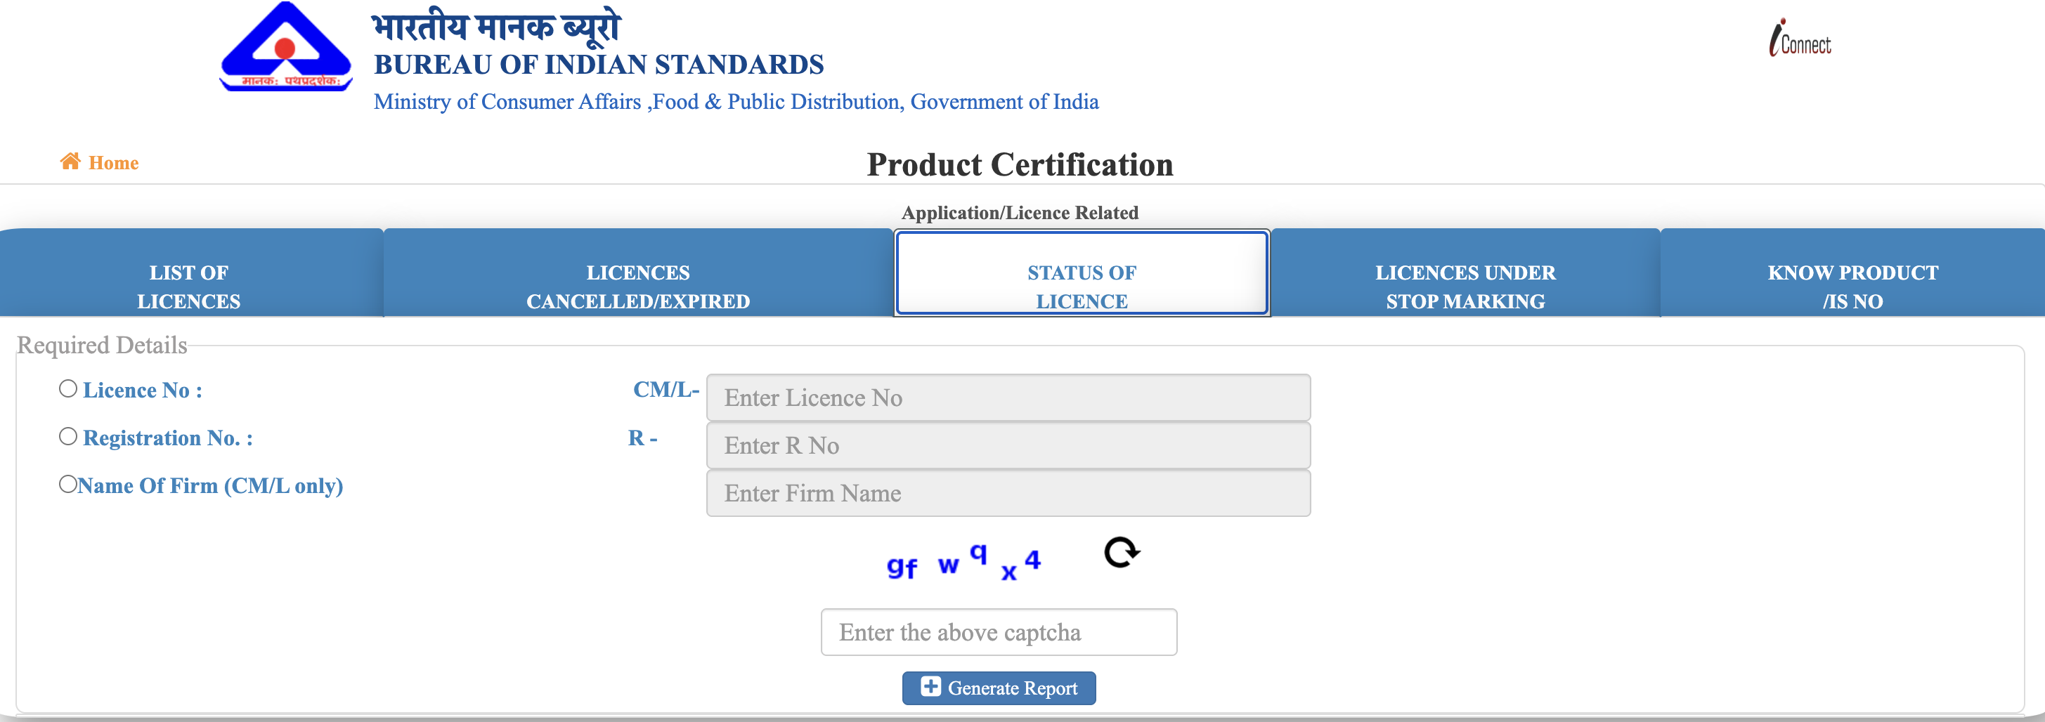
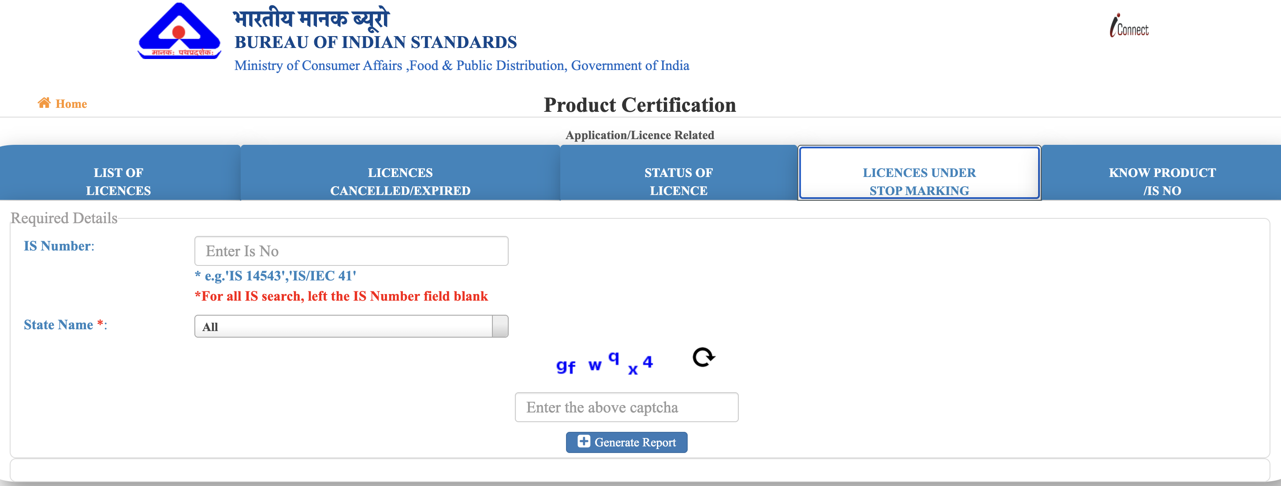
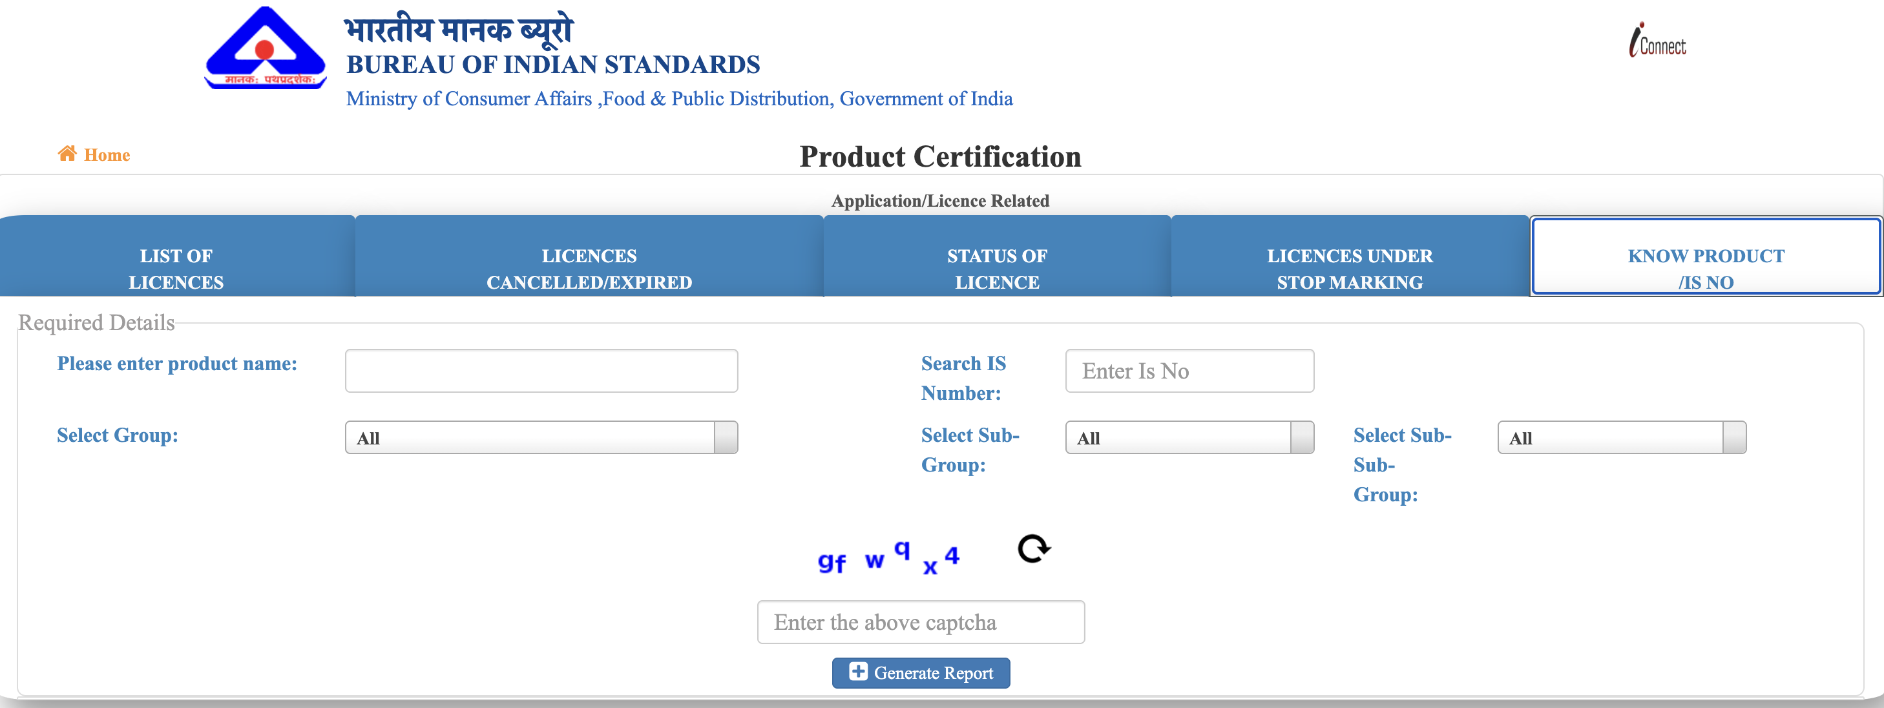
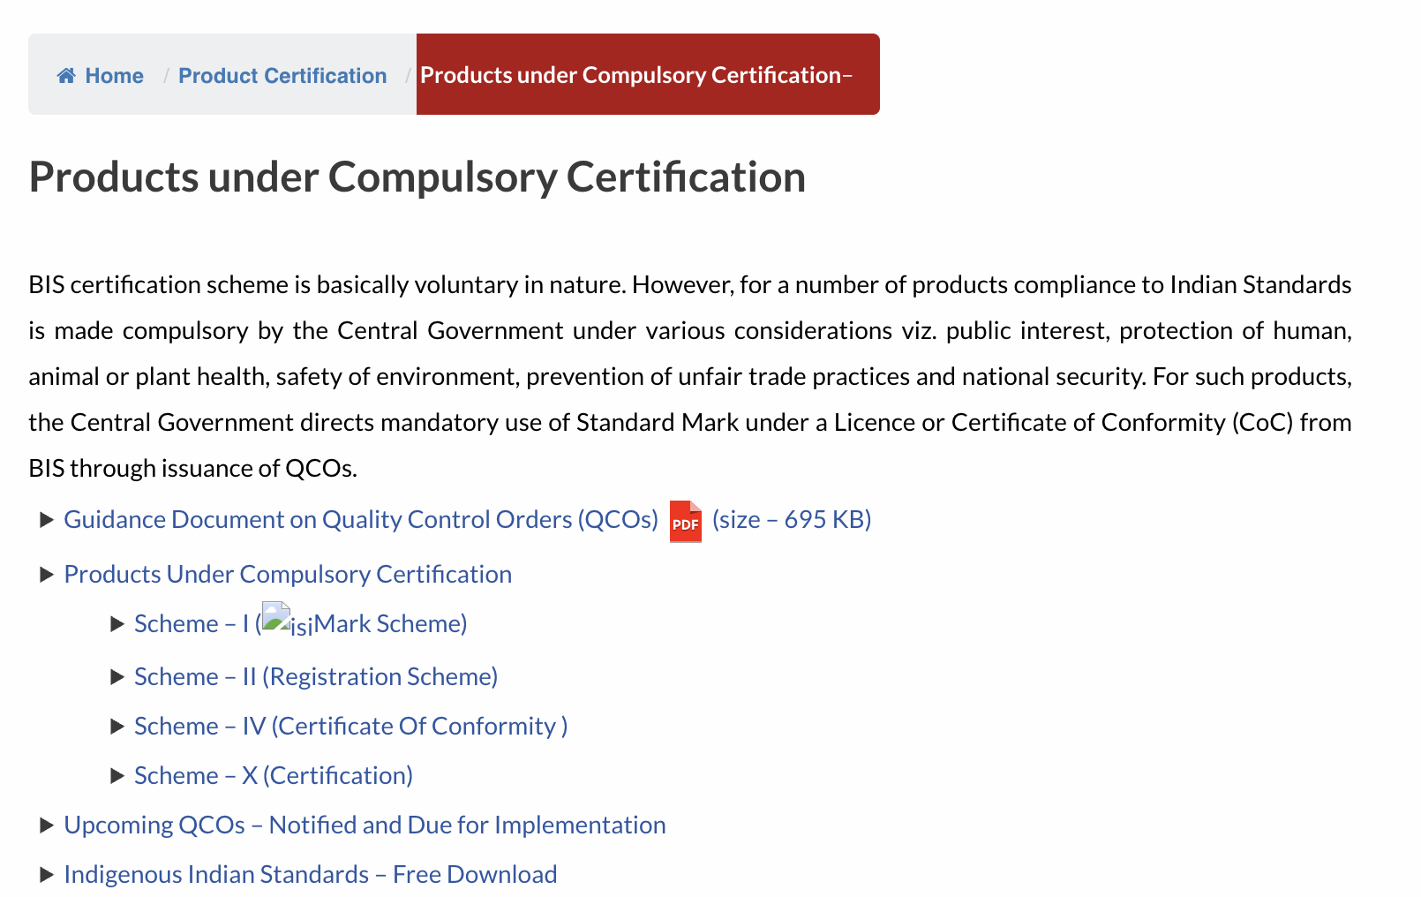
Q.3 For which products, the BIS licence is compulsory? Or I am manufacturing a product. Is it compulsory to get BIS licence for my product?
A. Products are brought under compulsory certification by the Central Government as per the provision of BIS Act, 2016 or other Acts. Detail of products covered under compulsory BIS certification is available at https://www.bis.gov.in/product-certification/products-under-compulsory-certification/. If your product is in this list, it is compulsory to get a BIS licence for it.[bis.gov]
Guidance Document on Quality Control Orders (QCOs)
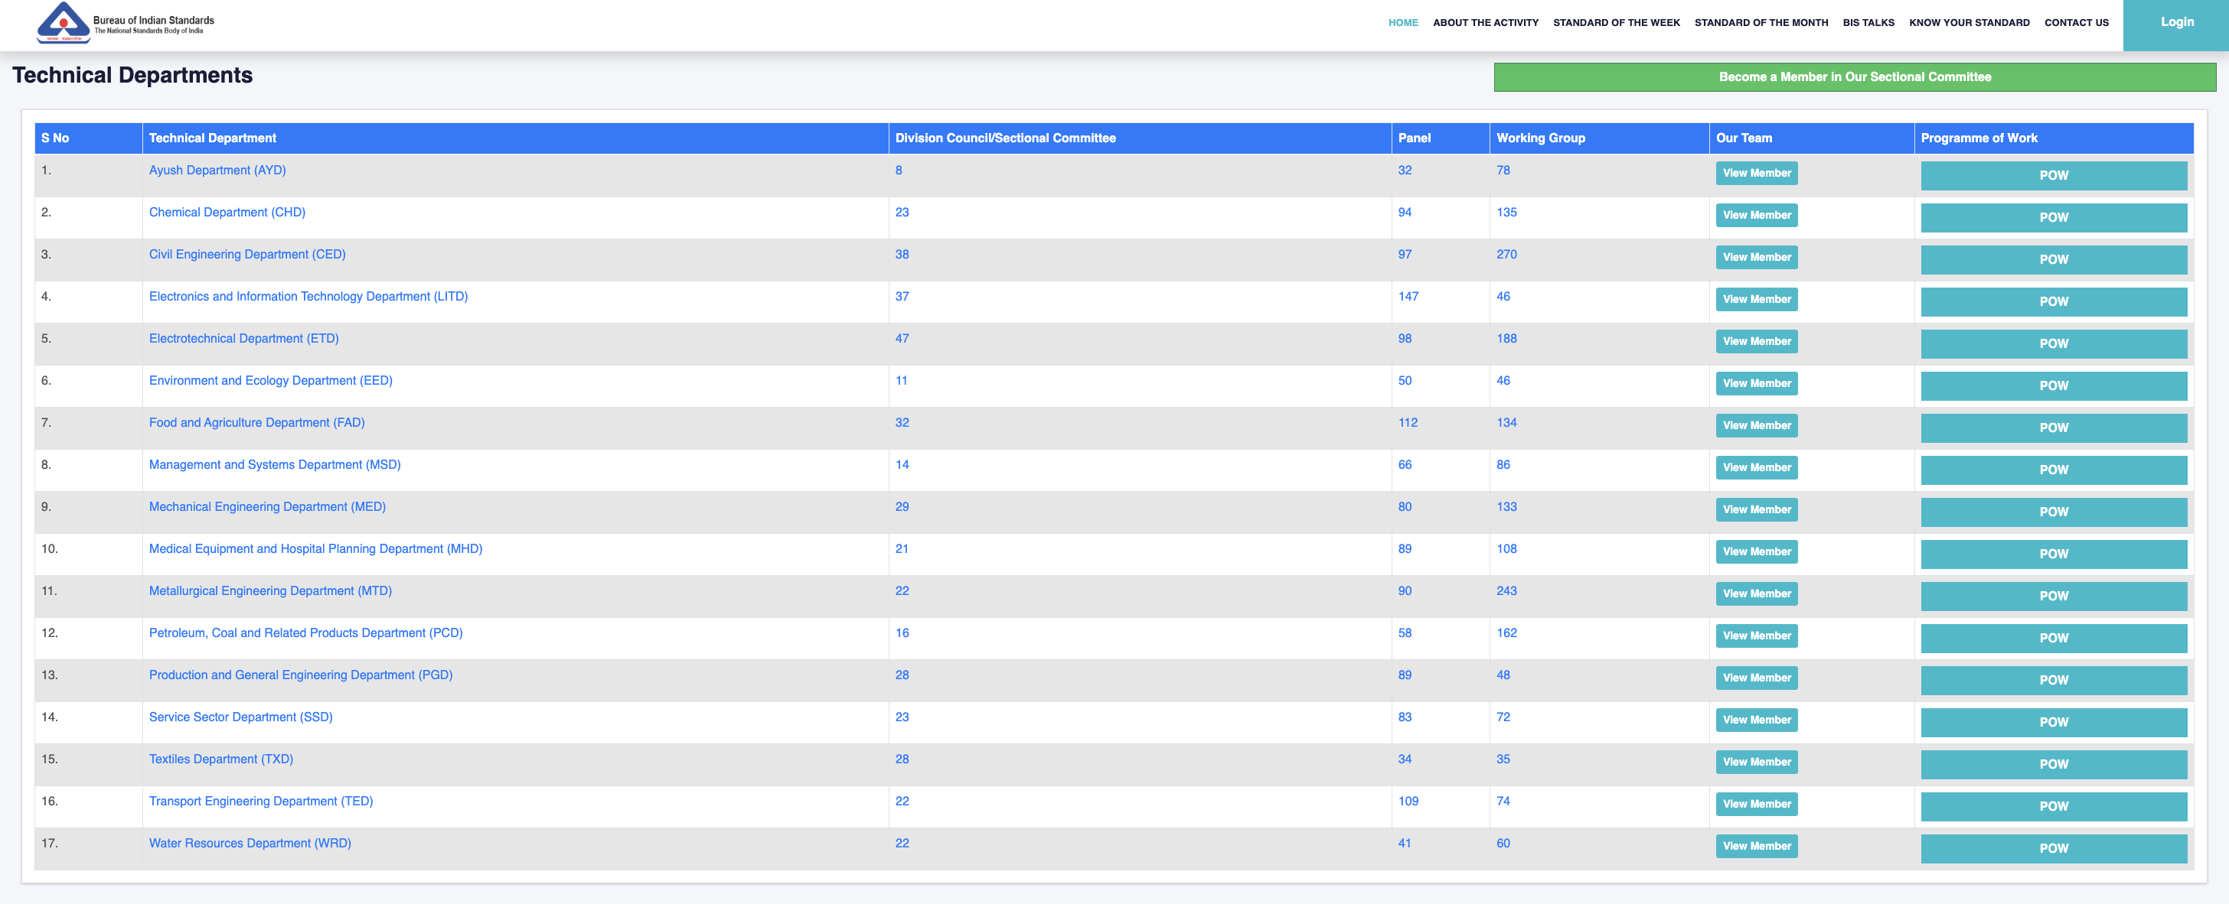
About this Guidance Document: This guidance document provides for easy comprehension of Quality Control Orders (QCOs) and explains various requirements specified in QCOs for better understanding towards implementation by the stakeholders.
QUALITY CONTROL ORDERS
1. Overview of QCO
1.1 Bureau of Indian Standards (BIS), the National Standards Body of India is engaged in the activities of Standardization, Conformity Assessment and Quality Assurance of goods, articles, processes, systems and services. The Indian Standards established by BIS forms the basis for the Product Certification Schemes, which provides Third Party Assurance of Quality, Safety and Reliability of products to consumers.
1.2 Thrust on Mandatory Certification
1.2.1 BIS certification scheme is basically voluntary in nature. However, for a number of products compliance to Indian Standards is made compulsory by the Central Government under various considerations viz. public interest, protection of human, animal or plant health, safety of environment, prevention of unfair trade practices and national security. For such products, the Central Government directs mandatory use of Standard Mark under a Licence or Certificate of Conformity (CoC) from BIS through issuance of QCOs.
2. Provisions of the BIS Act
2.1 The Central Government, after consulting BIS, publishes QCOs in exercise of the powers conferred by sub-sections (1) and (2) of section 16 read in conjunction with section 17 and subsection (3) of section 25 of the BIS Act, 2016 thereby bringing the products under BIS Mandatory Certification.
3. Conformity to Indian Standard and Compulsory use of Standard Mark
3.1 The products under QCOs shall conform to corresponding Indian Standard(s) mentioned in the QCO and shall bear the Standard Mark under a Licence or CoC from BIS as per the relevant Scheme of BIS (Conformity Assessment) Regulations, 2018 as notified in the Order.
4. Date of commencement
4.1 QCOs are issued by various Line Ministries (Regulators) under the Central Government depending upon the product(s)/ product categories being regulated through the Order, after having stakeholder consultations.
4.2 The date of commencement of the QCO is clearly emphasized in the Order itself so that the stakeholders are well aware of the timelines for its implementation in terms of necessary manufacturing and testing infrastructure and compliance of the product to the requirements of the relevant Indian Standard.
5. Prohibition Orders
5.1 After the date of commencement of the QCO, no person shall manufacture, import, distribute, sell, hire, lease, store or exhibit for sale any product(s) covered under the QCO without a Standard Mark except under a valid Licence or CoC from BIS.
6. Applicability on Imported Goods
6.1 Domestic Laws / Rules / Orders / Regulations applicable to domestically produced goods shall apply, mutatis mutandis, to imports, unless specifically exempted. If domestic product(s) are subjected to mandatory compliance with Indian Standards, such product(s) if imported would also need to comply with Indian Standards compulsorily. Thus, for these products, the manufacturer in foreign country will be required to obtain a Licence or CoC from BIS under the Foreign Manufacturers Certification Scheme (FMCS) of BIS.
7. Penalty for contravention of the provisions of QCO
7.1 Any person who contravenes the provisions of the Order shall be punishable under the provisions of sub-section (3) of section 29 of the BIS Act, 2016 with imprisonment or with fine or with both.
8. Exemptions from applicability of the Order
8.1 Any exemptions like non-applicability of the Order on specific product(s), product(s) meant for export etc. come under the purview of the Line Ministry (Regulator) who has issued the QCO. Wherever exemptions are permitted, these are clearly brought out in respective QCO itself.
9. Amendment / Revision of Indian Standards covered under QCO
9.1 The latest version of Indian Standards including the amendments issued thereof shall apply for implementing the provisions of QCOs. Whenever any amendment or revision is made to an Indian Standard covered under the QCO, such amendment or revision shall apply to the provisions of the QCO with effect from the date notified by BIS.
9.2 In such cases, BIS provides sufficient period for concurrent running of both the versions of Indian Standard (existing as well as revised). The licensee manufacturer shall changeover to the revised version of Indian Standard within the timelines notified by BIS from time to time.
10. Clarifications on QCO
10.1 If any person is having issues/queries/clarifications related to applicability of QCO on a particular product or implementation of QCO or any matters connected therewith or incidental thereto like extension in the date of implementation of QCO, exemptions, stock-in-hand as on the date of implementation of the Order etc., they may approach the concerned Line Ministry/Department of the Central Government that has issued the QCO.
10.2 If any person is having queries/clarifications related to coverage of any product under Indian Standard covered under QCO, they may approach BIS.
11. Role of BIS in implementation of QCOs
11.1 For the purpose of facilitating the Central Government in issuance of QCOs, BIS regularly interacts with Line Ministries/ Departments and provides technical inputs related to Indian Standards, appropriate Conformity Assessment Scheme etc. and also participates in stakeholder’s consultation meeting.
11.2 Further, for implementation of the provisions of QCO, BIS acts as the Certification Authority and grants Licence or CoC to manufacturers as per relevant Conformity Assessment Scheme. BIS also acts as the Enforcement Authority for the products specified in the QCO.
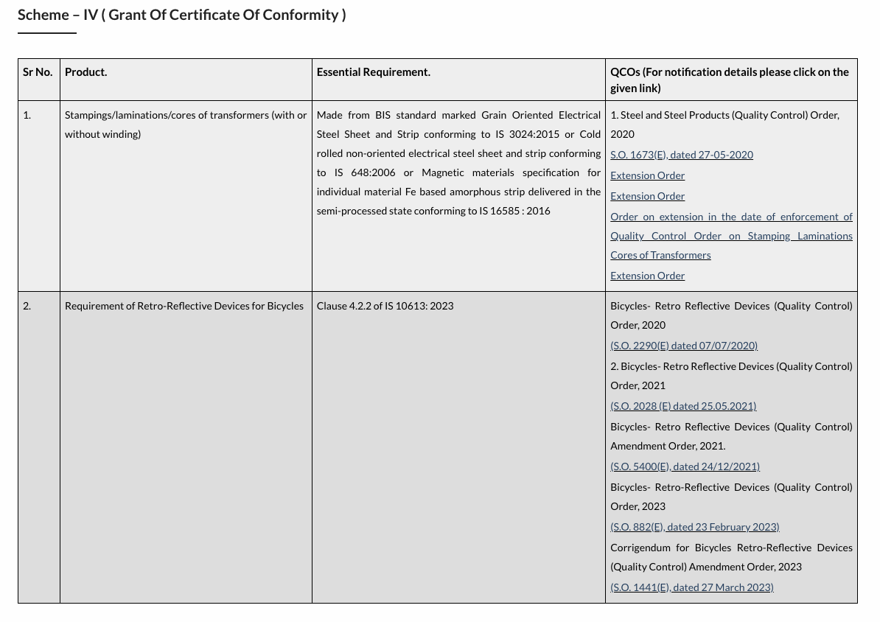
12. Information on QCOs
12.1 The information on QCOs issued by the Central Government can be obtained from BIS website under the following link Conformity Assessment -> Product Certification -> Products under Compulsory Certification.
Indigenous Indian Standards – Free Download

Q.4 What are the essential requirements to be possessed by a manufacturer for applying to BIS for obtaining licence?
A. For obtaining BIS licence, the manufacturer must have requisite manufacturing infrastructure, appropriate process controls, quality control and testing capabilities for the product as per relevant Indian Standard (ISS). The product shall also conform to all requirements laid down in the ISS.[bis.gov]

Q.5 How BIS grants the licence?
A. The Bureau grants the licence based on successful assessment of the manufacturing infrastructure, process controls, quality control and testing capabilities of the manufacturer through a visit to its manufacturing premises. Conformity of the product to the relevant standard(s) is also established through third party laboratory testing or testing in the manufacturing premises or a combination of both.[bis.gov]

Q.6 What is the procedure for obtaining BIS licence for use of BIS Standard Mark?
A. There are two options available for obtaining BIS product certification licence under Scheme – I. For details, please see Guidelines for grant of licence.[bis.gov]

Q.7 Where do I submit my application? or How can I apply for getting BIS licence for use of BIS standard mark (ISI) on the product?
A. BIS accepts application for product certification in online mode only, including all payments. To submit your application, please visit the online portal, www.manakonline.in. Before registering in the portal, you are advised to go through the applicant user manual and FAQs related to the portal at https://www.manakonline.in/MANAK/impLinks.[bis.gov]
System certifications

Q.7 Where do I submit my application?or How can I apply for getting BIS licence for use of BIS standard mark (ISI) on the product?
A.BIS accepts application for product certification in online mode only (including all payments). To submit your application, please visit our online portal, www.manakonlinein Before registering in the portal, you are advised to go through applicant user manual, FAQs related to portal at https://www.manakonline.in/MANAK/impLinks

ONLINE CERTIFICATION SERVICES

How to register as a user on this portal for online submission of application for grant of license, renewal of license, inclusion of varieties etc under Product Certification Scheme:-

- Normal Procedure (option-1 of Scheme-I) Application User Manual
- Simplified Procedure (option-2 of Scheme-I) Application User Manual.
- GST Implementation
- FAQs
- Integrity Pledge for Licensee/Applicants of BIS Certification
- Product Certification Application Form Template

- Normal Procedure (option-1 of Scheme-I) Application User Manual
- Grant of License Process Flow
- Step 1: Enter the URL https://www.manakonline.in/MANAK/login in Mozilla Firefox web browser.
- Step 2: Click on the Conformity Assessment (Manakonline) tab as shown in (Fig.1)
- 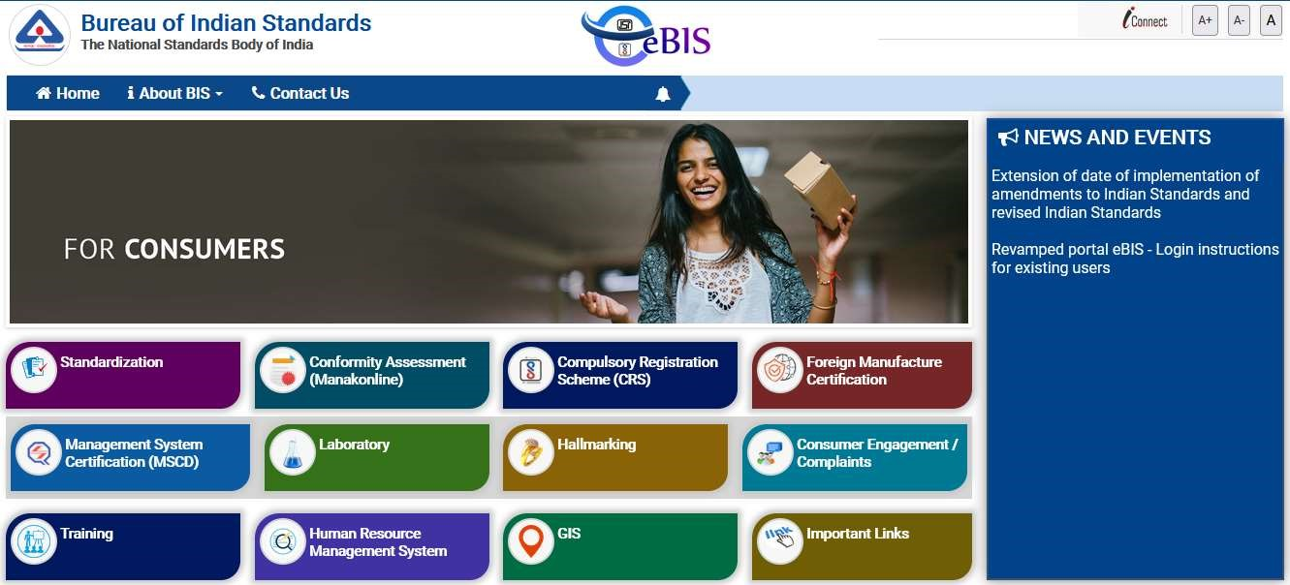
(
Fig.
1)
- Step 3: Click on LOGIN tab as shown in (Fig.2)
- 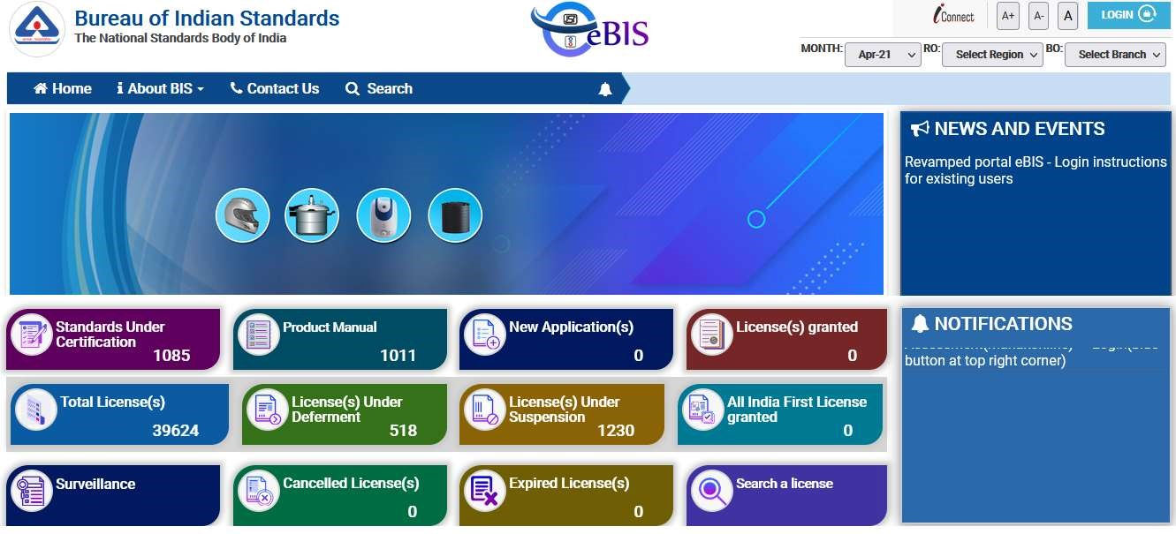
- (Fig.2)
- Step 4: Enter the Username, Password, Captcha and click on Sign in tab as shown in (Fig.3)
- 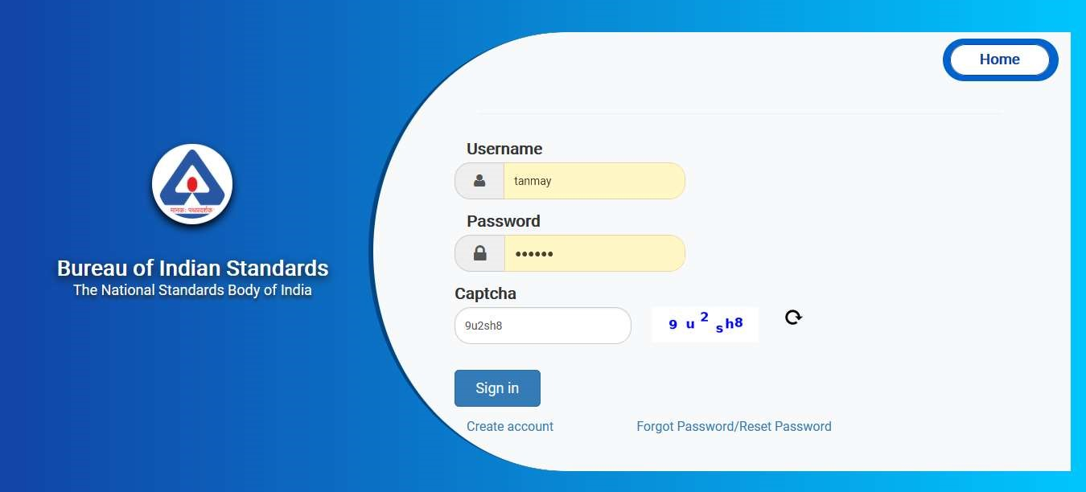
- (Fig.3)
- Step 5: Click on the Product Certification as shown in (Fig.4)
- 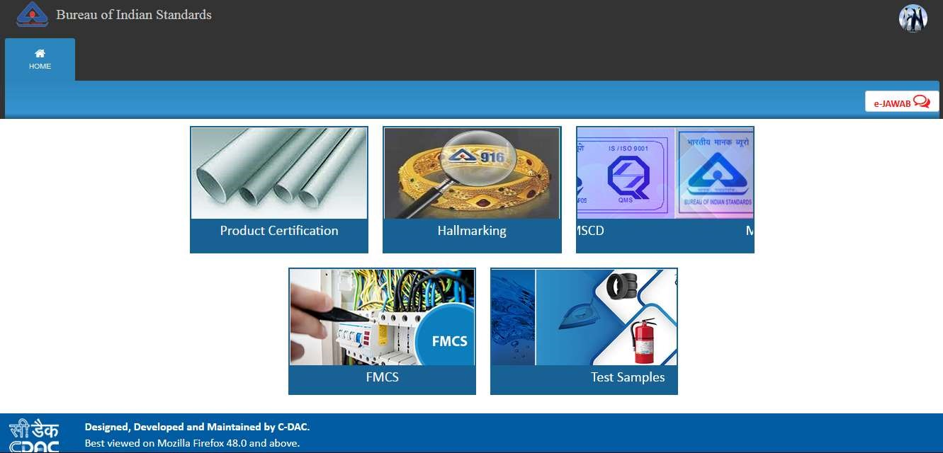
- (Fig.4)
- Step 6: Click on ‘Here’ link against Organization profile to fill the same as shown in (Fig.5)
- 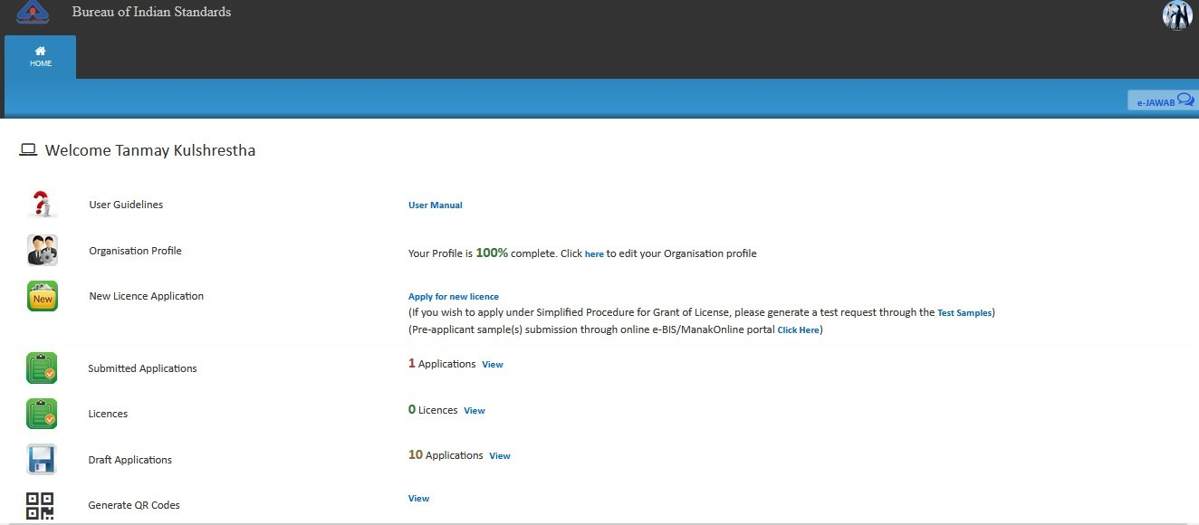
- (Fig.5)
- Step 7: In case you have not entered your organisation profile, please fill up the organisation profile.
- 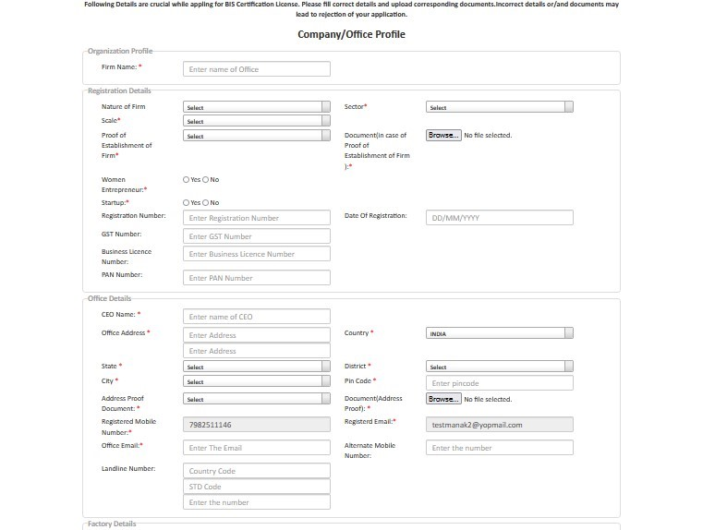
- 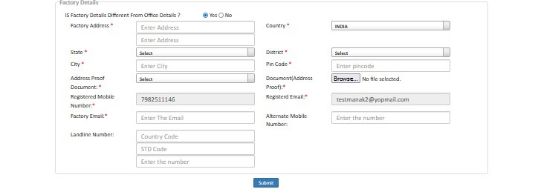
- (Fig.6)
- Step 8: After filling all the details of the profile, click on the ‘Submit’ button as shown in (Fig.7)
- 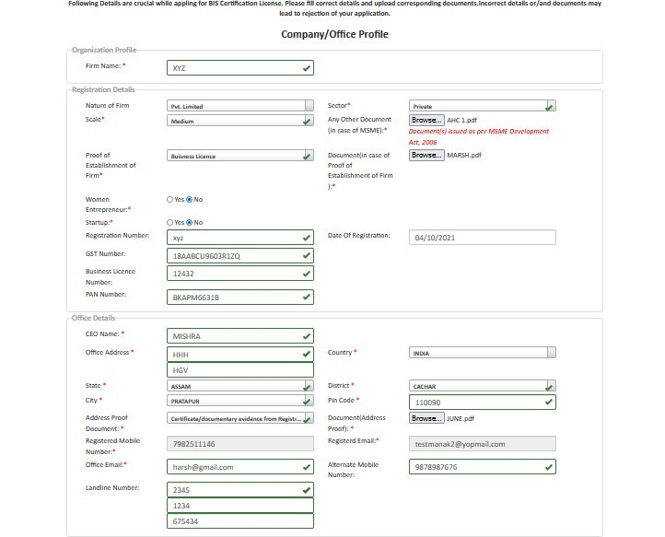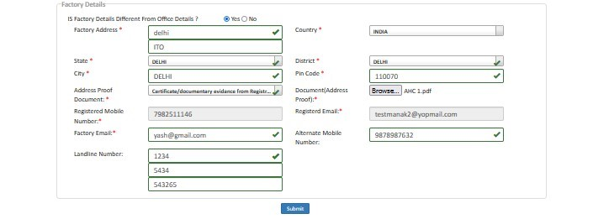
- (fig.7)
- Step 9: Then a success massage will reflect on your screen after successful updation of the profile as shown in (Fig.8)
- 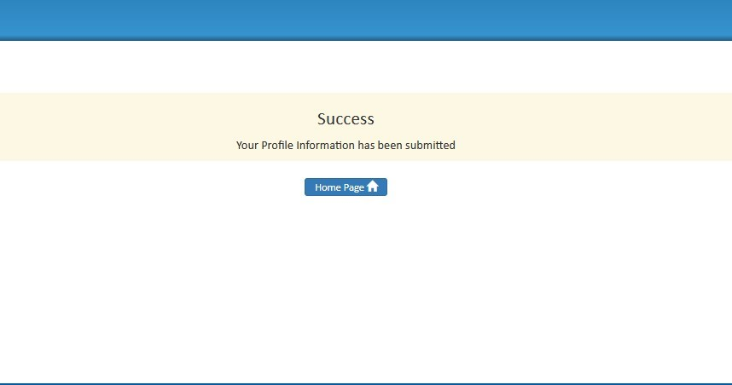
- (Fig.8)
- Step 10: You can apply for new license when the profile is updated. Click on the ‘Apply for New
- License’ link as shown below in (Fig.9). Before filling the application, please go through the guidelines provided by BIS for Grant of License. These can be accessed through following path:
- Go to bis.gov.in > Conformity Assessment > Product Certification Process > Guidelines for grant of license
- (or click on the link- https://www.bis.gov.in/wp-content/uploads/2021/08/GoL-Guidelines-
- WebsiteHosting.pdf)
- 
- (Fig.9)
- Step 11: Then the application form will appear as shown in (Fig.10).
- 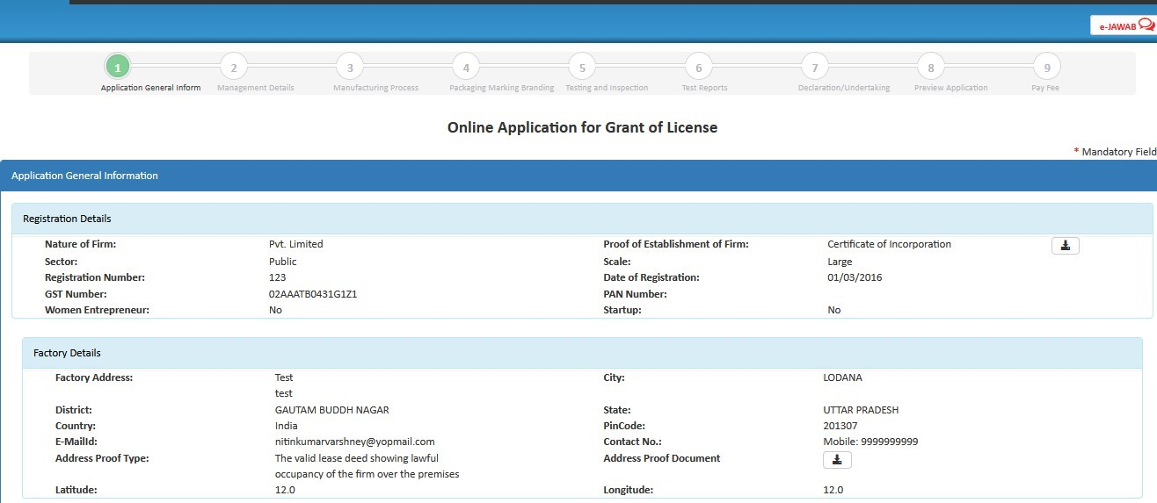
- (Fig.10)
- Step 12: Select option ‘Yes’ if you know the Indian Standard Specification (ISS) for the product against which license is sought and choose the standard accordingly as shown in (Fig.11) <Refer
- Guideline on the website for proper content>
- Provide the acceptance for Marking Fee and STI by clicking on the respective checkboxes and then select the Normal/Simplified procedure accordingly as shown in (Fig.11)
- 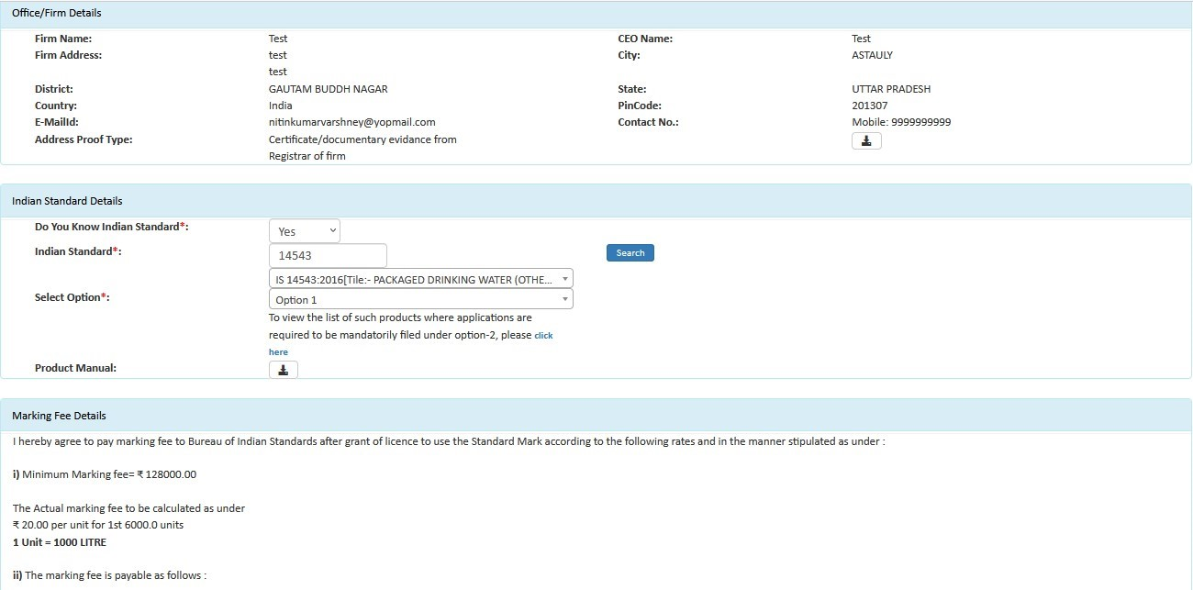
- (Fig 11)
- 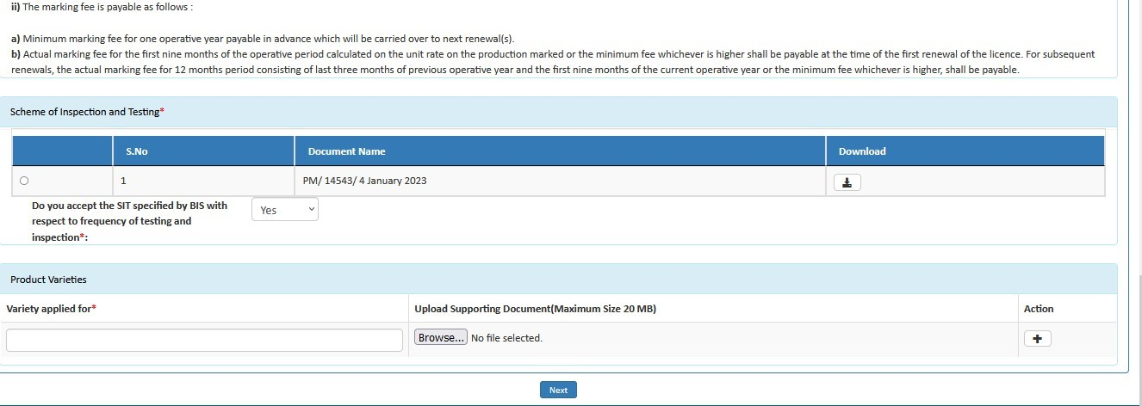
- Option 1 (Normal Procedure): After scrutiny of application is done, a factory visit is carried out and sample is drawn for testing. Once the testing is completed and a report is received, the Branch Office of BIS then process for the Grant of Licence. Sample(s) may not be drawn in case the Grant of Licence is to be consider on the basis of factory testing only.
- Option 2 (Simplified Procedure): The applicant has to submit a test report of their product along with the application. Once the application is submitted, a factory visit is carried out for the verification of manufacturing infrastructure, production process and quality control etc. And then the license may be processed for grant of license. The test report of the sample(s) drawn during the factory visit will be used for review purposes.
- Step 13: Fill the details of Top management, Technical management and Contact person (Fig.12)
- 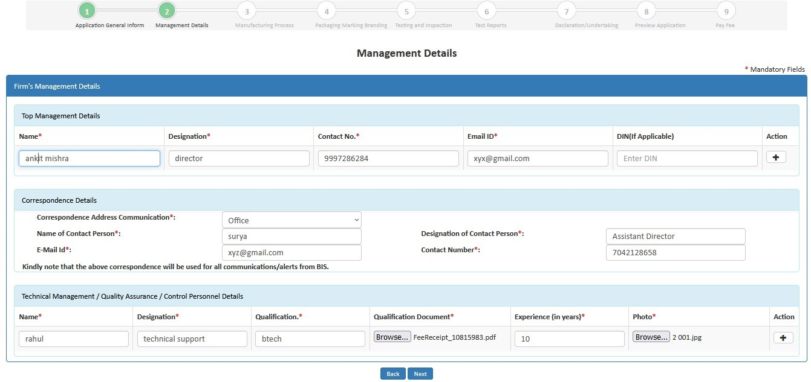
(
Fig
12)
- Step 14- Similarly, fill the details of ‘Testing Equipment’. Click on ‘Yes’ if you want to download the excel file, otherwise click on ‘No’.
- 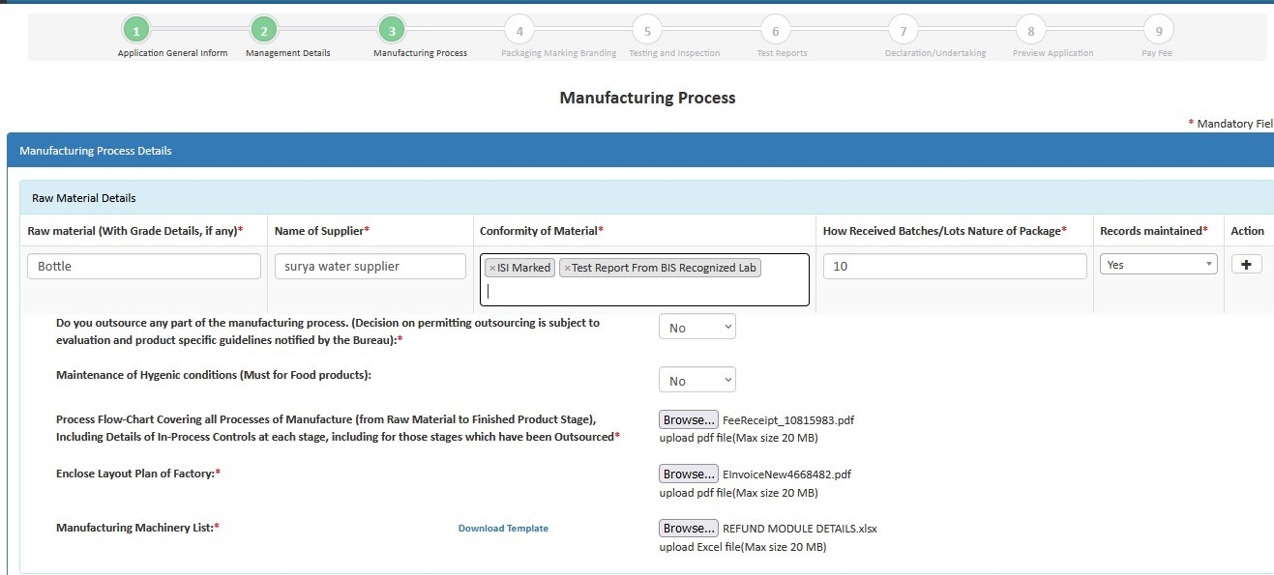
- ( Fig 13)
- Step 15: Then fill the production details, accept declarations and click on ‘Next’ to go to the next page as shown below in (Fig.14)
- 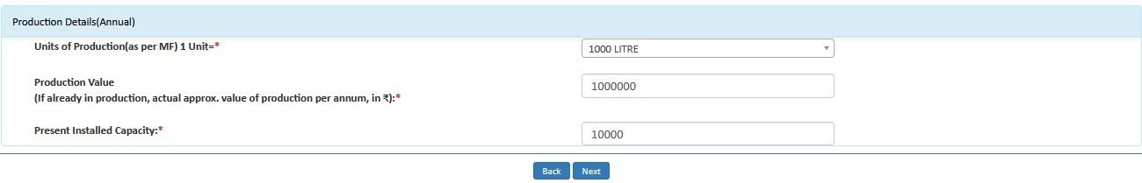
- Step 16: Fill the details of Brand details and click Next.
- 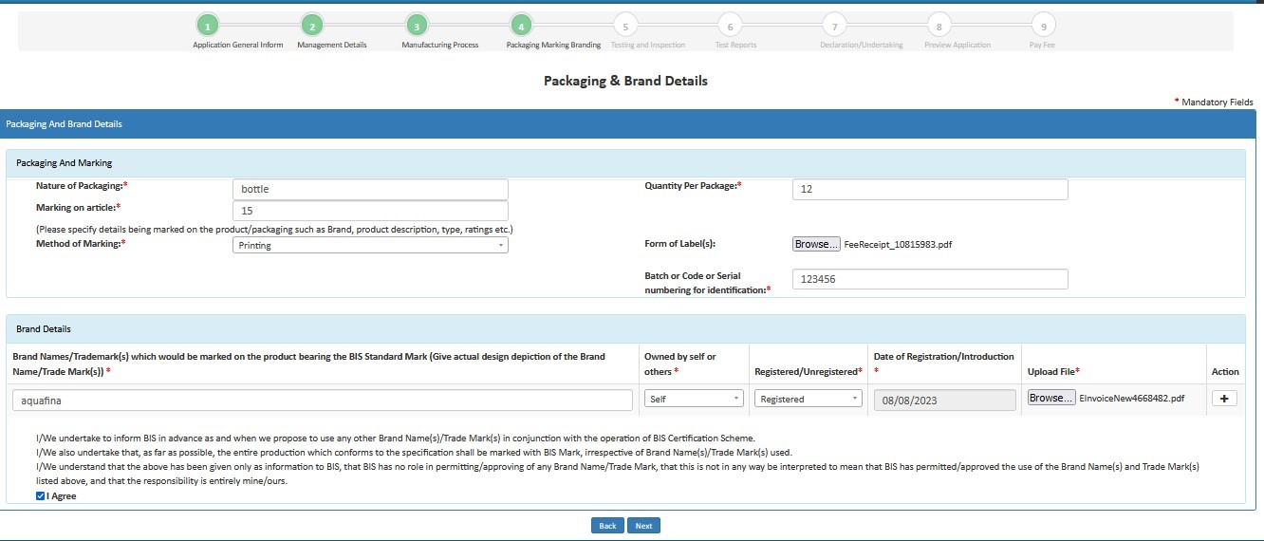
- ( Fig 15)
- Step 17: Fill Testing and Inspection Details as on (fig 16) then click Next Button
- 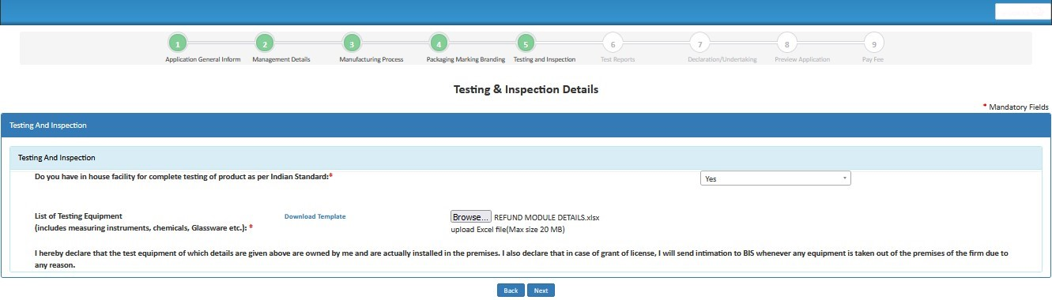
- (Fig 16)
- Step 18: Test Report Section as on (fig 17)
- 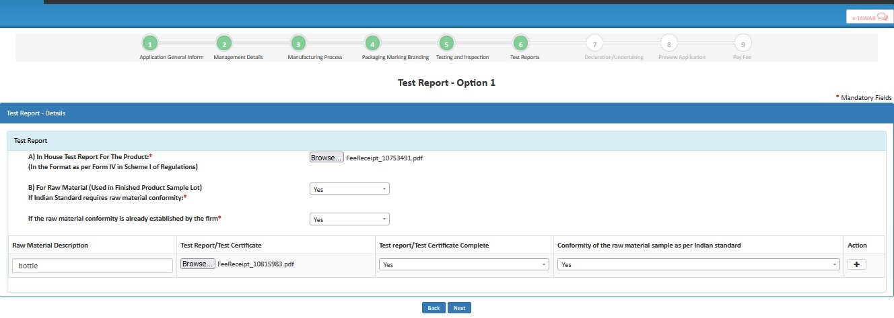
- (fig 17)
- Step 19: Fill Declaration & Undertaking then click on Next Button
- 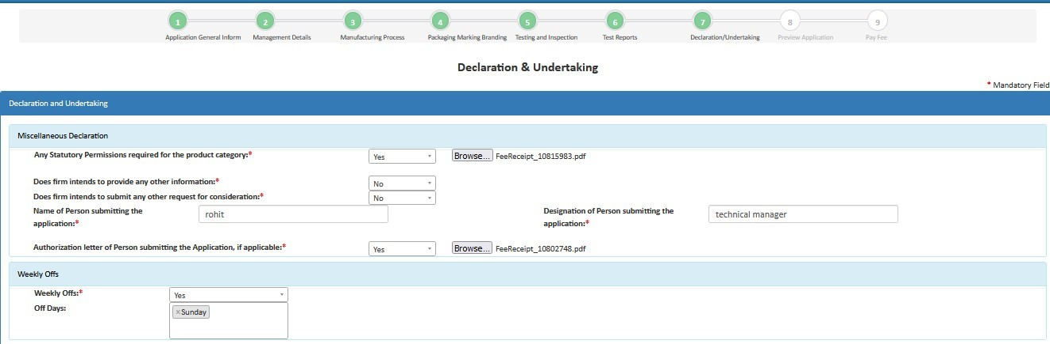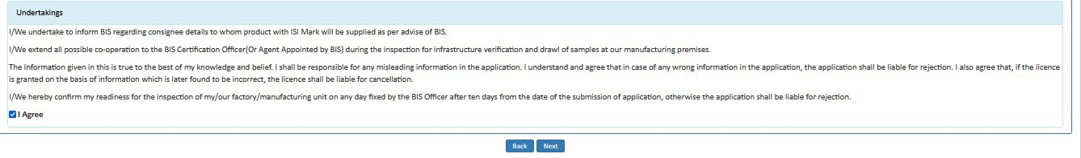
- (fig 18)
- Step 20 : Review Application Details
- 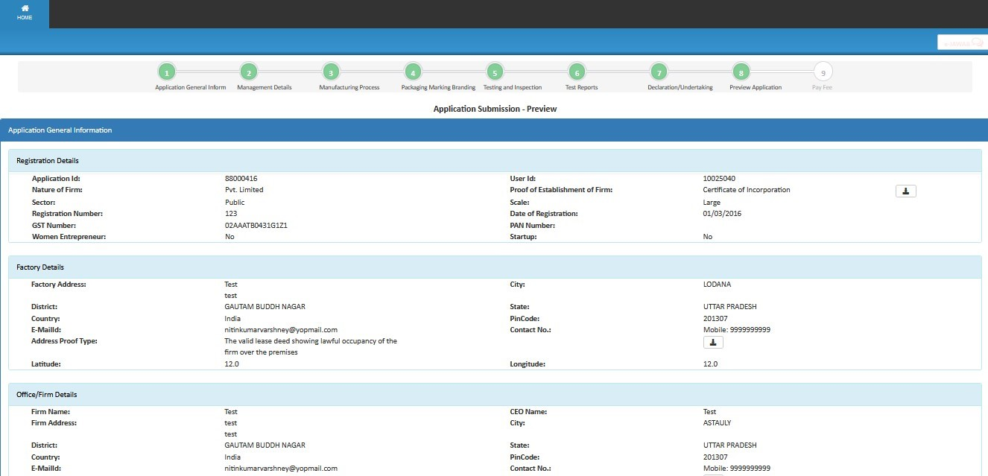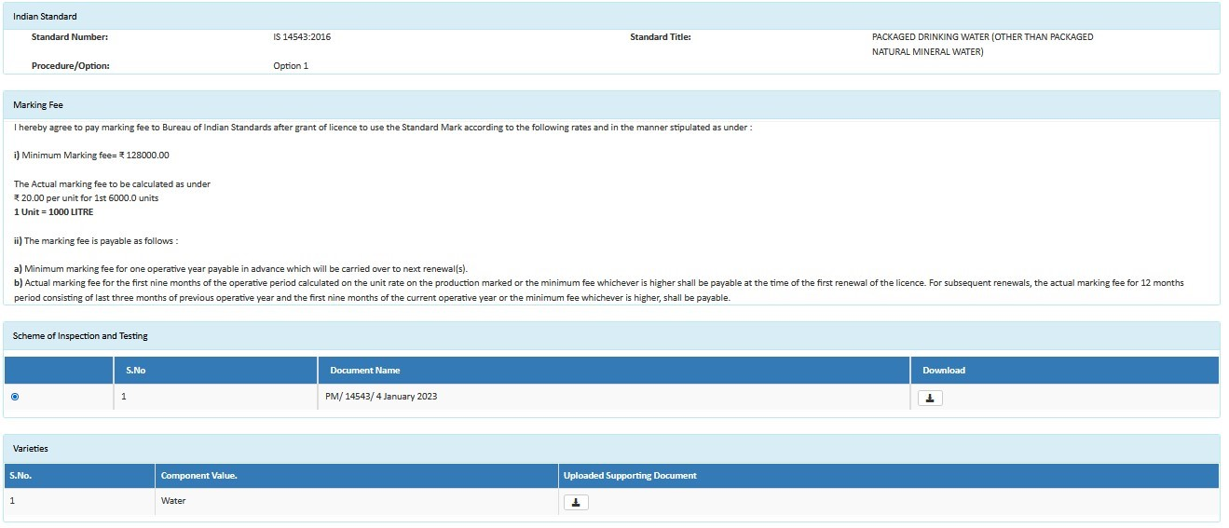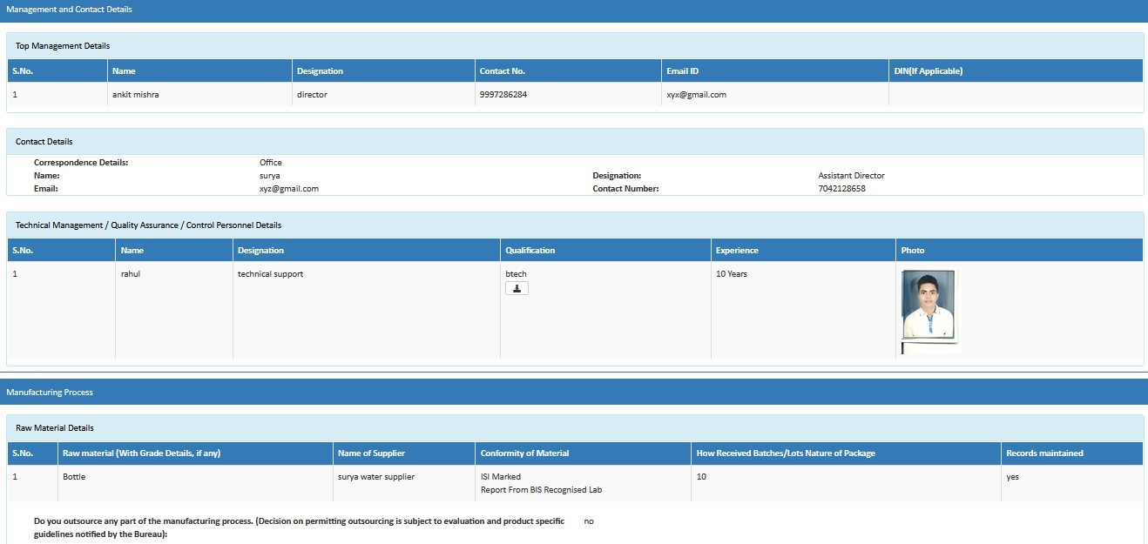
- 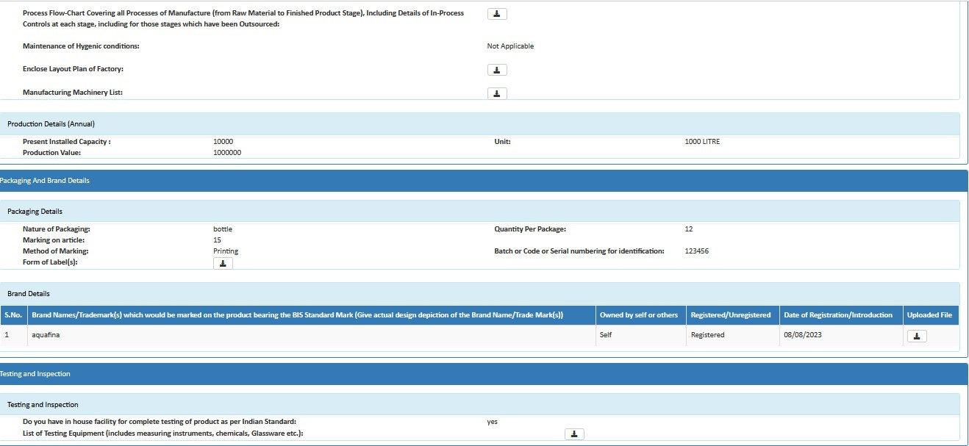
- 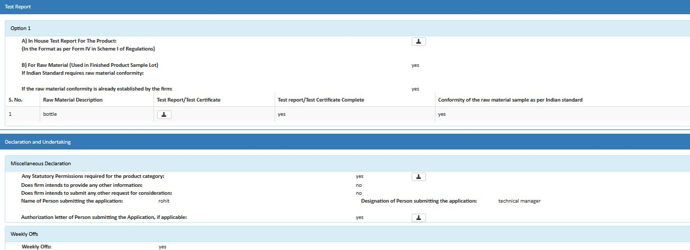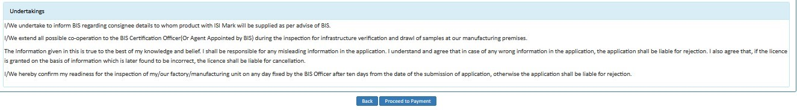
- (Fig 19) Step 21: Later an Application Fee and Contact BIS page will open. Here select the payment mode, agree to the terms and conditions and click on ‘Proceed to Payment’ button as shown in (Fig.20)
- 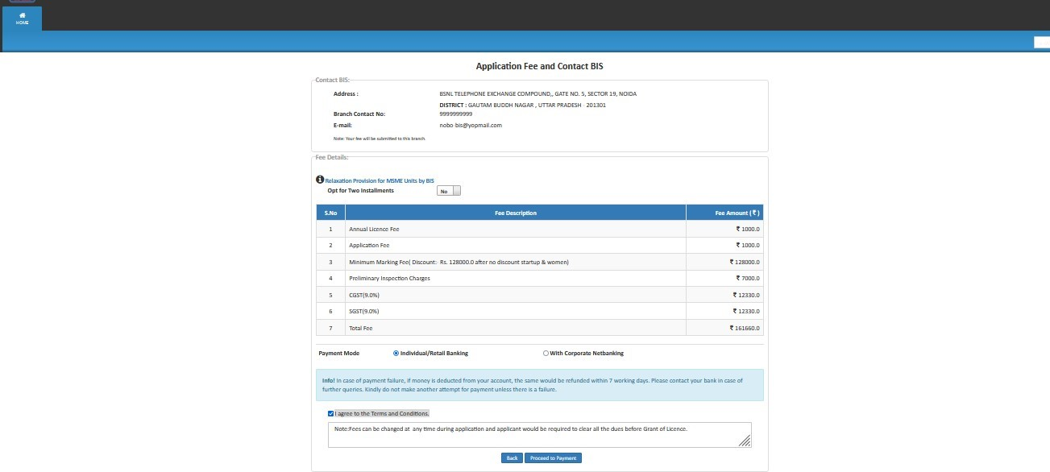
- (Fig 20)
- Ø Applicant can select checkboxes according to its preference
- Note: -Here Applicant has two payment modes:-
- · Individual/Retail Banking
- · With Corporate Banking
- Step 22: Then on Online Payment page go through the all the instructions regarding transaction charges and click on Pay Now as shown in (Fig.21)
- 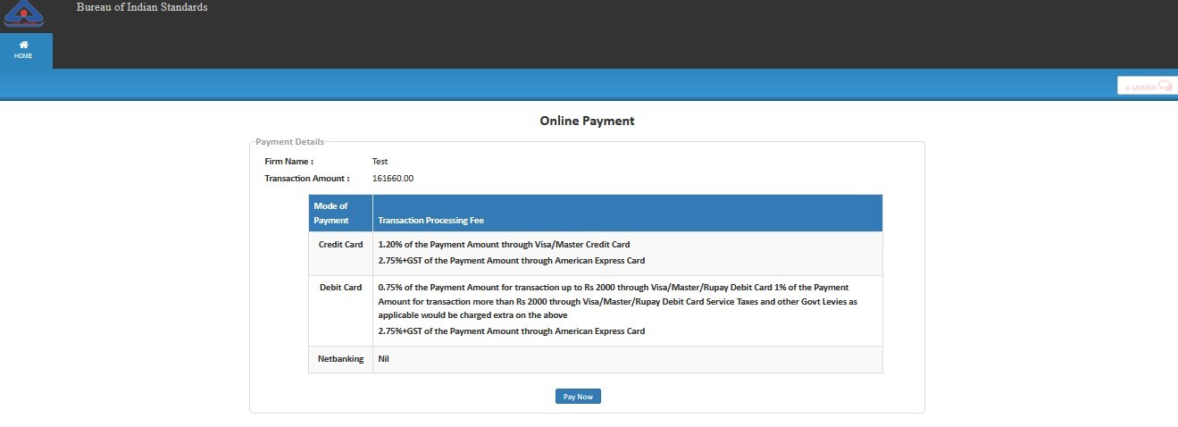
- (Fig 21)
- Step 23: Now, select the appropriate method and Make Payment as shown in
- (Fig.22)
- 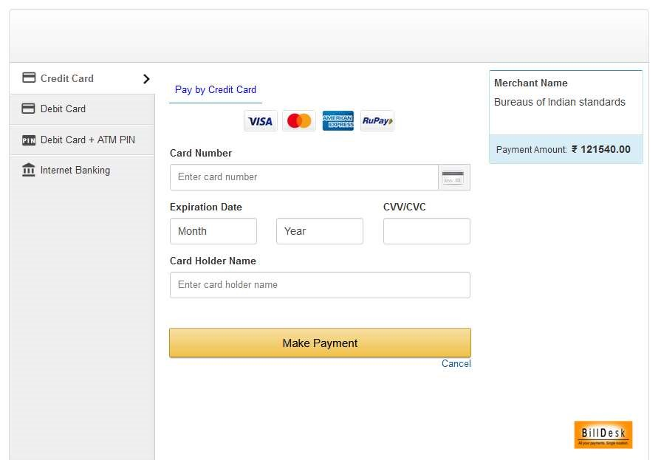
- (Fig 22)

- Simplified Procedure (option-2 of Scheme-I) Application User Manual.
- User Manual for Applying for Grant of License under Option 2
- (Simplified Procedure)

- Step 1: Enter the URL https://www.manakonline.in/MANAK/login in Mozilla Firefox web browser.
- Step 2: Click on the Conformity Assessment (Manakonline) tab as shown in Fig.1
- 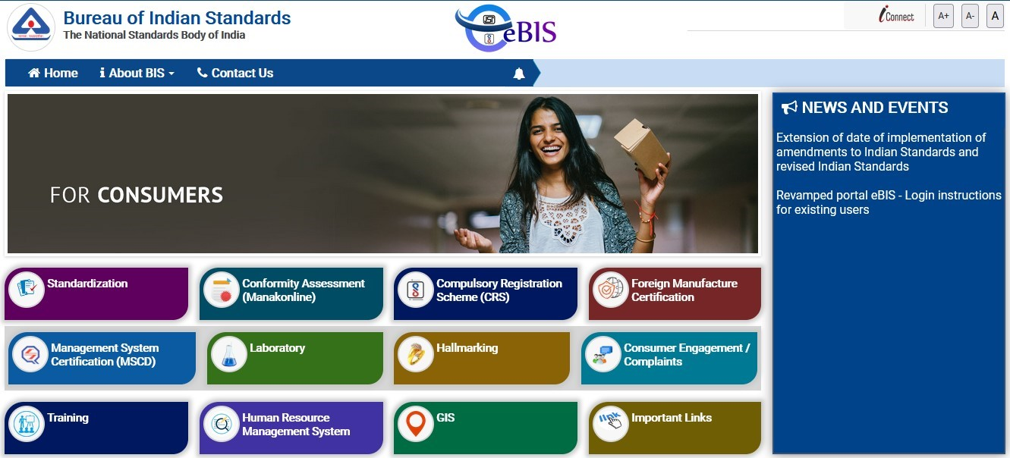

Fig.1

- 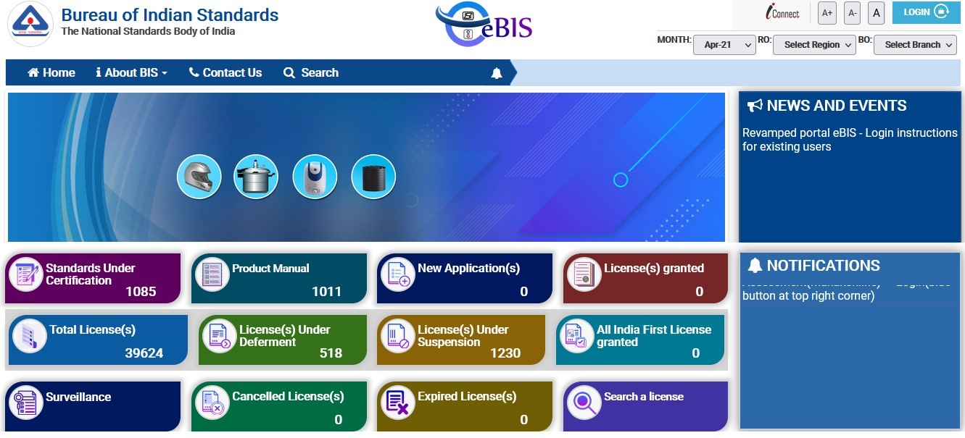
Step 3:

Click on LOGIN tab as shown in Fig.2

- Fig.2
- Step 4: Enter the Username, Password, Captcha and click on Sign in tab as shown in Fig.3
- 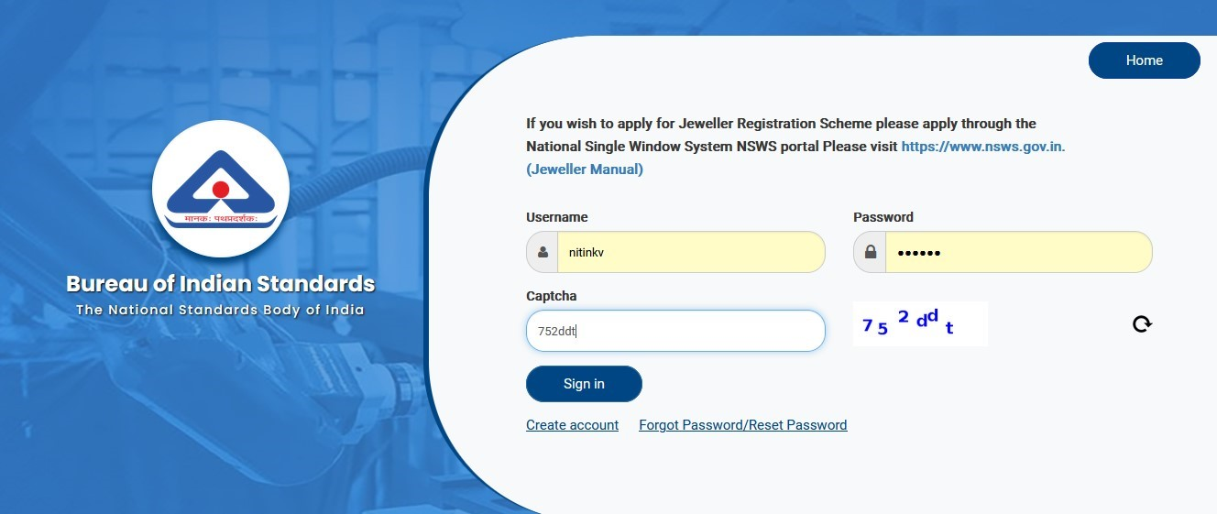

Fig.3

- Step 5: Click on the Product Certification as shown in Fig.4
- 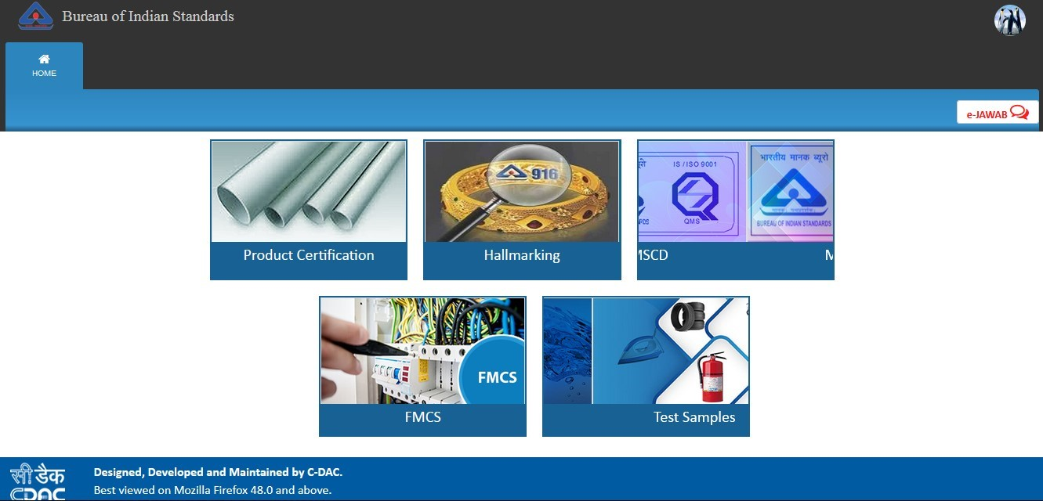

Fig.4

- Step 6: Click on ‘Here’ link against Organization profile to fill the same as shown in Fig.5
- 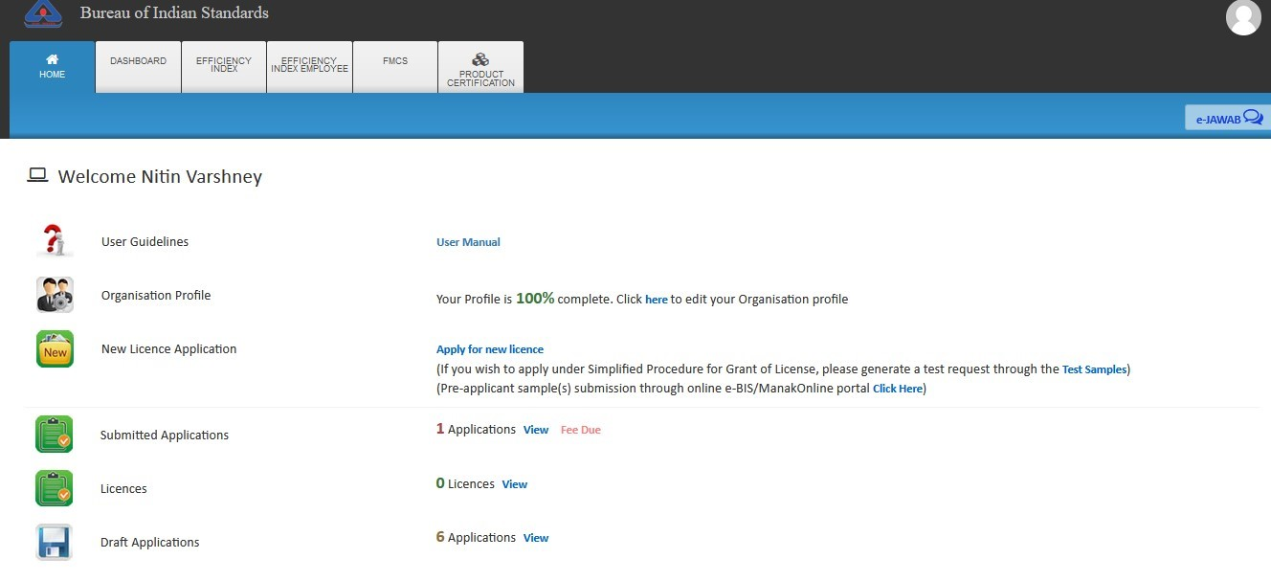

Fig.5

- Step 7: In case you have not entered your organisation profile, please fill up the organisation profile as shown in Fig. 6.
- 

- Fig.6
- Step 8: After filling all the details of the profile, click on the ‘Submit’ button as shown in Fig.7

- 

Fig.7

- Step 9: Then a success message will be reflected on your screen as shown in Fig.8 after successful updation of the profile.
- 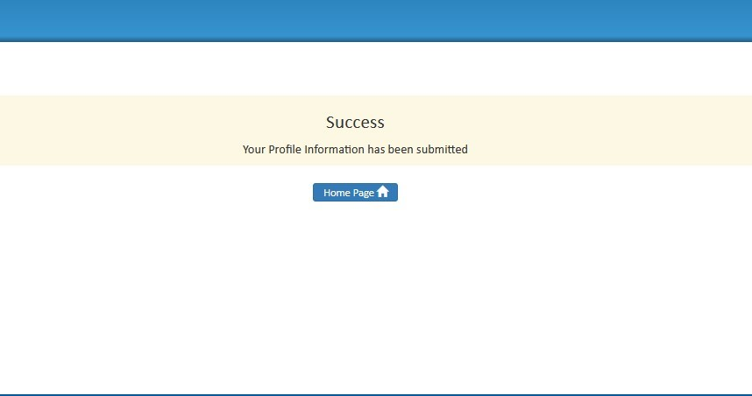

- Fig.8

- Step 10 (QR CODE generation procedure): Go to Applicant dashboard shown in the Fig 9
- and click on the Test Samples Tile.
- 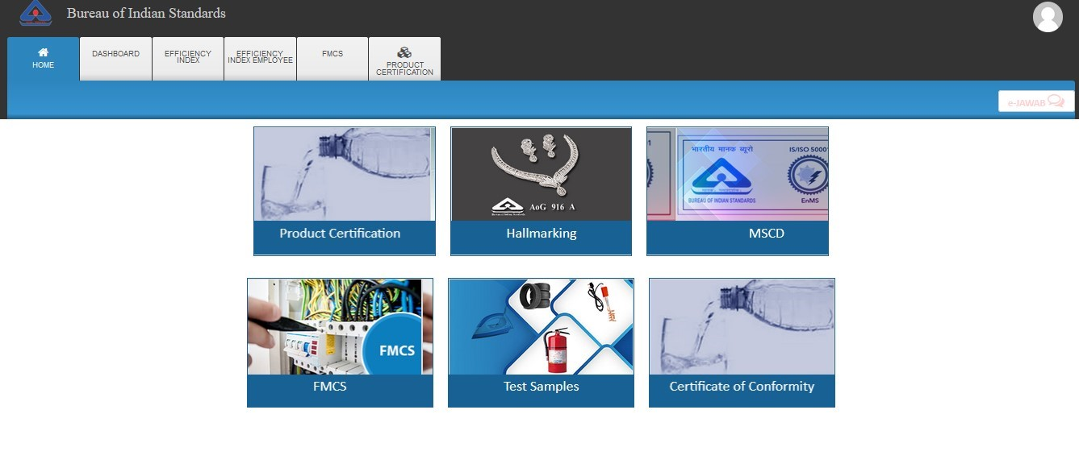

Fig.9

- Step 11: Click on the Generate QR Code “View” section as shown in Fig.10

- 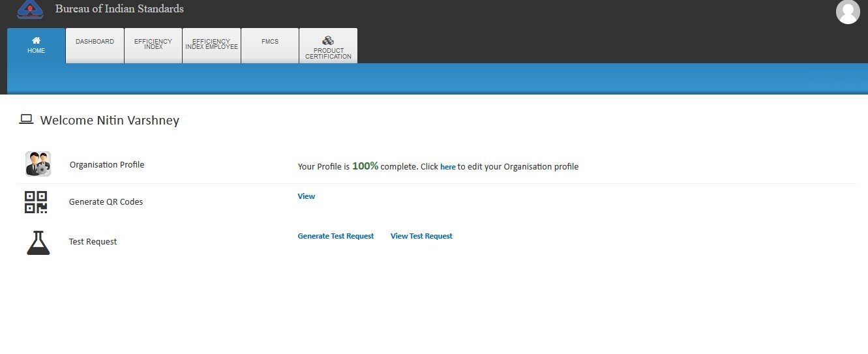

Fig.10

- Step 12: The QR Code Generation page will be shown as Fig. 11.

- 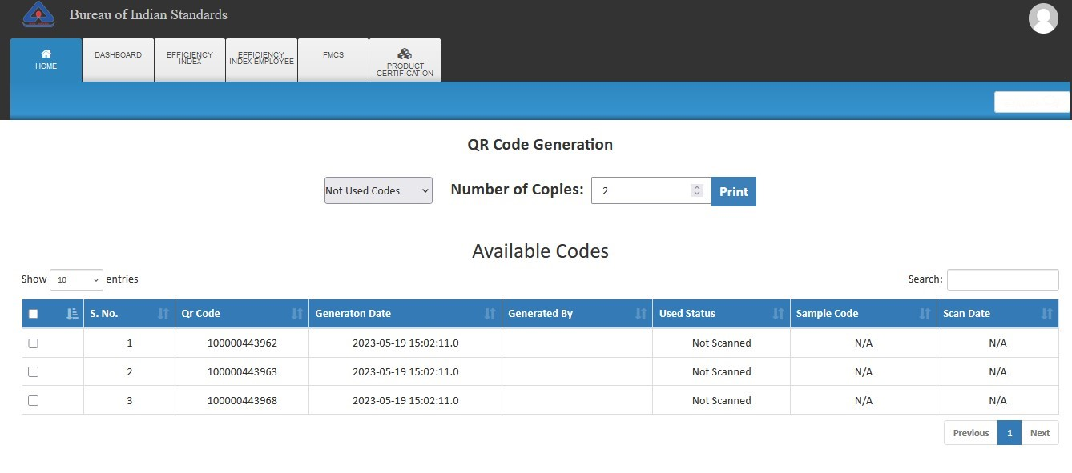
- Fig. 11

- Step 13.A: If sufficient codes available, user can skip the step 13.b
- Step 13.B: In case either available codes are NIL or user want to create new codes, select
- ‘Generate New Code’ from the drop-down and click on the Generate button. After that generated QR Code will be displayed as shown Fig 12.
- 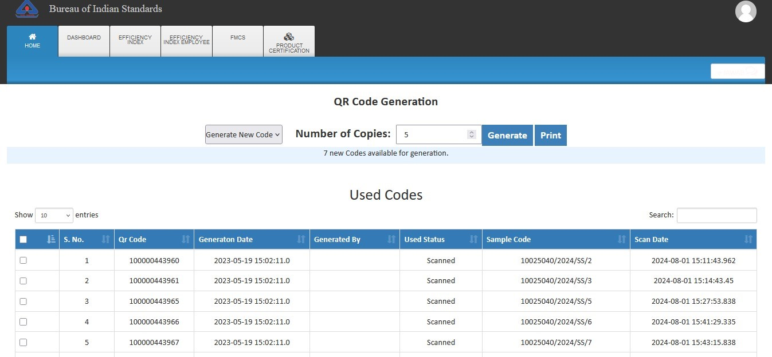

Fig
. 12

- Step 14 (Test Request Generation procedure): Again Go to Home Page and click on
- 
the ‘
Test Samples’
tile

as shown in Fig.13

- Fig.13

- Step 15: Click on the ‘Generate Test Request’ as shown in Fig. 14
- 

Fig. 14

- Step 16: Enter the IS Number and click on the search button as shown in the Fig.15
- 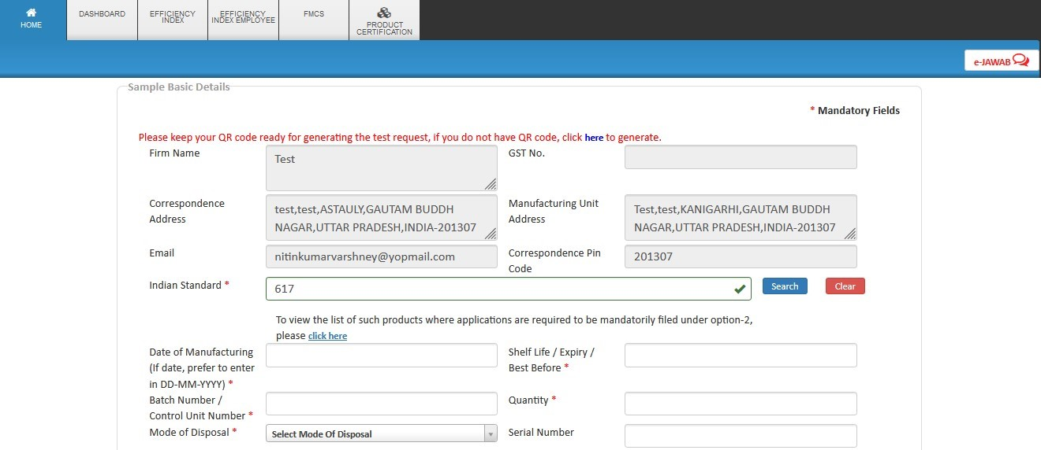

Fig.15

- Step 17: A list will appear below the search button with available IS numbers. Kindly select the required IS number and version from the populated list as shown in the Fig.16.
- 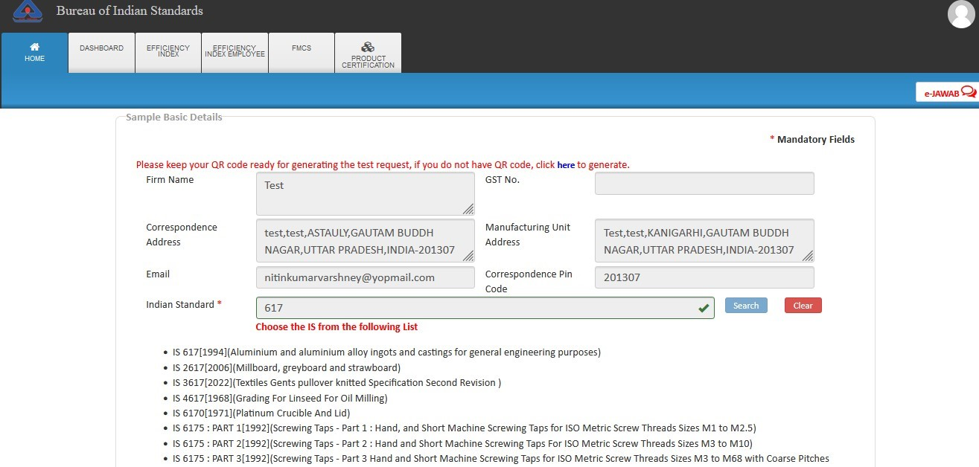

Fig.16

- Step 18: Fill the remaining fields and click on the ‘Check Lab Availability’ as shown in the Fig.17
- 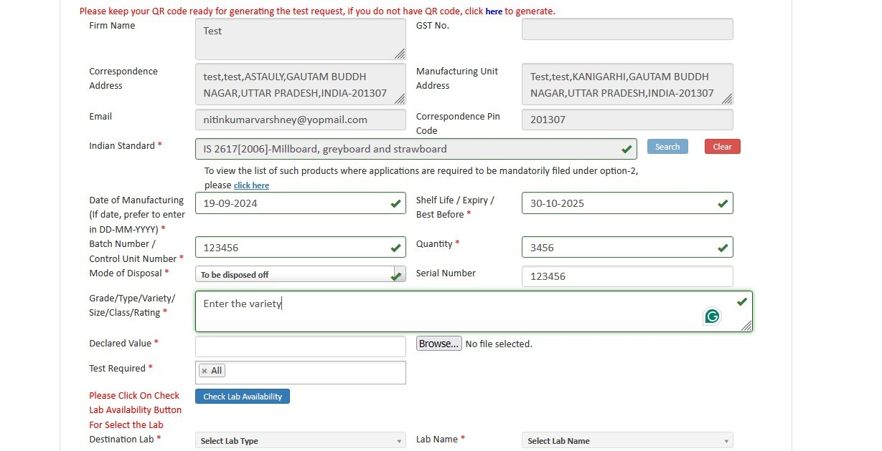

- Fig.17
- Step 19: The new POP window will be opened as shown in the Fig. 18 and click on the Radio
- 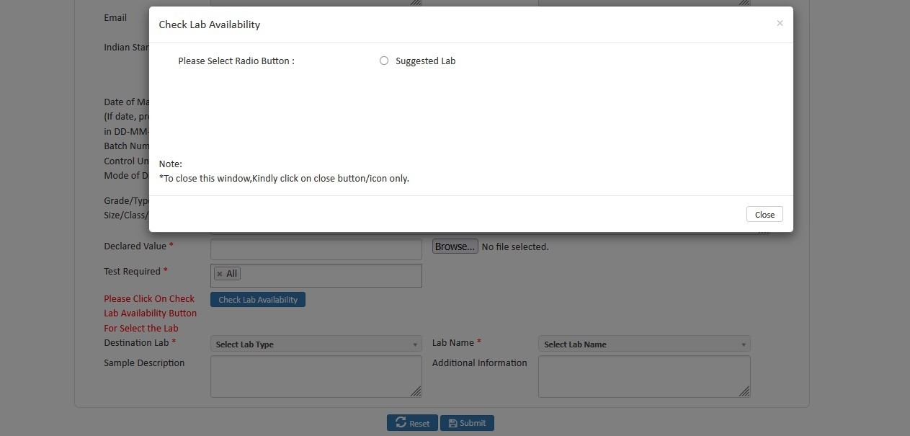
button Suggested Lab

- Fig. 18

- Step 20: Select any of the lab and click on the Submit button as shown in Fig. 19

- 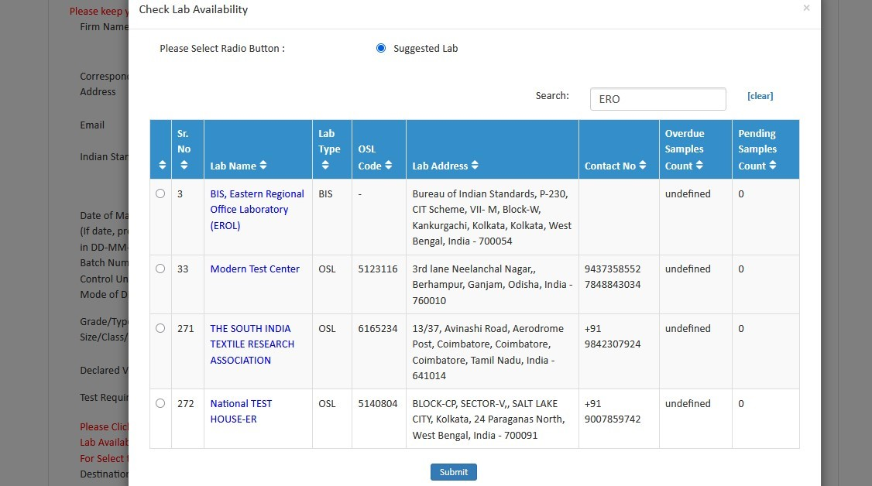

Fig.19

- Step 21: Fill the remaining details and click on the Submit button as shown in Fig.20

- 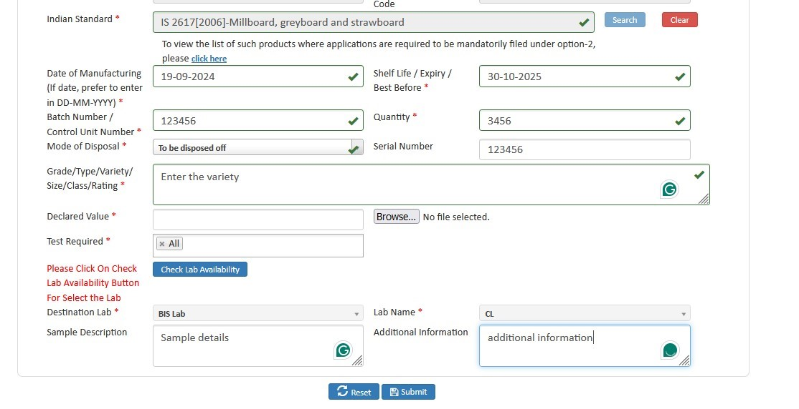

Fig.20

- Step 22: Please enter any of the available QR Code and click on the Submit button as shown in Fig.21.
- 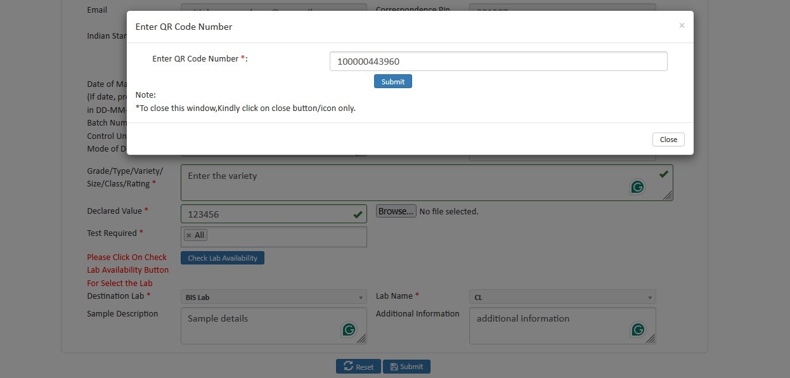

- Fig.21
- Step 23: After that the test request will be sent to the lab as shown in Fig.22 and click on the View Test Request List for checking the status of the generated test request.

- 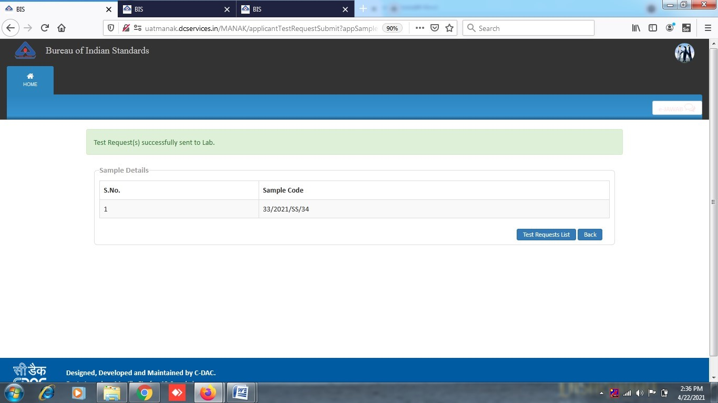

- Fig.22

- Step 24: The test request Details is shown as shown in Fig.23. Click on the View for printing the test request:

- 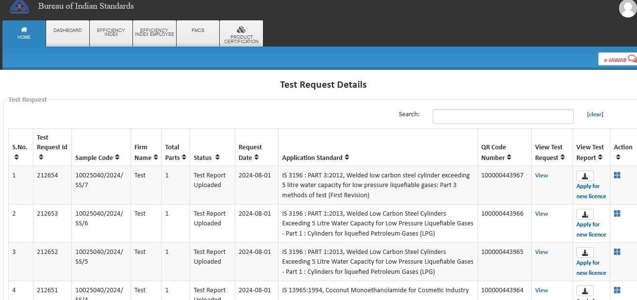

Fig.23

- Step 25: You can apply for new license when the Test report is uploaded by the LAB. Click on the ‘Apply for New License’ as shown in Fig.24

- 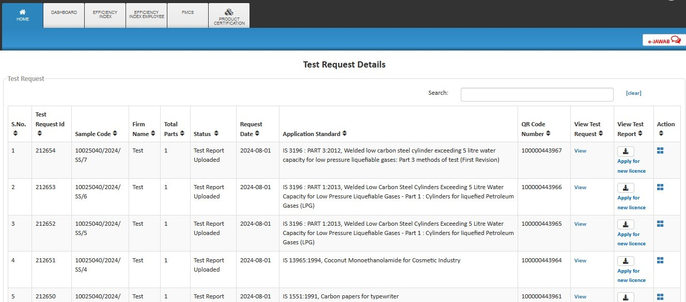

- Fig.24
- Step 26: Then the application form will appear as shown in Fig.25
- 

Fig.25

- Step 27: Select option ‘Yes’ if you know the Indian Standard Specification (ISS) for the product against which license is sought and choose the standard accordingly as shown in Fig.26 (Refer Guideline on the website)

- 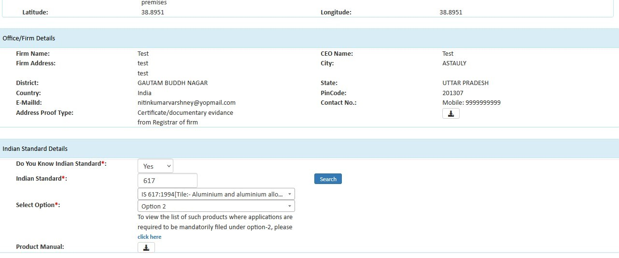

Fig 26

- Provide the acceptance for Marking Fee and STI by clicking on the respective checkboxes and then select the Simplified procedure accordingly as shown in Fig.27
- 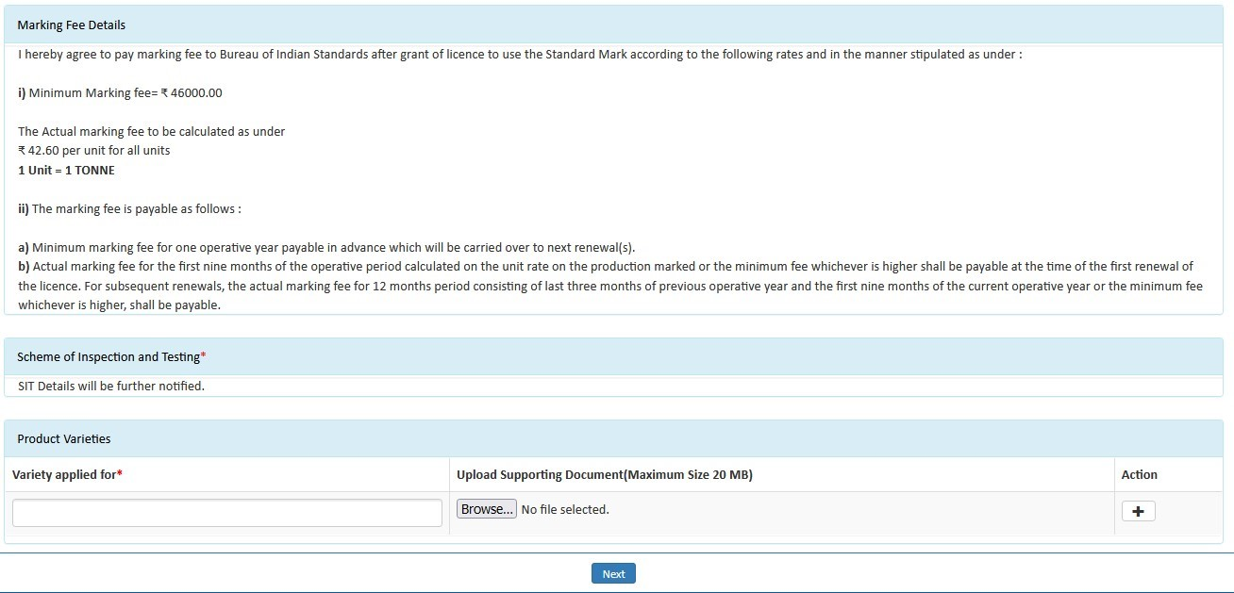

- Fig.27
- Step 28: Fill the details of Top management, Technical management and Contact person Fig.28
- 

Fig.28

- Step 29: Similarly, fill the details of ‘Testing Equipment’. Click on ‘Yes’ if you want to download the excel file, otherwise click on ‘No’.
- 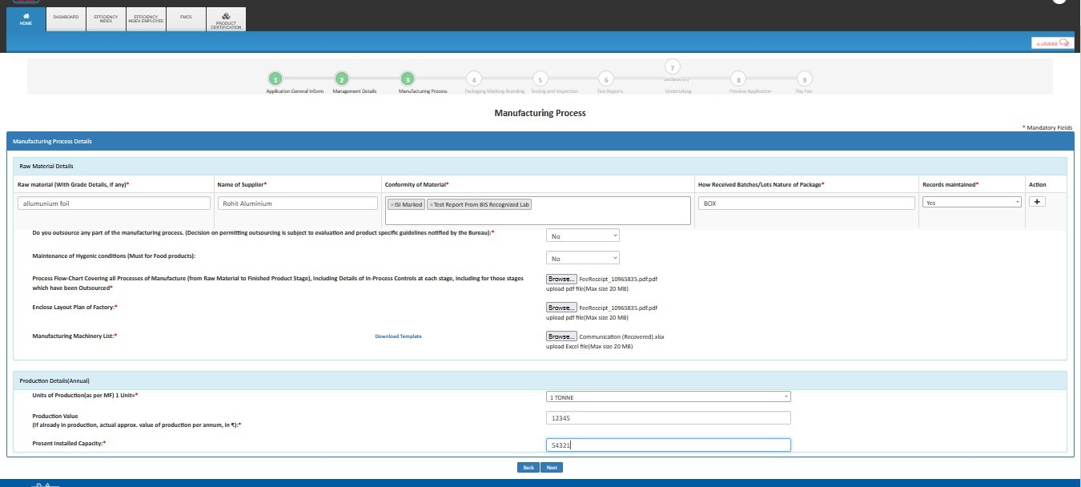

Fig. 29

- Step 30: Then fill the production details, accept declarations and Fill the details of Brand details and click ‘Next’ as shown below in Fig.30
- 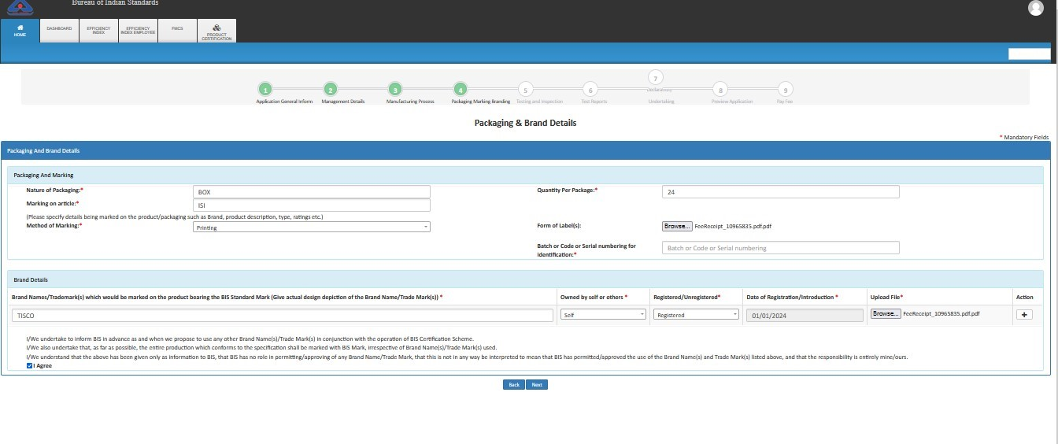

Fig. 30

- Step 31: Fill Testing and Inspection Details as on Fig. 31 then click Next Button
- 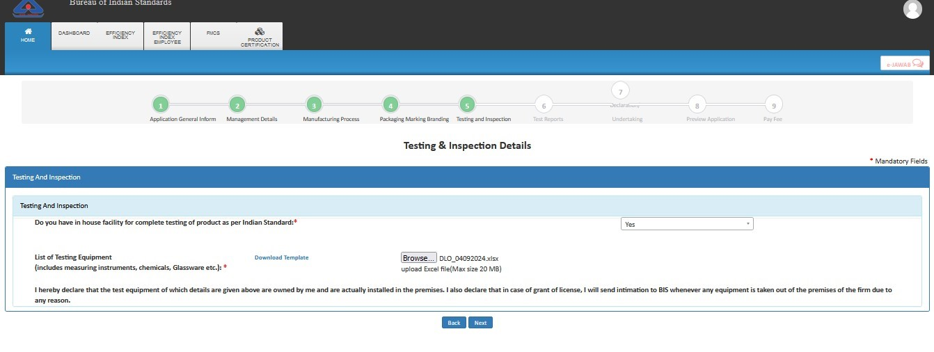

Fig. 31

- Step 32: Select the QR code in the available list as shown in the Fig. 32

- 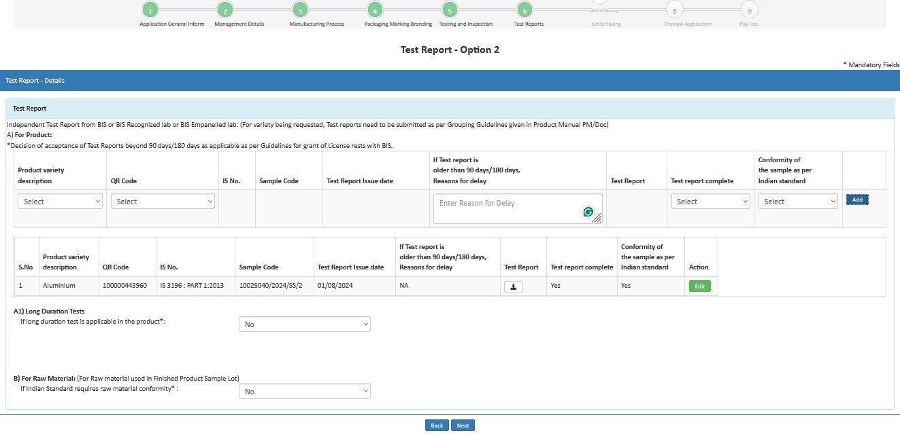

Fig. 32
- Step 33: Fill Declaration & Undertaking then click on Next Button
- 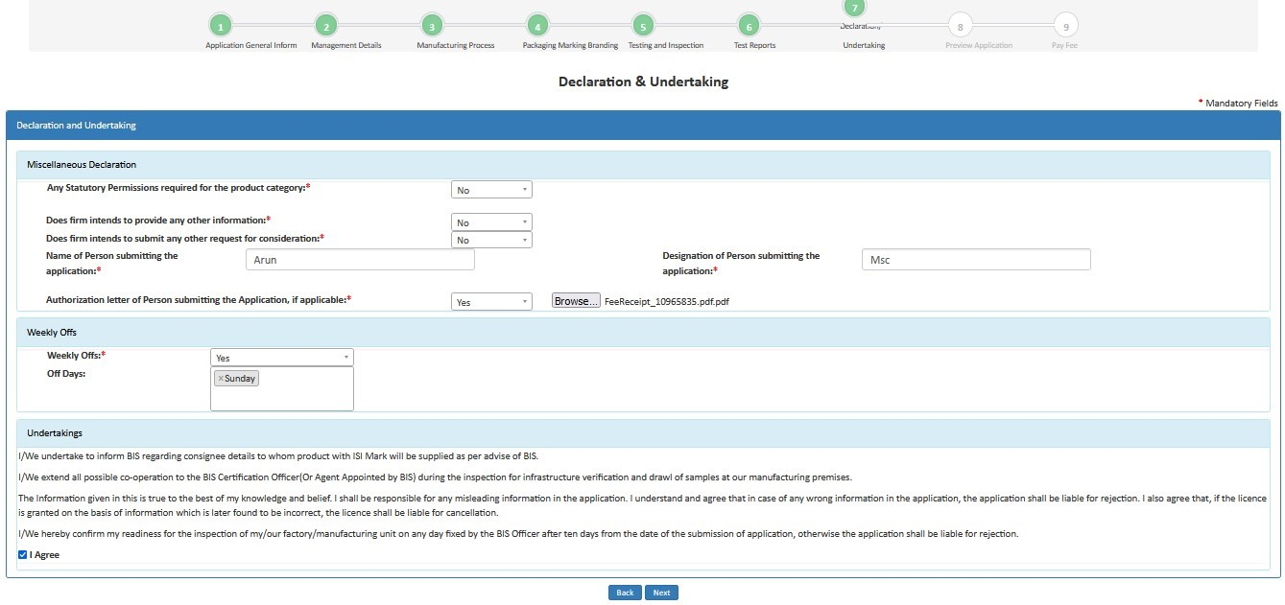

Fig. 33

- Step 34: Review Application Details

- 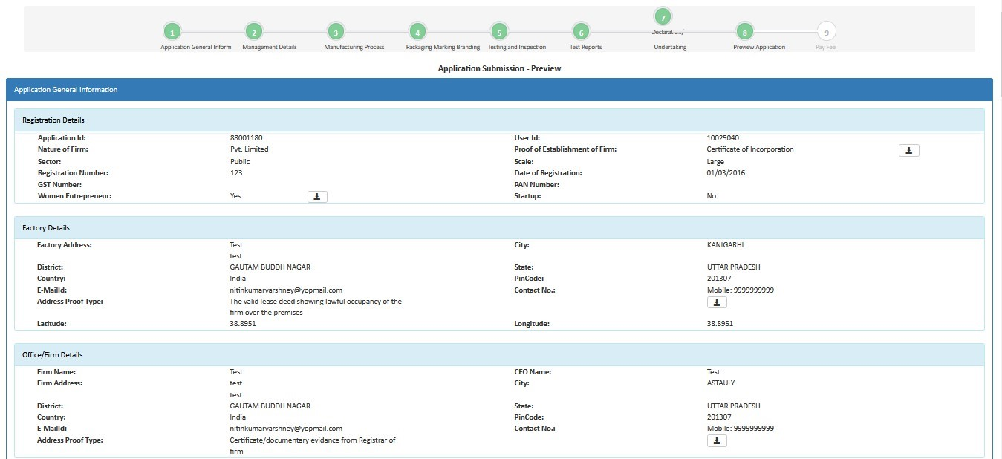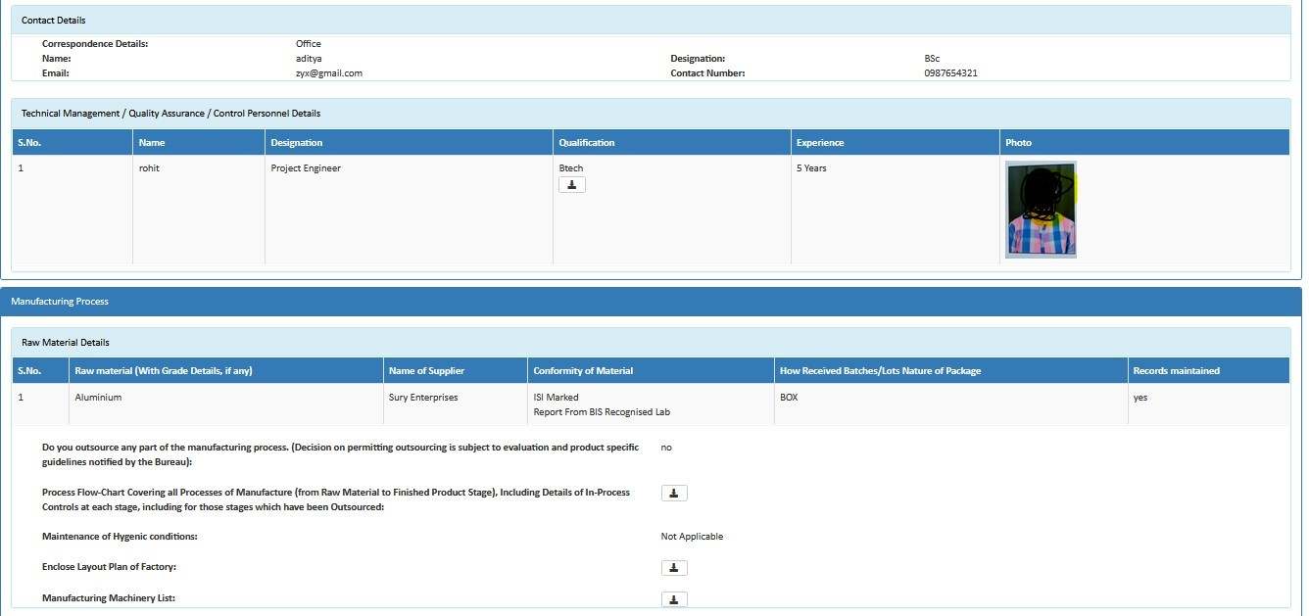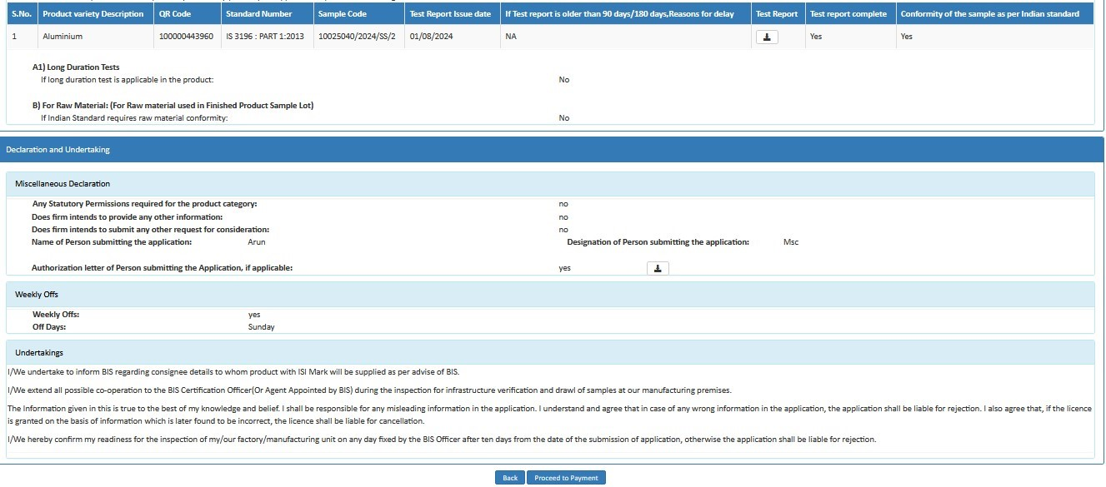

Fig.34
- Step 35: Later an Application Fee and Contact BIS page will open. Here select the payment mode, agree to the terms and conditions and click on ‘Proceed to Payment’ button as shown in Fig.35

- 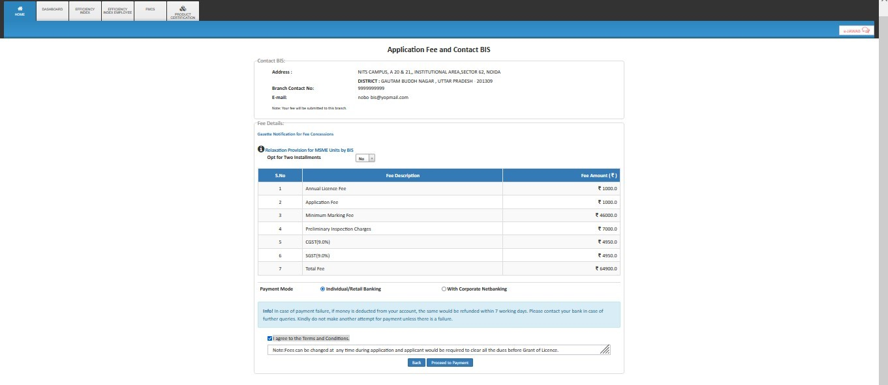

Fig.35

- Ø Applicant can select any one of the Retail Banking or Corporate Banking payment mode

- Step 36: Then on Online Payment page go through the all the instructions regarding transaction charges and click on Pay Now as shown in Fig.36

- 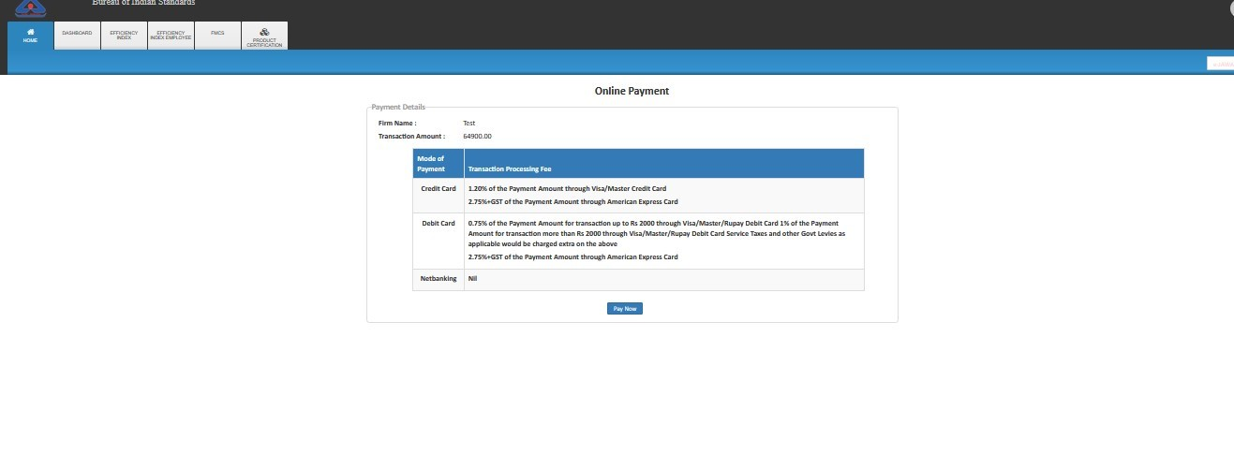

Fig. 36

- Step 37: After completion of payment Go to Home Screen >> Product Certification >> check under Submitted Application as shown in the Fig.37
- 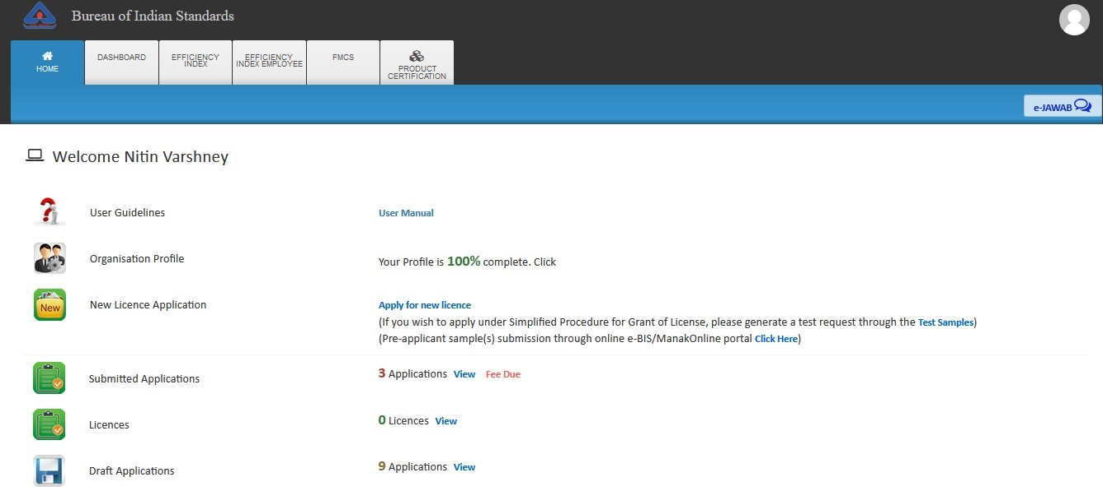

- Fig. 37

- GST Implementation
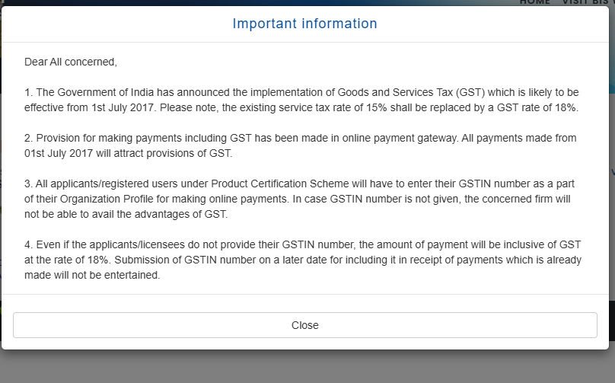

- FAQs
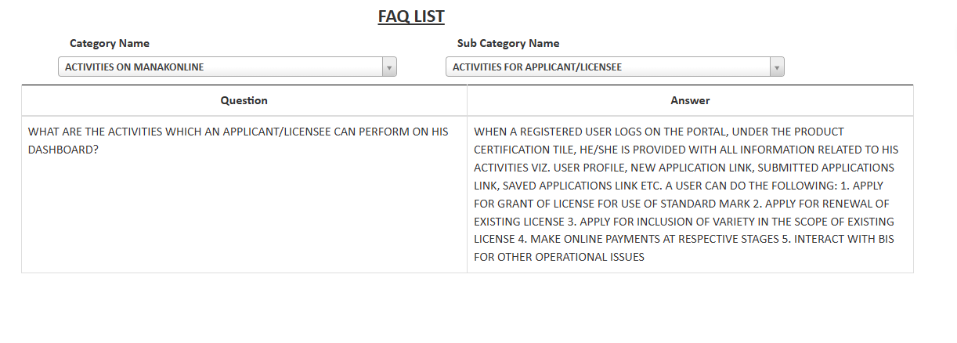
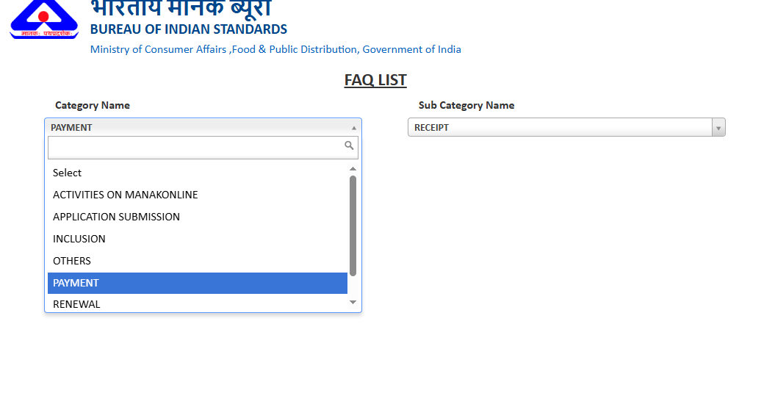

- Product Certification Application Form Template

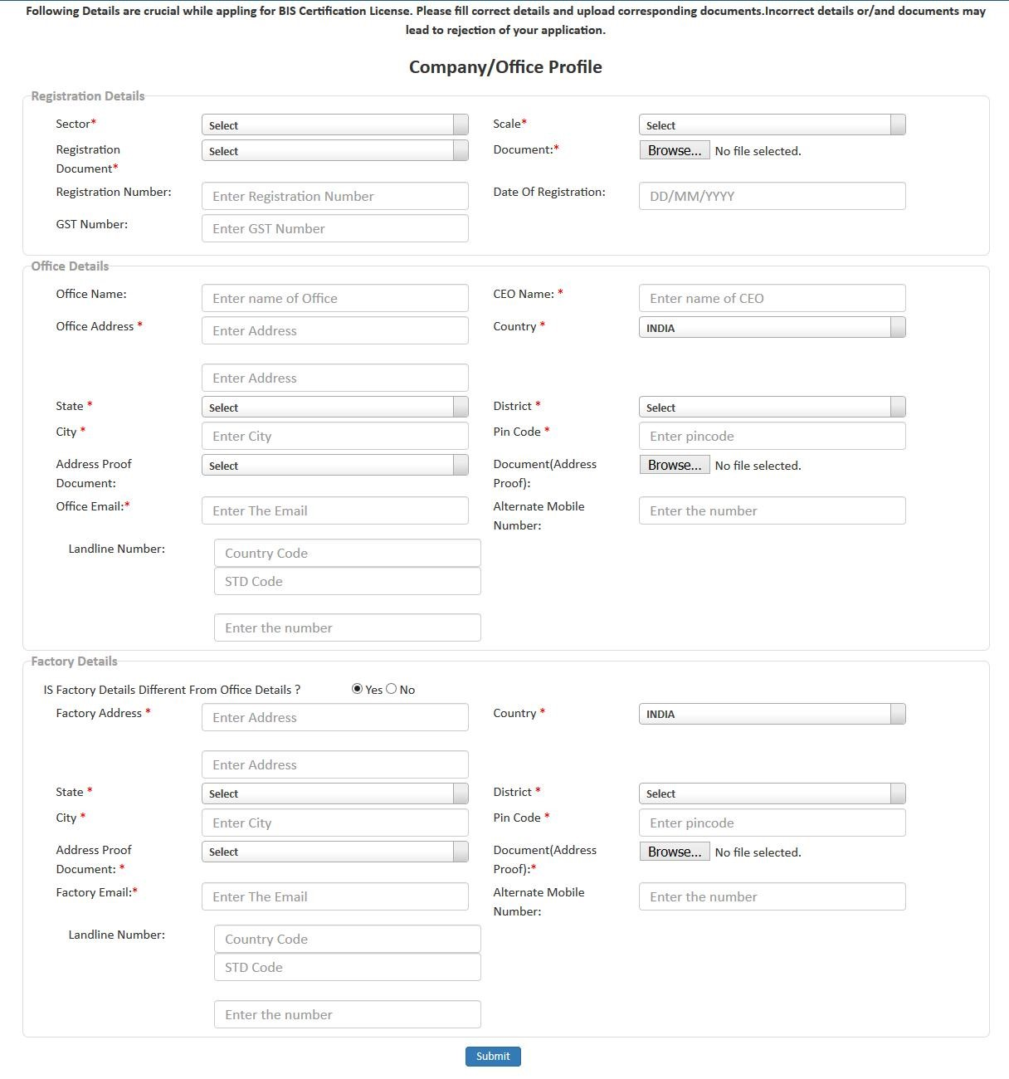
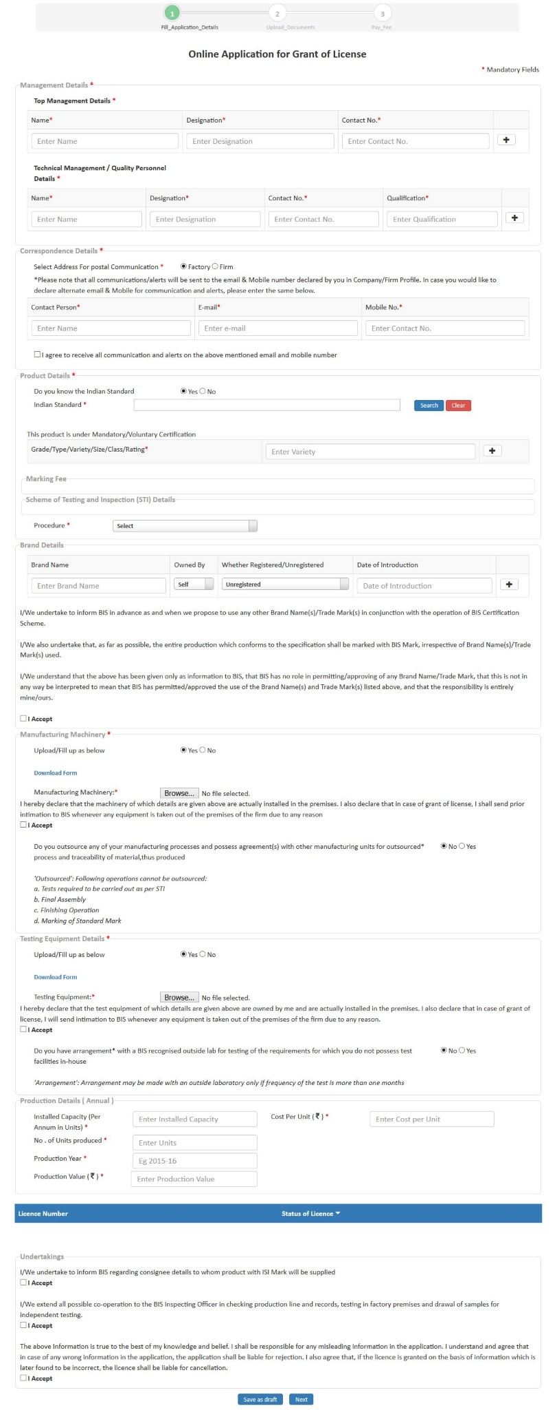
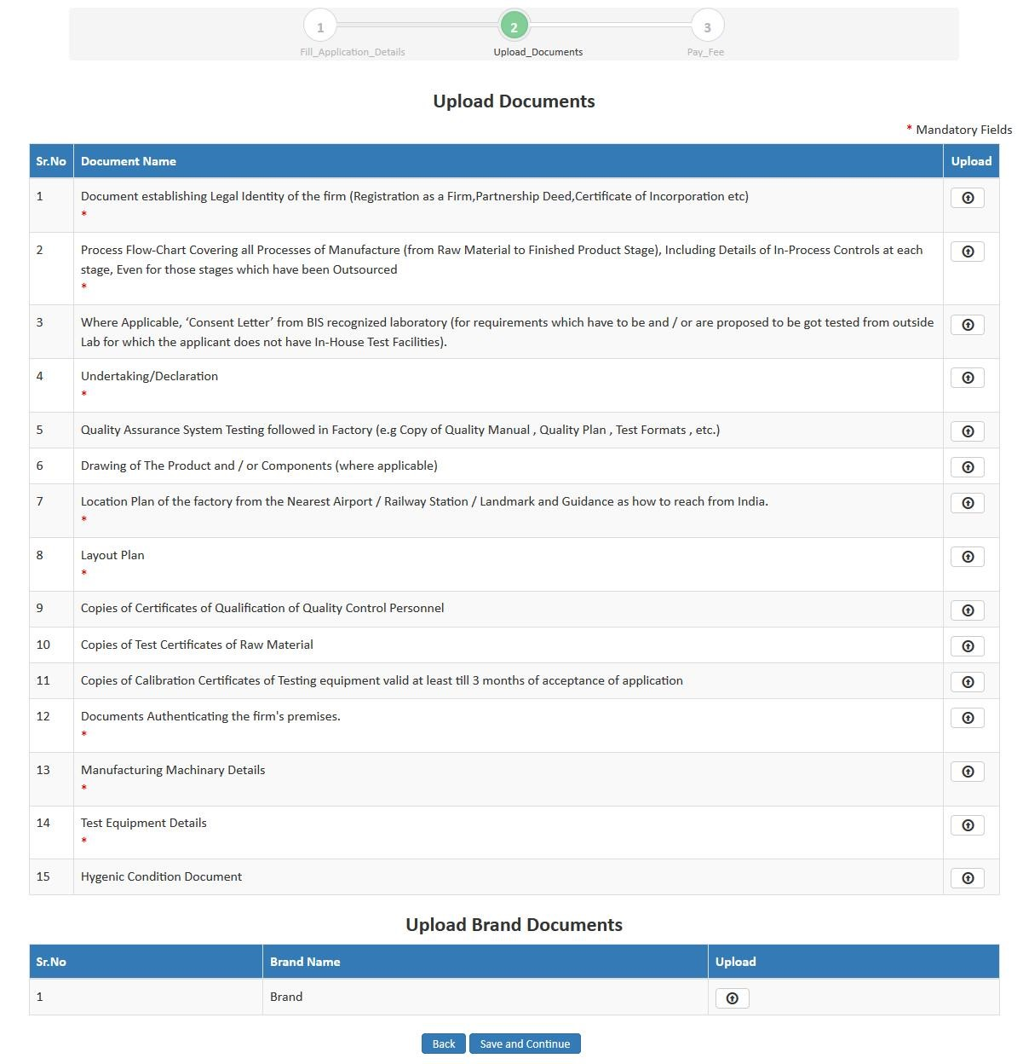

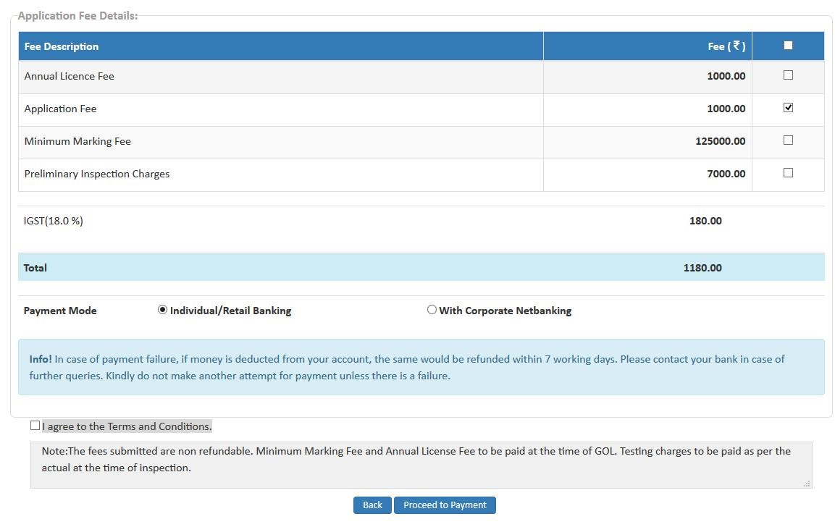

Q.8 Are there any technical guidelines available for the products under Product Certification Scheme of BIS?
A. Yes, the technical guidelines are available for all the products covered under Product Certification Scheme as “Product Manuals”. Product manuals include sampling guidelines, list of test equipment, Scheme of Inspection and Testing (SIT), description of scope, and more. To search the desired Product Manual, please follow the web link: www.bis.gov.in >> Conformity Assessment >> Product Certification >> Product Specific Guidelines >> Product Manuals.[bis.gov]

Q.9 If product specific guidelines i.e. Product Manual, SIT, grouping guidelines and/or marking fee rate for my product is not defined, will I still be able to obtain a BIS licence?
A. In case product specific guidelines and/or marking fee for your product is not defined, it is possible that you are the first manufacturer to apply for a BIS licence for a new product. However, you will still be able to obtain BIS licence as per Scheme I of BIS (Conformity Assessment) Regulation, 2018. BIS will interact with you throughout the certification process to define the product specific guidelines and marking fee rate. This will be called “All India First Licence”.[bis.gov]

Q.10 Can I submit one application for different products and Indian Standards (ISS) being manufactured at the same factory location?
A. No, separate application for each product and ISS is required to be submitted even for the same factory location.[bis.gov]

Q.11 Can I submit one application for same product being manufactured at different factory locations?
A. No, separate application for each factory location is required to be submitted, even if the product and ISS are the same.[bis.gov]

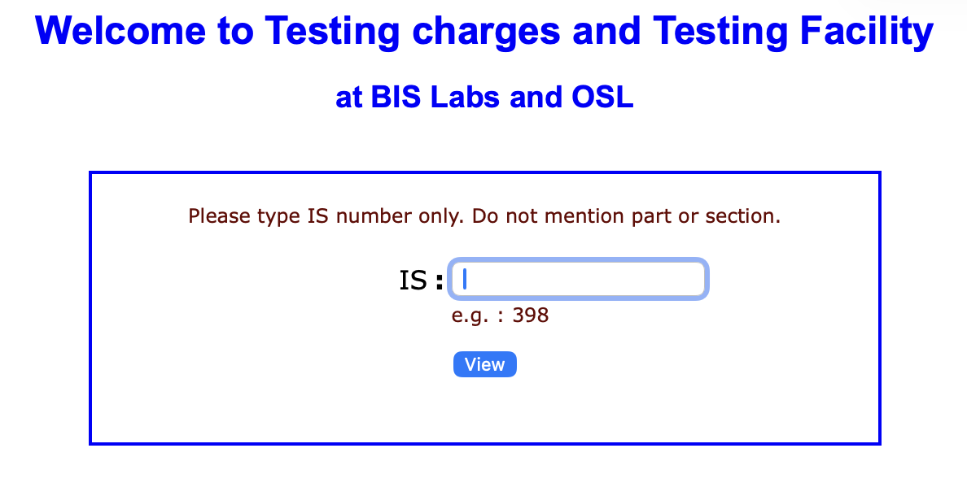
Q 12: Which are the laboratories of which test report will be acceptable to BIS for the purpose of grant of licence? Or Where can I get my products tested in order to get a licence under optionv- 2?
A. The test reports issued by only BIS or BIS recognized or empanelled laboratory for the product are acceptable for grant of a licence under option-2. To know details of laboratory for testing of a particular product, please visit http://164.100.105.198:8096/bis_access/iswise_v2.html.[bis.gov]

Q 13. Up to how much time, the test reports will remain valid for the purpose of grant of licence under option – 2?
A. The test reports of the product shall not generally be more than 90 days old. For complete details please visit www.bis.gov.in >> Conformity assessment >> Product Certification >> Certification process >> Guideline for Grant of Licence.[bis.gov]

Q 14. What is the fee applicable for Certification licence for a product?
A. The application is required to be submitted with an application fee of Rs. 1000. An inspection fee of Rs. 7,000 per man day is required to be paid before preliminary inspection visit by BIS. After evaluation and decision to grant the licence is taken by BIS, the applicant is required to deposit annual licence fee of Rs. 1000 plus the minimum marking fee specified for the product. The marking fee for each product is specified in Annexure I of Scheme I of BIS (Conformity Assessment) Regulations, 2018 as amended by BIS (Conformity Assessment) Amendment Regulations, 2020.[bis.gov]

Q 15. What is the timeline for grant of BIS product certification licence?
A. Average time taken for grant of licence under option-2 is generally one month and under option-1 four months from the date of receipt of complete application and its recording. It may vary for reasons like delay in response to queries raised, organizing inspections, sample deposition, and fee dues.[bis.gov]

Q 16. What are the conditions of BIS licence to use or apply a Standard Mark?
A. Conditions of BIS licence to use or apply a Standard Mark are as given in Regulation 6 of BIS (Conformity Assessment) Regulations, 2018.[bis.gov]

Q17. What are the punitive provisions for non-compliance with the conditions of the licence?
A. In case of violation of conditions of licence, the licence may be cancelled by the Bureau as per provision of Regulation 11 of BIS (Conformity Assessment) Regulations, 2018.[bis.gov]

Q 18. What is the validity of BIS product certification licence?
A. BIS certification under Scheme-I may be granted initially up to two years, valid only for the varieties mentioned in the licence. For extension of validity, application with requisite fee and documents under the existing licence is required to be submitted. Licence may be renewed up to five years from the last date of validity of licence.[bis.gov]

Q 19. How should one apply for the renewal of a licence?
A. Renewal of licence is required to be requested through online portal “manakonline” and is available through the dashboard of the licence holder. Renewal application with production details for the relevant period, and the relevant fee is required to be submitted online for renewal as per the period of renewal opted.[bis.gov]

Q 20. What is deferment of licence? When does it happen?
A. The renewal of licence can be deferred as per provision of Regulation 8 of BIS (Conformity Assessment) Regulations, 2018, if the renewal application and fee is not received till the last date of validity of licence or if the licence is under suspension.[bis.gov]

Q 21. Does BIS carry any surveillance on my licence regularly?
A. After grant of licence to a manufacturer, BIS carries out surprise factory surveillance inspections through visit to the factory by certification officers of BIS or by personnel of the agents appointed by BIS as per Rule 33 of BIS Rules, 2018. BIS also carries out market surveillance through purchase of samples of ISI marked product for verifying conformity to relevant ISS through third party laboratory testing.[bis.gov]

Q 22. What are the duties and responsibilities of the owner of a manufacturing unit holding BIS licence regarding factory surveillance?
A. BIS licence holder is required to extend co-operation to the certification officers of BIS or personnel of the agents appointed by BIS to carry out surveillance inspection. The licence holder shall also share relevant records and information sought, facilitate testing in the factory, and drawl of samples for independent testing in third party lab.[bis.gov]

Q 23. What are the consequences of non-cooperation by the manufacturing unit during factory surveillance
A. The page text under this question appears to contain a formatting error and continues with scope-of-licence information: one licence is granted for one product/one Indian Standard, though it may cover more than one variety/grade/size. It also says the scope can be changed for inclusion or deletion of varieties, with reference to the relevant guidelines.[bis.gov]

Q 24. I have already got licence from BIS for the product as per ISS in my factory. Can I use this licence on all varieties of the product being manufactured in the factory?
A. No, one licence is granted by BIS for one product/one Indian Standard, though it may cover more than one variety/grade/size specified in the standard. The Standard Mark can be used only on the products and varieties mentioned in the “Scope of licence”; for other varieties, the scope must be changed as per the relevant guidelines.[bis.gov]

Q. 25 What is the procedure for intimation regarding change of address or shifting of the manufacturing unit?
A. BIS licence holder is required to inform BIS of its intention to shift the manufacturing unit to a new address, with relevant documents for the new premises similar to those submitted at the time of application. The licensee shall suspend use of the Standard Mark on relocation, and the suspension may be revoked after verification of the old and new premises and production process.[bis.gov]

Q. 26 When can a license be suspended?
A. The licence can be suspended under provisions of paragraph 11 of Scheme I and Regulation 10 of BIS (Conformity Assessment) Regulations, 2018.[bis.gov]

Q.27 When can a license be cancelled?
A. The licence can be cancelled under provisions of Regulation 11 of BIS (Conformity Assessment) Regulations, 2018.[bis.gov]

Q. 28 How can a BIS licensee participate in the standard formulation/revision process?
A. The Indian standards are formulated and revised by BIS through consensus in technical committees. A BIS licensee can participate by becoming a member of the technical committee and may send comments to the concerned technical department through mail or the BIS website.[bis.gov]
A couple of items on the page have small wording/formatting issues, especially Q23 and a few link lines, but the FAQ content above reflects the page as shown.[bis.gov]
System certifications
- Q. Why should you take management system certification from BIS?
A. BIS is India’s National Standards Body and issues management system certification licences under the BIS Act, 2016. Its trained auditors help improve product and service quality, and QMS, EMS, and FSMS certification is accredited by NABCB for various sectors.[bis.gov]
- Q. What is a management system?
A. A management system is the way an organization manages its business.[bis.gov]
- Q. What is Management system Certification?
A. It is third-party certification of an organization’s management system to show that it meets the requirements of a management system standard.[bis.gov]
- Q. What are the management system certifications offered by BIS?
A. BIS offers 15 types of management system certification, including IS/ISO 9001, 14001, 45001, 22000, 50001, 13485, 39001, 21101, 21001, 37001, 27001, IS 15700, IS 15000 HACCP, IS 23485, and IS 16001. BIS also offers RMC certification and Integrated Milk certification.[bis.gov]
- Q. What is RMC certification by BIS?
A. It is Ready Mix Concrete certification for supplying units under IS 4629. It assures quality ready mix concrete at the customer’s delivery point and can be offered alone or with ISO 9001 certification.[bis.gov]
- Q. What is Integrated Milk certification by BIS?
A. It combines FSMS and product certification for pasteurised milk pouches. It covers milk collection through delivery and verifies conformity to IS 13668.[bis.gov]
- Q. What is IMS Certification?
A. IMS, or Integrated Management System certification, combines two or more management system certifications into one audit and one documentation set to save time and money.[bis.gov]
- Q. How to get Management systems certification from BIS?
A. Apply online at manakonline.in. Your application is scrutinized, then Stage 1 and Stage 2 audits are held at your site if applicable, and certification is granted if audit results are satisfactory.[bis.gov]
- Q. What is ISO 9001?
A. It is the international standard for a quality management system and is used to demonstrate consistent ability to provide products and services that meet customer and regulatory requirements.[bis.gov]
- Q. Who can take IS/ISO 9001 Certification?
A. Any organization, large or small, product-based or service-based, private or government, that wants to demonstrate consistent ability to meet customer and regulatory requirements.[bis.gov]
- Q. What is IS/ISO 14001?
A. It is the international standard for environmental management systems and helps organizations improve environmental performance through better resource use and less waste.[bis.gov]
- Q. Who can take ISO 14001 Certification?
A. Any organization that wants to improve environmental performance and contribute to sustainability, considering the lifecycle perspective of its activities, products, and services.[bis.gov]
- Q. What is ISO 45001?
A. It is the international standard for occupational health and safety management systems, aimed at safer workplaces and reduced work-related injury and ill health.[bis.gov]
- Q. Who can take ISO 45001 Certification?
A. Any organization that wants to establish and maintain an OH&S management system and reduce hazards and OH&S risks.[bis.gov]
- Q. What is ISO 50001?
A. It is the international standard for energy management systems, designed to help organizations reduce energy use, costs, and greenhouse gas emissions.[bis.gov]
- Q. Who can take ISO 50001 Certification?
A. Any organization, regardless of type, size, complexity, location, or culture, can take this certification.[bis.gov]
- Q. What is ISO 22000?
A. It is an international food safety management standard that helps identify and control food safety hazards across the food supply chain.[bis.gov]
- Q. Who can take ISO 22000 certification?
A. Any organization in the food chain, including producers, farmers, manufacturers, retailers, food service providers, and related suppliers.[bis.gov]
- Q. What is ISO 39001?
A. It is an international standard for road traffic safety management systems, intended to help reduce death and serious injuries from road crashes.[bis.gov]
- Q. Who can take ISO 39001 certification?
A. Organizations that interact with the road traffic system, such as transport companies, schools with buses, supermarkets, and road authorities.[bis.gov]
- Q. What is ISO 21001?
A. It is the international standard for educational organization management systems, aimed at supporting competence development through teaching, learning, or research.[bis.gov]
- Q. Who can take ISO 21001 Certification?
A. Any organization using a curriculum for teaching, learning, or research, including training departments of larger non-education organizations.[bis.gov]
- Q. What is ISO 37001?
A. It is the international standard that helps organizations prevent, detect, and address bribery through anti-bribery policies, controls, training, and investigation procedures.[bis.gov]
- Q. Who can take the ISO 37001 certification?
A. Any organization, public, private, voluntary, large, or small, in any country.[bis.gov]
- Q. What is ISO 27001?
A. It is the international standard for information security management systems, helping organizations manage sensitive information assets.[bis.gov]
- Q. Who can take ISO 27001 Certification?
A. Any organization that wants to demonstrate the security of its information assets.[bis.gov]
- Q. What is ISO 13485?
A. It is the international standard for a quality management system for medical devices and related services.[bis.gov]
- Q. Who can take ISO 13485 certification?
A. Organizations involved in any stage of the medical device lifecycle, including design, production, storage, distribution, installation, or servicing.[bis.gov]
- Q. What IS 23485?
A. It is an Indian standard formulated by BIS that specifies requirements of ISO 13485 and ISO 16142 for medical devices.[bis.gov]
- Q. Who can take IS 23485 certification?
A. Organizations involved in one or more stages of the medical device lifecycle, including design, development, production, storage, distribution, installation, or servicing.[bis.gov]
- Q. What is IS 15000?
A. It is an Indian standard on HACCP, covering food safety hazards from raw material production through manufacturing, distribution, and consumption.[bis.gov]
- Q. Who can take HACCP certification?
A. Any organization in the food chain involved directly or indirectly in food production, processing, packaging, transport, storage, and related services.[bis.gov]
- Q. What is IS 16001?
A. It is an Indian standard on social accountability that encourages socially and legally acceptable workplace practices.[bis.gov]
- Q. Who can take IS 16001 certification?
A. Any organization, regardless of type, size, ownership, or location, including government, private, academic, charitable, cooperative, NGO, or association bodies.[bis.gov]

