FAQS FMCS

1 What is FMCS ?
This is a certification scheme for a Foreign manufacturer who wants to obtain BIS Licence. The scheme is for certification of products other than Electronic and Information Technology Products. For Electronic and IT products please refer to Registration Scheme on this site at https://www.crsbis.in/BIS/about-crs.do

=================

About CRS
- Ministry of Electronics & Information Technology (MeitY) (erstwhile DeitY) has notified "Electronics and Information Technology Goods (Requirement for Compulsory Registration) Order, 2012" on 03 October 2012 for fifteen categories of electronics items. Fifteen more product categories were added by MeitY under this order on 07 November 2014. MeitY has also notified Indian Standard for ‘Indian Language Support for Mobile Phones’ on 24 October 2016. Another thirteen product categories were added by MeitY under this order on 17 August 2017. Another twelve product categories were added by MeitY under this order on 01 April 2020.Another seven product categories were added by MeitY under this order on 01 Oct 2020. MeitY has also notified Indian Standard for ‘Digital Television Receiver for Satellite Broadcast Transmission – Specification’on 26 April 2023.
- Ministry of New and Renewal Energy(MNRE) has notified five products under Solar Photovoltaics, Systems, Devices and Components Goods (Requirements for Compulsory Registration) Order, 2017 dated 30 August 2017.
- Ministry of Chemicals and Fertilizers has notified one product under Ortho Phosphoric Acid (Quality Control) Order, 2021 dated 15 June 2021, one more product has been added under the Polyphosphoric Acid (Quality Control) Order, 2021 dated 24 December 2021.Further,one more product has been added under Trimethyl Phosphite (Quality Control) Order, 2022 dated 05 April 2022.
- Ministry of Textiles has notified one product under Cotton Bales (Quality Control) Order, 2023 dated 28 February 2023.
- As per the Orders, no person shall manufacture or store for sale, import, sell or distribute goods which do not conform to the Indian standard specified in the order and do not bear the Standard Mark with unique registration number obtained from BIS.
- Bureau of Indian Standards grants licence to the manufacturers to use or apply Standard Mark with unique R-number,through registration based on self-declaration of conformity for goods and articles as per Indian Standards. The grant of licence and its operation under Compulsory Registration Scheme are carried out as per the conformity assessment scheme under Scheme - II of Schedule - II of BIS (Conformity Assessment) Regulations, 2018'.

1.Who can apply for CRS
Manufacturer (factory owner) of any product, which comes under the ambit of the Compulsory Registration Order (CRO) notified by Ministry of Electronics and Information Technology (MeitY), Ministry of New and Renewable Energy (MNRE),Ministry of Chemicals and Fertilizers and Ministry of Textiles.

2.Products under CRS
- Amplifiers With Input Power 2000w And Above
- Automatic Data Processing Machine
- Automatic Data Processing Machine
- Electronic Games (Video)
- Electronic Musical Systems With Input Power 200w And Above....Read More ».

—-------------------------------------------------------------------------------------------------------------

Sl. No. | Product | Indian Standard number( IS No.) | Date of Implementation of QCO
1 | AMPLIFIERS WITH INPUT POWER 2000W AND ABOVE | IS 616:2017 | 03 July 2013
2 | AUTOMATIC DATA PROCESSING MACHINE | IS 13252(Part 1):2010 | 03 July 2013
3 | ELECTRONIC CLOCKS WITH MAINS POWER | IS 302-2-26:2014 | 03 July 2013
4 | ELECTRONIC GAMES (VIDEO) | IS 616:2017 | 03 July 2013
5 | ELECTRONIC MUSICAL SYSTEMS WITH INPUT POWER 200W AND ABOVE | IS 616:2017 | 03 July 2013
6 | LAPTOP/NOTEBOOK/TABLET | IS 13252(Part 1):2010 | 03 July 2013
7 | MICROWAVE OVENS | IS 302-2-25:2014 | 03 July 2013
8 | OPTICAL DISC PLAYERS WITH BUILT IN AMPLIFIERS OF INPUT POWER 200W AND ABOVE | IS 616:2017 | 03 July 2013
9 | PLASMA/LCD/LED TELEVISIONS OF SCREEN SIZE 32"; AND ABOVE | IS 616 :2017 OR IS 616:2017 & IS 18112:2025 | 03 July 2013
10 | PRINTERS, PLOTTERS | IS 13252(Part 1):2010 | 03 July 2013
11 | SCANNERS | IS 13252(Part 1):2010 | 03 July 2013
12 | SET TOP BOX | IS 13252(Part 1):2010 | 03 July 2013
13 | TELEPHONE ANSWERING MACHINES | IS 13252(Part 1):2010 | 03 July 2013
14 | VISUAL DISPLAY UNITS, VIDEOS MONITORS OF SCREEN SIZE 32" AND ABOVE | IS 13252(Part 1):2010 | 03 July 2013
15 | WIRELESS KEYBOARDS | IS 13252(Part 1):2010 | 03 July 2013
16 | CASH REGISTERS | IS 13252(Part 1):2010 | 13 May 2015
17 | COPYING MACHINES/DUPLICATORS | IS 13252(Part 1):2010 | 13 May 2015
18 | PASSPORT READER | IS 13252(Part 1):2010 | 13 May 2015
19 | POINT OF SALE TERMINALS | IS 13252(Part 1):2010 | 13 May 2015
20 | MAIL PROCESSING MACHINES/POSTAGE MACHINES/FRANKING MACHINES | IS 13252(Part 1):2010 | 13 May 2015
21 | POWER BANKS FOR USE IN PORTABLE APPLICATIONS | IS 13252(Part 1):2010 | 13 May 2015
22 | SMART CARD READER | IS 13252(Part 1):2010 | 13 May 2015
23 | MOBILE PHONES | IS 13252(Part 1):2010 | 13 September 2015
24 | SELF-BALLASTED LED LAMPS FOR GENERAL LIGHTING SERVICES | IS 16102(Part 1):2012 | 13 September 2015
25 | DC OR AC SUPPLIED ELECTRONIC CONTROLGEAR FOR LED MODULES | IS 15885(Part 2/Sec 13):2012 | 01 Decmeber 2015
26 | POWER ADAPTORS FOR AUDIO,VIDEO & SIMILAR ELECTRONIC APPARATUS | IS 616:2010 | 01 Decmeber 2015
27 | POWER ADAPTORS FOR IT EQUIPMENTS | IS 13252(Part 1):2010 | 01 Decmeber 2015
28 | FIXED GENERAL PURPOSE LED LUMINAIRES | IS 10322(Part 5/Sec 1):2012 | 01 March 2016
29 | UPS/INVERTORS OF RATING <= 5KVA | IS 16242(Part 1):2014 | 01 March 2016
30 | SEALED SECONDARY CELLS/BATTERIES CONTAINING ALKALINE OR OTHER NON-ACID ELECTROLYTES FOR USE IN PORTABLE APPLICATIONS PART 1 NICKEL SYSTEMS | IS 16046(Part 1): 2018 | 01 June 2016
 | SEALED SECONDARY CELLS/BATTERIES CONTAINING ALKALINE OR OTHER NON-ACID ELECTROLYTES FOR USE IN PORTABLE APPLICATIONS PART 2 LITHIUM SYSTEMS | IS 16046(Part 2): 2018 | 01 June 2016
31 | INDIAN LANGUAGE SUPPORT FOR MOBILE PHONE HANDSETS | IS 16333 (Part 3) : 2022 | 01 May 2018
32 | Recessed LED Luminaries | IS 10322 (Part 5/Section 2) : 2012 | 23 May 2018
33 | LED Luminaires for Road and Street lighting | IS 10322 (Part 5/Section 3) : 2012 | 23 May 2018
34 | LED Flood Lights | IS 10322 (Part 5/Section 5) : 2013 | 23 May 2018
35 | LED Hand lamps | IS 10322 (Part 5/Section 6) : 2013 | 23 May 2018
36 | LED Lighting Chains | IS 10322 (Part 5/Section 7) : 2017 | 23 May 2018
37 | LED Luminaires for Emergency Lighting | IS 10322 (Part 5/Section 8) : 2013 | 23 May 2018
38 | UPS/Inverters of rating <= 10kVA | IS 16242 (Part 1) : 2014/  IS 16242 (Part 1): 2025 /IEC 62040-1: 2017 +AMD1: 2021 +AMD2: 2022 CSV | 23 May 2018
39 | Plasma/ LCD/LED Television of screen size up-to 32 | IS 616 :2017 OR IS 616:2017 & IS 18112:2025 | 23 May 2018
40 | Visual Display Units | IS 13252 (Part 1) : 2010 | 23 May 2018
41 | CCTV Cameras/CCTV Recorders | IS 13252 (Part 1) : 2010, Essential Requirement(s) for Security of CCTV | 23 May 2018
42 | Adapters for household and similar electrical appliances | IS 302 (Part 1) : 2008/  IS 302 (Part 1): 2024/IEC 60335-1:2020 | 23 May 2018
43 | USB driven Barcode readers, barcode scanners, Iris scanners, Optical fingerprint scanners | IS 13252 (Part 1) : 2010 | 23 May 2018
44 | Smart watches | IS 13252 (Part 1) : 2010 | 23 May 2018
45 | Crystalline Silicon Terrestrial Photovoltaic (PV) modules (Si wafer based) | IS 14286 (Part 1/Sec 1):2023/IEC 61215-1-1: 2021,  IS/IEC 61730-1 : 2016,  IS/IEC 61730-2 : 2016  OR  IS 14286 (Part 1/Sec 1):2023/IEC 61215-1-1: 2021,  IS/IEC 61730-1 : 2023,  IS/IEC 61730-2 : 2023 | 31 March 2019
46 | Thin-Film Terrestrial Photovoltaic (PV) Modules (a-Si, CiGs and CdTe) | IS 14286 (Part1/Sec 2): 2023/ IEC 61215-1-2:2021 + Amd-1:2022 & IS/IEC 61730-1: 2016,IS/IEC 61730-2: 2016 /  IS 14286 (Part 1/Sec 3 ): 2023/ IEC 61215-1-3 :2021 + Amd-1:2022 & IS/IEC 61730-1: 2016,IS/IEC 61730-2: 2016/  IS 14286 (Part 1/Sec 4): 2023/ IEC 61215-1-4: 2021 + Amd-1:2022 & IS/IEC 61730-1: 2016,IS/IEC 61730-2: 2016,  OR  IS 14286 (Part1/Sec 2): 2023/ IEC 61215-1-2:2021 + Amd-1:2022 & IS/IEC 61730-1: 2023,IS/IEC 61730-2: 2023/  IS 14286 (Part 1/Sec 3 ): 2023/ IEC 61215-1-3 :2021 + Amd-1:2022 & IS/IEC 61730-1: 2023,IS/IEC 61730-2: 2023/  IS 14286 (Part 1/Sec 4): 2023/ IEC 61215-1-4: 2021 + Amd-1:2022 & IS/IEC 61730-1: 2023,IS/IEC 61730-2: 2023 | 31 March 2019
47 | Power converters for use in photovoltaic power system | IS 16221 (Part 2):2015/ IEC 62109-2: 2011,  IS/IEC 61683: 1999 | 30 June 2021
48 | Utility-Interconnected Photovoltaic inverters | IS 16221 (Part 2):2015/ IEC 62109-2: 2011,  IS 16169: 2019/ IEC 62116: 2014,  IS 17980: 2022/IEC 62891:2020 | 30 June 2021
49 | Storage battery | IS 16270: 2023 | 01 January 2019
50 | Independent LED Modules for General Lighting | IS 16103 (Part 1) : 2012/  IS 16103 (Part 1):2025 /IEC 62031: 2018 | 01 April 2021
51 | Lighting Chain (Rope Lights) | IS 10322 (Part 5/Sec 9) : 2017 | 01 April 2021
52 | Keyboard | IS 13252 (Part 1) : 2010 | 01 April 2021
53 | Induction Stove | IS 302-2-6 : 2009 | 01 April 2021
54 | Automatic Teller Cash dispensing machines | IS 13252 (Part 1) : 2010 | 01 April 2021
55 | Standalone Hard Disk Drives | IS 13252 (Part 1) : 2010 | 01 April 2021
56 | Wireless Headphone and Earphone | IS 616 : 2017 | 01 April 2021
57 | USB Type External Solid-State Storage Devices (above 256 GB capacity) | IS 13252 (Part 1) : 2010 | 01 April 2021
58 | Electronic Musical System with input power below 200 Watts | IS 616 : 2017 | 01 April 2021
59 | Standalone Switch Mode Power Supplies (SMPS) with output voltage 48V (max) | IS 13252 (Part 1) : 2010 | 01 April 2021
60 | Television other than Plasma/ LCD/LED TVs | IS 616 :2017 OR IS 616:2017 & IS 18112:2025 | 01 April 2021
61 | Rice Cooker | IS 302-2-15 : 2009 | 01 April 2021
62 | Wireless Microphone | IS 616 : 2017 | 01 October 2021
63 | Digital Camera | IS 13252 (Part 1) : 2010 | 01 October 2021
64 | Video Camera | IS 616 : 2017 | 01 October 2021
65 | Webcam (Finished Product) | IS 616 : 2017 | 01 October 2021
66 | Smart Speakers (with and without Display) | IS 616 : 2017 | 01 October 2021
67 | Dimmers for LED products | IS 60669-2-1: 2008 | 01 October 2021
68 | Bluetooth Speakers | IS 616 : 2017 | 01 October 2021
69 | Ortho Phosphoric Acid | IS 798 : 2020 | 10 December 2022
70 | Polyphosphoric Acid | IS 17439:2020 | 22 December 2022
71 | Trimethyl Phosphite Technical Grade | IS 17412:2020 | 01 October 2022
72 | Television Sets | IS 18112:2025 | 26 July 2026
73 | Extended Reality Products (Augmented Reality, Virtual Reality, Mixed Reality etc.) | IS/IEC 62368: Part 1: 2023 | 05 December 2025

—----------------------------------------------------------------------------------------------------------------------------------

3.Standard Mark and Labeling Guidelines
Click here for guidelines for use of Standard Mark and labelling requirements under BIS Compulsory Registration Scheme.

—-------------------------------------------------------------------------------------------------------------------------------
BUREAU OF INDIAN STANDARDS (Registration Department) Our Ref: Registration/CRS E&IT & Solar Goods 06.09.2019 Subject: Marking requirement as per self-declaration of Conformity {Scheme-II of Schedule II of BIS (Conformity Assessment) Regulations, 2018} 1. BIS (Conformity Assessment) Regulations, 2018 have been notified and labelling and marking requirements are covered under para 6 of Scheme II of Schedule II of the regulations. BIS license holders under Scheme II are required to ensure compliance to these requirements. 2. The provision of e-labelling also exists for which guidelines as per circular CMD-III/9:6/e-labelling dated 13.09.2017 have been issued. 3. In regard to marking of reference to BIS website, as per provision of para 6 (7) of Scheme II, the following is clarified: i) BIS website reference www.bis.gov.in is to be marked on the product or package or both. ii) The marking is required even if the reference to BIS website is provided in e-labelling of the product. iii) Registered product meant to be integrated or built into the host product need to comply with the requirement of marking of reference to BIS website until integrated with the host product. 4. This circular supersedes all previous circulars other than above mentioned circular on e-labelling. This issues with the approval of Competent Authority. Sd/- Nishat S. Haque Head (Registration)
THE GAZETTE OF INDIA : EXTRAORDINARY [PART III—SEC. 4]
Labelling and marking requirements
(6)
(1) Each product or the package or both shall be marked with the Standard Mark as specified in the guideline to use the Standard Mark annexed with this Scheme as Annexure-I.
(2) The measurements of the Standard Mark shall be as specified in Annexure-II, annexed to this Scheme.
(3) The colour scheme of the Standard Mark shall be in accordance with the Annexure-III, annexed to this Scheme.
(4) The Standard Mark shall carry the licence number and reference to the Indian Standard in a visible manner and shall be as specified in the licence.
(5) In case the licence number cannot be placed beneath the Standard Mark, it shall be suitably placed close to the Standard Mark in a linear manner.
(6) The product detail, as per the requirement of the Indian Standard, which may include variety, model number, lot or batch number, date or week of manufacturing, complete address of manufacturer, shall be marked on either the product or the packaging or contained in a label attached to the product.
(7) The marking details shall contain reference to the website of the Bureau so that consumer may verify the authenticity of the standard marked product.
(8) If required by the Bureau, in addition to the Standard Mark, licensee shall mark either on the product or the package the words “self-declaration of conformity to” followed by relevant Indian Standard number.
(9) For any specific product, additional labelling and marking requirements may be specified by the Bureau to which the licensee shall comply with.
Conditions of licence
(7)
The conditions of licence shall be as provided in regulation 6 of these regulations.
Validity of licence
(8)
(1) The licence to use Standard Mark shall be granted initially for two years.
(2) The licence may be renewed for a further period not less than two years and up to five years.
Renewal of licence
(9)
(1) An application for renewal of licence to use Standard Mark shall be made before three months of its expiration to the Bureau in Form –VI annexed to this Scheme.
(2) The Bureau shall renew the licence in Form –VII annexed to this Scheme.
(3) The renewal of licence shall be done in accordance with regulation 8 of these regulations.
THE GAZETTE OF INDIA : EXTRAORDINARY [PART III—SEC. 4]
Annexure-I (Refer sub-paragraph (1) of paragraph 6 of Scheme II)
Guidelines for use of Standard Mark The monogram of the 'Standard Mark' consists of the pictorial representation, drawn in the exact style as indicated in the figure in Annexure II and III and its photographic reduction and enlargement is permitted.
(i) The 'Standard Mark' can be displayed in single colour or multi-colour as per the details given below. The colour scheme for the Standard Mark to be used in multi-colour shall be used as indicated below.
(ii) The licensee shall display the 'Standard Mark' on the article or the packaging, as the case may be, in a manner so as to be easily visible.
(iii) The Standard Mark shall be legible, indelible and non-removable and the durability of marking shall be as per the provisions of the relevant Indian Standard, wherever applicable.
(iv) The display of IS number, registration number and words shall not be less than arial font size 6. (v) Any device with an integrated display screen may present the Standard Mark electronically (e-labelling) in lieu of a physical presentation on the product.
Annexure-II (Refer sub-paragraph (2) of paragraph 6 of Scheme II)
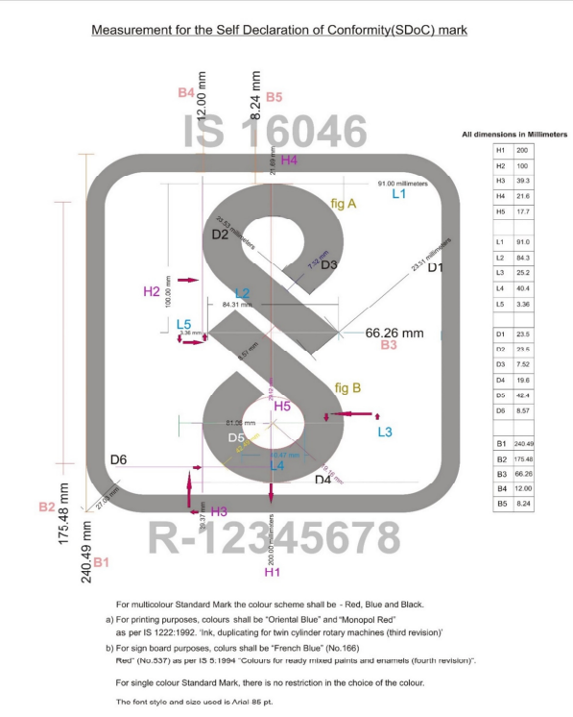
The IS number and licence number given above are examples only. Please also refer Gazette Notification S. O. 3240(E) dated 01 December 2015, for display of IS numbers for each product.
Annexure-III
(Refer sub-paragraph (3) of paragraph 6 of Scheme II)
Colour Scheme for the ‘Standard Mark’
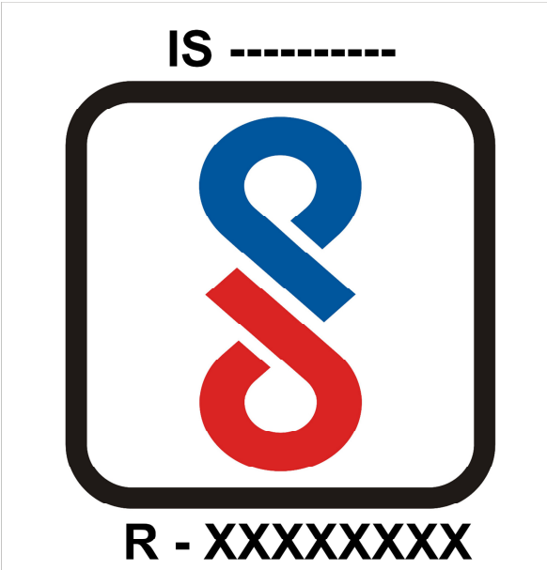
CENTRAL MARKS DEPARTMENT-III Ref: CMD III/9:6/e-labelling 13 09 2017 Subject: Electronic Labelling (e-labelling) Guidelines This has reference to the electronic labelling (e-labelling) of products covered under the Compulsory Registration Scheme of BIS. Any device with an integrated display screen may present the required labelling information including BIS “Standard Mark” electronically in lieu of a physical label or nameplate on the product. The guidelines shall apply to all devices which have an integral (non-removable) display screen and e-labelling of products shall not be mandatory. The Registered User shall have the option of using physical labels or e-labels or both. The requirements for e-labelling are as given below: 1. Devices utilizing e-labels shall have a physical label on the packaging of the product at the time of import, storage for sale and sale or distribution. For devices in bulk and not packaged individually, a removable adhesive label on the packaging is acceptable. 2. Devices shall not require any special accessory/tool or supplemental plug-in (e.g., the installation of a SIM/USIM card) to access the e-label. 3. The compliance related information shall be programmed by the responsible party and the information shall be secured in such a manner that third-party cannot modify it. The information can be in the firmware or software menu provided it is easily accessible and cannot be modified. 4. Users shall be able to access the information without requiring special access codes or permissions and, in all cases the information shall be accessible in no more than four steps in a device’s menu. 5. Users shall be provided specific instructions on how to access the information. The instructions shall be included in the user’s manual, operating instructions, or as an insert in the package of the product, or other similar means. 6. Alternately, the instructions to access the information may be available on the product related website. The instructions on how to access the website shall be provided in the user’s manual or package of the product. 7. All the applicable regulatory information required on the packaging or user manual shall be provided according to the applicable rules even if it is displayed electronically. 8. If the primary user manual or user guide is provided by other electronic media (e.g., CD or online access) this information may also be provided as part of e-label. 9. The “Standard Mark” displayed electronically shall meet all the relevant requirements of the guidelines issued by BIS vide circular reference CMD 3/8:1/6975 dated 3 Dec 2015. A R Unnikrishnan Head (CMD-

Notifications and Guidelines by BIS
- BIS is operating Compulsory Registration Scheme (CRS) as per Scheme - II of Schedule - II of BIS (Conformity Assessment) Regulations, 2018. Click here to refer BIS Act 2016, BIS Rules 2018, BIS (Conformity Assessment) Regulations 2018 and various guidelines framed there under.

Guidelines and Circulars issued by BIS


- BIS Act 2016
- BIS Rules 2018
- BIS (Conformity Assessment) Regulations 2018
- Guidelines for grant of licence
- Guidelines for change in scope of licence
- Guidelines for renewal of licence
- Guidelines for Suspension and Revocation of licence
- Guidelines for cancellation of licence
- Guidelines for dealing with non-conformity of product
- Guidelines for refund of online fee
For more Circulars issued for CRS, please click here.
For more Guidelines/ Circulars issued by BIS, please click here.

MeitY Notifications
- Electronics & Information Technology Goods (Requirements for Compulsory Registration) Order, 2012 Dated 7th September 2012
- Expansion of list of items under Electronics & Information Technology Goods (Requirements for Compulsory Registration) Order, 2012 dated 13th November 2014....Read More »

Important Orders/Notifications/Guidelines issued by MeitY


- Electronics & Information Technology Goods (Requirements for Compulsory Registration) Order, 2012 Dated 7th September 2012
- Expansion of list of items under Electronics & Information Technology Goods (Requirements for Compulsory Registration) Order, 2012 dated 13th November 2014
- Extension Order for Implementation of Compulsory Registration Order for Select Products included in Schedule of Gazette notified on 13.11.2014
- Indian language support for Mobile Phones was notified on 24 October 2016 by MeitY.
- Implementation of Server/Storage Power Supplied-Regarding. Kindly click here to read MeitY's circular dated 08th September 2016 and click here to read to read MeitY's circular dated 23rd December 2016.
- Extension in date of implementation of IS 16333 (Part 3):2016- Indian Language Support for Mobile Phones.
- Gazette Notification concerning expansion of list of items under CRO-Phase III.
- Extension in date of implementation of IS 16333 (Part 3):2016- Indian Language Support for Mobile Phones dated 29.09.2017
- Extension in date of implementation of IS 16333 (Part 3):2016- Indian Language Support for Mobile Phones dated 17.01.2018
- Extension Order for implementation of the products notified under CRO Phase III.
- Extension in date of implementation of IS 16333 (Part 3)2016- Indian Language Support for Mobile Phones dated 27.03.2018
- Gazette Notification concerning expansion of list of items under CRO-Phase IV
- Clarification regarding coverage of Multi-Function Devices (MFDs)
- Extension for products under CRO-Phase IV
- Gazette Notification for extension of phase V of CRO
Ministry - electronics-system-design-manufacturing-esdm | Ministry of Electronics and Information Technology .

MNRE Notifications
- Ministry of New and Renewal Energy(MNRE) has notified 6 products through notification dated 05 September 2017.
- Revised schedule and enforcement date of Solar Photovoltaic Systems/Devices/Components Goods Order 2017....Read More »

Important Notifications/Orders/Circulars issued by MNRE


- Solar Photovoltaics, Systems, Devices and Components Goods (Requirements for Compulsory Registration) Order, 2017 dated 30.08.2017
- Revised schedule and enforcement date of Solar Photovoltaic Systems/Devices/Components Goods order 2017 dated 26.03.2018
- Notification of revision of schedule of "Quality Control Order" incorporating self-certification clause dated 16.04.2018
- Revised Schedule of "Quality Control Order of Solar Photo Voltaic Systems, Devices and Components Goods 2017" dated 30.05.2018
- Notification of "Quality control order of Solar Photo voltaic Systems, Devices and Components GoodsÃƒÂ¢Ã¢â€šÂ¬Ã‚Â dated 13.07.2018
- Extension of Self Certification Relaxation for Quality Control Order on SPV Modules, Components and Devices Order 2017 dated 12.10.2018
- Extension of Self Certification for Inverters under MNRE Quality Control Order on SPV 2017 dated 04.01.2019
- OM regarding clarification on import of Lead Acid Battery for SPV Applications and other applications dated 06.05.2019
- OM regarding clarification on import of Lead Acid Battery for SPV Applications and other applications dated 28.05.2019
- Gazette notification for BIS extension for Inverters under MNRE Quality Control Order for SPV Systems, Components and Devices Order 2017 dated 03.07.2019
- Gazette Notification on BIS Registration Exemption for SPV Modules used in old SPV Power Projects dated 09.08.2019
- Gazette Notification for Extension of Self Certification for Solar Inverters under the Quality Control Order, 2017 dated 22.10.2019
- Date of implementation of the series of guidelines on SVP modules notified by MNRE on 16-04-2019 dated 04.11.2019
- Gazette notification for extension of dates for Solar Photovoltaic modules dated 13.02.2019
- Gazette notification for extension of dates for Solar Invertors dated 22.10.2019
- Gazette notification for extension of dates for Solar Invertors dated 13.01.2020
Click here for more circulars by MNRE.

=================

2. Whether BIS Licence is Mandatory to import products to India?
Generally certification scheme of BIS is voluntary in nature, however for certain products as notified by Government of India under Quality Control Orders, they can be imported to India only with Standard Mark under a valid licence from BIS. The list of such products are available here https://www.bis.gov.in/index.php/product-certification/products-undercompulsory-certification/
3. For which products, the BIS licence is mandatory?
BIS licence is mandatory for the products for details please click here https://www.bis.gov.in/index.php/product-certification/productsunder-compulsory-certification/
4. How to Apply for BIS Licence ?
The application can be made in the forms and formats available under FMCS with all relevant documents indicated in the application. BIS is making a provision to apply on line in due course of time.
5. Whether nomination of AIR is mandatory?

Yes, the foreign applicant has to nominate an Indian Resident as an Authorized Indian Representative (AIR) while submitting the application.
6. Who quality as an AIR ?

The AIR shall be an Indian resident and shall declare his consent to be responsible for compliance to the provisions of the BIS Act, rules, regulations and terms & conditions laid down in BIS Licence, Agreement, Undertaking etc. executed by or on behalf of the foreign manufacturer, by a senior person of branch/office in India shall be nominated as the AIR. In case, there is no such branch / office established in India or till it is established in India , the foreign manufacturer shall nominate an AIR in the prescribed format on firms’ letter-head. AIR is representative of one manufacturing firm only and doesn’t represent other foreign manufacturer(s) as AIR under the BIS Conformity Assessment schemes. However, in case of foreign manufacturers belonging to one group of companies and importers (related to the foreign manufacturer) nominated as AIR, the restriction shall not be applicable
7. Has the AIR to be an Indian resident only?
The AIR should be an Indian national; resident of India. However, he can be a foreign national if employed in any office/branch of the manufacturer in India but should be residing in India
8. What is the fee structure
For details of Fee Structure, Click here.
LIST OF FEE TO BE CHARGED FROM APPLICANT/LICENSEE (AS APPLICABLE) The fees to be remitted by applicants & licensees under Foreign Manufacturers Certification Scheme (FMCS) shall be same as applicable to domestic manufacturers (see A&B below). In addition, Per-diem charges shall be applicable as prescribed in Chapter II of Regulation 12 (4) (e) of the Bureau of Indian Standards (Terms and Conditions of Service of Employees) Regulations, 2007. All visits under FMCS shall be treated as special visits and cost of ticket, visa, insurance etc. shall be payable as per BIS norms. Payment against contingency fund of INR 10,000/- shall also be payable.
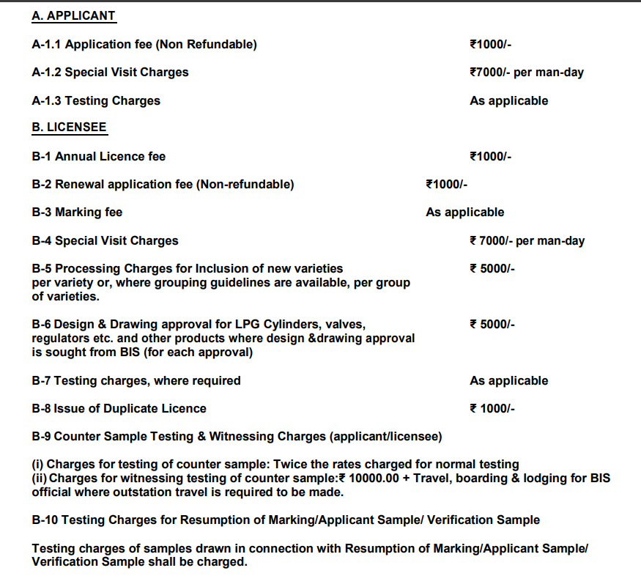
Notes: 1. All payments are to be made in equivalent USD by applicants/ licensees of NonSAARC Countries. All payments can be made either in Indian Rupees with GST (as applicable) or in Equivalent USD by applicants/ licensees of the South Asian Association for Regional Cooperation (SAARC) Countries, i.e. Afghanistan, Bangladesh, Bhutan, India, Nepal, the Maldives, Pakistan and Sri Lanka. 2. The amount indicated above are excluding bank commissions and transfer charges. Ensure that bank commission and/or transfer charges, if any, are deposited in addition to the abovementioned amount and fluctuation in the foreign exchange rate is also taken care of so that the above mentioned net fee/charges (in INR) are credited to BIS Account. 3. The payment may only be deposited with BIS through RTGS/NEFT/SWIFT transfer. Our Bank account details are as follows: Name of the Bank: Syndicate Bank Address of the Bank: BIS Branch, ManakBhavan, 9 Bahadur Shah Zafar Marg, New Delhi BIS Account No.: 90842180024625 Swift Code: SYNBINBB126 (For transfer in US Dollars) IFSC Code: SYNB0009084 (For transfer in INR)
9. Is the payment to be made to BIS in USD or INR?
For SAARC countries, the payment can be made in USD or Indian Rupee (INR) with GST. For other countries, the payment should be made in USD only.
10. Whether the test report as per IEC or any standard other than Indian Standard can be accepted?
Not accepted , only the test report as per relevant Indian Standard only be accepted.
11. Whether the sample of the product drawn during inspection can be tested in any ILAC/APLAC approved lab or, any Govt lab in the country of the manufacturer ?
No, the samples drawn during inspection shall be tested only in the laboratories of BIS and those recognized by BIS. The sample drawn by BIS shall be sent to Laboratory in India by the applicant firm. The actual testing charges shall be borne by the applicant firm.
12. What is the timeline for grant of licence?
Average time taken for grant of licence is generally six months from the date of receipt of complete application and its recording. It may vary for reasons like delay in response to queries raised, if any; organizing inspection(s); transportation of samples and remittance of dues, etc.
13. Can I submit one application for different products/ISS being manufactured at the same factory location?
No, separate application for each product/ISS is to be submitted for each factory location.
14. Can I submit one application for one product being manufactured at different locations?
No, separate application for each product/ISS is to be submitted for each factory location.
15. Whether separate application are to be made for different brand of a product manufactured at same location ?
No, the application for licence is for a product at a manufacturing premise. The firm to give submit an undertaking for the brand name with relevant documents
16. Whether any technical manual is available to help applicant to know details of required infrastructure, Scheme of Inspection and Testing, sampling guideline etc. for BIS Licence ?
A number of Product Manual and scheme of Inspection and Testing (SIT) are available for various Indian Standrads under certification. For details please click here https://www.bis.gov.in/index.php/product-certification/product-specificguideline/
17. I am an importer, can I apply for Licence on behalf of Manufacturer
No, Under FMCS scheme the application shall be made by the foreign manufacturer only
18. What are the process flow followed in grant of Licence
The details of process followed is given on BIS web site under FMCS, for information a typical process flow for grant of licence is given below:
19. What is the validity of BIS Licence ?
BIS certification under Scheme-I may be granted initially upto two years after payment of advance minimum marking fee. The licence is valid only for the varieties mentioned in the licence. For extension of validity and varieties covered in licence, application with requisite fee and documents under the existing licence is required to be submitted. Licence may renewed upto five years from the last of the validity
20. For further queries please contact
For further queries please contact
Room No. 459, Manakalaya Building
Bureau of Indian Standards,
9, Bahadur Shah Zafar Marg,
New Delhi – 110002.
Telephone: 011-2323 0131/3375/9402, 2360 8280/8319/8449
Email: fmcs[at]bis[dot]gov[dot]in

