**MODULE-2**

Q-1. Give the name of the Traditional and Digital platform where we can promote TOPS Technologies Pvt. Ltd, and suggest which platform will be better for their marketing activity with a reason?

ANS:

1. Newspapers (e.g., Times of India, Gujarat Samachar)
2. Magazines (Educational and Career-oriented magazines)
3. Radio Advertising (FM channels like Red FM, Radio Mirchi)
4. Television Advertising (Local and regional channels)
5. Billboards / Hoardings
6. Flyers & Brochures
7. Educational Fairs & Seminars
8. Posters in Colleges and Institutes
9. Word of Mouth / Referral Networks.
10. Local Sponsorships (college events, tech fests)

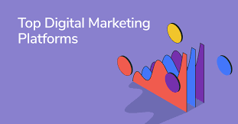

### Digital Marketing Platforms:

1. Google Ads (Search & Display Network)
2. Social Media:  
   * Facebook
   * Instagram
   * LinkedIn
   * Twitter (X)
   * YouTube
3. Email Marketing
4. Content Marketing (Blogs, Articles)
5. SEO (Search Engine Optimization)
6. WhatsApp Business Marketing
7. Online Classifieds (Justdial, Sulekha)
8. Affiliate or Influencer Marketing
9. Webinars / Online Workshops
10. Learning Platforms / Aggregators (Shiksha, UrbanPro)

This are the platforms we can promote TOPS.

Here the following are the reason for digital marketing is better for TOPS:

**Targeted Reach:**

* Can focus on specific demographics like students, job seekers, and IT professionals across specific locations.

**Cost-Effective:**

* Lower cost per lead compared to traditional methods like newspapers or TV.

**Measurable Results:**

* Tools like Google Analytics, Facebook Insights, and CRM tools help track ROI, engagement, and conversion.

**Two-way Communication:**

* Social media allows direct engagement with potential students and builds brand loyalty.

**Scalable and Flexible:**

* Campaigns can be adjusted or paused at any time depending on performance.

**High Visibility:**

* Most students and young professionals spend time online, especially on Instagram, YouTube, and LinkedIn.

**SEO and Content** can bring **organic traffic** and long-term brand value.

Q-2. What are the Marketing activities and their uses?

Ans:

## List of Marketing Activities and Their Uses

| Marketing Activity | Use / Purpose |
| --- | --- |
| 1. Market Research | Understand customer needs, competition, and market trends to make informed decisions. |
| 2. Content Marketing | Educate and engage audience via blogs, videos, and articles to build trust and SEO. |
| 3. Social Media Marketing | Increase brand awareness, engage with target audience, promote courses/events. |
| 4. Search Engine Optimization (SEO) | Improve organic visibility on Google, attract traffic without paid ads. |
| 5. Search Engine Marketing (SEM) | Drive targeted traffic through paid Google Ads. |
| 6. Email Marketing | Nurture leads, share updates/offers, re-engage old students or prospects. |
| 7. Influencer Marketing | Promote brand through local or micro influencers trusted by your target audience. |
| 8. Affiliate Marketing | Expand reach by partnering with others who promote your services for commission. |
| 9. Event Marketing / Seminars | Build brand awareness and direct engagement through offline or online events. |
| 10. Referral Programs | Encourage current students or alumni to refer others, increasing word-of-mouth. |
| 11. Print Advertising | Reach local audiences via newspapers, magazines, and brochures. |
| 12. Outdoor Advertising (OOH) | Enhance visibility in high-traffic areas through billboards or banners. |
| 13. Television / Radio Ads | Mass reach and brand building among general public. |
| 14. Webinars / Live Sessions | Showcase expertise, answer queries, and convert prospects in real time. |
| 15. Website Optimization | Improve user experience, lead capture, and mobile responsiveness. |
| 16. Online Reviews & Reputation Management | Build trust through testimonials and manage public perception. |
| 17. WhatsApp / SMS Marketing | Direct, personalized messaging for updates and promotions. |
| 18. Video Marketing (YouTube, Reels) | Explain complex topics, success stories, or center tours in engaging formats. |
| 19. CRM & Lead Management | Track, nurture, and convert prospects using automation tools. |
| 20. Branding & Positioning Activities | Define brand identity, USPs, and market differentiation. |

Q-3. What is Traffic?

Ans:

Traffic generally refers to the movement of vehicles, pedestrians, or data across a specific area or network. The term can be applied in various contexts: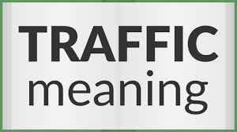

nternet traffic refers to the flow of data across the internet. It encompasses all the data packets transmitted between devices, servers, and networks. Here are some key aspects of internet traffic:

1. Data Types: Internet traffic includes various types of data, such as web page requests, file downloads, video streaming, online gaming, and email communications.
2. Measurement: Internet traffic is typically measured in bits per second (bps), kilobits per second (Kbps), megabits per second (Mbps), or gigabits per second (Gbps). These measurements help quantify the amount of data being transmitted over a network.
3. Traffic Patterns: Internet traffic can exhibit different patterns based on time of day, user behavior, and specific events (e.g., live sports events, product launches). Understanding these patterns is crucial for network management and optimization.
4. Network Congestion: High levels of internet traffic can lead to congestion, resulting in slower speeds, increased latency, and potential service interruptions. Network administrators often implement traffic management techniques to alleviate congestion.
5. Traffic Analysis: Tools and techniques are used to analyze internet traffic for various purposes, including security monitoring, performance optimization, and understanding user behavior.
6. Protocols: Internet traffic is governed by various protocols, such as Transmission Control Protocol (TCP) and User Datagram Protocol (UDP), which dictate how data is transmitted and received over the internet.

Overall, internet traffic is a critical aspect of how the internet functions, impacting everything from user experience to network performance.

Q-4. Things we should see while choosing a domain name for a company

Ans:Choosing a domain name for a company is a crucial step in establishing an online presence. Here are several important factors to consider:

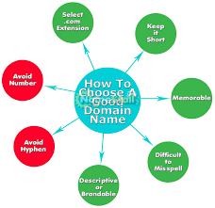

1. Relevance: The domain name should reflect your business name, brand, or the services/products you offer. It should give visitors an idea of what your company is about.
2. Simplicity: Choose a name that is easy to spell, pronounce, and remember. Avoid complex words or unusual spellings that could confuse potential visitors.
3. Length: Shorter domain names are generally better as they are easier to remember and type. Aim for a name that is concise, ideally under 15 characters.
4. Keywords: If possible, include relevant keywords that describe your business. This can help with search engine optimization (SEO) and make it easier for customers to find you.
5. Avoid Numbers and Hyphens: Numbers and hyphens can lead to confusion. For example, people may not know whether to use the numeral (5) or spell it out (five), and hyphens can be easily forgotten.
6. Domain Extension: Choose the right domain extension (TLD) for your business. While .com is the most popular and widely recognized, other extensions like .net, .org, or industry-specific TLDs (e.g., .tech, .store) can also be considered.
7. Uniqueness: Ensure that your domain name is unique and not similar to existing brands or websites. This helps avoid legal issues and confusion among customers.
8. Availability: Check if the domain name is available for registration. You can use domain registration websites to see if your desired name is already taken.
9. Future Growth: Consider a name that allows for future expansion of your business. Avoid names that are too specific to a particular product or service if you plan to diversify later.
10. Social Media Compatibility: Check the availability of the same or similar names on social media platforms. Consistency across your domain and social media handles can strengthen your brand identity.
11. Trademark Considerations: Research to ensure that the domain name does not infringe on existing trademarks. This can help you avoid legal complications down the line.
12. SEO Considerations: While not as critical as it once was, having a keyword in your domain can still provide some SEO benefits. However, prioritize branding and memorability over keyword stuffing.

Q-5. What is the difference between a Landing page and a Home page?

Ans:

A landing page and a home page serve different purposes in web design and marketing. Here are the key differences between the two:

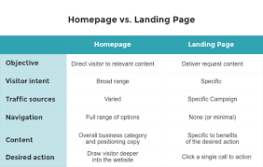

### **Home Page**

1. Purpose: The home page is the main entry point of a website. It provides an overview of the site’s content and serves as a navigation hub for visitors to explore other sections of the website.
2. Content: Home pages typically include a variety of content, such as links to different pages (e.g., services, products, about us, contact), featured articles, images, and sometimes a brief introduction to the business or organization.
3. Navigation: The home page usually has a comprehensive navigation menu that allows users to access various parts of the website easily.
4. Audience: It caters to a broad audience, including new visitors, returning users, and potential customers. The goal is to engage users and encourage them to explore further.
5. Design: Home pages often have a more complex design with multiple sections, images, and calls to action (CTAs) that guide users to different areas of the site.

### **Landing Page**

1. Purpose: A landing page is designed for a specific marketing campaign or goal, such as capturing leads, promoting a product, or encouraging sign-ups. It is often used in conjunction with online advertising or email marketing.
2. Content: Landing pages are focused and typically contain minimal content that is directly related to the campaign. They often include a clear value proposition, persuasive copy, and a single call to action (CTA).
3. Navigation: Landing pages usually have limited or no navigation options to minimize distractions and keep the visitor focused on the desired action (e.g., filling out a form, making a purchase).
4. Audience: The audience for a landing page is often more targeted, consisting of users who have clicked on a specific ad, link, or email. The goal is to convert these visitors into leads or customers.
5. Design: Landing pages are typically simpler in design, with a clear layout that emphasizes the CTA. They may include testimonials, images, or videos that support the campaign's message but are generally less cluttered than home pages.

### Summary

In summary, the home page serves as the main navigation point for a website, providing a broad overview of content, while a landing page is focused on a specific goal or campaign, designed to drive conversions with minimal distractions. Understanding these differences can help businesses effectively utilize both types of pages in their online strategy.

Q-6. List out some call-to-actions we use, on an e-commerce website.

Ans:

Call-to-actions (CTAs) are essential elements on an e-commerce website that guide users toward taking specific actions. Here are some effective CTAs commonly used in e-commerce:

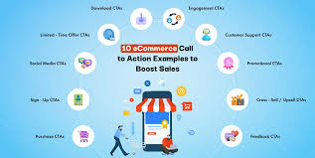

1. Shop Now: Encourages users to start browsing products immediately.
2. Add to Cart: Directs users to add a selected item to their shopping cart.
3. Buy Now: Prompts users to make an immediate purchase of a product.
4. View Cart: Allows users to review the items they have added to their shopping cart.
5. Checkout: Guides users to proceed to the payment and shipping process.
6. Sign Up for Discounts: Encourages users to subscribe to a newsletter in exchange for a discount or special offer.
7. Get Started: Invites users to begin a process, such as creating an account or exploring a service.
8. Learn More: Directs users to additional information about a product or service.
9. Limited Time Offer: Creates urgency by promoting a time-sensitive deal or discount.
10. Free Shipping on Orders Over [Amount]: Highlights a shipping incentive to encourage larger purchases.
11. Browse Collections: Encourages users to explore curated product categories or collections.
12. See Similar Products: Suggests related items to encourage additional purchases.
13. Join Our Loyalty Program: Invites users to sign up for a rewards program that offers benefits for repeat purchases.
14. Get a Quote: For services or customizable products, this CTA invites users to request a price estimate.
15. Download Our App: Encourages users to download a mobile app for a better shopping experience.
16. Follow Us on Social Media: Prompts users to connect with the brand on social media platforms.
17. Write a Review: Encourages customers to leave feedback on products they have purchased.
18. Refer a Friend: Invites users to share the website with friends, often with incentives for both parties.
19. Check Out Our Blog: Directs users to informative content that may enhance their shopping experience.
20. Contact Us: Provides an option for users to reach out for support or inquiries.

Using clear and compelling CTAs can significantly enhance user engagement and conversion rates on an e-commerce website.

Q-7. What is the meaning of keywords and what add-ons we can use with them?

Ans:

Keywords are specific words or phrases that users enter into search engines when looking for information, products, or services. In the context of digital marketing and search engine optimization (SEO), keywords are crucial because they help determine how well a website ranks in search engine results pages (SERPs). By optimizing content with relevant keywords, businesses can attract more organic traffic and reach their target audience effectively.

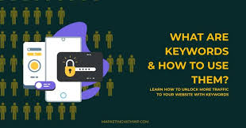

### **Types of Keywords**

1. Short-Tail Keywords: These are typically one or two words long and are very general (e.g., "shoes"). They usually have high search volume but also high competition.
2. Long-Tail Keywords: These are longer phrases (usually three or more words) that are more specific (e.g., "best running shoes for women"). They tend to have lower search volume but also lower competition, making them easier to rank for.
3. Local Keywords: These keywords include geographic locations (e.g., "coffee shop in New York") and are essential for businesses targeting local customers.
4. Transactional Keywords: These indicate a user's intent to make a purchase (e.g., "buy shoes online"). They are often used in e-commerce.
5. Informational Keywords: These are used by users seeking information (e.g., "how to tie shoes"). They are often associated with content marketing.

### **Add-Ons for Keywords**

When using keywords in your digital marketing strategy, several add-ons and tools can enhance their effectiveness:

1. Keyword Research Tools: Tools like Google Keyword Planner, SEMrush, Ahrefs, and Moz can help identify relevant keywords, search volume, competition, and related terms.
2. SEO Plugins: For websites built on platforms like WordPress, plugins such as Yoast SEO or All in One SEO Pack can assist in optimizing content with keywords, providing suggestions for on-page SEO improvements.
3. Content Optimization Tools: Tools like Clearscope or Surfer SEO analyze top-ranking content for specific keywords and provide recommendations for optimizing your content to improve its relevance and ranking.
4. Analytics Tools: Google Analytics and Google Search Console can help track keyword performance, user behavior, and traffic sources, allowing you to refine your keyword strategy over time.
5. Competitor Analysis Tools: Tools like SpyFu or SimilarWeb can help you analyze competitors' keyword strategies, revealing opportunities for your own keyword targeting.
6. Local SEO Tools: If you're targeting local keywords, tools like Moz Local or BrightLocal can help manage local listings and optimize for local search.
7. Social Media Tools: Platforms like BuzzSumo can help identify trending topics and keywords in your industry, allowing you to create relevant content that resonates with your audience.
8. Content Management Systems (CMS): Many CMS platforms have built-in features or plugins that help optimize content for keywords, making it easier to manage SEO efforts.

By effectively using keywords and leveraging these add-ons, businesses can improve their online visibility, attract more targeted traffic, and ultimately drive conversions.

Q-8. Please write some of the major Algorithm updates and their effect on Google rankings.

Ans:

Google's algorithm updates significantly impact website rankings, often leading to substantial changes in traffic and visibility. Major updates, such as Panda, Penguin, and core updates, focus on content quality, user experience, and relevance, reshaping how sites are evaluated and ranked in search results.

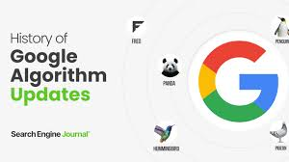

### **Major Google Algorithm Updates**

1. Panda Update
   * Launch Date: February 2011
   * Focus: Content quality
   * Effect: Penalized sites with low-quality, duplicate, or thin content. Websites that provided valuable, original content saw improvements in rankings.
2. Penguin Update
   * Launch Date: April 2012
   * Focus: Link quality
   * Effect: Targeted sites using manipulative link-building practices. Websites with natural, high-quality backlinks benefited, while those with spammy links faced penalties.
3. Hummingbird Update
   * Launch Date: August 2013
   * Focus: Semantic search
   * Effect: Improved understanding of user intent and context. Websites that optimized for conversational queries and relevant content saw better rankings.
4. Mobilegeddon
   * Launch Date: April 2015
   * Focus: Mobile-friendliness
   * Effect: Sites that were not mobile-optimized experienced drops in rankings on mobile search results. Mobile-friendly sites gained visibility.
5. RankBrain
   * Launch Date: October 2015
   * Focus: Machine learning
   * Effect: Enhanced Google's ability to process search queries and deliver relevant results. Websites that aligned with user intent and engagement metrics improved their rankings.
6. Bert Update
   * Launch Date: October 2019
   * Focus: Natural language processing
   * Effect: Improved understanding of the nuances and context of words in search queries. Content that addressed user questions more effectively saw ranking boosts.
7. Core Web Vitals Update
   * Launch Date: June 2021
   * Focus: User experience metrics
   * Effect: Sites that met performance benchmarks for loading speed, interactivity, and visual stability gained higher rankings. Poorly performing sites faced declines.
8. Helpful Content Update
   * Launch Date: August 2022
   * Focus: Content relevance and helpfulness
   * Effect: Penalized sites that produced content primarily for search engines rather than users. High-quality, user-focused content was rewarded with better rankings.

### **Conclusion**

These updates illustrate Google's ongoing commitment to improving search quality by prioritizing user experience, content relevance, and authoritative sources. Staying informed about these changes is essential for website owners and digital marketers to adapt their strategies and maintain or improve their rankings.

Q-9. What is the Crawling and Indexing process and who performs it?

Ans:

Crawling and indexing are fundamental processes that search engines use to discover, analyze, and store information from web pages. Here’s a detailed overview of each process and the entities involved:

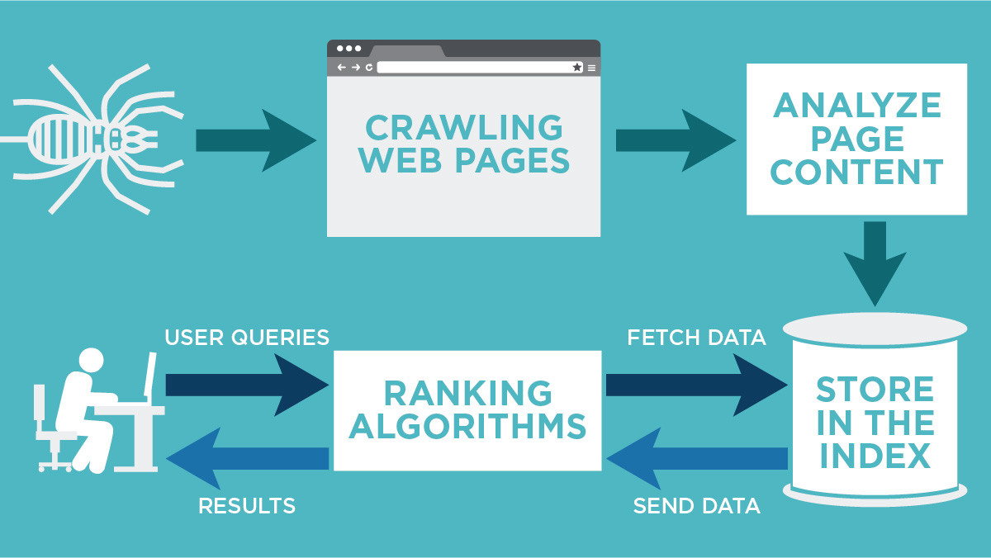

Definition: Crawling is the process by which search engines systematically browse the web to discover new and updated pages. This is done using automated programs known as "crawlers" or "spiders."

How It Works:

1. Starting Points: Crawlers begin with a list of known URLs (seed URLs) and follow links on those pages to discover additional pages.
2. Fetching Pages: The crawler requests the content of each page it visits, downloading the HTML and other resources (like images, CSS, and JavaScript).
3. Following Links: As crawlers navigate through pages, they identify and follow hyperlinks to other pages, continuously expanding their reach across the web.
4. Respecting Robots.txt: Crawlers check the robots.txt file of a website to determine which pages or sections should not be crawled, as specified by the website owner.

Who Performs Crawling: Major search engines like Google, Bing, and Yahoo use their own crawlers (e.g., Googlebot for Google) to perform this task. These crawlers are designed to efficiently navigate the vast expanse of the internet.

### Indexing

Definition: Indexing is the process of organizing and storing the information collected during crawling in a way that allows for quick retrieval when users perform searches.

How It Works:

1. Analyzing Content: Once a page is crawled, the search engine analyzes its content, including text, images, and metadata (like title tags and meta descriptions).
2. Storing Information: The analyzed data is then stored in a massive database known as an index. This index is structured to facilitate fast searches and retrieval.
3. Ranking Signals: During indexing, search engines also evaluate various ranking signals (such as keyword relevance, page authority, and user engagement metrics) to determine how to rank the page in search results.

Who Performs Indexing: The indexing process is carried out by the same search engines that perform crawling. They use sophisticated algorithms to analyze and organize the data collected from crawled pages.

Q-10. Difference between Organic and Inorganic results.

Ans:

In the context of search engine results, "organic" and "inorganic" (often referred to as "paid") results represent two different methods of achieving visibility on search engine results pages (SERPs). Here are the key differences between the two:

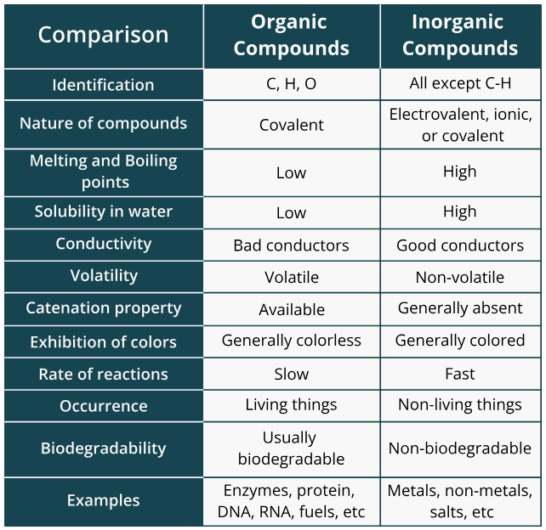

### **Organic Results**

1. Definition: Organic results are listings that appear in search engine results due to their relevance to the search query, as determined by the search engine's algorithms. These results are not paid for.
2. Ranking Factors: Organic rankings are influenced by various factors, including content quality, keyword relevance, backlinks, user engagement, and overall website authority. Search engines use complex algorithms to evaluate these factors.
3. Cost: There is no direct cost associated with appearing in organic search results. However, achieving high organic rankings often requires investment in search engine optimization (SEO) efforts, such as content creation, link building, and technical SEO.
4. Longevity: Organic results can provide long-term visibility and traffic, as high-ranking pages can maintain their positions for extended periods, especially if they continue to provide valuable content.
5. Trust and Credibility: Users often perceive organic results as more trustworthy and credible compared to paid ads, as they are based on relevance rather than payment.
6. Click-Through Rates (CTR): Organic results generally have higher click-through rates compared to paid ads, as users tend to trust them more.

### **Inorganic (Paid) Results**

1. Definition: Inorganic results are listings that appear in search engine results as a result of paid advertising. These are often labeled as "ads" or "sponsored" content.
2. Ranking Factors: Paid results are determined by a bidding system, where advertisers bid on keywords. The position of an ad is influenced by the bid amount, ad quality, and relevance to the search query.
3. Cost: Advertisers pay for clicks (Cost Per Click, or CPC) or impressions (Cost Per Mille, or CPM) when users interact with their ads. This can lead to significant advertising costs, especially in competitive markets.
4. Short-Term Visibility: Inorganic results provide immediate visibility and traffic, but once the advertising budget is exhausted or the campaign is paused, the visibility disappears.
5. Trust and Credibility: Some users may be skeptical of paid ads, viewing them as less trustworthy than organic results. However, well-crafted ads can still attract clicks and conversions.
6. Click-Through Rates (CTR): Paid ads typically have lower click-through rates compared to organic results, although this can vary based on the ad's relevance and quality.

Q-11. Create a blog for the latest SEO trends in the market using any blogging site.

Ans:<https://asiaticmultiverse.blogspot.com>

Q-12. Create a website for the business using www.blogger.com / Wordpress.com / Google Sites.

Ans:<https://dhyeychhadiya029.wixsite.com/my-site-2>