HR INTERVIEW APP
Recruiter & Administrator User Manual
AI-powered Interview Management System

DynaTech Systems
Document version 1.0
Audience: Recruiters & Administrators
Last updated: May 2026

Table of Contents
Right-click here and choose “Update Field” to build the table of contents.

1. Introduction

1.1 What is the HR Interview App?
The HR Interview App is an AI-powered interview management platform. It lets your recruitment team create AI-driven voice interviews, invite candidates by email, and then automatically score, transcribe, and analyse each candidate's responses. Beyond the live interview, the platform also screens résumés against a job description (ATS Scoring), discovers the companies candidates have worked at (Company Finder), tracks usage costs, and gives you a single dashboard to manage your whole hiring funnel.
This manual covers the recruiter- and administrator-facing side of the product — everything you do after signing in to the dashboard. The candidate's own interview experience (joining a call, camera/microphone checks, face verification) is delivered through a separate public link and is outside the scope of this manual.

1.2 Who should read this manual
- Recruiters — Recruiters who create interviews, invite candidates, and review results.
- Managers — Hiring managers who review shortlists and candidate scores.
- Administrators — Administrators who manage users, costs, and the advanced screening tools.

1.3 Key terms used in this manual
Interview: A reusable AI interview definition — a name, an AI interviewer, an objective, and a set of questions. Candidates are invited to take it.
AI Interviewer: The voice persona (voice, language, gender) that conducts the conversation with the candidate.
Candidate / Assignee: A person you have added to the system and can assign to an interview. Managed on the Users page.
Response: One candidate's completed interview attempt — including the recording, transcript, scores, and anti-cheat findings.
ATS Scoring: Automated résumé scoring against a job description, producing a ranked candidate list.
Company Finder: An admin tool that extracts and enriches the companies found in candidate résumés.
Violation: An anti-cheat event captured during the candidate's interview (e.g. tab switching, extra people detected).
ℹ Note
The dashboard is designed for desktop use. If you open the sign-in page on a phone you will see a message asking you to use a PC for the best experience.

2. Getting Started

2.1 Signing in
1. Open the application URL in a desktop browser (Google Chrome or Microsoft Edge are recommended).
2. Enter your email and password. Use the credentials provided by your administrator.
3. Click the eye icon inside the password field if you want to confirm what you typed.
4. Click Sign In. On success you are taken to the Dashboard overview.
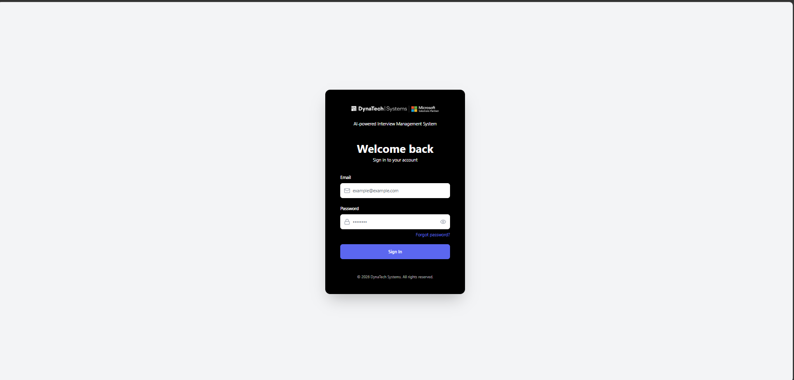

2.2 Resetting a forgotten password
1. On the sign-in screen, click Forgot password?
2. Enter your email address in the Reset Password dialog.
3. Click Send Reset Link. If the email exists, a reset link is sent to that address.
4. Open the email and follow the link to choose a new password.
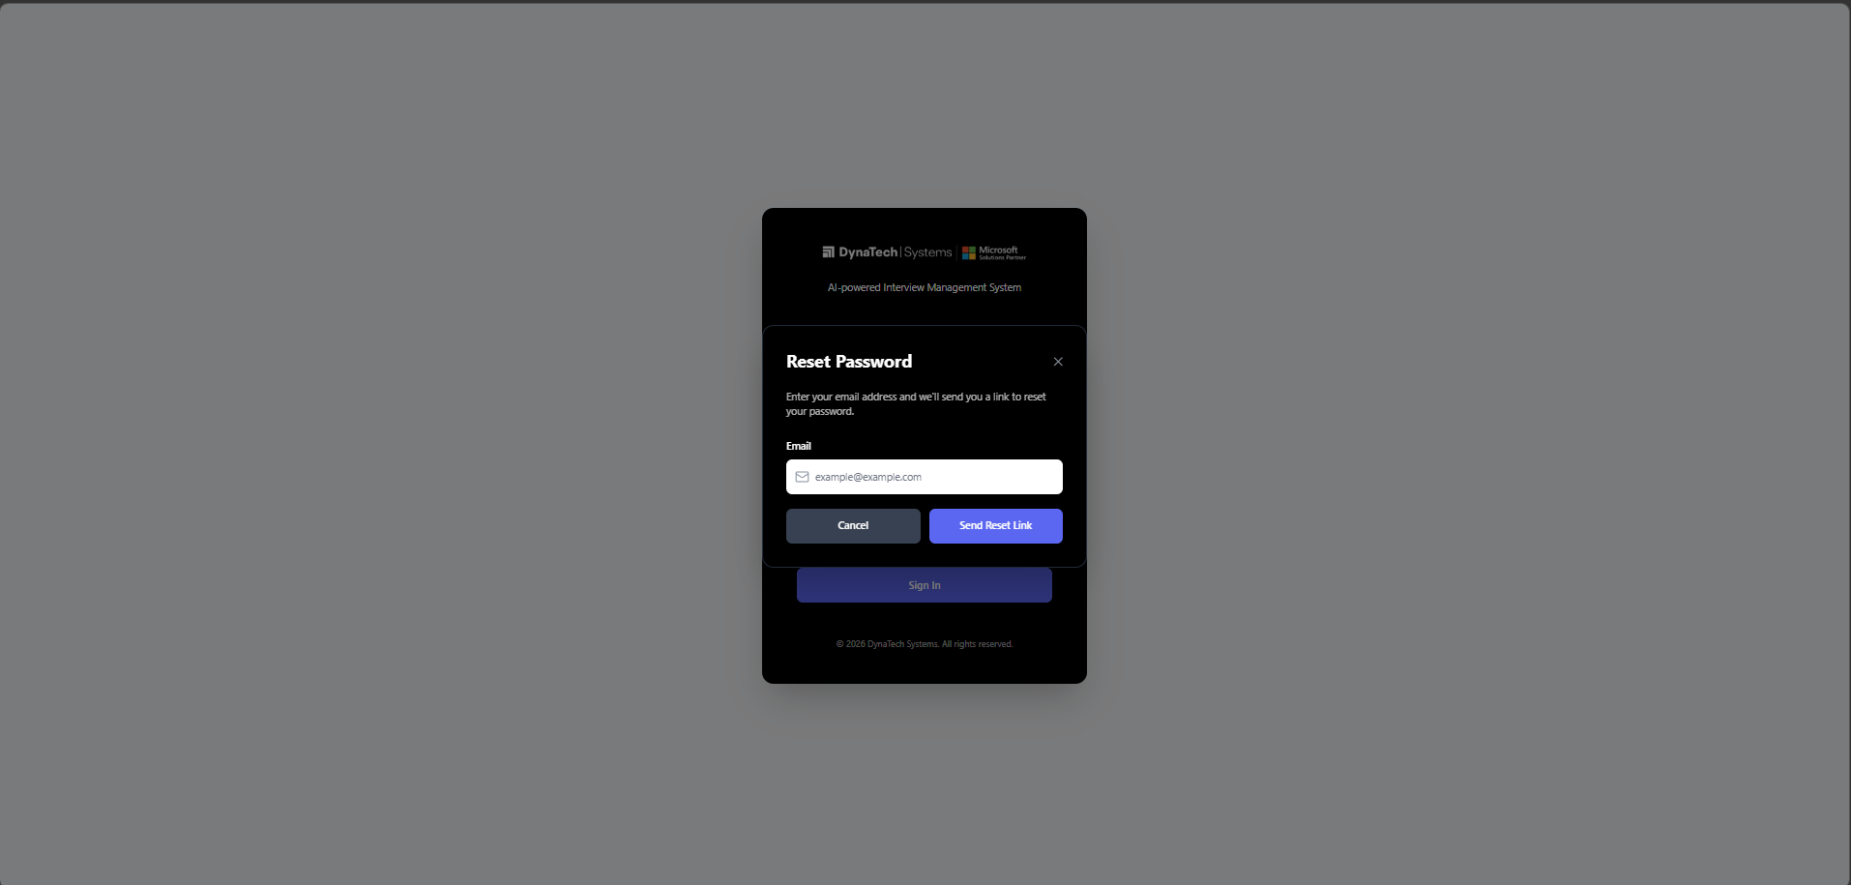

2.3 The dashboard layout
Once signed in, every screen shares the same frame:
- Top bar — the DynaTech logo (click it to return to your interviews) and your profile avatar.
- Left side menu — Dashboard, Interviews, Interviewers, Users, ATS Scoring, and — depending on your role — Company Finder and Cost & Analysis.
- User menu — click your avatar (top-right) to open Profile or to Sign Out.
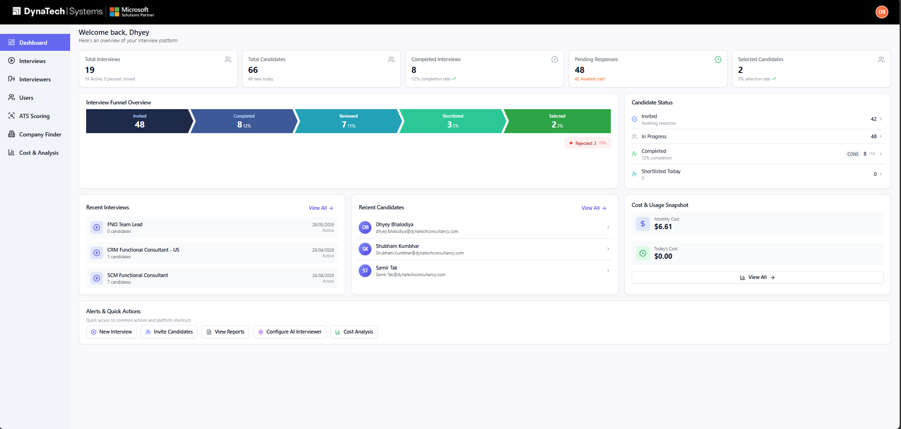

2.4 User roles and what each can access
Your role controls which menu items you can open. The table below summarises access to the role-restricted areas; all other areas are available to every role.
Role | Company Finder | Cost & Analysis
Admin | Yes | Yes
Manager | No | Yes
Interviewer | No | Yes
Viewer | No | Yes
Marketing | No | No
HR Consultant | No | No

ℹ Note
Company Finder is restricted to Administrators. Cost & Analysis is hidden from the Marketing and HR Consultant roles. If you cannot see a menu item described in this manual, your role does not have access to it.

3. Dashboard Overview
The Dashboard (the first screen after sign-in) gives you a live snapshot of your hiring pipeline. Open it any time from the Dashboard item at the top of the left menu.

3.1 Top statistics
Five cards summarise your activity. Click a card to jump straight to the matching screen:
- Total Interviews — total number of interviews, with how many are active vs. paused.
- Total Candidates — everyone added on the Users page.
- Completed Interviews — responses that have been captured, with a completion-rate percentage.
- Pending Responses — invitations sent but not yet completed.
- Selected Candidates — candidates marked Selected, with a selection-rate percentage.

3.2 Interview funnel and candidate status
The Interview Funnel Overview shows candidates flowing through five stages — Invited → Completed → Reviewed → Shortlisted → Selected — plus a Rejected count. The Candidate Status panel beside it lets you click any stage to open the Users page already filtered to that group.
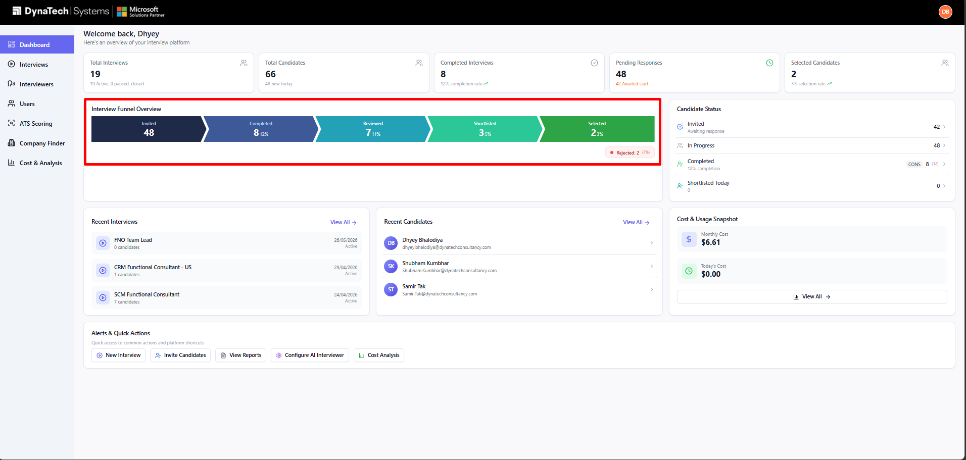

3.3 Recent activity, costs, and quick actions
- Recent Interviews — your three newest interviews; click one to open it.
- Recent Candidates — the three most recently updated candidates.
- Cost & Usage Snapshot — this month's and today's spend, with a link to full Cost & Analysis.
- Alerts & Quick Actions — one-click shortcuts: New Interview, Invite Candidates, View Reports, Configure AI Interviewer, Cost Analysis.
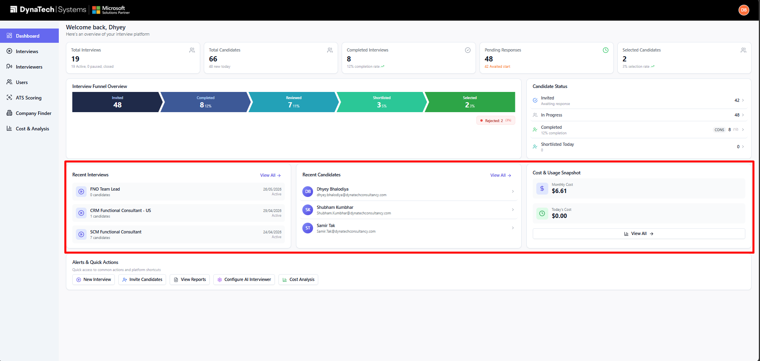

4. Managing Interviews

4.1 The Interviews page
Click Interviews in the left menu to see every interview you have created. From here you can:
- Search — find an interview by name using the search box.
- Grid / List view — switch between the card grid and a compact list using the view toggle.
- Create Interview — open the creation wizard with the Create Interview button.
- Open — click any interview card to open its detail page (responses, sharing, settings).
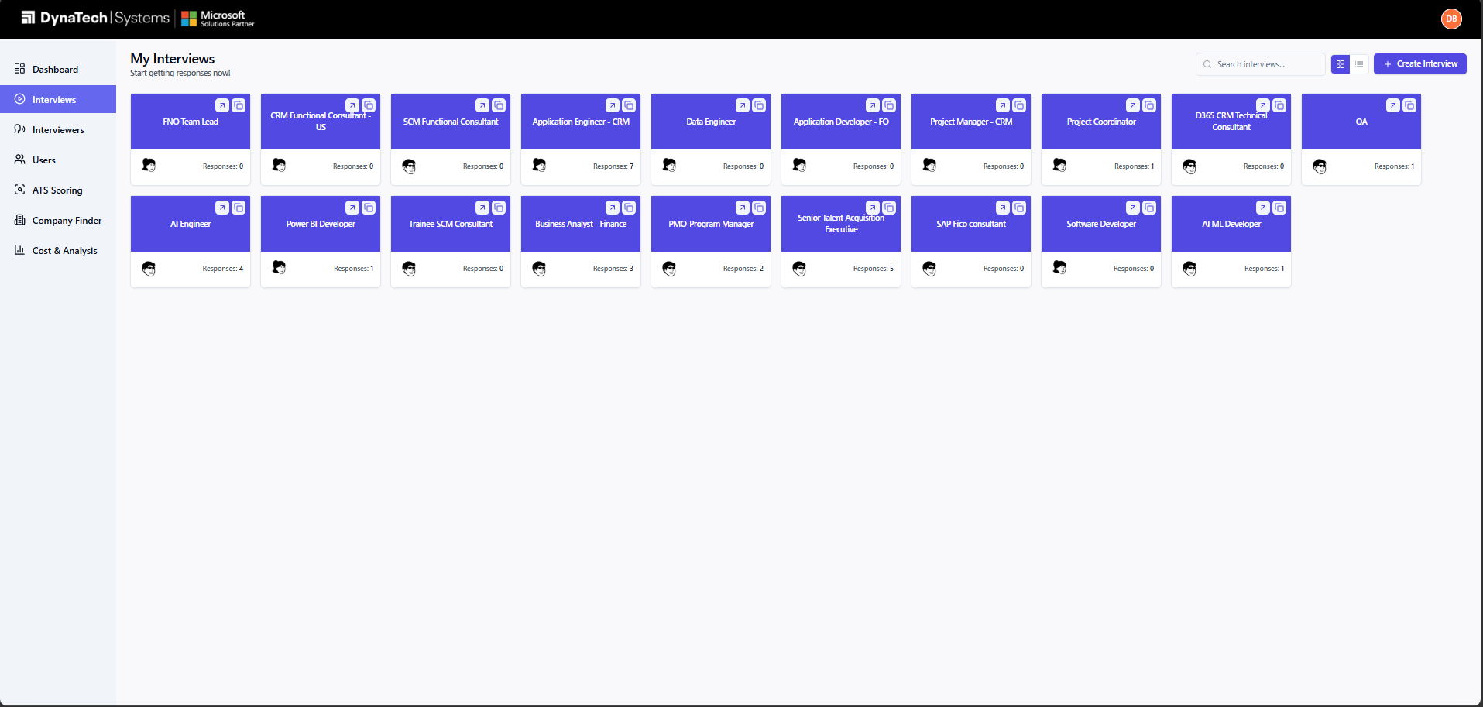

4.2 Creating an interview — Step 1: details
Click Create Interview to open the two-step wizard. On the first step you provide:
1. Interview Name — a clear title, e.g. “Senior .NET Developer — Screening”.
2. Select an Interviewer — click an AI interviewer's photo to choose its voice. Click the small info (i) icon to preview voice, provider and language details.
3. Objective — describe what you want to assess, e.g. “Evaluate technical depth in C# and past project ownership.”
4. Upload documents (optional) — attach a job description or reference document so the AI can generate more relevant questions.
5. Number of Questions — between 1 and 10.
6. Duration (mins) — the time limit for the interview, between 1 and 20 minutes.
Then choose how the questions are created:
- Generate Questions — the AI drafts questions for you based on the objective and any uploaded document.
- I'll do it myself — start with a blank question you fill in yourself.
💡 Tip
Uploading a job description before clicking Generate Questions produces noticeably sharper, role-specific questions. You can still edit every generated question on the next step.

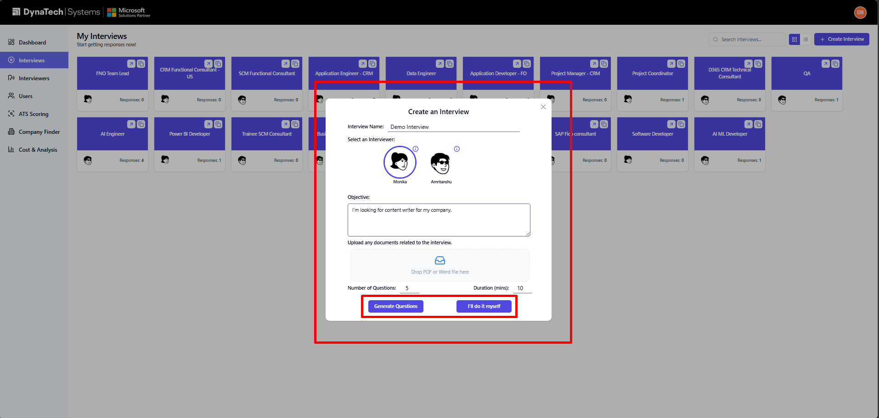

4.3 Creating an interview — Step 2: questions
1. Review the auto-generated Description and edit it if needed.
2. Review each question card. Edit the wording directly in the card.
3. Use Add Question to add more (up to the number you chose), or the delete icon on a card to remove one.
4. Click Save Interview. The interview now appears on your Interviews page.
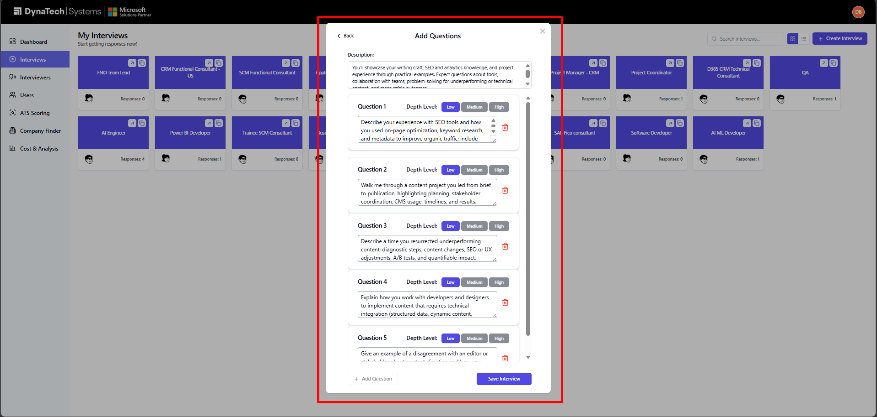

ℹ Note
Save Interview stays disabled until every question has text. The Add Question button is limited to the number of questions you selected on the first step.

4.4 The interview detail page
Clicking an interview opens its detail page. The toolbar at the top contains, from left to right:
- Share (↗ icon) — copy or open the candidate link to send to applicants.
- Preview (eye icon) — open the candidate-facing interview page in a new tab to see what applicants see.
- Theme colour (palette icon) — change the accent colour candidates see on the interview page.
- Edit (pencil icon) — change the interview's questions and settings.
- Active toggle — switch the interview on or off. While paused, candidates cannot start it.
The left column lists every response; the large area on the right shows the Overall Analysis summary (see Section 6) or, when you click a response, that candidate's full detail.
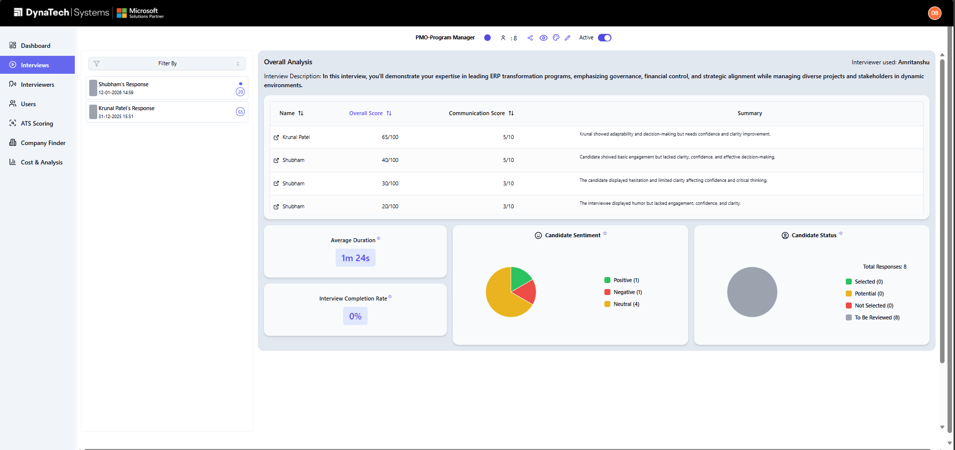

4.5 Sharing an interview with candidates
There are two ways to get candidates into an interview:
- Share link — use the Share button to copy the public interview link and send it yourself.
- Invite by email — add candidates on the Users page, assign them to this interview, then send invitation emails in bulk (see Section 7).
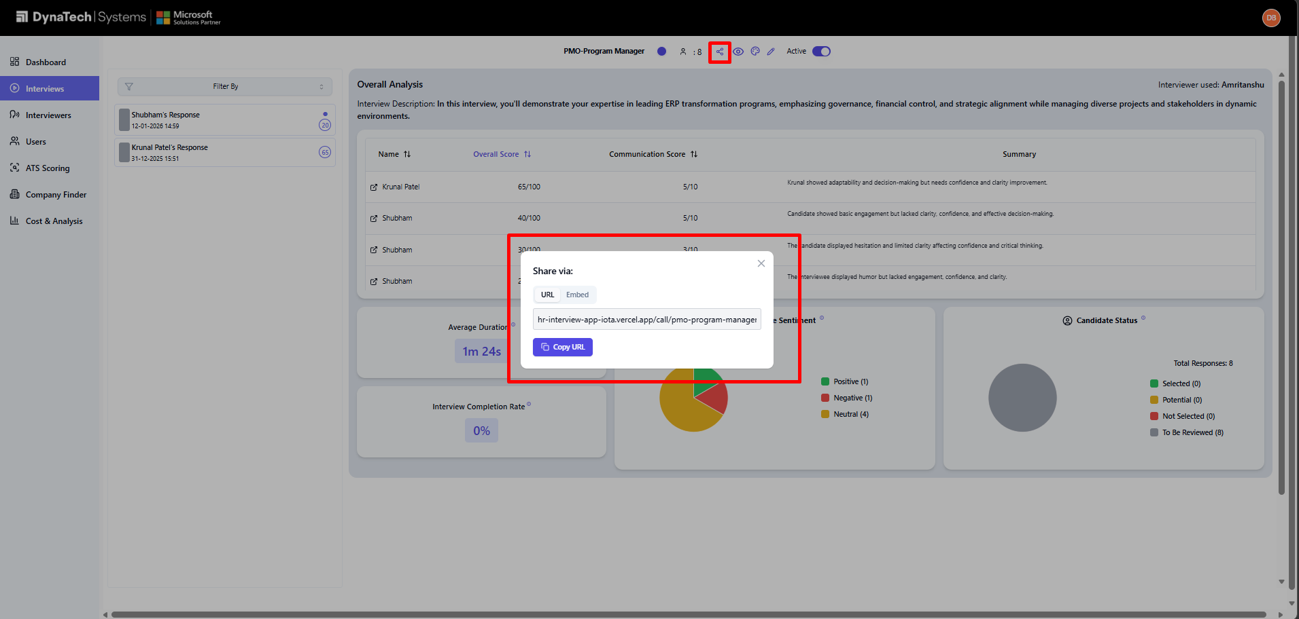

5. The AI Interviewers
Click Interviewers in the left menu to browse the AI interviewer personas available to your organisation. Each card shows the interviewer's name and photo. Click a card to open its details — voice, language, provider and a short description. You select one of these personas when creating an interview (Section 4.2).
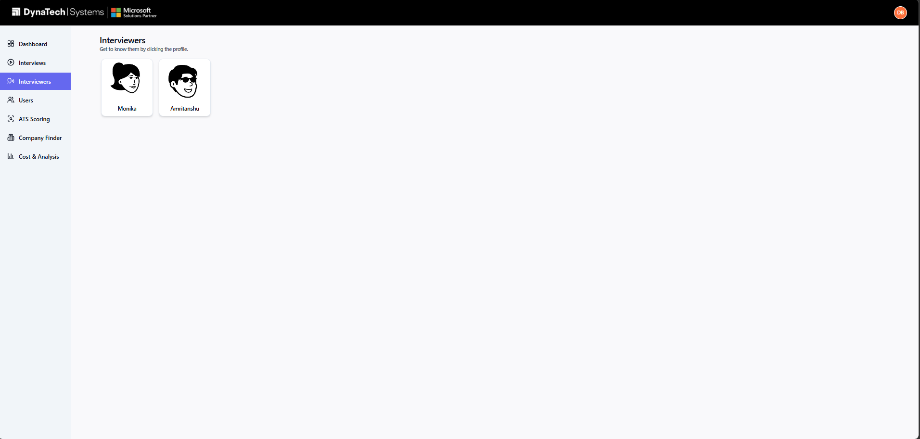
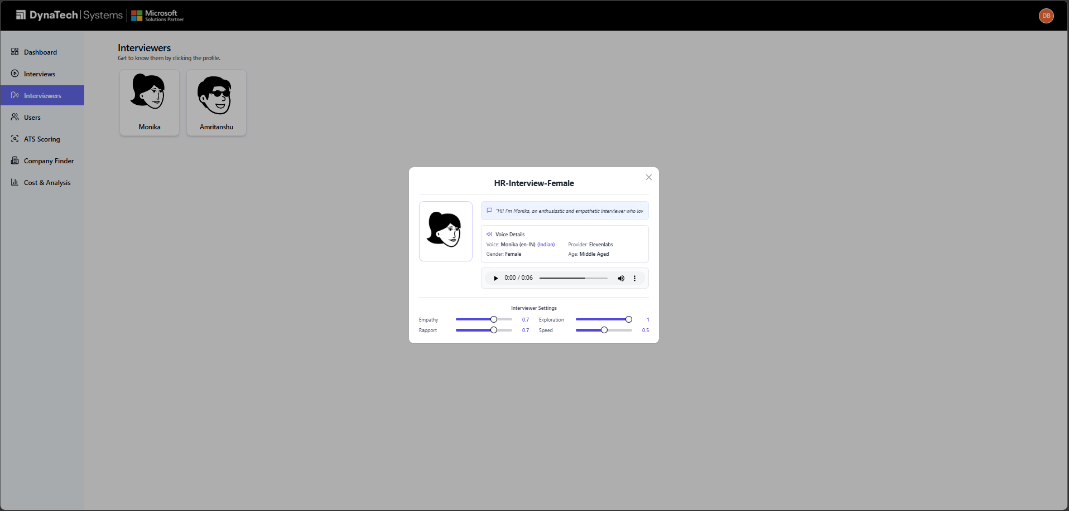

6. Reviewing Candidate Responses

6.1 The Overall Analysis summary
Open an interview and, with no individual response selected, the right-hand area shows the Overall Analysis for all responses:
- Results table — a sortable table of every candidate with their overall score, communication score, and a short call summary.
- Average Duration — the average time candidates took to complete the interview.
- Interview Completion Rate — the percentage of interviews completed successfully.
- Candidate Sentiment — a pie chart of Positive / Neutral / Negative sentiment.
- Candidate Status — a pie chart of Selected / Potential / Not Selected / To Be Reviewed.
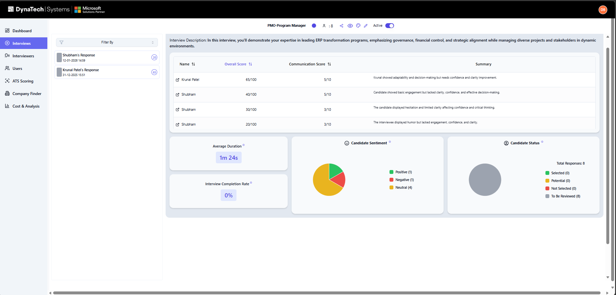

6.2 Filtering and opening a response
1. Use the Filter By dropdown above the response list to show only To Be Reviewed, Not Selected, Potential, or Selected candidates.
2. Click a candidate in the list to open their full response. A coloured dot shows their current status, and unread responses are flagged.

6.3 Inside an individual response
A single response gives you everything you need to evaluate the candidate:
- Interview Recording — play back the candidate's interview audio, adjust playback speed/volume, and download the recording.
- Overall Score — a circular overall score for the interview.
- Communication — a dedicated communication score.
- Transcript Summary — an accordion of each question paired with the candidate's answer.
- Transcript — the complete, speaker-labelled conversation transcript.
- Violations — anti-cheat findings such as tab switches, multiple people detected, or a blocked camera (see Section 6.4).
- Candidate status dropdown — set the candidate's status (Selected, Potential, Not Selected, To Be Reviewed); this syncs to the candidate on the Users page.
- Delete — permanently remove the response (asks for confirmation).
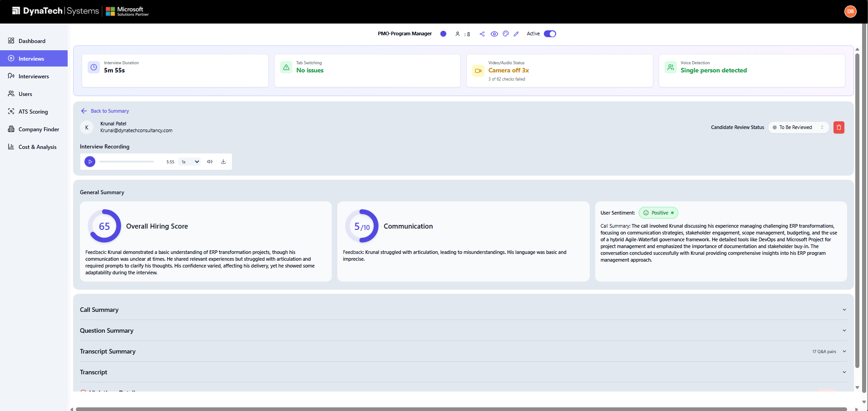

6.4 Anti-cheat / integrity findings
During the interview the platform monitors for integrity issues and records them on the response. In the response view you may see flags for tab/window switching, additional people detected on camera, a blocked or disabled camera, and similar events. Use these alongside the scores when deciding a candidate's status.
★ Best Practice
Treat integrity flags as context, not an automatic disqualification — a single brief tab switch is very different from repeated switching or multiple people on camera. Read the detail before changing a candidate's status.

6.5 Setting a candidate's status
1. Open the candidate's response.
2. Choose a status from the dropdown: Selected, Potential, Not Selected, or To Be Reviewed.
3. The status is saved immediately and is reflected on the Dashboard funnel, the interview pie charts, and the candidate's card on the Users page.

7. Managing Candidates (Users)
Click Users in the left menu to manage everyone who can be assigned an interview. The page is titled Interview Assignees.

7.1 Overview of the Users page
- Stat cards — Total, Interview Completed, and Interview Pending counts.
- Search — by name, email, tag, or candidate ID.
- Filters — by status, by interview, by department/tag, and by review status.
- Grid / List — switch between card Grid and a detailed table List. Candidates are grouped by the interview they are assigned to.
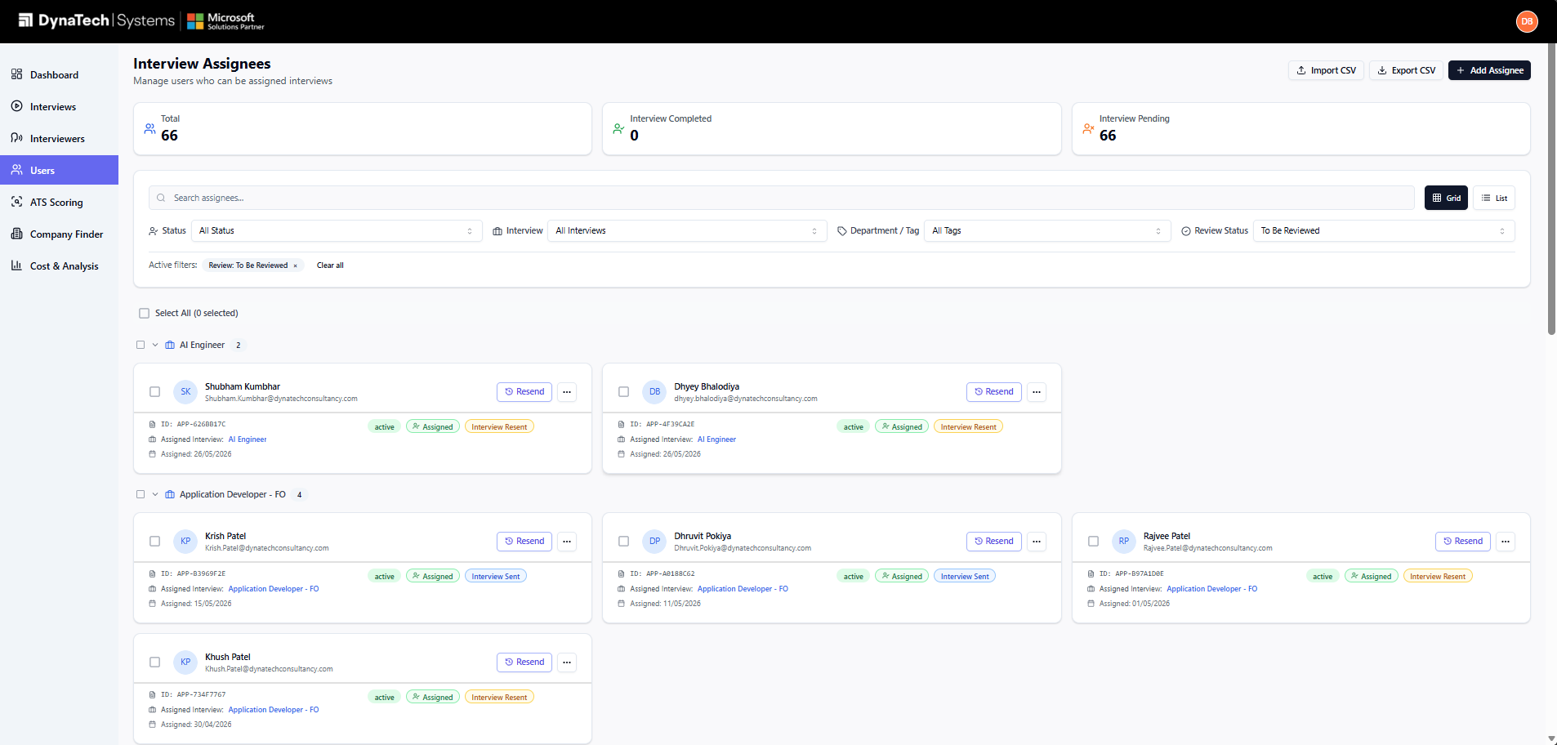

7.2 Adding a single candidate
1. Click Add Assignee (top-right).
2. Fill in the form. First Name, Last Name and Email are required; Phone, Candidate ID, Interview, Profile Image, Résumé/CV, Status, Department/Tag and Notes are optional.
3. Optionally attach a résumé (PDF or Word, max 10 MB) and a profile photo (image, max 5 MB).
4. Click Create Assignee.
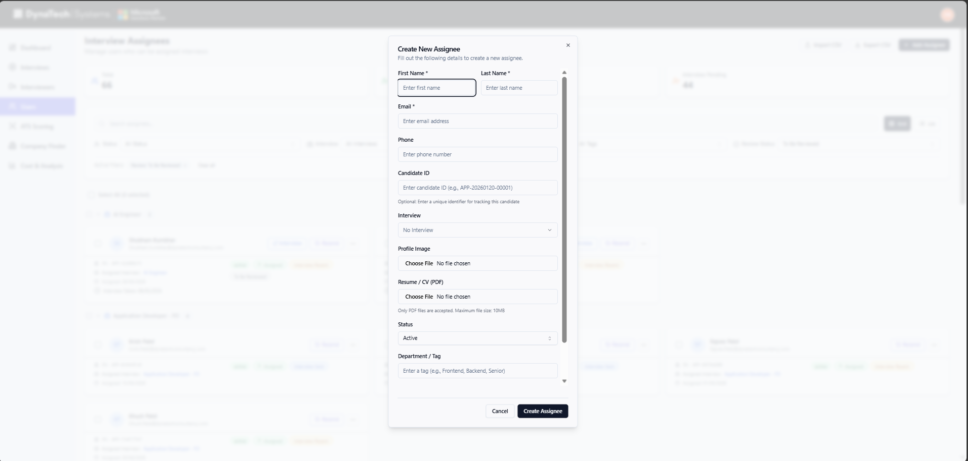
ℹ Note
Emails must be unique. If you enter an email — or upload a résumé containing an email — that already exists, the app warns you about the duplicate and does not create a second record.

7.3 Importing many candidates from a CSV file
1. Click Import CSV (top-right).
2. Click Download Template to get a correctly-formatted sample file (columns: email, first_name, last_name, phone, status, notes).
3. Fill the template with your candidates and save it as CSV.
4. Drag the file onto the upload area, or click to browse. The app previews the first rows and the total count.
5. Click Import N User(s). When it finishes you see a Successful / Failed summary and a list of any rows that errored.
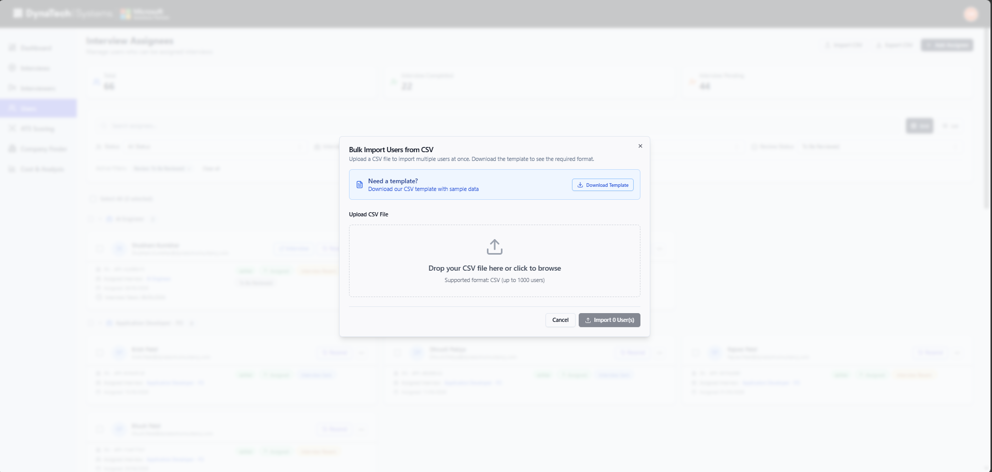
ℹ Note
You can import up to 1,000 candidates at once. Each row needs a valid, unique email; rows with missing or duplicate emails are skipped and listed in the results.

7.4 Bulk actions
Select candidates using the checkboxes (individually, by interview group, or Select All). A blue action bar appears with these options:
- Send Email — send the interview invitation email to the selected candidates (they must have an interview assigned).
- Change Status — update the review status of all selected candidates at once.
- Assign Interview — assign the selected candidates to an interview.
- Assign Tag — apply a department/tag to the selection.
- Delete — remove the selected candidates (asks for confirmation).
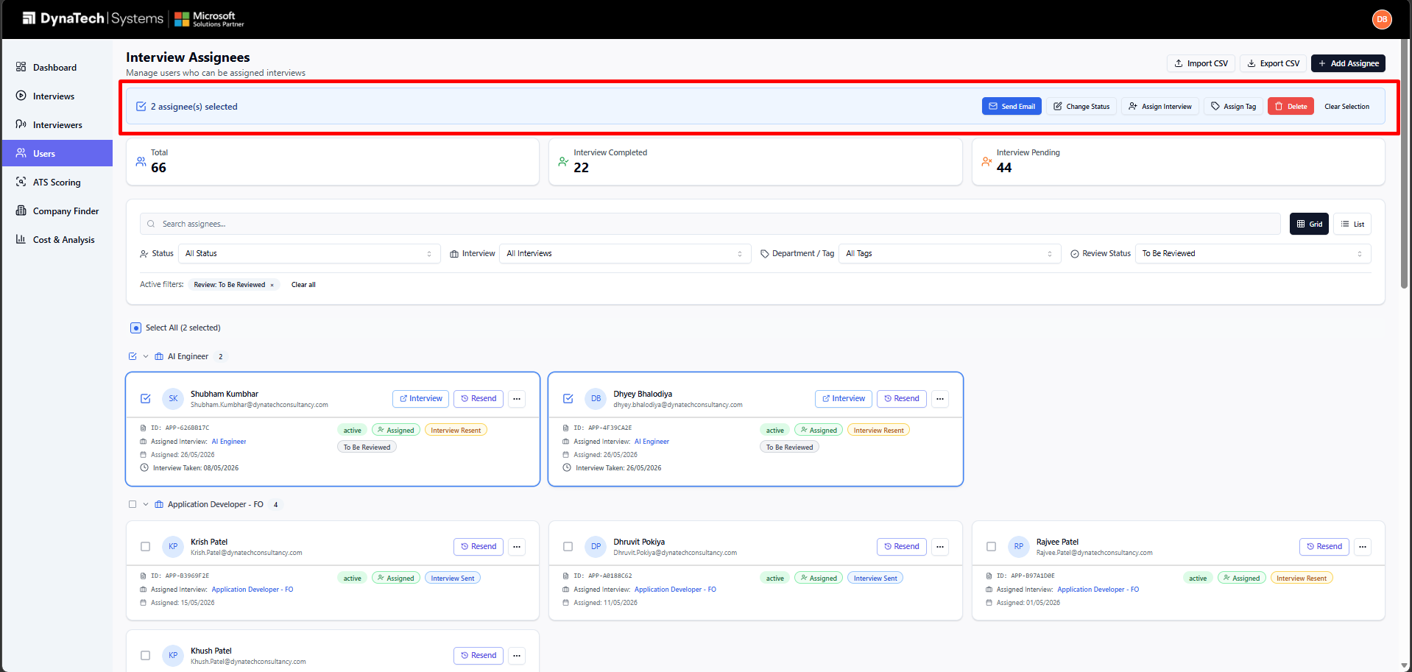

7.5 Sending interview invitations
1. Make sure each candidate has an interview assigned (use Add/Edit, or the Assign Interview bulk action).
2. Select the candidates you want to invite.
3. Click Send Email in the blue action bar.
4. Each candidate receives an email with their personal link to start the interview.
⚠ Important
Send Email only works for candidates who have both an interview assigned and a valid email address. Candidates without an assigned interview are skipped.

7.6 Viewing details and exporting
- View — open a candidate's View dialog to see their full profile and a link to their interview response (if they have taken it).
- Edit — change any of the candidate's fields.
- Export CSV — download the currently-filtered candidate list as a CSV file.
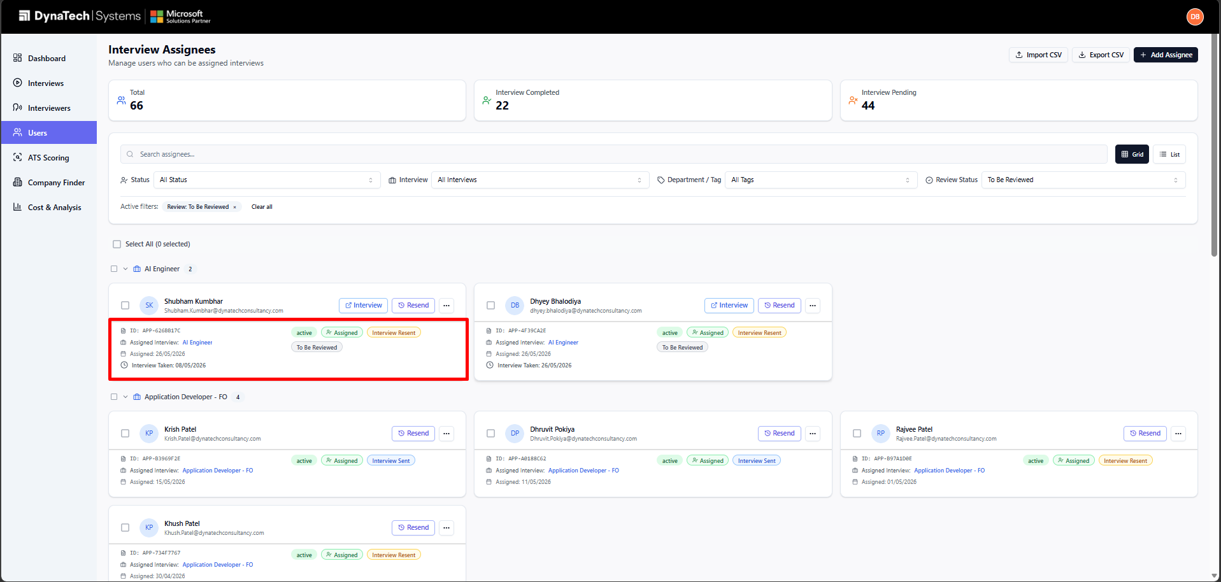

8. ATS Résumé Scoring
ATS Scoring screens a pile of résumés against a job description and ranks the candidates. Open it from ATS Scoring in the left menu.

8.1 Choosing a job
The first screen is a grid of scoring jobs. Each job is tied to one of your interviews so its results, job description and résumés stay together.
1. Click Add Job (or the equivalent control) and pick one or more interviews to create scoring jobs for them.
2. Click a job card to open its scoring workspace.
3. Use the remove control on a card to delete a job you no longer need.
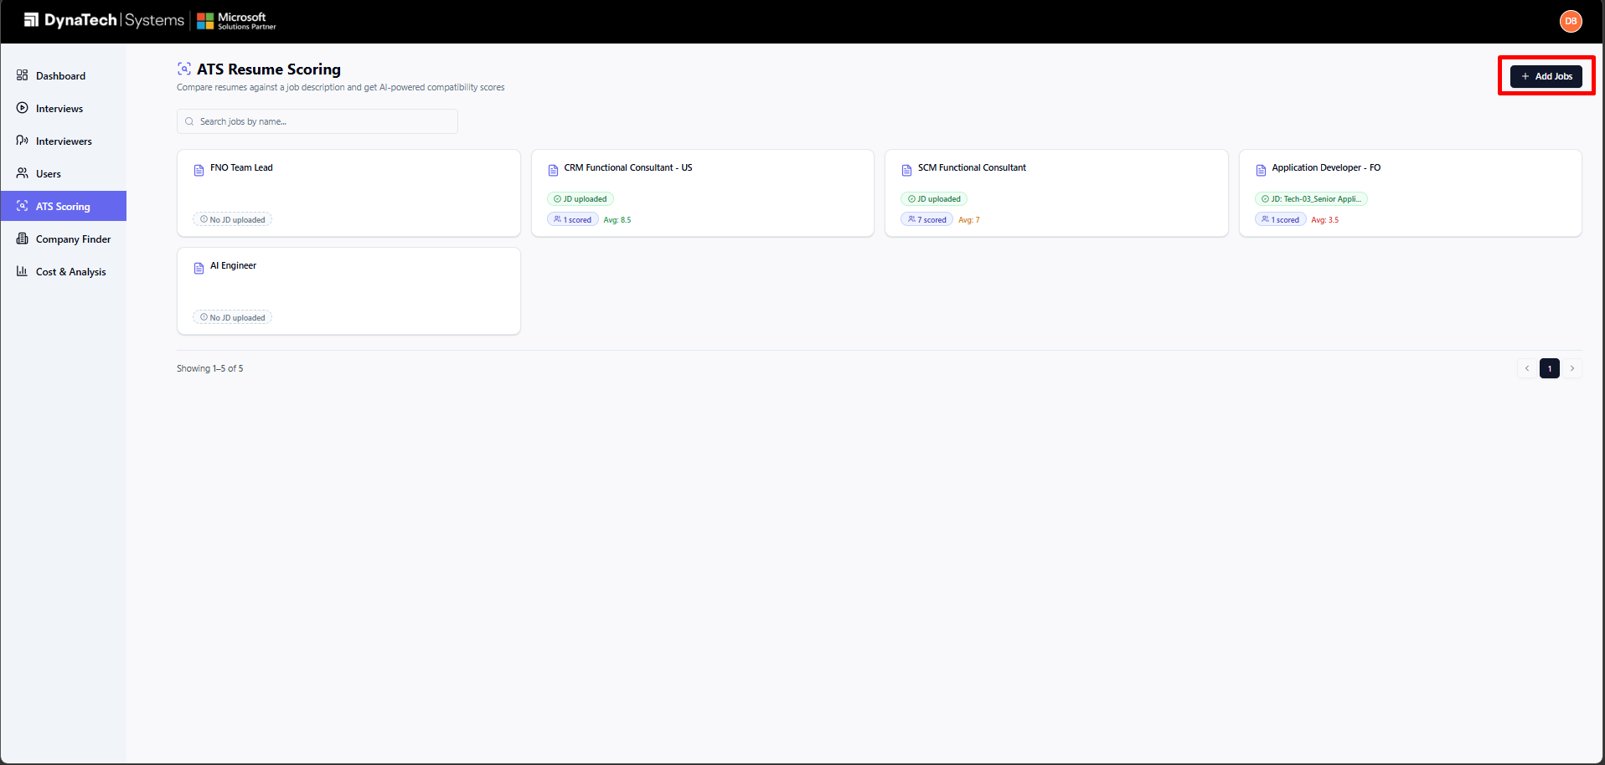

8.2 Providing the job description
- Text mode — paste the job description straight into the text box.
- PDF / Word mode — upload the job description as a PDF or Word file and let the app extract the text.
The job description is saved automatically as you work.

8.3 Uploading résumés and analysing
1. Drag-and-drop résumé files onto the upload area, or use the folder picker to add an entire folder. PDF, DOC and DOCX are supported (max 10 MB each).
2. Wait for the files to be parsed — a progress indicator shows how many are done.
3. Click Analyze. The résumés are queued and scored in the background; a progress bar tracks completion. You can navigate away and come back — the job keeps running.
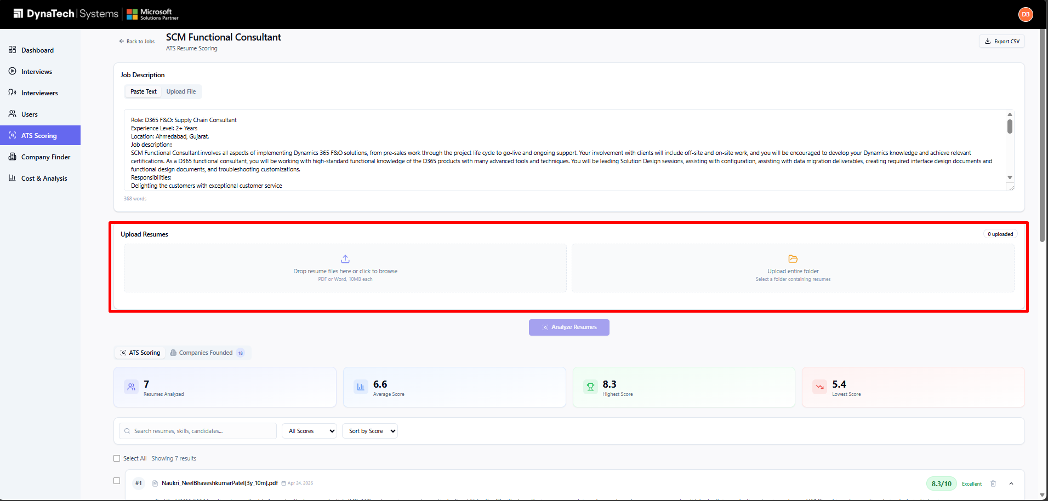

💡 Tip
You can keep adding résumés to the same job over time. Résumés that have already been scored are skipped, so only new files are analysed when you click Analyze again.

8.4 Reading the results
Results appear as ranked candidate cards, best match first. Each card includes:
- Scores — an overall match score and category scores (skills, experience, education, keywords).
- Skill analysis — matched skills, missing skills, strengths, and suggested interview focus areas.
- Candidate profile — current role/company, total experience, education, certifications and location.
- SWOT analysis — a strengths / weaknesses / opportunities / risks breakdown with a final hiring insight.
- Résumé viewer — open the original résumé with the eye icon.
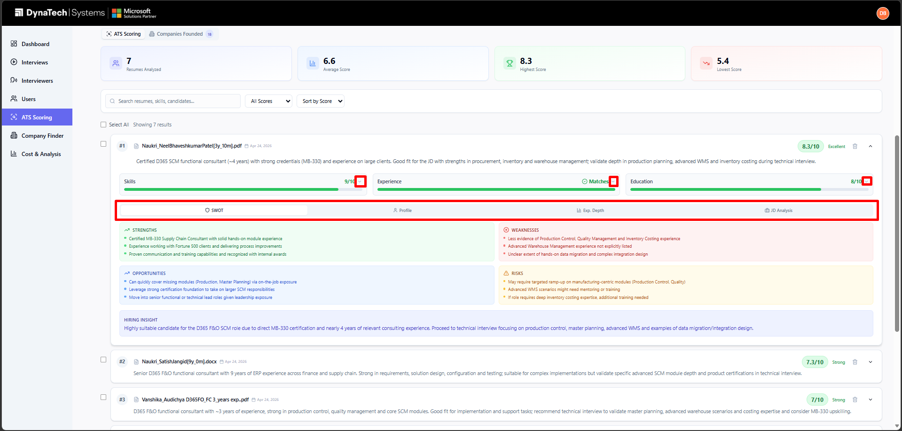

8.5 Exporting and creating candidates automatically
- Export CSV — download the full ranked analysis (scores, profile, SWOT and more) as a CSV file.
- Auto-create assignees — qualifying candidates are automatically added to your Users list (those who clear the minimum score and meet the experience requirement), ready to be assigned an interview and invited.
ℹ Note
Candidates whose experience does not match the job requirement, or who score below the minimum threshold, are not added automatically. You can still add them manually if you wish.

9. Company Finder (Administrators only)
Company Finder analyses the work history in candidate résumés and builds an enriched list of the companies they have worked at — including company type, headquarters, founding year, technologies and the résumés each company came from. It is available only to Administrators.
Company Finder runs automatically after an ATS scoring job finishes (using the same résumés), and its results appear under the Companies tab of the scoring workspace. Administrators can also open the dedicated Company Finder page from the left menu.

9.1 Working with company results
- Search — by company name.
- Filter — by company type (service provider vs. service consumer) and sort by frequency or name.
- Source résumés — click the source-résumé badges to open the résumé a company was found in.
- Export CSV — download the company list (type, info, headquarters, countries, frequency, sources) as CSV.
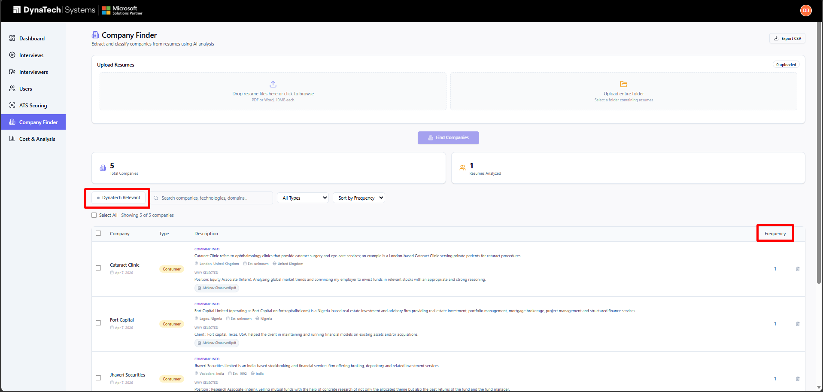

10. Cost & Analysis
Cost & Analysis tracks what the platform spends across AI text models, voice calls, file storage, résumé parsing, ATS scoring and Company Finder. It is available to all roles except Marketing and HR Consultant. Open it from Cost & Analysis in the left menu.

10.1 Summary cards
- This Month banner — spend so far in the current calendar month.
- Total Cost — all spend in the selected period, with token and voice-minute totals.
- GPT Cost — spend on AI text models plus web-search calls.
- Voice Cost — spend on the voice interview calls.
- Averages — average spend per completed interview and per résumé (ATS and Company Finder).
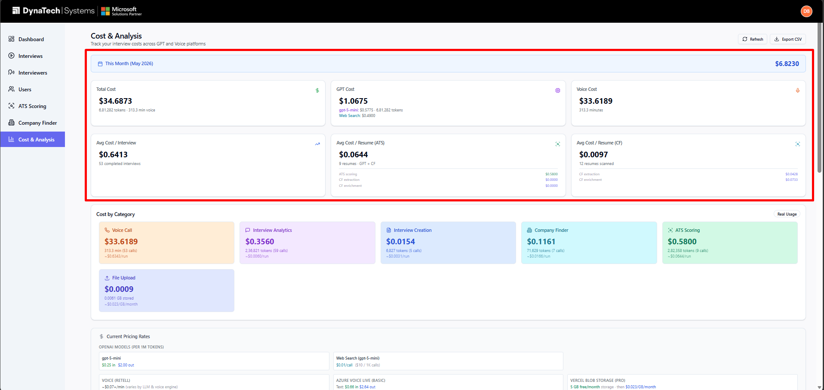

10.2 Breakdown, filters and export
1. Review Cost by Category to see where money is going (interview creation, responses, insights, voice calls, uploads, ATS, Company Finder, résumé parsing).
2. Use the Filters card to narrow by Start/End Date, Interview, or Category.
3. Browse the usage table; click a row to expand it for token counts, durations and item-level details.
4. Click Export CSV to download the data, or Refresh to reload it.
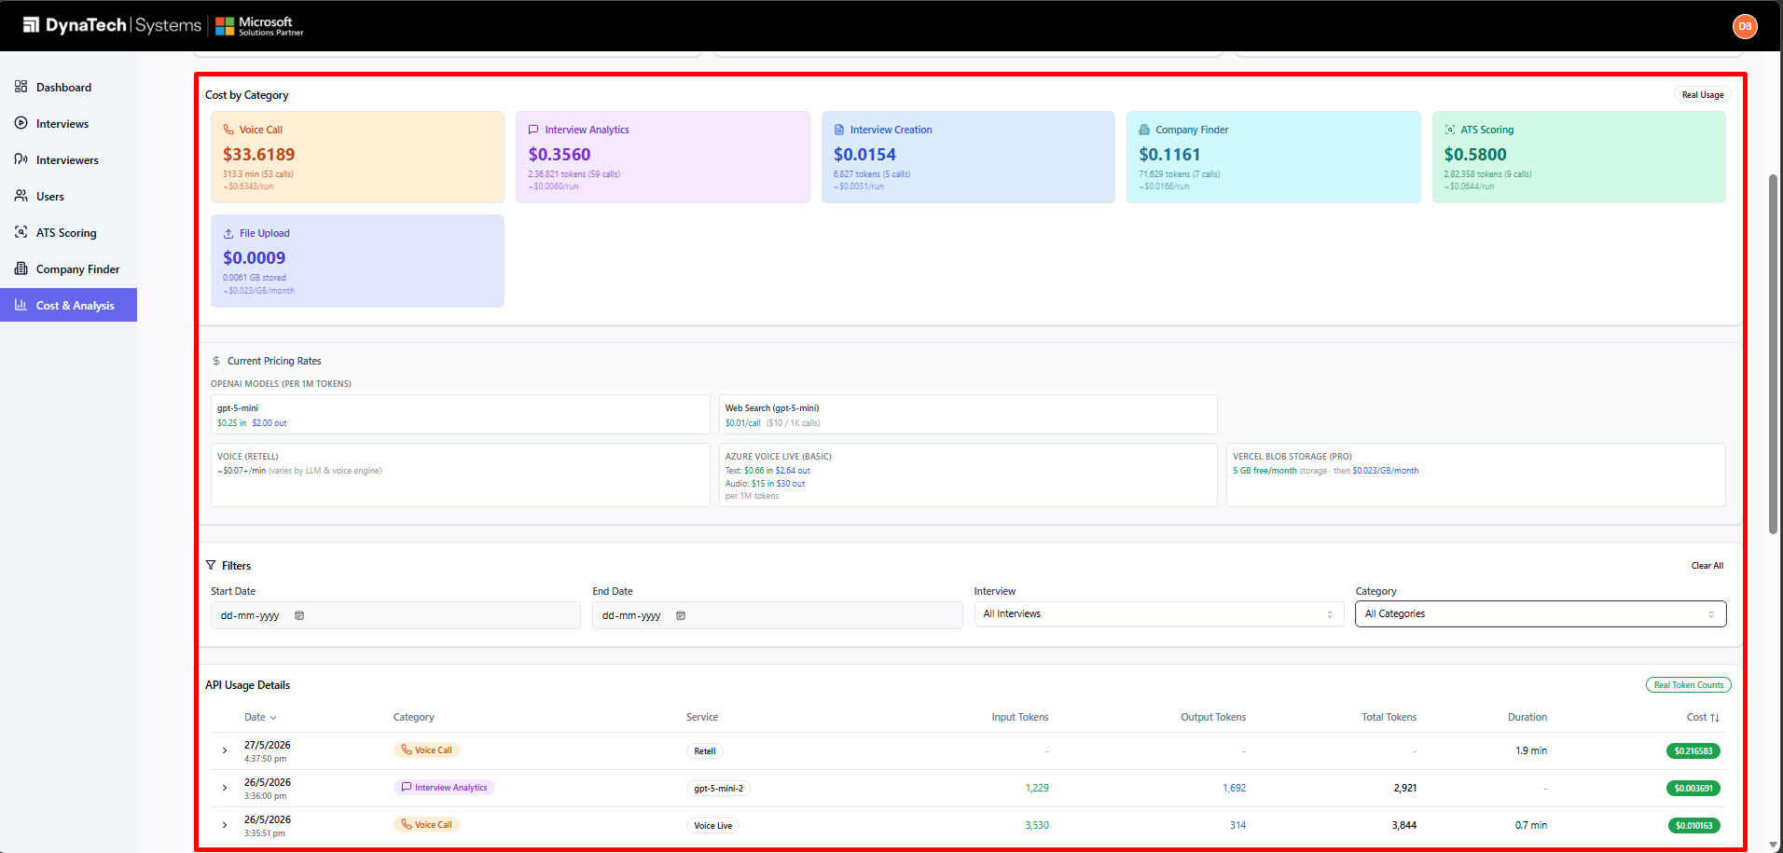

11. Profile & Account Settings
Open your profile from the avatar menu (top-right) → Profile.

11.1 Updating your profile
1. Click Upload Photo to set a profile picture (JPG/PNG/GIF, max 5 MB).
2. Update your First Name, Last Name and Phone Number. Your email address cannot be changed.
3. Click Save Changes.

11.2 Changing your password
1. Enter your current password.
2. Enter a new password (at least 6 characters) and confirm it.
3. Click Update Password.
The Account Information card shows your role, status, and the dates your account was created and last updated.
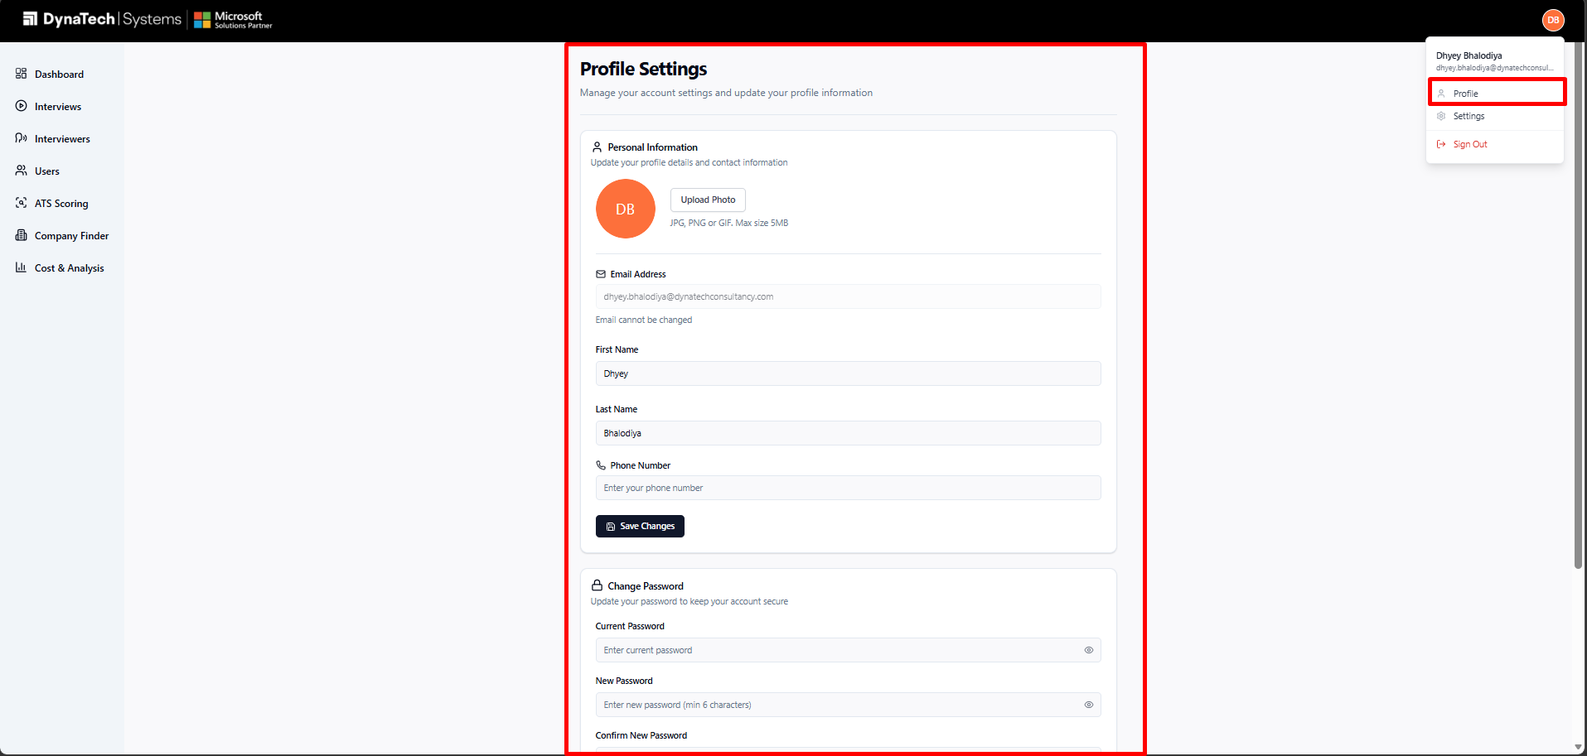

12. Troubleshooting & Best Practices

12.1 Recommended workflow
1. Create an interview with a clear objective and a job description so the AI generates strong questions.
2. (Optional) Run ATS Scoring to shortlist résumés — qualifying candidates are added to your Users list automatically.
3. Add or import candidates and assign them to the interview.
4. Send invitation emails in bulk from the Users page.
5. Review responses as they arrive, set each candidate's status, and watch the Dashboard funnel fill in.
6. Monitor spend from time to time on the Cost & Analysis page.

12.2 Common questions
Q: A menu item is missing.
A: Access depends on your role. Company Finder is admin-only, and Cost & Analysis is hidden from Marketing and HR Consultant roles.
Q: A candidate did not receive their invitation.
A: Confirm the candidate has an interview assigned and a valid email address — Send Email skips anyone missing either. Also ask them to check spam/junk.
Q: The interview link does not start for a candidate.
A: Check that the interview's Active toggle is on. While an interview is paused, candidates cannot start it.
Q: Some résumés were skipped during ATS scoring.
A: Files over 10 MB, unsupported formats, or résumés that could not be read are skipped and listed after parsing. Re-save them as a clean PDF and upload again.
Q: My CSV import reported failures.
A: Open the results list — each failed row shows the reason (usually a missing or duplicate email). Fix those rows and import again.
Q: The mobile sign-in shows an “under construction” message.
A: The dashboard is built for desktop. Sign in from a PC using Chrome or Edge.
★ Best Practice
Set a candidate's status as soon as you finish reviewing their response. Keeping statuses current keeps the Dashboard funnel, the interview pie charts, and your shortlists accurate for everyone on the team.

13. Glossary
Active toggle: The on/off switch on an interview. When off, candidates cannot start the interview.
Assignee: A candidate record on the Users page that can be assigned to an interview.
ATS Scoring: Automated résumé scoring against a job description, producing a ranked candidate list.
Company Finder: Admin-only tool that extracts and enriches the companies found in candidate résumés.
Department / Tag: A free-text label used to group candidates (e.g. Frontend, Senior).
Interviewer: The AI voice persona that conducts an interview.
Response: A single completed interview attempt by one candidate.
Review status: A candidate's evaluation outcome: Selected, Potential, Not Selected, or To Be Reviewed.
SWOT: Strengths, Weaknesses, Opportunities and Risks — part of the ATS candidate analysis.
Violation: An integrity/anti-cheat event recorded during a candidate's interview.

14. Appendix — Screenshot Checklist
This manual contains numbered screenshot placeholders. Capture each one from the live app and replace the matching placeholder box. The list below is your capture checklist — the screenshot numbers correspond to the boxes throughout the document.
Total placeholders to capture: 26.
💡 Tip
Capture screenshots at a consistent browser width (around 1440 px) with the same zoom level so the images look uniform. Blur or use test data for any real candidate names and email addresses before sharing the finished manual.

