Homework 2 – Exercise 2A
Improving Weak Prompts

Weak Prompt a) Explain regression
a) Improved prompt: Explain linear regression to a beginner in 3 short paragraphs. Define what it is, when it is used, and give a simple real-life example using house prices. End with 3 key takeaways and avoid advanced math.
b) Screenshot of the AI response:
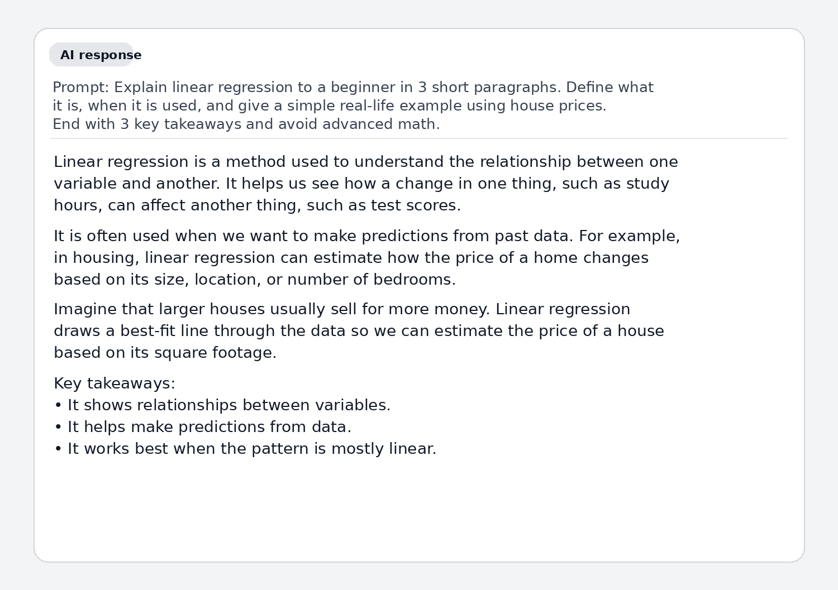
c) Why the revised prompt is stronger: This prompt is stronger because it clearly identifies the topic, audience, format, and level of detail. It also asks for a real-life example and key takeaways, which makes the response easier to understand and more useful for learning.

Weak Prompt b) Help me understand SQL
a) Improved prompt: Teach me SQL as a beginner. Explain what SQL is, what a database, table, row, and column mean, and show 4 basic commands—SELECT, WHERE, ORDER BY, and INSERT—using one small student table example. Keep it simple and include sample queries.
b) Screenshot of the AI response:
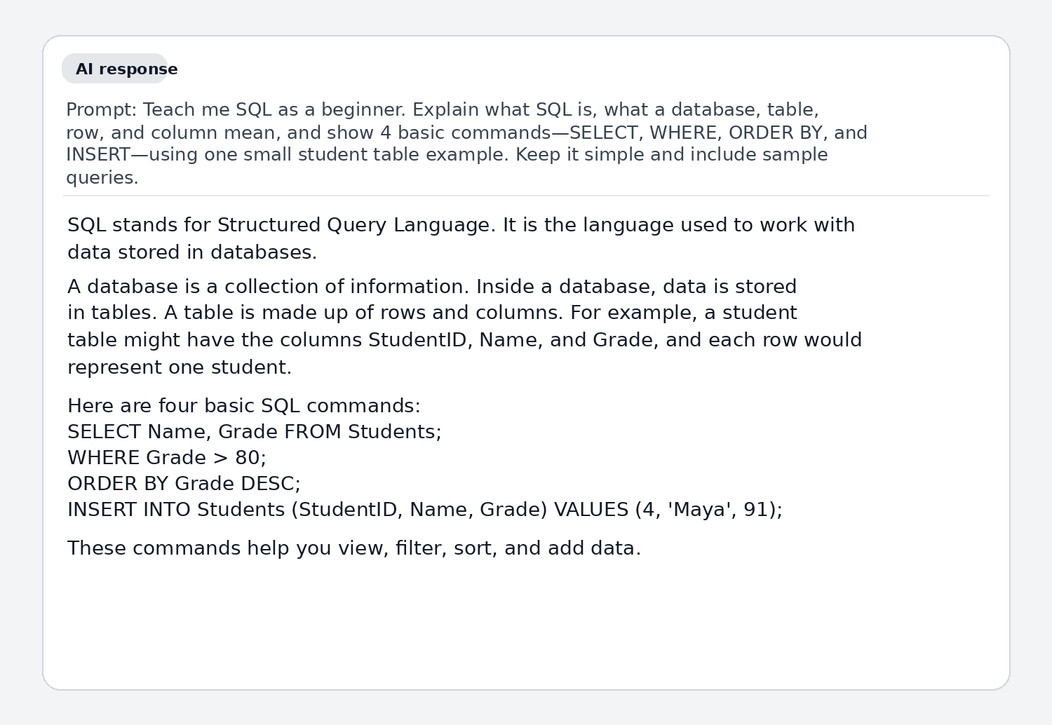
c) Why the revised prompt is stronger: This version is stronger because it gives the AI a clear role, defines the learner as a beginner, and asks for specific concepts and commands. The request for a single example table and sample queries also makes the explanation more concrete and easier to follow.

Weak Prompt c) Create a dataset
a) Improved prompt: Create a small dataset with 10 rows and 4 columns for a student gradebook: Student Name, Course, Score, and Attendance Rate. Present it as a clean table and make the values realistic.
b) Screenshot of the AI response:
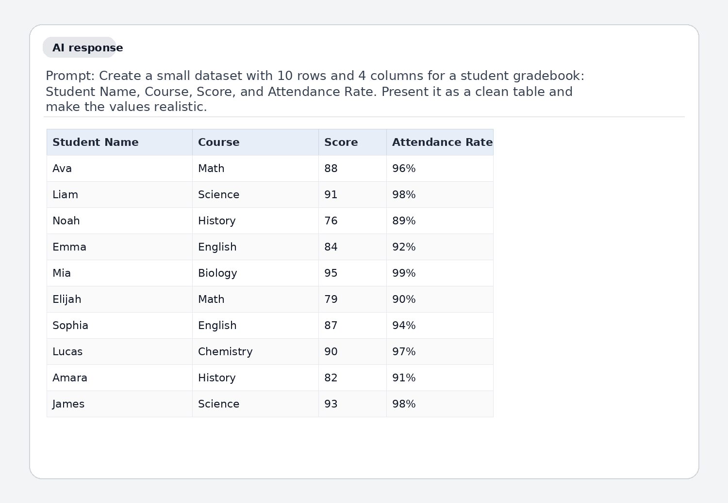
c) Why the revised prompt is stronger: This prompt is stronger because it explains exactly what kind of dataset is needed, how many rows and columns it should have, and how it should be presented. Adding the topic and realism requirement reduces ambiguity and leads to a more accurate result.

