**BUILDING A SMATER AI-POWERED SPAM CLASSIFIER**

**TEAM MEMBER**

**210221104007 : DHIVYA.M**

**PHASE-1 DOCUMENT SUBMISSION**

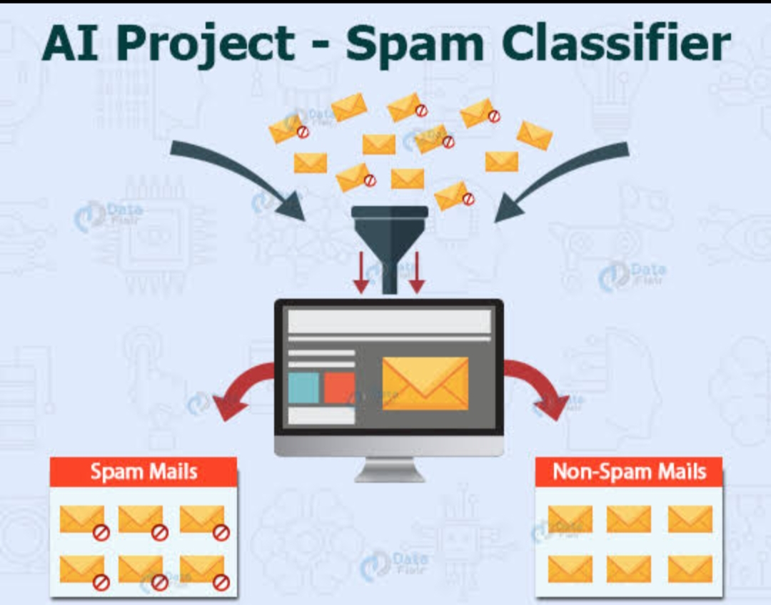

**PROJECT:** Spam Classifier

**THE GOAL OF THIS PROJECT IS TO DEVELOP A SMATER AI-POWERED SPAM CLASSIFIER THAT CAN EFFECTIVELY DISTINGUSH BETWEEN SPAM AND LEGITIMATE MESSAGES WITH HIGH PRECISION AND RECALL.**

**OBJECTIVE:-**

The objective of building a Smarter AI-Powered Spam Classifier project is to enhance the accuracy and efficiency of spam detection to reduce false positives and negatives to improve Spam detection and create a system capable of processing incoming messages or e-mails in real time to prevent spam from reaching user’s inboxes for real time processing. And develop a classifier that can adapt and learn from new spam patterns and tactics used by spammer’s for Adaptability and allow user’s to customize their spam filter’s to suite their preferences and needs for user customization and to explore the incorporation of various data type’s like text images or URl’s for more robust spam detection for multi model classification and optimize the AI model for resources , so it can run effectively even on devices with limited computing power for efficient resource usage and to make privacy and security,integration,evaluation,metrics,usereducation,sealavility,continuous improvement, compliance and cost effectiveness by adding these objectives, we can create a smarter AI-Powered Spam Classifier that effectively identifies and filter’s out unwanted message while minimizing disruptions to legitimate communication.

**PROBLEM STATEMENT:-**

In the age of digital communication, email and messaging platforms have became essential tools for personal and professional communication. However, the proliferation of spam messages has became a significant nuisance, causing inconvenience and potentially leading to security risks. Conventional spam filter’s opten fall short in accurately identifying and filtering out spam, resulting in genuine messages being classified as spam or voice versa.

**THE PRIMARY CHALLENGES INCLUDE’S:-**

* **INCREASING ACCURACY**
* **REDUCING FALSE POSTIVIES**
* **HANDLING MULTI MODEL DATA**
* **REAL TIME PROCESSING**
* **SCALABILITY AND GENERALIZATION**
* **USER FRIENDLY INTEGRATION**

**PROBLEM DEFINITION:-**

The main thing is to determine the scope of your spam classifier. Are you focusing on email spam, SMS spam, Comment spam, or a combination? Each may have unique characteristics and challenges to identify the scope and

* **DEFINE OBJECTIVES:-**

Clearly state the project’s objectives for example, reducing false positives, achieving a certain accuracy threshold, or handling a specific volume of message per day.

* **USER PERSONAL:-**

Create a user persona to understand the needs of the end-user

(example- e-mail user moderators, administrators) and their pain point’s related to spam.

**DESIGN THINKING:-**

**DATA COLLECTION:-**

We will need a dataset containing labeled examples of spam and non spam messages. We can use a kaggle for this purpose.

**DATA PREPROCESSING:-**

The text data needs to be cleaned and preprocessed. This involves removing special characters, converting text to lower case, and tokenizing the text into individual words.

**FUTURE EXTRACTION:-**

We will convert the tokenized words into numerical features using techniques like TF-IDF(term frequency:- inverse document frequency)

**MODEL SELECTION:-**

We can experiment with various machine learning algorithms such as Naïve Bay’s, support vector machine, and more advanced techniques like Deep learning using Neural networks.

**EVALUATION:-**

We will measure the model’s performance using metrics like accuracy, precision, recall, and F1-score.

**ITERATIVE IMPROVEMENT:-**

We will fine-tune the model and experiment with hyper parameters to improve its accuracy.

**CONCLUSION:-**

This project aims to create a solution that is robust, adaptable, and user-friendly, ultimately improving the online communication experience for user’s.