PROBLEM 1:

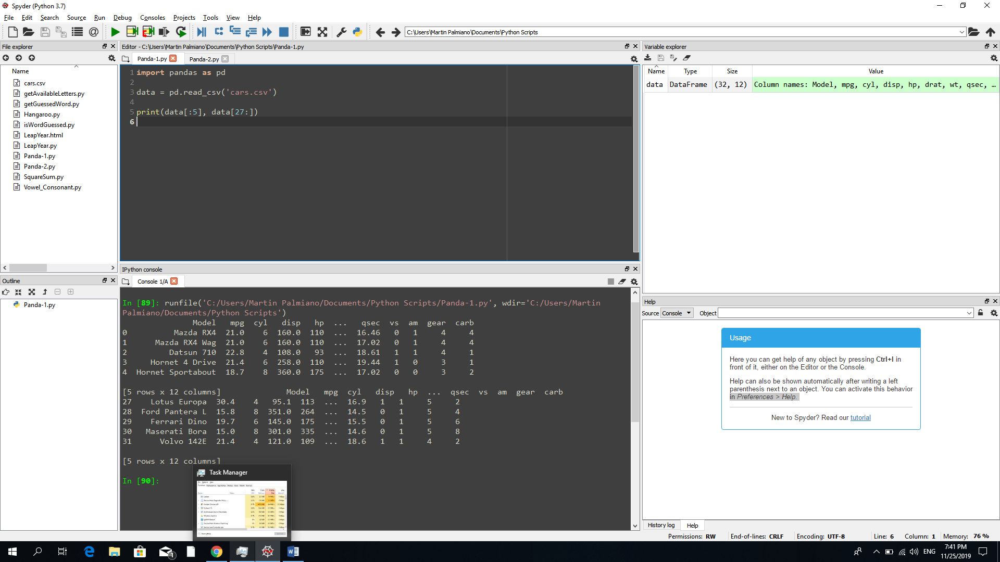

PROBLEM 2:

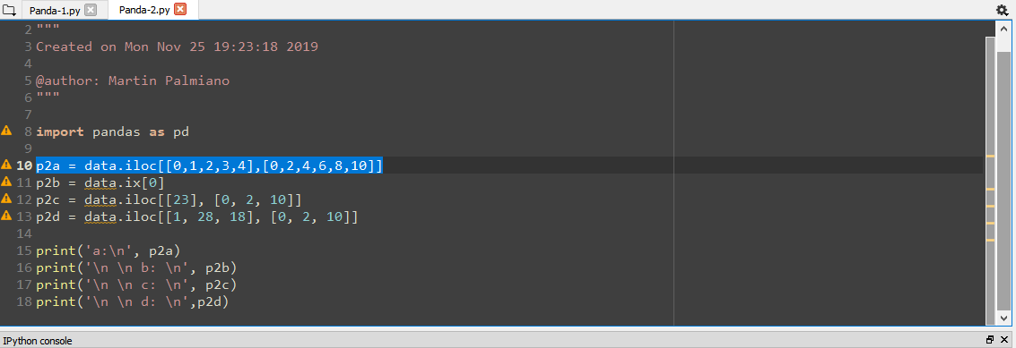

1. Display the first five rows with odd-numbered columns of cars.

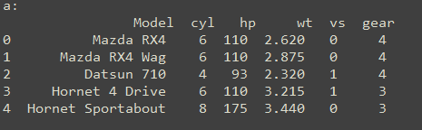

1. Display the row that contains the “Model” of ‘Mazda RX4’.

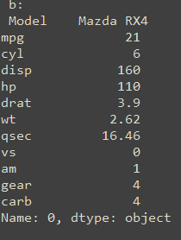

1. How many cylinders does the car model ‘Camaro Z28’ have?

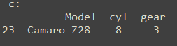

1. Determine how many cylinders and what gear type do the car models ‘Mazda RX4’, ‘Ford PanteraL’, and ‘Honda Civic’ have?

