Scott DiBisceglio

CMPT 308 – Lab 3

1. List the Ordno and Dollars for all orders

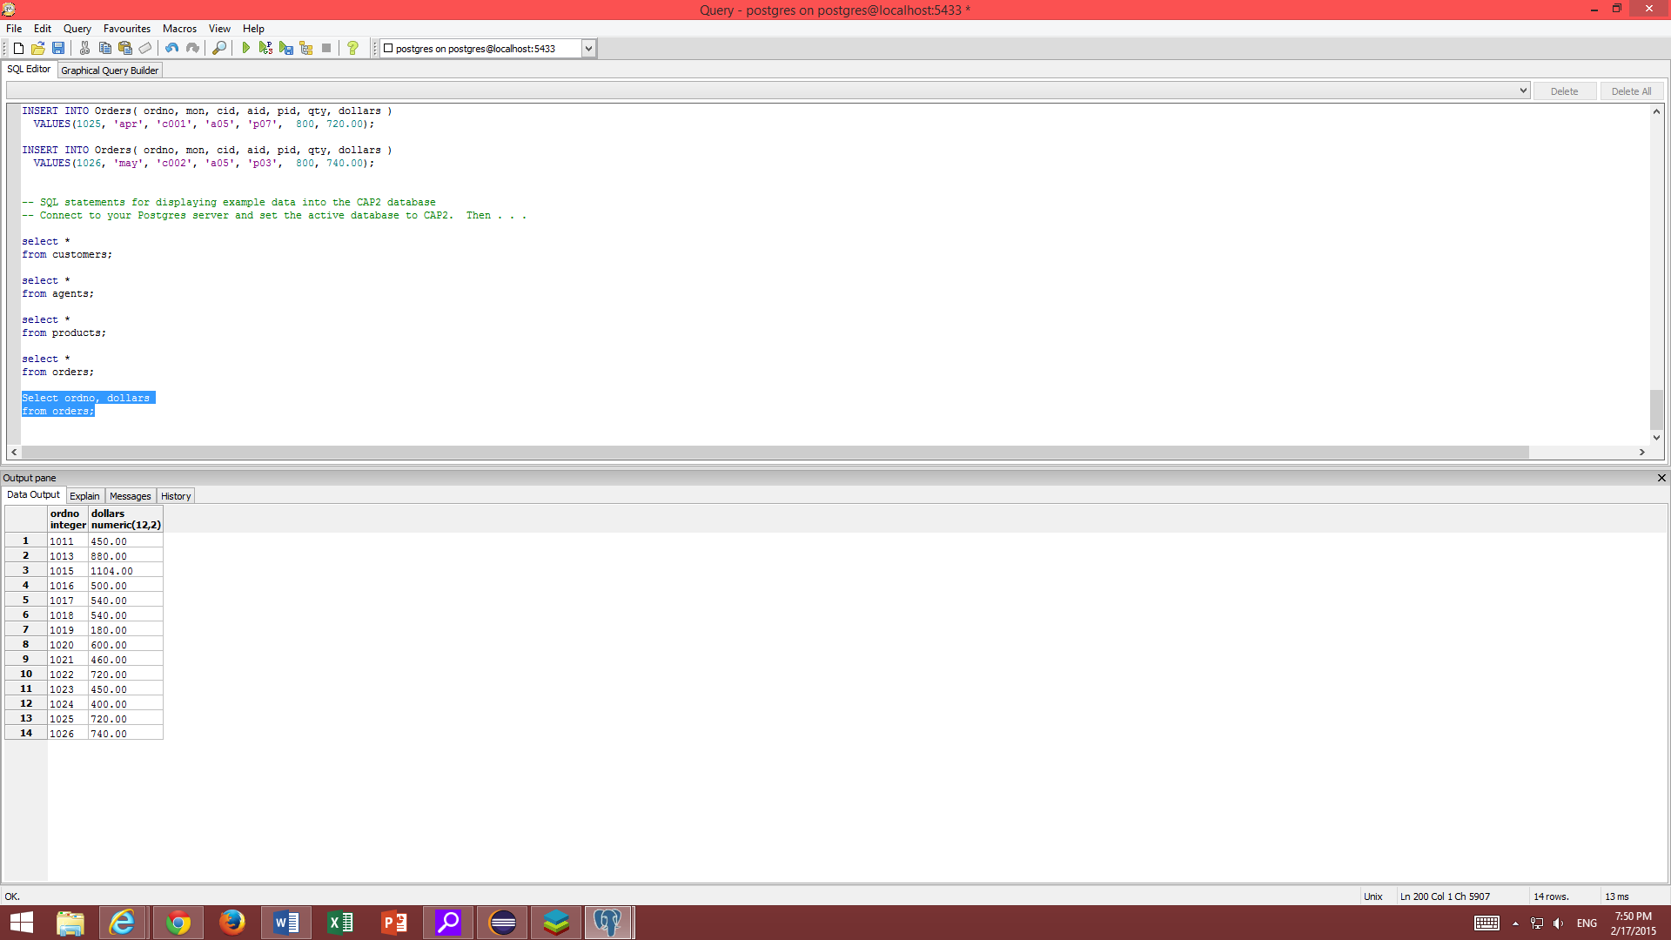

1. List the name and city of agents named Smith

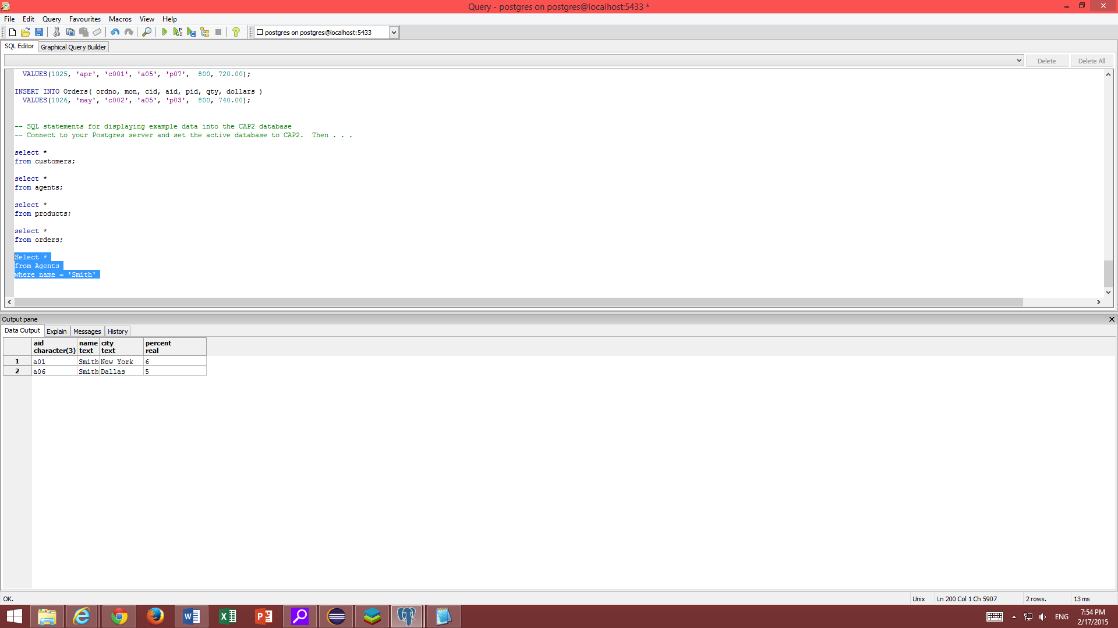

1. List the pid, Name, and PriceUSD of products with quantity more than 200,000

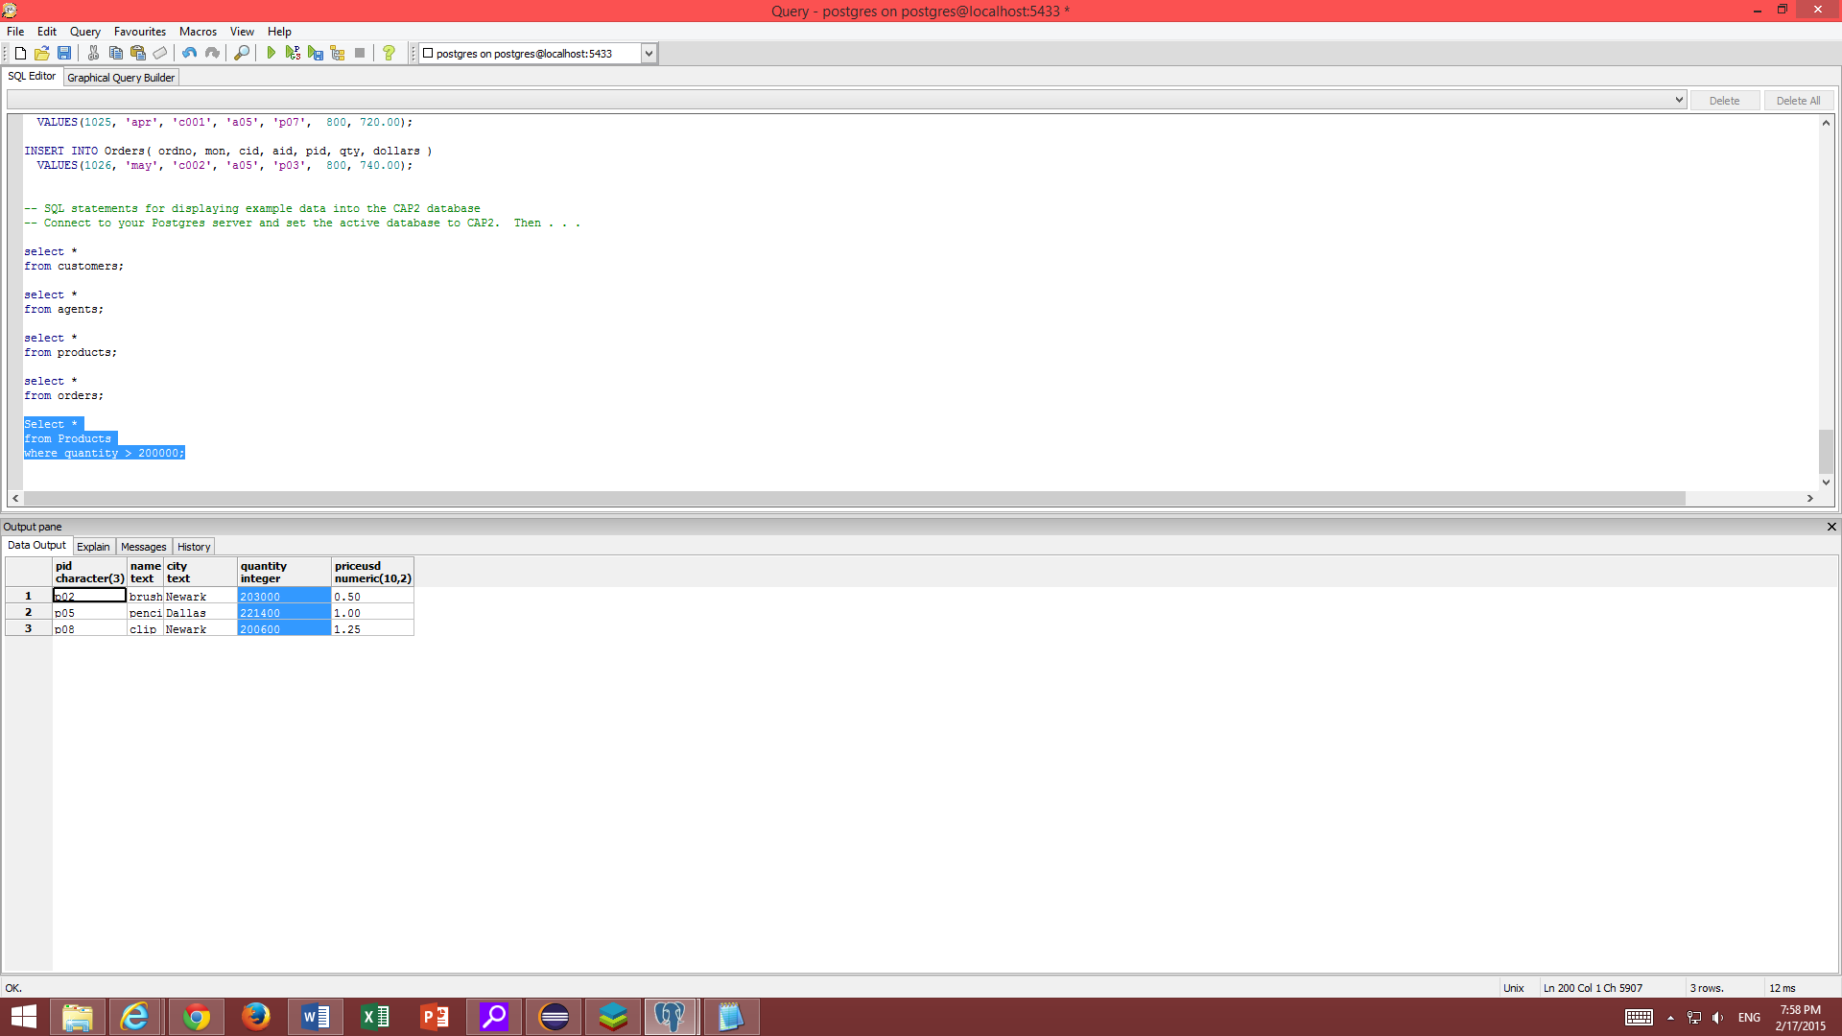

1. List the names and citys of customers in dallas

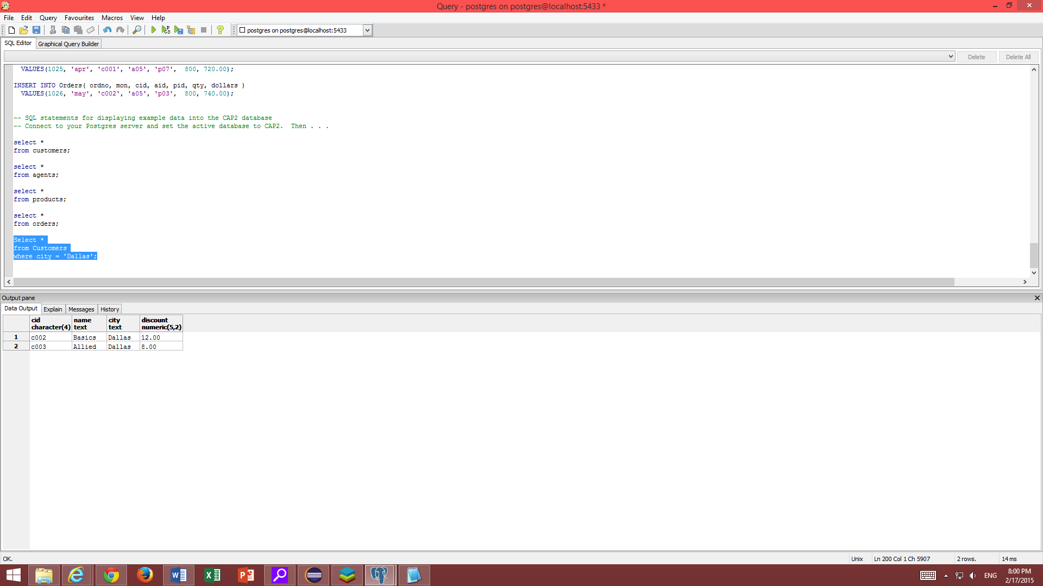

1. List the names of agents not in New York and not in Tokyo

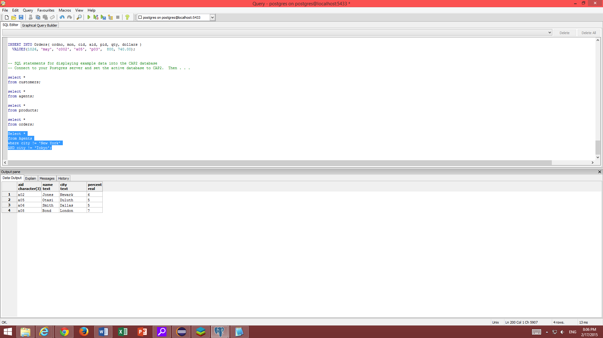

1. List all data for products not in Dallas or Duluth that cost more than $1USD

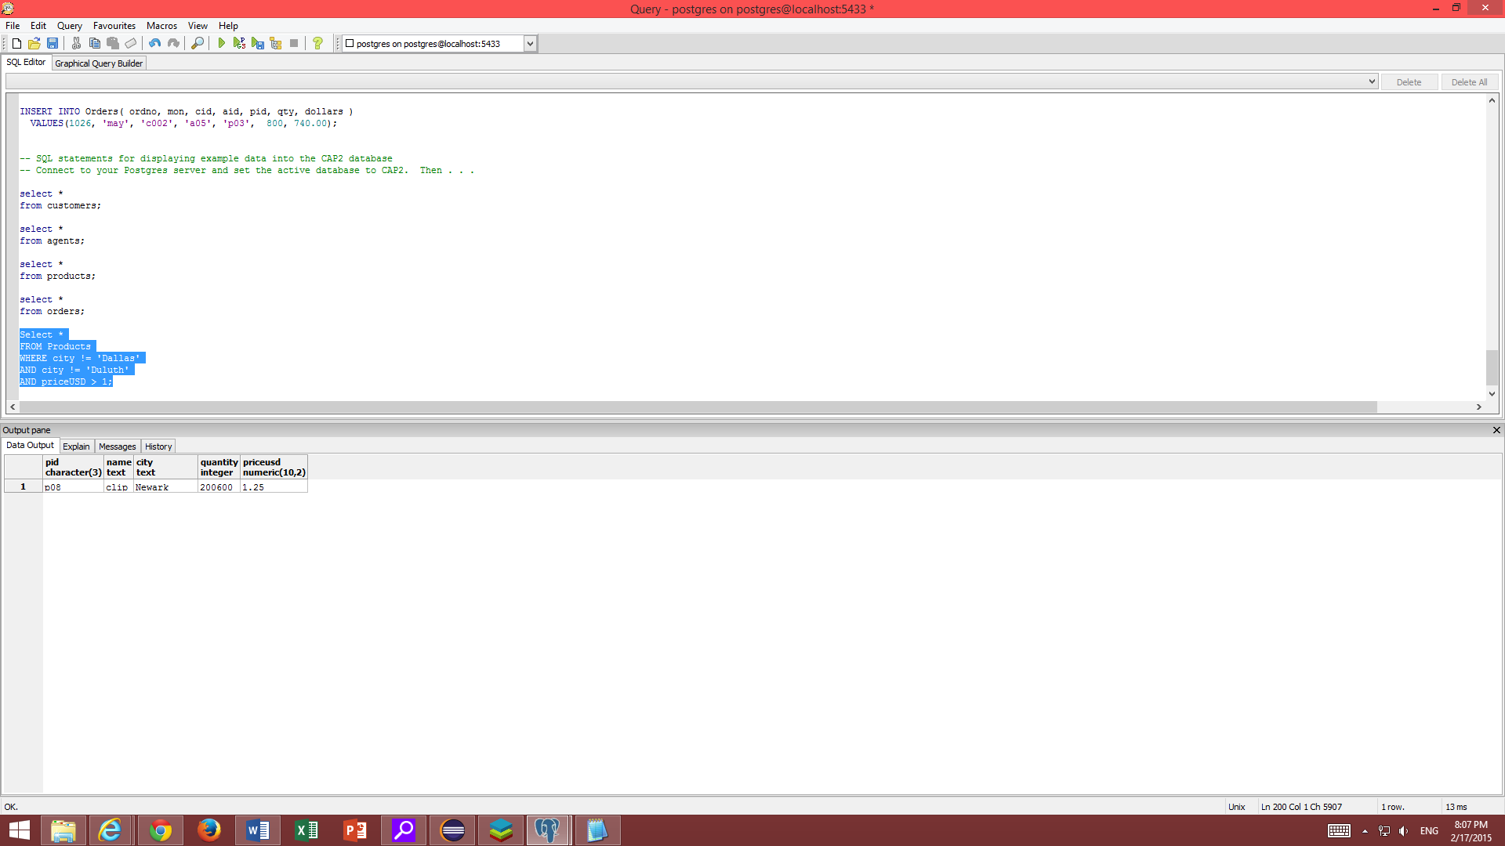

1. List all data for orders in January or May

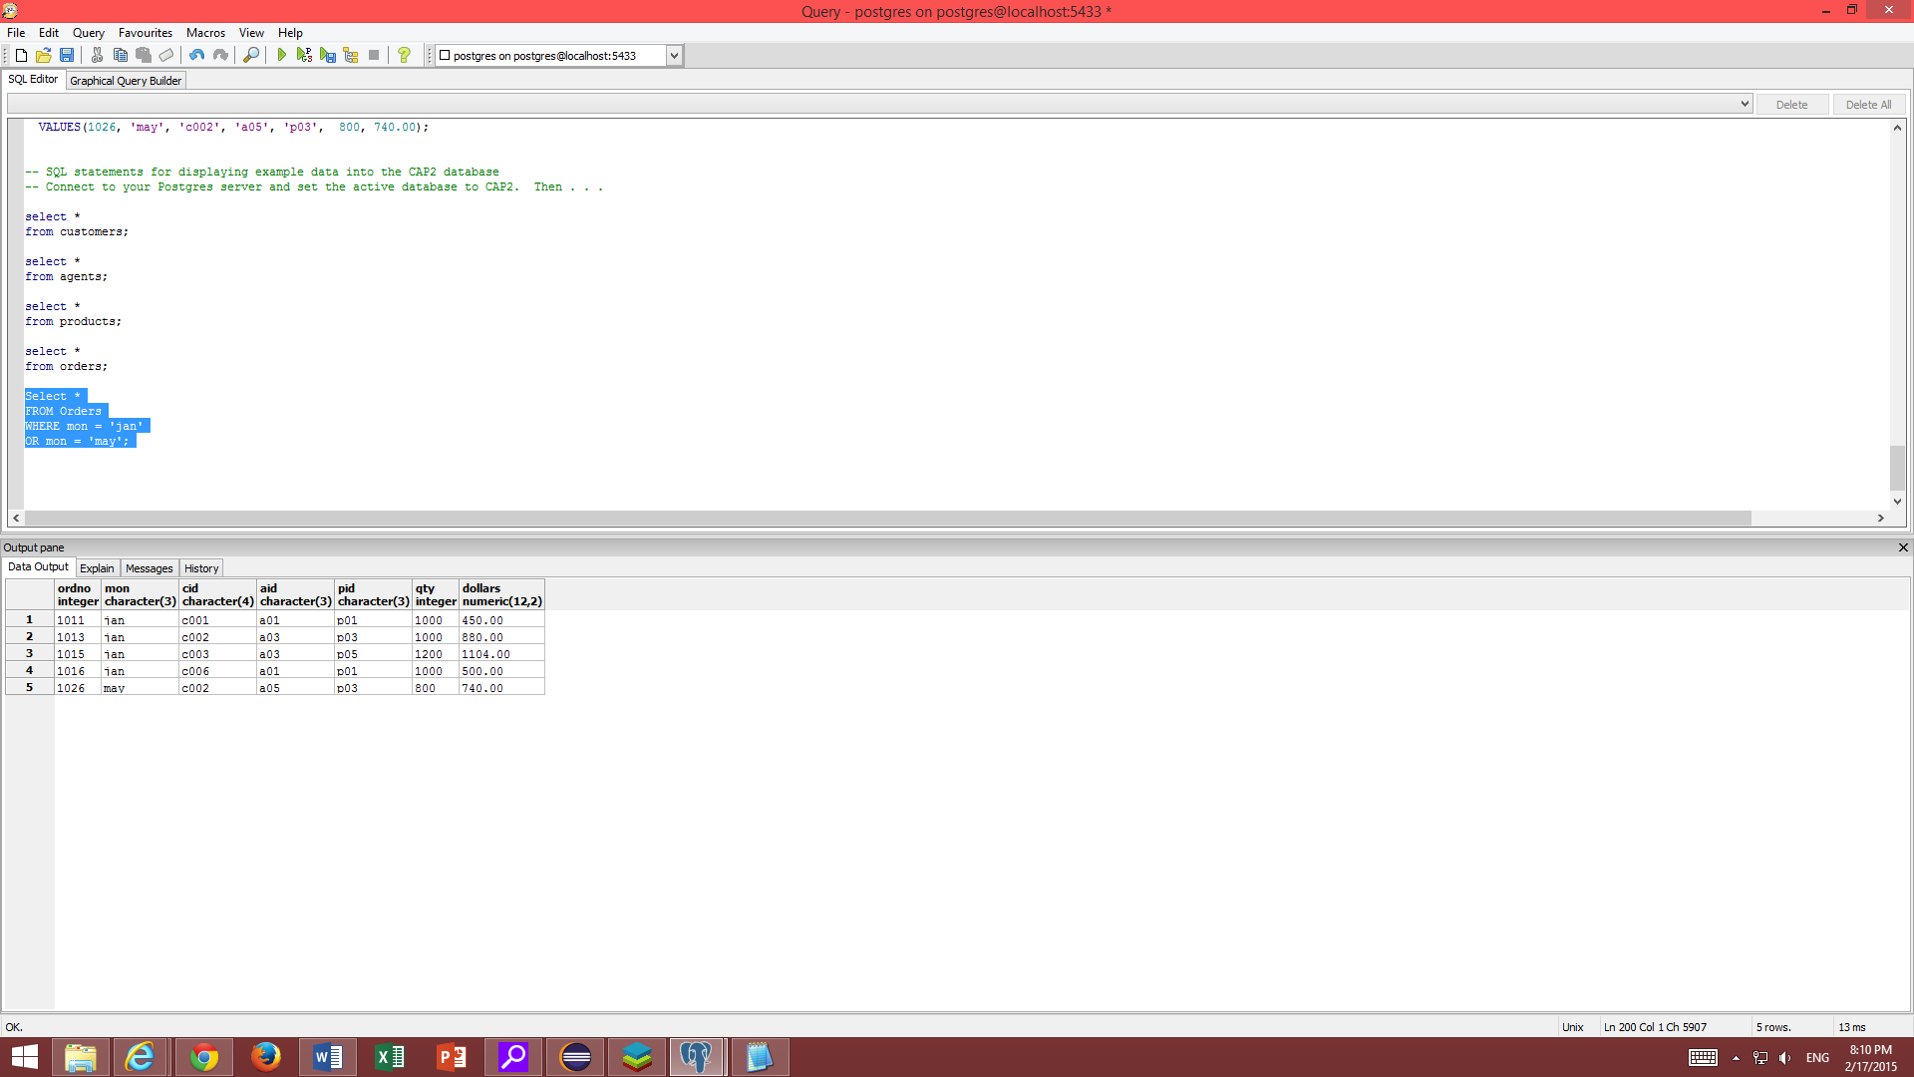

1. List all data for orders in Febuary more than $500USD

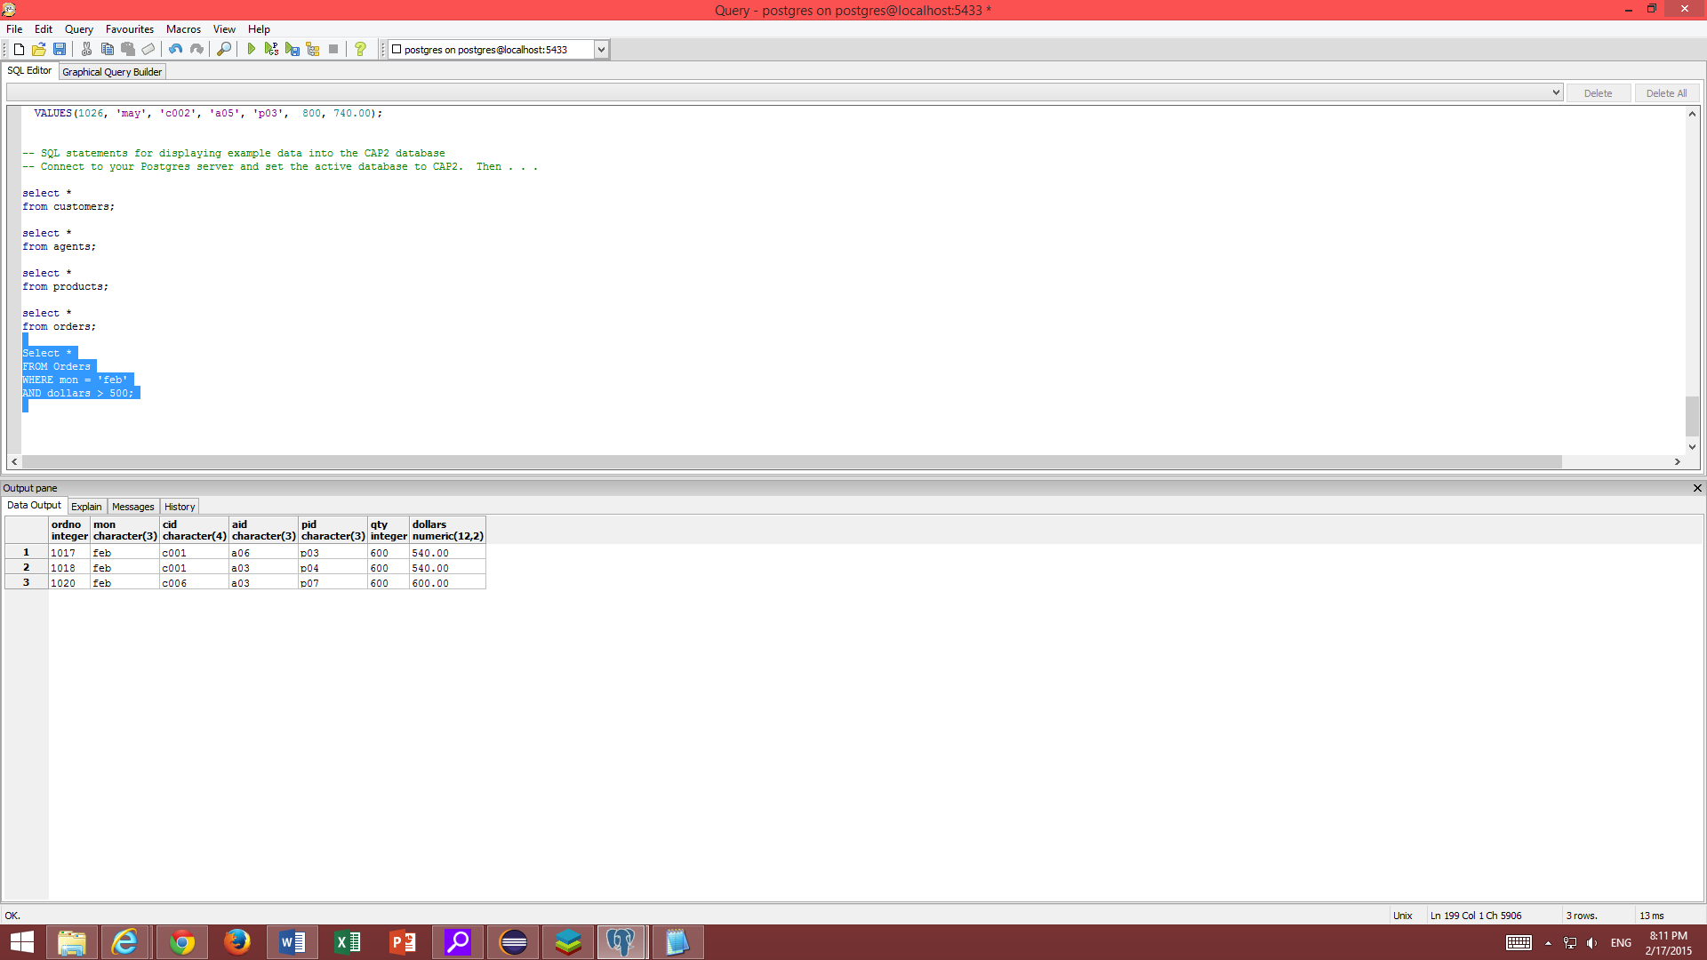

1. List all orders from the customer whos cid is c005

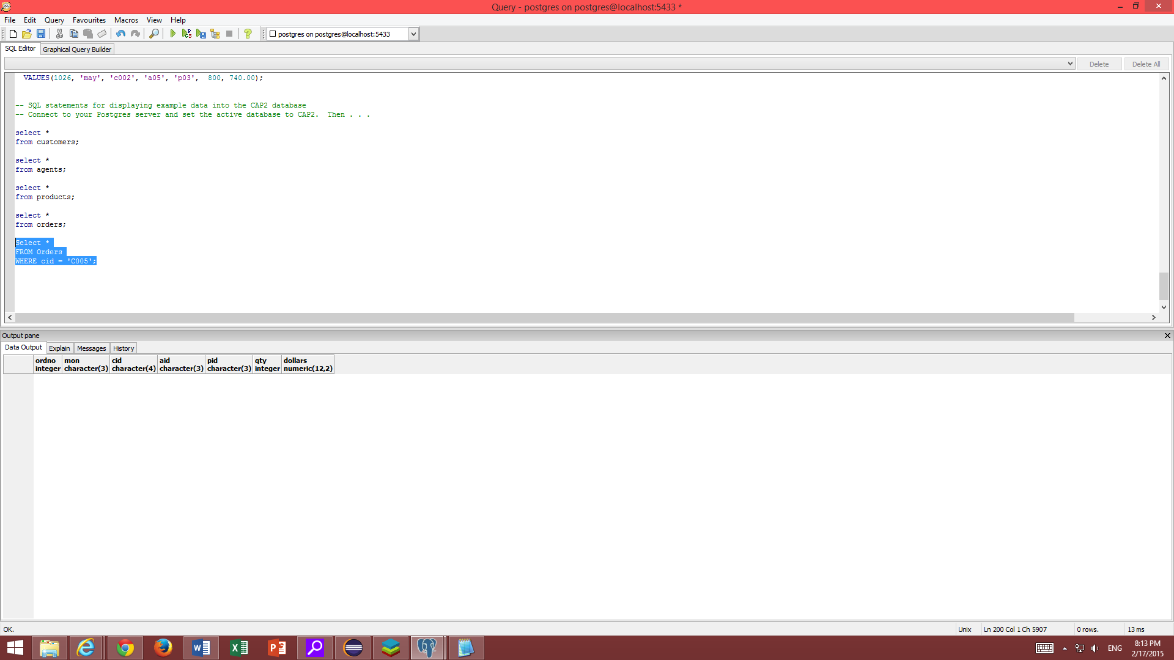

There are no orders from the person who is CID005