Restaurant Site Recommendation Using MapReduce And Hive

Caijie Zhao
Department of Computer Science
Courant Institute of Mathematical Sciences
New York University
New York, USA
cz1107@nyu.edu
Di Hou
Department of Computer Science
Courant Institute of Mathematical Sciences
New York University
New York, USA
di.hou@nyu.edu

Abstract — Restaurants and culinary experiences can be extremely valuable additions to a city. Site selection is a critical factor in planning a restaurant. For this project, we suppose someone would like to open a restaurant in New York City. Using Crawler, MapReduce and Hive techniques, we collect and analyze large-scale data, build up models to calculate restaurant visit frequency and provide practical advice to the person who plans to open a new restaurant.

Keywords — Restaurant Location Analytics, MapReduce, Hadoop, Hive, Cloudera, Crawler

Introduction
Location is a critical factor in planning a restaurant. The ability to capture sufficient customer volume from existing residents, day-workers and tourists is essential in estimating the feasibility of restaurants and other culinary venues. There is a variety of possible locations for the new restaurant owner. Each has its own advantages and disadvantages for specific types of cuisines. One needs to carefully examine the related factors to take this first step and lay a solid foundation for the restaurant’s later success.
For this project, we suppose someone would like to open a restaurant in New York City. We will provide him with some advice on choosing the best location for the new restaurant based on the analysis of the current restaurants distribution, the residential information and the average income of each location. We will first grab the current open restaurant information and map them based on their zip codes. We will also collect the community data and join them with the restaurant data. We then build up the model for scoring the location given the cuisine and the cost of a restaurant. In the end, we can apply our scoring model to calculate the score of each location and find out the top best ones.

Motivation
Restaurants and culinary experiences can be extremely valuable additions to a city. They serve workers and residents as well as attract visitors to the community. Thus they serve both an economic and a social role, helping cities thrive and maintain their role as an important gathering spot.
According to the NRA(National Regulatory Authority) in 2011, while the years during the economic recession were particularly difficult for restaurants, the restaurant, food, and beverage industry is still having a significant impact on the economy. Demand for restaurant and culinary experiences is always the center of people’s life. More and more new types of restaurants pop up, serving people’s various needs and tastes.
However, the first and most critical step for opening a new restaurant would be site selection with no doubt. The difficulty lies in that there are complex factors to consider and most of them need large amount of data analysis work to prove and support. In this aspect, we hope that by using data science techniques such as MapReduce and Hive, we can grab useful information and generate valuable advice for restaurant site selection in order to help new restaurant owners achieve sustainable business and social success, and eventually lead this industry to prosperous.

Related Work
Our reference works all come from recently published research papers in the field of data science and analytics.
The first two reference papers [1][2] explore the techniques to process large scale spatial data distributively, which provide us with the knowledge of recent data tools, especially MapReduce, and framework for analyzing large scale data efficiently.
The third reference paper [3] provides insights on how to efficiently collect target web resources among explosively generated data. Thus, this technique is helpful for our project in the aspect of extracting and collecting useful data from the internet. This paper focuses on how to efficiently collect data from the web across-the-board. It is widely recognized that the most effective method to collect a large amount of online data is to design and apply computer programs to extract information from large-scale web pages. Developers and researchers refer to this kind of computer program as a web crawler, a spider, or a web crawler based tool. Multi-threaded model has become a basic standard for web crawler design so that more web pages can be processed simultaneously.
The fourth paper [4] proposes a Hadoop-based scalable net-work traffic monitoring and analysis system for big traffic data. The system is designed and implemented following a multi-layer architecture which inspired us for building the analytic model for this project.
The other two papers[5][6] are both about the recommendation systems. Recommendation systems represent a powerful method for enabling users to filter through large information and product spaces. Researches on this topic have led to a varied set of algorithms and a rich collection of tools for evaluating their performance. Among them, two of the popular algorithms are the content-based filtering based on user profile and collaborative filtering base on the preference of a community of users to help individuals in that community to more effectively identify content of interest from a potentially overwhelming set of choices.
From reading these papers above, we have been introduced to a wide range of theories and knowledge related to the restaurant site selection project and a deeper understanding of how to collect our data from the information-explosive web, how to filter the data using MapReduce framework and how to develop an practical and efficient location recommendation model to help users during decision-making.

Design

The following four-step diagram (Figure 1) clearly shows the structure and organization of our analysis. The whole project will progress and develop according to this outline.
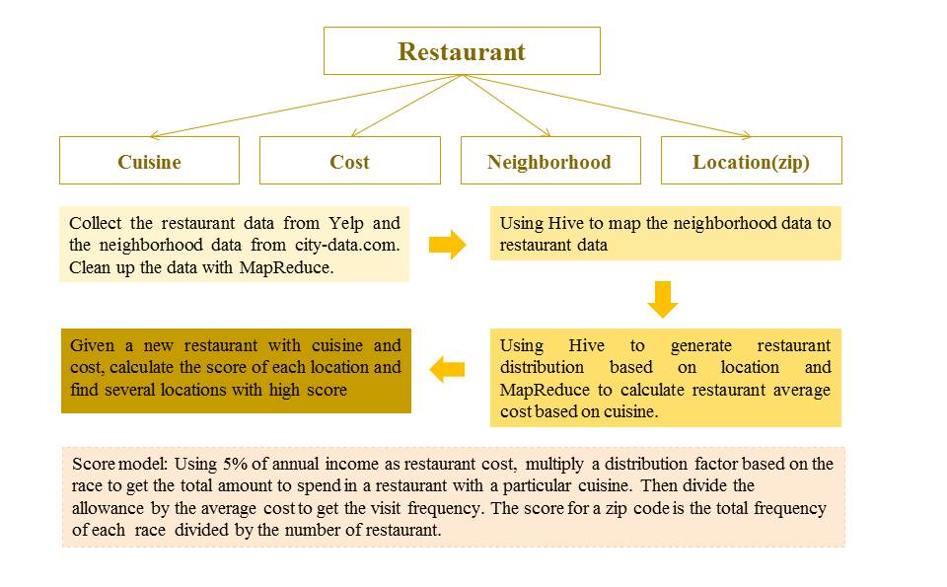
Figure1. Design diagram of the restaurant recommendation project.
First, we collect the restaurants and residential information from websites using Python Scrapy Crawler. We first collect the zip code range in New York City. Then we scraped the restaurants within those zip codes from Yelp.com. Finally, we obtained the demographics residential data including population, median income, median gross rent, race distribution as well as living cost. The initial size of the data scraped was about 150,000 and after removing duplicated records it finally came down to 30,000 for the analytics.
The second step is to clean up the data and get useful information. We first used Python to remove repeated records and format them while we were scraping. Then we used MapReduce to clean up and catalog restaurants based on their cuisine. We ran MapReduce to sort the restaurants based on their zip codes. Finally, we joined the restaurant data and city data based on their zip codes with Hive.
The third stage is to aggregate the statics results of restaurants with each cuisine. This is achieved by multiple Hive commands such as cross join, group by, etc. We also calculated the average cost for restaurants with different cuisine using MapReduce. The output of this stage was used as the database for building up the analysis model.
The last stage is to build the prediction model using the data from stage III. The program takes user input for cuisine, price range and output amount, and output the corresponding number of zip codes and their scores.
The entire architect of the project is shown in Figure 2.

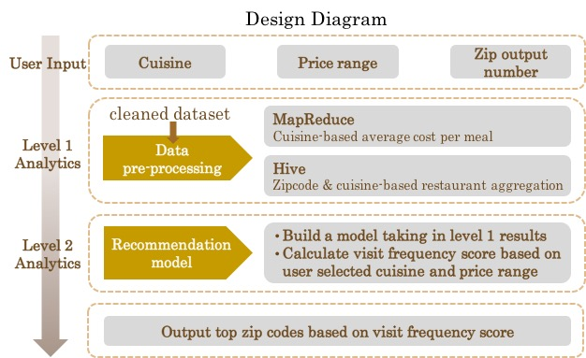
Figure 2. Data flow of the recommendation system.

Results
In the recommendation model, we used the average income multiply a factor as the total allowance for restaurant spend. We defined a preference profile for each ethnic group containing their preference for each cuisine. This is some kind subjective but we believe it is correct for average. Given the user input cuisine, we thus calculated the total amount of money spent on restaurants with this particular cuisine. We have calculated the average cost for restaurants with each cuisine. Then we predicted the visit frequency by total allowance and average cost. We calculated the score of each zip code by dividing the sum of this visit frequency with population and ethnic group distribution by the level of restaurants amount. Here we used restaurant level instead of the actual number to reduce the false high score of some zip codes with very little restaurants. We obtained the level by getting the average restaurants per zip code and used half of that as level increment. Another refinement we made was for the expensive restaurants. We considered the visits of expensive restaurants were highly depended on the income. So we calculated a factor by dividing the income of this zip code with the average of New York City. And if the restaurant price range is $$$ ($50 -$100), we multiplied the score with this factor once. And for restaurant with price range $$$$ ($100-$200), we multiplied the score with this factor twice.
In Figure 3, we showed the outcome of input American, $$ (the actual input is 2 representing 2 ‘$’). We also output the average income of each zip code for the user to consider how much the income weighted in the final result. They could simply neglect the zip code with extreme high income. From the result, we can see that the output zip code spanning a wide range of their score, which suggested that our model is effective.

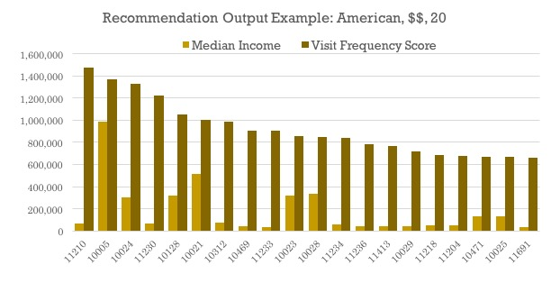
Figure 3. The top 20 outputs for opening an American cuisine restaurant with $20-$50 ($$) price range.

Future Work
There are two problems we have to face if we would like to refine our model. First of all, the model is built on top of the assumption that only the local residents would come to the restaurants. However, that is not true for most of the restaurants in an area that is easy to access. In order to get accurate visit frequency, we have to take into consideration the traffic and the tourist data. Since the tourists are not as patternized as local residents, this would involve large uncertainty in the final output and thus require large revision of the current model. We will have to run some analysis on the data to see what changes should be made.
Secondly, in the current model, we use some percentage (Engel's Coefficient) of the average income as the total allowance spent on restaurants. This is true for income in the middle range. But for extremely high and low income, this coefficient is some kind off. To improve our model, we will gather more data about this and set different coefficient for different income range in the future.
The next refinement we would consider is to catalog the restaurants both on cuisine and price range. This will increase the dimension of our data but provides more precise competition for the new open restaurant. We have obtained all data about the current restaurants. Thus adding it into the model would be an interesting attempt to improve our model.
Last, the model we have built is not only applicable for New York City but can be used in other city or country given the restaurants and residential data. The way we calculate the visit frequency can also be used in site selection for other business such as laundromat.

Conclusion
We have built a recommendation model for restaurant location selection. It utilizes the current restaurant data as well as the community information such as average income and race distribution to predict the number of customer visits. The model, although only being preliminary and lack of considering tourists, has provided useful zip code recommendation with large spread between different zip codes.

Acknowledgment
We would like to express our appreciation to Professor Suzanne McIntosh. The completion of this project could not have been possible without the help and advice from Prof. McIntosh. We would also like to thank Scrapy for their crawler framework and Cloudera for providing platforms for us to run our datasets.

References
- Simin You, Jianting Zhang and Le Gruenwald. Large-Scale Spatial Join Query Processing in Cloud.
- Shubin Zhang, Jizhong Han, Zhiyong Liu, Kai Wang and Shengzhong Feng. Spatial Queries Evaluation with MapReduce. Grid and Cooperative Computing, August 2009.
- Bing Li and Chan, K.C.C.. A Fast Big Data Collection System Using MapReduce Framework, Proceedings of CCIS November 2014.
- Jun Liu, Feng Liu and Nirwan Ansari. Monitoring and Analyzing Big Traffic Data of a Large-Scale Cellular Network with Hadoop. IEEE Network July/August 2014.
- Michael D. Ekstrand, John T. Riedl and Joseph A. Konstan. Collaborative Filtering Recommender Systems.
- Daniar Asanov, Berlin Institute of Technology Berlin, Germany. Algorithms and Methods in Recommender Systems.

