**Combining Deep Learning and network models to extract reliable statistics on COVID-19 transmission from partial tests.**

**Boston**

Brief:

Selection of days: ±100 days from the peak infectious+exposed day for training and testing from the 300 days.

Training set: 10k node, 20 realizations

Test set: 10K node, 10 realizations

dropout = 0.4, hidden_units=64,layers=3,learning rate =0.0002, epochs=250,batch_size=64

1. Precision on the classes Susceptibles, Exposed + Infected, Deads + Recovered for data coming from scenario 1.

Known nodes = 20%.

Total accuracy = 0.73

|  |  |  |
| --- | --- | --- |
| W=1.0,10k node | Accuracy | Precision |
| Susceptible | 0.67 | 0.98 |
| Infected + Exposed | 0.8 | 0.15 |
| Recovered+Dead | 0.8 | 0.8 |

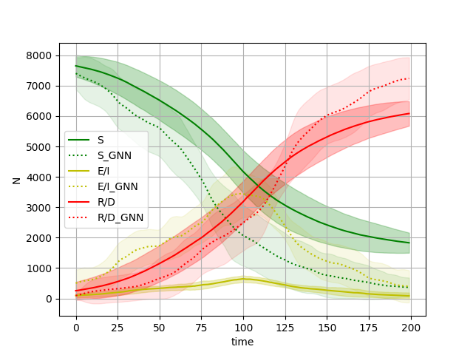

**Known nodes = 10%**

Total accuracy = 0.72

|  |  |  |
| --- | --- | --- |
| Wi=1.0,500 nodes | Accuracy | Precision |
| Susceptible | 0.67 | 0.98 |
| Infected + Exposed | 0.78 | 0.14 |
| Recovered+Dead | 0.79 | 0.79 |

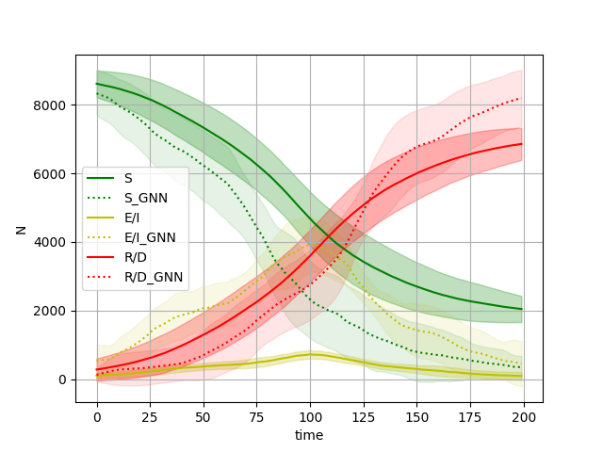

**Known nodes = 5%**

Total accuracy = 0.72

|  |  |  |
| --- | --- | --- |
|  | Accuracy | Precision |
| Susceptible | 0.67 | 0.97 |
| Infected + Exposed | 0.75 | 0.14 |
| Recovered+Dead | 0.78 | 0.79 |

