INTRODUCTION :

We combine cutting-edge technologies with strategic expertise to help customers meet their business needs. We utilize the latest technology to provide sophisticated and secure IT solutions using an effective delivery model to ensure flexibility and agility. Our specialty of operations includes Application Lifecycle Management, Infrastructure Lifecycle Management and Product Lifecycle Management. Our “High performance business” strategy builds on our expertise in consulting, technology and outsourcing to help clients perform at the highest levels so that they can create sustainable value for their customers and shareholders. Using our industry knowledge, service-offering expertise and technological capabilities, we identify new business and technology trends and develop solutions to help clients across the globe. For our clients, we offer a flexible and supportive work environment that focuses on the needs and career development goals of its people; while always focusing on delivering the highest quality.

Our Vision:

We strive to be a trusted partner as an IT Solution provider. We are committed to achieve Customer’s Business Objectives by Delivering Professional Services & adopting Innovative Technologies

. Our Mission: To channelize the Knowledge, Expertise and Experience that has gained over the years from recommending IT products and Effective solutions for our Customers. Deep industry knowledge and exceptional technical expertise combined with best business ethics makes TechPro the global leader in IT Services and Management Consulting.

PURPOSE:-

The use of this project:

1. Business Promotion: One of the primary purposes could be to promote and market Techpro solutions. By creating a project that showcases their products, history, and values, the aim is to attract more customers and increase brand awareness.

2. Customer Engagement: The project could serve as a platform to engage with existing and potential customers. This might include sharing updates, offers, and events, as well as responding to customer inquiries and feedback.

What can be achieved using this:

1. Educational Resource: The project can educate customers about the cultural and traditional significance of Indian sweets, creating a more informed and appreciative customer base.

PROBLEM DEFINITION & DESIGN THINKING:-

Empathy map:

1.Says: What customers explicitly state, such as their preferences, feedback, or opinions about techpro solutions.

2.Thinks: The thoughts, beliefs, and attitudes customers may have when thinking about or consuming techpro solutions.

3.Feels: The emotions and sentiments customers experience when interacting with techpro solutions, which can range from delight to frustration.

4.Does: The actions and behaviors customers exhibit when engaging with the brand, such as making purchases, sharing reviews, or participating in events.

5.Hears: The sources of information and recommendations that customers listen to, which may influence their decisions related to techpro solutions.

6.Pain Points: The challenges, concerns, or inconveniences that customers may encounter when dealing with techpro solutions. like long wait times or product availability issues.

7.Gains: The benefits, positive experiences, and rewards that customers derive from their interactions with techpro solutions, such as enjoying delicious sweets and experiencing cultural traditions.

Ideation & Brainstorming map:-

1. Product Development: Brainstorming new sweets and snacks, flavor combinations, and presentation ideas.

2. Marketing Strategies: Brainstorming marketing campaigns, social media content, and promotions.

3. Customer Engagement: Generating ideas for customer events, loyalty programs, and feedback channels.

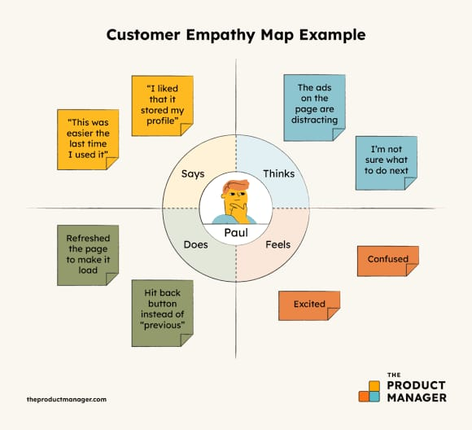

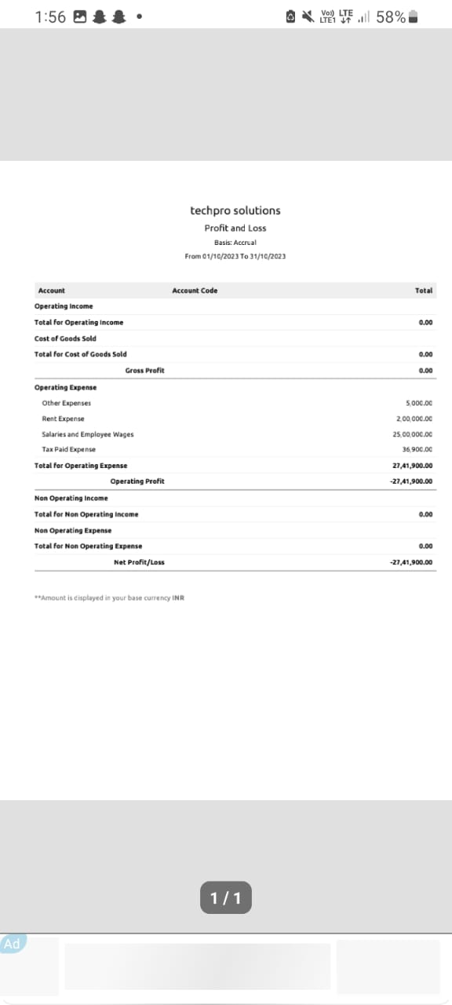

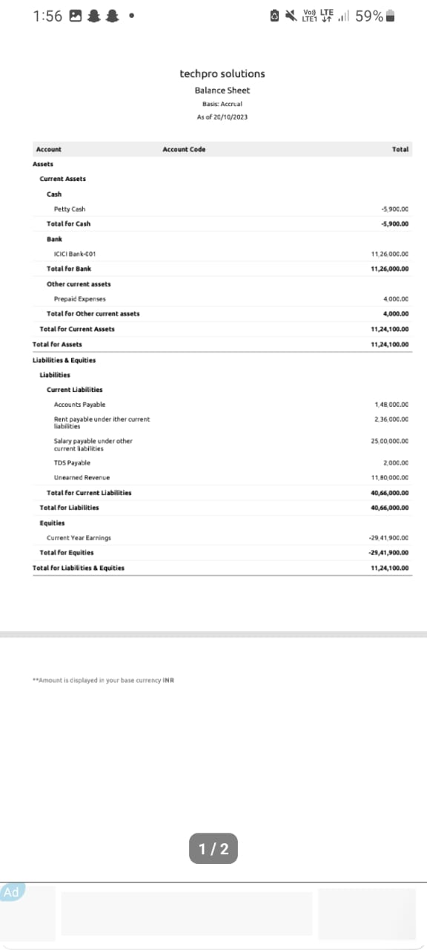

Conclusion

This is I conclude my project Techpro solutions has been a comprehensive exploration of the business, its operations, and the proposed solution of implementing an online sales platform.