Pre-order Traversal
Pre-order traversal is to visit the root first. Then traverse the left subtree. Finally, traverse the right subtree.

In-order Traversal
In-order traversal is to traverse the left subtree first. Then visit the root. Finally, traverse the right subtree.
Typically, for binary search tree, we can retrieve all the data in sorted order using in-order traversal.

Post-order Traversal
Post-order traversal is to traverse the left subtree first. Then traverse the right subtree. Finally, visit the root.

It is worth noting that when you delete nodes in a tree, deletion process will be in post-order. That is to say, when you delete a node, you will delete its left child and its right child before you delete the node itself.
Also, post-order is widely use in mathematical expression. It is easier to write a program to parse a post-order expression.
------------------------------------------------------------------------------------------------------------------------
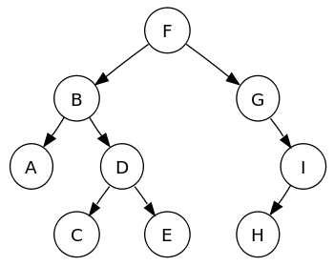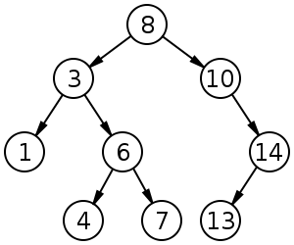

Pre-order traversal sequence: F, B, A, D, C, E, G, I, H (root, left, right)
In-order traversal sequence: A, B, C, D, E, F, G, H ,I (left, root, right)
Post-order traversal sequence: A, C, E, D, B, H, I, G, F (left, right, root)
A Greedy algorithm builds up a solution by choosing the option that looks the best at every step.
Say you're a cashier and need to give someone 67 cents (US) using as few coins as possible. How would you do it?
Whenever picking which coin to use, you'd take the highest-value coin you could. A quarter, another quarter, then a dime, a nickel, and finally two pennies. That's a greedy algorithm, because you're always greedily choosing the coin that covers the biggest portion of the remaining amount.
Some other places where a greedy algorithm gets you the best solution:
- Looking for a minimum spanning tree in a graph? At each step, greedily pick the cheapest edge that reaches a new vertex.
- Trying to fit as many overlapping meetings as possible in a conference room? At each step, schedule the meeting that ends earliest.
Careful: sometimes a greedy algorithm doesn't give you an optimal solution:
- When filling a duffel bag with cakes of different weights and values, choosing the cake with the highest value per pound doesn't always produce the best haul.
- To find the cheapest route visiting a set of cities, choosing to visit the the cheapest city you haven't been to yet doesn't produce the cheapest overall itinerary.
Validating that a greedy strategy always gets the best answer is tricky. Either prove that the answer produced by the greedy algorithm is as good as an optimal answer, or run through a rigorous set of test cases to convince your interviewer (and yourself) that its correct.

