Vajaran Nall

Assignment 5
This assignment aims to practice writing functions to make your script structured.
When you get multiple functions defined in Python script, follow the format as shown below:
import modules

GLOBAL_CONSTANTS

def main():
#mainline logic
helper_function_1()
helper_function_2()

def helper_function_1():
...

def helper_function_2():
...

if __name__ == "__main__":
main()

- Temperature_conversion.py (10 points)
Re-engineer the temperature_conversion script built in assignment 3, using the provided script skeleton, so the output shows like the screenshot below, illustrating both sunny-day and rainy-day scenarios.

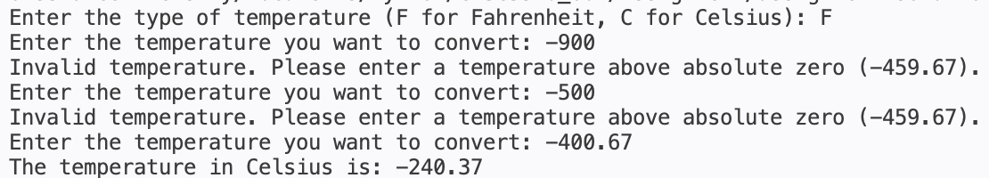

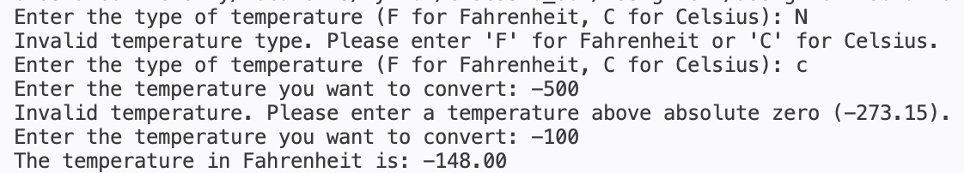
You can use upper() function from String object to help comparing the user input type.

- geometry_shape.py (10 points)
Please complete the provided script skeleton so that this script can generate the output as shown below:
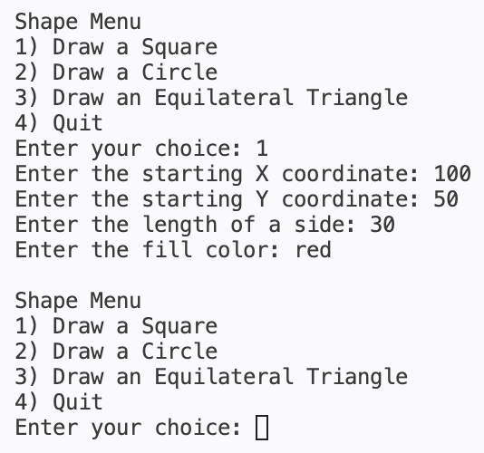 | 
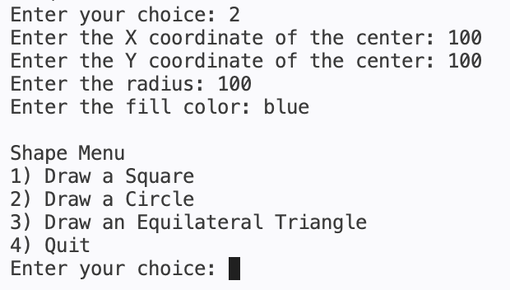 | 
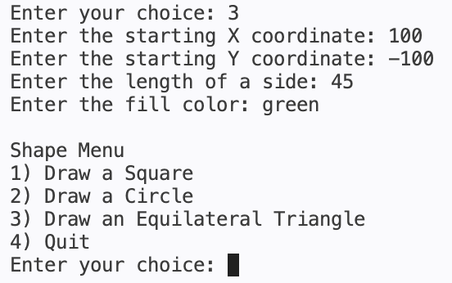 | 
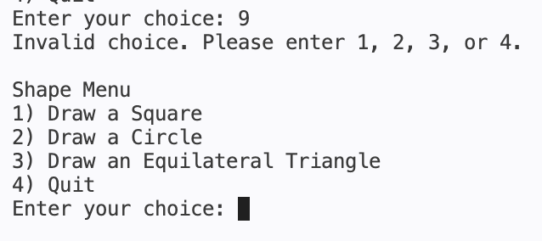 | 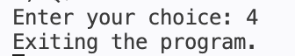

- write a brief reflection on this assignment on the challenges you encountered and how you solve them. List the techniques you applied from lecture 5 to this assignment. (5 points)
The code that I wrote in the second exercise was a fun practice session for writing main methods. Back at DePaul University we had to write a main method that would execute certain functions in response to specific user input using C and Emacs.
(We did a C-style implementation of python’s dictionary aka hash map)
Techniques applied during this assignment:
Value returning functions
Performing calculations only if user input was valid
Prompting input until valid data is passed in
Import modules

Quality Requirement:
- Organize your assignments: create a folder named “Assignment5” in your Python workspace to store all programs.
- Ensure the applied techniques consistent with our current progress. If advanced technique applied, please point them out and briefly explain how they help you achieve the purpose.
- Ensure you use the provided skeleton to complete the program.
- Understand the modularized script after building it with functions.
- Understand how to build functions with parameters and return values.
- Understand how to create menu-driven application.
- Validate user input. Get used to use walrus operator for receive user input while building test for condition structure.
Submission Requirement:
- Source script - Push the assignment5 source scripts into your established GitHub repo (the repo is built only once and can keep taking new files from future pushes). Follow this guide to perform the cloud operation. This “push to GitHub” guide is also posted on Blackboard > Configuration. Then simply submit your GitHub repo link to Blackboard. Your workspace for this course should structure like below snapshot (replace workspace name ‘assignment-solution’ with ‘PythonPractice’ and ‘ch05’ with ‘Assignment5’. Don’t add space in any identifier, especially the filename. They can lead to broken script.
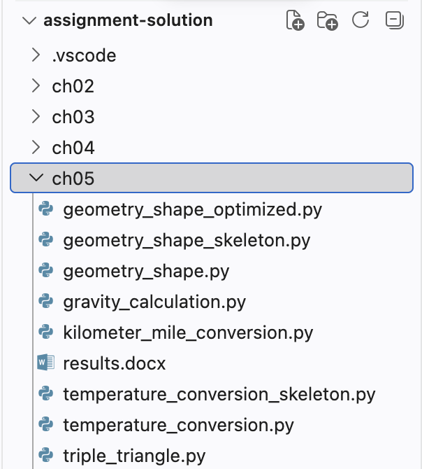

- Screenshots of the running result – PNG file can be stored/viewed directly in VS Code and migrated to GitHub.
