Introduction
There are many different types of sports, but the one sport that remains supreme in popularity around the world is soccer. Soccer can trace its origins back over 2,000 years to ancient China, Greece, and Rome and while the game then is different to what is played today, it is a sport that has survived the test of time. This incredible popularity means that anywhere on the globe you can find people who love the game and play either for a club, pick up games at the park, school soccer, or even professional soccer. Having this large pool of talent to pull from means that soccer clubs everywhere are trying to find the next wunderkind to help lead their team to glory. However, the difficult part is what makes a soccer player great and are these skills you can measure and analyze? If there are features that are measurable and able to be analyzed this can lead to clubs finding their “diamond in the rough” before other teams which gives them the advantage both on playing games and the monetary benefits, they receive from having top-tier players.
The problem to solve would be finding features that can be measured in a player that would help determine a player’s value on the pitch. The higher value a player, the greater the player is at soccer which leads to team wins and more money received. That is why if features can be selected that are found in high-value players these can be used to search the globe for people who fit those features and there is a greater chance for a club to find their wunderkind.
The data being analyzed is from 2018 which includes the top 100 soccer players in the world at the time with multiple columns representing a soccer players’ skills such as crossing, finishing, dribbling, etc… These skills are taken together to produce value for the player and the higher value a player is, the better that player is. Using different statistical models to compare them to each other before choosing the best fit model, this can then be used to determine what features are best in determining a high-value player.
Organized/summary milestones 1-3
Before getting into comparing feature selection models to extract the best features to use to determine a high-value player we must begin with a little bit of exploratory data analysis on the dataset being reviewed. This analysis phase is to visually view the data to see distributions amongst the dataset and while the visuals and information gleaned from this review is not used in feature selection, it does help show some additional information that would not have been noticed from glancing at the raw data.
Starting with the age distribution from the dataset with graph_1
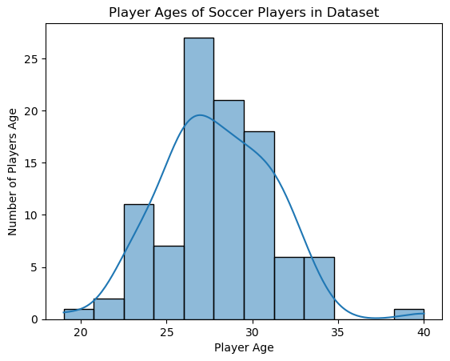
(graph_1)
Graph_1 is visually showing the players’ age distribution within the dataset. Since we’re dealing with the top 100 players in the world, we can see that majority of the top players are around 26-27 years old with positive skewing outliers around 39-40 years old. This helps to show that there may be an age you want to focus on when searching for high-value players and around 25-30 is when they’re being heavily represented, so time is ticking to try and find players before they hit their peak.
After the age distribution, we move to showing the average value of a player based on position. Graph_2 is going to give an idea of which player position, on average, has the highest value attached to it and this information can be used to build teams around player positions.
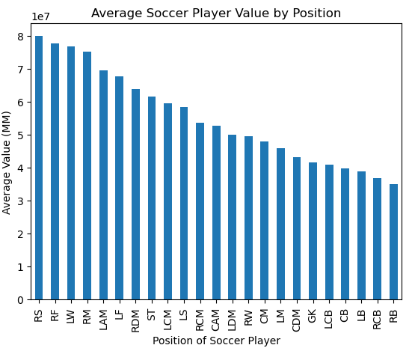
(graph_2)
Graph_3 is another visualization showing the distribution of the value of a player related to its position. This is useful to see which position has outliers that could potentially be affecting the average value of the position.
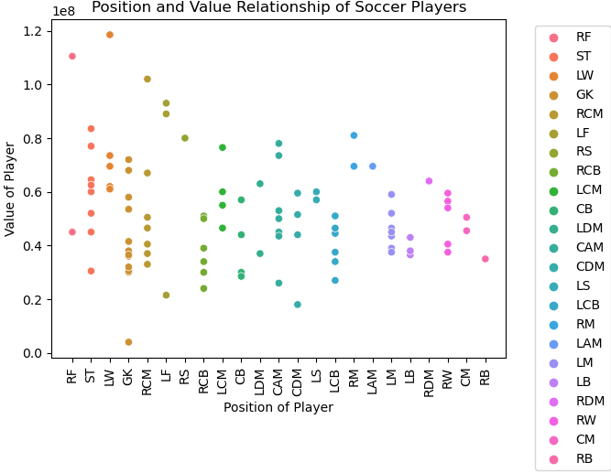
(graph_3)
Final visualization is graph_4 which breaks down the number of 100 high value players into which country they are from. This is useful for clubs to see which countries produce more of the top-value players and can also tap into some of the lesser-represented countries to find a high-value player before other clubs do.
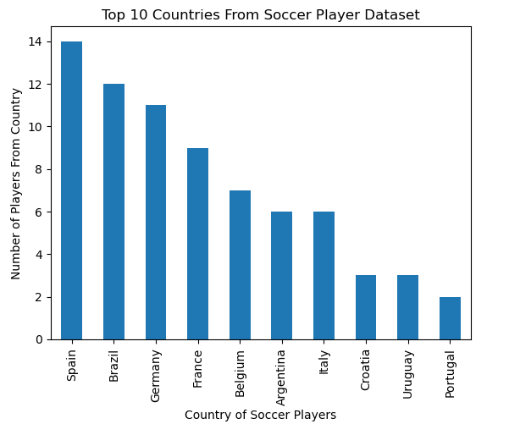
(graph_4)
After reviewing the visualizations of the raw dataset, we then move to preparing the data for our model. This involved dropping columns that are not considered useful in extracting player value as well as dropping the GK (Goalkeeper) position. The reason for this is that goalkeepers typically don’t fall into the same archetype of other position players and is a position where anyone can be slotted in to perform. After dropping the unnecessary columns and removing the GK position we can move to building the models and comparison as the dataset is relatively clean and does not require a lot of modifications.
Moving on to model building, the algorithms decided to be used for feature selection are linear regression and random forest regressor. The models will both be trained and tested using 80/20 split with R^2 and MSE to determine the best fit. R^2 (coefficient of determination) is used to evaluate whether the model is a good fit for the data, and we are looking for this number to be higher when comparing models. The MSE (mean squared error) is used to evaluate how predictive the model performs and the lower this value of the model determines that the predictions are closer to the true values (lower is better!).
Once the models have been fitted the results are below:
Linear Regression R^2: 0.6473639220707705
Random Forest Regressor R^2: 0.6654471538074893
Random Forest Regressor MSE: 221864295833333.34
Linear Regression MSE: 233856492346734.03
The comparison between linear regression and random forest regressor for both R^2 and MSE are very similar, but the random forest regressor does show a little better fit and predictive abilities than linear regression. As a result, the random forest regressor is selected to extract the top features that can be used to determine a high-value soccer player.
The final part of our model evaluation is to find which features from the dataset are best used to predict a high-value player. Using the random forest regressor algorithm we can extract the top 5 features of the dataset:
Feature | Feature Importance
Reactions | 0.244821
Dribbling | 0.088714
BallControl | 0.082038
LongShots | 0.064355
Finishing | 0.054348
The results above from the random forest regressor show that if you are wanting to find a high-value player then you would have more success focusing on reactions, dribbling, ball control, longshots, and finishing with a very heavy emphasis on reactions.
Conclusion
After comparing the linear regression to the random forest regression model, we can conclude that the random forest regression model provides better fit and predictions. We can then extract the features from dataset that would best be used to predict a high-value player, and this will give clubs a focus on which traits to look for. While the model is ready to be deployed on any dataset received, it still requires tuning if the dataset differs in anyway from what was used to build the model. I recommend either creating a way to pre-process the data to get it ready for the model, or to manually prepare the data beforehand to ensure it’s able to be fitted before moving on to running the model on the dataset. I believe that there is an opportunity to enhance the model such as incorporating a separate section for goalkeepers as well as finding different features that clubs may deem important in their player search and incorporating them into the dataset for the model selection.

