08.07.2017 23:22

# PHPStorm + XAMPP + xDebug

<https://medium.com/@evgeniyporemchuk/how-to-debug-a-yii2-project-with-xdebug-and-phpstorm-ide-112e6cf50768>

PHP.ini

[XDebug]

zend_extension = "D:\xampp\php\ext\php_xdebug.dll"

xdebug.profiler_append = 0

xdebug.profiler_enable = 1

xdebug.profiler_enable_trigger = 0

xdebug.profiler_output_dir = "C:\xampp\tmp"

xdebug.profiler_output_name = "cachegrind.out.%t-%s"

xdebug.remote_enable = 1

xdebug.remote_handler = "dbgp"

xdebug.remote_host = "localhost"

xdebug.trace_output_dir = "D:\xampp\tmp"

xdebug.remote_port = 8081

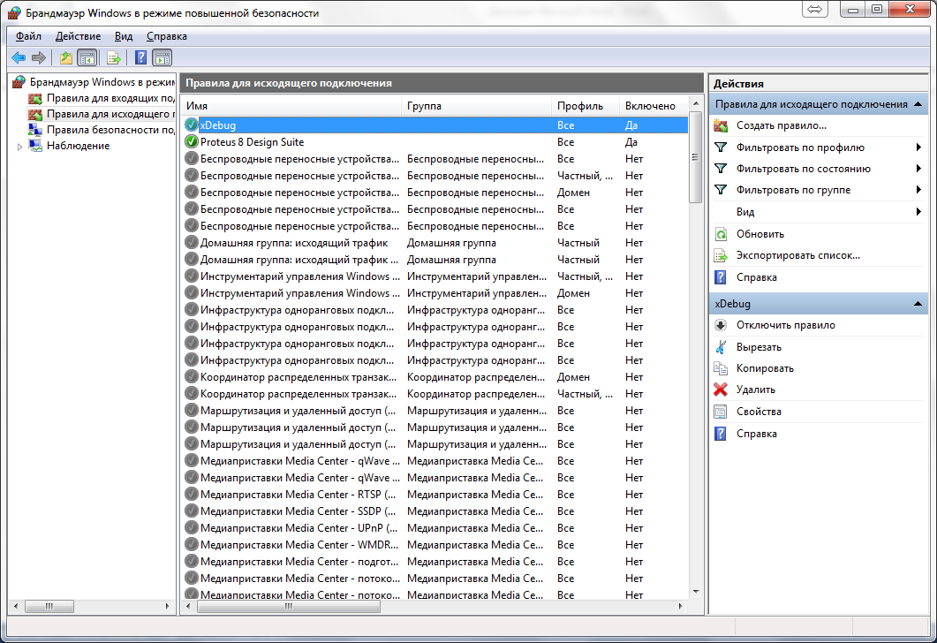

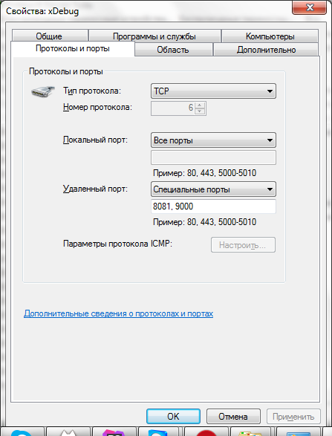

Setup PHPStorm

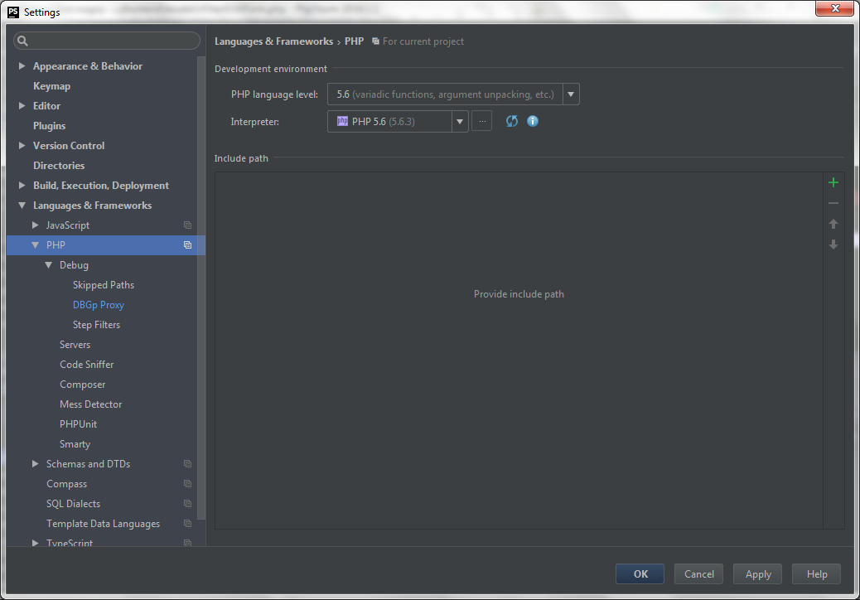

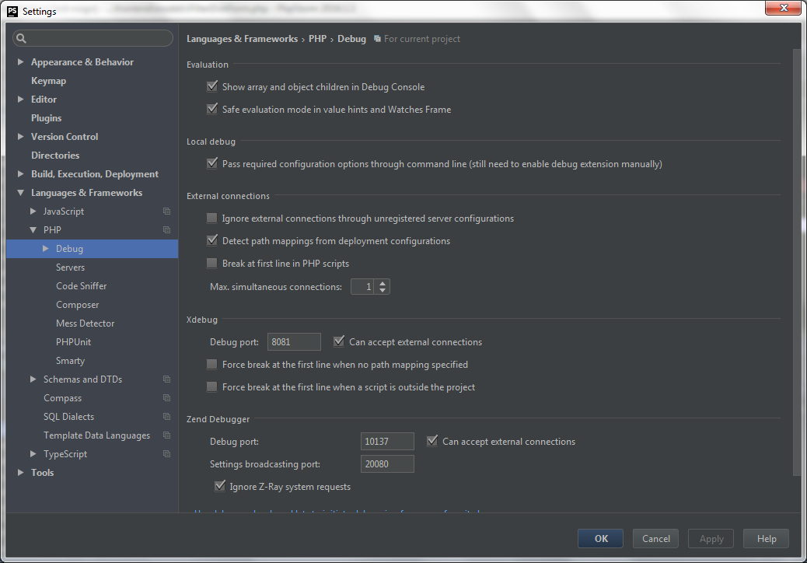

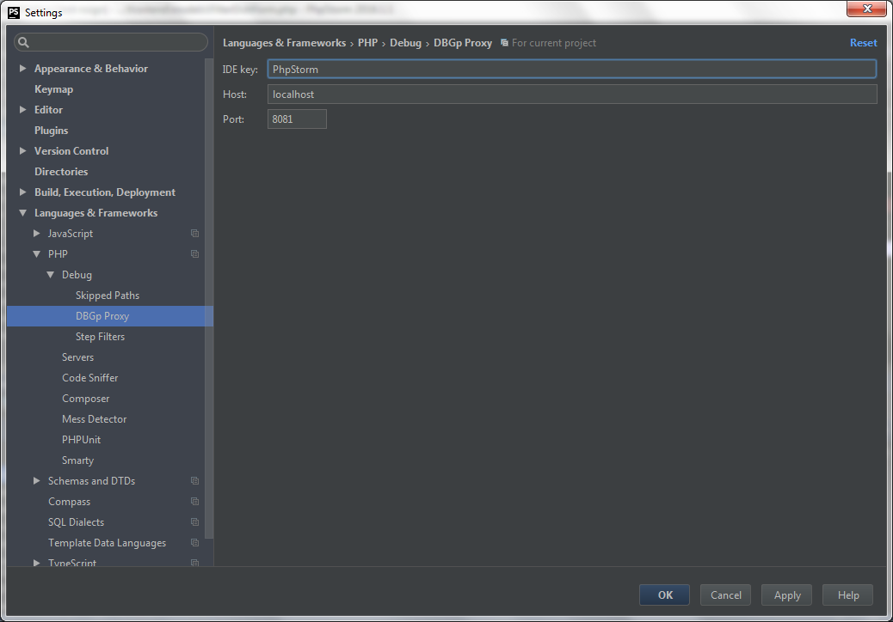

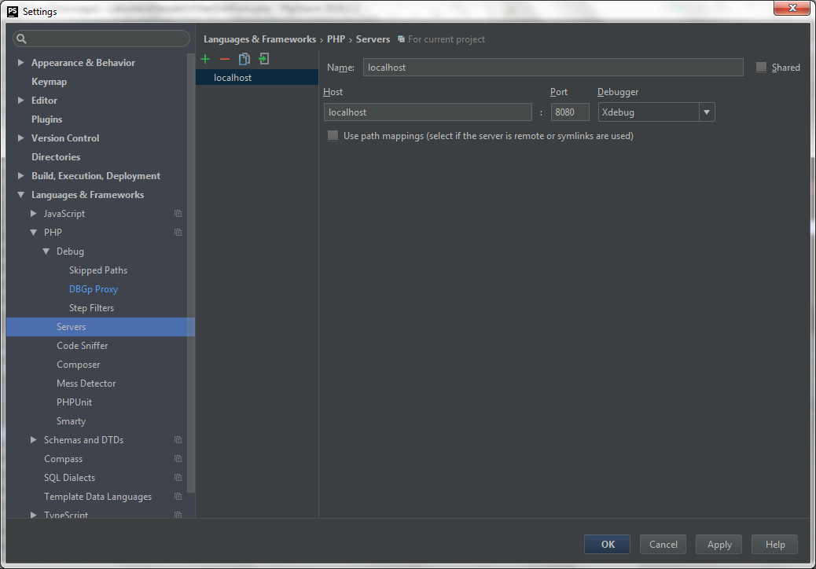

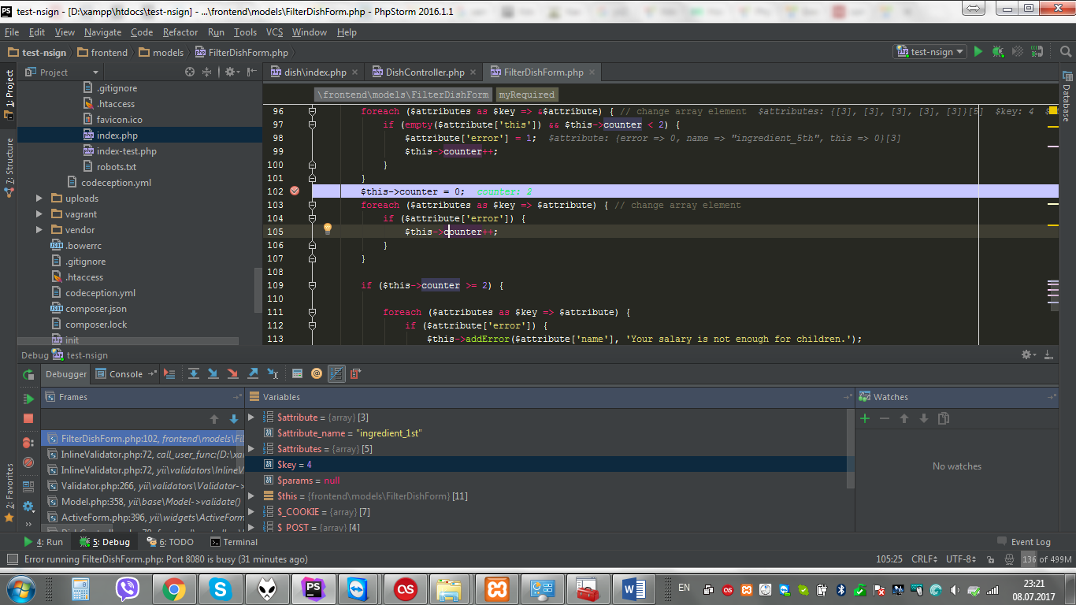

14.07.2017 00:50

# Not Less Than 2

/**  
 * @inheritdoc  
 */  
public function afterValidate()  
{  
 parent::afterValidate();  
   
 $test = $this->getAttributes();  
 foreach ($test as $key => $attr) {  
 if (!empty($attr)) {  
 $this->counter++;  
 }  
 }  
 if ($this->counter < 2) {  
 foreach ($this->getAttributes() as $key => $attr) {  
 if (empty($this->$key)) {  
  
 // Yii::$app->session->setFlash('success', 'Check your email for further instructions.');  
 $this->addError($key, 'Должно быть заполнено не менее двух полей.');  
 }  
 }  
  
 return false;  
 } else {  
 $this->counter = 0;  
 return true;  
 }  
  
}