DISTRIBUTED JOB SCHEDULER
System Architecture, UI Overhaul, & Technical Handoff Document
─────────────────────────────────────────────
Prepared By: AI Technical Engineering Partner
Project Handoff Target: GitHub Repository sync
GitHub Remote: https://github.com/DiStrix1/codity-assignment
Date: July 2026
Status: Option A (Modern Glassmorphic Sidebar) UI Deployed

1. Executive Summary
This project showcases a production-ready Distributed Job Scheduler composed of a high-performance Spring Boot backend and a visual, glassmorphic React SPA frontend. Underpinned by raw relational database concurrency optimizations (PostgreSQL Skip Locked), the engine is designed for reliable execution of thousands of tasks across multiple worker nodes.
Key requirements delivered in this sprint include the integration of a new RETRY_PENDING intermediate lifecycle state that mitigates scheduling loops, a persistent dual-theme layout (collapsible responsive navigation), a real-time throughput visual chart, and a comprehensive motion package ensuring smooth UX transitions inside the administration dashboard.
2. System Architecture & Workflow
The application architecture consists of three layers: client dashboard, scheduler endpoint routers, and concurrent background executors. The workers communicate with the core API to claim pending assignments, publish state telemetry heartbeats, and execute custom job handlers.
┌──────────────────────────────────────────────────────────────┐
│ React Front-End UI │
│ (Collapsible Glassmorphic Sidebar, Theme, Live Polling) │
└───────────────┬───────────────────────────────▲──────────────┘
│ REST API │ WebSocket
▼ │ Events
┌───────────────────────────────────────────────┴──────────────┐
│ Spring Boot REST API │
│ (JobController, WorkerController, JobEventPublisher Service)│
└───────────────┬───────────────────────────────▲──────────────┘
│ SKIP LOCKED Claim │ heartbeats
▼ │
┌───────────────────────────────────────────────┴──────────────┐
│ Distributed Job Executor Nodes │
│ (Concurrent Thread Executors, Stale worker recovery) │
└───────────────────────────────┬──────────────────────────────┘
▼ SQL Queries
┌──────────────────────────────────────────────────────────────┐
│ Relational Database Engine (PostgreSQL) │
│ (CHECK Status Constraints, SKIP LOCKED Row Containment) │
└──────────────────────────────────────────────────────────────┘
Setup & Command Instructions
- Pre-requisites: Java JDK 21+, Node.js v20+, Maven 3.8+, PostgreSQL server.
- Starting Backend service: Run standard Spring-boot profile. Use ./mvnw spring-boot:run at the root.
- Starting Frontend client: Run npm install followed by npm run dev inside the frontend/ folder.
- Database migrations: Flyway automigrates tables on launch via V1__create_schema.sql and V3__add_retry_pending_state.sql.
- Standard Endpoints: Frontend runs on http://localhost:5173/ and maps backend on http://localhost:8080/.
3. Database Schema & ER Model
State integrity is guaranteed at the database engine level via Check Constraints. Below is a specification of the main tables that coordinate task distribution:
Table Name | Primary Key | Important Fields | Purpose
jobs | id (UUID) | queue_id, status, attempt_count, next_run_at | Holds job payload, retry state, status checks.
workers | id (VARCHAR) | hostname, last_heartbeat_at, status | Tracks active executors and hosts online checkins.
queues | id (VARCHAR) | name, paused, concurrency_limit | Identifies task routing bins + configuration toggles.
retry_policies | id (VARCHAR) | max_attempts, backoff_base, backoff_factor | Enforces backoff delay equations on retry execution.

The Flyway migration script V3__add_retry_pending_state.sql added support for the new RETRY_PENDING status:
ALTER TABLE jobs DROP CONSTRAINT IF EXISTS jobs_status_check;
ALTER TABLE jobs ADD CONSTRAINT jobs_status_check
CHECK (status IN ('QUEUED', 'SCHEDULED', 'CLAIMED', 'RUNNING', 'COMPLETED',
'FAILED', 'DEAD_LETTER', 'RETRY_PENDING'));
4. Core API Documentation
API details exposed by the Controller layers supporting live telemetry synchronizations:
Method | Endpoint Path | Parameters | Description
GET | /api/jobs | status, queueId, page, size | Retrieves chunked list of jobs matching filters.
POST | /api/jobs | CreateRequest Payload | Submits a new job to be routed to a target queue.
GET | /api/jobs/{id} | id (UUID) | Returns detail view of single job with run step logs.
GET | /api/metrics/global | None | Returns real-time summaries used by dashboard numbers.
POST | /api/workers/heartbeat | WorkerId | Updates host heartbeats status block to active.
GET | /api/queues | page, size | Lists all configured queues with pause/resume states.

5. Design Decisions & Trade-Offs
A. Skip Locked Concurrency Design
Instead of heavy transactional isolation tables or external lock tables, worker threads poll for queued tasks using PostgreSQL SELECT ... FOR UPDATE SKIP LOCKED. This permits multiple concurrent worker daemons to poll the same table without experiencing blocking queries, serializing claims dynamically at high speeds.
Trade-Off: Introduces database polling pressure. If thread frequency is too high, select load escalates. This is alleviated by a smart client backoff model when the queue tables are empty.
B. Introduction of RETRY_PENDING Lifecycle State
Previously, job failures immediately reverted to QUEUED state. On failures with short timeouts, this resulted in execution 'hot loops' where a broken task was instantly retried, overwhelming the host.
The new RETRY_PENDING state keeps unsuccessful tasks quarantined until their specific exponentially-calculated next_run_at timestamp passes. A background scheduler promotion sweep promotes eligible jobs back to QUEUED using a atomic sweep.
6. Verification & Automated Tests
System correctness is validated with concurrent integration test suites in Spring Boot. The major test class is RetryPendingPromotionTest.java, which simulates multiple threads promotional runs and verifies that no race conditions result in double execution.
Test output verification snippet:
[INFO] Tests run: 2, Failures: 0, Errors: 0, Skipped: 0, Time elapsed: 4.872 s - in com.jobscheduler.RetryPendingPromotionTest
[INFO]
[INFO] Results:
[INFO]
[INFO] Tests run: 98, Failures: 0, Errors: 0, Skipped: 0
[INFO]
[INFO] ─────────────── BUILD SUCCESS ───────────────
7. User Interface Overhaul (Option A Deployed)
Below are screenshots collected from the live application showing the collapsible glassmorphic navigation layout (Option A), light/dark switching layout containing high contrast metrics, and the themed interactive graphs:
✦ Option A Glassmorphic Dark Layout:
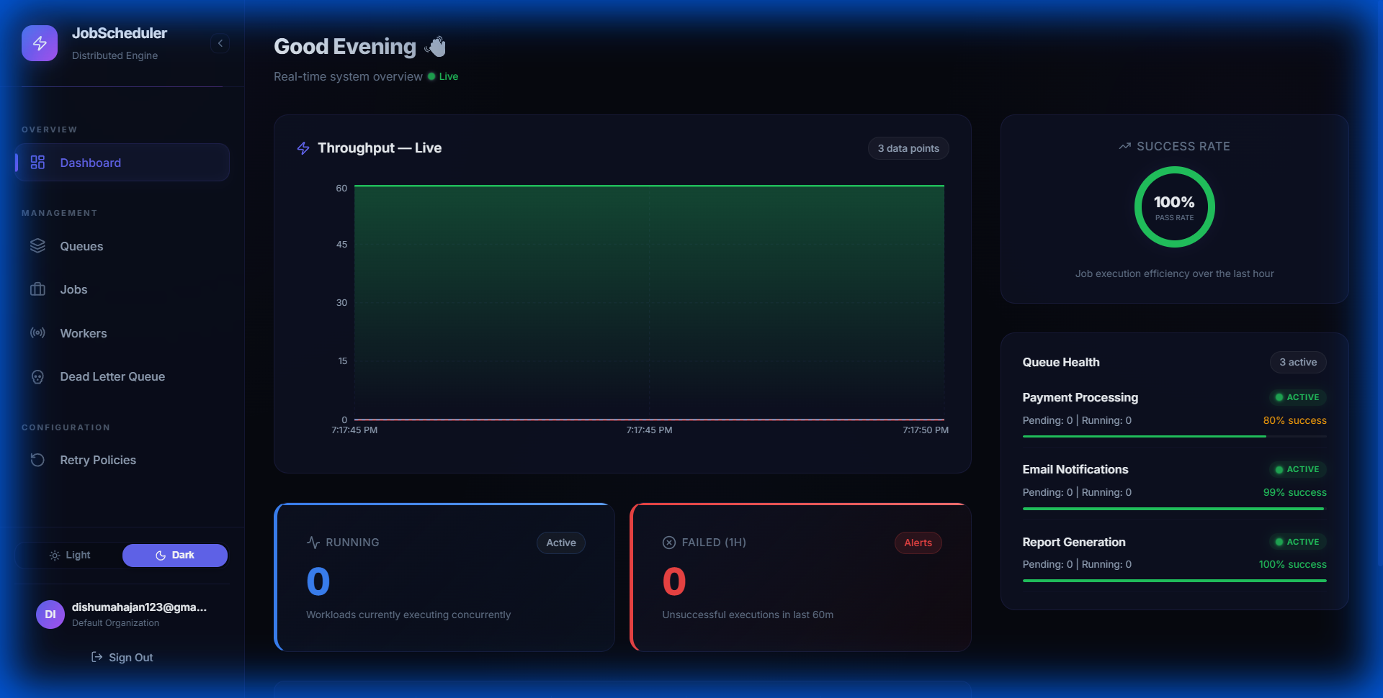
Figure: dashboard_sidebar_a_theme_1783086470823.png
✦ Light Theme Fixed Contrast Dashboard:
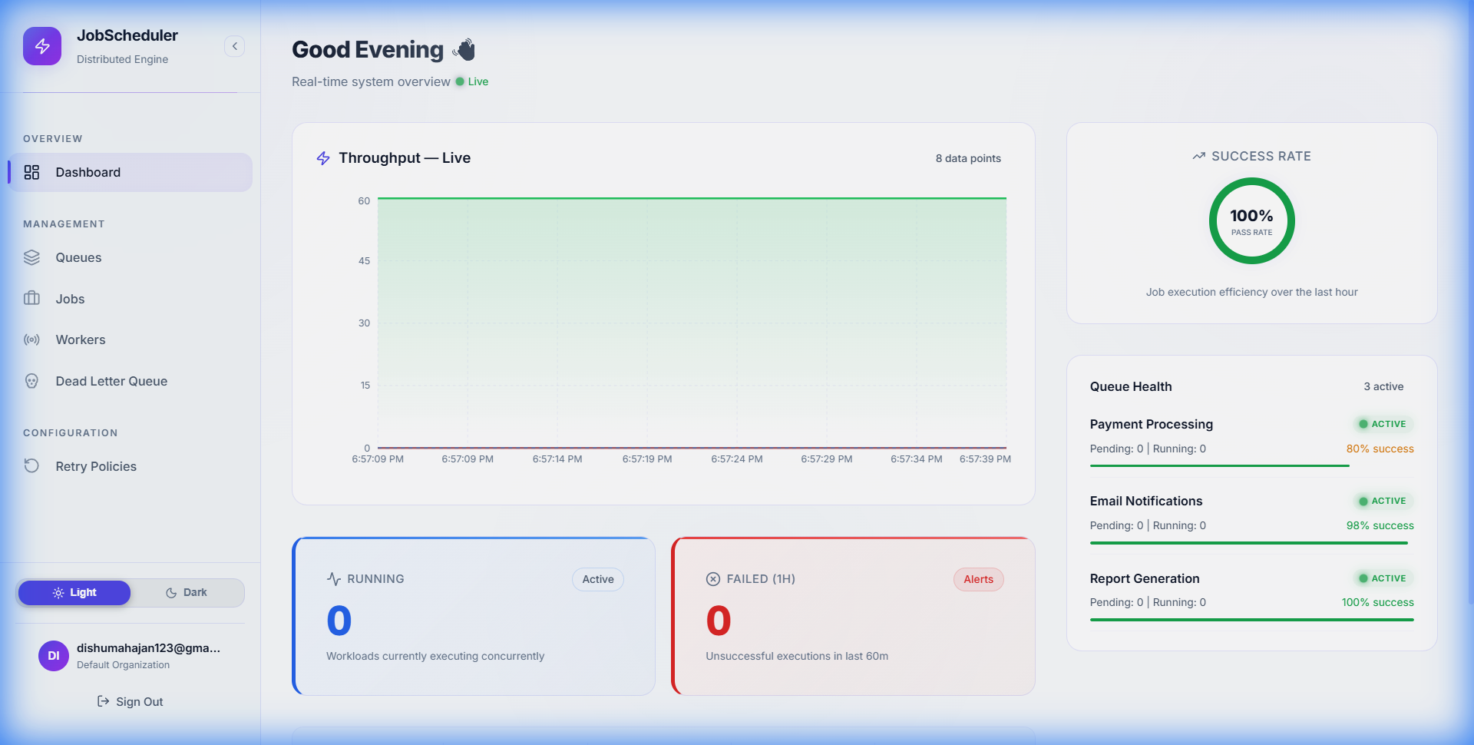
Figure: dashboard_light_fixed_cards_1783085262609.png
✦ Light Theme Lower Metric Info Strip:
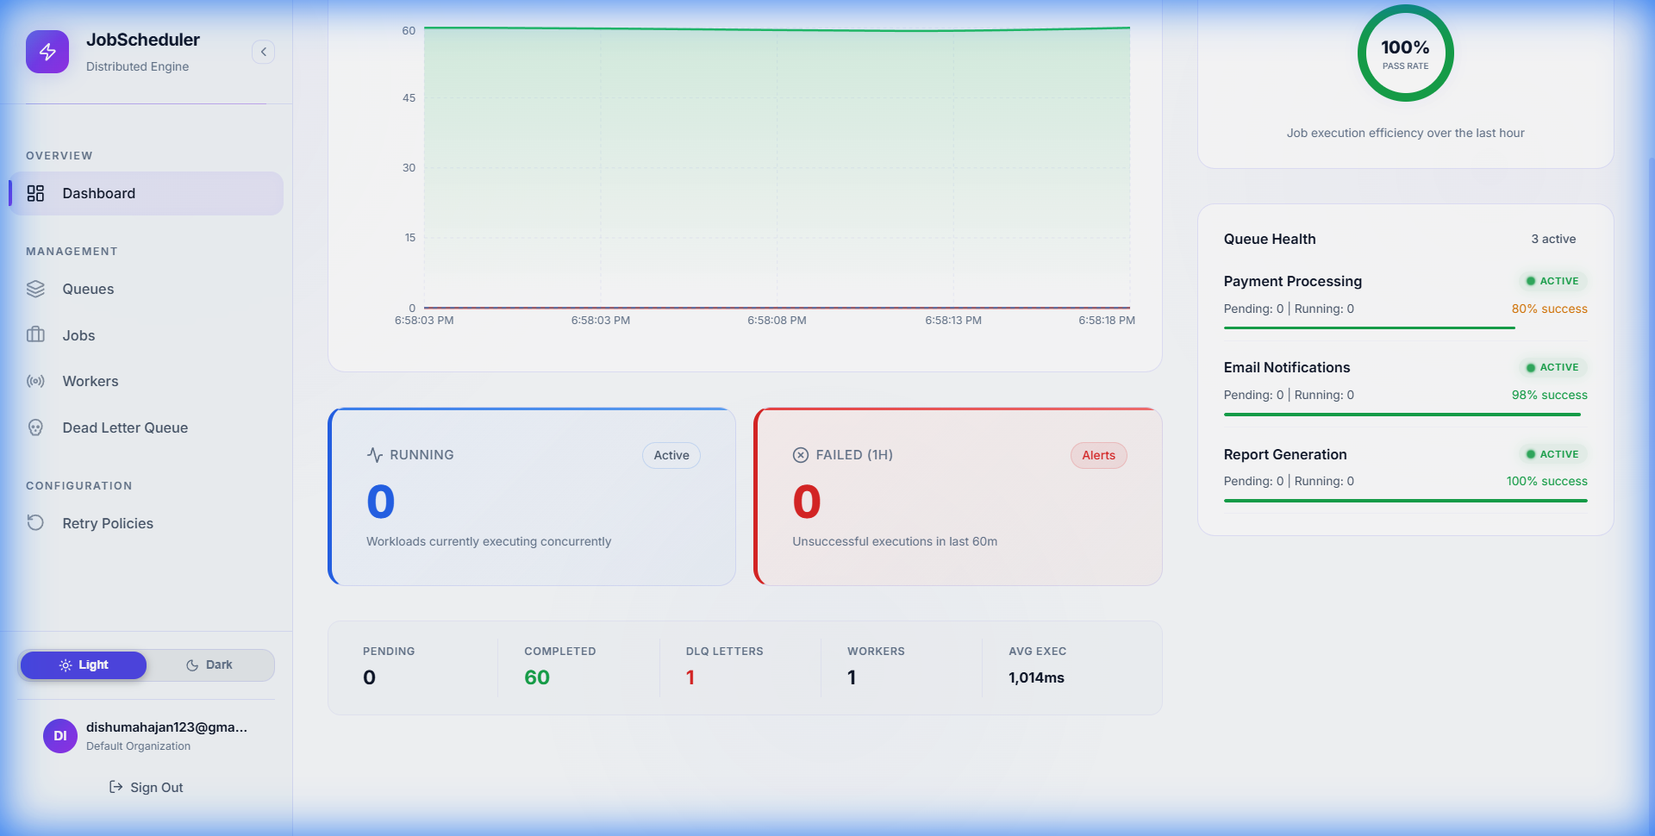
Figure: dashboard_light_scrolled_infostrip_1783085299172.png
✦ Jobs Detailed Layout & Filters Table:
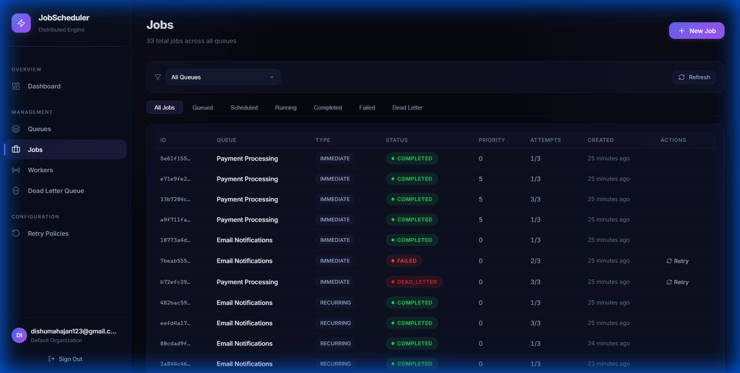
Figure: jobs_redesigned_1783083046761.png

