**Final Scope of the Project**

**I. Introduction**

**Project Title:**

**"Business Insights with Uplift NW: A Deep Dive into Data"**

**Team:**

**Team WeLift**

**Objective:**

The project aims to leverage existing datasets to inform strategic decisions for Uplift Northwest's future business operations. The objectives include analyzing demographic data and program outcomes, culminating in a presentation or report supported by visualization dashboards to tell the Uplift NW story through data.

**1.1 Client’s Objectives**

Uplift NW needs to make data-driven decisions about:

* The demographics of the participants it serves.
* The locations of these participants.
* The effectiveness of its programs.

**1.2 Proposed Project Problems & Deliverables**

1. **Data Visualized Dashboards:**
   * To answer:
     + Who are the participants?
     + Where do they live?
2. **Recommendation and Storytelling Report:**
   * With sample solutions to address:
     + What do the participants need?
     + What do the participants already have?
     + What more data should be collected?
     + How should the data be used?
     + What gaps and challenges are noticed?
3. **Final Presentation:**
   * Presenting the findings and recommendations.

**II. Summary**

**Initial Findings:**

During a visit to the Uplift facility, the team learned about Uplift's culture, mission, program, and history. The team identified two unique challenges in making data-driven decisions:

1. **Data Incompletion:**
   * Due to the disadvantaged status of Uplift’s participants, some data is naturally hard to track (e.g., living location, education level, housing status).
   * Intake interviews are conducted on the first day, and data is filled out by staff, representing the participant's status on that day.
   * Employment status tracking is challenging unless participants self-report.
2. **Lack of Unified Communication:**
   * There is no standard method for data communication among different organizations or cities.

**Considerations:**

These challenges will be considered when solving Uplift’s problems through data analysis and solution recommendations.

**III. Data Analysis Status & Questions**

**3.1 Data Analysis Status**

The following analyses have been completed or are in progress:

* **Age Distribution (2018-2024):**
  + Trends in average, largest, and smallest age.
  + Record count and incomplete input rates.
* **Participant Counts (2018-2024):**
  + Trends in yearly participant counts.
* **Housing Status (2018-2024):**
  + Total count and pie chart by percentage.
* **Hiring Data (2018-2024):**
  + Trends in renewal hire, most recent hire, orientation completion, incomplete input rates.
* **Job Placement Data (2018-2024):**
  + Placement counts, placement notes, incomplete input rates.
* **Insurance Status Count**
* **Working Location:**
  + Map in the Greater Seattle Area.
* **Employment Data:**
  + part-time or full-time status, job placement titles.

**3.2 Initial Observations:**

* **Age Distribution:**
  + Record counts are low before 2022.
  + Average age is trending younger.
  + Large age range needs more detailed data.
* **Hiring Data:**
  + Critical missing data (e.g., TempWork#).
  + Some data may be outdated or no longer useful.
  + Inconsistent campaign status updates.
* **Job Placement Data:**
  + High rate of incomplete inputs.
  + Non-uniform data input for locations.
  + Suggested deletion of non-useful columns.

**IV. Recommendations**

**4.1 Addressing Data Incompletion:**

* Eliminate records with no input in visualizations.
* Show incomplete input rates in visualizations.
* Provide a complete form for data entry.

**4.2 Unified Communication:**

* Develop a standard method for data communication among different organizations or cities.

**4.3 Data Usage and Collection:**

* Identify what data is currently collected.
* Determine what additional data should be collected.
* Recommend methods for data collection and usage.
* Identify gaps and challenges in the current data.

**4.4 Final Deliverables:**

* **Data Visualized Dashboards**
* **Recommendation and Storytelling Report**
  + We will also provide a suggestion list on how to unify data entry and a three-phase future roadmap for better data-driven decisions.
    - **Phase 1**: We recommend having a simple web application to input all data and output a unified form/dataset, which will be easy to connect to Salesforce or save as an Excel file. (The essential input list for phase 1 will be provided in the final report. The demo GitHub Link: <https://github.com/czhtoday/UpliftNW_Participant_Manager> )
    - 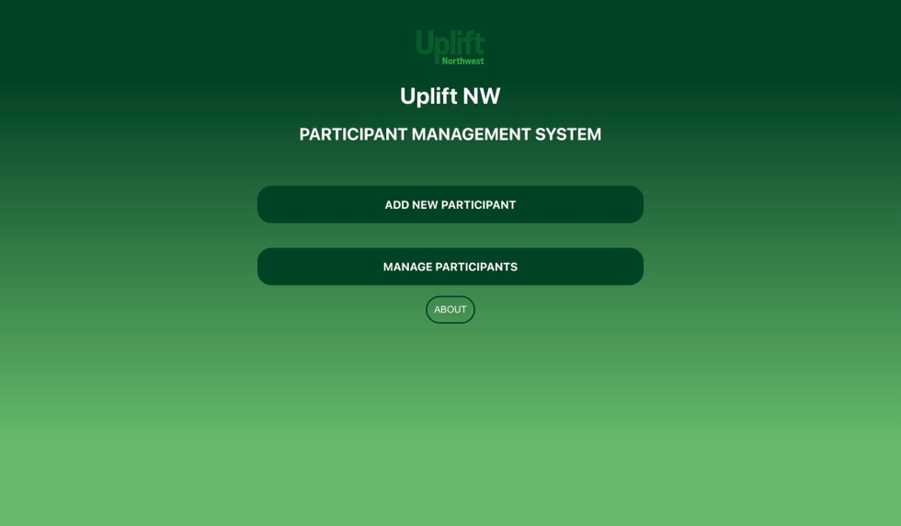
    - A screenshot of a green screen

      Description automatically generated
    - A screenshot of a computer

      Description automatically generated
    - A screenshot of a computer

      Description automatically generated
    - **Phase 2**: We should gather more data to understand better the participants Uplift serves. (The final report will provide the recommended input list for answering the clients’ questions about who the participants are and where they come from.)
    - **Phase 3**: We recommend that we gather more data to better use a prediction data model to understand the participants' tendencies and trends.
    - A screenshot of a graph

      Description automatically generated
    - 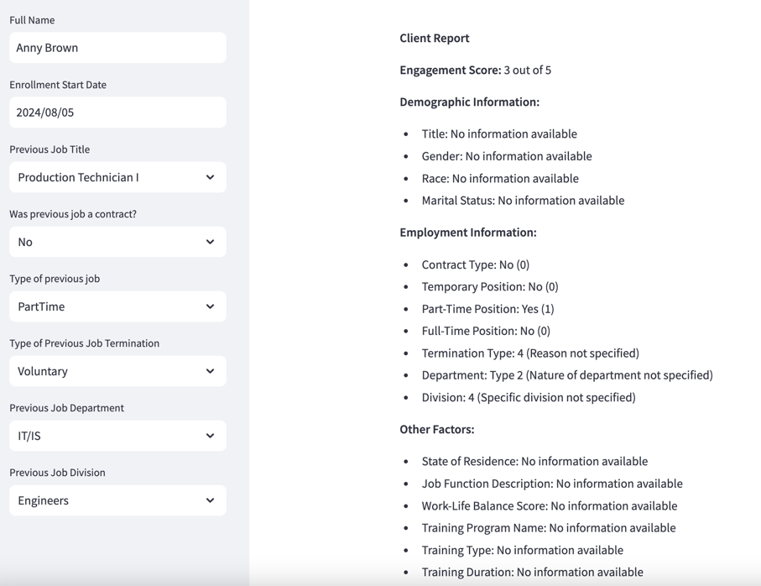
    - A screenshot of a computer

      Description automatically generated
* **Final Presentation**
  + **Final Presentation Date & location:**
    - Aug 14, 1:30 pm at Uplift NW
  + **The final showcase Poster presented to the community:**
    - Will send that out by Wednesday and would like to get Uplift NW’s approval