**Cairo University**

**Faculty of Computers and Artificial Intelligence**

**Information Systems Department**

**Progress Tracker 2030**

**Supervised by: Dr. Mohamed Nooreldien**

Team Members:

|  |  |  |
| --- | --- | --- |
| **ID** | **Name** | **Dept/Group** |
| **20160123** | **Tarek Abd El-Hak Mohamed** | **IS_DS (1,2)** |
| **20160121** | **Diaa Mamdouh Attia** | **IS_DS (1,2)** |
| **20160114** | **Sherif Gameel Moawad** | **IS_DS (1,2)** |
| **20160150** | **Alaa Abd El-Bari Mohamed** | **IS_DS (1,2)** |

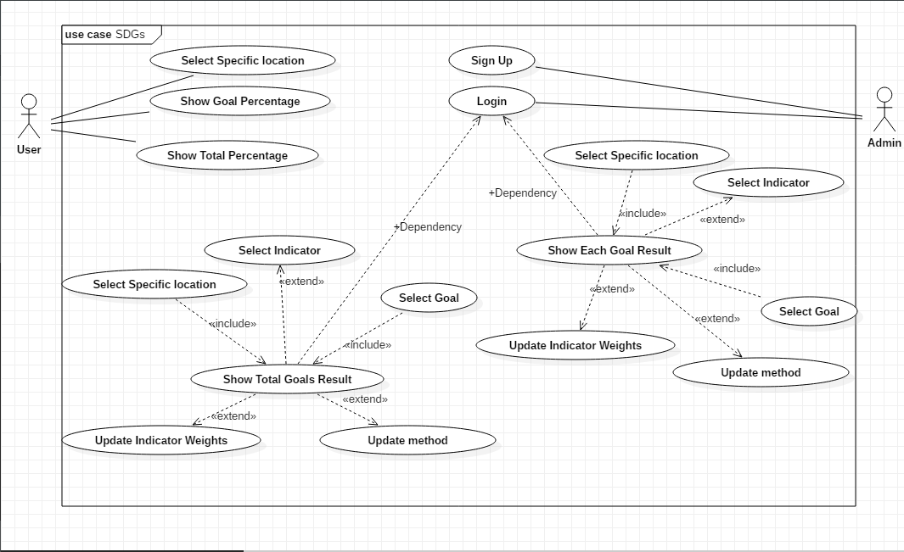**Use Case Diagram:**