|  |
| --- |
| Krazy Katz |
| Assignment 01 |
| **Nightmare of the Bunnies** |
| Version #XX  All work Copyright © 2012 by KrazyKatz.  All rights reserved. |
| **Khandker Faim Hussain** |
|  |



|  |
| --- |
| October 29, 2015 |

Table of Contents

**Version Control (History)3**

**Game Development4**

Game Overview4

Controls4

Interface Sketch4

Screen Descriptions4

Characters/Vehicles4

Enemies4

Scoring4

Sound Index4

Art/Multimedia Index4

**Version History**

* **Commit 1 – Added Player, added enemy AI, added scoring system, added health, and added minor audio**

Added player and player controller script, created texts for scoring and health and created the algorithm to calculate both and included audio cues for collisions between player and enemy, and player and pickup.

* **Commit 2 – Fixed Enemy AI and enemy prefab**

[This is the body of your video game design document. You should add and delete sections as they pertain to your game’s design.]

1. **Game Overview**

You play as Eddie who “wakes up” in his room as the size of a rat where he is being hunted down by deranged toy bunnies (zombies) and all he has to take them down is his rifle. Survive as long as you can until you reach your death.

1. **Controls**

Movement is with WASD and to shoot you click on the left side of the mouse.

1. **Interface Sketch**

(What does the game interface look like? Provide a screen shot or sketch)

1. **Menu and Screen Descriptions**

Start Scene:

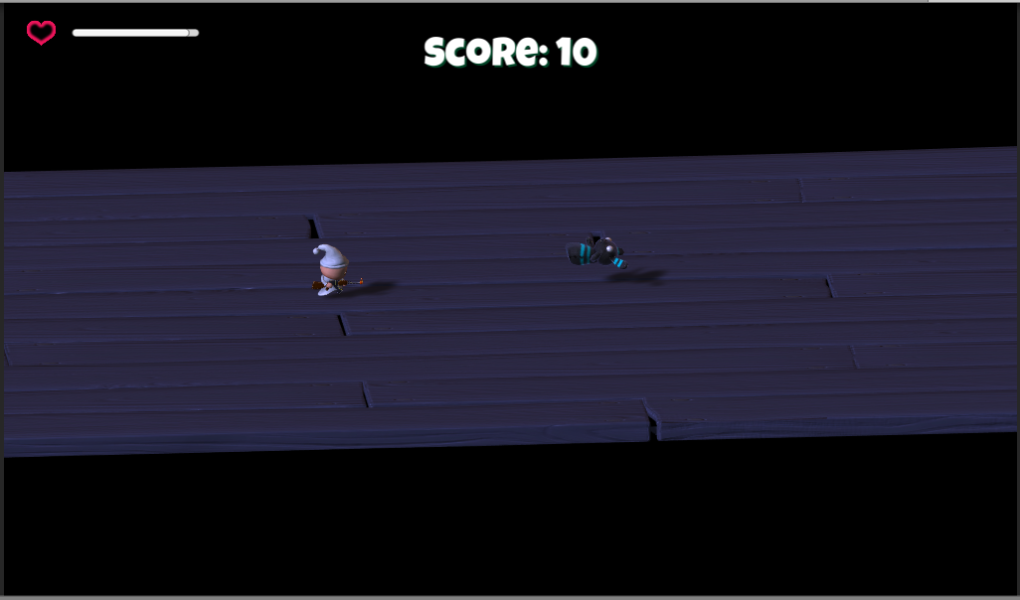

Gameplay Scene:

Game over Scene:

1. **Characters**The main character, the baby is downloaded from Unity’s Asset Store (“Survival Shooter Tutorial”)
2. **Enemies**

The main enemy, the Zombunny is downloaded from Unity’s Asset Store (“Survival Shooter Tutorial”)

1. **Scoring**

The player scores 10 points by killing each enemy, while picking up items on the floor gives him an additional 20 points.

1. **Sound Index**

* “Player Hurt.wav”
  + Survival Shooter (Asset Store Package)
* “Player Death.wav”
  + Survival Shooter (Asset Store Package)
* “Player Gun.wav”
  + Survival Shooter (Asset Store Package)
* “ZomBunny Hurt.wav”
  + Survival Shooter (Asset Store Package)
* “ZomBunny Death.wav”
  + Survival Shooter (Asset Store Package)
* “Backgorund Muscie.mp3”
  + Survival Shooter (Asset Store Package)

1. **Art / Multimedia Index**

* “Zombunny” prefab and material were downloaded under the package *Survival Shooter* (an Asset Store Package)
* “Player” prefab and material were downloaded under the package *Survival Shooter* (an Asset Store Package)
* “Floor” was a small portion that came from the “Environment” prefab under the package *Survival Shooter* (an Asset Store Package)
* “GunParticles” and the “HitParticles” prefabs were downloaded under the package *Survival Shooter* (an Asset Store Package)
* “Zombear” prefab downloaded under the package *Survival Shooter* (an Asset Store Package)