Plant Leaf Disease Detection and Classification Based on CNN with LVQ Algorithm

|  |  |
| --- | --- |
| Abhishek Kumar | Priyanshu Mathur |
| 21EE01051 | 21EC01044 |
| *Indian Institute of Technology, Bhubaneswar* | *Indian Institute of Technology, Bhubaneswar* |
| Odisha, India | Odisha, India |
| 21ee01051@iitbbs.ac.in | 21ec01044@iitbbs.ac.in |

***Abstract—*This paper presents an implementation of a Convolutional Neural Network (CNN) integrated with a Learning Vector Quantization (LVQ) classifier for plant leaf disease detection and classification. The dataset used in this study was manually curated from various publicly available datasets and categorized into five distinct classes: Bacterial Spot, Healthy, Late Blight, Septoria Leaf Spot, and Yellow Leaf Curl Virus. The CNN model has been optimized to match the methodology described in the referenced IEEE paper, ensuring enhanced feature extraction before classification using LVQ. The experimental results demonstrate the efficacy of the proposed approach in classifying plant diseases with high accuracy.**

***Keywords—*CNN, LVQ, Deep Learning, Plant Disease Detection, Image Classification, Feature Extraction**

I. INTRODUCTION

Plant diseases significantly impact agricultural yield and productivity, necessitating the development of automated and reliable detection systems. Traditional methods of disease detection rely on manual inspection, which is time-consuming and prone to human error. Recent advancements in deep learning provide robust solutions for plant disease classification using convolutional neural networks (CNNs). CNNs are particularly effective in image-based classification tasks due to their ability to automatically learn hierarchical feature representations.

While alternative deep learning models such as Vision Transformers (ViTs) and Capsule Networks exist, CNNs remain the preferred choice for plant disease classification due to their efficiency, lower computational requirements, and established performance in image recognition. Furthermore, the integration of Learning Vector Quantization (LVQ) as the classifier provides a competitive edge by refining decision boundaries and improving classification robustness, particularly for high-dimensional datasets such as plant leaf images.

II. DATASET PREPARATION AND PREPROCESSING

The dataset used for this implementation was personally curated by integrating images from multiple online sources. The images were organized into five classes, each represented by a folder: *Bacterial Spot, Healthy, Late Blight, Septoria Leaf Spot,* and *Yellow Leaf Curl Virus*. The dataset was pre-processed using the following steps:

* **Image Resizing:** Each image was resized to a fixed dimension (128x128) to ensure uniformity and compatibility with the CNN model. Maintaining a consistent input size allows the network to learn features effectively across all samples.
* **Normalization:** The pixel values were scaled to a range between 0 and 1, ensuring stable training dynamics and preventing issues related to varying lighting conditions in images.
* **Label Encoding:** The categorical labels were transformed into numerical representations, facilitating smooth processing within the deep learning framework.
* **Data Splitting:** The dataset was divided into training and testing subsets, typically in an 80-20 ratio, ensuring that the model generalizes well without overfitting.

These preprocessing steps play a crucial role in enhancing the model’s ability to learn patterns effectively, reducing noise, and improving classification performance.

III. CNN ARCHITECTURE AND FEATURE EXTRACTION

The CNN architecture used in this study was specifically designed to align with the methodology outlined in the referenced research paper. The model consists of multiple convolutional layers, each followed by a max-pooling operation to downsample the feature maps and reduce computational complexity. The key design choices for the CNN architecture include:

A. *Convolutional Layer*

The convolutional layer is the fundamental building block of CNNs. It performs a series of mathematical operations to extract spatial features from input images. A filter slides over the input, computing dot products between filter values and corresponding pixel values. This operation generates feature maps, capturing essential patterns such as edges and textures. In this study, four convolutional layers were employed, progressively extracting higher-level features using different filter sizes (9x9 and 5x5) to balance spatial structure recognition and fine-grained detail extraction.

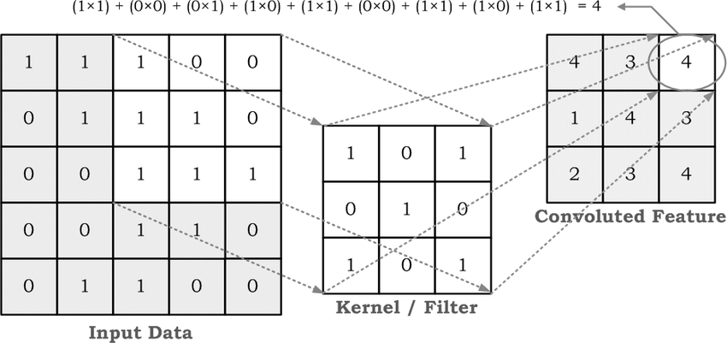

Fig. Convolution on a 5x5 image with a 3x3 filter

B. *Pooling Layer*

Pooling layers are used to downsample feature maps, reducing dimensionality while preserving critical information. This study applies max pooling with a 2x2 window, selecting the maximum value in each subregion. Max pooling enhances computational efficiency and reduces sensitivity to image translations and distortions, making the network more robust to variations in input images.

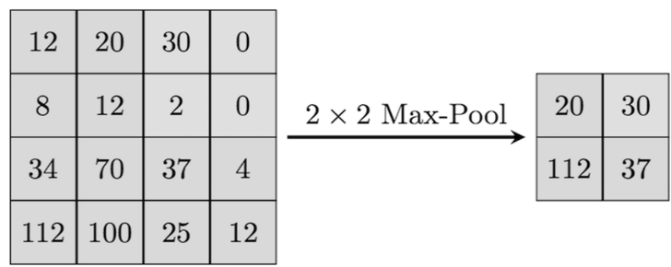

Fig. Max pooling with 2x2 filters

C. *Activation Layer*

Activation functions introduce non-linearity into the network, enabling it to learn complex patterns. The Rectified Linear Unit (ReLU) activation function was used in all convolutional layers due to its efficiency in mitigating vanishing gradient problems. ReLU sets all negative values to zero while retaining positive values, accelerating convergence during training and improving overall model performance.

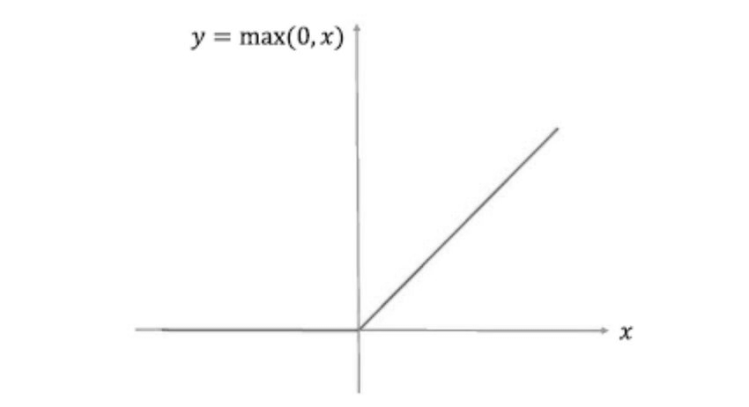

Fig. ReLU Activation Function

D. *Fully Connected Layer*

After convolution and pooling operations, the feature maps are flattened into a single vector and passed through fully connected layers. This stage transforms spatially structured features into class-specific representations. A dense layer with 128 neurons refines extracted features before classification. Additionally, dropout regularization (50%) is applied to mitigate overfitting, ensuring the model generalizes well to unseen data.

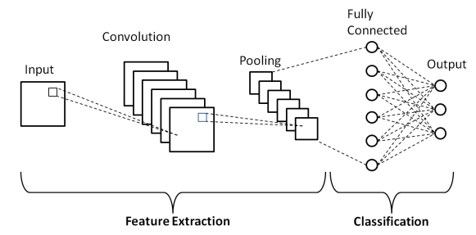

Fig. A general CNN Architecture

After feature extraction, the learned feature maps were passed to the LVQ classifier for final disease classification.

IV. LEARNING VECTOR QUANTIZATION (LVQ)

The choice of LVQ as the classifier was motivated by its effectiveness in high-dimensional feature spaces, particularly for structured datasets such as image classification. Unlike conventional softmax classifiers, which rely on probabilistic decision-making, LVQ operates based on prototype learning, adjusting representative vectors iteratively to optimize decision boundaries. The advantages of LVQ include:

* **Robust Classification in High-Dimensional Spaces:** CNN-extracted features are inherently complex, making prototype-based learning more effective in distinguishing subtle differences between similar classes.
* **Ability to Handle Non-Linearly Separable Data:** LVQ iteratively adjusts prototypes, ensuring better adaptability compared to traditional classifiers like Support Vector Machines (SVMs) and k-Nearest Neighbors (k-NN).
* **Efficient Learning with Small Training Samples:** LVQ is known for its ability to generalize well even with a relatively small number of training samples, making it ideal for datasets with limited labelled data.

The LVQ classifier was trained using an adaptive learning rate, ensuring that prototype vectors converged optimally for improved classification accuracy.

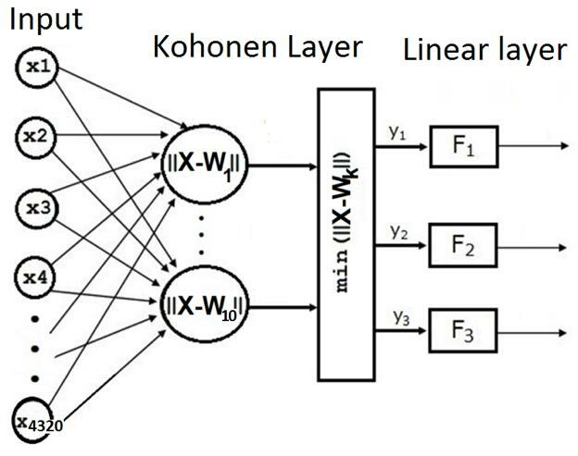

Fig. The LVQ architecture

V. THE PROPOSED METHOD

This study used 80% training and 20% test images from the “PlantVillage Tomato leaf” dataset, resized to 128x128 pixels. The new dataset made from this included five classes: *Bacterial Spot, Late Blight, Septoria Leaf Spot, Yellow Leaf Curl Virus,* and *Healthy Leaves.* The CNN model was designed to extract features efficiently, followed by LVQ classification.

Each disease class exhibits distinct characteristics:

* **Bacterial Spot:** Symptoms include small yellow-green or dark water-soaked lesions on leaves. This disease spreads rapidly and is difficult to control, making it highly destructive.
* **Late Blight:** This appears as large brown spots with green-gray edges on older leaves. As it progresses, the spots darken, eventually leading to widespread infection.
* **Septoria Leaf Spot:** This begins in the lower leaves as small, round, water-soaked spots that turn brown or black. The spot size varies between 1.5 mm and 6.5 mm.
* **Yellow Leaf Curl:** This disease causes stunted plant growth. Leaves roll inwards, become stiff, thick, and leathery, and turn yellowish.
* **Healthy Leaves:** Healthy tomato leaves exhibit a vibrant green color with no signs of lesions, spots, or discoloration. They have a uniform texture, free from curling, wilting, or deformities, which is crucial for the plant’s photosynthesis and overall growth.

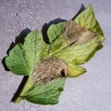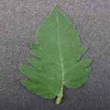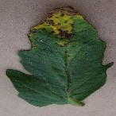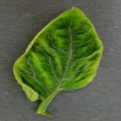

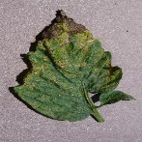(a) (b) (c)

(d) (e)

Fig. (a) Healthy Leaf (b) Bacterial Spot (c) Late Blight (d) Septoria Leaf Spot (e) Yellow Leaf Curl

The key reason for choosing CNN over other architectures was its superior spatial feature extraction capability, while LVQ was chosen due to its prototype-based learning approach, which enhances classification performance by refining decision boundaries.

Three input matrices were generated for R, G, and B channels, each processed through four convolutional layers using ReLU activation. Max pooling was applied three times to downsample features. The extracted features were then flattened and passed to LVQ for classification. The model was trained with an adaptive learning rate and optimized parameters to achieve high classification accuracy.

VI. RESULTS AND EVALUATION

The model’s performance was assessed using several evaluation metrics, including:

* **Accuracy:** The overall percentage of correctly classified images.
* **Confusion Matrix Analysis:** The confusion matrix helped visualize misclassifications, indicating which disease classes were more challenging to differentiate.

The proposed CNN-LVQ model was evaluated using accuracy and loss metrics. The confusion matrices for both the training and test sets illustrate the model’s classification performance. The final model achieved an accuracy of **95.49%**, indicating high reliability in disease detection and classification, with minimal confusion between disease categories. In particular, diseases with distinct visual characteristics (e.g., *Yellow Leaf Curl Virus*) were classified with near-perfect accuracy, whereas visually similar diseases (*Bacterial Spot* and *Septoria Leaf Spot*) exhibited slightly lower performance.

Here is the confusion matrix for the testing dataset, illustrating the model’s classification effectiveness:

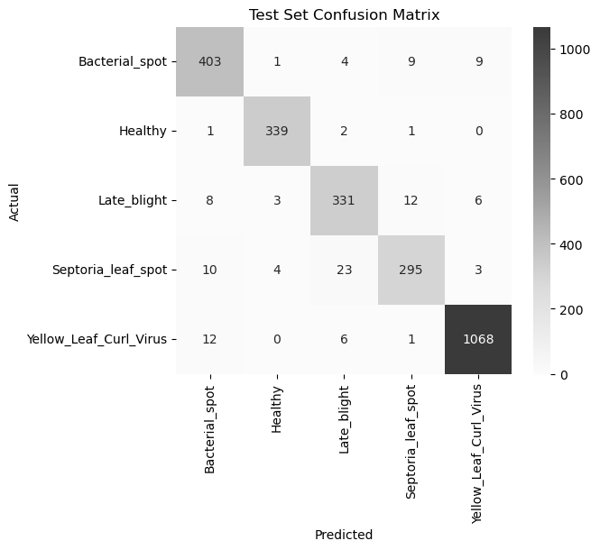

Fig. The Test Set Confusion Matrix

VII. CONCLUSION

This paper presented an optimized CNN architecture integrated with LVQ for plant leaf disease detection. The combination of deep feature extraction with CNN and classification using LVQ demonstrated significant accuracy in identifying plant diseases. The main advantages of the approach include:

* **Strong Feature Learning Ability:** CNN efficiently extracts relevant features from plant leaf images, improving classification performance.
* **Robust Classification Mechanism:** LVQ refines classification boundaries, ensuring better distinction between similar disease categories.
* **Scalability:** The model can be extended to classify additional plant diseases with minimal modifications.

The study highlights the potential of deep learning and competitive learning models in agricultural applications, providing an automated solution for plant disease identification.

VIII. REFERENCES

1. M. Sardogan, A. Tuncer, and Y. Ozen, ‘‘Plant leaf disease detection and classification based on CNN with LVQ algorithm,’’ in Proc. 3rd Int. Conf. Comput. Sci. Eng. (UBMK), Sep. 2018, pp. 382–385
2. PlantVillage Tomato Leaf Dataset (Kaggle)