|  |
| --- |
| **4COSC006C: Software Development I - APPENDIX 1 – TEST PLANS** Student Name/ID: Diadri Weerasekera/20210381(IIT)_18671238(UoW)  Seminar Day/Time: Module Tutor: Mr. Torin Wirasinghe |

|  |  |  |  |  |
| --- | --- | --- | --- | --- |
| Student Name: Student ID: | | | | |
| TEST PLAN for Part 1  Submit completed test plan with your code solution | | | | |
| Test  No. | Test Input | Expected Result | Actual Result  (or state ‘not attempted’) | Pass / Fail  (‘Actual Result’ matches ‘Expected Result = Pass’) |
| 1 | Pass = 120  Defer = 0  Fail = 0 | ‘Progress’ is displayed | Progress | Pass |
| 2 | Pass = 100  Defer = 20  Fail = 0 | ‘Progress (module trailer)’ displayed | Progress (module trailer) | Pass |
| 3 | Pass = 100  Defer = 0  Fail = 20 | ‘Progress (module trailer)’ displayed | Progress (module trailer) | Pass |
| 4 | Pass = 80  Defer = 20  Fail = 20 | ‘Module retriever’ is displayed | Module retriever | Pass |
| 5 | Pass = 60  Defer = 40  Fail = 20 | ‘Module retriever’ is displayed | Module retriever | Pass |
| 6 | Pass = 40  Defer = 40  Fail = 40 | ‘Module retriever’ is displayed | Module retriever | Pass |
| 7 | Pass = 20  Defer = 40  Fail = 60 | ‘Module retriever’ is displayed | Module retriever | Pass |
| 8 | Pass = 20  Defer = 20  Fail = 80 | ‘Exclude’ displayed | Exclude | Pass |
| 9 | Pass = 20  Defer = 0  Fail = 100 | ‘Exclude’ displayed | Exclude | Pass |
| 10 | Pass = 0  Defer = 0  Fail = 120 | ‘Exclude’ displayed | Exclude | Pass |
| Validation | | | | |
| 11 | Pass = a | ‘Integer required’ displayed | Integer required | Pass |
| 12 | Pass = 5 | ‘Out of range’ displayed | Out of range | Pass |
| 13 | Pass = 100  Defer = 40  Fail = 0 | ‘Total incorrect’ displayed | Total incorrect | Pass |
| Displaying Histogram | | | | |
| 14 | Program loops | Predicts multiple progression outcomes | Multiple progression outcomes are predicted | Pass |
| 15 | Enter ‘q’ to quit | Exits loop | Exists loop when ‘q’ is entered | Pass |
| 16 | Exit loop | Progress 1 : *  Trailer 2 : **  Retriever 4 : ****  Excluded 1 : *  8 outcomes in total. | Progress 1 : *  Trailer 2 : **  Retriever 4 : ****  Excluded 1 : *  8 outcomes in total | Pass |

|  |  |  |  |  |
| --- | --- | --- | --- | --- |
| TEST PLAN for Part 2, 3 and 4 | | | Actual Result  (or state ‘not attempted’) | Pass/Fail |
| 17 | Vertical Histogram | Progress 1 | Trailer 2 | Retriever 4 | Exclude 1  * * * *  * *  *  *  8 outcomes in total. | Progress 1 Trailer 2 Retriever 4 Excluded 1  * * * *  * *  *  * | Pass |
| 18 | Solution uses list, tuple or dictionary | Output uses data stored to and retrieved from list, tuple or dictionary | Progress - 120 0 0  Progress (Module trailer) - 100 0 20  Progress (Module trailer) - 100 20 0  Module retriever - 80 20 20  Module retriever - 60 0 60  Module retriever - 40 40 40  Module retriever - 20 40 60  Exclude - 40 0 80 | Pass |
| 19 | Solution uses text file | Output uses data stored to and retrieved from text file | Progress -120,0,0  Progress (Module trailer) -100,0,20  Progress (Module trailer) -100,20,0  Module retriever -80,20,20  Module retriever -60,0,60  Module retriever -40,40,40  Module retriever -20,40,60  Exclude -40,0,80 | Pass |

** Please see attached below the solutions for parts 1,2,3 and 4.

Solution for input progression and input validation

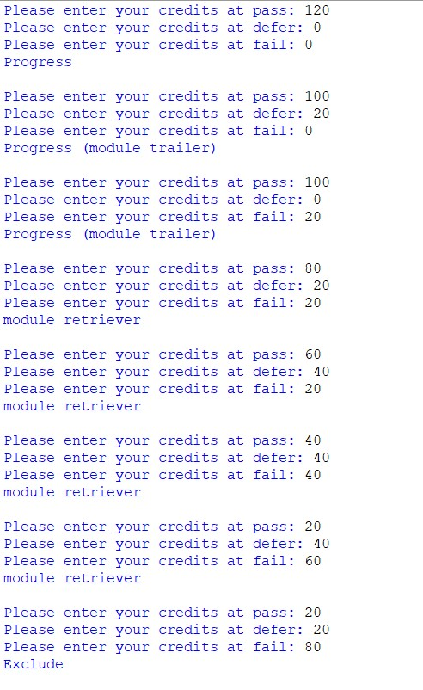

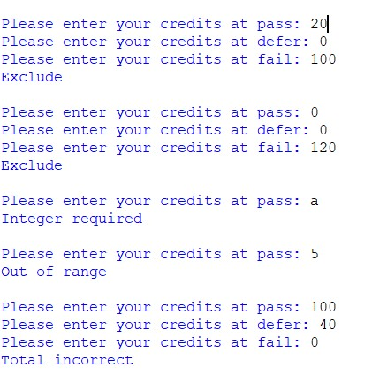

Predicting multiple input progressions solution

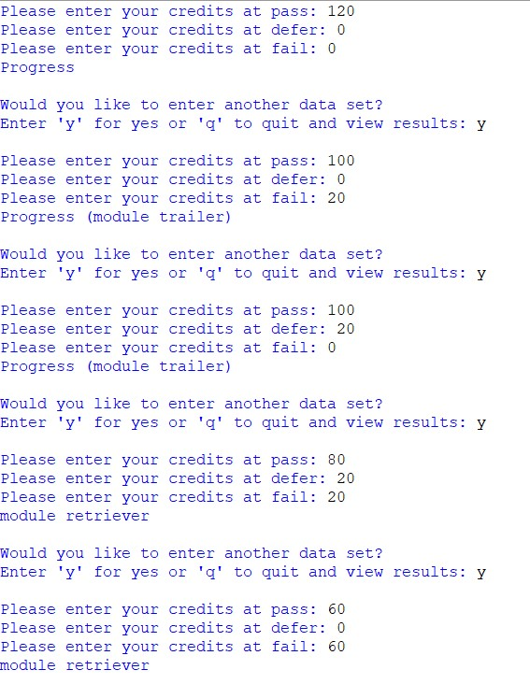

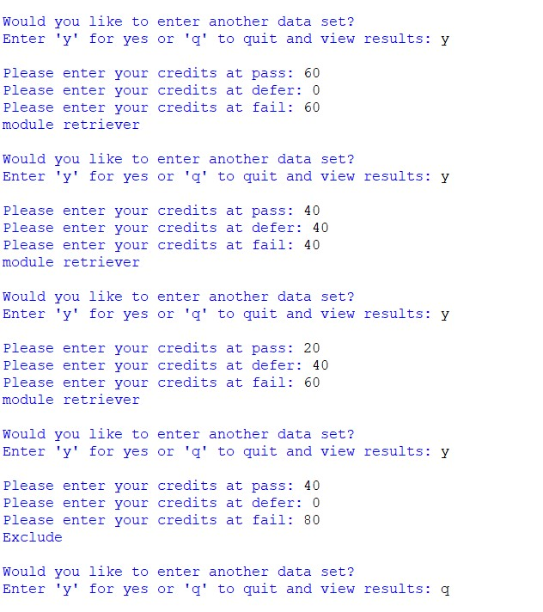

Displaying horizontal histogram – solution

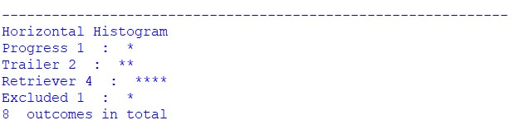

Displaying vertical histogram – solution

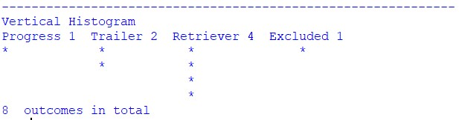

Displaying input progression into list/tuple/directory

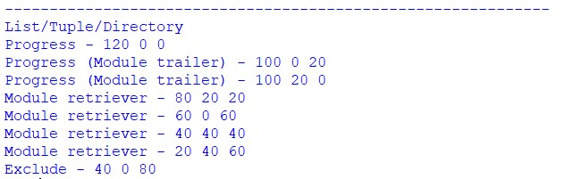

Displaying input progressions which are stored in a text file

