Title: Good and bad programming practices

Author: João Miguel Abrantes Dias

Date: 20/05/2020

**Index**

Introductory Note: 2

1. Summary / Abstract 2

2. Framework 2

3. Section 3 3

4. Section 4 3

4.1 Sub-Section X 3

4.2 Sub-Section Y 3

5. Conclusions 3

6. References 4

6.1 References (basic process – not recommended) 4

6.2 References (recommended) 5

Apendix 1. A Simple Proof for 2+ 2=4 6

**Introductory Note:**

The objective with this essay is to explore other concepts that were not lectured in the PDS class. The class mainly focused on design patterns but there are a lot of good practices that did not belong to the curricular plan. That said a lot of bad practices are made every day by people new to programming, some of those mistakes are fairly common, so, we are going to check some of them further ahead.

**Code Smells**

Let us start by analyzing the bad practices, also know as **code smells**. In the computer science field, a code smell is any type of characteristic in the code of a program that indicates that a deeper problem exists. They usually indicate some sort of violation of fundamental design principles and negatively impact the design quality. There are several types of **code smells**, but they usually are inside of one of the following categories.

**Bloaters:** Code, classes and/or classes that have increased in size to the point where it is very hard to work with. Usually these go unnoticed for quite sometime and over time the accumulation starts to occur. This accumulation can occur in method where we keep adding features to it until it gets too complex, it can occur in it’s own parameter list, we saw in “*TopicA”* about how using the Builder pattern we can avoid that in our constructors. Just like in the methods, it can happen in the class itself where we add a complex feature instead of just creating a separate class for that feature. It can also happen when creating a lot of primitive fields instead of creating a new class.

**Object-Orientation Abusers:** Characterized by the misusing object-oriented programming principles. Let us see some examples: The programmer created a class whose function was already able to be fulfilled by another one. The subclass uses little to no methods inherited from its parents. The use of complex switch operators or a long sequence of if statements usually means that a class using the Extract method could have been created instead. The same solution can also be applied to temporary fields.

**Change Preventers:** The program classes are not vey decoupled so a change in one place of the code means that changes need to also be made in other parts of the code too. For example: having to change unrelated methods of a class just because one of the methods was changed. Making any sort of modification will lead to very small changes needed to be made to different classes. When a subclass is created, another subclass needs to be also created for a different class.

<https://apiumhub.com/tech-blog-barcelona/code-smells/>

**Dispensables:** <https://sourcemaking.com/refactoring/smells/dispensables>

**Couplers:** <https://sourcemaking.com/refactoring/smells/couplers>

Antipatterns: <https://sourcemaking.com/antipatterns>  
 <https://en.wikipedia.org/wiki/Anti-pattern>

Good code practices: <https://code.tutsplus.com/tutorials/top-15-best-practices-for-writing-super-readable-code--net-8118>

Good and bad code practices: <https://www.cio.com/article/2448952/10-bad-coding-practices-that-wreck-software-development-projects.html>

# Summary / Abstract

This document addresses the problem XXXX …..,

Previous work on the subject is surveyed and an outline of the current state of the art is presented.

Several possible solutions are identified and evaluated. Solution YYYY is proposed and evaluated leading the following results: ….

…

…

# Framework

Over the last decades the area of XPTO… has registered striding developments [1], [2]……

…

The current offer of technologies and services is [3]

…

Several issues subsist, however, that … [4], [5],…

…

In accordance with the following citation[6]:

“..

A utilização de fibra óptica nas redes de acesso é um tema de grande importância no momento actual. Após várias décadas de desenvolvimento da tecnologia optoelectrónica e de várias vezes no passado ter sido anunciado para breve o advento da utilização generalizada da fibra óptica nas redes de acesso, o momento actual parece ser aquele em que, finalmente, esta visão se torna uma realidade. A esta circunstância não será certamente alheia a circunstância de, nos últimos anos se ter assistido a uma intensificação do uso dos serviços telemáticos (com particular destaque para os serviços suportados pelo protocolo IP tais como o acesso à Web, e o IPTV) e a sua crescente incorporação nos hábitos de vida das pessoas e nos processos de trabalho das organizações. Daqui decorrem volumes de informação cada vez maiores e uma maior predisposição para a utilização significativa dos rendimentos disponíveis das pessoas e das organizações na compra de serviços telemáticos. Todos estes factores fizeram com que os elevados factores de incerteza que ao longo da última década retardaram a generalização da fibra óptica nas redes de acesso se tenham reduzido consideravelmente parecendo ser hoje uma aposta relativamente segura investir na sua utilização. Várias questões subsistem, no entanto, que necessitam de estudo e reflexão.

…”

Sic “Fibra Óptica nas Redes de Acesso”, Manuel de Oliveira Duarte, Documento de Trabalho, Universidade de Aveiro, 27 de Julho de 2009 [6]

# Section 3

In Annex 1: A Simple Proof for 2+ 2=4 it is proved that:

|  |  |
| --- | --- |
| $$2+2=4$$ | Equation 1 |

This is a particular case of the more general result:

|  |  |
| --- | --- |
| $$n+n=2n$$ | Equation 2 |

Then….

As proved in Xxxxxx [7]

And finally…

# Section 4

Xxxxx

## Sub-Section X

Xxx

## Sub-Section Y

# Conclusions

From what has been presented in this document it can be concluded that …

…problem XXXX can be solved using technique / method / algorithm YYYY.

…the application of technique / method / algorithm YYYY to problems of type XXXX provides a close approximation / a bound / an estimate on the value of ZZZZ.

…

…

…

It still remains to do this and that,… so and so, etc.

# References

The following 2 referencing functionalities of Word can be used but the 2nd is the recommended:

## References (basic process – not recommended)

Insert reference:

[1]

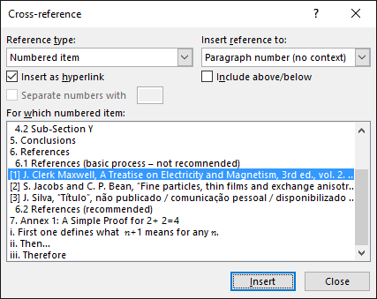

1. J. Clerk Maxwell, A Treatise on Electricity and Magnetism, 3rd ed., vol. 2. Oxford: Clarendon, 1892, pp.68–73.
2. S. Jacobs and C. P. Bean, “Fine particles, thin films and exchange anisotropy,” in Magnetism, vol. III, G. T. Rado and H. Suhl, Eds. New York: Academic, 1963, pp. 271–350.
3. J. Silva, “Título”, não publicado / comunicação pessoal / disponibilizado em ??/??/????

.

## References (recommended)

|  |  |
| --- | --- |
| [1] | J. C. Maxwell, A Treatise on Electricity and Magnetism, Oxford: Clarendon Press, 1892. |
| [2] | A. de Nomeada_1 e A. de Nomeada_2, “A importância das coisas importantes,” *Revista de Ciências e Artes,* vol. 5, nº 1, pp. 3-13, 2015. |
| [3] | J. M. Silva, *"On Sums and Subtractions",* Aveiro: Unpublished, 2010. |
| [4] | F. Parreño et ali, “A maximal-space algorithm for the container loading problem,” [Online]. Available: http://www.uv.es/sestio/TechRep/tr03-07.pdf. [Acedido em 7 9 2015]. |
| [5] | F. Parreño, R. Alvarez-Valdes, J. Tamarit e J. Oliveira, “A Maximal-Space Algorithm for the Container Loading Problem,” *INFORMS Journal on Computing,* vol. 20, nº 3, pp. 412-422, 2008. |
| [6] | A. M. de Oliveira Duarte, “Fibra Óptica nas Redes de Acesso,” DETI-UA, Aveiro, 2007. |
| [7] | “Creating a new transport system - An ADtranz case study,” ADtranz, [Online]. Available: http://businesscasestudies.co.uk/adtranz/creating-a-new-transport-system/introduction.html#axzz3l4IN0l1z. [Acedido em 7 9 2015]. |

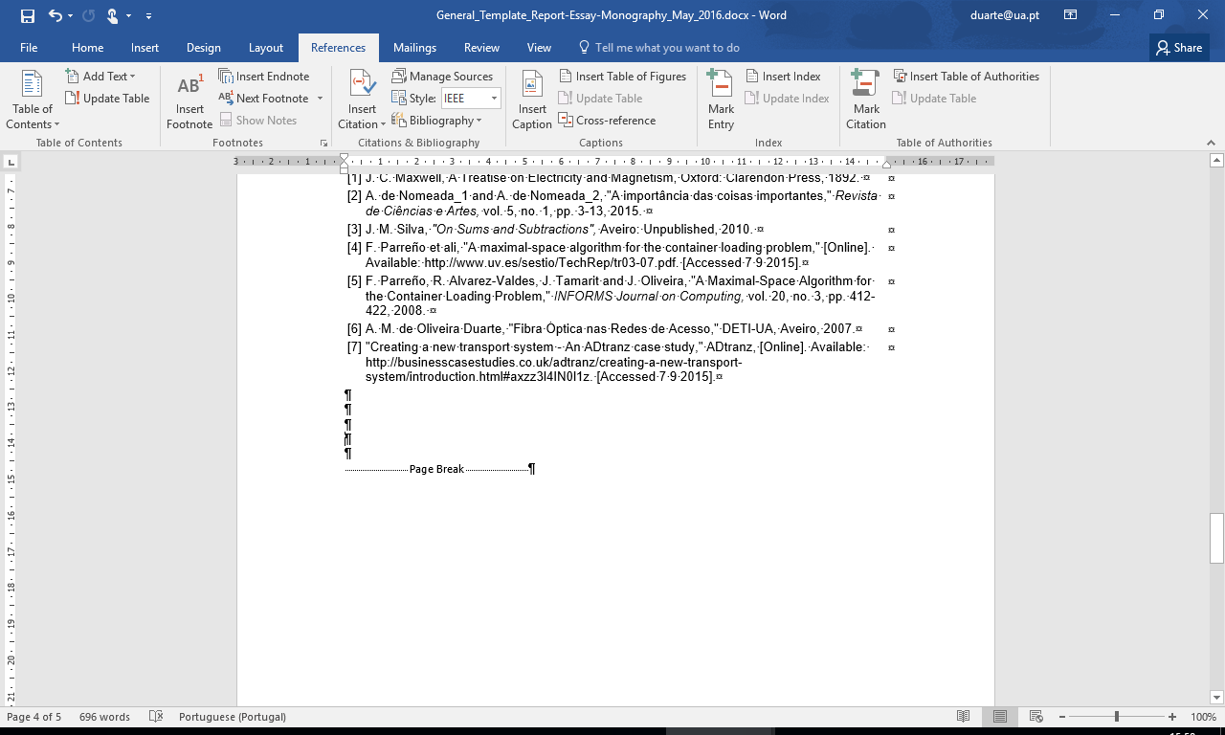



This process requires that a reference list of sources is built with the Bibliography tool of Word. This list can be reutilized by all Word documents hosted in the user computer.

1. A Simple Proof for 2+ 2=4

In Section 3 it was stated that

$$2+2=4$$

Here a simple proof for this unexpected result is provided as follows:

1. First one defines what $n+1$ means for any $n$.
2. Then…
3. Therefore
$4=(3+1)=((2+1)+1)=(2+(1+1)=2+2$

4. q.e.d.