**DIAL D4D Design Document**

**Version – 0.1**

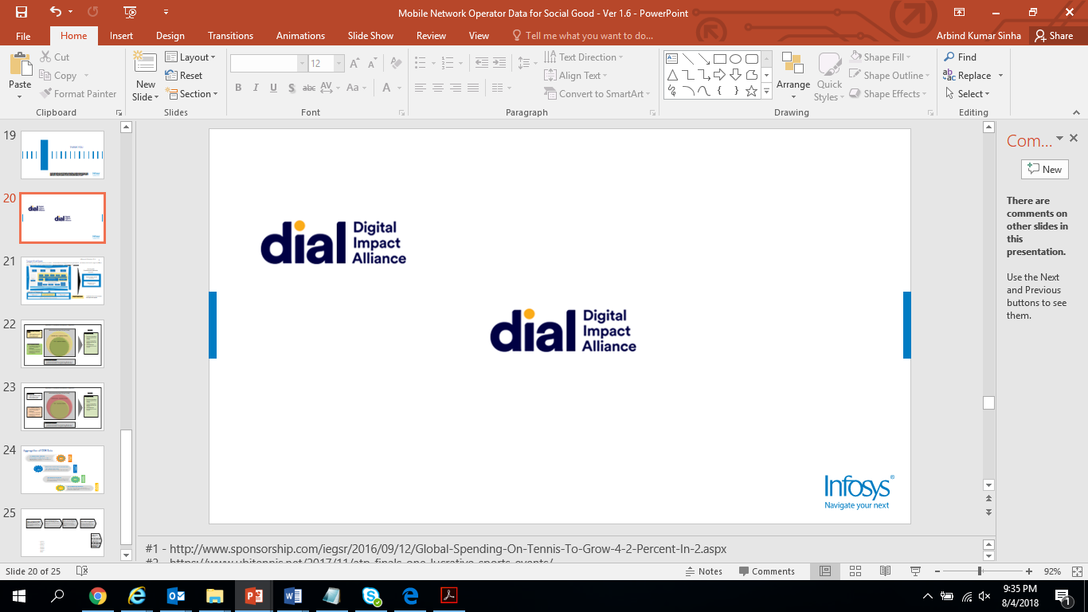

Table of Content

**DIAL D4D Design Document** 1

Introduction 3

High Level Data Flow 3

Data Flow Architecture 4

Data Ingestion 4

Malawi server to Azure BLOB 4

Azure BLOB to ADL 5

Azure ADL to Hive 5

Hive Database 8

Hive Tables 8

Reference Documents 13

# Introduction

This document covers details of the data model required for Malawi use case execution. This document will also provide details of the tables required and it’s loading logics

## High Level Data Flow

* Data from various sources will be transferred to a central repository in Malawi.
* From the central repository data will be then copied to identified Cloud Services Azure.
* Data processing and analytics will be performed on Azure Cloud
* Only the results will be published to the outside world.

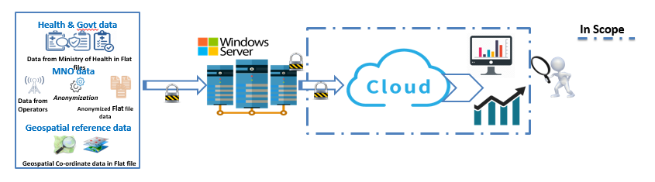

## Data Flow Architecture

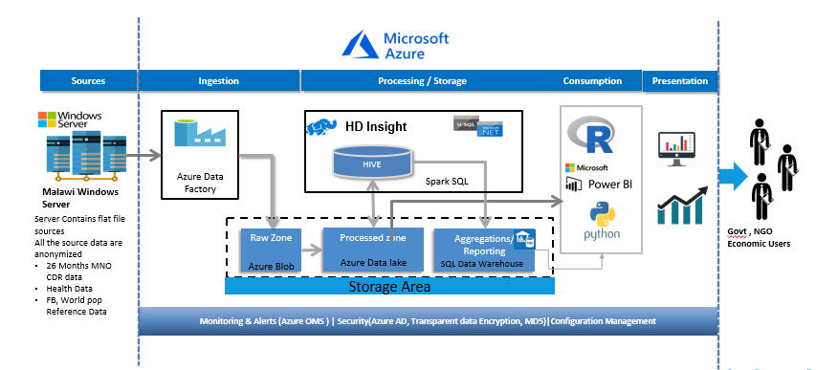

# Data Ingestion

The document should cover from Ingestion (Malawi server to Blob to ADL to Hive)

## Malawi server to Azure BLOB

The Source Data from Malawi Windows server will be transferred to Azure Blob storage.

Below is the two-step process involved.

* 1. Secured Virtual Network will be established to connect the cloud.
  2. Azure data factory will be used as a data pipeline to fetch the data from Malawi server to Azure Blob storage.

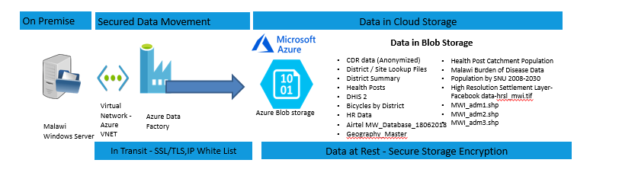

## Azure BLOB to ADL

1. Install adlcopy in your local machine.
2. In Powershell go the adlcopy location and execute below command.

Example:

./AdlCopy /source <https://nfosysalawidiag.blob.core.windows.net/mnodataanonymized/June_2017_done/> /dest swebhdfs://dialmalawi.azuredatalakestore.net/clusters/DIALMalawi/**mno_raw_data_anon**/ /sourcekey f9kSAy+LE1uWp4aaw0zwInludhyHvWzX8cTxzOX6MlTKnTlWBkMqvLV0UZU0cDSR2/YIOEKywTTMAQNIUC07Jg==

Green highlighted – Source file or folder name

Yellow highlighter – Target ADL directory.

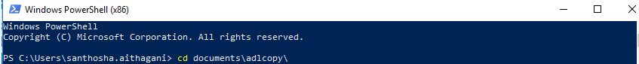

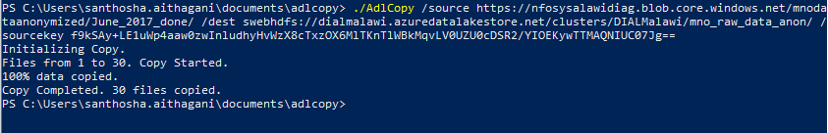

## Azure ADL to Hive

Create an external table pointing to the ADL location.

Example:

CREATE EXTERNAL TABLE IF NOT EXISTS **mno_raw_data_anon**(

    USAGE_TYPE_NAME STRING

    ,CALL_ORIGINATING_NUMBER STRING

    ,CALL_TERMINATING_NUMBER STRING

    ,CALL_START_DATE STRING

    ,CALL_START_TIME STRING

    ,Duration String

    ,LAC_ID STRING

    ,CELL_ID STRING)

    COMMENT 'Test data'

    ROW FORMAT DELIMITED

    FIELDS TERMINATED BY ','

    STORED AS TEXTFILE

    location 'adl://dialmalawi.azuredatalakestore.net/clusters/DIALMalawi/**mno_raw_data_anon** ';

**Identify Active subscribers:**

Identify active and inactive numbers from the aggregated set.

* Inactive number: - If the number is not used for 3 months consecutively, mark that number as inactive.
* From home_location_monthly table, flag the number which are identified as inactive.
* Script Location: /home/dialssh/dev/active_inactive_dev/active_users.sql

**Identify home_location:**

Home_location_day and home_location_month tables have multilple cell_id’s mapped to single originating number for a particular day and month respectively.

* Load the home_location_day table with most used cell_id for a particular day  and the latest cell_id used when there is tie in count.
* Load the home_location_month table likewise from home_location_day.

The no_of_unique_id column in mno_daily_agg should be calculated from home_location_day table. Likewise for mno_monthly_agg from home_location_monthhly.

* Script Location: /home/dialssh/dev/agg_on_MNO_FULL_DATA/10_homelocation_day.sql

**Filter for 7pm - 7am records:**

Filtered table with data from 7 pm to 7 am and do aggregation on top of this table.

* Script Location for filtering night records: /home/dialssh/dev/mno_NIGHT/mno_cdr_active_7pm_to_7am.sql
* Script location for aggregation on top of night records: /home/dialssh/dev/agg_on_MNO_FULL_DATA

**Prepare source tables:**

**Morning hours**: Filter table with data from 7am to 7 pm

* Script Location: /home/dialssh/dev/mno_MORNING/mno_7am_7pm.sql

**Rainy season:** Filter table with data from November to April

* Script Location: /home/dialssh/dev/MNO_NIGHT_seasons/MNO_NIGHT_RAINY_SEASON.sql

**non-rainy:** Filter table with data from May to October

* Script Location: /home/dialssh/dev/MNO_NIGHT_seasons/MNO_NIGHT_NON_RAINY_SEASON.sql

**weekend:** Filter table for weekends

* Script Location: /home/dialssh/dev/MNO_NIGHT_seasons/MNO_NIGHT_WEEKEND.sql

**weekday:** Filter table for weekdays

* Script Location: /home/dialssh/dev/MNO_NIGHT_seasons/MNO_NIGHT_WEEKDAY.sql

**Aggregation Rules on top of 5 source tables:** Apply aggregation on all the source tables

* Script Location: /home/dialssh/dev 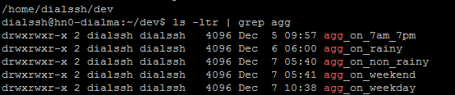

**Long term population movement:**

*Step1 :* Create a new table **homelocation_monthly_TA** by mapping existing 2 tables **homelocation_monthly** and **cell_id_withoutlocation.**

**Script Location:** /home/dialssh/dev/long_term_pop_scripts/homelocation_tables/homelocation_monthly_TA.sql

*Step2:-* Create 2 tables by transforming the above table. Each user to have 1 record with district mapping for each month in one table and TA mapping for each month in another table.

**Script Location:**

/home/dialssh/dev/long_term_pop_scripts/homelocation_tables/user_homelocation_monthly_TA.sql

/home/dialssh/dev/long_term_pop_scripts/homelocation_tables/user_homelocation_monthly_district.sql

**Short term population movement:**

This is to calculate the movement of the people for very short term over a week during the different seasons like rainy, non-rainy and weekend on the day data between 7AM to 9PM for every 2 hours as per the below table.

**Script Location:** /home/dialssh/dev/short_term_pop_scripts

**Steps to calculate the short term population:**

* Get the active user whose is active more than 4 hours per day records from the Main CDR table

Script Location:

/home/dialssh/dev/short_term_pop_scripts/ active_4_hr_bulk.sql

/home/dialssh/dev/short_term_pop_scripts/ active_4_hr_filtered.sql

/home/dialssh/dev/short_term_pop_scripts/ active_4_hr_filtered_part.sql

* Identify the data for short_term_pop_14days:

Script Location: /home/dialssh/dev/short_term_pop_scripts/short_term_pop_14days.sql

* short_term_pop_14days_Timeslot: Partition the table into consecutive 2 hour timeslots

Script Location:

/home/dialssh/dev/short_term_pop_scripts/ short_term_pop_14days_Timeslot.sql

* short_term_lvl1

Script Location: /home/dialssh/dev/short_term_pop_scripts/short_term_lvl1.sql

* short_term_Master

Script Location: /home/dialssh/dev/short_term_pop_scripts/short_term_Master.sql

**Rainy season:**

Table Name: short_term_pop_movement_Rainy_season

Script Location: /home/dialssh/dev/short_term_pop_scripts/short_term_pop_movement_Rainy_season.sql

Column Names:

call_originating_number string   
7amto9am string  
9amto11am string   
11amto13pm string   
13pmto15pm string   
15pmto17pm string   
17pmto19pm string   
19pmto21pm string   
call_start_date date

**Non-Rainy season:**

Table Name: short_term_pop_movement_Non_Rainy_season

Script Location:

/home/dialssh/dev/short_term_pop_scripts/ short_term_pop_movement_Non_Rainy_season.sql

Column Names:

call_originating_number string   
7amto9am string  
9amto11am string   
11amto13pm string   
13pmto15pm string   
15pmto17pm string   
17pmto19pm string   
19pmto21pm string   
call_start_date date

**Weekends:**

Table Name: short_term_pop_movement_Weekend

Script Location:

/home/dialssh/dev/short_term_pop_scripts/ short_term_pop_movement_Weekend.sql

Column Names:

call_originating_number string   
7amto9am string  
9amto11am string   
11amto13pm string   
13pmto15pm string   
15pmto17pm string   
17pmto19pm string   
19pmto21pm string   
call_start_date date

# Hive Database

## Hive Tables

|  |  |  |  |  |  |
| --- | --- | --- | --- | --- | --- |
| **SL No** | **database** | **Table name** | **Field names** | **Description** | **Loading Logic** |
| 1 | etldb | mno_cdr_data_cleansed | usage_type_name string, call_originating_number string, call_terminating_number string, call_start_date string, call_start_time string , duration string, lac_id string, cell_id string | Contains all the CDRs | 1:1 mapping from source |
| 2 | etldb | active_cdr_cleansed | usage_type_name string  call_originating_number string  call_terminating_number string  call_start_date date  call_start_time timestamp  duration string  lac_id string  cell_id string | Contains active records with call_start_time in timestamp format | The call originating numbers which appears on last 3 months are considered as Active Numbers.  Those numbers will be joined with complete MNO data to fetch CDR for the active numbers |
| 3 | etldb | mno_cdr_active_7pm_to_7am | usage_type_name string  call_originating_number string  call_terminating_number string  call_start_date date  call_start_time timestamp  duration string  lac_id string  cell_id string | Active records which are time filtered ( 7PM - 7 AM) | Filtered call_start_time column to have only records from 7pm to 7am |
| 4 | etldb | AGG_DAY_WISE | CALL_ORIGINATING_NUMBER string  CALL_START_DATE date  CELL_ID string  NO_OF_EVENTS int | Day wise aggregation on each subscriber at cell_id level | Day wise cell_id level aggregation done on mno_cdr_active_7pm_to_7am |
| 5 | etldb | AGG_MONTH_WISE | CALL_ORIGINATING_NUMBER string  CALL_MONTH_YEAR string  CELL_ID string  NO_OF_EVENTS int | Month wise aggregation on each subscriber at cell_id level | Month wise cell_id level aggregation done on mno_cdr_active_7pm_to_7am |
| 6 | etldb | HOMELOCATION_DAY | CALL_ORIGINATING_NUMBER string  CALL_START_DATE date  CALL_START_TIME timestamp  CELL_ID string  RANK int | Home location for each number | For each number in a given day , we are deriving the home location, based on cell id. 1. From which tower the 'number' made most number of calls 2. When there is a tie between multiple towers , the tower from where the last call made will be assumed as Home location |
| 7 | etldb | HOMELOCATION_MONTHLY | CALL_ORIGINATING_NUMBER STRING ,CALL_START_DATE DATE ,MONTH_YEAR STRING ,CELL_ID STRING ,RANK INT | Month wise homelocation for each active subscriber | For each number in a given month , we are deriving the home location, based on cell id. 1. From which tower the 'number' made most number of calls 2. When there is a tie between multiple towers , the tower from where the last call made will be assumed as Home location |
| 8 | etldb | MNO_DAILY_AGG_cdr | CELL_ID STRING ,CALL_START_DATE STRING ,NO_OF_EVENTS INT | Day wise count of events at each tower | This table calculates the no of subscribers calling from a particulat tower in a single day. |
| 9 | etldb | MNO_DAILY_AGG_HOME | CELL_ID STRING ,CALL_START_DATE STRING ,NO_OF_UNIQUE_ID INT | Distinct day wise records for each cell_id | This table calculates the distinct records per day at cell_id level from homelocation table. |
| 10 | etldb | MNO_DAILY_AGG | CELL_ID STRING ,CALL_START_DATE STRING ,NO_OF_EVENTS INT ,NO_OF_UNIQUE_ID INT | Day wise aggregstion on cell_id level | This table contains day wie aggregation on cell_id level with no_of_unique records from homelocation table. |
| 11 | etldb | MNO_MONTHLY_HOME | CELL_ID STRING  ,MONTH_YEAR STRING  ,NO_OF_UNIQUE_ID INT | Distinct month wise records for each cell_id | Distict records calculated from homelocation table on cell_id level |
| 12 | etldb | MNO_MONTHLY_CDR | CELL_ID STRING  ,MONTH_YEAR STRING  ,NO_OF_EVENTS INT | Month wise count of events at cell_id level | This table calculates the no of subscribers calling from a particulat tower monthly. |
| 13 | etldb | MNO_MONTHLY_AGG | CELL_ID STRING  ,CALL_MONTH_YEAR STRING  ,NO_OF_EVENTS INT  ,NO_OF_UNIQUE_ID INT | Month wise aggregation on cell_id level with unique records from homelocation table | Month wise aggregation on cell_id level with unique records from homelocation table |
| 14 | etldb | short_term_pop_movement_Rainy_season | call_originating_number string  ,7amto9am string  ,9amto11am string  ,11amto13pm string  ,13pmto15pm string  ,15pmto17pm string  ,17pmto19pm string  ,19pmto21pm string  ,call_start_date date | short term population movement for one week of day data in rainy season on every two hours | short term population movement for one week of day data in rainy season on every two hours |
| 15 | etldb | short_term_pop_movement_Non_Rainy_season | call_originating_number string  ,7amto9am string  ,9amto11am string  ,11amto13pm string  ,13pmto15pm string  ,15pmto17pm string  ,17pmto19pm string  ,19pmto21pm string  ,call_start_date date | short term population movement for one week of day data in Non-rainy season on every two hours | short term population movement for one week of day data in Non-rainy season on every two hours |
| 16 | etldb | short_term_pop_movement_Weekend | call_originating_number string  ,7amto9am string  ,9amto11am string  ,11amto13pm string  ,13pmto15pm string  ,15pmto17pm string  ,17pmto19pm string  ,19pmto21pm string  ,call_start_date date | short term population movement for two week end of day data in rainy and non-rainy season on every two hours | short term population movement for two week end of day data in rainy and non-rainy season on every two hours |
| 17 | etldb | AGG_DAY_WISE_rainy | CALL_ORIGINATING_NUMBER string ,CALL_START_DATE date  ,CELL_ID string ,NO_OF_EVENTS int | Day wise aggregation on each subscriber at cell_id level on rainy season | Day wise cell_id level aggregation done on MNO_NIGHT_RAINY_SEASON |
| 18 | etldb | HOMELOCATION_DAY_rainy | CALL_ORIGINATING_NUMBER string  ,CALL_START_DATE date  ,CALL_START_TIME timestamp  ,CELL_ID string  ,RANK int | Home location for each number on rainy season | For each number in a given day , we are deriving the home location, based on cell id. 1. From which tower the 'number' made most number of calls 2. When there is a tie between multiple towers , the tower from where the last call made will be assumed as Home location |
| 19 | etldb | MNO_DAILY_AGG_rainy | CELL_ID string  ,CALL_START_DATE string  ,NO_OF_EVENTS int  ,NO_OF_UNIQUE_ID int | Day wise aggregstion on cell_id level on rainy season | This table contains day wie aggregation on cell_id level with no_of_unique records from homelocation table. |
| 20 | etldb | AGG_DAY_WISE_non_rainy | CALL_ORIGINATING_NUMBER string ,CALL_START_DATE date  ,CELL_ID string ,NO_OF_EVENTS int | Day wise aggregation on each subscriber at cell_id level on non-rainy season | Day wise cell_id level aggregation done on MNO_NIGHT_NON_RAINY_SEASON |
| 21 | etldb | HOMELOCATION_DAY_non_rainy | CALL_ORIGINATING_NUMBER string  ,CALL_START_DATE date  ,CALL_START_TIME timestamp  ,CELL_ID string  ,RANK int | Home location for each number on non-rainy season | For each number in a given day , we are deriving the home location, based on cell id. 1. From which tower the 'number' made most number of calls 2. When there is a tie between multiple towers , the tower from where the last call made will be assumed as Home location |
| 22 | etldb | MNO_DAILY_AGG_non_rainy | CELL_ID string  ,CALL_START_DATE string  ,NO_OF_EVENTS int  ,NO_OF_UNIQUE_ID int | Day wise aggregstion on cell_id level on non-rainy season | This table contains day wie aggregation on cell_id level with no_of_unique records from homelocation table. |
| 23 | etldb | AGG_DAY_WISE_weekend | CALL_ORIGINATING_NUMBER string ,CALL_START_DATE date  ,CELL_ID string ,NO_OF_EVENTS int | Day wise aggregation on each subscriber at cell_id level on 6week end | Day wise cell_id level aggregation done on MNO_NIGHT_WEEKEND |
| 24 | etldb | HOMELOCATION_DAY_weekend | CALL_ORIGINATING_NUMBER string  ,CALL_START_DATE date  ,CALL_START_TIME timestamp  ,CELL_ID string  ,RANK int | Home location for each number on week end | For each number in a given day , we are deriving the home location, based on cell id. 1. From which tower the 'number' made most number of calls 2. When there is a tie between multiple towers , the tower from where the last call made will be assumed as Home location |
| 25 | etldb | MNO_DAILY_AGG_weekend | CELL_ID string  ,CALL_START_DATE string  ,NO_OF_EVENTS int  ,NO_OF_UNIQUE_ID int | Day wise aggregstion on cell_id level on week end | This table contains day wie aggregation on cell_id level with no_of_unique records from homelocation table. |
| 26 | etldb | AGG_DAY_WISE_weekday | CALL_ORIGINATING_NUMBER string ,CALL_START_DATE date  ,CELL_ID string ,NO_OF_EVENTS int | Day wise aggregation on each subscriber at cell_id level on week day | Day wise cell_id level aggregation done on MNO_NIGHT_WEEKDAY |
| 27 | etldb | HOMELOCATION_DAY_weekday | CALL_ORIGINATING_NUMBER string  ,CALL_START_DATE date  ,CALL_START_TIME timestamp  ,CELL_ID string  ,RANK int | Home location for each number on week end | For each number in a given day , we are deriving the home location, based on cell id. 1. From which tower the 'number' made most number of calls 2. When there is a tie between multiple towers , the tower from where the last call made will be assumed as Home location |
| 28 | etldb | MNO_DAILY_AGG_weekday | CELL_ID string  ,CALL_START_DATE string  ,NO_OF_EVENTS int  ,NO_OF_UNIQUE_ID int | Day wise aggregstion on cell_id level on week end | This table contains day wie aggregation on cell_id level with no_of_unique records from homelocation table. |
| 29 | etldb | AGG_DAY_WISE_7am_7pm | CALL_ORIGINATING_NUMBER string ,CALL_START_DATE date  ,CELL_ID string ,NO_OF_EVENTS int | Day wise aggregation on each subscriber at cell_id level on day data | Day wise cell_id level aggregation done on MNO_7AM_7PM |
| 30 | etldb | HOMELOCATION_DAY_7am_7pm | CALL_ORIGINATING_NUMBER string  ,CALL_START_DATE date  ,CALL_START_TIME timestamp  ,CELL_ID string  ,RANK int | Home location for each number on day data | For each number in a given day , we are deriving the home location, based on cell id. 1. From which tower the 'number' made most number of calls 2. When there is a tie between multiple towers , the tower from where the last call made will be assumed as Home location |
| 31 | etldb | MNO_DAILY_AGG_7am_7pm | CELL_ID string  ,CALL_START_DATE string  ,NO_OF_EVENTS int  ,NO_OF_UNIQUE_ID int | Day wise aggregstion on cell_id level on day data | This table contains day wie aggregation on cell_id level with no_of_unique records from homelocation table. |

# Reference Documents