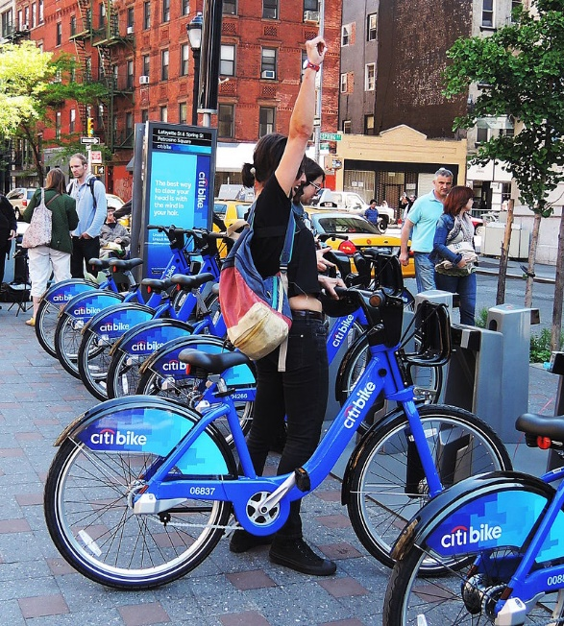According to the visualizations for the data from citibike from Jan to May, 2019 there are certain stations that have the highest 10 for starting and ending trips and lowest 10 for starting and ending trips. I would suggest increasing the number of available bikes for the highest 10 stations from the bikes available from the lowest 10 stations.

Also, as shown from the data the male gender has the highest numbers in using the bikes through that time of the year, taking it from there I would suggest to increase the awareness for the females in riding the bikes that could be done through decreasing the fees for females or making them collect a certain number of miles that they will get discounts from certain places that we can get an agreement with.

**Unexpected phenomena:**

We can also see the percentage increase from Feb to March then there was a slight decrease that can be due to the change from the winter to spring and people really wanted to enjoy the weather, then there was a slight decrease was really unexpected as the weather was getting better.

Also, we can see that the use of bikes from males is more than females by almost 3X but the average distance per trip for female is mostly higher than male for the same age.