DialogInsight Synchronization Plugin

[Download Plugin Registration Tool](https://docs.microsoft.com/en-us/dynamics365/customerengagement/on-premises/developer/download-tools-nuget#download-tools-using-powershell).

Execute PluginRegistration.exe in PluginRegistration folder.

1-Login to Plugin Registration Tool:

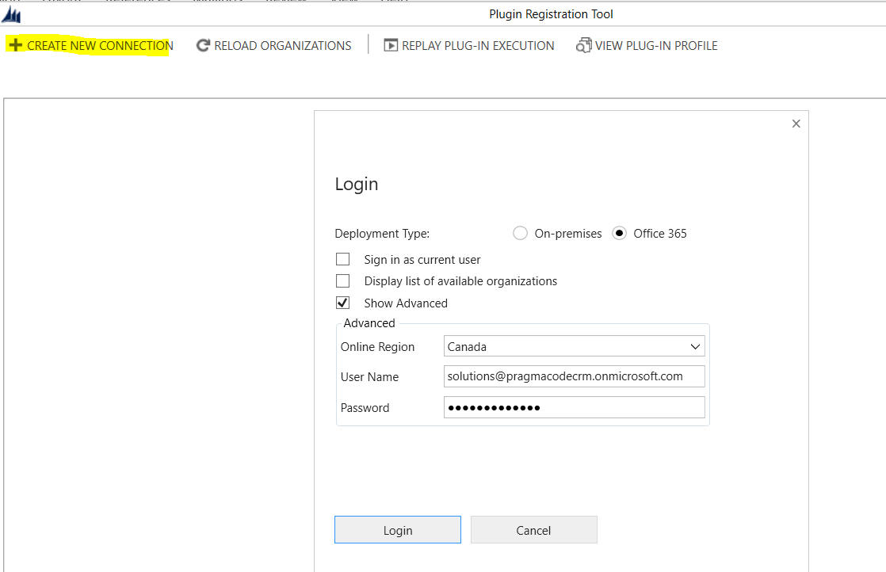

 2-Register Azure Service Bus endpoint:

* 1. 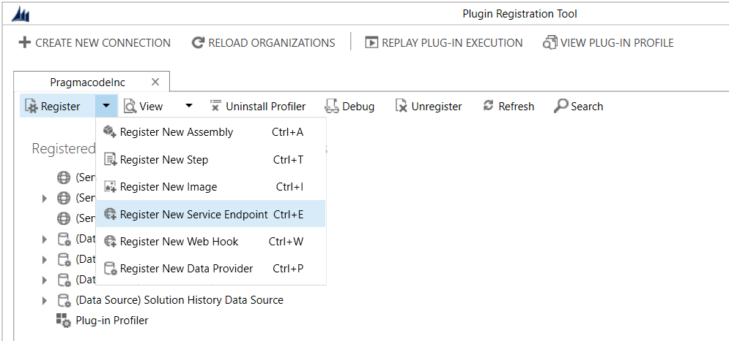

Use provided connection string:

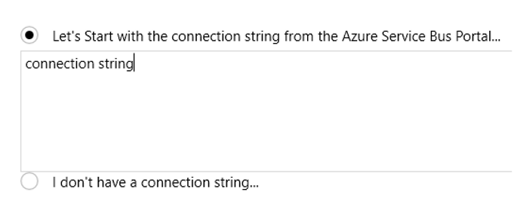

Register **contacts** queue endpoint

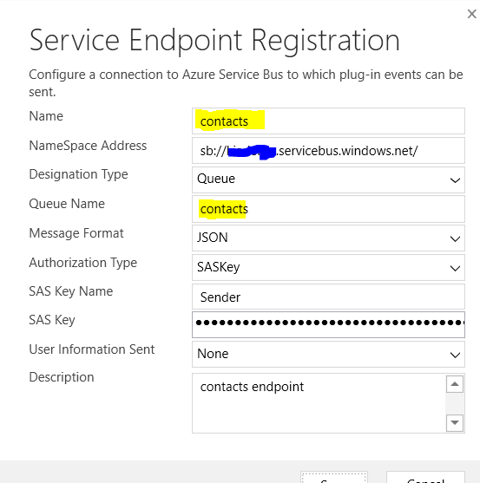

Login to Dynamics 365 and go to [organizationUri]/api/data/v9.0/serviceendpoints?$select=name,description,serviceendpointid



You should get a JSON response that looks like the following:

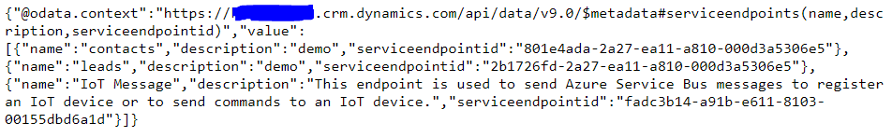

Extract serviceendpointid for contacts endpoint.

3-Register Plugin

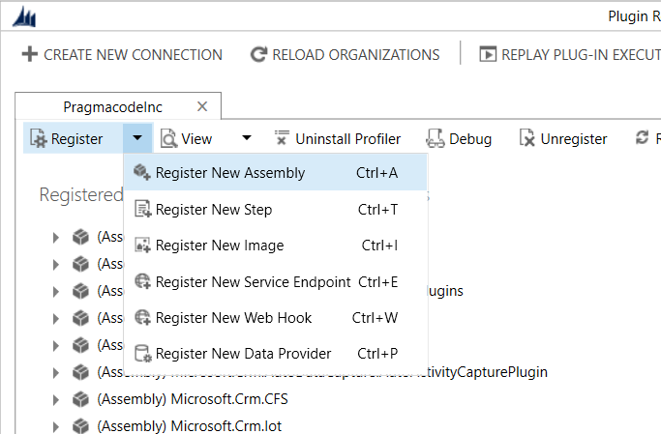

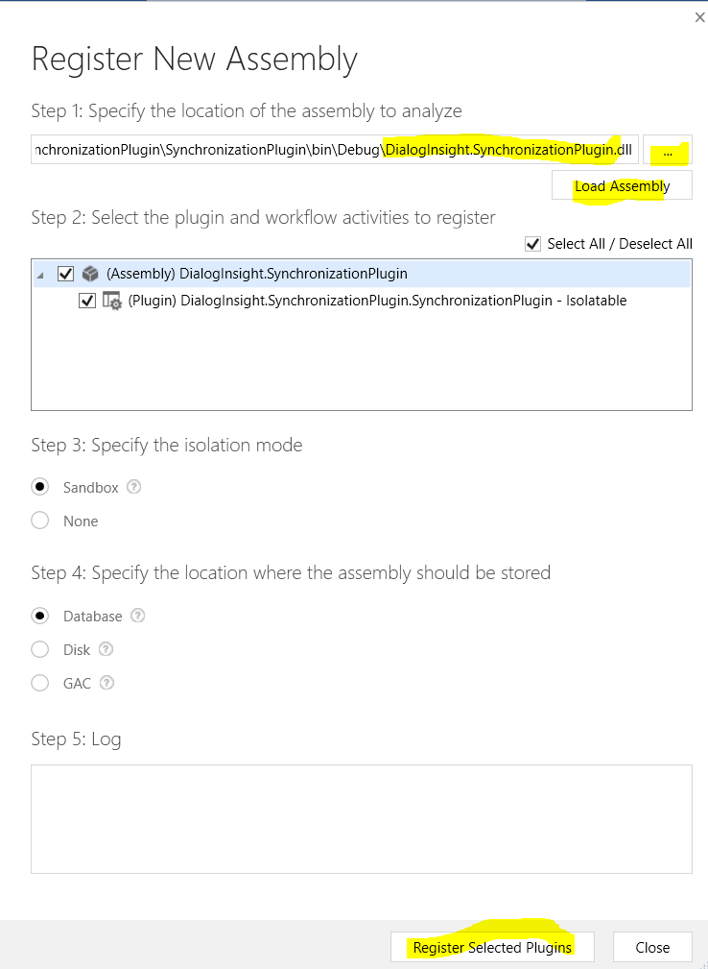

Choose DialogInsight.SynchronizationPlugin.dll, hit Load Assembly, make sure Select All is checked and finally hit Register Selected Plugin.

4-Register steps

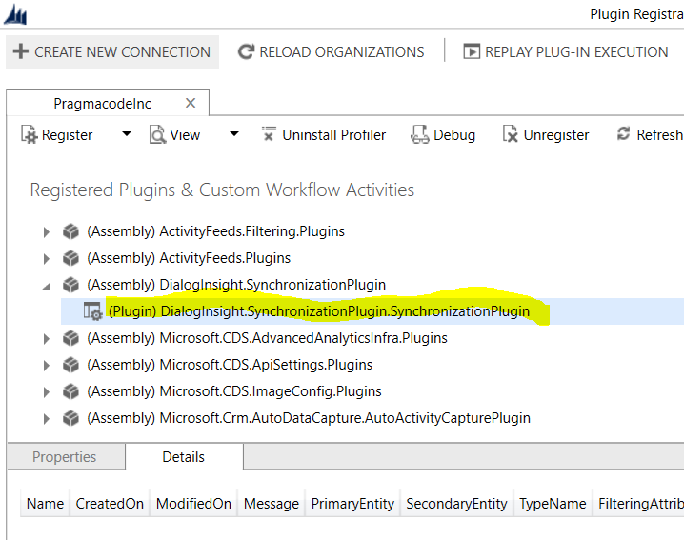

Choose the plugin and register steps

Step1: Create contact

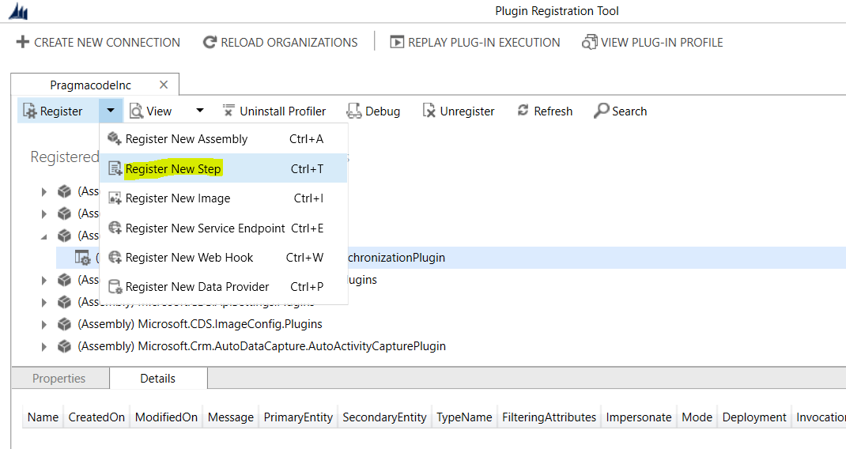

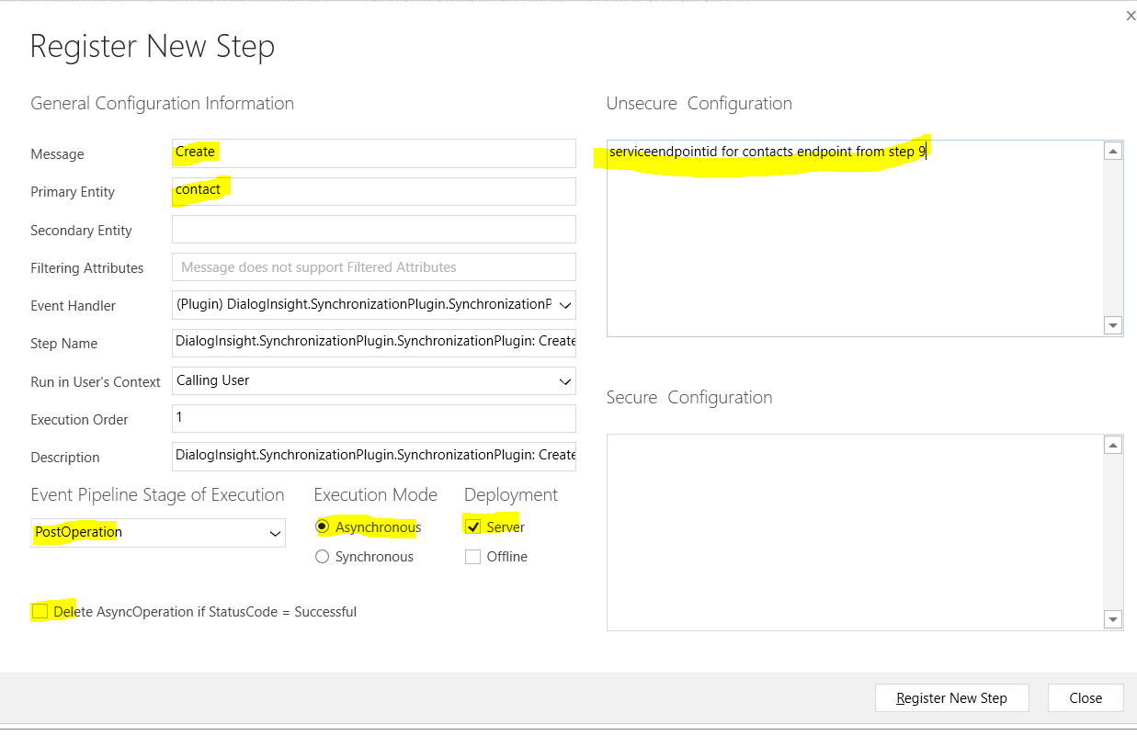

Step2: Update contact

Repeat Step1 with one change

Message: update

 Step3: Delete Contact

Repeat Step1 with one change

Message: Delete

**Add images**

For update and delete steps, we need to add images.

Click right on step "Update of contact" and "Register New Image"

Ensure that the name and the alias have the value "PostImage". Click on the three dots of the parameters field to choose the attributes. Select all attributes except the first one (traversedpath).

Machine generated alternative text:
Image Type 
Pre Image 
Na me 
Entity Alias 
Parameters 
Post Image 
hostlmage 
Postlmage 
haschildrencode, addressl _postofficebox, addressl _county, addressl_utcoffset a 

Make an image for the steps "delete of contact" but this time, choose only the option "pre image" and name it PreImage.

Machine generated alternative text:
Pre Image 
Na me 
Entity Alias 
Parameters 
Post Image 
Prelmage 
Prelmage 
haschildrencode, addressl _postofficebox, addressl _county, addressl_utcoffset a 