**Github Link**

<https://github.com/DiamSardar/DataVisualization/blob/main/assignement2.ipynb>

**Dataset**

https://www.kaggle.com/code/noelsudhish/cost-of-living-analysis-visualizations/data

**Line Graph**

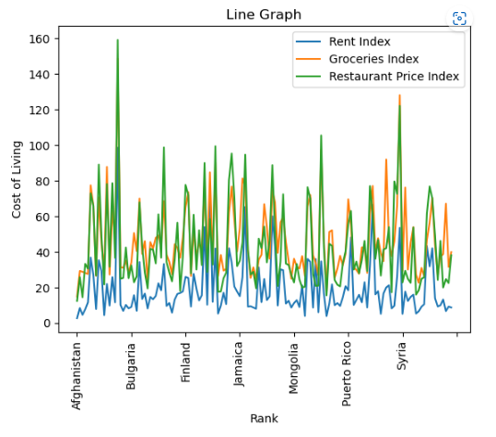

This line graph is showing cost of living of different countries. These lines are showing clearly that rent prices are less than groceries and restaurant prices in almost all counties. Whereas Restaurant cost is much higher in all countries.

**Scatter Plot**

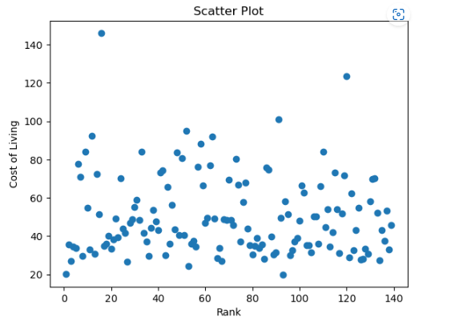  
This scatter plot is showing the relationship between cost of living index and rank of different countries. It is representing that different countries has different cost of living according to the rank given to it. Country with Rank 16 has highest cost of living.

**Bar Graph**

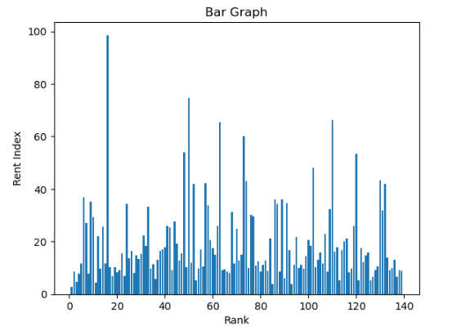

This bar plot is showing the relationship between rent index and rank of different countries. It is representing that different countries has different rent according to the rank given to it. Country with Rank 15 has highest rent.