**Creating date/times**

There are three types of date/time data that refer to an instant in time:

* A **date**. Tibbles print this as <date>.
* A **time** within a day. Tibbles print this as <time>.
* A **date-time** is a date plus a time: it uniquely identifies an instant in time (typically to the nearest second). Tibbles print this as <dttm>. Elsewhere in R these are called POSIXct, but I don’t think that’s a very useful name. . Date-times are substantially more complicated because of the need to handle time zones

To get the current date or date-time you can use *today()* or *now()*

Otherwise, there are three ways you’re likely to create a date/time:

* From a string.
* From individual date-time components.
* From an existing date/time object.

### **From strings**

To use them, identify the order in which year, month, and day appear in your dates, then arrange “y”, “m”, and “d” in the same order. That gives you the name of the lubridate function that will parse your date. For example:

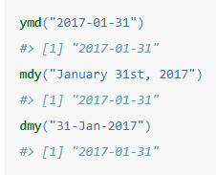

These functions also take unquoted numbers. *ymd()* is short and unambiguous:

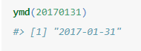

To create a date-time, add an underscore and one or more of “h”, “m”, and “s” to the name of the parsing function:

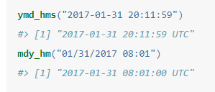

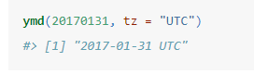creation of a date-time from a date by supplying a timezone:

### From individual components

To create a date/time from this sort of input, use *make_date()* for dates, or *make_datetime()* for date-times:

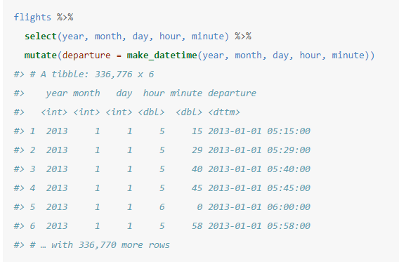

To make it work in Flight table, it would like like this:

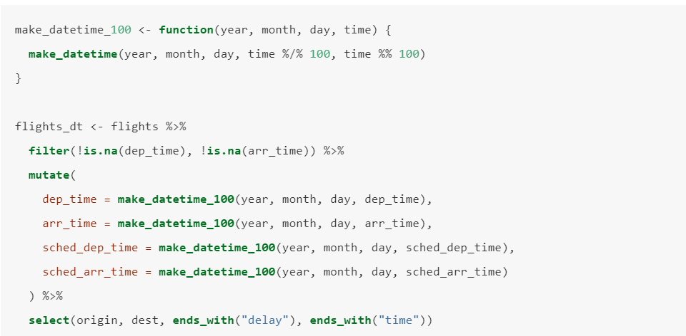

### From other types

You may want to switch between a date-time and a date. That’s the job of *as_datetime()* and *as_date():*

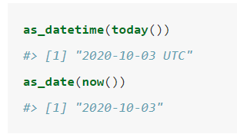

Sometimes you’ll get date/times as numeric offsets from the “Unix Epoch”, 1970-01-01. If the offset is in seconds, use *as_datetime();* if it’s in days, use *as_date().*

