cleaning:

check:

seamingly good correlation between curr. liab and assets

simple multiple regression:



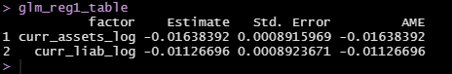

Logit:

simplest model (X1 vars):logit model

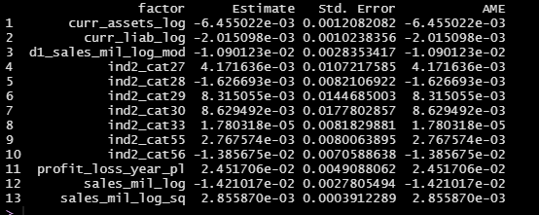

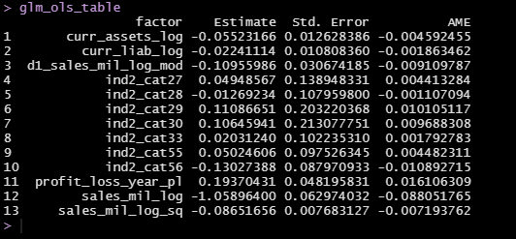

Random forrest

model1:

in excel

cross validation:

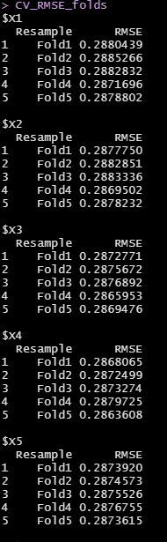

with lasso:

