CLASS DIAGRAM DESIGN
Group 29 members:
- Diamond Msibi 34854320

SCOPE DEFINITION
- Maintain medical practitioners
- Maintain patients
- Maintain appointment
- Record appointment attendance and absence
- Request report (Top 10 Practitioners (based on the no. of appointments per Time Period), Appointments per Time period)

USE CASE DIAGRAM

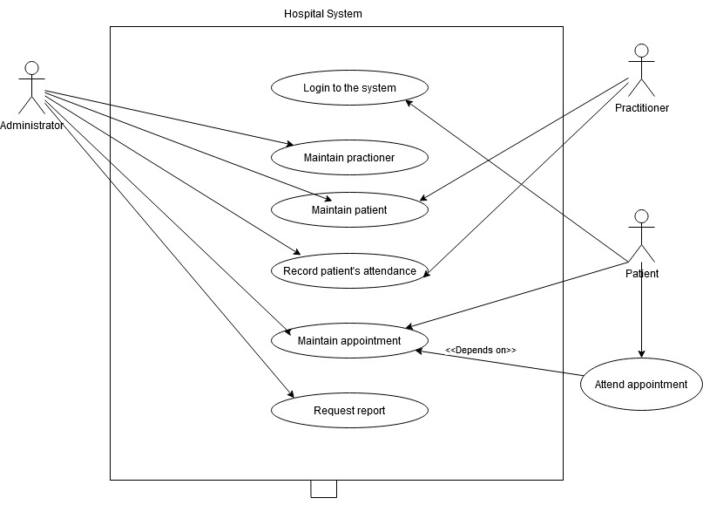

DATA MODEL DIAGRAM

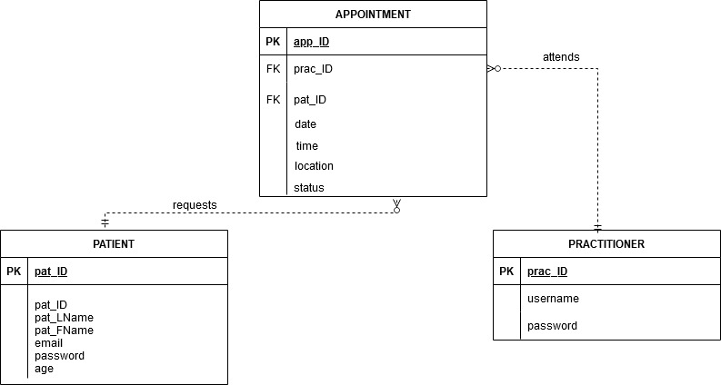

PROCESS MODEL DIAGRAM

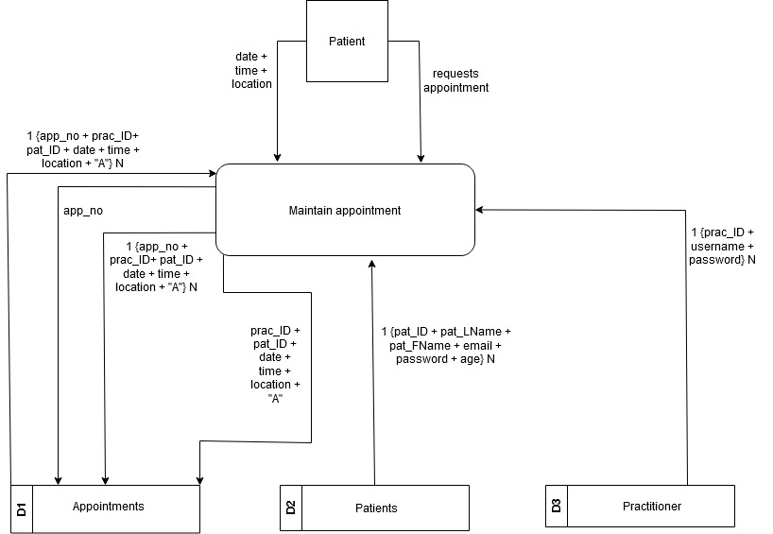

EZ-FLOW VERSION 2.0 User Manual

Congratulations on choosing EZ-FLOW VERSION 2.0! This user manual is designed to help you get the most out of your new device. Please read it carefully before use.

Table of Contents
- Introduction
  - 1.1 What is EZ-FLOW?
  - 1.2 Key Features
  - 1.3 Package Contents
- Getting Started
  - 2.1 System Requirements
  - 2.2 Installation
  - 2.3 Powering On/Off
  - 2.4 Initial Setup
- Using EZ-FLOW
  - 3.1 Main Screen
  - 3.2 Basic Operations
  - 3.3 Advanced Features
  - 3.4 Troubleshooting
- Maintenance and Care
  - 4.1 Cleaning
  - 4.2 Storage
  - 4.3 Battery Care
- Safety and Precautions
  - 5.1 General Safety
  - 5.2 Electrical Safety
  - 5.3 Environmental Considerations
- Warranty and Support
  - 6.1 Warranty Information
  - 6.2 Contact Information

1. Introduction

1.1 What is EZ-FLOW?
EZ-FLOW VERSION 2.0 is a cutting-edge device designed to streamline your daily tasks. It offers a wide range of features to make your life easier and more efficient.

1.2 Key Features
- Intuitive Touchscreen: A user-friendly interface for easy navigation.
- Wireless Connectivity: Seamlessly connect to your devices for data sharing.
- Advanced Task Automation: Simplify your routine tasks with customizable workflows.
- Long Battery Life: Enjoy extended usage without frequent recharging.
- Security Features: Protect your data with built-in encryption and biometric authentication.

1.3 Package Contents
Your EZ-FLOW VERSION 2.0 package should include the following:
- EZ-FLOW VERSION 2.0 Device
- Charging Cable
- User Manual
- Warranty Card (if applicable)

2. Getting Started

2.1 System Requirements
Before using EZ-FLOW, ensure that your system meets the following requirements:
- Compatible operating system (refer to manufacturer specifications)
- Available USB port for charging and data transfer
- Wi-Fi or Bluetooth connectivity for wireless features

2.2 Installation
- Charge your EZ-FLOW device fully using the provided charging cable.
- Turn on the device by pressing and holding the power button.
- Follow the on-screen instructions to set up your device.

2.3 Powering On/Off
- To power on: Press and hold the power button until the screen lights up.
- To power off: Press and hold the power button, then select the "Power Off" option on the screen.

2.4 Initial Setup
During the initial setup, you will configure your device settings, including language, time zone, and connectivity options. Follow the on-screen prompts for a smooth setup process.

3. Using EZ-FLOW

3.1 Main Screen
Once you've completed the setup, you'll be on the main screen. Here, you can access various features and applications. Swipe, tap, or use the touchscreen to navigate.

3.2 Basic Operations
- Touchscreen: Tap icons and options to select them.
- Swipe: Swipe left or right to switch between screens or applications.
- Settings: Access device settings by tapping the gear icon.
- Notifications: Swipe down from the top of the screen to view notifications.

3.3 Advanced Features
EZ-FLOW VERSION 2.0 offers advanced features like:
- Custom Workflows: Create automated tasks to simplify your daily routines.
- Wireless Sync: Seamlessly connect with your other devices for data sharing.
- Security: Set up biometric authentication and encryption for data protection.
- App Store: Download additional apps to enhance functionality.

3.4 Troubleshooting
If you encounter issues or have questions, refer to the troubleshooting section in the user manual or contact customer support (see Section 6.2).

4. Maintenance and Care

4.1 Cleaning
- Clean the touchscreen with a soft, lint-free cloth.
- Avoid using abrasive cleaners or solvents.
- Keep ports and connectors free of dust and debris.

4.2 Storage
- Store your EZ-FLOW in a cool, dry place.
- Use a protective case when transporting the device.

4.3 Battery Care
- Charge your device when the battery is low to extend its lifespan.
- Avoid overcharging; unplug when fully charged.
- If not using for an extended period, store with at least a 50% charge.

5. Safety and Precautions

5.1 General Safety
- Keep the device away from water and moisture.
- Do not expose to extreme temperatures or direct sunlight.
- Avoid dropping or subjecting the device to physical shocks.

5.2 Electrical Safety
- Use only the provided charging cable and adapter.
- Ensure proper ventilation during charging.
- Disconnect the charger when not in use.

5.3 Environmental Considerations
- Dispose of the device responsibly in accordance with local regulations.
- Recycle or properly dispose of batteries.

6. Warranty and Support

6.1 Warranty Information
Please refer to the warranty card included in your package for details on the warranty coverage and duration.

6.2 Contact Information
For product inquiries, technical support, or assistance, contact our customer support team at:
Customer Support Hotline: 1-800-EZ-FLOW Email: support@ez-flow.com Website: www.ez-flow.com/support

